AIMAN COLLEGE OF ARTS AND SCIENCE FOR WOMEN DEPATMENT OF PHYSICS
III B.Sc PHYSICS
Subject Title: NUCLEAR PHYSICS
Subject code: 16SCCPH8
Semester: 6

Unit v:
- Classification of elementary particles- Pions and Muons- K mesons- Hyperons
Already explained this topic during class hours. Notes given from modern physics book
- Conservation laws – exact laws- approximate conservation laws
(For exam, refer the attached pdf)
In physics, a conservation law states that a particular measurable property of an isolated physical system does not change as the system evolves over time. Exact conservation
laws include conservation of energy, conservation of linear momentum, conservation of angular momentum,
and conservation of electric charge.

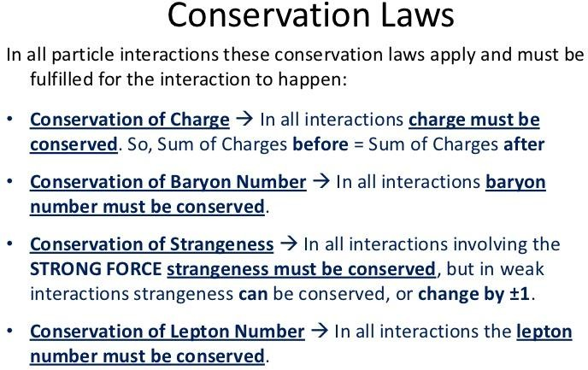

  - Conservation of isospin
In particle physics and nuclear physics, isospin, I or I₃, is a quantum number related to the strong nuclear
force. Isospin is associated with a conservation law which requires strong interaction decays to conserve isospin.
... Isospin is mathematically similar to spin, though it has nothing to do with angular momentum.
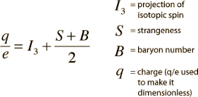
- Fundamental interactions
(For exam, refer the attached pdf)

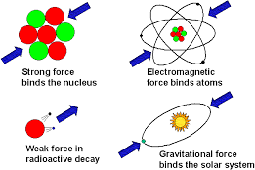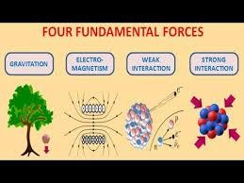

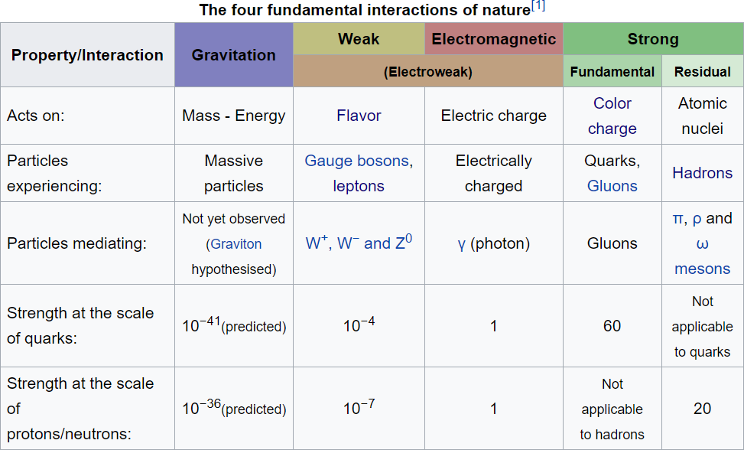

Four basic forces—gravitational, electromagnetic, strong, and weak All the known forces of nature can be traced to these fundamental interactions. The fundamental interactions are characterized on the basis of the following four criteria:

  - the types of particles that experience the force
  - the relative strength of the force
  - the range over which the force is effective
  - the nature of the particles that mediate the force.
The gravitational force acts between all objects having mass.
The electromagnetic force is responsible for the repulsion of like and the attraction of unlike electric charges.
The strong force acts between quarks, the constituents of all subatomic particles, including protons and neutrons.
The weak force manifests itself in certain forms of radioactive decay and in the nuclear reactions .

- Anti-particles
Already explained this topic during class hours. Notes given from modern physics book
- Resonance Particles (Material for exam)
Resonance, in particle physics, an extremely short-lived phenomenon associated with subatomic particles
called hadrons that decay via the strong nuclear force.
A resonance is the peak located around a certain energy found in differential cross sections of scattering experiments. These peaks are associated with subatomic particles, which include a variety of bosons, quarks and hadrons and their excitations.
It occurs when the total energy of the colliding subatomic particles is just enough to produce its rest mass, which the strong force then causes to disintegrate within10⁻²³ second.

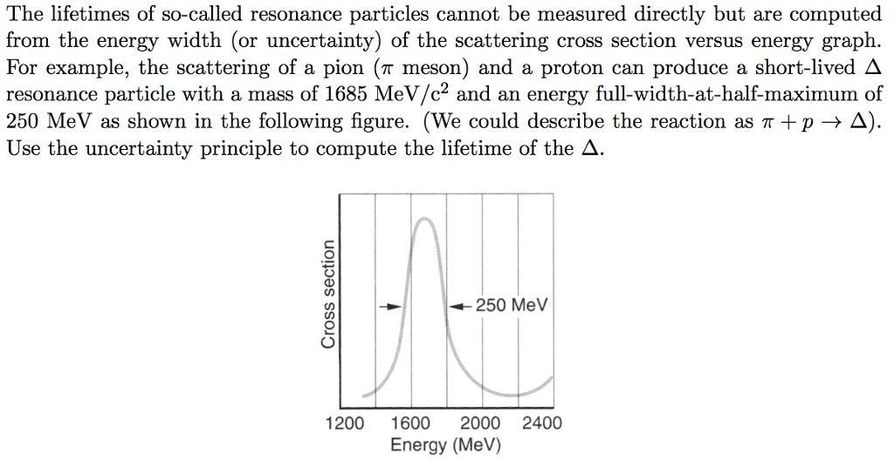

- Hyper nucleus (Material for exam)
A hypernucleus is a nucleus which contains at least
one hyperon (a baryon carrying the strangeness quantum number) in addition to the normal protons and neutrons. They have been studied by measuring the momenta of the K and pi mesons in the direct strangeness exchange reactions.
Hypernuclei can be made by a nucleus capturing a Lambda or a K meson in a compound nuclear reaction by the direct strangeness exchange reaction.
K + nucleus → π + hypernucleus

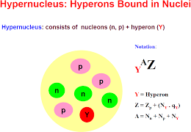

Hypernuclei containing the lightest hyperon, the Lambda, live long enough to have sharp nuclear energy levels.
Hypernucleus differs from that of normal nuclei because a hyperon, having a non-zero strangeness quantum number, can share space and momentum coordinates with the usual four nucleon states that can differ from each other
in spin and isospin. They are not restricted by the Pauli exclusion principle from any single-particle state in the nucleus.

- Symmetry classification of elementary particles (For exam, refer the attached pdf)
  - Conservation laws are related to three symmetry principles that apply to changing the total circumstances of an event rather than changing a particular quantity.
The three symmetry operations associated with these principles are:
  - charge conjugation (C), which is equivalent to exchanging particles and antiparticles;
  - parity (P), which is a kind of mirror-image symmetry involving the exchange of left and right; and

  - time-reversal (T), which reverses the order in which events occur.

According to the symmetry principles (or invariance principles), performing one of these symmetry operations on a possible particle reaction should result in a second reaction that is also possible.
However, it was found that parity is not conserved in the weak interactions, i.e., there are some possible particle decays whose mirror- image counterparts do not occur. Although not conserved individually, the combination of all three operations performed successively is conserved; this law is known as the CPT theorem.
- Quark Model
(For exam, refer the attached pdf)
Quarks are the building blocks which build up matter, i.e., they are seen as the "elementary particles". There are six "flavors" of quarks. The most familiar baryons are the proton and neutron, which are each constructed from up and down quarks. Quarks are observed to occur only in combinations of two quarks (mesons), three quarks (baryons).
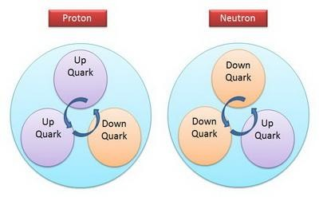

Quark | Symbol | Spin | Charge | Baryon Number | S | C | B | T | Mass*
Up | U | 1/2 | +2/3 | 1/3 | 0 | 0 | 0 | 0 | 1.7-3.3 MeV
Down | D | 1/2 | -1/3 | 1/3 | 0 | 0 | 0 | 0 | 4.1-5.8 MeV
Charm | C | 1/2 | +2/3 | 1/3 | 0 | +1 | 0 | 0 | 1270 MeV
Strange | S | 1/2 | -1/3 | 1/3 | -1 | 0 | 0 | 0 | 101 MeV
Top | T | 1/2 | +2/3 | 1/3 | 0 | 0 | 0 | +1 | 172 GeV
Bottom | B | 1/2 | -1/3 | 1/3 | 0 | 0 | -1 | 0 | 4.19 GeV(MS)  4.67 GeV(1S)

Prepare well All the best

