Bharath College of Science and Management,Thanjavur-5

Title of the Paper : IMMUNOTECHNOLOGY

Subject Code: 16SMBEBT3

Prepared By : Dr.S.Jawahar,

Assistant Professor & Head,

Department of Bio Technology.

MAJOR BASED ELECTIVE III IMMUNOTECHNOLOGY
Unit I
Introduction to Immunotechnology Principles, methods of immunization. Hybridoma technology
- monoclonal & polyclonal antibody production, antigen nature, animals of choice and purification of antibodies. Quantification of immunoglobulin by RID, EID and nephlometry. Immunization techniques, antibody titer assessment. Immunochemistry. Purification of antibody
- ammonium sulphate precipitation, PEG Precipitation, affinity purification and column chromatography.

Unit II
Cellular Immunology Purification of mononuclear cells from peripheral blood, isolation and characterization of T cell subsets, B cells and macrophages High content screening & cell imaging by fluorescent activated cell sorter (FACS). Mitogen and antigen induced lympho - proliferation assay; cell mediated lympholysis, and mixed lymphocyte reaction. Assessment of delayed type hypersensitivity reactions. Macrophage cultures, assay for macrophage activation and isolation of dendritic cells. In - situ and In - vivo characterization of cells from tissues, generation of T cell clones and HLA typing.

Unit III
Antigen – Antibody Reaction Surface plasma resonance. Biosensor assays for assessing ligand – receptor interaction.

Unit IV
New generation antibodies Multigene organization of immunoglobulin genes, antibody diversity, antibody engineering and phage display libraries. Antibodies as in - vitro and in - vivo probes. Immuno regulators as therapeutic products. Production of immuno regulators, process design, selection criteria for cell lines, culture media, process development, product recovery, stability checking and validation.

Unit V
Therapeutic agents Rationale for vaccine design based on clinical requirements. Recombinant DNA and protein based vaccines, plant-based vaccines and reverse vaccinology. Peptide vaccines, conjugate vaccines, cell therapy and cell based vaccines. Growth factors, interferon, tumor necrosis factor, cytokines, lymphokines & chemokines.

Text Books
- D. M. Weir, John Stewart. 1997. Immunology. 8th Edition. Churchill Livingstone.
- P.J.Delves I S.J.artin I D.R.Burton I I.M.Roitt. 2006. Essential Immunotechnology. 12th Edition,
- Roitt, I. 2000. Essential Immunology, IV Edition. Blackwell Sci. NY.

Reference Books
- Benjamini E, Coico R and G. Sunskise. 2000. Immunology a short course. IV Edition. Wiley – Liss publication, NY.
- Goldsby R.A. Kindt T.I and Osborne B.A Kuby. 2000. Immunology 4th Edition. WH Freeman &Co, NY.

UNIT I

  - Introduction to Immunotechnology Principles, methods of immunization.

  - Hybridoma technology - monoclonal & polyclonal antibody production,

  - antigen nature,

  - Animals of choice and purification of antibodies.

  - Quantification of immunoglobulin by RID, EID and nephlometry.

  - Immunization techniques,

  - Antibody titer assessment.

  - Immunochemistry.

  - Purification of antibody - ammonium sulphate precipitation, PEG Precipitation, affinity purification and column chromatography.

Principles and methods of immunization.

Immunization is the process whereby a person is made immune or resistant to an infectious disease, typically by the administration of a vaccine. Vaccines stimulate the body's own immune system to protect the person against subsequent infection or disease.

According to the WHO guideline [27], “complete or full immunization” coverage is defined as a child has received a BCG vaccination against tuberculosis; three doses of DPT vaccine to prevent diphtheria, pertusis, and tetanus (DPT); at least three doses of polio vaccine; and one dose of measles vaccine.

Children completely immunized for primary immunization - it is defined as children who have received BCG, zero dose of OPV, all three doses of OPV/DPT/hepatitis B and measles vaccines.

Active immunization utilizes an immunogen to generate a host response designed to eliminate the malignant cells, whereas in passive immunization preformed antibodies or cells are administered to directly eliminate the transformed cells - examples of each are considered in this review.

Hybridoma technology

Hybridoma technology is a method for producing large numbers of identical antibodies (also called monoclonal antibodies). ... The myeloma cell line that is used in this process is selected for its ability to grow in tissue culture and for an absence of antibody synthesis.

Polyclonal antibodies are made using several different immune cells. They will have the affinity for the same antigen but different epitopes, while monoclonal antibodies are made using identical immune cells that are all clones of a specific parent cel

Polyclonal antibodies are produced by injecting an immunogen into an animal. Monoclonal
antibodies (mAbs) are generated by identical B cells which are clones from a single parent cell. This means that the monoclonal antibodies have monovalent affinity and only recognize the same epitope of an antigen.

The traditional monoclonal antibody (mAb) production process usually starts with generation of mAb-producing cells (i.e. hybridomas) by fusing myeloma cells with desired antibody-producing splenocytes (e.g. B cells). These B cells are typically sourced from animals, usually mice. After cell fusion, large numbers of clones are screened and selected on the basis of antigen specificity and immunoglobulin class. Once candidate hybridoma cell lines are identified, each "hit" is confirmed, validated, and characterized using a variety of downstream functional assays. Upon completion, the clones are scaled up where additional downstream bioprocesses occur.

What Is the Difference Between Polyclonal and Monoclonal Antibodies?
Antibodies, also known as immunoglobulins, are secreted by B cells (plasma cells) to neutralize antigens such as bacteria and viruses. The classical representation of an antibody is a Y-shaped molecule composed of four polypeptides-two heavy chains and two light chains. Each tip of the "Y" contains a paratope (a structure analogous to a lock) that is specific for one particular

epitope (similarly analogous to a key) on an antigen, allowing these two structures to bind together with precision. The ability of binding to an antigen has led to their ubiquitous use in a variety of life science and medical science. These antibodies can be classified into two primary types (monoclonal and polyclonal) by the means in which they are created from lymphocytes. Each of them has important role in the immune system, diagnostic exams, and treatments.
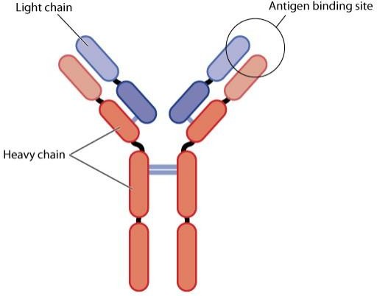
This overview will describe the synthesis of monoclonal and polyclonal antibodies, their differentiating properties, and their role in clinical diagnostics and therapeutics.
The structure of the antibody

Polyclonal Antibodies vs. Monoclonal Antibodies: Production.
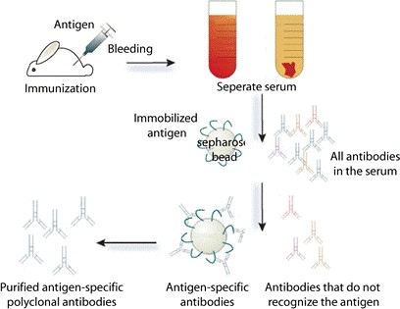
Polyclonal antibodies (pAbs) are mixture of heterogeneous which are usually produced by different B cell clones in the body. They can recognize and bind to many different epitopes of a single antigen. Polyclonal antibodies are produced by injecting an immunogen into an animal. After being injected with a specific antigen to elicit a primary immune response, the animal is given a secondary even tertiary immunization to produce higher titers of antibodies against the particular antigen. After immunization, polyclonal antibodies can be obtained straight from the serum (blood which has had clotting proteins and red blood cells removed) or purified to obtain a solution which is free from other serum proteins.

The process to generate the polyclonal antibody

Monoclonal antibodies (mAbs) are generated by identical B cells which are clones from a single parent cell. This means that the monoclonal antibodies have monovalent affinity and only recognize the same epitope of an antigen. Unlike polyclonal antibodies, which are produced in

live animals, monoclonal antibodies are produced ex vivo using tissue-culture techniques. The process begins with an injection of the desired antigen into an animal, often a mouse, multiple times. Once the animal develops an immune response, the B-lymphocytes are isolated from the animal’s spleen and fused with a myeloma cell line, creating immortalized B cell-myeloma hybridomas. The hybridomas, which are able to grow continuously in culture while producing antibodies, are then screened for desired mAb.

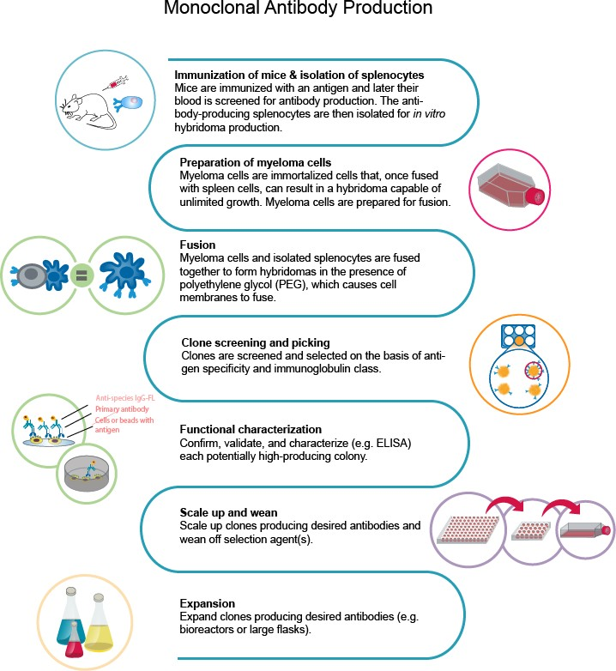

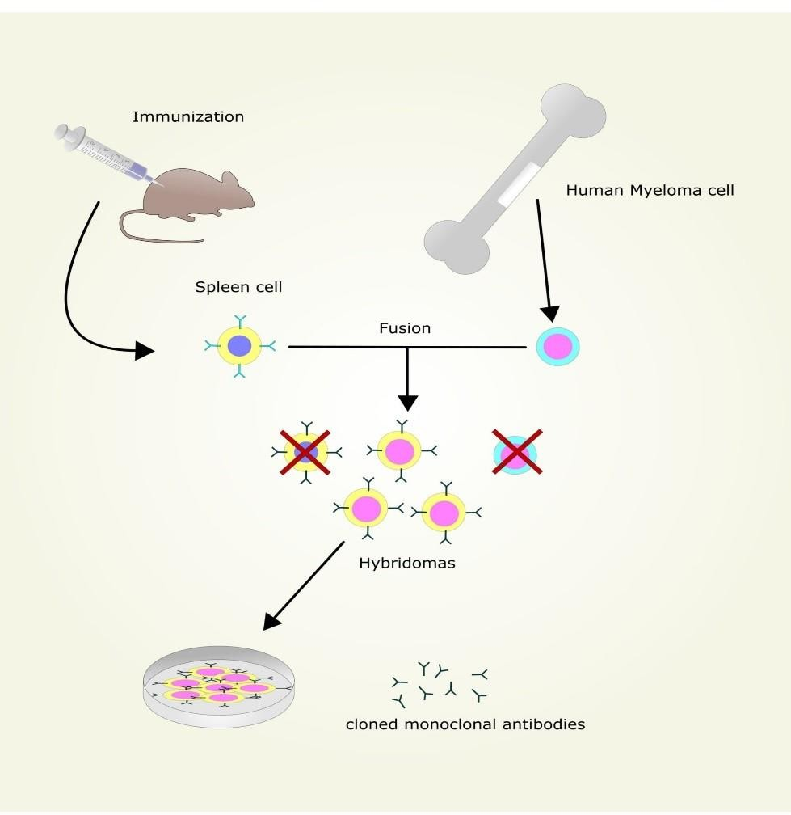

The process to generate the monoclonal antibody\

Polyclonal Antibodies vs. Monoclonal Antibodies: Advantages and Disadvantages
Both polyclonal and monoclonal antibodies have their own advantages and disadvantages which make them useful for different applications.
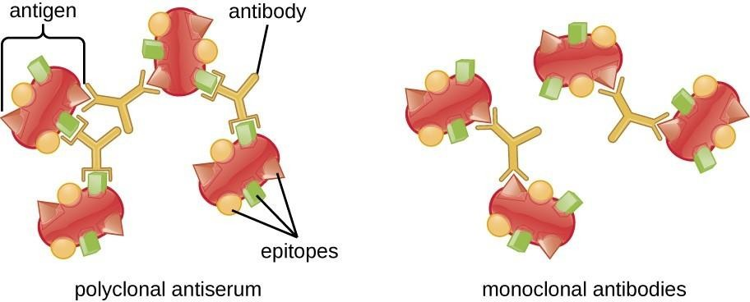

The specificity of polyclonal antibodies and monoclonal antibodies

  - Polyclonal Antibodies
  - The advantages and disadvantages of polyclonal antibodies were mainly determined by their multi-epitope specificity. The key advantages and disadvantages are listed below:
•

Advantages:
  - Short production time and low cost.
  - Highly stable and tolerant of pH or buffer changes.
  - High affinity. Since the antibodies bind to more than one epitope, they can help amplify the signal from target protein even with low expression level. This makes these antibodies ideal for immunoprecipitation and chromatin immunoprecipitation.
  - Tolerant of minor changes of antigen. Polyclonal antibodies are less sensitive to antigen changes (slight denaturation, polymorphism, heterogeneity of glycosylation) than monoclonal antibodies.

Disadvantages:
  - Prone to batch to batch variability.
  - Multiple epitopes make it important to check immunogen sequence for any cross- reactivity.

Monoclonal Antibodies
  - The advantages and disadvantages of monoclonal antibodies were mainly based on their high specificity to the same epitope of an antigen. The key advantages and disadvantages are listed below:

Advantages:
  - Highly specific recognition of only one epitope of an antigen
  - Immortal hybridoma cell lines have the ability to produce unlimited quantities of antibodies
  - High consistency among experiments
  - Minimal background noise and cross-reactivity
  - Excellent for affinity purification

Disadvantages:
  - Developing a monoclonal takes time and requires high technical skills.
  - They can produce large amounts of specific antibodies but may be too specific to detect in across a range of species.
  - Vulnerable to the change of epitope. Even a slight change in conformation may lead to dramatically reduced binding capacity.

Polyclonal Antibodies vs. Monoclonal Antibodies: Diagnostic Studies
Which is better, a monoclonal or a polyclonal antibody? It depends on the different characteristics of monoclonal and polyclonal antibodies.
Polyclonal antibodies are ideal reagents in diagnostic assays and hemagglutination reactions due to their ability to recognize different epitopes of a target molecule. The best use of polyclonal antibodies is to detect unknown antigens. Polyclonal antibodies are used as a secondary antibody in immunoassays (e.g. ELISA, western blotting, microarray assays, immunohistochemistry, flow

cytometry). Their role is to bind to different epitopes and amplify the signal, leading to better detection.

Monoclonal antibodies, in contrast, provide an unlimited source of antibody that is homogeneous and, once characterized, predictable in its behavior. Monoclonal antibodies are often used as primary antibodies in immunoassays due to their ability of specifically binding to a single epitope of an antigen. Through the use of clinical application, some of the disadvantages of using each type of antibody has been nullified. Companies can purify polyclonal antibodies to limit the degree of cross-reactivity in their assays. The combination of monoclonal antibodies leads to the capture of multiple epitopes and expanding its’ specificity.

Polyclonal Antibodies vs. Monoclonal Antibodies: Treatment
Where monoclonal antibodies have stood out in a clinical setting is their ability to find and target specific molecules. Monoclonal antibodies’ Fc regions are initially tagged with markers and are used to discover cellular surface components. This research promotes the monoclonal antibodies used as medicine. OKT3 (also called Muromonab) was first approved by FDA in 1985 as a specific transplant rejection drug for organ transplant patients preventing graft disease. Since then, forty-one other antibodies have been approved by FDA to fight cancers, rheumatoid arthritis, and asthma and other illnesses. Monoclonal antibodies are also being used as vectors to bring drug to the target cell (e.g. a cancerous cell). When the Antibody-drug conjugates meet the target cell, the drug is released and exerts its effect.

Polyclonal antibodies, in contrast, are not as adept as monoclonal antibodies at treating cancer cells due to their lack of specificity and a high degree of cross reactivity. Research is showing that polyclonal antibody therapy can be useful in the treatment of some diseases and as an immunosuppressant for transplant patients.
Return to Resources

Radial immunodiffusion (RID)

Radial immunodiffusion (RID) or Mancini method, Mancini immunodiffusion or single radial immunodiffusion assay, is an immunodiffusion technique used in immunology to determine the quantity or concentration of an antigen in a sample.

Preparation
A solution containing antibody is added to a heated medium such as agar or agarose dissolved in buffered normal saline. The molten medium is then poured onto a microscope slide or into an open container, such as a Petri dish, and allowed to cool and form a gel. A solution containing the antigen is then placed in a well that is punched into the gel. The slide or container is then covered or closed to prevent evaporation.

The antigen diffuses radially into the medium, forming a circle of precipitin that marks the boundary between the antibody and the antigen.[1] The diameter of the circle increases with time as the antigen diffuses into the medium, reacts with the antibody, and forms insoluble precipitin complexes. The antigen is quantitated by measuring the diameter of the precipitin circle and comparing it with the diameters of precipitin circles formed by known quantities or concentrations of the antigen.

Antigen-antibody complexes are small and soluble when in antigen excess. Therefore, precipitation near the center of the circle is usually less dense than it is near the circle's outer edge, where antigen is less concentrated. Expansion of the circle reaches an end point and stops when free antigen is depleted and when antigen and antibody reach equivalence. However, the clarity and density of the circle's outer edge may continue to increase after the circle stops expanding.

Interpretation
For most antigens, the area and the square of the diameter of the circle at the circle's end point are directly proportional to the quantity of antigen and are inversely proportional to the concentration of antibody. Therefore, a graph that compares the quantities or concentrations of antigen in the original samples with the areas or the squares of the diameters of the precipitin circles on linear scales will usually be a straight line when all circles have reached their end points (equivalence method). Circles that small quantities of antigen create reach their end points before circles that large quantities create. Therefore, if areas or diameters of circles are measured while some, but not all, circles have stopped expanding, such a graph will be straight in the portion that contains the smaller quantities or concentrations of antigen and will be curved in the portion that contains the larger quantities or concentrations.

Radial immunodiffusion techniques

- Measuring circles while all are expanding (kinetic method
- Measuring circles after all reach their end points (equivalence method)

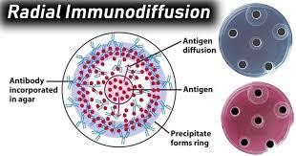

An immunoprecipitation method called electroimmunodiffusion (EID) is described in which antigen diffuses, under the influence of an electric field, into a layer of agar containing specific antiserum. The antigen-antibody precipitate length is proportional to the concentration of antigen in the well, and to the duration of electrophoresis. The method is rapid, accurate, and reproducible, and requires 4 μL of sample. EID is more sensitive than simple radial diffusion. The lower limits of accurate quantitation are γG, 0.2 mg. per cent; γA, 0.5 mg. per cent; γM, 0.8 mg. per cent. The method is suitable for the measurement of immunoglobulins in small samples of dilute and unconcentrated biological fluids. Conditions for the measurement of γG-globulin in cerebrospinal fluid (CSF) are described. Normal CSF contained 1.0 to 3.1 mg. per 100 ml. γG.

What is the antibody titer test?
The antibody titer is a test that detects the presence and measures the amount of antibodies within a person’s blood. The amount and diversity of antibodies correlates to the strength of the body’s immune response.

The immune system produces antibodies to mark invading microorganisms for destruction or to neutralize them before they can cause an infection. Invading microorganisms are known as pathogens. Pathogens have markers on them known as antigens, which antibodies find and bind to.

The binding of antigens to antibodies sparks the immune response. This is a complex interaction of immune tissues and cells that work to defend against invading organisms and fight infection.

Why did my doctor prescribe the antibody titer test?
An antibody titer test is used to determine if you’ve had previous infections and whether or not you need certain immunizations. This test can be used to determine the following:
  - if you need a booster shot
  - whether you recently had or currently have an infection
  - whether your immune system has a strong response to your own tissues, possibly indicating an autoimmune disorder
  - whether an immunization triggers a strong enough response against the disease it’s meant to protect you against

How should I prepare for the test?
It’s essential that you tell your doctor about any prescription or nonprescription medications, dietary supplements, and vitamins you’re currently taking before a medical test is performed.
In general, no special preparation is needed for this test. However, researchTrusted Source has shown people receiving chemotherapy have a decrease in antibody levels, so let your doctor know if you’ve recently undergone or are currently undergoing chemotherapy.

What happens during the test?
The antibody titer is a blood test. A healthcare provider ties a band above the site where the blood will be taken. They next clean and sterilize the site with antiseptic before inserting a small needle directly into a vein.
Most people feel sharp pain at the initial puncture, which quickly fades as the blood is drawn. Once the blood is collected, the healthcare provider removes the needle, and you will be asked to apply pressure to the puncture site with a cotton ball or gauze. A bandage is placed on the site, and you are then free to leave.
This test is a low-risk procedure. However, slight risks can include:
  - feeling faint at the sight of blood
  - dizziness or vertigo
  - soreness or redness at the puncture site
  - hematoma (bruising)
  - pain
  - infection

What do abnormal results mean?
Abnormal test results may indicate immune disorders such as:
  - hyper-IgE syndrome
  - antiphospholipid antibody syndrome (aPL)

  - X-linked hyper-IgM syndrome
  - Abnormal results may also indicate other current or past infections, such as:
  - meningitis, which is inflammation of the membranes that cover your brain and spinal cord
  - diphtheria, a bacterial infection
  - infection from helicobacter pylori bacteria
  - chickenpox
  - mononucleosis
  - Hepatitis

Antibody Purification Methods

The production and use of specific antibodies as detection probes and purification ligands—often called immunodetection or immunotechnology—has revolutionized bioresearch and diagnostic technologies. Animals immunized with prepared antigens will produce specific antibodies against the antigen. Once they are purified (and possibly after labeling them with an enzyme or fluorescent tag), these antibodies can be used directly to probe the specific antigen in Western blotting, ELISA and other applications. Antiserum from an immunized animal can be used directly for certain applications, but more often some form of antibody purification is required to obtain an antibody probe that is effective for multiple types of detection methods. This article summarizes the main approaches and tools available for accomplishing antibody purification.

Introduction
Antibody purification involves selective enrichment or specific isolation of antibodies from serum (polyclonal antibodies), ascites fluid or cell culture supernatant of a hybridoma cell line (monoclonal antibodies). Purification methods range from very crude to highly specific and can be classified as follows:

  - Physicochemical fractionation—differential precipitation, size-exclusion or solid-phase binding of immunoglobulins based on size, charge or other shared chemical characteristics of antibodies in typical samples. This isolates a subset of sample proteins that includes the immunoglobulins.

  - Class-specific affinity—solid-phase binding of particular antibody classes (e.g., IgG) by immobilized biological ligands (proteins, lectins, etc.) that have specific affinity to immunoglobulins. This purifies all antibodies of the target class without regard to antigen specificity.

  - Antigen-specific affinity—affinity purification of only those antibodies in a sample that bind to a particular antigen molecule through their specific antigen-binding domains. This purifies all antibodies that bind the antigen without regard to antibody class or isotype.

  - Antibodies that were developed as monoclonal antibody hybridoma cell lines and produced as ascites fluid or cell culture supernatant can be fully purified without using an antigen-specific affinity method (third type) because the target antibody is (for most

practical purposes) the only immunoglobulin in the production sample. By contrast, for polyclonal antibodies (serum samples), antigen-specific affinity purification is required to prevent co-purification of nonspecific immunoglobulins. For example, generally only 2– 5% of total IgG in mouse serum is specific for the antigen used to immunize the animal. The type(s) and degree of purification that are necessary to obtain usable antibody depend upon the intended application(s) for the antibody.

PurIficatIon ofIgGAntIbodIes wIth AmmonIum Sulphate

Objective
To demonstrate the purification protocols of antibodies for use in research and diagnostics.

Principle
The diversity of the antibody-antigen interaction and our ability to manipulate the characteristics of this interaction has created many uses for antibodies and antibody fragments, both for immunochemical techniques within general research and for therapeutic and diagnostic applications. Ascites are intraperitoneal fluid from mice with peritoneal tumors that has been induced by injecting single cloned hybridoma cells. In mouse peritoneum, hybridoma cells grow to high densities and secrete antibodies of interest. Ammonium sulfate precipitation is a method used to purify antibodies by altering their solubility from ascites ,serum or hybridoma supernatant. It is a specific case of a more general technique known as salting out.Antibody precipitation can be carried out using a variety of agents ranging from distilled water to complex glycols and specialized acids. A more popular technique for immunoglobin isolation is salt precipitation. Immunoglobulins precipitate out of either sodium or ammonium sulphate especially when non refined fractions of immunoglobulin are required. Further refinement can be done by ion exchange or other forms of chromatographic technique.

Dialysis
Dialysis Tubing is a type of semi- or partially permeable membrane tubing made from regenerated cellulose or cellophane. The solution to be dialyzed is placed in a sealed dialysis membrane and immersed in a selected buffer; small solute molecules then equilibrate between the sample and the dialysate. Concomitant with the movement of small solutes across the membrane, however, is the movement of solvent in the opposite direction. This can result in some sample dilution (usually <50%). It is used in clinical circumstances to ensure a filtered flow of molecules, preventing the flow of larger solute molecules.

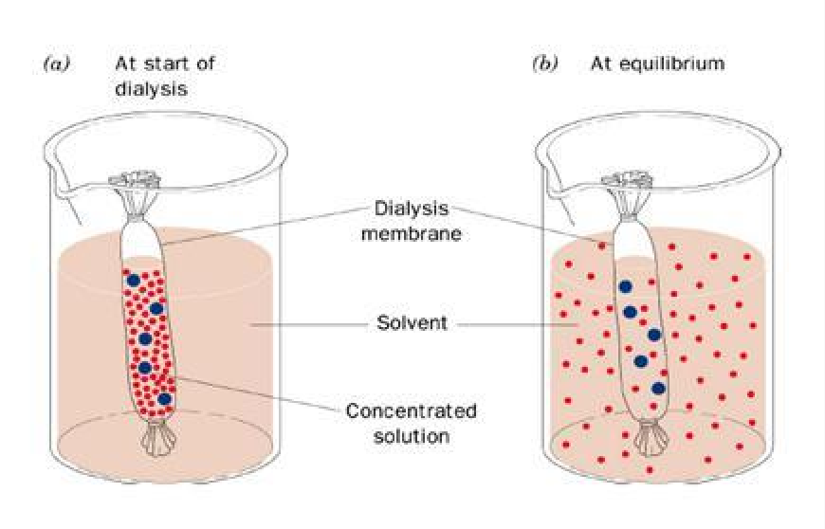

Dialysis membranes are available in a number of thicknesses and pore sizes. Thicker membranes are tougher, but restrict solute flow and reach equilibrium more slowly. Pore size is defined by “molecular weight cut-off” (MWCO) i.e., the size of the smallest particle that cannot penetrate the membrane. Knowledge of the precise MWCO is usually not required; however, it is necessary only to use a membrane with a pore size that is much smaller than the macromolecule of interest. For most plasmid and protein dialyses, a MWCO of 12,000 to 14,000 is appropriate, whereas a MWCO of 3500, 2000, or even 1000 is appropriate for peptides. Most dialysis membranes are made of derivatives of cellulose. They come in a wide variety of MWCO values, ranging from 500 to 500,000.

Selection and Preparation of Dialysis Membrane:

  - Remove membrane from the roll and cut into usable lengths - Always use gloves to handle dialysis membrane, as it is susceptible to a number of cellulolytic microorganisms. Membrane is available as sheets or preformed tubing.
  - Wet membrane and boil it for several minutes in a large excess of 10 mM sodium bicarbonate.
  - Boil several minutes in 10 mM Na2EDTA - Boiling speeds up the treatment process but is not necessary. A 30-min soak with some agitation can substitute for the boiling step.
  - Wash several times in distilled water.
  - Store at 4°C in 20% to 50% ethanol to prevent growth of cellulolytic microorganisms.

Purification of antibodies using chromatography
The use of antibodies as therapeutics in diagnostics and in biological sensors has revolutionized modern medicine, laboratory-based science, and environmental and “in situ” monitoring. Monoclonal antibodies (mAbs), polyclonal antibodies, recombinant antibodies, and antibody fragments all have their niche uses, requiring different purification techniques. The current capabilities of antibody production by recombinant techniques has increased the need for purification on a larger scale (up to 100 kg batches),1 thus requiring innovative purification methodologies. To achieve current industry standards for antibody purification, affinity chromatographic bioaffinity ligands are commonly used. However, at present, there is a

movement away from the use of bioaffinity ligands such as Protein A, because of a number of limiting factors such as the leakage of Protein A from the column with associated product contamination, high cost, low reusability of resin, and putative antibody aggregation during low pH elution.

Purification can alternatively be achieved through the use of genetically fused purification tags, the most common of which is a polyhistidine tag (poly-His or His6) that is utilized in immobilized metal affinity chromatography (IMAC). The production of a poly-His tag exerts a low metabolic burden on the producing host; however, it is not as specific as affinity chromatography.

Ion-exchange chromatography using a multicolumn countercurrent solvent gradient purification (MCSGP) system has been described as an alternative to Protein A-based chromatography.6 This system recycles partially purified fractions, therefore increasing the protein yield, and by using a simulation model and experimental setup, it was shown that ion-exchange MCSGP can achieve industrial levels of antibody yield with high purity.

Affinity chromatography
MAbs are commonly used as therapeutics in the treatment of cancer, autoimmune disorders, and inflammatory diseases; these entities require the highest degree of purification before they are suitable for patient administration. MAbs are batch-purified from mammalian cells such as Chinese hamster ovary (CHO) cells. The removal of impurities such as endogenous viruses (used during antibody production), DNA, host cell proteins (HCPs), endotoxins, and aggregates is highly important as they could potentially activate the immune system of the patient. Removal can be achieved by a number of processes, the most popular of which are combinatorial approaches; for example, utilizing Protein-A affinity chromatography followed by anion- exchange chromatography.

Affinity chromatography has been the predominant method of antibody purification because of its high selectivity. Many forms of affinity chromatography have been exploited; however, one of the most commonly used forms is affinity chromatography using bacterially derived receptors such as staphylococcal Protein-A (SpA), streptococcal Protein-G, Protein-L from Peptostreptococcus magnus and Protein-M from Mycoplasma (Table 1).11,12 Protein-A and
-G are multispecific, binding the region of immunoglobulin-connecting CH2 and CH3.¹³ Protein-A chromatography is the method of choice for the capture and purification of therapeutic IgG and Fc-fusion proteins on an industrial scale.14 Native Protein-A (42 kDa) is a single polypeptide chain that is composed of five Fc binding domains (known as E, D, A, B, C, and finally X, a cell wall–binding domain).15–17 A hydrophobic reaction binds Protein-A and the Fc region of IgG, but this interaction is weakened at low pH, thus allowing elution of IgG.14 However, the combination of high protein concentration and the elution of Fc-fusion molecules or IgG at low pH can destabilize the protein or cause loss of function and can cause the formation of aggregate species, which are potentially harmful (immunogenic or toxic) if administered to a patient.18 Their presence also increases production costs and loss of effective material.19,2

Unit II

  - Cellular Immunology Purification of mononuclear cells from peripheral blood,

  - Isolation and characterization of T cell subsets, B cells and macrophages

  - High content screening & cell imaging by fluorescent activated cell sorter (FACS).

  - Mitogen and antigen induced lympho - proliferation assay;

  - Cell mediated lympholysis, and mixed lymphocyte reaction.

  - Assessment of delayed type hypersensitivity reactions.

  - Macrophage cultures, assay for macrophage activation and isolation of dendritic cells.

  - In - situ and In - vivo characterization of cells from tissues,

  - Generation of T cell clones and HLA typing.

A peripheral blood mononuclear cell (PBMC) is any peripheral blood cell having a round nucleus. These cells consist of lymphocytes (T cells, B cells, NK cells) and monocytes, whereas erythrocytes and platelets have no nuclei, and granulocytes (neutrophils, basophils, and eosinophils) have multi-lobed nuclei.

How do you isolate peripheral blood mononuclear cells?
To isolate PBMCs, whole blood, diluted with PBS, is gently layered over an equal volume of Ficoll in a Falcon tube and centrifuged for 30-40 minutes at 400-500 g without brake. Four layers will form, each containing different cell types—the uppermost layer will contain plasma, which can be removed by pipetting

How do you separate blood from lymphocytes?
Typical process for carrying out lymphocyte separation is the density gradient centrifugation. Centrifugation is the commonly used method for processing blood so that the cells and particles of the same size, shape and density sediment as separate zones without convection.

Prepare Peripheral Blood Mononuclear Cells
PBMCs include lymphocytes (i.e. T cells, B cells, and NK cells), monocytes, and dendritic cells, and are defined as white blood cells with round nuclei. Preparation of a PBMC fraction from whole blood is a common step prior to the isolation of specific immune cell subsets. The most common PBMC isolation method involves using a density gradient medium (e.g. Ficoll™ or Lymphoprep™) and centrifugation. This method takes advantage of the differences in density between the cells in blood and the density gradient medium.

Whole blood is first diluted with phosphate buffered saline (PBS) and then carefully layered over the density gradient medium. During centrifugation, the cells with higher densities (i.e. granulocytes and erythrocytes) sediment through the density gradient medium. The PBMCs settle at the interface between the density gradient medium and the plasma, from which they can be carefully collected.
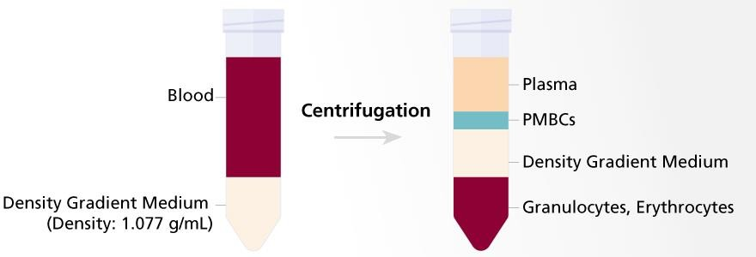

The isolation and characterization of the human suppressor inducer T cell subset.
Immunization of mice with lower primate lymphoid cells has provided a useful strategy for raising monoclonal antibodies against functionally important surface determinants on human T lymphocytes. The present results suggest that anti-2H4 antibody defines the human suppressor

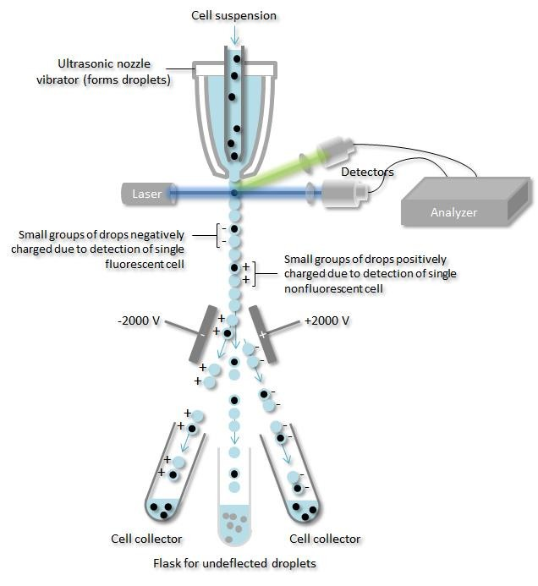induced subset of lymphocyte previously described as T4+JRA+. Last, the results reemphasize the previously documented remarkable structural conservation of certain T cell-specific determinants on lymphocytes of phylogenetically distant primates.

Fluorescence-activated cell sorting (FACS)
Fluorescence-activated cell sorting (FACS) is a specialized type of flow cytometry. It provides a method for sorting a heterogeneous mixture of biological cells into two or more containers, one cell at a time, based upon the specific light scattering and fluorescent characteristics of each cell. It is a useful scientific instrument, as it provides fast, objective and quantitative recording of fluorescent signals from individual cells as well as physical separation of cells of particular interest.

A fluorescence-activated cell sorter (FACS).
An antibody specific for a particular cell surface protein is associated to a fluorescent molecule and then added to a mixture of cells. For fluorescence when the specific cells pass through a laser beam they are monitored. Droplets containing single cells are given a positive or negative charge, based on whether the cell has limited the fluorescently-tagged antibody or not. Droplets ontaining a single cell are then detected by an electric field into collection tubes according to their charge.

Interests are first labeled with an antibody which is individual for a particular cell surface molecule. Antibody is coupled to a fluorescent dye, like when in a narrow stream the individual cells pass a laser beam in single file, the fluorescence of each cell is measured. A vibrating nozzle then forms small droplets which each containing a single cell which are given a negative or positive charge based on whether the cell they contain is fluorescing. A strong electric field defects the various charged droplets into separate containers so that each container has a homogeneous population of cells eventually with respect to the cell surface molecule tagged along fluorescent antibody. For biochemical analysis or grown in culture these homogeneous populations may then be used. By flow cytometry the RNA and DNA content of a cell can be measured also.

Fluorescence-activated cell sorting (FACS)

DELAYED HYPERSENSITIVITY (DTH)

and other phagocytes to the site. These sensitized T cells, of the Th1 class, will also activate cytotoxic T cells.
In delayed hypersensitivity, the first exposure to an antigen is called sensitization, such that on re-exposure, a secondary cellular response results, secreting cytokines that recruit macrophages

Hypersensitivity (also called hypersensitivity reaction or intolerance) refers to undesirable reactions produced by the normal immune system, including allergies and autoimmunity. Hypersensitivity reactions require a pre-sensitized (immune) state of the host.
ype IV hypersensitivity is often called delayed type hypersensitivity as the reaction takes several days to develop.[1] Unlike the other types, it is not antibody-mediated but rather is a type of cell-mediated response. This response involves the interaction of T-cells, monocytes, and macrophages.

This reaction is caused when CD4+ Th1 helper T cells recognize foreign antigen in a complex with the MHC class II on the surface of antigen-presenting cells. These can be macrophages that secrete IL-12, which stimulates the proliferation of further CD4+ Th1 cells. CD4+ T cells secrete IL-2 and interferon gamma, inducing the further release of other Th1 cytokines, thus mediating the immune response. Activated CD8+ T cells destroy target cells on contact, whereas activated macrophages produce hydrolytic enzymes and, on presentation with certain intracellular pathogens, transform into multinucleated giant cells.
The overreaction of the helper T cells and overproduction of cytokines damage tissues, cause inflammation, and cell death. Type IV hypersensitivity can usually be resolved with topical corticosteroids and trigger avoidance.

An example of a tuberculosis (TB) infection that comes under control: M. tuberculosis cells are engulfed by macrophages after being identified as foreign, but due to an immuno-escape mechanism peculiar to mycobacteria,[5] TB bacteria are able to block the fusion of their enclosing phagosome with lysosomes which would destroy the bacteria. Thereby TB can continue to replicate within macrophages. After several weeks, the immune system somehow [mechanism as yet unexplained] ramps up and, on stimulation with IFN-gamma, the macrophages become capable of killing M. tuberculosis by forming phagolysosomes and nitric oxide radicals. The hyper-activated macrophages secrete TNF-α which recruits multiple monocytes to the site of infection. These cells differentiate into epithelioid cells which wall off the infected cells, but results in significant inflammation and local damage.
Some other clinical examples:

- Temporal arteritis
- Leprosy
- Coeliac disease
- Graft-versus-host disease[6]
- Chronic transplant rejection
- Hypersensitivity
- Type I hypersensitivity
- Type II hypersensitivity
- Type III hypersensitivity
- Type V hypersensitivity

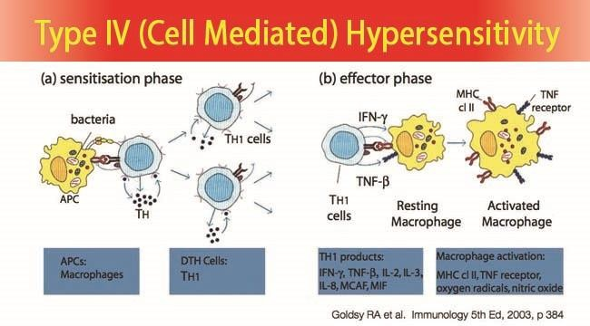
Examples of DTH reactions are contact dermatitis (eg, poison ivy rash), tuberculin skin test reactions, granulomatous inflammation (eg, sarcoidosis, Crohn disease), allograft rejection, graft versus host disease, and autoimmune hypersensitivity reactions.

HLA Typing

HLA typing is a kind of genetic test used to identify certain individual variations in a person’s immune system. The process is critical for identifying which people can safely donate bone marrow, cord blood, or an organ to a person who needs a transplant. HLA stands for human leukocyte antigen, but it is almost always referred to as HLA. HLA typing is also sometimes called HLA matching.

Purpose of HLA Typing
By far, the most common reason for HLA typing is to help determine which people can provide the safest tissue transplants (solid organ or hematopoietic stem cell transplantation).1 Potential tissue recipients must have the typing, as must anyone who might potentially want to donate tissue. This might include relatives of someone needing a transplant.

People can also volunteer to have their HLA type included in a bone marrow registry, for stem cell transplantation. HLA typing may also be performed on terminally ill or recently deceased people who will be serving as organ donors.

The best possible donors have HLAs that closely match the HLA patterns of the recipient. The best possible donors have HLAs that closely match the HLA patterns of the recipient. This makes it more likely the transplant will successfully treat your disease, and it lowers the risk of complications after transplant, such as organ rejection.2

What Is the HLA System?
The HLA system refers to a group of related genes that play an important role in the immune system. Together, the proteins made from these genes form something called the major

histocompatibility complex (MHC). These proteins are attached to almost all of the cells of your body (excluding red blood cells).

The Process of HLA Typing
HLA typing assesses the particular HLA genes that you have inherited (i.e., your string colors). Because there are a number of different HLA genes, as well as different variations of these genes, there are very many different possible color combinations that together make up your specific HLA type.1

HLA typing also usually includes testing for antibodies targeted to specific HLA proteins. Antibodies are made by part of the immune system. If a person already has an antibody against an HLA protein (i.e., if it already is primed to attack a certain color string), it may attack that protein if it is transplanted. This may cause the transplant to fail. So generally, you shouldn’t receive a transplant from someone if you already have an antibody against one of their HLA proteins.

Similarly, HLA typing also often includes something called lymphocyte crossmatching. Lymphocytes are a type of immune cell. Lymphocyte crossmatching checks to see if the recipient has an antibody against a protein on the donor’s lymphocytes. If so, that person generally shouldn’t receive a transplant from that particular person. These people are at high risk of a transplant that won’t be successful.4

Ethnicity
Groups of HLA “colors” run in certain ethnic groups. So even if someone in your family isn’t a good match, it may be more likely that someone from a shared genetic heritage will be a match for you. This is part of the reason it may be harder for some people to find a good HLA match than others.

For example, bone marrow registries currently contain fewer potential donors of African American descent. This may make it less likely that these individuals can find a good HLA match from a non-relative.5

HLA Typing and Tissue Registries
Information about your HLA type is included in databases that link potential donors to recipients. For example, the United Network of Organ Sharing determines who gets organs from deceased donors in the US. It uses information about donors’ and recipients’ HLA types when calculating the best matches for these organs. It is one of many factors that determine who receives them.

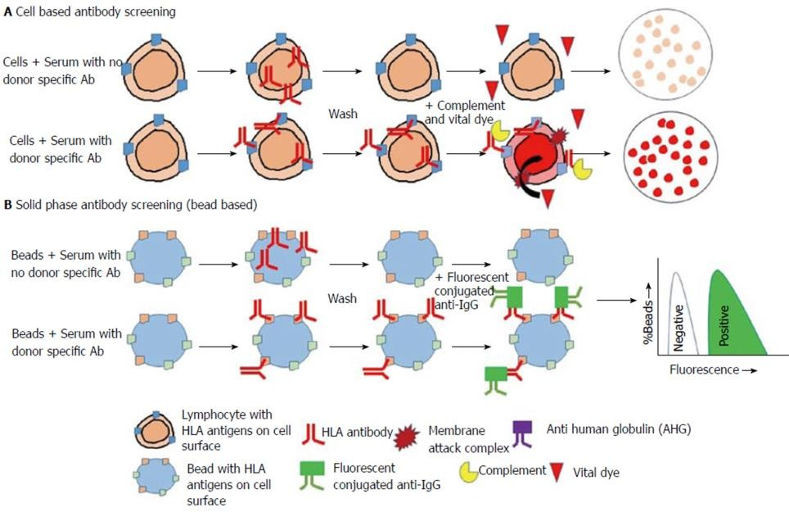

UNIT III

  - Antigen – Antibody.

  - Reaction Surface plasma resonance.

  - Biosensor assays for assessing ligand –receptor interaction.

Antigen-antibody interaction, or antigen-antibody reaction, is a specific chemical interaction between antibodies produced by B cells of the white blood cells and antigens during immune reaction.The antigens and antibodies combine by a process called agglutination.It is the fundamental reaction in the body by which the body is protected from complex foreign molecules, such as pathogens and their chemical toxins. In the blood, the antigens are specifically and with high affinity bound by antibodies to form an antigen-antibody complex. The immune complex is then transported to cellular systems where it can be destroyed or deactivated.

The first correct description of the antigen-antibody reaction was given by Richard J. Goldberg at the University of Wisconsin in 1952. It came to be known as "Goldberg's theory" (of antigen- antibody reaction).

There are several types of antibodies and antigens, and each antibody is capable of binding only to a specific antigen. The specificity of the binding is due to specific chemical constitution of each antibody. The antigenic determinant or epitope is recognized by the paratope of the antibody, situated at the variable region of the polypeptide chain. The variable region in turn has hyper-variable regions which are unique amino acid sequences in each antibody. Antigens are bound to antibodies through weak and noncovalent interactions such as electrostatic interactions, hydrogen bonds, Van der Waals forces, and hydrophobic interactions.
The principles of specificity and cross-reactivity of the antigen-antibody interaction are useful in clinical laboratory for diagnostic purposes. One basic application is determination of ABO blood group. It is also used as a molecular technique for infection with different pathogens, such as HIV, microbes, and helminth parasites.

Types of Antigen – Antibody Reaction:The types of antigen – antibody reactions are:• Precipitation Reaction. Agglutination Reaction. Complement Fixation. ELISA – Enzyme Linked ImmunoSorbent Assay. Avidity is perhaps a more informative measure of the overall stability or strength of the antibody-antigen complex. It is controlled by three major factors: antibody epitope affinity, the valence of both the antigen and antibody, and the structural arrangement of the interacting parts. Antibodies, also called immunoglobulins, Y-shaped molecules are proteins manufactured by the body that help fight against foreign substances called antigens. Antigens are any substance that stimulates the immune system to produce antibodies. Antigens can be bacteria, viruses, or fungi that cause infection and disease. When some antibodies combine with antigens, they activate a cascade of nine proteins, known as complement, that have been circulating in inactive form in the blood. Complement forms a partnership with antibodies, once they have reacted with antigen, to help destroy foreign invaders and remove them from the body.

Antibody structur
Structural model of an antibody molecule. Rounded portions indicate antigen binding sites. In an antibody, the Fab (fragment, antigen-binding) region is formed from the amino-terminal end of both the light and heavy chains of the immunoglobulin polypeptide. This region, called the variable (V) domain, is composed of amino acid sequences that define each type of antibody and their binding affinity to an antigen. The combined sequence of variable light chain (VL) and

variable heavy chain (VH) creates three hypervariable regions (HV1, HV2, and HV3). In VL these are roughly from residues 28 to 35, from 49 to 59, and from 92 to 103, respectively. HV3 is the most variable part. Thus these regions are the paratope, the binding site of an antigen. The rest of the V region between the hypervariable regions are called framework regions. Each V domain has four framework domains, namely FR1, FR2, FR3, and FR4.Structure of hen egg lysozyme (HEL) antigen. (A) The 3-D structure of HEL (CPK representation) together with three Abs (ribbon representation). (B) The structure of HEL colored according to the same three epitopes as in (A). (C) The structure of HEL colored according to the epitopes predicted by Discotope (light blue), ellipro (purple), and seppa (pink).

Properties

Chemical basis of antigen-antibody interaction[
Antibodies bind antigens through weak chemical interactions, and bonding is essentially non- covalent. Electrostatic interactions, hydrogen bonds, van der Waals forces, and hydrophobic interactions are all known to be involved depending on the interaction sites.[7][8] Non-covalent bonds between antibody and antigen can also be mediated by interfacial water molecules. Such indirect bonds can contribute to the phenomenon of cross-reactivity, i.e. the recognition of different but related antigens by a single antibody

Auto immune disease

Normally antibodies can detect and differentiate molecules from outside of the body and those produced inside the body as a result of cellular activities. Self molecules as ignored by the immune system. However, in certain conditions, the antibodies recognise self molecules as antigens and triggers unexpected immune responses. This results in different autoimmune diseases depending on the type of antigens and antibodies involved. Such conditions are always harmful and sometimes deadly. The exact nature of antibody-antigen interaction in autoimmune disease is not yet understood.

Application

Antigen-antibody interaction is used in laboratory techniques for serological test of blood compatibility and various pathogenic infections. The most basic is ABO blood group determination, which is useful for blood transfusion.[13] Sophisticated applications include ELISA,[14] enzyme-linked immunospot (Elispot), immunofluorescence, and immunoelectrophoresis.

Precipitation reaction
Soluble antigens combine with soluble antibodies in presence of an electrolyte at suitable temperature and pH to form insoluble visible complex. This is called a precipitation reaction. It is used for qualitative and quantitative determination of both antigen and antibody. It involves the reaction of soluble antigen with soluble antibodies to form large interlocking aggravated called lattice. It occurs in two distinct stages. Firstly, the antigen and antibody rapidly form antigen-antibody complexes within few seconds and this is followed by a slower reaction in which the antibody-antigen complexes forms lattices that precipitate from the solution. A special ring test is useful for diagnosis of anthrax and determination of adulteration in food.

Agglutination reaction
It acts on antigen-antibody reaction in which the antibodies cross-link particulate antigens resulting in the visible clumping of the particle. There are two types, namely active and passive agglutination. They are used in blood tests for diagnosis of enteric fever.
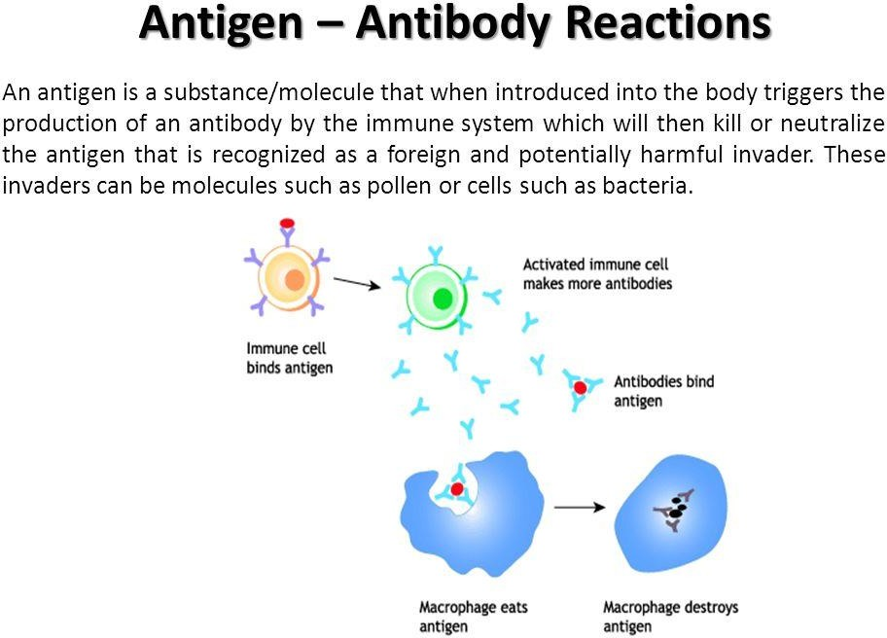

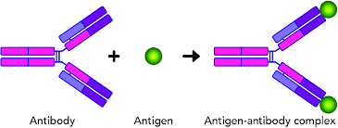

Surface plasmon resonance (SPR) is the resonant oscillation of conduction electrons at the interface between negative and positive permittivity material stimulated by incident light. SPR is the basis of many standard tools for measuring adsorption of material onto planar metal (typically gold or silver) surfaces or onto the surface of metal nanoparticles. It is the fundamental principle behind many color-based biosensor applications, different lab-on-a-chip sensors and diatom photosynthesis.

Explanation

The surface plasmon polariton is a non-radiative electromagnetic surface wave that propagates in a direction parallel to the negative permittivity/dielectric material interface. Since the wave is on the boundary of the conductor and the external medium (air, water or vacuum for example), these oscillations are very sensitive to any change of this boundary, such as the adsorption of molecules to the conducting surface.

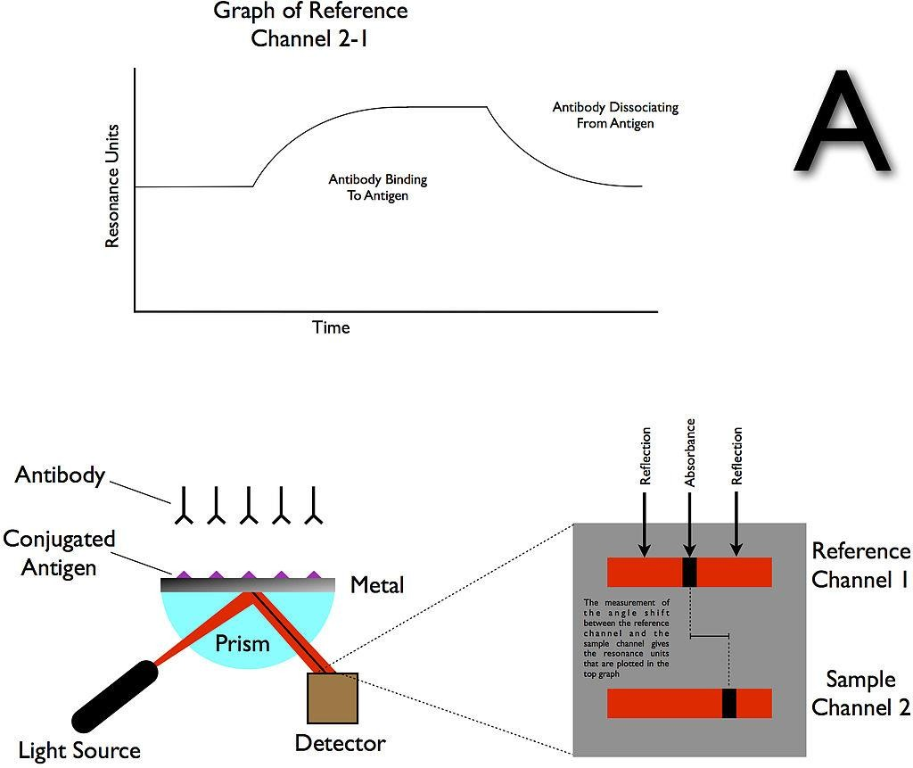

Ligand-receptor interaction

ligand-receptor interaction definition. interaction between a molecule (usually of an extracellular origin) and a protein on or within a target cell. One type of ligand-receptor interaction can be between steroid hormones and their cytoplasmic or nuclear receptors.
A ligand is a molecule that binds another specific molecule, in some cases, delivering a signal in the process. Ligands can thus be thought of as signaling molecules. Ligands interact with proteins in target cells, which are cells that are affected by chemical signals; these proteins are also called receptors.

Ligands are small molecules that transmit signals in between or within cells. Ligands exert their effects by binding to cellular proteins called receptors. The ligand is like the baton, and the receptor is like the next runner in line.
The interaction is reversible. The receptor, ligand, and ligand-receptor complex are in equilibrium. The receptor contains one binding site for the ligand. The ligand and receptor interact rapidly to form the ligand-receptor complex

Types of Ligands
  - Unidentate ligands: Ligands with only one donor atom, e.g. NH3, Cl⁻, F⁻ etc.
  - Bidentate ligands: Ligands with two donor atoms, e.g. ethylenediamine, C O 2-(oxalate
2 4
ion) etc.
  - Tridentate ligands: Ligands which have three donor atoms per ligand, e.g. (dien) diethyl triamine.

UNIT IV

  - New generation antibodies Multigene organization of immunoglobulin genes,

  - Antibody diversity, antibody engineering and phage display libraries.

  - Antibodies as in - vitro and in - vivo probes.

  - Immuno regulators as therapeutic products.

  - Production of immuno regulators, process design, selection criteria for cell lines,

  - Culture media, process development, product recovery, stability checking and validation.

Immunoglobulins

The antigens are highly varied; to be able to respond to them, the immunoglobulins must be equally diverse (there are 1011 to 1012 different Igs!), which corresponds to the diversity of the amino acids of the N-terminal parts of the L and H chains (i.e. to the variable domains).

The immunoglobulin (Ig) genes (heavy, kappa, and lambda) are comprised of numerous, discontinuous coding segments. As B cells develop, the segments are rearranged such that each mature B cell and plasma cell has a unique rearrangement profile. Other cell types usually retain the nonrearranged gene structures.

Medical Definition of C gene
: a gene that codes genetic information for the constant region of an immunoglobulin — compare v gene.

There are five immunoglobulin classes (isotypes) of antibody molecules found in serum: IgG, IgM, IgA, IgE and IgD. They are distinguished by the type of heavy chain they contain. IgG molecules possess heavy chains known as γ-chains; IgMs have μ-chains; IgAs have α-chains; IgEs have ε-chains; and IgDs have δ-chains.

Immunoglobulins, also known as antibodies, are glycoprotein molecules produced by plasma cells (white blood cells). They act as a critical part of the immune response by specifically recognizing and binding to particular antigens, such as bacteria or viruses, and aiding in their destruction.

IgM is the largest antibody, and it is the first antibody to appear in the response to initial exposure to an antigen. In the case of humans and other mammals that have been studied, the spleen, where plasmablasts responsible for antibody production reside, is the major site of specific IgM production.

VDJ recombination. VDJ recombination, also known as antigen receptor gene rearrangement or antigen-independent diversification, is a diversity generating assembly process affecting the variable domain of immunoglobulin and TCR genes.

The heavy and light chains of the immunoglobulin molecule are derived from separate sets of immunoglobulin genes located on different chromosomes. Although the heavy chain (H) genes are located in a single locus on human chromosome 14 (mouse chromosome 12), the light chain genes can be derived from one of two loci: kappa (κ) on human chromosome 2 (mouse chromosome 6) or lambda (λ) on human chromosome 22 (mouse chromosome 16). The organization of the genes in each of these clusters mimics the domain structure of the heavy and light chain polypeptides. Thus, the heavy chain, κ light chain and λ light chain loci have variable region genes that encode the variable domain (responsible for antigen binding) and constant region genes that encode the constant domain.

Generation of B-cell / antibody diversity
Paul A. Blair & Anneleen Bosma, Centre for Rheumatology Research, University College London, UK
One of the major roles that B cells play in an immune response is the production of antibodies, that specifically recognise and bind to proteins on the invading bacteria or virus particles. The binding of specific antibody to its target can prevent viruses from entering cells or aid phagocytes in identifying and destroying the bacteria or viruses. Given that each B cell can only produce antibody with one specificity, and that there are an enormous variety of organisms that can infect us, the immune system needs to generate vast numbers of B cells that each produce a different antibody.
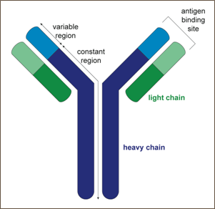
Figure 1. Schematic diagram of an antibody molecule composed of two heavy chains and two light chains. Both the heavy chain and the light chain comprise a variable and a constant region.

The variable regions are responsible for binding of a specific protein called an antigen.
The specificity of a particular antibody, i.e. what the antibody recognises, is determined by the shape of its variable region (Figure 1); a particular antibody will bind to a protein that has a region with a complementary structure to the antibody’s own variable region. Diversity in the specificity of antibodies is initially generated at the earliest stages of B-cell development. While still at the B-cell progenitor stage in the bone marrow, B cells randomly rearrange their variable (V), diversity (D), and joining (J) genes to form the blueprint for the variable regions of their antibodies. Diversity comes from the fact that there are multiple copies of the V, D and J genes that can be joined together in different combinations (Figure 2). In a majority of mammals, each antibody molecule is composed of both a heavy and light chain (Figure 1), which each have their own V and J genes to rearrange (only the heavy chain has D genes). Further diversity is added to the variable region genes by an enzyme called terminal deoxynucleotidyl transferase (TdT) that adds extra nucleotides between the V, D and J regions, changing the structure of the variable regions that will be produced.

Source of Antibody Diversity
Antibody diversity in humans comes from several stages of Ig (Immunoglobulin) development, including both pre-immune repertoire, in which antibodies are developed for sampling the

system for foreign bodies, and the post-immune repertoire, in which antibodies against foreign antigens are selected for and matured. In the pre-immune repertoire, there are four major sources of antibody diversity. The first source of pre-immune diversity is the recombination of VH, DH, and JH chains to build a functional VH chain, and VL and VJ (λ or κ) chains to build a functional light chain. To build a functional VH gene, there is a random assortment in which one of 39 functional VH genes is coupled with one of 27 functional D genes and 6 JH chains. Second, within the VDJ joining process, the junctional diversity created in the recombination process adds infinitely more diversity in 4 different ways. 1. The D genes can be translated in any one of three open reading frames in either direction to yield a total of six possible peptide fragments. 2. During the rearrangement process, a hairpin is formed that when resolved can result in the addition or deletion of N nucleotides resulting in added diversity. 3. About the VDJ joining mechanism, N nucleotides can be added or deleted as part of the VDJ joining process. In some cases, the coding sequences for several amino acid residues can be lost during the recombination process. 4. N nucleotides can be added or replaced by the activities of TdT (Terminal deoxynucleotidyl Transferase), particularly on either side of the D segment within the VDJ junctions, which make up CDR-H3 in the functional V-region. It has been estimated that these N changes can result in up to >107 different variations of CDR-H3, including CDR lengths ranging from just a few amino acid residues to over 25. Combined together, the somatic rearrangements, the combinatorial diversity within chains, the inherent mutagenesis that occurs in the assembly process, and the combination of heavy and light chains result in a potential pre- immune diversity of >1016 different antibodies.

After exposure of cell-bound IgM to antigen, the antibody genes undergo an affinity maturation process, generating new diversity from which antibodies with higher affinity to the targeted antigen epitope are selected, resulting in more effective binding and elimination of the antigen from circulation during the secondary immune response. It has been demonstrated that during the affinity maturation process, the average number of mutations in VH and VL are eight and five, respectively.

Human Antibody Gene Organization
Antibody molecules are encoded by three independent groups of genes. Two genes dictate λ chains: one comprises Vλ and Cλ genes; k comprises Vk and Ck, genes, while the third group dictates H chains and has VH and CH genes.

Antibody Gene Rearrangement and Diversity In Vivo
Before synthesizing Ig chains, however, Ig genes must be assembled within a genome of differentiating cells (rearrangement). The overall, high-level, assembly process for the heavy chain and light chain gene assembly and translation into an IgG antibody sequence is shown in Fig. 2. The extraordinary diversity of human antibodies comes from the combination of the assembly of different VH, DH, and JH, Vκ and Jκ segments, or Vλ and Jλ segments, and pairing of the heavy and light chains, to generate the primary antibody repertoire. The process of Ig diversification in humans is very complex and hierarchically coupled with the five stages of B cell development in the bone marrow, with each biochemical and genetic stage required for the next step and matched to a cell development stage.

The following antigen independent steps in B cell development occur in the bone marrow:

- Stem cell – heavy chain (IGH) and kappa (κ) and lambda (λ) light chain (IGK and IGL) genes are in germline configuration.

- Early pro-B cell – IGH undergoes D–J gene rearrangement with loss of DNA between the joined D and J segments. Upon induction of recombination activating gene 1 (RAG1), RAG2, and TdT in the pro-B cells, the DH and JH gene segments are joined first by a RAG-1, 2-dependent process.

- Late pro-B cell – IGH undergoes V–DJ rearrangement (VDJ rearrangement) with loss of DNA between the joined V and D segments. Recombination can be somewhat imprecise, since during this process several nucleotides may be removed from or added to a junction, so combination of VDJ segments of H chains results in a large number of possible sequences (that is, antibodies). This reshuffling process, known as combinatorial joining, is the prevalent source of Antibody

- Small pre-B cell – V–J rearrangement of light chain gene(s). κ chain is rearranged first then, if rearrangement of both κ alleles is unsuccessful, λ chain is rearranged.

- Large pre-B cell – intracellular expression and transient surface expression of m chain with invariant pseudo light chain (pre-B cell receptor). Successful cell surface expression of pre-B cell receptor triggers allelic exclusion to prevent rearrangement of second allele and also initiates pre-B cell proliferation, which results in different light chains matched with the same heavy chain rearrangement in different daughter cells.

- The following antigen dependent steps in B cell development take place in the periphery:

- Immature B cell – IgM surface expression. In the most common scenario, a VDJ segment joins first with Cμ genes, and subsequently with Cγ, Cε, Cα genes, with synthesis of a complete H IgM chain, etc. Without an associated L chain, surface expression is not possible and only cytoplasmic μ is found (pre-B cells).

- Mature naïve B cell – IgD and IgM expressed on cell surface, made from alternatively spliced transcripts.

- Lymphoblast – alternative splicing results in secreted IgM.
- Memory B cell – isotype switch to IgG. Somatic hypermutation of IGH occurs in the germinal center of lymph nodes. Mutated Ig are selected for improved antigen binding in a process termed affinity maturation.

- Subset of B cell expressing surface IgD and IgM undergo a further DNA rearrangement, class switch, which results in expression of IgG, IgA, or IgE, changing the IgH constant region, and therefore effector functions associated with the Ig, without changing specificity

- A subset of B cells survive as long-lived memory B cells, which respond rapidly to antigen and differentiate into antibody producing plasma cells.

- Terminally differentiated plasma cell – alternative splicing yields both membrane-bound and secreted Ig.

Antibody Diversity
Principle of antibody diversity is completely understood. There is very close relationship in amino acide sequence and antibody function. As we know, there is huge diverse function between two antibodies which have almost same amino acid even if one amino acide is different. Based on it, accuracy of antibody sequencing is very important in related research. Creative Biolabs Provides world-class de novo antibody sequencing services with 100% accuracy for research, diagnostic, and therapeutic industries.
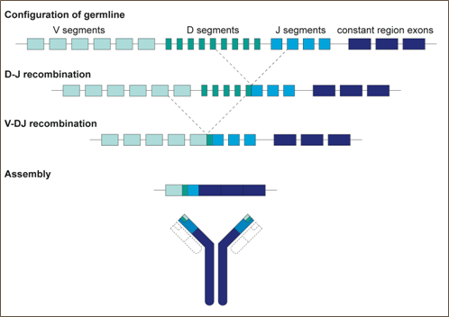
Figure 2. Schematic representation of the rearrangement of variable region genes

During the course of an infection, B cells can further alter the specificity of the antibody they produce. When a mature B cell meets an antigen that its B-cell receptor recognises (the B-cell receptor comprises the antibody the cell produces anchored on the cell surface) then the B cell can undergo a process called somatic hypermutation. Here an enzyme called activation- induced cytidine deaminase (AID) makes random mutations in the antibody variable region genes. If the mutations result in an antibody that more strongly binds to their targets then these B cells will survive and may differentiate into antibody-producing plasma cells with the new specificity.

Table 10-1. Number of Genes Coding for V, D, J, and C Regions in Light and Heavy Chains

 | Kappa Light Chains | Lambda Chains | Heavy Chains
Variable segments | 30 | 35 | 100
Diversity segment | 0 | 0 | 23
Joining segment | 5 | 7 | 5
Constant region | 1 | 1 | 5∗
Potential different antibodies | 150 | 245 | 115,000

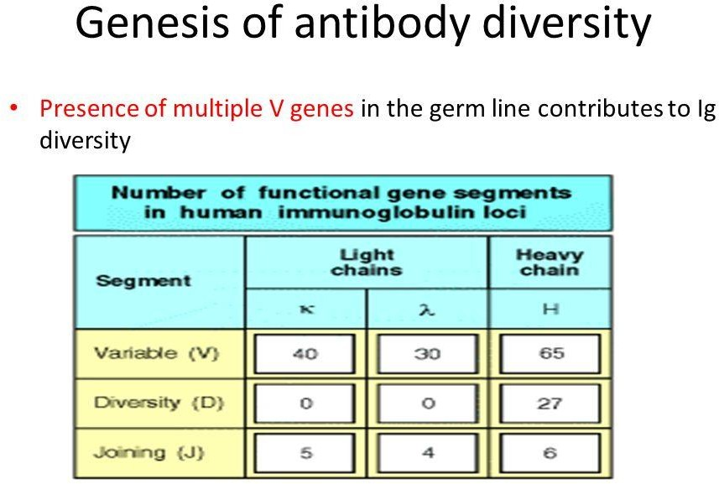

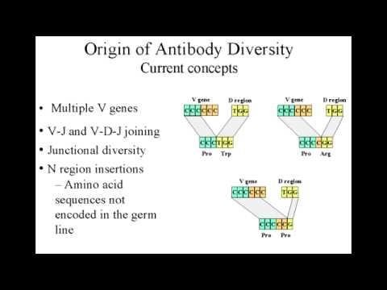

In immunological studies, antibodies can be used in vivo to deplete specific cells for functional analyses. Antibodies are also in vivo for neutralization of cell surface receptors to enable binding to soluble factors. Antibodies are widely used in flow cytometry for intracellular analysis.

Detection of antigens or antibodies by ELISA. ... If antibodies against the virus are present in the specimen, they will bind to the immobilized antigen. The bound antibodies are then detected by using a second antibody that binds to the first antibody.

Antibody tests involve analysing a patient's sample (usually blood) for the presence or absence of a particular antibody (qualitative) or for the amount of antibody that is present (quantitative). Antibodies are part of the body's immune system. ... Each antibody that is produced is unique.

The principle behind the Immunoassay test is the use of an antibody that will specifically bind to the antigen of interest. The antibodies used in the Immunoassay must have a high affinity for the antigen.

Immunoassays can be used to test for the presence of a specific antibody or a specific antigen in blood or other fluids. ... When immunoassays are used to test for the presence of antigens in a blood or fluid sample, the test contains antibodies to the antigen of interest.

Engineered synthetic antibodies as probes to quantify the energetic contributions of ligand binding to conformational changes in proteins.
Conformational changes in proteins due to ligand binding are ubiquitous in biological processes and are integral to many biological systems. However, it is often challenging to link ligand- induced conformational changes to a resulting biological function because it is difficult to distinguish between the energetic components associated with ligand binding and those due to structural rearrangements. Here, we used a unique approach exploiting conformation-specific and regio-specific synthetic antibodies (sABs) to probe the energetic contributions of ligand binding to conformation changes. Using maltose-binding protein (MBP) as a model system, customized phage-display selections were performed to generate sABs that stabilize MBP in different conformational states, modulating ligand-binding affinity in competitive, allosteric, or peristeric manners. We determined that the binding of a closed conformation-specific sAB (sAB- 11M) to MBP in the absence of maltose is entropically driven, providing new insight into designing antibody-stabilized protein interactions. Crystal structures of sABs bound to MBP, together with biophysical data, delineate the basis of free energy differences between different conformational states and confirm the use of the sABs as energy probes for dissecting enthalpic and entropic contributions to conformational transitions. Our work provides a foundation for investigating the energetic contributions of distinct conformational dynamics to specific biological outputs. We anticipate that our approach also may be valuable for analyzing the energy landscapes of regulatory proteins controlling biological responses to environmental changes.

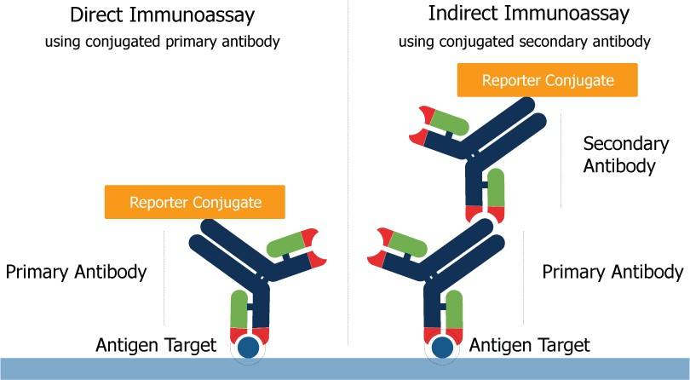

Classes of immunoglobulins
The five primary classes of immunoglobulins are IgG, IgM, IgA, IgD and IgE. These are distinguished by the type of heavy chain found in the molecule. IgG molecules have heavy chains known as gamma-chains; IgMs have mu-chains; IgAs have alpha-chains; IgEs have epsilon-chains; and IgDs have delta-chains.
Differences in heavy chain polypeptides allow these immunoglobulins to function in different types of immune responses and at particular stages of the immune response. The polypeptide protein sequences responsible for these differences are found primarily in the Fc fragment. While there are five different types of heavy chains, there are only two main types of light chains: kappa (κ) and lambda (λ).
Antibody classes differ in valency as a result of different numbers of Y-like units (monomers) that join to form the complete protein. For example, in humans, functioning IgM antibodies have five Y-shaped units (pentamer) containing a total of 10 light chains, 10 heavy chains and 10 antigen-binding.

IgG class

Properties of IgG:
  - Molecular weight: 150,000
  - H-chain type (MW): gamma (53,000)
  - Serum concentration: 10 to 16 mg/mL
  - Percent of total immunoglobulin: 75%
  - Glycosylation (by weight): 3%
  - Distribution: intra- and extravascular
  - Function: secondary response
  - Learn more about IgG »
•

IgM class

Properties of IgM:

  - Molecular weight: 900,000
  - H-chain type (MW): mu (65,000)
  - Serum concentration: 0.5 to 2 mg/mL
  - Percent of total immunoglobulin: 10%
  - Glycosylation (by weight): 12%
  - Distribution: mostly intravascular
  - Function: primary response
  - Learn more about IgM »
•

IgA class

Properties of IgA:
- Molecular weight: 320,000 (secretory)
- H-chain type (MW): alpha (55,000)
- Serum concentration: 1 to 4 mg/mL
- Percent of total immunoglobulin: 15%
- Glycosylation (by weight): 10%
- Distribution: intravascular and secretions
- Function: protect mucus membranes
- Learn more about IgA »

IgD and IgE class

Properties of IgD:
  - Molecular weight: 180,000
  - H-chain type (MW): delta (70,000)
  - Serum concentration: 0 to 0.4 mg/mL
  - Percent of total immunoglobulin: 0.2%
  - Glycosylation (by weight): 13%
  - Distribution: lymphocyte surface
  - Function: unknown Properties of IgE:
  - Molecular weight: 200,000
  - H-chain type (MW): epsilon (73,000)
  - Serum concentration: 10 to 400 ng/mL
  - Percent of total immunoglobulin: 0.002%
  - Glycosylation (by weight): 12%
  - Distribution: basophils and mast cells in saliva and nasal secretions
  - Function: protect against parasites

Subclasses of immunoglobulins
In addition to the major immunoglobulin classes, several Ig subclasses exist in all members of a particular animal species. Antibodies are classified into subclasses based on minor differences in the heavy chain type of each Ig class. In humans there are four subclasses of IgG: IgG1, IgG2, IgG3 and IgG4 (numbered in order of decreasing concentration in serum).
Variance among different subclasses is less than the variance among different classes. For example, IgG1 is more closely related to IgG2, IgG3 and IgG4 than to IgA, IgM, IgD or IgE.

Consequently, antibody-binding proteins (e.g., Protein A or Protein G) and most secondary antibodies used in immunodetection methods cross-react with multiple subclasses but usually not multiple classes
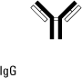
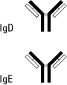
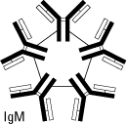

Immunomodulators are medications used to help regulate or normalize the immune system. Examples include one class of immunomodulator which is used as an add-on therapy to treat asthma and another which treats hereditary angioedema.

mmunomodulators work by suppressing or weakening a patient's immune system in order to reduce inflammation and the symptoms it causes. However, they can also have the effect of decreasing the body's ability to combat infection.

CYTOKINES AND IMMUNOREGULATION
- OVERVIEW
Cytokines are a diverse group of non-antibody proteins that act as mediators between cells. They were initially identified as products of immune cells that act as mediators and regulators of immune processes but many cytokines are now known to be produced by cells other than immune cells and they can have effects on non-immune cells as well. Cytokines are currently being used clinically as biological response modifiers for the treatment of various disorders. The term cytokine is a general term used to describe a large group of proteins but there are other terms that are commonly used to describe particular kinds of cytokines.
These include:
  - Monokines, cytokines produced by mononuclear phagocytic cells
  - Lymphokines, cytokines produced by activated lymphocytes, especially Th cells
  - Interleukins, cytokines that act as mediators between leukocytes

Cytokines are not typically stored as preformed proteins. Rather their synthesis is initiated by gene transcription and their mRNAs are short lived. They are produced as needed in immune responses. Many individual cytokines are produced by many cell types and act on many cell types (i.e., they are pleotropic) and in many cases cytokines have similar actions (i.e., they are redundant). Redundancy is due to the nature of the cytokine receptors. Receptors for cytokines are heterodimers (sometimes heterotrimers) that can be grouped into families in which one subunit is common to all members of a given family. Some examples are shown in Figure 1. Since the subunit common to all members of the family functions in binding cytokine and in signal transduction, a receptor for one cytokine can often respond to another cytokine in the same family. Thus, an individual lacking IL-2, for example, is not adversely affected because other cytokines (IL-15, IL-7, IL-9, etc.) assume its function. Similarly, a mutation in a cytokine receptor subunit other than the one in common often has little effect. On the other hand, a mutation in the common subunit has profound effects. For example, a mutation in the gene for

the IL-2R gamma subunit causes human X-linked severe combined immunodeficiency (XSCID) characterized by a complete or nearly complete T and B cell defects. One cytokine often influences the synthesis of other cytokines. They can produce cascades, or enhance or suppress production of other cytokines. In addition, they can often influence the action of other cytokines. The effects can be:
  - Antagonistic
  - Additive
  - Synergistic
Cytokines bind to specific receptors on target cells with high affinity and the cells that respond to a cytokine are either: 1) the same cell that secreted cytokine (autocrine); 2) a nearby cell (paracrine) or 3) a distant cell reached through the circulation (endocrine). Cellular responses to cytokines are generally slow (hours) because they require new mRNA and protein synthesis.

CATEGORIES OF CYTOKINES

Cytokines can be grouped into different categories based on their functions or their source but it is important to remember that because they can be produced by many different cells and act on many different cells, any attempt to categorize them will be subject to limitations.

Mediators of natural immunity
Cytokines that play a major role in the innate immune system include: TNF-α, IL-1, IL-10, IL-12, type I interferons (IFN-α and IFN-β), IFN-γ, and chemokines.

TNF-α
Tumor necrosis factor alpha is produced by activated macrophages is response to microbes, especially the lipopolysaccharide (LPS) of Gram negative bacteria. It is an important mediator of acute inflammation. It mediates the recruitment of neutrophils and macrophages to sites of infection by stimulating endothelial cells to produce adhesion molecules and by producing chemokines which are chemotactic cytokines. TNF- α also acts on the hypothalamus to produce fever and it promotes the production of acute phase proteins.

2.IL-1
Interleukin 1 is another inflammatory cytokine produced by activated macrophages. Its effects are similar to that of TNF-α and it also helps to activate T cells.

3.IL-10
Interleukin 10 is produced by activated macrophages and Th2 cells. It is predominantly an inhibitory cytokine. It inhibits production of IFN-γ by Th1 cells, which shifts immune responses toward a Th2 type. It also inhibits cytokine production by activated macrophages and the expression of class II MHC and co- stimulatory molecules on macrophages, resulting in a dampening of immune responses.

4.IL-12
Interleukin 12 is produced by activated macrophages and dendritic cells. It stimulates the production of IFN-γ and induces the differentiation of Th cells to become Th1 cells. In addition, it enhances the cytolytic functions of Tc and NK cells.

TypeIinterferons
Type I interferons (IFN-α and IFN-β) are produced by many cell types and they function to inhibit viral replication in cells. They also increase expression of class I MHC molecules on cells making them more susceptible to killing by CTLs. Type I interferons also activate NK cells.

INF-γ
Interferon gamma is an important cytokine produced by primarily by Th1 cells, although it can also be produced by Tc and NK cells to a lesser extent. It has numerous functions in both the innate and adaptive immune systems as depicted in Figure 2.

- Chemokines
Chemokines are chemotactic cytokines produced by many kinds of leukocytes and other cell types. They represent a large family of molecules that function to recruit leukocytes to sites of infection and play a role in lymphocyte trafficking.

Mediators of adaptive immunity
Cytokines that play a major role in the adaptive immune system include: IL-2, IL-4, IL-5, TGF-β, IL-10 and IFN-γ.

IL-2
Interleukin 2 is produced by Th cells, although it can also be produced by Tc cells to a lesser extent. It is the major growth factor for T cells. It also promotes the growth of B cells and can activate NK cells and monocytes as depicted in Figure 3. IL-2 acts on T cells in an autocrine fashion. Activation of T cells results in expression of IL-2R and the production of IL-2. The IL-2 binds to the IL-R and promotes cell division. When the T cells are no longer being stimulated by antigen, the IL-2R will eventually decay and the proliferative phase ends Figure 4.

IL-4
Interleukin 4 is produced by macrophages and Th2 cells. It stimulates the development of Th2 cells from naïve Th cells and it promotes the growth of differentiated Th2 cells resulting in the production of an antibody response. It also stimulates Ig class switching to the IgE isotype.

IL-5
Interleukin 5 is produced by Th2 cells and it functions to promote the growth and differentiation of B cells and eosinophiles. It also activates mature eosinophiles.

TGF-β
Transforming growth factor beta is produced by T cells and many other cell types. It is primarily an inhibitory cytokine. It inhibits the proliferation of T cells and the activation of macrophages. It also acts on PMNs and endothelial cells to block the effects of pro-inflammatory cytokines.

Stimulators of hematopoesis
Some cytokines stimulate the differentiation of hematopoetic cells. These include GM-CSF which promotes the differentiation of bone marrow progenitors, M-CSF, which promotes

growth and differentiation of progenitors into monocytes and macrophages and G-CSF, which promotes production of PMNs.

CYTOKINE
Although the focus has been on the production and action of cytokines on cells of the immune system, it is important to remember that many of them have effects on other cells and organ systems. A schematic diagram showing some of the interactions in the cytokine network is presented in Figure 5a, b and c.

IMMUNOREGULATION

The magnitude of an immune response is determined by the balance between antigen-driven activation of lymphocytes and negative regulatory influences that prevent or dampen the response. Regulatory mechanisms can act at the recognition, activation or effector phases of an immune response. Examples of regulation that have already been discussed include:
- Recognition of antigen in the absence of co-stimulation resulting in anergy
- Recognition of antigen with CTLA-4 engagement of B7 resulting in down regulation of T cell activation
- Cytokines with stimulatory or inhibitory activities on immune cells
- Idiotype/anti-idiotype interactions leading to stimulation or inhibition of immune responses.
In addition to these there are other ways in which immune responses can be regulated.

Regulation by antibody (Figure 6)
Soluble antibody can compete with antigen receptors on B cells and block or prevent B cell activation. In addition antigen antibody complexes can bind to Fc receptors on B cells, sending an inhibitory signal to B cells.

Regulation by regulatory T cells (Tregs)
Regulatory T cells (Tregs) are a recently described populations of cells that can regulate immune responses. They do not prevent initial T cell activation; rather, they inhibit a sustained response and prevent chronic and potentially damaging responses. They do not have characteristics of Th1 or Th2 cells but they can suppress both Th1 and Th2 responses.
- Naturally occurring Tregs – The thymus gives rise to CD4+/CD25+/Foxp3+ cells that functions as Tregs. These Tregs suppress immune responses in a cell contact dependent manner but the mechanism of suppression has not been established.

- Induced Tregs – In the periphery some T cells are induced to become Tregs by antigen and either IL-10 or TGF-β. Tregs induced by IL-10 are CD4+/CD25+/Foxp3- and are referred to as Tr1 cells. These cells suppress immune responses by secretion of IL10. Tregs induced by TGF-β are CD4+/CD25+/Foxp3+ and are referred to as induced Tregs. These cells suppress by secretion of TGF-β

UNIT V

  - Therapeutic agents Rationale for vaccine design based on clinical requirements.

  - Recombinant DNA and protein based vaccines,

  - Plant-based vaccines and reverse vaccinology.

  - Peptide vaccines, conjugate vaccines, cell therapy and cell based vaccines.

  - Growth factors, interferon, tumor necrosis factor, cytokines, lymphokines & chemokines.

Recombinant vaccines and the development of new vaccine strategies
Vaccines were initially developed on an empirical basis, relying mostly on attenuation or inactivation of pathogens. Advances in immunology, molecular biology, biochemistry, genomics, and proteomics have added new perspectives to the vaccinology field. The use of recombinant proteins allows the targeting of immune responses focused against few protective antigens. There are a variety of expression systems with different advantages, allowing the production of large quantities of proteins depending on the required characteristics. Live recombinant bacteria or viral vectors effectively stimulate the immune system as in natural infections and have intrinsic adjuvant properties. DNA vaccines, which consist of non- replicating plasmids, can induce strong long-term cellular immune responses. Prime-boost strategies combine different antigen delivery systems to broaden the immune response. In general, all of these strategies have shown advantages and disadvantages, and their use will depend on the knowledge of the mechanisms of infection of the target pathogen and of the immune response required for protection. In this review, we discuss some of the major breakthroughs that have been achieved using recombinant vaccine technologies, as well as new approaches and strategies for vaccine development, including potential shortcomings and risks.

Recombinant vaccines rely on the capacity of one or multiple defined antigens to induce immunity against the pathogen, when administered in the presence of adjuvants or when expressed by plasmids or harmless bacterial/viral vectors. Recombinant protein vaccines permit the avoidance of several potential concerns raised by vaccines based on purified macromolecules, such as the risk of co-purification of undesired contaminants or reversal of the toxoids to their toxigenic forms, if considering diphtheria or tetanus toxoid vaccines, for example. Another fundamental issue overcome by this technology is the complexity involved in obtaining sufficient quantities of purified antigenic components.

However, one of the main challenges in the development of these new strategies of immunization consists of designing vaccines that elicit the appropriate kind of immune response to confer immunity mainly to intracellular pathogens and especially to those that establish chronic, often lifelong infections. For this, the knowledge of the biology of highly conserved antigens involved in pathogenesis and of the immune mechanisms that should be elicited for protection must be obtained to rationally design vaccine strategies that can overcome the low protective immunity naturally generated by infection (reviewed in Ref. 4).

Recombinant DNA and protein based vaccines,

Recombinant vaccine strategies

Several genes from different etiologic agents have been cloned, expressed and purified to be tested as vaccines. There are a variety of expression systems for antigenic protein components, such as bacteria, yeast, mammalian cells and insect cells, in which the DNA encoding the antigenic determinant can be inserted and expressed. However, several factors must be taken into account before selecting the system for antigen expression. The level of expression obtained using each specific expression vector and promoter, the selection marker of choice, the presence or absence of post-translational modification by the recombinant vector, among others, are essential features that interfere in the efficacy of production of recombinant antigens as vaccines. Bacterial expression systems are the most used due to the ease of handling and to their capacity for high level expression. However, for antigens in which post-translational modifications (e.g., glycosylation) are necessary, the use of mammalian or insect cells should be considered (7,8).

RECOMBINANT PROTEIN VACCINES

Most of the vaccines under investigation today are based on highly purified recombinant proteins or subunits of pathogens (9). The classical example of recombinant protein vaccines currently in use in humans is the vaccine against hepatitis B (Table 1) (10). Hepatitis B virus (HBV) infection is a chronic liver disease occurring worldwide. HBV presents a marked tropism for human liver cells, partially due to a specific receptor that is expressed on the surface of infected cells. The current vaccines are produced by expressing the hepatitis B surface antigen (HBsAg) in yeast cells. The HBsAg assembles into virus-like particles (VLPs), which are extremely immunogenic, making the HBV vaccine a very efficacious vaccine. The yeast expression system may secrete the antigen into the culture supernatant that can facilitate its purification (11,12). Furthermore, yeast cells offer some of the eukaryotic cellular machinery responsible for the post- translational modification of proteins, being capable of rendering proteins glycosylated. The technology of production of the HBV vaccine has been transferred to several manufacturers and the prices have decreased due to competition, which has rendered this vaccine affordable to most developing countries.

Live recombinant vaccines using bacterial or viral vectors
As a result of advances in the fields of molecular biology and genetic engineering it is now possible to create live recombinant vectors capable of delivering heterologous antigens by the introduction of antigen-encoding genes. The idea behind this approach is to use the capacity of infection and the immunological properties of the live vector to elicit an immune response against its own proteins, as well as towards the heterologous protein being presented (16). A number of bacteria (such as Salmonella typhi (17) and bacille Calmette-Guérin (BCG) (18) and viruses (such as vaccinia and adenovirus) (19) have been investigated as live recombinant vector vaccines. In general, these approaches have advantages that are intrinsic to the pathogen itself, such as mimicry of a natural infection, their capacity of stimulating both CD4+ and CD8+ T-cell subsets, and, in some cases, the possibility to be administered orally.

The use of live-attenuated bacterial vaccines is not novel. However, their utilization as carriers or delivery vehicles for heterologous antigen expression represents a technology with broad applicability that may have a significant impact on vaccine development. Significant advances in molecular biology have enabled precise deletions of genes encoding important virulence factors, as well as the introduction of recombinant DNA into avirulent yet immunogenic vaccine strains. Bacterial vectors have many advantages that make them attractive systems for heterologous antigen presentation. They can elicit humoral and/or cellular immune responses and can be administered orally, thereby eliciting mucosal immunity. Most are antibiotic-sensitive strains, which allow antibiotic treatment if any adverse reaction occurs. In general, they display very favorable cost-effectiveness (9).

Plant-based vaccines and reverse vaccinology.

The achievement, almost the equivalent of vaccinating a plant species permanently against a virus, has long been a goal in agricultural genetic engineering. Unlike animals, plants do not
have immune defense systems and thus do not gain protection through production of antibodies and other defensive substances.

Production. Edible vaccines are subunit vaccines; they contain the antigen proteins for a pathogen but lack the genes for the full pathogen to form. The pathogen sequence is inserted
into the transfer DNA (T-DNA) to produce the antigenic protein.

The concept of edible vaccines was developed by Arntzen (www.genomenewsnetwork.org) in the 1990s. He currently heads the department of plant biology at the Arizona State University. He fell upon the idea after he attended a conference in New York, organized by the WHO.

Following are some major drawbacks of edible vaccines,
  - Individual may develop immune tolerance to the particular vaccine protein or peptide.
  - Dosage required varies from generation to generation and, plant to plant, protein content, patient is age, weight, ripeness of the fruit and quantity of the food eaten.

Gene vaccines are a new approach to immunization and immunotherapy in which, rather than a live or inactivated organism (or a subunit thereof), one or more genes that encode proteins of the pathogen are delivered.

Transgenic plants are plants into which one or more genes from another species have been introduced into the genome, using genetic engineering processes. Techniques include the biolistic method—in which a heavy metal is coated with plasmid DNA is shot into cells—and Agrobacterium tumefaciens mediated transformation.

A single gene transferred into a tomato or banana plant is reproduced as a protein thousands of times inside the fruit. When eaten it passes into the intestine and then into the blood stream producing antibodies against hepatitis B - working the same way as a traditionally injected but much more expensive vaccine

Bananas have emerged as the best candidate to deliver a bite-sized vaccine for hepatitis B virus (HBV) to millions of people in developing countries, according to an article scheduled for the June 1 issue of ACS' Biotechnology Progress, a bi-monthly journal co-published with the American Institute of Chemical Engineers

Production of Plant-Based Vaccines
Plant-based vaccine production mainly involves the integration of transgene into the plant cells. The target sequence of the selected antigen is integrated with the vector before being transferred into the expression system. The transgene can then be expressed in the plants either through a stable transformation system or through transient transformation system, depending on the location where the transgene has been inserted in the cells. Stable transformation system can be achieved through nuclear or plastid integration [14]. It is called stable or permanent due to the permanent changes occurring in recipient cells’ genetics as the target transgene is integrated into the genome of host plant cells [15]. Biolistic and genetically modified Agrobacterium strain can lead to the formation of stable transfection. However, as Agrobacterium tumefaciens is not infecting many plant species naturally, it limits the application of Agrobacterium strain for stable transformation of the desired gene. Generally, stably transgenic plant cells produce a lower amount of subunit antigen, in the range of 0.01 to 0.30% of total soluble plant protein.
On the other hand, transient transformation system involves the production of desired protein or antigen soon after the heterologous gene resides transiently in the host cells [14, 16]. The

transgene is not incorporated into the genome of the plant cells. In this plant expression system, the regeneration of whole plant is not required and the frequency of its occurrence is higher. These characteristics overcome the pitfalls related to the stable integration [14]. Two most commonly used methods that would achieve transient expression of a desired protein in plants are the Agrobacterium-mediated transformation of genetically modified plant virus and particle bombardment.

Plant-based Vaccines
Problems about unavailability of vaccines for the treatment of severe diseases have driven worldwide attention towards production of safer, easier, and more effective vaccines, which initiates the development of plant-based vaccines. Conventional vaccine production methods include egg-based vaccines, cell-based vaccines and investigational-manufacturing systems which the plant-based vaccines belong to. Egg-based vaccines have a history over 60 years and the method requires the injection of virus particles into eggs and an extra incubation for virus replication. The procedure involving selection for appropriate virus strains to be replicated in eggs, complicated purification process in downstream antigen expression and a demand for huge number of eggs makes vaccine production far more time-consuming. For cell-based vaccines, requirements for costly fermentation facilities also limit its scale-up production.

Plant-based vaccines are a kind of recombinant vaccines that introduce antigens against particular pathogens into the selected plant. By far, scientists have developed over 200 proteins expressed in plants. These encouraging results demonstrate a brighter future for plant-based vaccines. Hiatt and his colleagues firstly made attempt to produce vaccines using plants since 1989. National Institute of Allergic and Infectious Diseases (NIAID) certified that plant-based vaccines could induce sufficient immunogenicity in inoculated individuals in 1998. After 8-year development, world’s first plant-based vaccine against Newcastle disease virus (NDV) was approved by the United States Department of Agriculture (USDA) for poultry.

Indirect Gene Delivery Methods
Despite using direct gene delivery method, indirect gene delivery methods show more significant efficacy in vaccines production as indirect gene delivery involves the utilization of plant bacteria, particularly the Agrobacterium species and plant viruses, which naturally infect the plant cells and are able to integrate the gene of interest into plant genome

INTERFERON
Interferons (IFNs, /ˌɪntərˈfɪərɒn/[1]) are a group of signaling proteins[2] made and released by host cells in response to the presence of several viruses. In a typical scenario, a virus-infected cell will release interferons causing nearby cells to heighten their anti-viral defenses. IFNs belong to the large class of proteins known as cytokines, molecules used for communication between cells to trigger the protective defenses of the immune system that help eradicate pathogens.[3] Interferons are named for their ability to "interfere" with viral replication[3] by protecting cells from virus infections. IFNs also have various other functions: they activate immune cells, such as natural killer cells and macrophages; they increase host defenses

by up-regulating antigen presentation by virtue of increasing the expression of major histocompatibility complex (MHC) antigens. Certain symptoms of infections, such as fever, muscle pain and "flu-like symptoms", are also caused by the production of IFNs and other cytokines.

More than twenty distinct IFN genes and proteins have been identified in animals, including humans. They are typically divided among three classes: Type I IFN, Type II IFN, and Type III IFN. IFNs belonging to all three classes are important for fighting viral infections and for the regulation of the immune system.

Uses. This medication is used to treat various cancers (e.g., leukemia, melanoma, AIDS-related Kaposi's sarcoma). It is also used to treat virus infections (e.g., chronic hepatitis B, chronic hepatitis C, condylomata acuminata). This medication is the same as a protein that your body naturally produces (interferon).

The combination of interferon and ribavirin is now no longer used as safer, shorter highly effective and more tolerable tablet only treatments are now available. We include this information for historical reference only. If you are offered pegylated interferon and ribavirin, Interferons (IFNs) comprise a family of secretory proteins induced in response to specific extracellular stimuli through stimulation of toll-like receptors (TLRs; Table 52-1). Acting in paracrine or autocrine modes, IFNs stimulate intra- and intercellular networks for regulating innate and acquired immunity, resistance to viral infections, and normal and tumor cell survival and death. Through high-affinity cell surface receptors IFNs stimulate genes (Table 52-1), using signaling molecules used by other cytokines, but first identified through studies of IFNs. Perturbations in these pathways can lead to overstimulation of cellular functions or can make cells resistant to a given ligand, facilitating either progression or resistance of malignancy. IFNs act on almost every cell type and through their cellular actions can be effective in inhibition of tumor emergence, progression, and for inducing regression.

Tumor necrosis factor (TNF)
Tumor necrosis factor (TNF, cachexin, or cachectin; once named as tumor necrosis factor alpha or TNFα) is a cell signaling protein (cytokine) involved in systemic inflammation and is one of the cytokines that make up the acute phase reaction. It is produced chiefly by activated macrophages, although it can be produced by many other cell types such as CD4+ lymphocytes, NK cells, neutrophils, mast cells, eosinophils, and neurons.[5] TNF is a member of the TNF superfamily, consisting of various transmembrane proteins with a homologous TNF domain.

The primary role of TNF is in the regulation of immune cells. TNF, being an endogenous pyrogen, is able to induce fever, apoptotic cell death, cachexia, inflammation and to inhibit tumorigenesis and viral replication and respond to sepsis via IL1- & IL6-producing cells. Dysregulation of TNF production has been implicated in a variety of human diseases including Alzheimer's disease,[6] cancer,[7] major depression,[8] psoriasis[9] and inflammatory bowel disease (IBD).[10] Though controversial, studies of depression and IBD are currently being linked to increased levels of TNF.[11][12] Recombinant TNF is used as an immunostimulant under the INN tasonermin. TNF can be produced ectopically in the setting of malignancy and parallels parathyroid hormone both in causing secondary hypercalcemia and in the cancers with which excessive production is associated.

Tumor necrosis factors (TNF family) refer to a group of cytokines which are mainly secreted by macrophages and can induce cell death of certain tumor cell lines. The first two members of the family to be identified were: Tumor Necrosis Factor Alpha (TNF Alpha) and Tumor necrosis factor-beta (TNF-β), also known as Lymphotoxin-alpha, a cytokine that is inhibited by interleukin 10.

Tumor necrosis factor alpha (TNF-alpha), also known as TNF, TNFA or TNFSF2, is the prototypic cytokine of the TNF superfamily, and is a multifunctional molecule involved in the regulation of a wide spectrum of biological processes including cell proliferation, differentiation, apoptosis, lipid metabolism, and coagulation. Two TNF-alpha receptors, TNF-R1 (TNF receptor type 1; CD120a; p55/60) and TNF-R2 (TNF receptor type 2; CD120b; p75/80), bind to TNF- alpha. TNF-alpha protein is produced mainly by macrophages, and large amounts of this

cytokine are released in response to lipopolysaccharide, other bacterial products, and Interleukin- 1 (IL-1). TNF-alpha is involved in fighting against the tumorigenesis, thus, is regarded as a molecular insight in cancer treatment.

What is the Function of Tumor Necrosis Factor (TNF) Gene
From Entrez Gene: This gene encodes a multifunctional proinflammatory cytokine that belongs to the tumor necrosis factor (TNF) superfamily. This cytokine is mainly secreted by macrophages. It can bind to, and thus functions through its receptors TNFRSF1A/TNFR1 and TNFRSF1B/TNFBR. This cytokine is involved in the regulation of a wide spectrum of biological processes including cell proliferation, differentiation, apoptosis, lipid metabolism, and coagulation. This cytokine has been implicated in a variety of diseases, including autoimmune diseases, insulin resistance, and cancer. Knockout studies in mice also suggested the neuroprotective function of this cytokine. [provided by RefSeq, Jul 2008]
From UniProt: Cytokine that binds to TNFRSF1A/TNFR1 and TNFRSF1B/TNFBR. It is mainly secreted by macrophages and can induce cell death of certain tumor cell lines. It is potent pyrogen causing fever by direct action or by stimulation of interleukin-1 secretion and is implicated in the induction of cachexia, Under certain conditions it can stimulate cell proliferation and induce cell differentiation.The TNF intracellular domain (ICD) form induces IL12 production in dendritic cells.

Cytokines
Cytokines are a broad and loose category of small proteins (~5–20 kDa) that are important in cell signaling. Cytokines are peptides, and cannot cross the lipid bilayer of cells to enter the cytoplasm. Cytokines have been shown to be involved in autocrine, paracrine and endocrine signaling as immunomodulating agents. Their definite distinction from hormones is still part of ongoing research. Cytokines include chemokines, interferons, interleukins, lymphokines, and tumour necrosis factors, but generally not hormones or growth factors (despite some overlap in the terminology). Cytokines are produced by a broad range of cells, including immune cells like macrophages, B lymphocytes, T lymphocytes and mast cells, as well as endothelial cells, fibroblasts, and various stromal cells; a given cytokine may be produced by more than one type of cell.

They act through receptors, and are especially important in the immune system; cytokines modulate the balance between humoral and cell-based immune responses, and they regulate the maturation, growth, and responsiveness of particular cell populations. Some cytokines enhance or inhibit the action of other cytokines in complex ways. They are different from hormones, which are also important cell signaling molecules, in that hormones circulate in higher concentrations and tend to be made by specific kinds of cells. They are important in health and disease, specifically in host responses to infection, immune responses, inflammation, trauma, sepsis, cancer, and reproduction.

Cytokines are a large group of proteins, peptides or glycoproteins that are secreted by specific cells of immune system. Cytokines are a category of signaling molecules that mediate and regulate immunity, inflammation and hematopoiesis.

Cytokines are produced by a broad range of cells, including immune cells like macrophages, B lymphocytes, T lymphocytes and mast cells, as well as endothelial cells, fibroblasts, and various stromal cells; a given cytokine may be produced by more than one type of cell.

Cytokines are a group of proteins secreted by cells of the immune system that act as chemical messengers. Cytokines released from one cell affect the actions of other cells by binding to receptors on their surface. Through this process, cytokines help regulate the immune response.

Type-1 cytokines are cytokines produced by Th1 T-helper cells while Type-2 cytokines are those produced by Th2 T-helper cells. Type-1 cytokines include IL-2 (IL2), IFN-gamma (IFN- G), IL-12 (IL12) & TNF-beta (TNF-b), while Type 2 cytokines include IL-4 (IL4), IL-5 (IL5), IL-6 (IL6), IL-10(IL10), and IL-13 (IL13).

Cytokines are a large group of proteins, peptides or glycoproteins that are secreted by specific cells of immune system. Cytokines are a category of signaling molecules that mediate and regulate immunity, inflammation and hematopoiesis.

Chemokines

Chemokines (Greek -kinos, movement) are a family of small cytokines, or signaling proteins secreted by cells. Their name is derived from their ability to induce directed chemotaxis in nearby responsive cells; they are chemotactic cytokines.
Cytokine proteins are classified as chemokines according to behavior and structural characteristics. In addition to being known for mediating chemotaxis, chemokines are all approximately 8-10 kilodaltons in mass and have four cysteine residues in conserved locations that are key to forming their 3-dimensional shape.

These proteins have historically been known under several other names including the SIS family of cytokines, SIG family of cytokines, SCY family of cytokines, Platelet factor-4 superfamily or intercrines. Some chemokines are considered pro-inflammatory and can be induced during an immune response to recruit cells of the immune system to a site of infection, while others are considered homeostatic and are involved in controlling the migration of cells during normal processes of tissue maintenance or development. Chemokines are found in all vertebrates, some viruses and some bacteria, but none have been described for other invertebrates.

Chemokines have been classified into four main subfamilies: CXC, CC, CX3C and XC. All of these proteins exert their biological effects by interacting with G protein-linked transmembrane receptors called chemokine receptors, that are selectively found on the surfaces of their target cells.

Function
Chemokines released by infected or damaged cells form a concentration gradient. Attracted cells move through the gradient towards the higher concentration of chemokine. The major role of chemokines is to act as a chemoattractant to guide the migration of cells. Cells that are attracted by chemokines follow a signal of increasing chemokine concentration towards the source of the chemokine. Some chemokines control cells of the immune system during processes of immune surveillance, such as directing lymphocytes to the lymph nodes so they can screen for invasion of pathogens by interacting with antigen-presenting cells residing in these tissues. These are known as homeostatic chemokines and are produced and secreted without any need to stimulate their source cell(s).

Some chemokines have roles in development; they promote angiogenesis (the growth of new blood vessels), or guide cells to tissues that provide specific signals critical for cellular maturation. Other chemokines are inflammatory and are released from a wide variety of cells in response to bacterial infection, viruses and agents that cause physical damage such as silica or the urate crystals that occur in gout. Their release is often stimulated by pro-inflammatory cytokines such as interleukin 1. Inflammatory chemokines function mainly as chemoattractants for leukocytes, recruiting monocytes, neutrophils and other effector cells from the blood to sites of infection or tissue damage. Certain inflammatory chemokines activate cells to initiate an immune response or promote wound healing. They are released by many different cell types and serve to guide cells of both innate immune system and adaptive immune system.
Types by function

Lymphokines
Lymphokines are a subset of cytokines that are produced by a type of immune cell known as a lymphocyte.[1] They are protein mediators typically produced by T cells to direct the immune system response by signaling between its cells. Lymphokines have many roles, including the attraction of other immune cells, including macrophages and other lymphocytes, to an infected site and their subsequent activation to prepare them to mount an immune response. Circulating lymphocytes can detect a very small concentration of lymphokine and then move up the concentration gradient towards where the immune response is required. Lymphokines aid B cells to produce antibodies.
Important lymphokines secreted by the T helper cell include:[2]
- Interleukin 2
- Interleukin 3
- Interleukin 4
- Interleukin 5
- Interleukin 6
- Granulocyte-macrophage colony-stimulating factor
- Interferon-gamma

Lymphokines are defined as nonimmunoglobulin secretory products of activated lymphocytes with a wide range of potent physiological effects on inflammation and immune responses. In this review, we summarized the recent development in lymphokine researches, including biochemical and immunological approaches. An increasing number of assay methods enabled us to detect various lymphokine activities released in the culture medium of lectin activated lymphoid cells. However, some of the results in a number of independent studies about lymphokines were rather complicated for precise interpretation, since the lymphoid cell-culture medium comprises a mixture of very heterogeneous lymphokines molecules. This problem has now been overcome by generating hybridomas producing rather homogeneous lymphokine. By utilizing such relatively homogeneous lymphokines, we analyzed the mechanism of cytoxic T lymphocyte (CTL) generation, and discussed a possibility for utilization of this approach to the future antitumor immunotherapy.

2 MARKS

Immunization is the process whereby a person is made immune or resistant to an infectious disease, typically by the administration of a vaccine. Vaccines stimulate the body's own immune system to protect the person against subsequent infection or disease.

Hypoxanthine-guanine phosphoribosyltransferase (HGPRT) is an enzyme encoded in humans by the HPRT1 gene. HGPRT is a transferase that catalyzes conversion of hypoxanthine to inosine monophosphate and guanine to guanosine monophosphate.

PEG, PEO, and POE refer to an oligomer or polymer of ethylene oxide. PEGs are prepared
by polymerization of ethylene oxide and are commercially available over a wide range of molecular weights from 300 g/mol to 10,000,000 g/mol. PEG and PEO are liquids or low- melting solids, depending on their molecular weights.

HAT Medium (hypoxanthine-aminopterin-thymidine medium) is a selection medium for mammalian cell culture, which relies on the combination of aminopterin, a drug that acts as a powerful folate metabolism inhibitor by inhibiting dihydrofolate reductase, with hypoxanthine (a purine derivative) and thymidine (a deoxynucleoside) which are intermediates in DNA synthesis. The trick is that aminopterin blocks DNA de novo synthesis, which is absolutely required for cell division to proceed, but hypoxanthine and thymidine provide cells with the raw material to evade the blockage (the "salvage pathway"), provided that they have the right enzymes, which means having functioning copies of the genes that encode them.

Multiple myeloma cells are abnormal plasma cells (a type of white blood cell) that build up in the bone marrow and form tumors in many bones of the body. Normal plasma cells make antibodies to help the body fight infection and disease.

A paratope, also called an antigen-binding site, is a part of an antibody which recognizes and binds to an antigen. It is a small region (of 5 to 10 amino acids) of the antibody's Fv region, part of the fragment antigen-binding (Fab region), and contains parts of the antibody's heavy and light

chains. Each arm of the Y shape of an antibody monomer is tipped with a paratope, which is a set of complementarity determining regions.
The part of the antigen to which the paratope binds is called an epitope. This can be mimicked by a mimotope. The figure given on the right hand side depicts the antibody commonly found on a B leukocyte. The engraved inner portions of idiotype (encircled region no.5 in the above diagram) is the paratope where the epitope of the antigen binds.

An epitope, also known as antigenic determinant, is the part of an antigen that is recognized by the immune system, specifically by antibodies, B cells, or T cells. For example, the epitope is the specific piece of the antigen to which an antibody binds. The part of an antibody that binds to the epitope is called a paratope. Although epitopes are usually non-self proteins, sequences derived from the host that can be recognized (as in the case of autoimmune diseases) are also epitopes.
The epitopes of protein antigens are divided into two categories, conformational epitopes and linear epitopes, based on their structure and interaction with the paratope. A conformational epitope is composed of discontinuous sections of the antigen's amino acid sequence. These epitopes interact with the paratope based on the 3-D surface features and shape or tertiary structure of the antigen. The proportion of epitopes that are conformational is unknown.

Immunoglobulin G (IgG) is a type of antibody. Representing approximately 75% of serum antibodies in humans, IgG is the most common type of antibody found in blood circulation.[1] IgG molecules are created and released by plasma B cells. Each IgG has two antigen binding sites.

Natural killer cells (also known as NK cells, K cells, and killer cells) are a type of lymphocyte (a white blood cell) and a component of innate immune system. NK cells play a major role in the host-rejection of both tumours and virally infected cells.

Fluorescence-activated cell sorting (FACS) is a specialized type of flow cytometry. It provides a method for sorting a heterogeneous mixture of biological cells into two or more containers, one cell at a time, based upon the specific light scattering and fluorescent characteristics of each cell.

Macrophages (abbreviated as Mφ or MΦ) (Greek: big eaters, from Greek μακρός (makrós) = large, φαγεῖν (phagein) = to eat) are a type of white blood cell of the immune system, that engulfs and digests cellular debris, foreign substances, microbes, cancer cells, and anything else that does not have the type of proteins specific to healthy body cells on its surface[2] in a process called phagocytosis.

Type IV hypersensitivity (also called delayed-type hypersensitivity [DTH]) involves T cell– antigen interactions that cause activation, cytokine secretion, and potential granuloma formation. This type of hypersensitivity requires sensitized lymphocytes that respond 24 to 48 hours after exposure to soluble antigen.

Dendritic cells (DCs) are antigen-presenting cells (also known as accessory cells) of the mammalian immune system. Their main function is to process antigen material and present it on the cell surface to the T cells of the immune system. They act as messengers between the innate and the adaptive immune systems.

n situ hybridization (ISH) is a type of hybridization that uses a labeled complementary DNA, RNA or modified nucleic acids strand (i.e., probe) to localize a specific DNA or RNA sequence in a portion or section of tissue (in situ) or if the tissue is small enough (e.g., plant seeds, Drosophila embryos), in the entire tissue (whole mount ISH), in cells, and in circulating tumor cells (CTCs). This is distinct from immunohistochemistry, which usually localizes proteins in tissue sections.

The human leukocyte antigen (HLA) system or complex is a gene complex encoding the major histocompatibility complex (MHC) proteins in humans. These cell-surface proteins are responsible for the regulation of the immune system in humans. The HLA gene complex resides on a 3 Mbp stretch within chromosome 6p21.

In coordination chemistry, a ligand is an ion or molecule (functional group) that binds to a central metal atom to form a coordination complex. The bonding with the metal generally involves formal donation of one or more of the ligand's electron pairs.

A vaccine is a biological preparation that provides active acquired immunity to a particular infectious disease. A vaccine typically contains an agent that resembles a disease-causing microorganism and is often made from weakened or killed forms of the microbe, its toxins, or one of its surface proteins.

Interferons (IFNs, /ˌɪntərˈfɪərɒn/) are a group of signaling proteins made and released by host cells in response to the presence of several viruses. In a typical scenario, a virus-infected cell will release interferons causing nearby cells to heighten their anti-viral defenses.

Interleukin (IL), any of a group of naturally occurring proteins that mediate communication between cells. Interleukins regulate cell growth, differentiation, and motility. They are particularly important in stimulating immune responses, such as inflammation.

Tumor necrosis factor (TNF, cachexin, or cachectin; once named as tumor necrosis factor alpha or TNFα) is a cell signaling protein (cytokine) involved in systemic inflammation and is one of the cytokines that make up the acute phase reaction.

Chemokines (Greek -kinos, movement) are a family of small cytokines, or signaling proteins secreted by cells. Their name is derived from their ability to induce directed chemotaxis in nearby responsive cells; they are chemotactic cytokines.

Lymphokines are a subset of cytokines that are produced by a type of immune cell known as a lymphocyte. They are protein mediators typically produced by T cells to direct the immune system response by signaling between its cells.

Cytokines are a broad and loose category of small proteins that are important in cell signaling. Cytokines are peptides, and cannot cross the lipid bilayer of cells to enter the cytoplasm. Cytokines have been shown to be involved in autocrine, paracrine and endocrine signaling as immunomodulating agents.

