UNIT – I

Management information system: meaning – features – requisites of an effective MIS – MIS Model – components – subsystems of an MIS – role and importance – corporate planning for MIS – growth of MIS in an organization – centralization vs decentralization of MIS. Support – Limitations of MIS.

Management
Management covers the planning, control, and administration of the operations of a concern. The top management handles planning; the middle management concentrates on controlling; and the lower management is concerned with actual administration.

Information
Information, in MIS, means the processed data that helps the management in planning, controlling and operations. Data means all the facts arising out of the operations of the concern. Data is processed i.e. recorded, summarized, compared and finally presented to the management in the form of MIS report.

System
Data is processed into information with the help of a system. A system is made up of inputs, processing, output and feedback or control.
Thus MIS means a system for processing data in order to give proper information to the management for performing its functions.

What is MIS?
MIS is the acronym for Management Information Systems. MIS is a collection of systems, hardware, procedures and people that all work together to process, store, and produce information that is useful to the organization and decision makers can use to make day to day decisions.
The need for MIS
The following are some of the justifications for having an MIS system
Decision makers need information to make effective decisions. Management Information Systems (MIS) make this possible.
MIS systems facilitate communication within and outside the organization – employees within the organization are able to easily access the required information for the day to day operations. Facilitates such as Short Message Service (SMS) & Email make it possible to communicate with customers and suppliers from within the MIS system that an organization is using.
Record keeping – management information systems record all business transactions of an organization and provide a reference point for the transactions.

Objectives of MIS
The goals of an MIS are to implement the organizational structure and dynamics of the enterprise for the purpose of managing the organization in a better way and capturing the potential of the information system for competitive advantage.
Following are the basic objectives of an MIS −
Capturing Data − Capturing contextual data, or operational information that will contribute in decision making from various internal and external sources of organization.
Processing Data − The captured data is processed into information needed for planning, organizing, coordinating, directing and controlling functionalities at strategic, tactical and operational level. Processing data means −
  - making calculations with the data
  - sorting data
  - classifying data and
  - summarizing data
Information Storage − Information or processed data need to be stored for future use.

Types of Information Systems
The type of information system that a user uses depends on their level in an organization. The following diagram shows the three major levels of users in an organization and the type of information system that they use.
Transaction Processing Systems (TPS)
This type of information system is used to record the day to day transactions of a business. An example of a Transaction Processing System is a Point of Sale (POS) system. A POS system is used to record the daily sales.
Management Information Systems (MIS)
Management Information Systems are used to guide tactic managers to make semi-structured decisions. The output from the transaction processing system is used as input to the MIS system.
Decision Support Systems (DSS)
Decision support systems are used by top level managers to make semi-structured decisions. The output from the Management Information System is used as input to the decision support system.DSS systems also get data input from external sources such as current market forces, competition, etc.
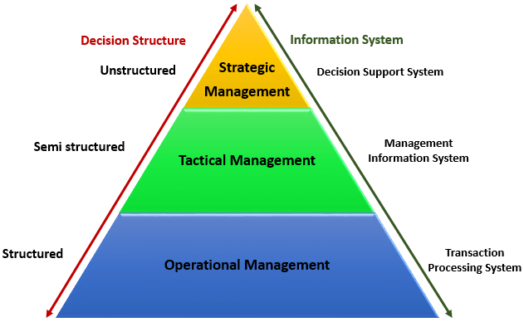

Manual Information Systems VS Computerized Information Systems (MIS)
Data is the bloodstream of any business entity. Everyone in an organization needs information to make decisions. An information system is an organized way of recording, storing data, and retrieving information.
Manual Information System
A manual information system does not use any computerized devices. The recording, storing and retrieving of data is done manually by the people, who are responsible for the information system.
The following are the major components of a manual information system
People –people are the recipients of information system
Business Procedures –these are measures put in place that define the rules for processing data, storing it, analyzing it and producing information
Data –these are the recorded day to day transactions
Filing system – this is an organized way of storing information
Reports –the reports are generated after manually analyzing the data from the filing system and compiling it.

Advantages and Dis-advantages of a manual information system
Advantages:
The following are the advantages of manual information systems
Cost effective – it is cheaper compared to a computerized system because there is no need to purchase expensive equipment such as servers, workstations, printers, etc.
Flexible –evolving business requirements can easily be implemented into the business procedures and implemented immediately
Disadvantages:
The following are some of the disadvantages of a manual information system.
Time consuming –all data entries need to be verified before filing, this is a time consuming task when done by humans. Retrieving data from the filing system also takes a considerable amount of time
Prone to error – the accuracy of the data when verified and validated by human beings is more prone to errors compared to verification and validation done by computerized systems.
Lack of security – the security of manual systems is implemented by restricting access to the file room. Experience shows unauthorized people can easily gain access to the filing room
Duplication of data –most departments in an organization need to have access to the same data. In a manual system, it is common to duplicate this data to make it easy to accessible to all authorized users. The challenge comes in when the same data needs to be updated
Data inconsistency – due to the duplication of data, it is very common to update data in one file and not update the other files. This leads to data inconsistency
Lack of backups – if the file get lost or mishandled, the chances of recovering the data are almost zero.

Computerized information system
Computerized systems were developed to address the challenges of manual information systems. The major difference between a manual and computerized information system is a computerized system uses a combination of software and hardware to record, store, analyze and retrieve information.

Advantages and Disadvantages of a computerized information system (MIS)
Advantages:
Fast data processing and information retrieval – this is one of the biggest advantages of a computerized information system. It processes data and retrieves information at a faster rate. This leads to improved client/customer service
Improved data accuracy – easy to implement data validation and verification checks in a computerized system compared to a manual system.
Improved security – in addition to restricting access to the database server, the computerized information system can implement other security controls such as user’s authentication, biometric authentication systems, access rights control, etc.
Reduced data duplication – database systems are designed in such a way that minimized duplication of data. This means updating data in one department automatically makes it available to the other departments
Improved backup systems – with modern day technology, backups can be stored in the cloud which makes it easy to recover the data if something happened to the hardware and software used to store the data
Easy access to information – most business executives need to travel and still be able to make a decision based on the information. The web and Mobile technologies make accessing data from anywhere possible.
Disadvantages:
It is expensive to set up and configure – the organization has to buy hardware and the required software to run the information system. In addition to that, business procedures will need to be revised, and the staff will need to be trained on how to use the computerized information system.
Heavy reliance on technology – if something happens to the hardware or software that makes it stop functioning, then the information cannot be accessed until the required hardware or software has been replaced.
Risk of fraud – if proper controls and checks are not in place, an intruder can post unauthorized transactions such as an invoice for goods that were never delivered, etc.

Management Information System Features
A management information system (MIS), or information management system, is particularly critical to businesses that work in conjunction with other businesses, so the two must share information with, or transfer information to, each other. In addition, businesses with more than one department or unit can use the MIS to compile information in one central location, thereby preventing information loss. An MIS has four key features.

Data Collection
Organizations use an MIS to store data. The MIS stores the information in one of two database systems. The first kind of database, the relational database, stores input from users, then relates that information to other information throughout the system. The database subsequently puts that information into graphs or charts so users can compare data. The second kind of database, the hierarchical database, stores data in the order that it was received, but provides no comparison tables for the user.

Report Generation
While the MIS serves to store data, it also uses that data to generate reports. Users of the system determine the types of reports, with specific templates available in the system for various types of reporting. When prompted by the user, the system compiles the report required, inserting data into the template, then printing the report for the business.

Accessibility and Integration
The MIS functions with open access. Open access means that the primary MIS can be connected to, or integrated with, other systems within the business, enabling changes to data from different sources and from multiple locations. This function provides two important outcomes. Organizations can update the system to provide information in conjunction with policies and regulations, and the system can be maintained without needing professional service personnel.

Scalability
An important feature of an MIS is that businesses can purchase a small version of a system and then, over time, add to it as finances allow. Businesses can add increased data capabilities, as well as system features, to the initial system as the business grows, eliminating the need for the business owner to purchase an entirely new system every few years.

Prerequisites of an Effective MIS
(i) Qualified System and Management Staff : The prerequisite of an effective MIS is that it should be managed by qualified officers. These officers should have a mutual understanding about the roles and responsibilities of each other and be understand clearly the view of their fellow officers. For this, each organization should have two categories of officers:
(a) System and Computer Experts who in addition to their expertise in their subject area , they should also be capable of understanding management concepts to facilitate the understanding of problems asked by concern. They should also be clear about the process of decision making and information requirements for planning.
(b) Management experts who should also understand quite clearly the concepts and operations of a computer. This basic knowledge of computer will be useful will place them in a comfortable position, while working with systems, technicians in designing or other wise, of the information system.
(ii) Futuristic Perspective : An effective MIS should be capable of meeting the future requirements of its executives as well. This capability can be achieved by regular monitoring and updating the MIS.
(iii) Support of Top Management : For a management information system to be effective, it must receive the full support of top management. The Reasons for this are :
(a) Subordinate managers are usually lethargic about activities which do not receive the support of their superiors.
(b) The resources involved in computer based information system are larger and are growing larger and larger in view of importance gained by management information system.
(iv) Common Database : It is an integrated collection of data and information which is utilized by several information subsystems of an organization. A common database may be defined as a super file which consolidates and integrates data records formerly stored in a separate data file. Such a database can be organized as an integrated collection of data records into a single super file or it can be organized as an integrated collection of several data file.
(v) Control and maintenance of MIS : Control of the MIS means the operation of the system as it was designed to operate. Some times, users develop their own procedures or short cut methods to use the system which reduces its effectiveness.
Components of MIS and their relationship
A management information system is made up of five major components namely people, business processes, data, hardware, and software. All of these components must work together to achieve business objects.
People – these are the users who use the information system to record the day to day business transactions. The users are usually qualified professionals such as accountants, human resource managers, etc. The ICT department usually has the support staff who ensure that the system is running properly.
Business Procedures – these are agreed upon best practices that guide the users and all other components on how to work efficiently. Business procedures are developed by the people i.e. users, consultants, etc.

Data – the recorded day to day business transactions. For a bank, data is collected from activities such as deposits, withdrawals, etc.
Hardware – hardware is made up of the computers, printers, networking devices, etc. The hardware provides the computing power for processing data. It also provides networking and printing capabilities. The hardware speeds up the processing of data into information.
Software – these are programs that run on the hardware. The software is broken down into two major categories namely system software and applications software. System software refers to the operating system i.e. Windows, Mac OS, and Ubuntu, etc. Applications software refers to specialized software for accomplishing business tasks such as a Payroll program, banking system, point of sale system, etc.
SUBSYSTEMS OF AN MIS
Two approaches of defining the subsystems of an MIS are :
• According to the organizational functions which they support
• According to managerial activities for which they are used.
Organizational Function Subsystems
Major Functional subsystem Some typical uses
Marketing Sales forecasting, sales planning, customer and sales analysis
Manufacturing Production planning and scheduling, cost control analysis
Logistics Planning and control of purchasing, inventories, distribution
Personnel Planning personnel requirements, analyzing performance,
salary administration
Finance and accounting Financial analysis, cost analysis, Capital requirements planning,
income measurement
Information processing Information system planning, cost-effectiveness analysis
Top management Strategic planning, resource allocation

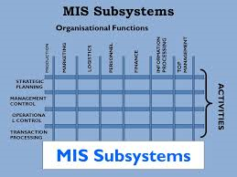
Activities Subsystems
Activity subsystem Some typical uses
Transaction processing Processing of orders, shipments, and receipts
Operational control Scheduling of activities and performance reports
Management control Formulation of budgets and resource allocation
Strategic planning Formulation of objectives and strategic
ROLE OF MANAGEMENT INFORMATION SYSTEM
The role of the MIS in an organization can be compared to the role of heart in the body. The information is the blood and MIS is the heart. In the body the heart plays the role of supplying pure blood to all the elements of the body including the brain. The heart work faster and supplies more blood when needed. It regulates and controls the incoming impure blood, processed it and sends it to the destination in the quantity needed. It fulfills the needs of blood supply to human body in normal course and also in crisis.
The MIS plays exactly the same role in the organization. The system ensures that an appropriate data is collected from the various sources, processed and send further to all the needy destinations. The system is expected to fulfill the information needs of an individual, a group of individuals, the management functionaries: the managers and top management.
Here are some of the important roles of the MIS:
The MIS satisfies the diverse needs through variety of systems such as query system, analysis system, modelling system and decision support system.
The MIS helps in strategic planning, management control, operational control and transaction processing. The MIS helps in the clerical personal in the transaction processing and answers the queries on the data pertaining to the transaction, the status of a particular record and reference on a variety of documents.
The MIS helps the junior management personnel by providing the operational data for planning, scheduling and control , and helps them further in decision-making at the operation level to correct an out of control situation.
The MIS helps the middle management in short term planning, target setting and controlling the business functions. It is supported by the use of the management tools of planning and control.
The MIS helps the top level management in goal setting, strategic planning and evolving the business plans and their implementation.
The MIS plays the role of information generation, communication, problem identification and helps in the process of decision-making. The MIS, therefore, plays a vital role in the management, administration and operation of an organization.
IMPORTANCE OF MIS
To control the creation and growth of records
Despite decades of using various non-paper storage media, the amount of paper in our offices continues to escalate. An effective records information system addresses both creation control (limits the generation of records or copies not required to operate the business) and records retention (a system for destroying useless records or retiring inactive records), thus stabilizing the growth of records in all formats.
To reduce operating costs
Recordkeeping requires administrative dollars for filing equipment, space in offices, and staffing to maintain an organized filing system (or to search for lost records when there is no organized system).
To improve efficiency and productivity
Time spent searching for missing or misfiled record is non-productive. A good records management program (e.g. a document system) can help any organization upgrade its recordkeeping systems so that information retrieval is enhanced, with corresponding improvements in office efficiency and productivity. A well designed and operated filing system with an effective index can facilitate retrieval and deliver information to users as quickly as they need it.
To incorporate new records management technologies
A good records management program provides an organization with the capability to incorporate new technologies and take advantage of their many benefits. Investments in new computer systems whether this is financial, business or otherwise, don't solve filing problems unless current manual recordkeeping or bookkeeping systems are analyzed before automation is applied.
To safeguard vital information
Every organization, public or private, needs a comprehensive program for protecting its vital records and information from catastrophe or disaster, because every organization is vulnerable to loss. Operated as part of a good management information system, vital records programs preserve the integrity and confidentiality of the most important records and safeguard the vital information assets according to a "Plan" to protect the records. This is especially the case for financial information whereby ERP (Enterprise Resource Planning) systems are being deployed in large companies.
To support better management decision making
In today's business environment, the manager that has the relevant data first often wins, either by making the decision ahead of the competition, or by making a better, more informed decision. A good management information system can help ensure that managers and executives have the information they need when they need it.
By implementing an enterprise-wide file organization, including indexing and retrieval capability, managers can obtain and assemble pertinent information quickly for current decisions and future business planning purposes. Likewise, implementing a good ERP system to take account of all the business’ processes both financial and operational will give an organization more advantages than one who was operating a manual based system.
To preserve the corporate memory
An organization's files, records and financial data contain its institutional memory, an irreplaceable asset that is often overlooked. Every business day, you create the records, which could become background data for future management decisions and planning.
Corporate Planning for MIS
Corporate planning is the act of creating a long-term plan to improve your business. A corporate plan examines a business's internal capabilities and lay out strategies for how to use those capabilities to improve the company and meet goals.
The plan for development and its implementation is a basic necessity for MIS. In MIS the information is recognized as major resource like capital and time. If this resource has to be managed well, it calls upon the management to plan for it and control it, so that the information becomes a vital resource for the system.
The management information system needs good planning. This system should deal with the management information not with data processing alone. It should provide support for the management planning, decision making and action. It should provide support to the changing needs of business management. A long range MIS plan provides direction for the development of the system and provides a basis for achieving the specific targets or tasks against time frame.

Following are the contents of MIS planning :
MIS Goals and Objectives : It is necessary to develop the goal and objectives for the MIS which will support the business goals. The MIS goals and objectives will consider management philosophy, policy constraints, Business risk, internal and external environment of the organization and business. The goals and objectives of the MIS would be so stated that they can be measured. The typical statements of the goals can be providing online information on the stock and market; the query processing should not exceed more than three seconds and the like.
Strategy for Plan Achievement : The designer has to take a number of strategic decisions for the achievement of MIS goals and objectives.
The Architecture of MIS : The architecture of the MIS plan provides a system and subsystem structure and their input, output and linkage. It spells out in details the subsystem from the data entry to processing, analysis to modelling and storage to printing.
Hardware and Software Plan : Giving due regards to the technical and operational feasibility, the economics of investment is worked out. Then the plan of procurement is made after selecting the hardware and software. One can take the phased approach of investing starting from the lower configuration of hardware going to the higher as development take place. The process needs matching the technical decisions with the financial decisions.
Growth of MIS in an organization
It is pertinent to realize the importance of growth of MIS in stages in order to encounter increasing complexity of business processes and changing scenario of management. MIS development evolves from EDP systems. The EDP systems have rudimentary technology to handle clerical and supervisory operations in an organisation. This is initiation stage.
The advantages of computerization are gradually realized by most of the people in an organisation. This realization leads to proliferation of computer, networking technologies and computer based system applications within an organisation. This is contagious stage.
Next stage is typified by planning and control. As demand for computerization increases, a need is realized for cost-benefit analysis. This is imperative to plan for future MIS in a cost effective manner.
Next stage of MIS development is integration of subsystems. This comes with realization of interdependence of inflow of data from various sources for valid information. Management plans to leverage existing subsystems to a unified system. Objective of a unified system is to obliterate data redundancy and facilitate communication of information amongst various departments.
After creation of an integrated system, management focuses its attention to database administration. Here impetus is on regulating data for company wide communication. This stage is also referred to as architecture stage.
Next to data administration stage an organisation reaches a stage of MIS maturity. This is the state when MIS department is geared up to plan future MIS needs for the organisation. MIS department future development plans emanate for feedback of the users of existing MIS. At this stage, users are in complete control of MIS and become aware of their system needs.
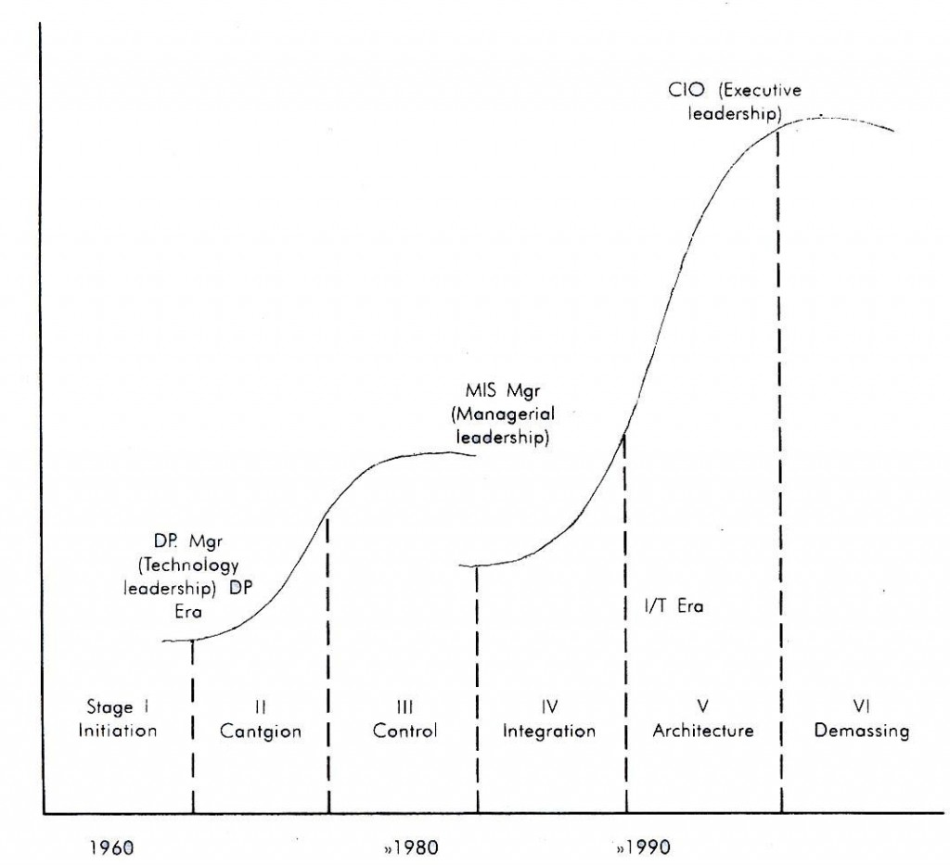
Centralization Vs Decentralization of MIS
Centralization
Centralization of authority means the power of planning and decision making are exclusively in the hands of top management.

A centralised database holds all of an organisation’s data on a central computer, whether mainframe or server. Dumb terminals on a mainframe system and PCs on a network system can access it. These terminals and PCs can be some distance from the central database, but the point is that all the data is together at the same place.
Information held by the company can be found fairly easily by querying its centralised database. Usually a multi-user or network system is used which means that any user on the system can have access to the database.
Advantages
It is much easier to organise, edit, update and back-up the data.
Communications are easier if the data is held on one central computer rather than spread over several.
It is far easier to manage and control if all the data is in one location. For example, in an ordering system, a customer may phone orders and gives notice that their address has changed; when the order operator changes that address it has been changed across the system. If the accounts department then wish to send a statement to the customer they will have the customer’s new address.
Decentralization
Decentralization refers to the dissemination of powers by the top management to the middle or low-level management. It is the delegation of authority, at all the levels of management.

A distributed database is a database that consists of two or more files located at different sites on a computer network. Because the database is distributed, different users can access it without interfering with one another.
Traditionally a distributed database was a collection of data and files, which actually belonged to a system but was physically distributed to a number of computers that were connected via some communication network. Nowadays it is more likely to be independent database systems with facilities for exchanging data.
Limitations of Management Information System
MIS takes into account mainly quantitative factors, thus it ignores the non-quantitative factors like morale, attitudes of members of the organisation, which have an important bearing on the decision making process of executives.
MIS is less useful for making non-programmed decision making. Such types of decisions are not of routine type and thus they require information, which may not be available from existing MIS to executives. MIS effectiveness decreases due to frequent changes in top management, organisational structure and operational team.
MIS is not a substitute for effective management. It means that it cannot replace managerial judgement in making decisions in different functional areas. It is merely an important tool in the hands of executives for decision making and problem solving.
The quality of the outputs of MIS is basically governed by the quality of inputs and processes.
MIS may not have requisite flexibility to quickly update itself with the changing needs of time, especially in a fast changing and complex environment.
The effectiveness of MIS is reduced in organisation, where the culture of hoarding information and not sharing with others hold.
MIS cannot provide tailor made information packages suitable for the purpose of every type of decision made by executives.

Unit - II
System concepts – elements of system – characteristics of a system – types of system – categories of information system – system development life cycle – system enhancement.
System Concepts
A system is a group of interrelated components working together towards a common goal, by accepting inputs and producing outputs in an organized transformation process. The interrelated components which are systematically arranged to form a system are called subsystems. In simple words, system is a set of elements which operate together to accomplish an objective.
The study of system concepts has three basic implications:
1. A system must be designed to achieve a predetermined objective.
2. Interrelationships and interdependence must exist among the components.
3. The objectives of the organization as a whole have a higher priority than the objectives of
its subsystems.
Characteristics of a system
1. Organization:
It implies structure and order. It is the arrangement of components that helps to achieve objectives.
2. Interaction:
It refers to the manner in which each component functions with other components of the system.
3. Interdependence:
It means that parts of the organization or computer system depend on one another. They are coordinated and linked together according to a plan. One subsystem depends on the output of another subsystem for proper functioning.
4. Integration:
It refers to the holism of systems. It is concerned with how a system is tied together.

5. Central Objective:
A system should have a central objective. Objectives may be real or stated. Although a stated objective may be the real objective, it is not uncommon for an organization to state one objective and operate to achieve another. The important point is that users must know the central objective of a computer application early in the analysis for a successful design and conversion.
Elements of a System
1. Outputs and inputs:
A major objective of a system is to produce an output that has value to its user. In order to get a good output, inputs to system must be appropriate. It is important to point out here that determining the output is a first step in specifying the nature, amount and regularity of the input needed to operate a system.
2. Processors:
It is the element of a system that involves the actual transformation of input into output. It is the operational component of a system. Processors may modify the input totally or partially, depending on the specifications of the output. In some cases, input is also modified to enable the processor to handle the transformation.
3. Control:
The control elements guide the system. It is the decision-making subsystem that controls the pattern of activities governing input, processing, and output.
4. Feedback:
Feedback measures output against a standard in some form of cybernetic procedure that includes communication and control. Feedback may be positive or negative, routine or informational. Positive feedback strengthens the performance of the system. It is routine in nature. Negative feedback generally provides the controller with information for action.
5. Environment:
The environment is the “supra-system” within which an organization operates. It is the source of external elements that impinge on the system. In fact, it often determines how a system must function.

6. Boundaries and Interfaces:
A system should be defined by its boundaries- the limits that identify its components, processes, and interrelationships when it interfaces with another system.
Types of System
1. Physical or Abstract Systems:
Physical systems are tangible entities that may be static or dynamic in operation. Abstract systems are conceptual or nonphysical entities. They may be formulas of relationships among sets of variables or models – the abstract conceptualization of physical situations.
2. Open or Closed Systems:
An open system has many interfaces with its environment. It permits interaction across its boundaries; it receives inputs from and delivers outputs to the outside. A closed system is isolated from environment influences.
3. Man-made Information Systems:
An information system is the basis for interaction between the user and the analyst. It provides instructions, commands, and feedback. It determines the nature of relationships among decision makers. From this basis, an information system may be defined as a set of devices, procedures, and operating systems designed around user-based criteria to produce information and communicate it to the user for planning, control and performance.
Types of Information System
An information system is a group of interrelated components that work to carry out input, processing, storage, output and control actions in order to convert data into information that can be used to support forecasting, planning, control, coordination, decision making and operational activities in an organisation.
There are several categories of information system:
- Data Processing Systems (DPS)
- Management Information Systems (MIS)
- Decision Support Systems (DSS)
- Executive Information System (EIS).

Data processing systems
Commercial computing systems were first developed in the 1950s and 60s, initially by what can only be called enthusiasts consisting of businessmen with a vision. These systems were data processing systems that either replaced the manual clerical procedures currently in use (like bank records), or in new areas where humans were unable to perform the calculations involved due to their complexity. A Data Processing System is sometimes referred to as a Transaction Processing System (TPS), because it deals with the day-to-day transactions of an organisation.
Examples include systems for accountancy, invoicing, stock control and data entry. For example, a clerk processing a customer order needs to know whether the item is in stock, what the price of the item is, as well as customer details including name and address.
Another example is each item sold in a supermarket. For each item the bar code would be scanned and used to find the name and the price of the product and then the price used to calculate the total bill for a customer. This type of event would be stored in the supermarket’s transaction file for each day’s business.
Data processing systems are usually tools used at the operational level of an organisation, since most organisations at an operational level produce large amounts of data from the events that contribute to their running.
Another simpler example of a DPS, within a school context, is the gathering of pupil attendance records. Usually some attendance data is gathered for pupils in a school, in the morning and afternoon. This data is then input into the attendance information system. It can be used to calculate pupil, class, and year-group attendance percentages. Pupil support staff enquiring about pupil illness or poor attendance can also use the information produced by this system.
Management information systems
An MIS is a system that converts data from internal and external sources into information, communicated in an appropriate form to managers at different levels of an organisation. The information can contribute to effective decision making or planning to be carried out.
The source of data for an MIS usually comes from numerous databases. These databases are usually the data storage for Data Processing Systems.
MIS summarise and report on the organisation’s basic operations. The basic data from the DPS is condensed and is usually presented in long reports that are produced on a regular basis.
MIS produce reports for managers interested in historic trends on a weekly, monthly and yearly basis (not on the day-to-day activities of the DPS). The information in these reports provides answers to routine pre-defined questions. An example from a supermarket will provide reports that show the sales figures for each department each day for a week, with weekly totals, monthly totals, comparisons with last month and the corresponding month last year. Once the information is in the system many reports can be extracted.
These systems are generally not very flexible and have little analytical capability. Most MIS use simple routines such as summaries and comparisons as opposed to sophisticated mathematical models or statistical techniques.
Decision support systems
A DSS provides information and models in a form to help tactical and strategic decision-making. DSS support management decision making by integrating:
- company performance data
- business rules in a decision table
- analytical tools and models for forecasting and planning
- a simple user interface to query the system.
DSS are particularly useful when making ad-hoc, one-off decisions. These types of decisions tend to be unstructured and irregular.
DSS enable a manager to explore a range of alternatives under a variety of conditions. For example, a manager may wish to know the effects on profits if sales increase and costs decrease.
The source of data for a DSS tends to be a combination of summary information gathered from lower level DPS and MIS; it also includes significant information from external data sources.
Executive information system
An EIS provides senior managers with a system to assist in taking strategic and tactical decisions. Its purpose is to analyse, compare and identify trends to help the strategic direction of the organisation.
EIS address unstructured decisions and create a generalised computing and communications environment, rather than providing any fixed application or specific capability. Such systems are not designed to solve specific problems, but to tackle a changing array of problems.
EIS are designed to incorporate data about external events, such as new tax laws or competitors, and also draw summarised information from internal MIS and DSS. These systems filter, compress, and track critical data; emphasising the reduction of time and effort required to obtain information useful to strategic management. They employ advanced graphics software to provide highly visual and easy-to-use representations of complex information and current trends, but they tend not to provide analytical models.
EIS allow the user to look at specific data that has been summarised from lower levels within the organisation and then drill down to increase the level of detail, which is provided by the information systems in different areas. This is an example of data warehouse analysis, which we will discuss later.
Expert systems
An expert system is a computer program that tries to emulate human reasoning. It does this by combining the knowledge of human experts and then, following a set of rules, it draws inferences.
An expert system is made up of three parts: a knowledge base; an inference engine; a user interface.
The knowledge base stores all of the facts, rules and information needed to represent the knowledge of the expert. The inference engine is the part of the expert system that interprets the rules and facts using backward and forward chaining to find solutions to user queries. The user interface allows the user to enter new knowledge and query the system.
Reasons for expert systems in business:
- To store information in an active form as organisational memory, creating an organisational knowledge base that many employees can examine and preserving expertise that might be lost when an acknowledged expert leaves the organisation
- To create a mechanism that is not subject to human feelings, such as fatigue and worry. This may be especially useful when jobs may be environmentally, physically or mentally dangerous to humans. These systems may also be useful advisers in times of crisis.
- To enhance the organisation’s knowledge base by generating solutions to specific problems that are too substantial and complex to be analysed by human beings in a short period of time.
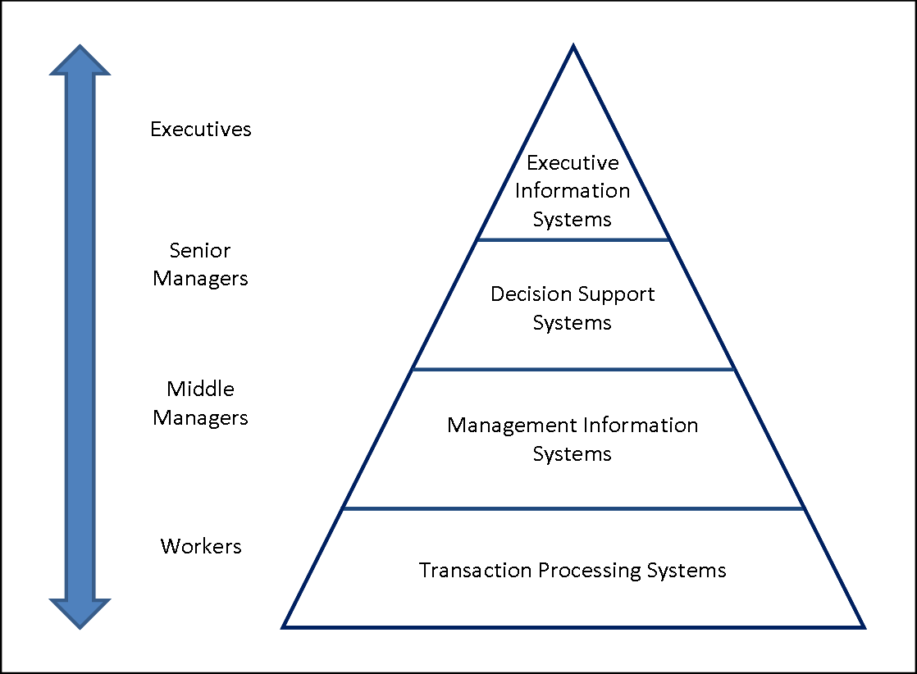
MIS - System Development Life Cycle
Planning and Requirement Analysis
The project planning part involves the following steps −
Reviewing various project requests
Prioritizing the project requests
Allocating the resources
Identifying the project development team
The requirement analysis part involves understanding the goals, processes and the constraints of the system for which the information system is being designed. It is basically an iterative process involving systematic investigation of the processes and requirements. The analyst creates a blueprint of the entire system in minute details, using various diagramming techniques like −
Data flow diagrams
Context diagrams
Requirement analysis has the following sub-processes −
Conducting preliminary investigation
Performing detailed analysis activities
Studying current system
Determining user requirements
Recommending a solution
Defining Requirements
The requirement analysis stage generally completes by creation of a 'Feasibility Report'. This report contains −
A preamble
A goal statement
A brief description of the present system
Proposed alternatives in details
The feasibility report and the proposed alternatives help in preparing the costs and benefits study. Based on the costs and benefits, and considering all problems that may be encountered due to human, organizational or technological bottlenecks, the best alternative is chosen by the end-users of the system.
Designing System Architecture
System design specifies how the system will accomplish this objective. System design consists of both logical design and physical design activity, which produces 'system specification' satisfying system requirements developed in the system analysis stage.
In this stage, the following documents are prepared −
Detailed specification
Hardware/software plan
Building or Developing the System
The most creative and challenging phase of the system life cycle is system design, which refers to the technical specifications that will be applied in implementing the candidate system. It also includes the construction of programmers and program testing.
It has the following stages −
Acquiring hardware and software, if necessary
Database design
Developing system processes
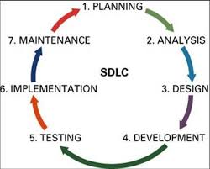
Coding and testing each module
The final report prior to implementation phase includes procedural flowcharts, record layout, report layout and plan for implementing the candidate system. Information on personnel, money, hardware, facility and their estimated cost must also be available. At this point projected cost must be close to actual cost of implementation.
Testing the System
System testing requires a test plan that consists of several key activities and steps for programs, strings, system, and user acceptance testing. The system performance criteria deals with turnaround time, backup, file protection and the human factors.
Testing process focuses on both −
The internal logic of the system/software, ensuring that all statements have been tested;
The external functions, by conducting tests to find errors and ensuring that the defined input will actually produce the required results.
In some cases, a 'parallel run' of the new system is performed, where both the current and the proposed system are run in parallel for a specified time period and the current system is used to validate the proposed system.
Deployment of the System
At this stage, system is put into production to be used by the end users. Sometime, we put system into a Beta stage where users' feedback is received and based on the feedback, the system is corrected or improved before a final release or official release of the system.

System Evaluation and Maintenance
Maintenance is necessary to eliminate the errors in the working system during its working life and to tune the system to any variation in its working environment. Often small system deficiencies are found, as system is brought into operation and changes are made to remove them. System planner must always plan for resources availability to carry on these maintenance functions.
System Enhancement
An enhancement is any product change or upgrade that increases software or hardware capabilities beyond original client specifications. Enhancements allow software and hardware product performance scalability. Hardware component enhancements, such as those to integrated circuits, are often small and demand few resources.
In general, product enhancements include:
- Additional functionality
- Error/bug repair and handling
- Greater processing speed
- Better cross-platform compatibility

Unit - III
Information systems in business and management: Transaction processing system: Information repeating and executive information system.
Transaction Processing System
Definition: A Transaction Processing System (TPS) is a type of information system that collects, stores, modifies and retrieves the data transactions of an enterprise. A transaction is any event that passes the ACID test in which data is generated or modified before storage in an information system
Transactions Processing Qualifiers
In order to qualify as a TPS, transactions made by the system must pass the ACID test. The ACID tests refers to the following four prerequisites:
Atomicity
Atomicity means that a transaction is either completed in full or not at all. For example, if funds are transferred from one account to another, this only counts as a bone fide transaction if both the withdrawal and deposit take place. If one account is debited and the other is not credited, it does not qualify as a transaction. TPS systems ensure that transactions take place in their entirety.
Consistency
TPS systems exist within a set of operating rules (or integrity constraints). If an integrity constraint states that all transactions in a database must have a positive value, any transaction with a negative value would be refused.
Isolation
Transactions must appear to take place in isolation. For example, when a fund transfer is made between two accounts the debiting of one and the crediting of another must appear to take place simultaneously. The funds cannot be credited to an account before they are debited from another.
Durability
Once transactions are completed they cannot be undone. To ensure that this is the case even if the TPS suffers failure, a log will be created to document all completed transactions.
These four conditions ensure that TPS systems carry out their transactions in a methodical, standardised and reliable manner.
Example:
The routines associated with general banking transactions typify the use of standard operating procedures for the handling of deposits and withdraws, cashing of cheques, and other processes.
Customer Activity MIS System Activity
Enter A/C Number Verify the a/c no is acceptable or not.
Enter password (****) Verify that password is valid for the a/c.
Enter withdrawal amount Verify that amount is within limits set by
The bank. Record transaction in Ledger.
Dispense money. Issue receipt for
transaction.
Remove receipt & money Ready for next transaction
Transaction Processing cycle
Transaction processing systems capture and process data describing business transactions. Then they update organizational files and databases and produce a variety of information products for internal and external use. Transaction processing systems generally go through a five-stage cycle of
1) Data entry activities
2) Transaction processing activities
3) File and database processing
4) Document and report generation
5) Inquiry processing activities.
Data Entry
The input activity in transaction processing systems involves a data entry process. In this process, data is captured, or collected by recording, coding, and editing activities. Then the data may be converted to a form that can be entered into a computer system. Data entry activities have always been a bottleneck in the use of computers for transaction processing.
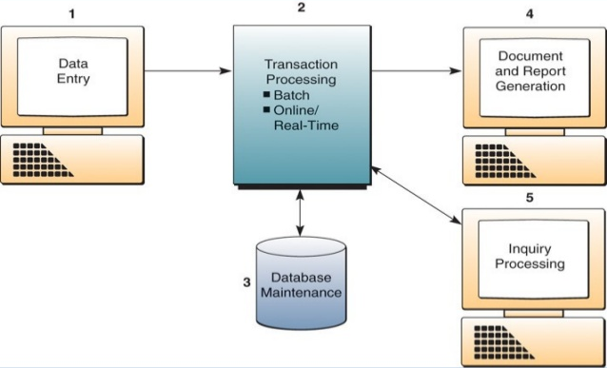
Transaction Processing
Transaction processing systems process data in two ways.
a) Batch processing
b) Real-time processing
Batch Processing
In a batch processing system, transaction data is accumulated over a period of time and processed periodically. It includes credit card transactions, for which the transactions are processed monthly rather than in real time. Credit card transactions need only be processed once a month in order to produce a statement for the customer, so batch processing saves IT resources from having to process each transaction individually.
Advantages
1. Control over time of processing
2. Standardization
3. Reduced setup and processing costs
Disadvantages
1. Time delay in gathering data , storing and bulk processing
2. Operation cost may increase
3. Only identical data is processed in one batch
4. Errors are corrected after the processing of data

Examples of batch transaction processing
Cheque clearance
Bill generation
Credit card sales transactions (Manual)
Real Time Processing
In many circumstances the primary factor is speed. For example, when a bank customer withdraws a sum of money from his or her account it is vital that the transaction be processed and the account balance updated as soon as possible, allowing both the bank and customer to keep track of funds
Advantages
1. Error correction can be immediate
2. Data is processed as demand
3. No time delay
Disadvantages
1. Standardization may not exist or may be more difficult
2. Processing needs make control difficult
3. System hardware and software is expensive
4. Security is critical
Examples of real time transaction processing
Reservation systems
Point of sale terminals
Library loan system
Database maintenance
An organizations databases must be updated by its transaction processing systems so that they are always correct and up-to-date. Therefore , transaction processing systems serve to assist in maintaining the corporate databases of an organization to reflect changes resulting from day to day business transactions. For example; credit sales made to customer will cause customer a/c balance to be increased and the amount of inventory on hand to be decreased. ▪ Database maintenance ensures that these and other changes are reflected in the data records stored in the company’s databases.

Document and report generation
Transaction processing system produce a variety of documents and reports. Example of Transaction documents include purchase orders, sales receipts, customer statement etc..Transaction reports might take the form of a transaction listing such as a payroll register, or edit reports that describe errors detected during processing.
Inquiry Processing
Many transaction processing systems allow you to use the Internet, intranets, extranet, and web browser or database management query languages to make inquiries and receive responses concerning the results of transaction processing activity. Typically, responses are displayed in a variety of pre specified formats or screens. For example, you might check on the status of a sales order, the balances in an account, or the amount of stock in inventory and receive immediate responses at your PC.

Executive information system
An Executive information system (EIS), also known as an Executive support system (ESS) is a type of management support system that facilitates and supports senior executive information and decision-making needs. It provides easy access to internal and external information relevant to organizational goals. It is commonly considered a specialized form of decision support system (DSS). Senior managers need systems that address strategic issues and long-term trends, both in firm and in the external environment. They are mainly concerned with the following frequently asked questions so as to find the suitable solutions.
What will employment levels be in 5 years?
What are the long term industry cost trends, and where does our firm fit in?
How well competitors performing?
What products should we be making in 5 years?
What new acquisitions would protect us from cyclical business swings?
Components of EIS
Hardware
Software
User interface
Telecommunications
Hardware
When talking about computer hardware for an EIS environment, we should focus on the hardware that meets the executive's needs. The executive must be put first and the executive's needs must be defined before the hardware can be selected. The basic hardware needed for a typical EIS includes four components:
1.Input data-entry devices. These devices allow the executive to enter, verify, and update data immediately
2.The central processing unit (CPU), which is the most important because it controls the other computer system components
3.Data storage files. The executive can use this part to save useful business information, and this part also helps the executive to search historical business information easily
4.Output devices, which provide a visual or permanent record for the executive to save or read. This device refers to the visual output device such as monitor or printer
Software
Choosing the appropriate software is vital to an effective EIS. Therefore, the software components and how they integrate the data into one system are important. A typical EIS includes four software components:
1.Text-handling software—documents are typically text-based
2.Database—heterogeneous databases on a range of vendor-specific and open computer platforms help executives access both internal and external data
3.Graphic base—graphics can turn volumes of text and statistics into visual information for executives. Typical graphic types are: time series charts, scatter diagrams, maps, motion graphics, sequence charts, and comparison-oriented graphs (i.e., bar charts)
4.Model base—EIS models contain routine and special statistical, financial, and other quantitative analysis
User interface
An EIS must be efficient to retrieve relevant data for decision makers, so the user interface is very important. Several types of interfaces can be available to the EIS structure, such as scheduled reports, questions/answers, menu driven, command language, natural language, and input/output.
Telecommunication
As decentralizing is becoming the current trend in companies, telecommunications will play a pivotal role in networked information systems. Transmitting data from one place to another has become crucial for establishing a reliable network. In addition, telecommunications within an EIS can accelerate the need for access to distributed data.
Applications of EIS
EIS helps executives find data according to user-defined criteria and promote information-based insight and understanding. Unlike a traditional management information system presentation, EIS can distinguish between vital and seldom-used data, and track different key critical activities for executives, both which are helpful in evaluating if the company is meeting its corporate objectives. After realizing its advantages, people have applied EIS in many areas, especially, in manufacturing, marketing, and finance areas.
Manufacturing
Manufacturing is the transformation of raw materials into finished goods for sale, or intermediate processes involving the production or finishing of semi-manufactures. It is a large branch of industry and of secondary production. Manufacturing operational control focuses on day-to-day operations, and the central idea of this process is effectiveness.
Marketing
In an organization, marketing executives' duty is managing available marketing resources to create a more effective future. For this, they need make judgments about risk and uncertainty of a project and its impact on the company in short term and long term. To assist marketing executives in making effective marketing decisions, an EIS can be applied. EIS provides sales forecasting, which can allow the market executive to compare sales forecast with past sales. EIS also offers an approach to product price, which is found in venture analysis. The market executive can evaluate pricing as related to competition along with the relationship of product quality with price charged. In summary, EIS software package enables marketing executives to manipulate the data by looking for trends, performing audits of the sales data, and calculating totals, averages, changes, variances, or ratios.
Financial
Financial analysis is one of the most important steps to companies today. Executives needs to use financial ratios and cash flow analysis to estimate the trends and make capital investment decisions. An EIS integrates planning or budgeting with control of performance reporting, and it can be extremely helpful to finance executives. EIS focuses on financial performance accountability, and recognizes the importance of cost standards and flexible budgeting in developing the quality of information provided for all executive levels.
Advantages of EIS
- Easy for upper-level executives to use, extensive computer experience is not required in operations
- Provides strong drill-down capabilities to better analyze the given information.
- Information that is provided is better understood
- EIS provides timely delivery of information. Management can make decisions promptly.
- Improves tracking information
- Offers efficiency to decision makers
Disadvantages of EIS
- System dependent
- Limited functionality, by design
- Information overload for some managers
- Benefits hard to quantify
- High implementation costs
- System may become slow, large, and hard to manage
- Need good internal processes for data management
- May lead to less reliable and less secure data
- Excessive cost for small company
Characteristics & capabilities of EIS
Drill Down
The investigation of information in detail. For e.g. an executive may notice a decline in corporate sales by region or by any means.

Critical Success Factors (CSFs)
The factors those are most critical to the success of an organization. Such factors can be strategic, managerial, or operational and are derived mainly from three resources like organizational, industrial and environmental.

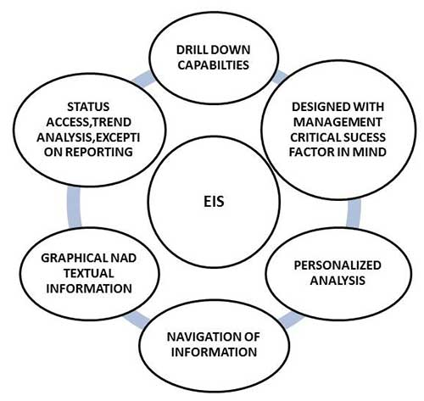
Status Access
A rapid access to current information, provided by a computer. It may require daily or even hourly operational tracking and reporting. In extreme cases, real-time reporting may be required.
Analysis
Analytic capabilities are available in EIS that use mathematical formulas to derive an optimal solution directly or to predict a certain result, mainly in solving structured problems.
Exception Reporting
It is based on the concept of management by exception. That means in exception reporting, the executive's attention is called only to cases with a very bad or very good performance.
Use Of Colors And Audio
Typically, critical items are reported not only numerically but also in color. For example,
GREEN for OK
YELLOW for WARNING
RED for DANGER, that means the performance outside the preset boundaries of the plan. Some systems are equipped with audio signals to alert the user to arriving information.
Communication
The mode of communications for the executives may be by e-mail, a transfer of a report addressed to the attention of someone, a call for a meeting, or a comment made to news group on the internet.
Unit - IV
Database management systems – conceptual presentation – client server architectures networks.
Data
- Data is stored facts
- Data may be numerical data which may be integers or floating point numbers, and non-numerical data such as characters, date and etc.,
Example:
The above numbers may be anything: It may be distance in kms or amount in rupees or no of days or marks in each subject etc.,
Information
- Information is data that have been organized and communicated in a coherent and meaningful manner.
- Data is converted into information, and information is converted into knowledge.
- Knowledge; information evaluated and organized so that it can be used purposefully.
Example:
The data ( information) which is used by an organization – a college, a library, a bank, a manufacturing company – is one of its most valuable resources.
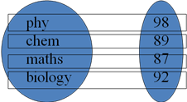
Database
Database is a collection of information organized in such a way that a computer program can quickly select desired pieces of data.
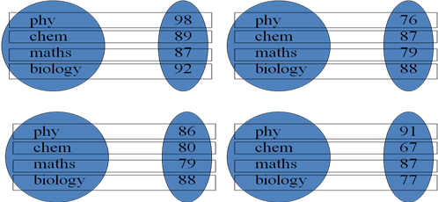
Database Management System (DBMS)
- A collection of programs that enables you to store, modify, and extract information from a database.
- A collection of interrelated data and a set of programs to access those data.
- The primary goal of a DBMS is to provide an environment that is both convenient and efficient to use in retrieving and storing database information.
Database System Vs File System
The information can be either a conventional file processing system or a database system. In the conventional file processing system each and every subsystem of the information system will have its own set of files. As a result, there will be a duplication of data between various subsystems of the information system. But in database systems, there is a single centralized database which minimizes the redundancy of data to a greater extent.
Drawbacks of Conventional File Processing System :
- Data redundancy & inconsistency
- Difficulty in accessing data
- Data Isolation
- Concurrent access anomalies
- Security Problems
- Integrity Problems
Data redundancy & inconsistency:
The files have different formats and the programs may be written in several programming languages. The same information may be duplicated in several places. This redundancy leads to higher storage and access cost. So it may lead to data inconsistency. For example: The address of a customer may appear in savings account file and personal information file. A changed customer address may be reflected in personal information file but not in savings account records file.

Difficulty in accessing data
Conventional file processing environments do not allow needed data to be retrieved in a convenient and efficient manner. Suppose the bank officer needs to find out the names of all the customers who live within the city’s 78733 Zip code. The bank officer has now two choices. Either get the list of all customers and extract the needed information manually or ask the data processing dept to have a system programmer to write the necessary application program. Both alternatives are unsatisfactory.
Data Isolation
Data is scattered in various files and files may be in different format, it is difficult to write new application programs to retrieve appropriate data.
Integrity Problems
The data values stored in the database must satisfy certain types of consistency constraints. These constraints are enforced in the system by adding appropriate code in the various application programs. It is hard to add new constraints or change existing ones. For Example, the balance of a bank account may change from $25 to $50.
Atomicity of updates
Failures may leave database in an inconsistent state with partial updates carried out. Example: Consider a program to transfer $50 from account A to B. If a system failure occurs during the execution of the program, it is possible that the $50 was removed from account A but was not credited to account B, resulting in an inconsistent database state. Transfer of funds from one account to another should be atomic – it must happen in its entirety or not at all.
Concurrent access anomalies
In order to improve the overall performance of the system and obtain a faster response time. Many systems allow multiple users to update the data simultaneously. In such environment interaction of concurrent updates may result in inconsistent data.
Example : Consider bank account A containing $500. If two customers withdraw funds (say $50 and $100 respectively) from account A at about the same time, they may both read the value $500, and write back $450 and $400 respectively. But the correct value is $350.
Security Problems
Not every user of the database system should be able to access all the data. It is Hard to provide user access to some, but not all, data. Example : In a banking system, payroll personnel need to see only the information about the various employees. They do not need access information about customer accounts.
Advantages of Database
Database is a way to consolidate and control the operational data centrally. The advantages of having a centralized control of data are
- Redundancy can be reduced.
- Inconsistency can be avoided.
- The data can be shared.
- The standards can be enforced
- Security can be enforced.
- Integrity can be enforced.

Reducing Data Redundancy

The file based data management systems contained multiple files that were stored in many different locations in a system or even across multiple systems. Because of this, there were sometimes multiple copies of the same file which lead to data redundancy. This is prevented in a database as there is a single database and any change in it is reflected immediately. Because of this, there is no chance of encountering duplicate data.

Sharing of Data

In a database, the users of the database can share the data among themselves. There are various levels of authorisation to access the data, and consequently the data can only be shared based on the correct authorisation protocols being followed.

Many remote users can also access the database simultaneously and share the data between themselves.

Data Integrity

Data integrity means that the data is accurate and consistent in the database. Data Integrity is very important as there are multiple databases in a DBMS. All of these databases contain data that is visible to multiple users. So it is necessary to ensure that the data is correct and consistent in all the databases and for all the users.

Data Security

Data Security is vital concept in a database. Only authorised users should be allowed to access the database and their identity should be authenticated using a username and password. Unauthorised users should not be allowed to access the database under any circumstances as it violates the integrity constraints.

Privacy

The privacy rule in a database means only the authorized users can access a database according to its privacy constraints. There are levels of database access and a user can only view the data he is allowed to. For example - In social networking sites, access constraints are different for different accounts a user may want to access.

Backup and Recovery

Database Management System automatically takes care of backup and recovery. The users don't need to backup data periodically because this is taken care of by the DBMS. Moreover, it also restores the database after a crash or system failure to its previous condition.

Data Consistency

Data consistency is ensured in a database because there is no data redundancy. All data appears consistently across the database and the data is same for all the users viewing the database. Moreover, any changes made to the database are immediately reflected to all the users and there is no data inconsistency.

Disadvantages of DBMS
The disadvantages of the database approach are summarized as follows:
1. Complexity : The provision of the functionality that is expected of a good DBMS makes the DBMS an extremely complex piece of software. Database designers, developers, database administrators and end-users must understand this functionality to take full advantage of it. Failure to understand the system can lead to bad design decisions, which can have serious consequences for an organization.
2. Size : The complexity and breadth of functionality makes the DBMS an extremely large piece of software, occupying many megabytes of disk space and requiring substantial amounts of memory to run efficiently.
3. Performance: Typically, a File Based system is written for a specific application, such as invoicing. As result, performance is generally very good. However, the DBMS is written to be more general, to cater for many applications rather than just one. The effect is that some applications may not run as fast as they used to.
4. Higher impact of a failure: The centralization of resources increases the vulnerability of the system. Since all users and applications rely on the ~vailabi1ity of the DBMS, the failure of any component can bring operations to a halt.
5. Cost of DBMS: The cost of DBMS varies significantly, depending on the environment and functionality provided. There is also the recurrent annual maintenance cost.
6. Additional Hardware costs: The disk storage requirements for the DBMS and the database may necessitate the purchase of additional storage space. Furthermore, to achieve the required performance it may be necessary to purchase a larger machine, perhaps even a machine dedicated to running the DBMS. The procurement of additional hardware results in further expenditure.
7. Cost of Conversion: In some situations, the cost oftlle DBMS and extra hardware may be insignificant compared with the cost of converting existing applications to run on the new DBMS and hardware. This cost also includes the cost of training staff to use these new systems and possibly the employment of specialist staff to help with conversion and running of the system. This cost is one of the main reasons why some organizations feel tied to their current systems and cannot switch to modern database technology.
View of Data
A database system is a collection of interrelated data and a set of programs that allow users to access and modify these files major purpose is to provide users with an abstract view of the data. That is the system hides certain details of how the data are stored and maintained and retrieved efficiently.
Data Abstraction
For the system to be usable, it must retrieve data efficiently. The need for efficiency is to use complex data structures to represent data in the database. The developers hide the complexity from users through several levels of abstraction, to simplify users’ interactions with the system. The design of complex data structures for the representation of data in the database are
- Physical Level
- Conceptual Level
- View Level
Physical Level: The lowest level of abstraction describes how the data are actually stored. The physical level describes complex low-level data structures in detail.
Logical / Conceptual Level: The next higher level of data abstraction describes what data are actually stored in the database and the relationship that exists among the data. Here the entire database is described in terms of a smaller no of relatively simple structures. The user of this level need not know the complexities of the physical level.
View Level / External Level: The highest level of abstraction describes only part of the entire database. When we use simple structures at the conceptual level, some complexities remain because of the large size of the database. To simplify the interaction with the system, the view level of abstraction is defined. The system may provide many views of the same database.

View Level
View 3
……………
View 2
View 1

Logical Level

Physical Level

The three levels of data abstraction
Data Model
- A collection of conceptual tools for describing data, data relationships, data semantics & consistency constraints.
- A data model provides a way to describe the design of a database at the physical, logical and view level.
Relational Model:
- It uses a collection of tables to represent both data and the relationships among those data.
- Each table has multiple columns and each column has a unique name.
- Each table contains records of a particular type.
- Each record type defines a fixed no. of fields, or attributes.
- It is the most widely used data model.
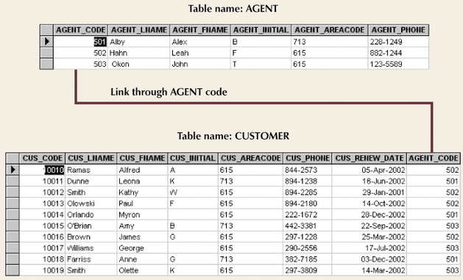
Relational Database Model
Entity Relationship Model
- It is based on a perception of a real world that consists of a collection of basic objects, called entities and of relationships among these objects.
- An entity is a thing or object in the real world that is distinguishable from other objects.
Example of schema in the entity-relationship model

Object Oriented Data Model
An object-oriented database is a database model in which information is represented in the form of objects as used in object-oriented programming.
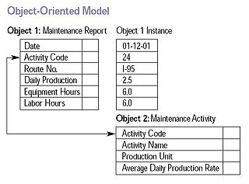
Object Relational data Model
It combines the features of the object oriented data model and relational data model.
Hierarchical data model
- A hierarchical data model is a data model in which the data is organized into a tree-like structure.
- Logically represented by an upside down tree
- Each parent can have many children
- Each child has only one parent
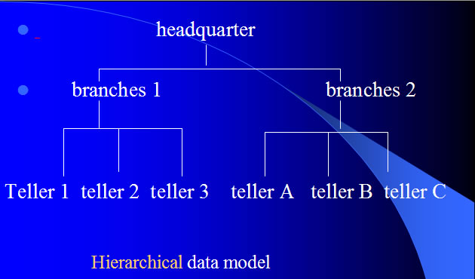

Network data model
A network is a type of mathematical graph that captures relationships between objects using connectivity.
- The following are some key terms related to the network data model:
- A node represents an object of interest.
- A link represents a relationship between two nodes. A link may be directed or undirected
- A path is an alternating sequence of nodes and links, beginning and ending with nodes, and usually with no nodes and links appearing more than once.
- A network consists of a set of nodes and links. Each link (sometimes also called an edge or a segment) specifies two nodes.
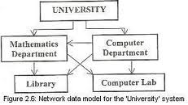
Database Languages
A database system provides two different types of languages:
1. Data Definition Language (DDL) - To specify the database schema
2. Data Manipulation Language (DML) - To express the queries and updates.
Data Definition Language
- Used by the DBA and database designers to specify the conceptual schema of a database.
- In some DBMSs, separate storage definition language (SDL) and view definition language (VDL) are used to define internal and external schemas.
- SDL is typically realized via DBMS commands provided to the DBA and database designers.
- DDL compiler generates a set of tables stored in a data dictionary.
- A data dictionary is a file that contains metadata (ie. Data about data)
Data Manipulation Language :
DML is a language that enables users to access or manipulate as organized as the appropriate data model. The types of accesses are :
- Retrieval of information stored in the database
- Insertion of new item into the data base.
- Deletion of information from the database.
- Modification of information stored in the database.
Database Users and Administrators
  - People who work with database can be categorized as,
  - Database users and
  - Database administrators
Database Users
There are four different types of users, differentiated by the way they expect to interact with the system. Different types of user interfaces have been designed for the different types of users.
Naive Users
Naive users are those users who do not have any technical knowledge about the DBMS. They use the database through application programs by using simple user interface. They perform all operations by using simple commands provided in the user interface.
Ex : View balance of an account
The typical user interface for naïve users is a forms interface, where the user can fill in appropriate fields of the form. They also read reports.
Application Programmers :
- They are computer professionals who write application programs.
- They can choose from many tools to develop user interfaces.
- Rapid Application Development tools are tools used to construct forms and reports with minimal efforts.
Sophisticated Users:
Sophisticated users are the users who are familiar with the structure of database and facilities of DBMS. Such users can use a query language such as SQL to perform the required operations on databases.
Specialized Users:
They write specialized database applications that do not fit into the traditional data-processing framework.
Database Administrator: (DBA)
A Person who has the central control over the system (ie) control of both data and programs to access those data, is called DBA.
Functions of DBA include
Schema Definition:
DBA creates the original db schema by executing DDL statements.
Schema and Physical organization modification
The DBA carries out changes to the schema and physical organization to reflect the changing needs of the organization.
Granting of authorization for data access
Providing authorization for different types of users. So he can regulate the user access.
Routine maintenance
    - Periodically backing up the db, either onto tapes or onto remote servers to prevent loss of data.
    - Ensuring that enough free disk space is available for normal operations and upgrading disk space as required.
    - Monitoring jobs running on the database and ensuring that performance is not degraded by very expensive tasks submitted by some users.
Database System Structure
- A Database system is partitioned into modules that deal with each of the responsibilities of the overall system.
- The functional components of a database system can be broadly divided into,
      - the storage manager and
      - query processor components.
Storage Manager
A storage manager is a program module that provides the interface between the low level data stored in the database and the application programs and queries submitted to the system.
The storage manager translates the various DML statements into low level file system commands.
The storage manager is responsible for storing, retrieving and updating data in the database.
The storage manager components include:
Authorization and integrity manager Which tests for the satisfaction of integrity constraints and checks the authority of users to access data.
Transaction manager Which ensures that the database remains in a consistent correct) state despite system failures, and that concurrent transaction executions proceed without conflicting.
File Manager Which manages the allocation of space on disk storage and the data structures used to represent information stored on disk.
Buffer manager Which is responsible for fetching data from disk storage into main memory, and deciding what data to cache in main memory. The storage manager implements several data structures as part of the physical system implementation:
- Data files, which store the database itself.
- Data dictionary, which stores metadata (ie) data about data in particular the schema of the database.
- names of the tables, names of attributes of each table, length of attributes, and number of rows in each table.
- Relationships
- Constraints
- Access Authorization
Indices:
It provides fast access to data items holding particular values.

Overall System Structure
The Query Processor
The query processor components include
DDL interpreter, which interprets DDL statements and records the definitions in the data dictionary.
DML Compiler and Query optimizer - The DML commands such as insert, update, delete, retrieve from the application program are sent to the DML compiler for compilation into object code for database access. The object code is then optimized in the best way to execute a query by the query optimizer and then send to the data manager.
Query evaluation engine - which executes low level instructions generated by the DML compiler.
Database System Applications
Railway Reservation System
Database is required to keep record of ticket booking, train’s departure and arrival status. Also if trains get late then people get to know it through database update.
Library Management System
There are thousands of books in the library so it is very difficult to keep record of all the books in a copy or register. So DBMS used to maintain all the information relate to book issue dates, name of the book, author and availability of the book.
Banking
We make thousands of transactions through banks daily and we can do this without going to the bank. So how banking has become so easy that by sitting at home we can send or get money through banks. That is all possible just because of DBMS that manages all the bank transactions.
Universities and colleges
Examinations are done online today and universities and colleges maintain all these records through DBMS. Student’s registrations details, results, courses and grades all the information is stored in database.
Credit card transactions
For purchase of credit cards and all the other transactions are made possible only by DBMS. A credit card holder knows the importance of their information that all are secured through DBMS.
Social Media Sites
We all are on social media websites to share our views and connect with our friends. Daily millions of users signed up for these social media accounts like facebook, twitter, and Google plus. All the information of users is stored and they become able to connect to other people because of DBMS.
Telecommunications
Any telecommunication company cannot even think about their business without DBMS. DBMS is must for these companies to store the call details and monthly post paid bills.
Finance
For storing information about holdings, sales and purchases of financial instruments such as stocks and bonds.To enable on-line trading by customers and automated trading by the firm database is user for storing real-time market data.
Military
Military keeps records of millions of soldiers and it has millions of files that should be keep secured and safe. As DBMS provides a big security assurance to the military information so it is widely used in militaries. One can easily search for all the information about anyone within seconds with the help of DBMS.
Online Shopping
Online shopping has become a big trend of these days. No one wants to go to shops and waste his time. Everyone wants to shop from home. So all these products are added and sold only with the help of DBMS. Purchase information, invoice bills and payment, all of these are done with the help of DBMS.
Human Resource Management
Big firms have many workers working under them. Human resource management department keeps records of each employee’s salary, tax and work through DBMS.
Manufacturing
Manufacturing companies make products and sales them on the daily basis. To keep records of all the details about the products like quantity, bills, purchase, supply chain management, DBMS is used.
Airline Reservation system
Same as railway reservation system, airline also needs DBMS to keep records of flights arrival, departure and delay status
Client Server architecture
Client-server architecture is network architecture in which each computer or process on the network is either a client or a server.
Server - Servers are powerful computers or processes dedicated to managing disk drives (file servers), printers (print servers), or network traffic (network servers).
Client - Clients are PCs or workstations on which users run applications. Clients rely on servers for resources, such as files, devices, and even processing power.

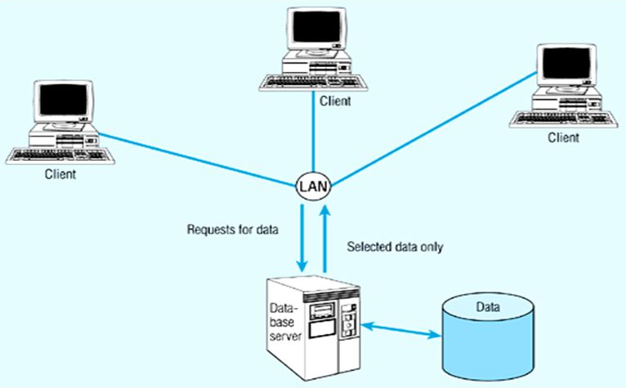
The following are the examples of client/server architectures.
Two tier architectures
Two-tier architecture is where a client talks directly to a server, with no intervening server. It is typically used in small environments(less than 50 users).
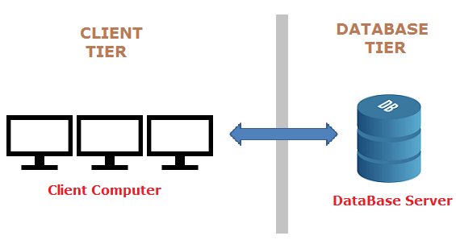
In two tier client/server architectures, the user interface is placed at user's desktop environment and the database management system services are usually in a server that is a more powerful machine that provides services to the many clients. Information processing is split between the user system interface environment and the database management server environment.
Advantages:
- Easy to maintain and modification is bit easy 2. Communication is faster
Disadvantages:
- In two tier architecture application performance will be degrade upon increasing the users
- Cost-ineffective
Three tier architectures
The three tier architecture is introduced to overcome the drawbacks of the two tier architecture. In the three tier architecture, a middleware is used between the user system interface client environment and the database management server environment.
These middleware are implemented in a variety of ways such as transaction processing monitors, message servers or application servers. The middleware perform the function of queuing, application execution and database staging. In addition the middleware adds scheduling and prioritization for work in progress.
The three tier client/server architecture is used to improve performance for large number of users and also improves flexibility when compared to the two tier approach.
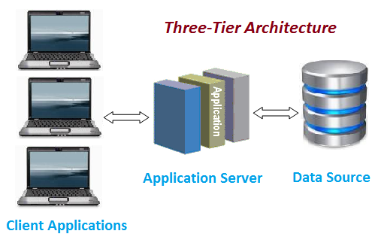
Database (Data) Tier − At this tier, the database resides along with its query processing languages. We also have the relations that define the data and their constraints at this level.
Application (Middle) Tier − At this tier reside the application server and the programs that access the database. For a user, this application tier presents an abstracted view of the database. End-users are unaware of any existence of the database beyond the application. At the other end, the database tier is not aware of any other user beyond the application tier. Hence, the application layer sits in the middle and acts as a mediator between the end-user and the database.
User (Presentation) Tier − End-users operate on this tier and they know nothing about any existence of the database beyond this layer. At this layer, multiple views of the database can be provided by the application. All views are generated by applications that reside in the application tier.

