UNIT – 4
SERVICES PROCESS
ASSISTANT PROFESSOR: A.KAMATCHI.
INTRODUCITON
Service process is the sixth element of service marketing mix. The service process refers to how a service is provided or delivered to a customer. Processes involve the procedures, tasks, schedules, mechanisms, Processes involve the procedures, tasks, schedules, activities and routines by which a service is delivered to the customer activities and routines by which a service is delivered to the customer.
MEANING
Process in services refets to the actual procedures, mechanisms and flow of activites by which the service is delivered- the service delivery and operating systems.
In fast food outliets the process cmprises buying the coupons at one counter and picing up the food against that at another counter.

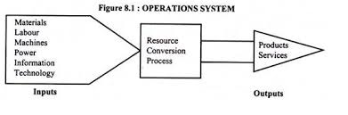
CLASSIFICATION OF SERVICE OPERATING SYSTEMS
Service operating system may be classified in a number of ways. Two considered here for illustrative purposes are according to:
A) Type of process
B) The degree of contact
A) THE TYPE OF PROCESS
Three types of process of relevance to service organisation are:
- Line operations
- Job shop operations
- Intermittent operations
- Line operations
Line operations progress in a linear fashion. Thus, the client passes through a sequential experience beginning at point A, when they first enter the store or contact the business. Now, service delivery passes through a number of processes before finalizing the transaction.
Although this is perhaps the simplest of the service processes to understand, it has several drawbacks. If one element in the linear operation is flawed or bottlenecked, the client will judge the service as a whole based on this weak area.
It’s also not a service process that allows for much flexibility. That does make controlling it easier, but it would only suit a standard offering that implements repetitive processes with little or no variation. This type of service process is the easiest to automate because it is so standardized. Every customer has a similar customer experience, and the service process does not vary.

b) Job Shop Operations
This type of service model provides customer satisfaction by tailoring the service to the client’s needs. For example, a professional organization such as a law firm or a bespoke service such as that which a carpenter may provide is only open to a limited level of standardization. Each client’s needs will vary to some degree, and the service process must, therefore, vary accordingly.
Being able to offer flexibility makes this model attractive, but it can complicate scheduling and workflows.

c) Intermittent Operations
Some service projects are unique and seldom repeated. For example, construction projects or branding initiatives would fall under this category. In most instances, the projects themselves are of a relatively large scale. They will involve bringing together several elements so that they can work harmoniously.
Planning will be key, and managers would evaluate each project independently in order to determine what process flows would contribute to the final result: providing the desired service to its clients. Critical path analysis is often used in this context.

B). THE DEGREE OF CONTACT:
Managing service operations with a high level of customer contact with the service delivery process presents different challenges compared with those systems where there is a low level of customer contact. The amount of customer contact has an effect on many of the decision’s operations managers have to make. These kinds of systems (high contact or low contact) have an effect upon service operations and have implications for managers of service systems.
]
Some of these are:
(a) High contact systems are more difficult to control since the customer can make an input to the process or even disrupt the process;
(b) In high contact systems the customer can affect the timing of demand and it is more difficult to balance the capacity of the system to meet demands placed upon it;
(c) Workers in high contact systems can have a great influence upon the customers’ view of the service provided;
(d) In high contact systems production scheduling is more difficult;
(e) It may be more difficult to rationalize high contact systems (e.g. by substituting technology);
(f) It may be beneficial to separate high contact and low contact elements of a service system and encourage staff specialization in these different functions because of the varying skills required.
POLICIES AND FLOWCHARTING
Flow charting offers a number of advantages in services process.
- Providing a visual representation of the service system.
- Identifying possible bottlenecks in the process and estimating capacity required at each stage
- Identifying the steps in which the customers is involved in the process.
- Identifying information requirements at each stage of the process.
Some of the key questions service managers need to consider in developing policy for service organisations emergence from this kind of analysis. They include:
- What steps are involved in the process?
- Are they arranged logically?
- Can some steps be eliminated or combined?
- Are the capacities of each step balanced?
- Where are customers involved in the process?
- Can unnecessary customer contact be reduced or eliminated?
- Can technology be used to speed up the process?
- Can some steps in the process be transferred elsewhere?
BALANCING SUPPLY AND DEMAND
Inventory wherever possible(e.g.spare capacity,people,etc) | Have customer wait in favourable environment
Schedule workers according to demand( e.g.shift working, part-time employee) | Schedule customers( e.g. appointment systems)
Subcontract work to other service organisatons | Provide substitute goods or services (e.g. automatic tellers)
Have peak-time efficiency routines (e.g.only do essential jobs) | Diversity demands(e.g.enter counter seasonal markets)
Increase customer participation in the production process(e.g. self-service) | Turn customers away during peak demand period (e.g. differential pricing)
Share services/facilities with other service organisations | Use marketing to shift demand (e.g. advertising campaigns)
Improve the service system(e.g. use technology where possible) | Change customer expectations of service (e.g. through usage)

THE PURCHASE PROCESS FOR SERVICESS
- Seeking information from respected personal sources (family, friends, peers)
- Relying on a firm with a good reputation
- Looking for guarantees and warranties
- Visiting service facilities or trying aspects of the service before purchasing
- Asking knowledgeable employees about competing services
- Examining tangible cues or other physical evidence
- Using the Web to compare service offerings One strategy to help reduce the risk perceived by customers is to educate them about the features of the service, describe the types of users who can most benefit from it, and offer advice on how to obtain the best results

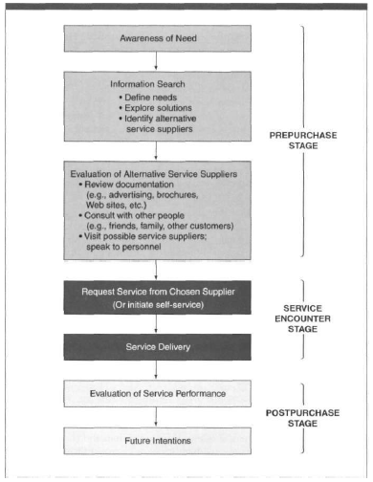

FACILITATING PROCESS
The facilitator firm is defined by its ability to acquire market information and expertise and to bring these to bear in matching the needs of buyers and sellers in order to complete a transaction.
t
CHALLENGES FOR SERVICE MANAGERS
- As the service on a higher degree of interaction and customisation
- The management must deal with higher costs and more talented labour.
- Managing costs effectively-either by keeping them down or by passing them down or by passing them on to customers-becomes a significant challenge.
- Maintaining quality and responding to consumer intervention are also challenge one.
- Talented employees demand attention and expect advancement in the organisation
BREAKTHROUGH SERVICE
As like products the service providers are also in a condition to provide breakthrough services. The process of creating breakthrough services the following things are to be taken into account,
It full fills the consumers’ needs to greater degree than existing services.
- Developing a vision of the service business
- Building customer loyalty
- Focusing and positioning a service
- Determining the true cost of poor quality
- Developing devices for achieving total customer satisfaction
- Managing for quality and productivity gains
- Managing demand and supply
- Management of networks
- Managing information technology
- Mobilising people
- Organising work and envisioning future breakthroughs.

SERVICE DESIGN
Service design is the activity of planning and organizing people, infrastructure, communication and material components of a service in order to improve its quality and the interaction between the service provider and its customers. Service design may function as a way to inform changes to an existing service or create a new service entirely.

