SRINIVASAN COLLEGE OF ARTS & SCIENCE, PERAMBALUR-621 212
DEPARTMENT OF BIOTECHNOLOGY
CLASS – I B.Sc., BIOTECHNOLOGY SUB CODE :16SCCBT2
SUBJECT - MOLECULAR BIOLOGY
UNIT 1
Cytoskeleton

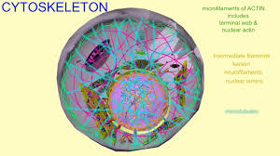

Cytosol contains a system of protein fibers called cytoskeleton – a network of cytoplasmic filaments that are responsible for the movement of the cell and give the cell its shape. Cytoskeleton is connected to most organelles within the cytoplasm. The three types of proteins, which make up the cytoskeleton are: microtubles, intermediate filaments and microfilaments.

The microfilaments (actin protein) are twisted double strands, which helps in muscle contraction and changes in cell shape. The intermediate filaments (keratin and other types of proteins) consist of eight subunits, which maintains cell shape.

The microtubules (tubulin protein) are tubes consisting of spiraling two-part protein subunits, whose function is the movement of chromosomes during cell division.

The cytoplasm helps materials move around the cell by moving and churning, through a process called cytoplasmic streaming. The nucleus often flows with the cytoplasm changing the shape as it moves. The cytoplasm is the site where most cellular activities are done. The cytoplasm holds and protects organelles such as the vacuole, mitochondria, the endoplasmic reticulum, the Golgi apparatus, lysosomes, and in plant cells - chloroplasts. The functions for cell expansion, growth and replication are carried out in the cytoplasm of the cell.

Cytoplasm has three main functions – energy, storage and manufacturing. It contains other organelles, which store and produce energy. Synthesis of fatty acids, nucleotides and some amino acids also take place in the cytosol. The organelles are the metabolic machinery of the cell and are like little organs themselves.

Nucleus - Genetic Library of the Cell

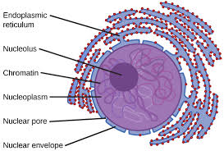

The nucleus is the brain of eukaryotic cells. It is only present in eukaryotic cells (which are eukaryotic because they have a nucleus) and there is only one of these organelles in each cell.

The nucleus is a major, centrally located spherical cellular component. The nucleus is a highly specialized organelle that serves as the information processing and administrative center of the cell.

The nucleus stores the cell's hereditary material, or DNA. It plays an important part in cell division and it controls and coordinates various life processes of the cell, which include growth, intermediary metabolism, protein synthesis.

A double−layered membrane, the nuclear envelope, separates the contents of the nucleus from the cellular cytoplasm. Nuclear envelope encloses a space between two nuclear membranes and is connected to a system of membranes called the endoplasmic reticulums (ER) where protein synthesis occurs, and is usually studded with ribosomes.

The envelope contains many pores called nuclear pores and encloses a semi fluid substance called nucleoplasm. Nuclear pores allow specific types and sizes of molecules to pass back and forth between the nucleus and the cytoplasm.
Red Blood cells of humansNucleus holds the cell's genetic material It is the membrane bound structure that contains the cell's hereditary information and controls the cell's growth and reproduction. The main function of the cell nucleus is to control gene expression and mediate the replication of DNA during the cell cycle.

Significance of Nucleus
Two types of nuclear structures called the nucleolus (plural: nucleoli) and chromatin material are embedded within the nucleoplasm. The nucleus may contain one nucleolus or more nucleoli.

The nucleolus contains ribosomes, RNA, DNA, and proteins. The nucleolus synthesizes protein−producing macromolecular assemblies called ribosomes. Nucleolus is known as factory of ribosomes

Allele
An allele is a variant form of a gene. Some genes have a variety of different forms, which are located at the same position, or genetic locus, on a chromosome. Humans are called diploid organisms because they have two alleles at each genetic locus, with one allele inherited from each parent. Each pair of alleles represents the genotype of a specific gene. Genotypes are described as homozygous if there are two identical alleles at a particular locus and as heterozygous if the two alleles differ. Alleles contribute to the organism's phenotype, which is the outward appearance of the organism.

Some alleles are dominant or recessive. When an organism is heterozygous at a specific locus and carries one dominant and one recessive allele, the organism will express the dominant phenotype. Alleles can also refer to minor DNA sequence variations between alleles that do not necessarily influence the gene's phenotype.

Loci
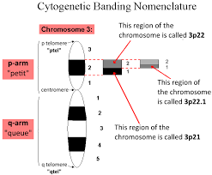
, a locus (plural loci) is a specific, fixed position on a chromosome where a particular gene or genetic marker is located.[1] Each chromosome carries many genes, with each gene occupying a different position or locus; in humans, the total number of protein-coding genes in a complete haploid set of 23 chromosomes

Genes may possess multiple variants known as alleles, and an allele may also be said to reside at a particular locus. Diploid and polyploid cells whose chromosomes have the same allele at a given locus are called homozygous with respect to that locus, while those that have different alleles at a given locus are called heterozygous.[3] The ordered list of loci known for a particular genome is called a gene map. Gene mapping is the process of determining the specific locus or loci responsible for producing a particular phenotype

Gene
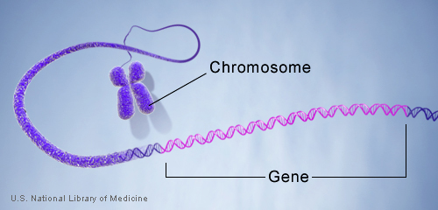
A gene is the basic physical and functional unit of heredity. Genes are made up of DNA. Some genes act as instructions to make molecules called proteins. However, many genes do not code for proteins. In humans, genes vary in size from a few hundred DNA bases to more than 2 million bases. The Human Genome Project estimated that humans have between 20,000 and 25,000 genes.

Every person has two copies of each gene, one inherited from each parent. Most genes are the same in all people, but a small number of genes (less than 1 percent of the total) are slightly different between people. Alleles are forms of the same gene with small differences in their sequence of DNA bases. These small differences contribute to each person’s unique physical features.

Chromatin
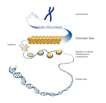

Chromatin is a substance within a chromosome consisting of DNA and protein. The DNA carries the cell's genetic instructions. The major proteins in chromatin are histones, which help package the DNA in a compact form that fits in the cell nucleus. Changes in chromatin structure are associated with DNA replication and gene expression

Mitosis
Mitosis is a form of eukaryotic cell division that produces two daughter cells with the same genetic component as the parent cell. Chromosomes replicated during the S phase are divided in such a way as to ensure that each daughter cell receives a copy of every chromosome. In actively dividing animal cells, the whole process takes about one hour.
The replicated chromosomes are attached to a 'mitotic apparatus' that aligns them and then separates the sister chromatids to produce an even partitioning of the genetic material. This separation of the genetic material in a mitotic nuclear division (or karyokinesis) is followed by a separation of the cell cytoplasm in a cellular division (or cytokinesis) to produce two daughter cells.
In some single-celled organisms mitosis forms the basis of asexual reproduction. In diploid multicellular organisms sexual reproduction involves the fusion of two haploid gametes to produce a diploid zygote. Mitotic divisions of the zygote and daughter cells are then responsible for the subsequent growth and development of the organism. In the adult organism, mitosis plays a role in cell replacement, wound healing and tumour formation.
Mitosis, although a continuous process, is conventionally divided into five stages: prophase, prometaphase, metaphase, anaphase and telophase.

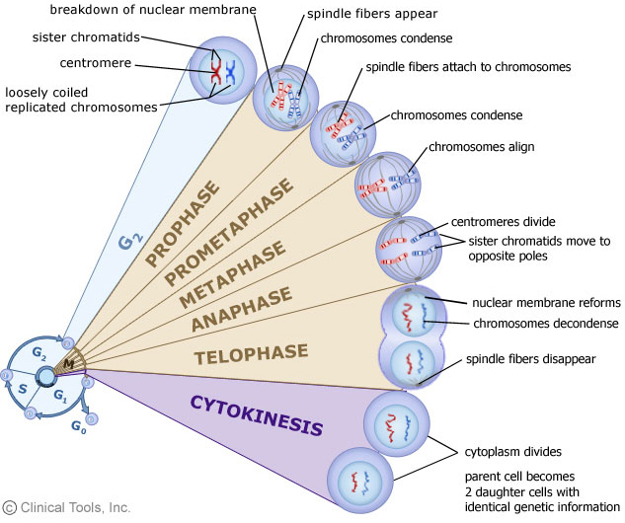
The phases of mitosis

Prophase
Prophase occupies over half of mitosis. The nuclear membrane breaks down to form a number of small vesicles and the nucleolus disintegrates. A structure known as the centrosome duplicates itself to form two daughter centrosomes that migrate to opposite ends of the cell. The centrosomes organise the production of microtubules that form the spindle fibres that constitute the mitotic spindle. The chromosomes condense into compact structures. Each replicated chromosome can now be seen to consist of two identical chromatids (or sister chromatids) held together by a structure known as the centromere.

Prometaphase
The chromosomes, led by their centromeres, migrate to the equatorial plane in the mid-line of the cell - at right-angles to the axis formed by the centrosomes. This region of the mitotic spindle is known as the metaphase plate. The spindle fibres bind to a structure associated with the centromere of each chromosome called a kinetochore. Individual spindle fibres bind to a kinetochore structure on each side of the centromere. The chromosomes continue to condense.

Metaphase
The chromosomes align themselves along the metaphase plate of the spindle apparatus.

Anaphase
The shortest stage of mitosis. The centromeres divide, and the sister chromatids of each chromosome are pulled apart - or 'disjoin' - and move to the opposite ends of the cell, pulled by spindle fibres attached to the kinetochore regions. The separated sister chromatids are now referred to as daughter chromosomes. (It is the alignment and separation in metaphase and anaphase that is important in ensuring that each daughter cell receives a copy of every chromosome.)

Telophase
The final stage of mitosis, and a reversal of many of the processes observed during prophase. The nuclear membrane reforms around the chromosomes grouped at either pole of the cell, the chromosomes uncoil and become diffuse, and the spindle fibres disappear

UNIT 2
Polytene Chromsomes or Salivary Gland Chromosomes
The giant chromosomes were first observed in the cells of salivary glands, gut, trachea and other body parts of dipteran insects by E.G. Balbiani in 1881. The name polytene was assigned to these chromosomes by Kollar. The polytene chromosomes are much larger than the normal somatic chromosomes. How this increase in size of chromosomes is brought about is not known.
The giant chromosomes consist of a bundle of chromonemal fibrils which arise by a series of about 10 consecutive duplications of the initial chromonemata that increase the DNA content about 1,000 times the DNA content of somatic cells (Fig. 9.10). Because of the multi-stranded condition, these chromosomes are called polytene chromosomes.
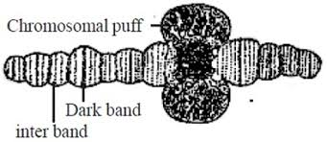

Model of Dupraw and Rae and Method of "Puffing" in one of the Bands

The process of reduplication of strands without separation is called endoduplication. The homologous polytene chromosomes always remain closely paired in mitotic prophase . This is called somatic pairing and these chromosomes are thought to be in permanent prophase.
The polytene chromosomes bear along their entire length a series of dark bands alternated by light bands or interbands. The dark bands are narrow or broad disc shaped structures. They are euchromatic in nature and contain large amount of DNA, small amount of RNA and certain basic proteins. They are feulgen positive and absorb ultraviolet (UV) light of 2600 A.
The light bands or interbands are fibrillar, feulgen negative, heterochromatic regions containing small amount of DNA. large amount of RNA and acidic proteins and they absorb little amount of UV light.
The number, distribution and localization of discs or bands are notably similar in homologous polytene chromosomes of Drosophila. The centromeres of all these chromosomes fuse to form chromocentre in Drosophila. During certain developmental stages, the single bands or adjacent bands of polytene chromosomes produce local reversible swellings which are called ‘chromosomes puffs’ or bulbs.
The chromonemata of polytenic chromosomes give out many series of loops laterally. These loops or rings are known as the balbiani rings and they are rich in DNA and RNA
Polytene Chromosome with Puffs and Puff is Magnified

2. Lampbrush Chromosomes:
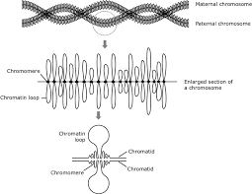
Lampbrush chromosomes are special type of giant chromosomes found in the nuclei of oocytes of many vertebrates, such as fishes, amphibians, reptiles and birds during the prolonged diplotene stage of first meiosis. They are also found in the nucleus of Drosophila spermatocyte. Lampbrush chromosomes were first observed by Flemming in 1882 and given the name by Ruckert in 1892.

These chromosomes may sometime become even larger than the polynemic or polytenic chromosomes of salivery glands of dipterans. The largest chromosomes may sometime be as long as 1 mm in urodele amphibians. These chromosomes consist of main axis and many fine lateral projections or loops which give them the appearance of a test tube brush or lampbrush (Fig. 9.13).

Actually, the main axis consists of four chromatids or two bivalent chromosomes and the chromonemeta of these chromatids give out fine loops at the lateral sides. Only the kinetochore bears no lateral loops. Ris (1957) studied the loops with electron microscope and suggested that the loops were integral parts of chromonemata which are extended in the form of major coils .
Generally one to nine loops may arise from a single chromomeral area. The size of loop varies from an average of 9.5µ in frog to nearly 200 µ in newt. These loops probably consist of one DNA double helix from which fibrils project which are covered with loop matrix consisting of RNA and proteins.
Loop formation is interpreted by Gall (1958) as a reversible physiological change which is probably non-genetic. The number of pairs of loops increases in meiosis till it reaches a maximum in diplotene. After diplotene stage, the number of loop pairs gradually decreases and the loops disappear at Metaphase 1. Physiological studies indicate that the loops of lamp-brush chromosomes and balbiani rings of polytene chromosomes are the sites of active genes.
Chromosome abnormalities
Chromosome abnormalities in the baby may be inherited from the parent or may occur with no family history. These are the most common:
Aneuploidy
This means there are more or fewer chromosomes than the normal number. Examples include:
Down syndrome (trisomy 21). Cells contain 3 copies of the 21st chromosome.
Turner syndrome. One of the 2 sex chromosomes is not transferred. This leaves a single X chromosome for 45 total chromosomes instead of 46.
Deletion
This is when part of a chromosome is missing, or part of the DNA code is missing.
Inversion
This is when a chromosome breaks and the piece of it turns around and reattaches itself. Inversions can be passed down in families, but they may or may not cause birth defects.
Ring
A ring chromosome is one where the ends are attached to itself to form a ring. Rings can be passed down in families. They may or may not cause health problems.
Translocation
This is when a chromosome segment rearranges from one location to another. It can happen either within the same chromosome or move to another chromosome. There are 2 types:
Balanced translocation. This is when the DNA is equally exchanged between chromosomes. No DNA is lost or added. A parent with a balanced translocation is healthy, but he or she may be at risk for passing on unbalanced chromosomes to a child.
Robertsonian translocation. This is a balanced translocation in which 1 chromosome joins the end of another.
Mosaicism
This is when a person has 2 or more sets of chromosomes in his or her cells with different genetic material.
single-gene changes
A change in a single gene causes a defect or abnormality. Single-gene changes usually have a higher risk of being passed on to children. Single-gene changes can be:
Dominant
This means the abnormality occurs when only 1 of the genes from 1 parent is abnormal. If the parent has the disorder, the baby has a 1 in 2 chance of inheriting it. Examples include:
Achondroplasia. This is a bone development disorder that causes dwarfism.
Marfan syndrome. This is a connective tissue disorder that causes long limbs and heart defects.
Recessive
This means the abnormality only occurs when both parents have a copy of an abnormal gene. If both parents are carriers, a baby has a 1 in 4 chance of having the disorder. Examples include:
Cystic fibrosis. This is a disorder of the glands that causes excess mucus in the lungs. It also causes problems with how the pancreas works and with how food is absorbed.
Sickle cell disease. This condition causes abnormal red blood cells that don’t carry oxygen normally.
Tay-Sachs disease. This is an inherited condition that causes the central nervous system to decline. The condition is fatal, usually by age 5.
X-linked
The disorder is determined by genes on the X chromosome. Males are mainly affected and have the disorder. Daughters of men with the disorder are carriers of the trait and have a 1 in 2 chance of passing it to their children. Sons of women who are carriers each have a 1 in 2 chance of having the disorder. Examples include:
Duchenne muscular dystrophy. This is a disease that causes muscle wasting.
Hemophilia. This is a bleeding disorder caused by low levels or lack of a blood protein that is needed for clotting.
Population genetics and developmental genetics of Drosophila
Drosophila embryogenesis, the process by which Drosophila (fruit fly) embryos form, is a favorite model system for genetics and developmental biology. The study of its embryogenesis unlocked the century-long puzzle of how development was controlled, creating the field of evolutionary developmental biology.[1] The small size, short generation time, and large brood size make it ideal for genetic studies. Transparent embryos facilitate developmental studies. Drosophila melanogaster was introduced into the field of genetic experiments by Thomas Hunt Morgan in 1909.
Life cycle
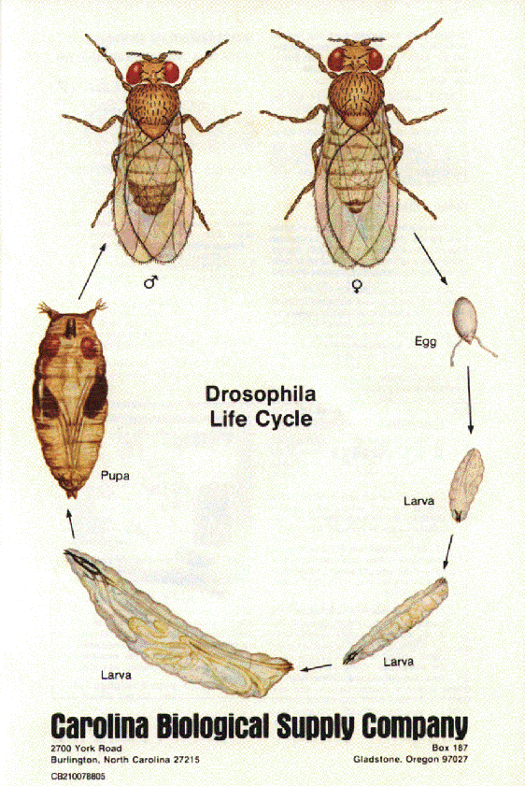
Drosophila display a holometabolous method of development, meaning that they have three distinct stages of their post-embryonic life cycle, each with a radically different body plan: larva, pupa and finally, adult. The machinery necessary for the function and smooth transition between these three phases develops during embryogenesis. During embryogenesis, the larval stage fly will develop and hatch at a stage of its life known as the first larval instar. Cells that will produce adult structures are put aside in imaginal discs. During the pupal stage, the larval body breaks down as the imaginal disks grow and produce the adult body. This process is called complete metamorphosis. About 24 hours after fertilization, an egg hatches into a larva, which undergoes three molts taking about 5.5 to 6 days, after which it is called a pupa. The pupa metamorphoses into an adult fly, which takes about 3.5 to 4.5 days. The entire growth process from egg to adult fly takes an estimated 10 to 12 days to complete at 25 °C.[2]
The mother fly produces oocytes that already have anterior-posterior and dorsal-ventral axes defined by maternal activities.
Embryogenesis in Drosophila is unique among model organisms in that cleavage occurs in a multinucleate syncytium (strictly a coenocyte). Early on, 256 nuclei migrate to the perimeter of the egg, creating the syncytial blastoderm. The germ line segregates from the somatic cells through the formation of pole cells at the posterior end of the embryo. After thirteen mitotic divisions and about 4 hours after fertilization, an estimated 6,000 nuclei accumulate in the unseparated cytoplasm of the oocyte before they migrate to the surface and are encompassed by plasma membranes to form cells surrounding the yolk sac producing a cellular blastoderm.

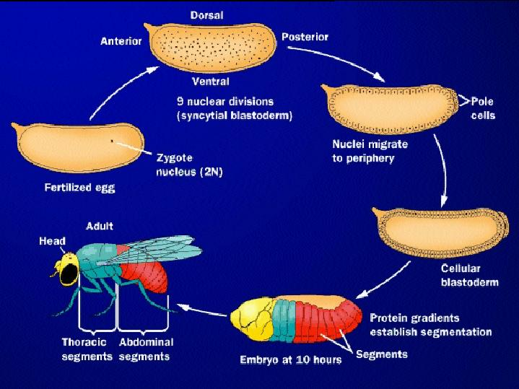
Like other triploblastic metazoa, gastrulation leads to the formation of three germ layers: the endoderm, mesoderm, and ectoderm. The mesoderm invaginates from the ventral furrow (VF), as does the ectoderm that will give rise to the midgut. The pole cells are internalized by a different route.
Germ band elongation involves many rearrangements of cells, and the appearance of distinct differences in the cells of the three germ bands and various regions of the embryo. The posterior region (including the hindgut) expands and extends towards the anterior pole along the dorsal side of the embryo. At this time, segments of the embryo become visible, creating a striped arrangement along the anterior-posterior axis. The earliest signs of segmentation appear during this phase with the formation of parasegmental furrows. This is also when the tracheal pits form, the first signs of structures for breathing.
Germ band retraction returns the hindgut to the dorsal side of the posterior pole and coincides with overt segmentation. The remaining stages involve the internalization of the nervous system (ectoderm) and the formation of internal organs (mainly mesoderm).

Stomatic cell genetics
somatic cells contain DNA arranged in chromosomes. If a somatic cell contains chromosomes arranged in pairs, it is called diploid and the organism is called a diploid organism. (The gametes of diploid organisms contain only single unpaired chromosomes and are called haploid.) Each pair of chromosomes comprises one chromosome inherited from the father and one inherited from the mother. For example, in humans, somatic cells contain 46 chromosomes organized into 23 pairs. By contrast, gametes of diploid organisms contain only half as many chromosomes. In humans, this is 23 unpaired chromosomes. When two gametes (i.e. a spermatozoon and an ovum) meet during conception, they fuse together, creating a zygote. Due to the fusion of the two gametes, a human zygote contains 46 chromosomes (i.e. 23 pairs).
However, a large number of species have the chromosomes in their somatic cells arranged in fours ("tetraploid") or even sixes ("hexaploid"). Thus, they can have diploid or even triploid germline cells. An example of this is the modern cultivated species of wheat, Triticum aestivum L., a hexaploid species whose somatic cells contain six copies of every chromatid.
The frequency of spontaneous mutations is significantly lower in advanced male germ cells than in somatic cell types from the same individual. Female germ cells also show a mutation frequency that is lower than that in corresponding somatic cells and similar to that in male germ cells.[6] These findings appear to reflect employment of more effective mechanisms to limit the initial occurrence of spontaneous mutations in germ cells than in somatic cells. Such mechanisms likely include elevated levels of DNA repair enzymes that ameliorate most potentially mutagenic DNA damages

Mendelian laws
Characters are unitary. That is, they are discrete (purple vs. white, tall vs. dwarf).
Genetic characteristics have alternate forms, each inherited from one of two parents. Today, we call these alleles.
One allele is dominant over the other. The phenotype reflects the dominant allele.
Gametes are created by random segregation. Heterozygotic individuals produce gametes with an equal frequency of the two alleles.Different traits have independent assortment. In modern terms, genes are unlinked.
According to customary terminology we refer here to the principles of inheritance discovered by Gregor Mendel as Mendelian laws, although today's geneticists also speak of Mendelian rules or Mendelian principles, as there are many exceptions summarized under the collective term Non-Mendelian inheritance. 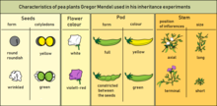

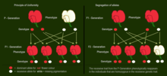

P-Generation and F1-Generation: The dominant allele for purple-red flower hides the phenotypic effect of the recessive allele for white flowers. F2-Generation: The recessive trait from the P-Generation phenotypically reappears in the individuals that are homozygous with the recessive genetic trait.

Myosotis: Colour and distribution of colours are inherited independently.
Mendel selected for the experiment the following characters of pea plants:
Form of the ripe seeds (round or roundish, surface shallow or wrinkled)
Colour of the seed–coat (white, gray, or brown, with or without violet spotting)
Colour of the seeds and cotyledons (yellow or green)
Flower colour (white or yellow)
Form of the ripe pods (simply inflated, not contracted, or constricted between the seeds and wrinkled)
Colour of the unripe pods (yellow or green)
Position of the flowers (axial or terminal)
Length of the stem
When he crossed purebred white flower and purple flower pea plants (the parental or P generation) by artificial pollination, the resulting flower colour was not a blend. Rather than being a mix of the two, the offspring in the first generation (F1-generation) were all purple-flowered. Therefore he called this biological trait dominant. When he allowed self-fertilization in the uniform looking F1-generation, he obtained both colours in the F2 generation with a purple flower to white flower ratio of 3 : 1. In some of the other characters also one of the traits was dominant.

He then conceived the idea of heredity units, which he called hereditary "factors". Mendel found that there are alternative forms of factors — now called genes — that account for variations in inherited characteristics. For example, the gene for flower color in pea plants exists in two forms, one for purple and the other for white. The alternative "forms" are now called alleles. For each trait, an organism inherits two alleles, one from each parent. These alleles may be the same or different. An organism that has two identical alleles for a gene is said to be homozygous for that gene (and is called a homozygote). An organism that has two different alleles for a gene is said be heterozygous for that gene (and is called a heterozygote)
Mendel hypothesized that allele pairs separate randomly, or segregate, from each other during the production of the gametes in the seed plant (egg cell) and the pollen plant (sperm). Because allele pairs separate during gamete production, a sperm or egg carries only one allele for each inherited trait. When sperm and egg unite at fertilization, each contributes its allele, restoring the paired condition in the offspring. Mendel also found that each pair of alleles segregates independently of the other pairs of alleles during gamete formation
The genotype of an individual is made up of the many alleles it possesses. The phenotype is the result of the expression of all characteristics that are genetically determined by its alleles as well as by its environment. The presence of an allele does not mean that the trait will be expressed in the individual that possesses it. If the two alleles of an inherited pair differ (the heterozygous condition), then one determines the organism’s appearance and is called the dominant allele; the other has no noticeable effect on the organism’s appearance and is called the recessive allele.

Mendel's laws of inheritance
Law of dominance and uniformity
Some alleles are dominant while others are recessive; an organism with at least one dominant allele will display the effect of the dominant allele.
Law of segregation
During gamete formation, the alleles for each gene segregate from each other so that each gamete carries only one allele for each gene.
Law of independent assortment
Genes of different traits can segregate independently during the formation of gametes.

Law of Dominance and Uniformity

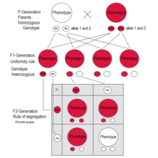
F1 generation: All individuals have the same genotype and same phenotype expressing the dominant trait (red).
F2 generation: The phenotypes in the second generation show a 3 : 1 ratio.
In the genotype 25 % are homozygous with the dominant trait, 50 % are heterozygous genetic carriers of the recessive trait, 25 % are homozygous with the recessive genetic trait and expressing the recessive charakter.
In Mirabilis jalapa and Antirrhinum majus are examples for intermediate inheritance. As seen in the F1-generation, heterozygous plants have "light pink" flowers—a mix of "red" and "white". The F2-generation shows a 1:2:1 ratio of red : light pink : white
If two parents are mated with each other who differ in one genetic characteristic for which they are both homozygous (each pure-bred), all offspring in the first generation (F1) are equal to the examined characteristic in genotype and phenotype showing the dominant trait. This uniformity rule or reciprocity rule applies to all individuals of the F1-generation.
The principle of dominant inheritance discovered by Mendel states that in a heterozygote the dominant allele will cause the recessive allele to be "masked": that is, not expressed in the phenotype. Only if an individual is homozygous with respect to the recessive allele will the recessive trait be expressed. Therefore a cross between a homozygous dominant and a homozygous recessive organism yields a heterozygous organism whose phenotype displays only the dominant trait.
The F1 offspring of Mendel's pea crosses always looked like one of the two parental varieties. In this situation of "complete dominance," the dominant allele had the same phenotypic effect whether present in one or two copies
But for some characteristics, the F1 hybrids have an appearance in between the phenotypes of the two parental varieties. A cross between two four o'clock (Mirabilis jalapa) plants shows an exception to Mendel's principle, called incomplete dominance. Flowers of heterozygous plants have a phenotype somewhere between the two homozygous genotypes. In cases of intermediate inheritance (incomplete dominance) in the F1-generation Mendel's principle of uniformity in genotype and phenotype applies as well. Research about intermediate inheritance was done by other scientists. The first was Carl Correns with his studies about Mirabilis jalapa.

Law of Segregation of genes

A Punnett square for one of Mendel's pea plant experiments – self-fertilization of the F1 generation
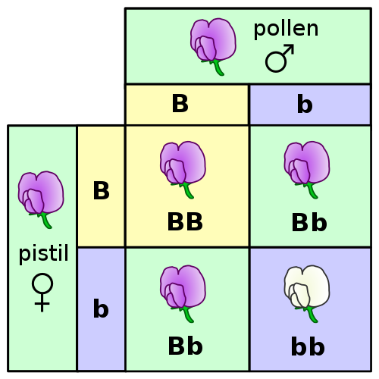
The Law of Segregation of genes applies when two individuals, both heterozygous for a certain trait are crossed, for example hybrids of the F1-generation. The offspring in the F2-generation differ in genotype and phenotype, so that the characteristics of the grandparents (P-generation) regularly occur again. In a dominant-recessive inheritance an average of 25 % are homozygous with the dominant trait, 50 % are heterozygous showing the dominant trait in the phenotype (genetic carriers), 25 % are homozygous with the recessive trait and therefore express the recessive trait in the phenotype. The genotypic ratio is 1 : 2 : 1, the phenotypic ratio is 3 : 1.
In the pea plant example, the capital "B" represents the dominant allele for purple blossom and lowercase "b" represents the recessive allele for white blossom. The pistil plant and the pollen plant are both F1-hybrids with genotype "B b". Each has one allele for purple and one allele for white. In the offspring, in the F2-plants in the Punnett-square, three combinations are possible. The genotypic ratio is 1 BB : 2 Bb : 1 bb. But the phenotypic ratio of plants with purple blossoms to those with white blossoms is 3 : 1 due to the dominance of the allele for purple. Plants with homozygous "b b" are white flowered like one of the grandparents in the P-generation.
In cases of incomplete dominance the same segregation of alleles takes place in the F2-generation, but here also the phenotypes show a ratio of 1 : 2 : 1, as the heterozygous are different in phenotype from the homozygous because the genetic expression of one allele compensates the missing expression of the other allele only partially. This results in an intermediate inheritance which was later described by other scientists.
In some literature sources the principle of segregation is cited as "first law". Nevertheless, Mendel did his crossing experiments with heterozygous plants after obtaining these hybrids by crossing two purebred plants, discovering the principle of dominance and uniformity at first.
Molecular proof of segregation of genes was subsequently found through observation of meiosis by two scientists independently, the German botanist Oscar Hertwig in 1876, and the Belgian zoologist Edouard Van Beneden in 1883. Most alleles are located in chromosomes in the cell nucleus. Paternal and maternal chromosomes get separated in meiosis, because during spermatogenesis the chromosomes are segregated on the four sperm cells that arise from one mother sperm cell, and during oogenesis the chromosomes are distributed between the polar bodies and the egg cell. Every individual organism contains two alleles for each trait. They segregate (separate) during meiosis such that each gamete contains only one of the alleles. When the gametes unite in the zygote the alleles - one from the mother one from the father - get passed on to the offspring. An offspring thus receives a pair of alleles for a trait by inheriting homologous chromosomes from the parent organisms: one allele for each trait from each parent. Heterozygous individuals with the dominant trait in the phenotype are genetic carriers of the recessive trait.

Law of Independent Assortment

Segregation and independent assortment are consistent with the chromosome theory of inheritance.
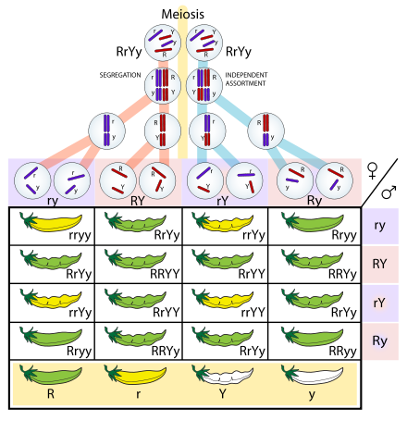
The Law of Independent Assortment states that alleles for separate traits are passed independently of one another. That is, the biological selection of an allele for one trait has nothing to do with the selection of an allele for any other trait. Mendel found support for this law in his dihybrid cross experiments. In his monohybrid crosses, an idealized 3:1 ratio between dominant and recessive phenotypes resulted. In dihybrid crosses, however, he found a 9:3:3:1 ratios. This shows that each of the two alleles is inherited independently from the other, with a 3:1 phenotypic ratio for each.
Independent assortment occurs in eukaryotic organisms during meiotic metaphase I, and produces a gamete with a mixture of the organism's chromosomes. The physical basis of the independent assortment of chromosomes is the random orientation of each bivalent chromosome along the metaphase plate with respect to the other bivalent chromosomes. Along with crossing over, independent assortment increases genetic diversity by producing novel genetic combinations.
There are many deviations from the principle of independent assortment due to genetic linkage.
Of the 46 chromosomes in a normal diploid human cell, half are maternally derived (from the mother's egg) and half are paternally derived (from the father's sperm). This occurs as sexual reproduction involves the fusion of two haploid gametes (the egg and sperm) to produce a zygote and a new organism, in which every cell has two sets of chromosomes (diploid). During gametogenesis the normal complement of 46 chromosomes needs to be halved to 23 to ensure that the resulting haploid gamete can join with another haploid gamete to produce a diploid organism.
In independent assortment, the chromosomes that result are randomly sorted from all possible maternal and paternal chromosomes. Because zygotes end up with a mix instead of a pre-defined "set" from either parent, chromosomes are therefore considered assorted independently. As such, the zygote can end up with any combination of paternal or maternal chromosomes. For human gametes, with 23 chromosomes, the number of possibilities is 223 or 8,388,608 possible combinations.[34] This contributes to the genetic variability of progeny. Generally, the recombination of genes has important implications for many evolutionary processes.
Unit 3
Prokaryotic Transcription- Enzymes, Steps, Significance:
- Transcription is the process by which the information in a strand of DNA is copied into a new molecule of messenger RNA (mRNA).
- In prokaryotic organisms transcription occurs in three phases known as initiation, elongation and termination.
Enzyme(s) Involved:
- RNA is synthesized by a single RNA polymerase enzyme which contains multiple polypeptide subunits.
- In E. coli, the RNA polymerase has subunits: two α, one β, one β’ and one ω and σ subunit (α2ββ’ωσ). This complete enzyme is called as the holoenzyme.
- The σ subunit may dissociate from the other subunits to leave a form known as the core enzyme.
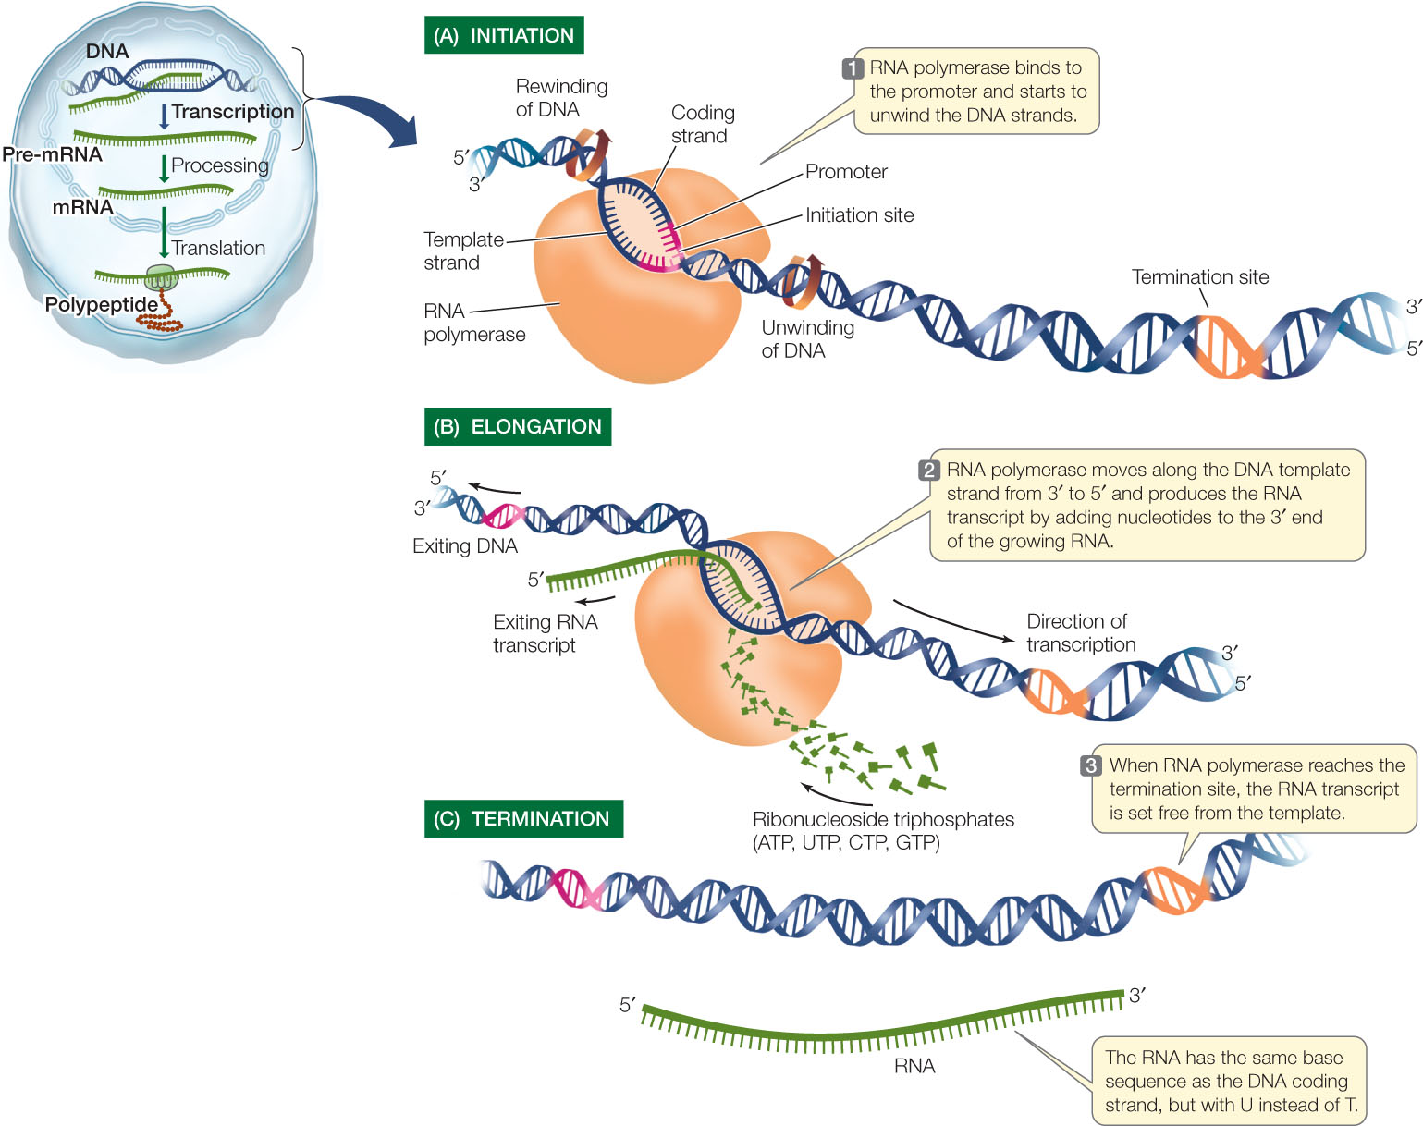
Initiation Phase:
During initiation, RNA polymerase recognizes a specific site on the DNA, upstream from the gene that will be transcribed, called a promoter site and then unwinds the DNA locally.
Promoters and Initiation:
- The holoenzyme binds to a promoter region about 40–60 bp in size and then initiates transcription a short distance downstream (i.e. 3 to the promoter).
- Within the promoter lie two 6 base pair sequences that are particularly important for promoter function.
- They are highly conserved between species.
- Using the convention of calling the first nucleotide of a transcribed sequence as +1, these two promoter elements lie at positions –10 and –35, that is about 10 and 35 bp, respectively, upstream of where transcription will begin.
- The –10 sequence has the consensus Because this element was discovered by Pribnow, it is also known as the Pribnow box. It is an important recognition site that interacts with the σ factor of RNA polymerase.
- The –35 sequence has the consensus TTGACA and is important in DNA unwinding during transcriptional initiation.
- RNA polymerase does not need a primer to begin transcription; having bound to the promoter site, the RNA polymerase begins transcription directly.
Elongation Phase:
- After transcription initiation, the σ factor is released from the transcriptional complex to leave the core enzyme (α2 ββω) which continues elongation of the RNA transcript.
- The core enzyme contains the catalytic site for polymerization, probably within the β subunit.
- The first nucleotide in the RNA transcript is usually pppG or pppA.
- The RNA polymerase then synthesizes RNA in the 5’ →3’ direction, using the four ribonucleoside 5-triphosphates (ATP, CTP, GTP, UTP) as precursors.
- The 3-OH at the end of the growing RNA chain attacks the α phosphate group of the incoming ribonucleoside 5-triphosphate to form a 3’5′ phosphodiester bond.
- The complex of RNA polymerase, DNA template and new RNA transcript is called a ternary complex (i.e. three components) and the region of unwound DNA that is undergoing transcription is called the transcription bubble.
- The RNA transcript forms a transient RNA–DNA hybrid helix with its template strand but then peels away from the DNA as transcription proceeds.
- The DNA is unwound ahead of the transcription bubble and after the transcription complex has passed, the DNA rewinds.
- Thus, during the elongation, the RNA polymerase uses the antisense (-) strand of DNA as template and synthesizes a complementary RNA molecule.
- The RNA produced has the same sequence as the non-template strand, called the sense (+) strand (or coding strand) except that the RNA contains U instead of T.
- At different locations on the bacterial chromosome, sometimes one strand is used as template, sometimes the other, depending on which strand is the coding strand for the gene in question.
- The correct strand to be used as template is identified for the RNA polymerase by the presence of the promoter site.
Termination Phase:
- Transcription continues until a termination sequence is reached.
- The most common termination signal is a GC-rich region that is a palindrome, followed by an AT-rich sequence.
- The RNA made from the DNA palindrome is self- complementary and so base pairs internally to form a hairpin structure rich in GC base pairs followed by four or more U residues.
- However, not all termination sites have this hairpin structure. Those that lack such a structure require an additional protein, called rho, to help recognize the termination site and stop transcription.
- Thus the RNA polymerase encounters a termination signal and ceases transcription, releasing the RNA transcript and dissociating from the DNA.
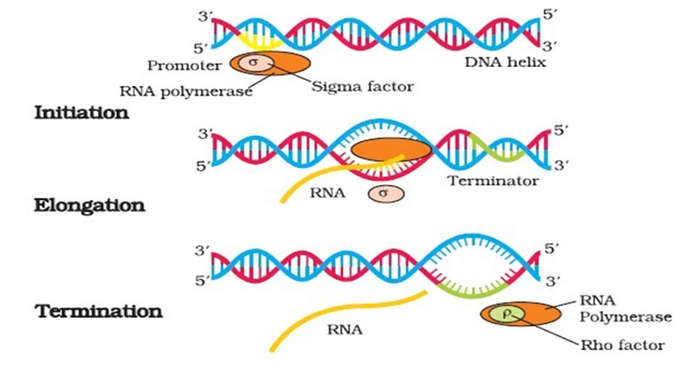
RNA processing:
- In prokaryotes, RNA transcribed from protein-coding genes (messenger RNA, mRNA), requires little or no modification prior to translation.
- Many mRNA molecules begin to be translated even before RNA synthesis has finished.
- However, since ribosomal RNA (rRNA) and transfer RNA (tRNA) are synthesized as precursor molecules, they require post-transcriptional processing.
Eukaryotic Transcription:
- Transcription is the process by which the information in a strand of DNA is copied into a new molecule of RNA.
- It is the first step of gene expression, in which a particular segment of DNA is copied into RNA (especially mRNA) by the enzyme RNA polymerase.
- It results in a complementary, antiparallel RNA strand called a primary transcript.
Transcription in Eukaryotes:
Transcription occurs in eukaryotes in a way that is similar to prokaryotes with reference to the basic steps involved. However, some major differences between them include:
- Initiation is more complex.
- Termination does not involve stem-loop structures.
- Transcription is carried out by three enzymes (RNA polymerases I, II and III).
- The regulation of transcription is more extensive than prokaryotes.
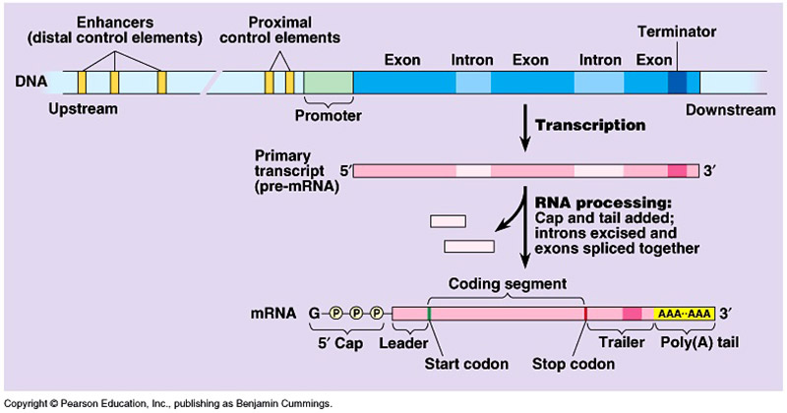

Enzyme(s) Involved in Eukaryotic Transcription:
Unlike prokaryotes where all RNA is synthesized by a single RNA polymerase, the nucleus of a eukaryotic cell has three RNA polymerases responsible for transcribing different types of RNA.
- RNA polymerase I (RNA Pol I) is located in the nucleolus and transcribes the 28S, 18S, and 5.8S rRNA genes.
- RNA polymerase II (RNA Pol II) is located in the nucleoplasm and transcribes protein-coding genes, to yield pre-mRNA, and also the genes encoding small nucleolar RNAs (snoRNAs) involved in rRNA processing and small nuclear RNAs (snRNAs) involved in mRNA processing, except for U6 snRNA.
- RNA polymerase III (RNA Pol III) is also located in the nucleoplasm. It transcribes the genes for tRNA, 5S rRNA, U6 snRNA, and the 7S RNA
- associated with the signal recognition particle (SRP) involved in the translocation of proteins across the endoplasmic reticulum membrane.
- Each of the three eukaryotic RNA polymerases contains 12 or more subunits and so these are large complex enzymes.
- The genes encoding some of the subunits of each eukaryotic enzyme show DNA sequence similarities to genes encoding subunits of the core enzyme of E. coli RNA polymerase.
- However, four to seven other subunits of each eukaryotic RNA polymerase are unique in that they show no similarity either with bacterial RNA polymerase subunits or with the subunits of other eukaryotic RNA polymerases.
Features of Eukaryotic Transcription:
- Transcription in eukaryotes occurs within the nucleus and mRNA moves out of the nucleus into the cytoplasm for translation.
- The initiation of RNA synthesis by RNA polymerase is directed by the presence of a promoter site on the 5’ side of the transcriptional start site.
- The RNA polymerase transcribes one strand, the antisense (-) strand, of the DNA template.
- RNA synthesis does not require a primer.
- RNA synthesis occurs in the 5’ → 3’ direction with the RNA polymerase catalyzing a nucleophilic attack by the 3-OH of the growing RNA chain on the alpha-phosphorus atom on an incoming ribonucleoside 5-triphosphate.
- mRNA in eukaryotes is processed from the primary RNA transcript, a process called maturation.

Process of Eukaryotic Transcription:
The basic mechanism of RNA synthesis by these eukaryotic RNA polymerases can be divided into the following phases:

Initiation Phase
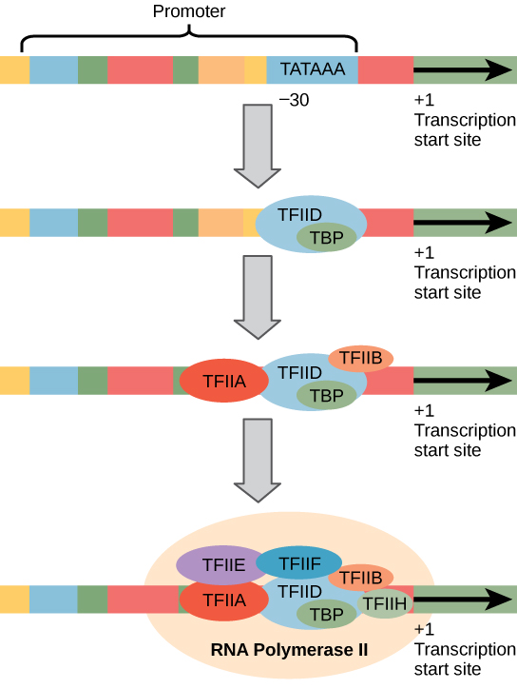
- During initiation, RNA polymerase recognizes a specific site on the DNA, upstream from the gene that will be transcribed, called a promoter site and then unwinds the DNA locally.
- Most promoter sites for RNA polymerase II include a highly conserved sequence located about 25–35 bp upstream (i.e. to the 5 side) of the start site which has the consensus TATA(A/T)A(A/T) and is called the TATA box.
- Since the start site is denoted as position +1, the TATA box position is said to be located at about position -25.
- The TATA box sequence resembles the -10 sequence in prokaryotes (TATAAT) except that it is located further upstream.
- Both elements have essentially the same function, namely recognition by the RNA polymerase in order to position the enzyme at the correct location to initiate transcription.
- The sequence around the TATA box is also important in that it influences the efficiency of initiation. Transcription is also regulated by upstream control elements that lie 5′ to the TATA box.
- Some eukaryotic protein-coding genes lack a TATA box and have an initiator element instead, centered around the transcriptional initiation site.
- In order to initiate transcription, RNA polymerase II requires the assistance of several other proteins or protein complexes, called general (or basal) transcription factors, which must assemble into a complex on the promoter in order for RNA polymerase to bind and start transcription.
- These all have the generic name of TFII (for Transcription Factor for RNA polymerase II).
- The first event in initiation is the binding of the transcription factor IID (TFIID) protein complex to the TATA box via one its subunits called TBP (TATA box binding protein).
- As soon as the TFIID complex has bound, TFIIA binds and stabilizes the TFIID-TATA box interaction. Next, TFIIB binds to TFIID.
- However, TFIIB can also bind to RNA polymerase II and so acts as a bridging protein. Thus,
- RNA polymerase II, which has already complexed with TFIIF, now binds.
- This is followed by the binding of TFIIE and H. This final protein complex contains at least 40 polypeptides and is called the transcription initiation complex.
- Those protein-coding genes that have an initiator element instead of a TATA box appear to need another protein(s) that binds to the initiator element.
- The other transcription factors then bind to form the transcription initiation complex in a similar manner to that described above for genes possessing a TATA box promoter.

Elongation Phase
TFIIH has two functions:
- It is a helicase, which means that it can use ATP to unwind the DNA helix, allowing transcription to begin.
- In addition, it phosphorylates RNA polymerase II which causes this enzyme to change its conformation and dissociate from other proteins in the initiation complex.
- The key phosphorylation occurs on a long C-terminal tail called the C-terminal domain (CTD) of the RNA polymerase II molecule.
- Interestingly, only RNA polymerase II that has a non-phosphorylated CTD can initiate transcription but only an RNA polymerase II with a phosphorylated CTD can elongate RNA.
- RNA polymerase II now starts moving along the DNA template, synthesizing RNA, that is, the process enters the elongation phase.
- RNA synthesis occurs in the 5’ → 3’ direction with the RNA polymerase catalyzing a nucleophilic attack by the 3-OH of the growing RNA chain on the alpha-phosphorus atom on an incoming ribonucleoside 5-triphosphate.
- The RNA molecule made from a protein-coding gene by RNA polymerase II is called a primary transcript.

Termination Phase
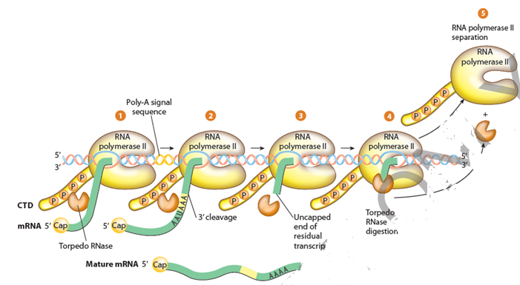
- Elongation of the RNA chain continues until termination occurs.
- Unlike RNA polymerase in prokaryotes, RNA polymerase II does not terminate transcription at a specific site but rather transcription can stop at varying distances downstream of the gene.
- RNA genes transcribed by RNA Polymerse II lack any specific signals or sequences that direct RNA Polymerase II to terminate at specific locations.
- RNA Polymerase II can continue to transcribe RNA anywhere from a few bp to thousands of bp past the actual end of the gene.
- The transcript is cleaved at an internal site before RNA Polymerase II finishes transcribing. This releases the upstream portion of the transcript, which will serve as the initial RNA prior to further processing (the pre-mRNA in the case of protein-encoding genes.)
- This cleavage site is considered the “end” of the gene. The remainder of the transcript is digested by a 5′-exonuclease (called Xrn2 in humans) while it is still being transcribed by the RNA Polymerase II.
- When the 5′-exonulease “catches up” to RNA Polymerase II by digesting away all the overhanging RNA, it helps disengage the polymerase from its DNA template strand, finally terminating that round of transcription.
RNA processing
The primary eukaryotic mRNA transcript is much longer and localised into the nucleus, when it is also called heterogenous nuclear RNA (hnRNA) or pre- mRNA.
It undergoes various processing steps to change into a mature RNA:
Cleavage
- Larger RNA precursors are cleaved to form smaller RNAs.
- Primary transcript is cleaved by ribonuclease-P (an RNA enzyme) to form 5-7 tRNA precursors.
Capping and Tailing
- Initially at the 5′ end a cap (consisting of 7-methyl guanosine or 7 mG) and a tail of poly A at the 3′ end are added.
- The cap is a chemically modified molecule of guanosine triphosphate (GTP).
Splicing
- The eukaryotic primary mRNAs are made up of two types of segments; non-coding introns and the coding exons.
- The introns are removed by a process called RNA splicing where ATP is used to cut the RNA, releasing the introns and joining two adjacent exons to produce mature mRNA.
Nucleotide Modifications
- They are most common in tRNA-methylation (e.g., methyl cytosine, methyl guanosine), deamination (e.g., inosine from adenine), dihydrouracil, pseudouracil, etc.
Post-transcription processing is required to convert primary transcript into functional RNAs.

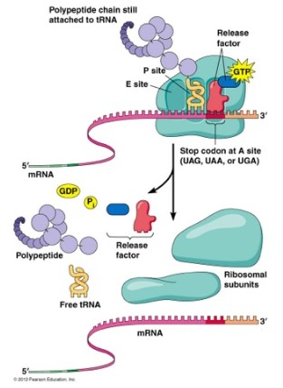

UNIT 4
Prokaryotic DNA Replication- Enzymes, Steps and Significance:
- DNA replication is the process by which an organism duplicates its DNA into another copy that is passed on to daughter cells.
- Replication occurs before a cell divides to ensure that both cells receive an exact copy of the parent’s genetic material.
- DNA replication uses a semi-conservative method that results in a double-stranded DNA with one parental strand and a new daughter strand.
- Prokaryotic DNA replication is often studied in the model organism coli, but all other prokaryotes show many similarities.
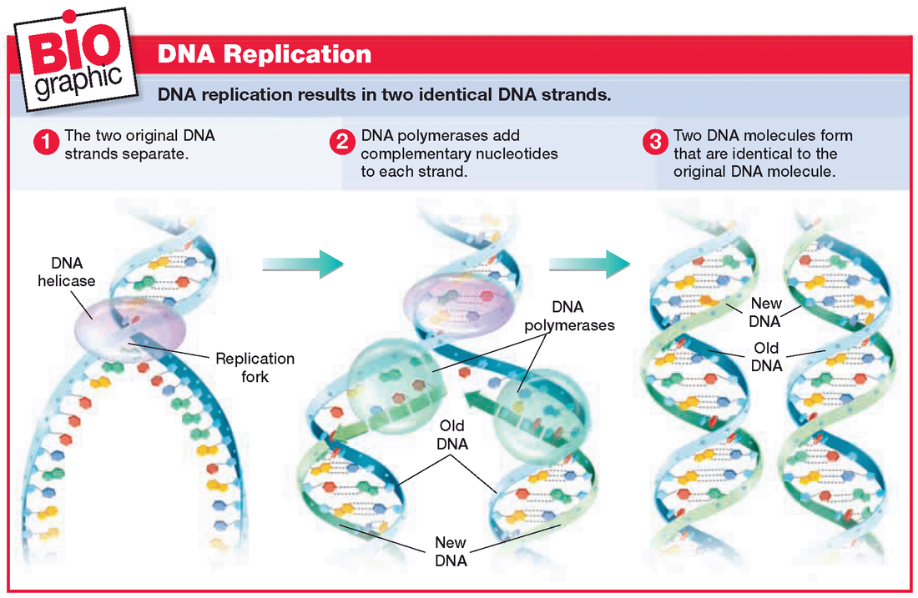
Features of Prokaryotic DNA Replication:
- Replication is bi-directional and originates at a single origin of replication (OriC).
- Takes place in the cell cytoplasm.
- Synthesis occurs only in the 5′to 3′direction.
- Individual strands of DNA are manufactured in different directions, producing a leading and a lagging strand.
- Lagging strands are created by the production of small DNA fragments called Okazaki fragments that are eventually joined together.
Enzymes of DNA Replication:
- Helicases: Unwind the DNA helix at the start of replication.
- SSB proteins: Bind to the single strands of unwound DNA to prevent reformation of the DNA helix during replication.
- Primase: Synthesizes the RNA primer needed for the initiation of DNA chain synthesis.
- DNA Polymerase III (DNAP III): Elongates DNA strand by adding deoxyribonucleotides to the 3′end of the chain. Synthesis can only occur in the 5′to 3′direction because of DNAP III.
- DNA Polymerase I (DNAP I): Replaces RNA primer with the appropriate deoxynucleotides.
- DNA topoisomerase I: Relaxes the DNA helix during replication through creation of a nick in one of the DNA strands.
- DNA topoisomerase II: Relieves the strain on the DNA helix during replication by forming supercoils in the helix through the creation of nicks in both strands of DNA.
- DNA ligase: Forms a 3′-5′phosphodiester bond between adjacent fragments of DNA.
Steps of DNA Replication:
- DNA replication begins at a specific spot on the DNA molecule called the origin of replication.
- At the origin, enzymes unwind the double helix making its components accessible for replication.
- The helix is unwound by helicase to form a pair of replication forks.
- The unwound helix is stabilized by SSB proteins and DNA topoisomerases.
- Primase forms RNA primers (10 bases), which serve to initiate synthesis of both the leading and lagging strand.
- The leading strand is synthesized continuously in the 5′to 3′ direction by DNAP III.
- The lagging strand is synthesized discontinuously in the 5′to 3′ direction through the formation of Okazaki fragments.
- DNAP I remove the RNA primers and replace the existing gap with the appropriate deoxynucleotides.
- DNA ligase seals the breaks between the Okazaki fragments as well as around the primers to form continuous strands.

Eukaryotic DNA Replication- Features, Enzymes, Process, Significance:
- DNA replication is the process by which an organism duplicates its DNA into another copy that is passed on to daughter cells.
- Replication occurs before a cell divides to ensure that both cells receive an exact copy of the parent’s genetic material.
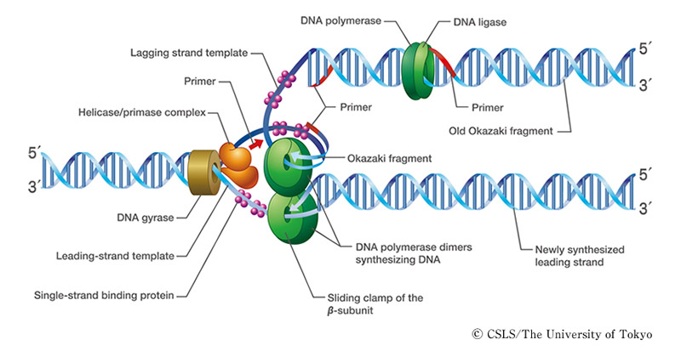

Features of Eukaryotic DNA Replication:
- Replication is bi-directional and originates at multiple origins of replication (Ori C) in eukaryotes.
- DNA replication uses a semi-conservative method that results in a double-stranded DNA with one parental strand and a new daughter strand.
- It occurs only in the S phase and at many chromosomal origins.
- Takes place in the cell nucleus.
- Synthesis occurs only in the 5′to 3′direction.
- Individual strands of DNA are manufactured in different directions, producing a leading and a lagging strand.
- Lagging strands are created by the production of small DNA fragments called Okazaki fragments that are eventually joined together.
- Eukaryotic cells possess five types of polymerases involved in the replication process.
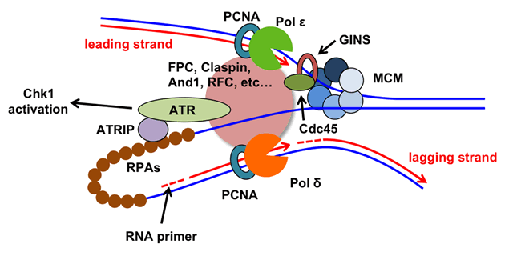

THE ENZYMES OF DNA REPLICATION:
- Helicases: Unwind the DNA helix at the start of replication.
- SSB proteins: Bind to the single strands of unwound DNA to prevent reformation of the DNA helix during replication.
- Eukaryotic cells contain five different DNA polymerases; α, β, γ, δ and ε.
- DNA polymerases α and δ replicate chromosomal DNA, DNA polymerases β and ε repair DNA, and DNA polymerase γ replicates mitochondrial DNA.
- DNA polymerase α and δ synthesize the lagging strand, via Okazaki fragments.
- The RNA primers are synthesized by DNA polymerase α which carries a primase subunit.
- DNA polymerase δ synthesizes the leading strand.
- Telomerase, a DNA polymerase that contains an integral RNA that acts as its own primer, is used to replicate DNA at the ends of chromosomes (telomeres).
- DNA topoisomerase I: Relaxes the DNA helix during replication through creation of a nick in one of the DNA strands.
- DNA topoisomerase II: Relieves the strain on the DNA helix during replication by forming supercoils in the helix through the creation of nicks in both strands of DNA.
- DNA ligase: Forms a 3′-5′phosphodiester bond between adjacent fragments of DNA.
Process of Eukaryotic DNA Replication:
- Replication of each linear DNA molecule in a chromosome starts at many origins, one every 30–300 kb of DNA depending on the species and tissue, and proceeds bi-directionally from each origin.
- At each origin, a replication bubble forms consisting of two replication forks moving in opposite directions. The DNA replicated under the control of a single origin is called a replicon. DNA synthesis proceeds until replication bubbles merge together.
- At the origin, enzymes unwind the double helix making its components accessible for replication.
- The helix is unwound by helicase to form a pair of replication forks.
- The unwound helix is stabilized by SSB proteins and DNA topoisomerases.
- The RNA primers required are made by DNA polymerase α which carries a primase subunit.
- DNA polymerase α initiates synthesis of the lagging strand, making first the RNA primer and then extending it with a short region of DNA.
- DNA polymerase δ then synthesizes the rest of the Okazaki fragment.
- The leading strand is synthesized by DNA polymerase δ.
- The leading strand is synthesized continuously in the 5′to 3′ direction while the lagging strand is synthesized discontinuously in the 5′to 3′ direction through the formation of Okazaki fragments.
- At the completion of synthesis, DNA ligase seals the breaks between the Okazaki fragments as well as around the primers to form continuous strands.

MODES OF REPLICATION
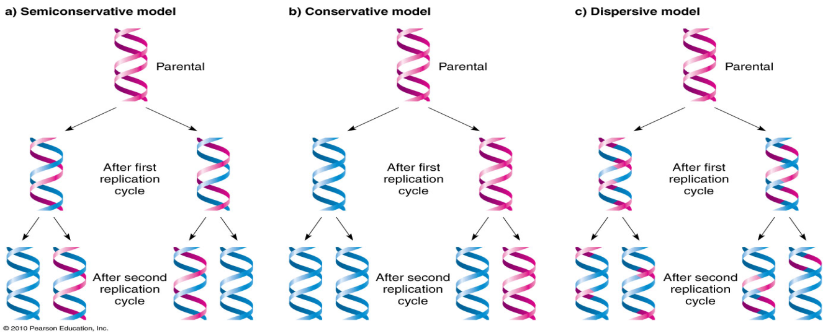
Semi-Conservative, Conservative, & Dispersive models of DNA replication

In the semi-conservative model, the two parental strands separate and each makes a copy of itself. After one round of replication, the two daughter molecules each comprises one old and one new strand. Note that after two rounds, two of the DNA molecules consist only of new material, while the other two contain one old and one new strand.
In the conservative model, the parental molecule directs synthesis of an entirely new double-stranded molecule, such that after one round of replication, one molecule is conserved as two old strands. This is repeated in the second round.
In the dispersive model, material in the two parental strands is distributed more or less randomly between two daughter molecules. In the model shown here, old material is distributed symmetrically between the two daughters molecules. Other distributions are possible.
The semi-conservative model is the intuitively appealing model, because separation of the two strands provides two templates, each of which carries all the information of the original molecule.
Roling cycle mechanisms
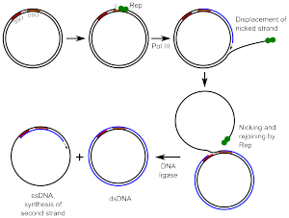
Rolling circle DNA replication is initiated by an initiator protein encoded by the plasmid or bacteriophage DNA, which nicks one strand of the double-stranded, circular DNA molecule at a site called the double-strand origin, or DSO. The initiator protein remains bound to the 5' phosphate end of the nicked strand, and the free 3' hydroxyl end is released to serve as a primer for DNA synthesis by DNA polymerase III. Using the unnicked strand as a template, replication proceeds around the circular DNA molecule, displacing the nicked strand as single-stranded DNA. Displacement of the nicked strand is carried out by a host-encoded helicase called PcrA (the abbreviation standing for plasmid copy reduced) in the presence of the plasmid replication initiation protein.
Continued DNA synthesis can produce multiple single-stranded linear copies of the original DNA in a continuous head-to-tail series called a concatemer. These linear copies can be converted to double-stranded circular molecules
First, the initiator protein makes another nick in the DNA to terminate synthesis of the first (leading) strand. RNA polymerase and DNA polymerase III then replicate the single-stranded origin (SSO) DNA to make another double-stranded circle. DNA polymerase I removes the primer, replacing it with DNA, and DNA ligase joins the ends to make another molecule of double-stranded circular DNA.
As a summary, a typical DNA rolling circle replication has five steps:
Circular dsDNA will be "nicked".
The 3' end is elongated using "unnicked" DNA as leading strand (template); 5' end is displaced.
Displaced DNA is a lagging strand and is made double stranded via a series of Okazaki fragments.
Replication of both "unnicked" and displaced ssDNA.
Displaced DNA circularizes
Inhibitors of replication
Quinolones are a key group of antibiotics that interfere with DNA synthesis by inhibiting topoisomerase, most frequently topoisomerase II (DNA gyrase), an enzyme involved in DNA replication. DNA gyrase relaxes supercoiled DNA molecules and initiates transient breakages and rejoins phosphodiester bonds in superhelical turns of closed-circular DNA. This allows the DNA strand to be replicated by DNA or RNA polymerases. The fluoroquinolones, second-generation quinolones that include levofloxacin, norfloxacin, and ciprofloxacin, are active against both Gram-negative and Gram-positive bacteria.
Topoisomerases are present in both prokaryotic and eukaryotic cells, but the quinolones are specific inhibitors of bacterial topoisomerase II. Inhibitors that are effective against mammalian topoisomerases, such as irinotecan and etoposide, are used as antineoplastic drugs to kill cancer cells.
Rifampicin blocks initiation of RNA synthesis by specifically inhibiting bacterial RNA polymerase. It does not interact with mammalian RNA polymerases, making it specific for Gram-positive bacteria and some Gram-negative bacteria.

Some antibiotics that interfere with RNA synthesis by inhibiting RNA polymerase, such as doxorubicin and actinomycin D (dactinomycin), are not specific for bacteria and interfere with both bacterial and mammalian systems. These are most often used as antineoplastic and antitumor drugs, attacking rapidly growing malignant cells as well as normal cells. Because cancerous cells are growing at a faster rate than surrounding normal tissue, a higher percentage of malignant cells are attacked by cytotoxic drugs. However, antitumor drugs cannot differentiate between malignant cells and fast-dividing normal cells such as those of the intestinal epithelium or hair follicles.

DNA repair
. In order to repair damage to one of the two paired molecules of DNA, there exist a number of excision repair mechanisms that remove the damaged nucleotide and replace it with an undamaged nucleotide complementary to that found in the undamaged DNA strand.
Base excision repair (BER) damaged single bases or nucleotide are most commonly repaired by removing the base or the nucleotide involved and then inserting the correct base or nucleotide. In base excision repair, repair glycosylases enzyme removes the damaged base from the DNA by cleaving the bond between base and deoxyribose sugars. These enzymes remove a single nitrogenous base to create an apurinic or apyrimidinic site (AP site). Enzymes called AP endonucleases nick the damaged DNA backbone at the AP site. DNA polymerase then removes the damaged region using its 5’ to 3’ exonuclease activity and correctly synthesizes the new strand using the complementary strand as a template. The gap is then sealed by enzyme DNA ligase]
Nucleotide excision repair (NER) repairs damaged DNA which commonly consists of bulky, helix-distorting damage, such as pyrimidine dimerization caused by UV light. Damaged regions are removed in 12–24 nucleotide-long strands in a three-step process which consists of recognition of damage, excision of damaged DNA both upstream and downstream of damage by endonucleases, and resynthesis of removed DNA region. NER is a highly evolutionarily conserved repair mechanism and is used in nearly all eukaryotic and prokaryotic cells. In prokaryotes, NER is mediated by Uvr proteins. In eukaryotes, many more proteins are involved, although the general strategy is the same.
Mismatch repair systems are present in essentially all cells to correct errors that are not corrected by proofreading. These systems consist of at least two proteins. One detects the mismatch, and the other recruits an endonuclease that cleaves the newly synthesized DNA strand close to the region of damage. In E. coli , the proteins involved are the Mut class proteins: MutS, MutL, and MutH. In most Eukaryotes, the analog for MutS is MSH and the analog for MutL is MLH. MutH is only present in bacteria. This is followed by removal of damaged region by an exonuclease, resynthesis by DNA polymerase, and nick sealing by DNA ligase.

UNIT 5
Lac operan
The lactose operon (lac operon) is an operon required for the transport and metabolism of lactose in E.coli and many other enteric bacteria. Although glucose is the preferred carbon source for most bacteria, the lac operon allows for the effective digestion of lactose when glucose is not available through the activity of beta-galactosidase.Gene regulation of the lac operon was the first genetic regulatory mechanism to be understood clearly, so it has become a foremost example of prokaryotic gene regulation. It is often discussed in introductory molecular and cellular biology classes for this reason. This lactose metabolism system was used by François Jacob and Jacques Monod to determine how a biological cell knows which enzyme to synthesize. Their work on the lac operon won them the Nobel Prize in Physiology in 1965.
Bacterial operons are polycistronic transcripts that are able to produce multiple proteins from one mRNA transcript. In this case, when lactose is required as a sugar source for the bacterium, the three genes of the lac operon can be expressed and their subsequent proteins translated: lacZ, lacY, and lacA. The gene product of lacZ is β-galactosidase which cleaves lactose, a disaccharide, into glucose and galactose. lacY encodes Beta-galactoside permease, a membrane protein which becomes embedded in the cytoplasmic membrane to enable the cellular transport of lactose into the cell. Finally, lacA encodes Galactoside acetyltransferase.

Layout of the lac operon.
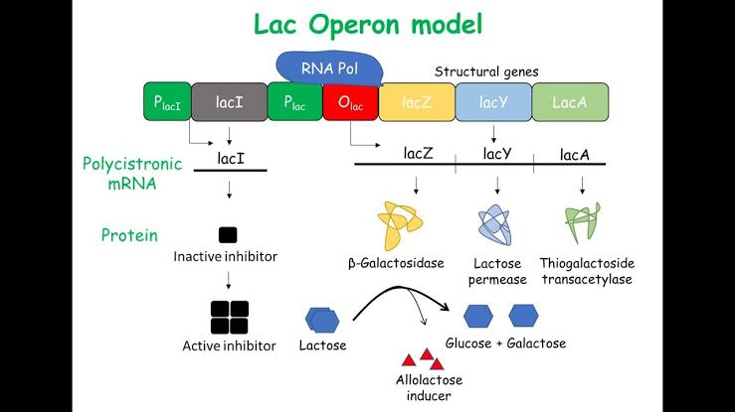

The lac operon. Top: Repressed, Bottom: Active.
1: RNA polymerase, 2: Repressor, 3: Promoter, 4: Operator, 5: Lactose, 6: lacZ, 7: lacY, 8: lacA.
It would be wasteful to produce enzymes when no lactose is available or if a preferable energy source such as glucose were available. The lac operon uses a two-part control mechanism to ensure that the cell expends energy producing the enzymes encoded by the lac operon only when necessary.[2] In the absence of lactose, the lac repressor, lacI, halts production of the enzymes encoded by the lac operon.[3] The lac repressor is always expressed, unless a co-inducer binds to it. In other words, it is transcribed only in the presence of small molecule co-inducer. In the presence of glucose, the catabolite activator protein (CAP), required for production of the enzymes, remains inactive, and EIIAGlc shuts down lactose permease to prevent transport of lactose into the cell
Ara operan 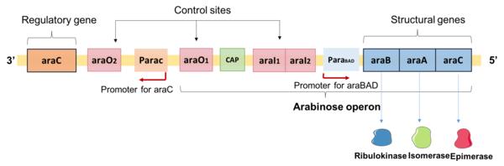

The L-arabinose operon, also called the ara or araBAD operon, is an operon required for the breakdown of the five-carbon sugar L-arabinose in Escherichia coli.[1] The L-arabinose operon contains three structural genes: araB, araA, araD (collectively known as araBAD), which encode for three metabolic enzymes that are required for the metabolism of L-arabinose.[2] AraB (ribulokinase), AraA (an isomerase), AraD (an epimerase) produced by these genes catalyse conversion of L-arabinose to an intermediate of the pentose phosphate pathway, D-xylulose-5-phosphate.[2]
The structural genes of the L-arabinose operon are transcribed from a common promoter into a single transcript, a mRNA.[3] The expression of the L-arabinose operon is controlled as a single unit by the product of regulatory gene araC and the catabolite activator protein (CAP)-cAMP complex.[4] The regulator protein AraC is sensitive to the level of arabinose and plays a dual role as both an activator in the presence of arabinose and a repressor in the absence of arabinose to regulate the expression of araBAD.[5] AraC protein not only controls the expression of araBAD but also auto-regulates its own expression at high AraC levels.
TRP operan
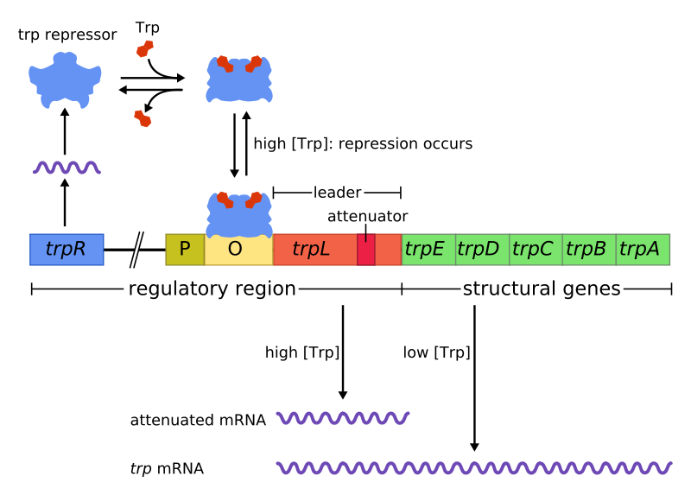
The trp operon is an operon—a group of genes that is used, or transcribed, together—that codes for the components for production of tryptophan. The trp operon is present in many bacteria, but was first characterized in Escherichia coli. The operon is regulated so that when tryptophan is present in the environment, the genes for tryptophan synthesis are not expressed. It was an important experimental system for learning about gene regulation, and is commonly used to teach gene regulation.
Trp operon contains five structural genes: trpE, trpD, trpC, trpB, and trpA, which encode enzymatic parts of the pathway. It also contains a repressive regulator gene called trpR. trpR has a promoter where RNA polymerase binds and synthesizes mRNA for a regulatory protein. The protein that is synthesized by trpR then binds to the operator which then causes the transcription to be blocked. In the trp operon, tryptophan binds to the repressor protein effectively blocking gene transcription. In this situation, repression is that of RNA polymerase transcribing the genes in the operon. Also unlike the lac operon, the trp operon contains a leader peptide and an attenuator sequence which allows for graded regulation.[1]
It is an example of repressible negative regulation of gene expression. Within the operon's regulatory sequence, the operator is bound to the repressor protein in the presence of tryptophan

Gene loss
'gene loss' is used in a broad sense, not only referring to the absence of a gene that is identified when different species are compared, but also to any allelic variant carrying a loss-of-function (that is, non-functionalization) mutation that is found within a population
Gene amplification
Gene amplification is an increase in the number of copies of a gene without a proportional increase in other genes. This can result from duplication of a region of DNA that contains a gene through errors in DNA replication and repair machinery as well as through fortuitous capture by selfish genetic element
Gene rearrangement
a chromosomal rearrangement is a mutation that is a type of chromosome abnormality involving a change in the structure of the native chromosome. Such changes may involve several different classes of events, like deletions, duplications, inversions, and translocations.
Regulation of primary transcript
A primary transcript is the single-stranded ribonucleic acid (RNA) product synthesized by transcription of DNA, and processed to yield various mature RNA products such as mRNAs, tRNAs, and rRNAs. The primary transcripts designated to be mRNAs are modified in preparation for translation. For example, a precursor mRNA (pre-mRNA) is a type of primary transcript that becomes a messenger RNA (mRNA) after processing.
Pre-mRNA is synthesized from a DNA template in the cell nucleus by transcription. Pre-mRNA comprises the bulk of heterogeneous nuclear RNA (hnRNA). Once pre-mRNA has been completely processed, it is termed "mature messenger RNA", or simply "messenger RNA". The term hnRNA is often used as a synonym for pre-mRNA, although, in the strict sense, hnRNA may include nuclear RNA transcripts that do not end up as cytoplasmic mRNA.
There are several steps contributing to the production of primary transcripts. All these steps involve a series of interactions to initiate and complete the transcription of DNA in the nucleus of eukaryotes. Certain factors play key roles in the activation and inhibition of transcription, where they regulate primary transcript production. Transcription produces primary transcripts that are further modified by several processes. These processes include the 5' cap, 3'-polyadenylation, and alternative splicing. In particular, alternative splicing directly contributes to the diversity of mRNA found in cells. The modifications of primary transcripts have been further studied in research seeking greater knowledge of the role and significance of these transcripts. Experimental studies based on molecular changes to primary transcripts and the processes before and after transcription have led to greater understanding of diseases involving primary transcripts.

Hormonal Control of Gene Expression
Hormones are molecules that are produced in one cellular location in an organism, and whose effects are seen in another tissue or cell type. In mammals hormones can be proteins or steroids. The protein hormones do not enter the cell, but bind to receptors in the cell membrane and mediate gene expression through intermediate molecules. Steroids, though actually enter the cell and interact with steroid receptor proteins to control gene expression.
Glucocorticoid is one type of steroid whose method of controlling gene expression has been determined. The steroid interacts with a receptor protein, and this interaction serves two function. First, binding stimulates the release of the protein Hsp90 that is bound to the receptor protein. When Hsp90 is bound to the receptor protein, gene expression is not activated. This would be expected, if the steroid is the signal required for the expression of specific genes in the tissue. When the steroid is bound and Hsp90 is released, the receptor protein forms a dimer (two proteins together) with another copy of the receptor protein. This complex then binds to specific enhancer sequences and gene expression is activated.
A number of steroid receptor proteins have been characterized, and a number of features are in common among them. First, the N-teriminal region of the protein is required to activate transcription in some manner, but the mechanism is not known. This is the least conserved region among the eight proteins. The central portion of the protein is required for DNA binding, and this region is highly conserved (42-94% amino acid identity). The C-terminal region is required for steroid binding and is moderately conserved (15-52% amino acid identity). This overall conservation suggests that an ancestral gene may have been the model for each of these genes.

