SRINIVASAN ARTS AND SCIENCE COLLEGE (CO-ED) PERAMBALUlR - 621212
DEPARTMENT OF BIOTECHNOLOGY
CLASS : III B.SC., BIOTECHNOLOGY
SUBJECT: MICROBIALBIOTECHNOLOGY SUB CODE : 16SCCBT8

UNIT-I
A bioprocess is any process that uses complete living cells or their components (e.g., bacteria, enzymes, chloroplast) to obtain desired products. This process is commonly referred to as Fermentation.

STAGES OF BIOPROCESSING
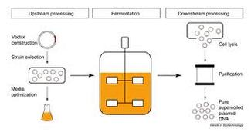
The entire process can be divided in three stages.
Stage I : Upstream processing which involves preparation of liquid medium, separation of particulate and inhibitory chemicals from the medium, sterilization, air purification etc.
Upstream processes include selection of a microbial strain characterized by the ability to synthesize a specific product having the desired commercial value. This strain then is subjected to improvement protocols to maximize the ability of the strain to synthesize economical amounts of the product. Included in the upstream phase is the fermentation process itself which usually is carried out in large tanks known as fermenters or bioreactors. In addition to mechanical parts which provide proper conditions inside the tank such as aeration, cooling, agitation, etc., the tank is usually also equipped with complex sets of monitors and control devices in order to run the microbial growth and product synthesis under optimized conditions. The processing of the fermentation reactions inside the fermenter can be done using many modifications of engineering technologies. One of the most commonly used fermenter types is the stirred-tank fermenter which utilizes mechanical agitation principles, mainly using radial-flow impellers, during the fermentation process.
Stage II: Fermentation which involves the conversion of substrates to desired product with the help of biological agents such as microorganisms.
Techniques for large-scale production of microbial products. It must both provide an optimum environment for the microbial synthesis of the desired product and be economically feasible on a large scale. They can be divided into surface (emersion) and submersion techniques. The latter may be run in batch, fed batch, continuous reactors
In the surface techniques, the microorganisms are cultivated on the surface of a liquid or solid substrate. These techniques are very complicated and rarely used in industry
In the submersion processes, the microorganisms grow in a liquid medium. Except in traditional beer and wine fermentation, the medium is held in fermenters and stirred to obtain a homogeneous distribution of cells and medium. Most processes are aerobic, and for these the medium must be vigorously aerated. All important industrial processes (production of biomass and protein, antibiotics, enzymes and sewage treatment) are carried out by submersion processes.
Stage III: Downstream processing which involves separation of cells from the fermentation broth, purification and concentration of desired product and waste disposal or recycle.
Downstream processing, the various stages that follow the fermentation process, involves suitable techniques and methods for recovery, purification, and characterization of the desired fermentation product. A vast array of methods for downstream processing, such as centrifugation, filtration, and chromatography, may be applied. These methods vary according to the chemical and physical nature, as well as the desired grade, of the final product.

Isolation OF MICRO ORGANISMS (microbiology)
In microbiology, the term isolation refers to the separation of a strain from a natural, mixed population of living microbes, as present in the environment, for example in water or soil flora, or from living beings with skin flora, oral flora or gut flora, in order to identify the microbe(s) of interest. Historically, the laboratory techniques of isolation first developed in the field of bacteriology and parasitology (during the 19th century), before those in virology during the 20th century. Methods of microbial isolation have drastically changed over the past 50 years, from a labor perspective with increasing mechanization, and in regard to the technology involved, and hence speed and accuracy.

History
The laboratory techniques of isolating microbes first developed during the 19th century in the field of bacteriology and parasitology using light microscopy. Proper isolation techniques of virology did not exist prior to the 20th century. The methods of microbial isolation have drastically changed over the past 50 years, from a labor perspective with increasing mechanization, and in regard to the technologies involved, and with it speed and accuracy.

General techniques
In order to isolate a microbe from a natural, mixed population of living microbes, as present in the environment, for example in water or soil flora, or from living beings with skin flora, oral flora or gut flora, one has to separate it from the mix.
Traditionally microbes have been cultured in order to identify the microbe(s) of interest based on its growth characteristics. Depending on the expected density and viability of microbes present in a liquid sample, physical methods to increase the gradient as for example serial dilution or centrifugation may be chosen. In order to isolate organisms in materials with high microbial content, such as sewage, soil or stool, serial dilutions will increase the chance of separating a mixture.
In a liquid medium with few or no expected organisms, from an area that is normally sterile (such as CSF, blood inside the circulatory system) centrifugation, decanting the supernatant and using only the sediment will increase the chance to grow and isolate bacteria or the usually cell-associated viruses.
If one expects or looks for a particularly fastidious organism, the microbiological culture and isolation techniques will have to be geared towards that microbe. For example, a bacterium that dies when exposed to air, can only be isolated if the sample is carried and processed under airless or anaerobic conditions. A bacterium that dies when exposed to room temperature (thermophilic) requires a pre-warmed transport container, and a microbe that dries and dies when carried on a cotton swab will need a viral transport medium before it can be cultured successfully.

Bacterial and fungal culture

Inoculation
Laboratory technicians inoculate the sample onto certain solid agar plates with the streak plate method or into liquid culture medium, depending what the objective of the isolation is:
1.If one wants to isolate only a particular group of bacteria, such as Group A Streptococcus from a throat swab, one can use a selective medium that will suppress the growth of concomitant bacteria expected in the mix (by antibiotics present in the agar), so that only Streptococci are "selected", i.e. visibly stand out. To isolate fungi, Sabouraud agar can be used. Alternatively, lethal conditions for streptococci and gram negative bacteria like high salt concentrations in Mannitol salt agar favor survival of any staphylococci present in a sample of gut bacteria, and phenol red in the agar acts as a ph indicator showing if the bacteria are able to ferment mannitol by excreting acid into the medium. In other agar substances are added to exploit an organism's ability to produce a visible pigment (e.g. granada medium for Group B Streptococcus) which changes the bacterial colony's color, or to dissolve blood agar by hemolysis so that they can be more easily spotted. Some bacteria like Legionella species require particular nutrients or toxin binding as in charcoal to grow and therefore media such as Buffered charcoal yeast extract agar must be used.
2.If one wants to isolate as many or all strains possible, different nutrient media as well as enriched media, such as blood agar and chocolate agar and anaerobic culture media such as thioglycolate broth need to be inoculated. To enumerate the growth, bacteria can be suspended in molten agar before it becomes solid, and then poured into petri dishes, the so-called 'pour plate method' which is used in environmental microbiology and food microbiology (e.g. dairy testing) to establish the so-called 'aerobic plate count'.

Incubation
After the sample is inoculated into or onto the choice media, they are incubated under the appropriate atmospheric settings, such as aerobic, anaerobic or microaerophilic conditions or with added carbon dioxide (5%), at different temperature settings, for example 37 °C in an incubator or in a refrigerator for cold enrichment, under appropriate light, for example strictly without light wrapped in paper or in a dark bottle for scotochromogen mycobacteria, and for different lengths of time, because different bacteria grow at a different speed, varying from hours (Escherichia coli) to weeks (e.g.mycobacteria).
At regular, serial intervals laboratory technicians and microbiologists inspect the media for signs of visible growth and record it. The inspection again has to occur under conditions favoring the isolate's survival, i.e. in an 'anaerobic chamber' for anaerobe bacteria for example, and under conditions that do not threaten the person looking at the plates from being infected by a particularly infectious microbe, i.e. under a biological safety cabinet for Yersinia pestis (plague) or Bacillus anthracis (anthrax) for example.

Identification
When bacteria have visibly grown, they are often still mixed. The identification of a microbe depends upon the isolation of an individual colony, as biochemical testing of a microbe to determine its different physiological features depends on a pure culture. To make a subculture, one again works in aseptic technique in microbiology, lifting a single colony off the agar surface with a loop and streaks the material into the 4 quadrants of an agar plate or all over if the colony was singular and did not look mixed.
Gram staining the raw sample before incubation or staining freshly grown colony material helps to determine if a colony consists of uniformly appearing bacteria or is mixed, and the color, and shape of bacteria allow a first classification based on morphology.
In clinical microbiology numerous other staining techniques for particular organisms are used (acid fast bacterial stain for mycobacteria). Immunological staining techniques, such as direct immunofluorescence have been developed for medically important pathogens that are slow growing (Auramine-rhodamine stain for mycobacteria) or difficult to grow (such as Legionella pneumophila species) and where the test result would alter standard management and empirical therapy.
Biochemical testing of bacteria involves a set of agars in vials to separate motile from non-motile bacteria. In 1970 a miniaturized version was developed, called the analytical profile index.
Successful identification via e.g. genome sequencing and genomics depends on pure cultures.

Bacteria, culture-independent
While the most rapid method to identify bacteria is by sequencing their 16S rRNA gene, which has been PCR-amplified beforehand, this method does not require isolation. Since most bacteria cannot be grown with conventional methods (particularly environmental or soil bacteria) metagenomics or metatranscriptomics are used, shotgun sequencing or PCR directed sequencing of the genome. Sequencing with mass spectrometry as in Matrix-assisted laser desorption/ionization (MALDI-TOF MS) is used in the analysis of clinical specimens to look for pathogens. Whole genome sequencing is an option for a singular organism that cannot be sufficiently characterized for identification. Small DNA microarrays can also be used for identification.
producer strain should possess the following characters:
1. It should be able to grow on relatively cheaper substrates.
2. It should grow well in an ambient temperature preferably at 30-40°C. This reduces the cooling costs.
3. It should yield high quantity of the end product.
4. It should possess minimum reaction time with the equipment used in a fermentationprocess.
5. It should possess stable biochemical characteristics.
6. It should yield only the desired substance without producing undesirable substances.
7. It should possess optimum growth rate so that it can be easily cultivated on a large scale.
Detection and isolation of a microorganism from a natural environment like soil containing large number of microbial population is called as screening. It is very time consuming and expensive process. For example, Eli Lilly & Co. Ltd discovered three species of antibiotic producing organisms in a span of 10 years and after screening 4,00,000 organisms.
Although there are many screening techniques, all of them are generally grouped into two broad categories.
They are:
1. Primary screening, and
2. Secondary screening.

1. Primary Screening of Microorganisms:
Primary screening may be defined as detection and isolation of the desired microorganism based on its qualitative ability to produce the desired product like antibiotic or amino acid or an enzyme etc. In this process desired microorganism is generally isolated from a natural environment like soil, which contains several different species. Sometimes the desired microorganism has to be isolated from a large population of different species of microorganisms.
The following are some of the important primary screening techniques:
(i) The crowded plate technique
(ii) Indicator dye technique
(iii) Enrichment culture technique
(iv) Auxanographic technique
(v) Technique of supplementing volatile and organic substrates.
(i) The Crowded Plate Technique:
This technique is primarily employed for detecting those microorganisms, which are capable of producing antibiotics. This technique starts with the selection of a natural substratum like soil or other source consisting of microorganisms. Progressive serial dilution of the source is made. Suitable aliquot of the serial dilution is chosen which is able to produce 300 to 400 individual colonies when plated on an agar plate, after incubation. Such a plate is called as crowded plate.
The antibiotic producing activity of a colony is indicated by no growth of any other bacterial colony in its vicinity. This region of no growth is indicated by the formation of a clear and colorless area around the antibiotic producing microorganism’s colony on the agar plate. This region is called as growth inhibitory zone.
Such a colony is isolated from the plate and purified either by making repeated sub-culturing or by streaking on a plate containing a suitable medium, before stock culture is made. The purified culture is then tested for its antibiotic spectrum.
However, the crowded plate technique has limited applications, as it will not give indication of antibiotic producing organism against a desired organism. Hence, this technique has been improved later on by employing a test organism to know the specific inhibitory activity of the antibiotic.
In this modified procedure, suitable serially diluted soil suspension is spread on the sterilized agar plate to allow the growth of isolated and individual microbial colonies (approximately 30 to 300 per plate) after incubation. Then the plates are flooded with a suspension of test organism and the plates are incubated further to allow the growth of the test organism. The formation of inhibitory zone of growth around certain colonies indicates the antibiotic activity against the test organism.
A rough estimation of the relative amounts of antibiotic produced by a microbial colony can be estimated by measuring the diameter of the zone of inhibited test organism’s growth. Antibiotic producing colonies are later on isolated from the plate and are purified before putting to further testing to confirm the antibiotic activity of a microorganism.
(ii) Indicator Dye Technique:
Microorganisms capable of producing acids or amines from natural sources can be detected using this method by incorporating certain pH indicator dyes such as neutral red or bromothymol blue into nutrient agar medium. The change in the color of a particular dye in the vicinity of a colony will indicate the ability of that colony to produce an organic acid or base.
- Production of an organic acid can also be detected by an alternative method. In this method calcium carbonate is incorporated into the agar medium. The production of organic acid is indicated by the formation of a clear zone around those colonies which release organic acid into the medium.
- The identified colonies are isolated and purified either by repeated sub-culturing or by streaking methods and a stock culture is made which may be used for further qualitative or quantitative screening tests.
iii) Enrichment Culture Technique:
This technique is generally employed to isolate those microorganisms that are very less in number in a soil sample and possess specific nutrient requirement and are important industrially. They can be isolated if the nutrients required by them is incorporated into the medium or by adjusting the incubation conditions.
(iv) Auxanotrophic Technique:
This technique is employed for the detection and isolation of microorganisms capable of producing certain extracellular substances such as growth stimulating factors like amino acids, vitamins etc. A test organism with a definite growth requirement for the particular metabolite is used in this method.
For this purpose, spread a suitable aliquot on the surface of a sterilized agar plate and allow the growth of isolated colonies, after incubation. A suspension of test organism with growth requirement for the particular metabolite is flooded on the above plate containing isolated colonies, which are subjected to further incubation.
The production of the particular metabolite required by the test organism is indicated by its increased growth adjacent to colonies that have produced the required metabolite. Such colonies are isolated, purified and stock cultures are prepared which are used for further screening process.
v) Technique of Supplementing Volatile Organic Substances:

This technique is employed for the detection and isolation of microorganisms capable of utilizing carbon source from volatile substrates like hydrocarbons, low molecular weight alcohols and similar carbon sources. Suitable dilution of a microbial source like soil suspension are spread on to the surface of sterile agar medium containing all the nutrients except the one mentioned above.
The required volatile substrate is applied on to the lid of the petri plates, which are incubated by placing them in an inverted position. Enough vapors from the volatile substrate spread to the surface of agar within the closed atmosphere to provide the required specific nutrient to the microorganism, which grows and form colonies by absorbing the supplemented nutrient. The colonies are isolated, purified and stock cultures are made which may be utilized for further screening tests.

2. Secondary Screening of Microorganisms:
Primary screening helps in the detection and isolation of microorganisms from the natural substrates that can be used for industrial fermentations for the production of compounds of human utility, but it cannot give the details of production potential or yield of the organism. Such details can be ascertained by further experimentation.
This is known as secondary screening, which can provide broad range of information pertaining to the:
i. Ability or potentiality of the organism to produce metabolite that can be used as an industrial organism.
ii. The quality of the yield product.
iii. The type of fermentation process that is able to perform.
iv. Elimination of the organisms, which are not industrially important.
To evaluate the true potential of the isolated microorganisms both qualitative and quantitative analysis are generally conducted. The sensitivity of the test organism towards a newly discovered antibiotic is generally analysed during qualitative analysis, while the quantum yield of newly discovered antibiotic is estimated by the quantitative analysis.
Evaluation of Potentialities of Microorganisms:
Microorganisms isolated in the primary screening are critically evaluated in the secondary screening so that industrially important and viable potentialities can be assessed.
They include:
1. To determine the product produced by an organism is a new compound or not.
2. A determination should be made about the yield potentialities of various isolated microorganisms that are detected in primary screening for that new compound.
3. It should determine about the various requirements of the microorganism such as pH, aeration, temperature etc.
4. It should detect whether the isolated organism is genetically stable or not.
5. It should reveal whether the isolated organism is able to destroy or alter chemically their own fermentative product by producing adaptive enzymes if they accumulate in higher quantities.
6. It should reveal the suitability of the medium or its constituent chemicals for the growth of a microorganism and its yield potentialities.
7. It should determine the chemical stability of the product.
8. It should reveal the physical properties of the product.
9. It should determine whether the product produced by a microorganism in a fermentative process is toxic or not.
10. Secondary screening should reveal that whether the product produced in fermentation process exists in more than one chemical form. If so, the amount of formation of each chemical formation of these additional products is particularly important since their recovery and sale as byproducts can greatly improve the economic status of the fermentation industry.
11. The new organism should be identified to the species level. This will help in making a comparison of growth pattern, yield potentialities and other requirements of test organism with those already described in the scientific and patent literature, as being able to synthesize products of commercial value.
12. It should select industrially important microorganisms and discard others, which are not useful for fermentation industry.
13. It should determine the economic status of a fermentation process undertaken by employing newly isolated microorganism.
Methods of Secondary Screening:
Secondary screening gives very useful information pertaining to the newly isolated microorganisms that can be employed in fermentation processes of commercial value. These screening tests are conducted by using petri dish containing solid media or by using flasks or small fermenters containing liquid media. Each method has some advantages and disadvantages. Sometimes both the methods are employed simultaneously.
Liquid media method is more sensitive than agar plate method because it provides more useful information about the nutritional, physical and production responses of an organism to actual fermentation production conditions. Erlenmeyer flasks with baffles containing highly nutritive liquid media are used for this method. Flasks are fully aerated with glass baffles and continuously shaken on a mechanical shaker in order to have optimum product yield.
There are several techniques and procedures that can be employed for secondary screening. However, only a specific example of estimation of antibiotic substance produced by species of Streptomyces, is described in the following paragraph. Similar methods could be used for the detection and isolation of microorganisms capable of producing other industrial products.
(i) Giant Colony Technique:
This technique is used for isolation and detection of those antibiotics, which diffuse through solid medium. Species of Streptomyces, is capable of producing antibiotics during primary screening. The isolated Streptomyces culture is inoculated into the central area of a sterilized petri plates containing nutrient agar medium and are selected. The plates are incubated until sufficient microbial growth takes place.
Cultures of test organism, whose antibiotic sensitivity is to be measured are streaked from the edges of plate’s upto but not touching the growth of Streptomyces and are further incubated to allow the growth of the test organisms. Then the distance over which the growth of different test organisms is inhibited by the antibiotic secreted Streptomyces is measured in millimeters.
The relative inhibition of growth of different test organisms by the antibiotic is called inhibition spectrum. Those organisms whose growth is inhibited to a considerable distance are considered more sensitive to the antibiotic than those organisms, which can grow close to the antibiotic. Such species of Streptomyces, which have potentiality of inhibiting microorganisms is preserved for further testing.
(ii) Filtration Method:
This method is employed for testing those antibiotics which are poorly soluble in water or do not diffuse through the solid medium. The Streptomyces is grown in a broth and its mycelium is separated by filtration to get culture filtrate. Various dilutions of antibiotic filtrates are prepared and added to molten agar plating medium and allowed to solidify.
Later on cultures of various test organisms are streaked on parallel lines on the solidified medium and such plates are incubated. The inhibitory effect of antibiotic against the test organisms is measured by their degree of growth in different antibiotic dilutions.
(iii) Liquid Medium Method:
This method is generally employed for further screening to determine the exact amount of antibiotic produced by a microorganism like Streptomyces.
Erlenmeyer conical flasks containing highly nutritive medium are inoculated with Streptomyces and incubated at room temperature. They are also aerated by shaking continuously and vigorously during incubation period to allow Streptomyces to produce the antibiotic in an optimum quantity.
Samples of culture fluids are periodically withdrawn aseptically for undertaking the following routine checks:
1. To check the suitability of different media for maximum antibiotic production.
2. To determine the value of pH at which there will be maximum growth of the microorganism and antibiotic production.
3. To check for contamination.
4. To determine whether the antibiotic produced is new or not.
5. To check the stability of the antibiotic at various pH levels and temperatures.
6. To determine the solubility of the antibiotic in various organic solvents.
7. To check about the toxicity of the antibiotic against the experimental animals.
After carrying out the above mentioned routine tests further studies are also conducted to know the following additional information:
1. Effect of incubation temperature and antifoaming agents on fermentation.
2. Rate of resistance developed among the test organisms.
3. Checking the antibiotic for its bacteriostatic or bactericidal properties. Its ability to precipitate serum proteins to cause hemolysis of blood or to harm phagocytes.
4. Checking for possibility of inclusion of precursor chemical of the antibiotic production in the medium.
5. Suitability of the organism for mutation and other genetic studies.

Microbial Growth KINETICS

Microbial cells use nutrients for growth, energy production and product formation as indicated in the following expression;
Nutrients + microbial cells > cell growth + energy + reaction products
Consider the operation of the "Batch" system shown in Figure 1. This container initially contains a known growth substrate concentration S. The container is well mixed and therefore the dissolved oxygen concentration O2 does not become a limiting factor for microbial growth. Initially a known concentration X of viable microbial cells (i.e. inoculum) is added to the container and, with time, growth substrate S is utilized for cell growth. We therefore over time will observe a decrease in S (negative dS/dt) and a corresponding increase in X (positive dX/dt).
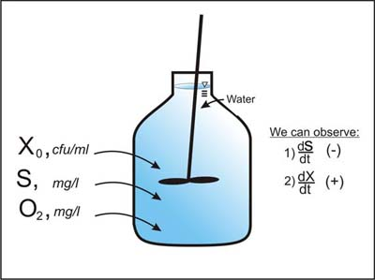
Permissions
A. Cunningham, Center for Biofilm Engineering, Montana State Univeristy, Bozeman, MT
Figure. Microbial growth and substrate utilization in a well mixed batch container.
A conceptual plot of microbial cell concentration vs time for the batch system is called a growth curve, as shown in Figure 2.
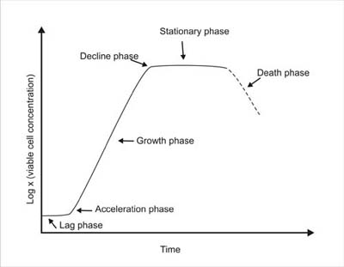
Permissions
A. Cunningham, Center for Biofilm Engineering, Montana State Univeristy, Bozeman, MT
Typical growth curve for a batch system.
By plotting the log of viable cell concentration, X, with time, five distinct phases of the growth curve can be identified; 1) the lag phase which occurs immediately after inoculation and persists until the cells have acclimated to their new environment, 2) exponential growth phase, during which time cell growth proceeds at an exponential rate (indicated by a straight line on the semi-log plot), 3) a deceleration phase, when essential nutrients are depleted or toxic products begin to accumulate, 4) a stationary phase during which time the net cell growth is approximately zero, and 5) death phase where some cells loose viability or are destroyed by lysis.

Microbial Growth Kinetics
During the lag phase dX/dt and dS/dt are essentially zero. However as exponential growth phase begins it is possible to measure dX/dt and dS/dt values which are very useful for defining important microbial kinetic parameters. Using corresponding observations of dS/dt and dX/dt obtained just after the onset of exponential growth phase in Figure 2 we can compute the yield coefficient Y_{XS} and the specific growth rate µ as:

Yield coefficient
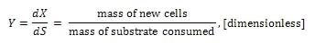 (1)

Specific growth rate
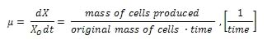(2)
The yield coefficient, commonly referred to as the substrate-to-biomass yield, is used to convert between cell growth rate dX/dt and substrate utilization rate dS/dt. The yield coefficient and the specific growth rate used to develop three types of microbial growth kinetic relationships; Monod , first order ,and zero order kinetics.

Monod Kinetics
The batch experiment shown in Figure 1 can be repeated by varying initial substrate concentration S over a wide range of values—resulting in observation of individual µ values which correspond to each substrate concentration. An arithmetic plot of µ vs S will exhibit the general behavior shown in Figure 3.
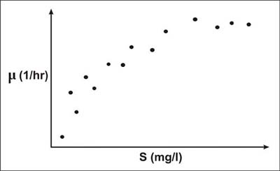
Permissions
A. Cunningham, Center for Biofilm Engineering, Montana State Univeristy, Bozeman, MT
Figure 3. Specific growth rate plotted respect to initial substrate concentration in a batch system.
The most widely used expression for describing specific growth rate as a function of substrate concentration is attributed to Monod (1942, 1949). This expression is:
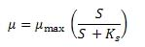(3)
Figure 4. Shows conceptually how the Monod equation is fit to the observed substrate and specific growth rate data in Figure 3. In Figure 4 it is seen that µ_{max} is the maximum specific growth rate observed and K_{S} is the substrate concentration corresponding to 1/2 µ_{max}.
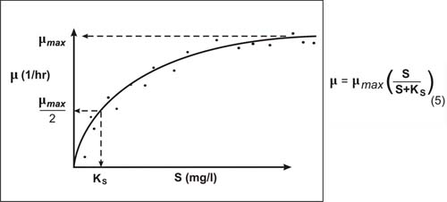
Permissions
A. Cunningham, Center for Biofilm Engineering, Montana State Univeristy, Bozeman, MT
Figure 4. Monod Equation fit to observed data.

Monod Kinetics
By combining equations 2 and 3 we can write the following expression for time-rate-of-change of biomass:
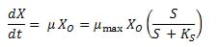(4)
Similarly, by combining equations 1 and 3 we can write an expression for substrate utilization rate.
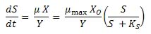(5)

First Order Kinetics
Equation 5 describes the Monod kinetic relationship for substrate utilization. From Figure 4 it can be seen if S << K_{S} , Equation 5 can be approximated as:
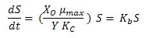(6)
Equation 6 describes the condition where substrate utilization is proportional to substrate concentration (i.e. first order with respect to S).

Zero Order Kinetics
Likewise if S >> K_{S} Equation 5 can be approximated as:
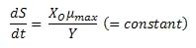(7)
Equation 7 describes the condition where substrate utilization rate is a constant (i.e. zero order with respect to S).

Starinrms:
Strain improvementas Plert
About this page
Industrial strain improvement is generally limited by lack of knowledge concerning the precise genetic and molecular mechanisms underlying commercially important multifactorial traits such as freeze tolerance. It is generally believed that freeze tolerance, like most important baker's yeast characteristics, is determined by the interaction of many genes. From this point of view, multiple modifications of genes or the modification of control genes with multiple downstream effects would be needed to substantially improve freeze tolerance . Indeed, next to the aquaporin-encoding genes, no single gene has been identified that allows reducing or enhancing baker's yeast freeze tolerance by manipulation of its expression level without affecting other commercially important properties.
Furthermore, there is also the large gap between theoretical knowledge and practical application: Results obtained with laboratory strains or in laboratory conditions do not always directly apply to industrial strains or industrial conditions. Industrial baker's and brewer's strains are usually polyploid. Little is known about the importance of gene copy number and allele variation for a specific trait such as freeze tolerance. In addition, it is well known that a yeast strain showing a high freeze tolerance when grown and tested in laboratory conditions often does not display the same features in industrial conditions.
Although there are many potential applications of genetically modified baker's yeasts in traditional industries, for instance, in frozen doughs, the effective introduction on the market of such strains is still stalled by negative public perception. Only a limited number of genetically modified organisms have received official approval for commercial use and, in spite of this permission, they are currently not exploited. Commercial freeze-tolerant yeast strains that are on the market now do not display satisfactory characteristics. If a superior strain becomes available via genetic engineering which clearly shows perceptible benefits, not only to frozen dough manufacturers and bakers but also to private consumers, such a strain might become more acceptable.
Classical genetic methods of S. cerevisiae strain improvement involve construction of new hybrids with enhanced traits for fermentation. These methods have been described in greater detail elsewhere and include hybridization, protoplast fusion, rare mating, and mutagenesis.

Generally, such methods have proven more successful than genetic engineering approaches to improve stress tolerance in bioethanol yeast strains . In addition, the use of spontaneous mutants of S. cerevisiae, such as the respiratory-deficient petite mutants that are a frequent mutation of brewing yeast strains, has been proposed for commercial ethanol fermentations .

Classical genetic strain improvement strategies or the use of natural mutations are attractive because resultant strains are not regarded as GM although they do have drawbacks.
For example, the improvement of existing strains is relatively imprecise and often requires high-throughput screening methods to identify the desired characteristics.
Additionally the methods are not generally applicable to industrial strains with complex genetic backgrounds. In this context a problem with many currently used industrial S. cerevisiae strains, particularly those employed for brewing, is their polygenic nature.
That is, strains that are polyploid (multiple copies of chromosomes) or aneuploid (with odd numbers of the same chromosomes) are very difficult to genetically improve using these classical genetic manipulations. One way to counteract the genetic intractability of industrial strains of S. cerevisiae is to use more precise, and quicker, modern strain engineering approaches.
In the context of yeasts exploited for alcohol fermentations, strain engineering refers to manipulation of individual genes or pathways involved in metabolism with a view to increasing the rate and the extent of sugar conversions to ethanol
Various molecular genetic techniques are now available to improve yeast strains for industrial alcohol fermentations, including genetic engineering, gene editing, and, potentially, synthetic biology.
Although a certain sense of direction is inherent in all strain improvement programs, the directionality of effort is a strong focal point of metabolic engineering compared to random mutagenesis, as it plays a dominant role in enzymatic target selection, experimental design, and data analysis.
On the other hand, direction in cell improvement should not be interpreted as rational pathway design and modification, in the sense that it is totally decoupled from random mutagenesis. In fact, strains that are obtained by random mutation and exhibit superior properties can be the source of critical information about pathway configuration and control, extracted via reverse metabolic engineering.
The lineage of strains with varying penicillin production potentials generated during the penicillin strain improvement process represents a unique source of genetic material to examine directed evolution, and to identify genes whose modifications affect metabolite production. DNA microarray technology is a particularly well-suited tool for uncovering variations between closely related strains.
Microarrays are often generated using DNA representing known open reading frames (where genomic sequence is available) or ESTs. Since neither sequence information nor ESTs were available for P. chrysogenum, we utilized a random fragment genomic microarray approach to assess the changes that have occurred within the Penicillium production strains
DNA from the progenitor strain (ATCC 9480, NRRL 1951) was isolated, digested to produce fragments of approximately 2 KB, and cloned. Approximately 13,000 PCR products were generated from the resulting fragment library using a common primer pair.
In addition, PCR fragments were generated for all known P. chrysogenum genes. Resulting PCR products were purified and transferred to 384-well plates to generate the microarray.
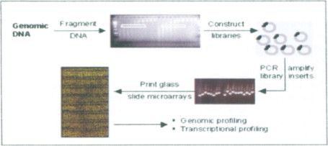
fig.. Schematic of random fragment genomic microarrays for genomic and transenptional profiling
Microarrays are typically utilized to examine mRNA, ie the pattern of expression of genes. However, microarrays can also be utilized to directly compare the genomes of closely related strains. In the current study, the microarray of strain ATCC 9480 was utilized to compare the genomes of the starting, wild type strain and the improved P-2 strain (ATCC 48271, ) of the P. chrysogenum production lineage.
Genomic DNA was prepared from each strain, partially digested to a length of approximately 1 KB, and differentially labeled with fluorescent nucleotides (Cy3-dCTP or Cy5-dCTP) using a random priming reaction.
Competitive microarray hybridizations were performed using DNA from the starting strain and differentially labeled DNA from the P2 strain. Wild type DNA was also competitively hybridized to itself to determine the experimental reproducibility.
Genomic fragments that displayed signal intensities with absolute value log2 ratios > 0.8 were considered significantly amplified or deleted, relative to the wild type strain, and were selected for sequence analysis .
A number of genomic fragments were identified which were associated with stronger hybridization signals in the improved P-2 strain. Not surprisingly, sequence analysis revealed that many of these genomic fragments contained genes of the penicillin biosynthetic cluster.
These results were consistent with results of previous studies in which Southern blot hybridizations and sequencing techniques were used to show that the penicillin biosynthetic cluster has been amplified from 1 copy in the progenitor strain to 5 to 7 copies in the P-2 strain. The genomic fragment microarray approach has, in addition identified at least 2 more genes that are either contained within or closely linked to the 55 kb amplified region and could be associated with penicillin production.
These include a putative isoamyl alcohol oxidase, which could regulate formation of valine, a precursor of penicillin; and a zinc binuclear cluster transcription factor that could regulate transcription of genes involved in penicillin production.
The microarray approach also identified a number of amplified genes that do not reside within the penicillin amplification unit, and might be important for penicillin production. Specific ABC transporter efflux pumps have been either amplified or deleted.
This seemingly contradictory finding is plausible, since certain pumps could positively impact penicillin production by increasing penicillin efflux into the medium, while other pumps could negatively impact penicillin production by transporting precursors into the medium.
Multiple amplified fragments were identified that encode a glucose transporter/sensor which may regulate the flux of carbon into central metabolism or the transition from primary to secondary metabolism. A fragment that contains a putative HMG CoA synthase; which can regulate flux into branch chain amino acid biosynthesis was also identified.
Finally, two clones were found to contain sequence that suggests amplification of a transposon. It is possible that this transposon could be involved in the amplification of the penicillin biosynthetic cluster.
Genomic profiling is well suited for detecting significant size deletions and insertions in wild type, and particularly in mutagenized production strains.
Clearly, such gross changes can be detected in enhanced penicillin strains, and similarly, genomic rearrangements are expected to be associated with the increased production of other secondary metabolites.
Furthermore, genomic profiling using genomic fragment microarrays can be employed in combination with gene expression studies, more sensitive genomic profiling methods, and sequencing efforts in order to gain a detailed understanding of the genetic control of secondary metabolite production.
For example, in strains such as P. chrysogenum and P. citrinum, for which the secondary metabolite gene clusters have been cloned, but whole genomic sequence is lacking, genomic profiling is particularly well suited for identifying important genes that are not physically linked to the cluster.
In uncharacterized systems, transcriptional profiling using random fragment microarrays can be used to rapidly identify biosynthetic genes that have not been previously identified
Transduction Mechanisms
In recent years, signal transduction pathways have gained attention as tools for strain improvement in T. reesei . Altering transmission of signals, which ultimately leads to the adjustment of enzyme production to the given environment represents a promising alternative or addition to increasing the efficiency of promoter activity of genes of interest.

Light Signaling
As one of the most fundamental cues in nature, light response plays a fundamental role in physiology of Trichoderma spp. . Photoreceptors related to the N. crassa White collar 1 (WC-1) and White collar 2 (WC-2) play the major role in light signal transmission in most fungi, along with Vivid (VVD-1), the presence of which is less conserved (Idnurm and Heitman, 2005).
WC-1 and WC-2 are transcription factors, which form a complex .
The activity of this complex is modified by VVD, which can act as a universal brake for light responses and is important for sensing of light intensities such as the difference between daylight and moonlight (Malzahn et al., 2010) for adjustment to daily rhythms. In Trichoderma, the homologs of these photoreceptors are BLR1 and BLR2 (blue light regulators 1 and 2) and ENV1, with ENV1 not being closely related to VVD, but not a functional homolog of VVD . Light as well as the photoreceptors are known to regulate expression of cellulase genes. In case of cbh1 and cbh2 a twofold increase is observed upon growth in light versus darkness on cellulose and since the positive regulation of transcript levels of cellulase genes by photoreceptors does not strictly correlate with the effect on cellulase activity secreted into the medium by the respective mutants, posttranscriptional regulation in light or due to the function of photoreceptors is assumed.
In T. reesei and T. atroviride, around 2.8% of all genes are regulated by light in the wild-type . In T. reesei, these genes show enrichment in the functions of carbohydrate metabolism and transport on cellulose and hence reveal the expression of glycoside hydrolases as a target of light signaling
Additionally, complex formation within the cbh2 promotor is different in light and darkness, hence indicating altered regulation transcription factor binding by light
.

The Heterotrimeric G-Protein Pathway
The discovery that cellulase gene expression is modulated by light led to the question how this modulation is accomplished and how light signaling interacts with nutrient signaling. One of the most prominent pathways for nutrient signaling is the heterotrimeric G-protein pathway . After detection of a ligand by a cell surface bound G-protein coupled receptor in the environment, GDP is exchanged for GTP at the G-alpha subunit and these subunits dissociate from the complex with the G-beta and G-gamma subunits. Subsequently, all three subunits are free to act on their respective signaling target in the cell.
Due to the intrinsic GTPase activity of G-protein alpha subunits they become inactivated after acting on their targets, a process which is regulated by the so called RGS (regulator of G-protein signaling) proteins .
In T. reesei the G-protein alpha subunits GNA1 and GNA3 were found to be involved in light dependent regulation of cellulase gene expression. Thereby, GNA3 has a strongly positive effect on cellulase gene expression only in light, which is assumed to be modulated by an RGS protein . Also GNA1 has a positive effect on cellulase gene expression in light, but interestingly, deletion of gna1 results in a strong upregulation of cellulases in darkness, but downregulation in light .
This finding reflects that the function of G-proteins can be strongly dependent on light conditions and interpretation of their function is impossible unless cultivation is performed under controlled conditions. Analysis of regulation of gna1 and gna3 by the light response machinery showed that in both cases a positive feedback cycle is operative, which is dependent on the carbon source in case of gna1. ENV1 impacts the regulation of both genes and hence indicates an interrelationship between heterotrimeric G-proteins and photoreceptors . Investigation of the function of GNA1 and GNA3 hinted at a contribution of the G-protein beta and gamma subunits (GNB1 and GNG1). Transcriptome analysis of the effect of deletion of GNB1 and GNG1 in T. reesei as well as of the phosducin like protein PHlP1 revealed glycoside hydrolases as a major target of light dependent signaling by heterotrimeric G-proteins.
In T. atroviride and T. virens, investigation of G-protein alpha subunits rather concentrated on mycoparasitism and biocontrol, which can involve hydrolytic enzymes. Altered chitinase expression was shown for strains lacking the G-alpha subunits TGA1 or TGA3 . Therefore, these findings showed the importance of G-protein signaling pathway in the regulation of chitinase expression.

The cAMP Pathway
As major components of the cAMP pathway, protein kinase A, adenylate cyclase and phosphodiesterases represent downstream targets of the heterotrimeric G-protein pathway. cAMP was shown to positively influence cellulase gene expression and a light dependent effect was observed . Moreover, GNA3 was found to strongly impact cAMP levels, albeit this influence did not strictly correlate with cellulase levels .
A connection between light response and the cAMP pathway has been observed in T. atroviride and this connection was investigated with respect to cellulase gene expression in T. reesei. Both PKAC1 (protein kinase A catalytic subunit 1) and ACY1 (adenylate cyclase 1) show a light dependent effect on cellulase gene expression, which is likely mediated by XYR1 on lactose.
In strains lacking pkac1 complex formation in light at the cbh2 promotor is altered, which is in accordance with light dependent transcription factor regulation . ENV1 was shown to have a strongly positive effect on intracellular cAMP levels, but this effect is not dependent on adenylate cyclase, but rather due to a modulated activity of phosphodiesterases .
Consequently it is likely that also phosphodiesterases have a function in cellulase regulation.

MAP Kinases
Regulation by mitogen activated kinases (MAP kinases) occurs in cascades with three serine/threonine protein kinases acting consecutively . In Trichoderma spp. the MAP kinases pathways for pheromone response/pathogenicity, cell integrity and stress response, each consisting of three members were detected .
The effect of these signaling factors on CAZyme gene expression is not yet studied in detail, but in T. virens, the MAP kinase TVK1 was found to among other processes regulate secretion of cell wall degrading enzymes .
It can be expected that regulation of CAZymes by MAP kinases also occurs in other species of the genus and might extend to a broader array of enzymes.

Ras GTPases
Recently also Ras GTPases were shown to influence cellulase gene expression in T. reesei, which is likely mediated by regulation of xyr1 transcript levels
targets not only for strain improvement but also for waking up silent biosynthetic gene clusters in streptomycetes. A better understanding of regulatory pathways that control antibiotic production in streptomycetes is currently making the approaches described here more efficient.
The stambomycins were the first example of Streptomyces natural products discovered by overexpressing a transcriptional activator and waking up a silent gene cluster. Most interestingly, LAL regulators can be identified in several cryptic clusters in genomic databases. This strategy is applicable to other Streptomyces spp. and is not limited to LAL regulators but other positive regulators (SARP, SrmR, etc.) can be overexpressed as described here.
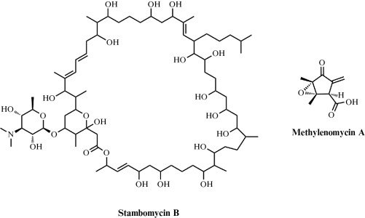
Stambomycin B and methylenomycin A overproduced by engineering Streptomyces pathway-specific transcriptional regulators.
Similarly, disrupting a negative pathway-specific regulator can also result in overproduction of biologically active metabolites. TetR repressors represent a very large group of bacterial transcriptional regulators and their manipulation could be central in the exploitation of the large number of untapped biosynthetic gene clusters that have been revealed using Streptomyces genome mining. Many new natural products with potential clinical utility could therefore be discovered.
Importantly, the approaches described herein could also be applicable to gene clusters identified from metagenomic DNA.
Increased production of the trans-AT hybrid PKS/NRPS product mycosubtilin has focused on both strain improvement and fermentation development. Sophisticated fed-batch culture techniques have enabled high levels of production to be achieved, with a yield of 1.3 mg of mycosubtilin per gram of biomass per hour. This represents substantially higher production of mycosubtilin than what has previously been achieved. Methods have also been developed to effectively transform the producing strain, enabling the ability to monitor the mycosubtilin biosynthesis under various conditions. For example, replacement of the endogenous pathway promoter with a constitutive promoter resulted in a 15-fold increase in production when compared to wild type.
This finding underscores the benefit of incorporating relatively straightforward genetic changes into the producing organism. Changes in simple experimental variables, such as reducing the culture temperature from 37 °C to 25 °C, resulted in a 30-fold increase in mycosubtilin production.
As illustrated in the mycosubtilin example, methods incorporating strain improvement and media development can have dramatic effects on production efficiency; however, not all organisms are genetically tractable to manipulation, and some even are resistant to growing in laboratory culture (i.e., nonculturable). Thus, despite their potential, these powerful techniques cannot be used to optimize metabolite production in all desirable cases.

Whole-genome shuffling

Maxygen Inc. and its subsidiary Codexis Inc. has recently pioneered whole-genome shuffling to accelerate the process of strain improvement. They demonstrated that recursive genomic recombination within a population of bacteria can efficiently generate combinatorial libraries of new strains. The rapid improvement of tylosin production from Streptomyces fradiae showed the potential of this non-rationale based method to facilitate cell and metabolic engineering without detailed knowledge of the biochemical networks involved . Whole-genome shuffling, in principle, is applicable to any metabolic network and for any target product. However, practical applications of the method rely on high-throughput screening or a selectable marker. Often, the screening capability and a lack of a selection method limit the use of this method.

Aspergillus Strain Improvement

The use of conventional and molecular tools to manipulate for augmenting the metabolic potential for commercial purposes is known as strain improvement. Strain improvement is important to enhance the commercial product and also to reduce the cost economy. The success of any industry employing microbes is dependent on the potential and ability of strains to perform better and better, which is achieved by continuous improvement . The improvement in any strain is the target to improve the desired metabolic or commercial product, using simple and inexpensive carbon and nitrogen sources and reduction in unwanted cometabolites. Nowadays, the main tools to improve the Aspergillus strain are either classical or conventional genetic medications or modern molecular tools. Both methods have their own distinct advantages and in some cases both techniques are used for better results.

Conventional Genetic Approach
In this technique the Aspergillus strain is improved by mutation (chemical or physical) and then further screening and selection. Thereafter, production of metabolites or desired product is checked by various fermentation tests and finally the strain is selected. The physical means of mutation are UV light or some ionizing radiation, while the chemical means are use of N-methyl-N'-nitro-N-nitrosoguanidine or ethyl methane sulfonate. Aspergillus niger was exposed to UV radiation and chemical mutagen agents (ethyl methane sulfonate and ethidium bromide) to develop its higher-producing mutants for enhanced citric acid production. The mutant strain EB-3 (treated with 1 mg/mL ethidium bromide) resulted in higher citric acid production (64.2 mg/mL) in 72 h and was selected as a hyperproducing mutant.
Furthermore, the EB-3 mutant was again optimized to augment citric acid production by mutant in solid state fermentation. Aspergillus niger EB-3 mutant produced 67.72 mg/mL citric acid in 72 h using banana stalks as one of the growth materials (Javeda et al., 2010). In another classical work to improve extracellular phytase production by A. niger, UV was employed as physical mutagen and resistance to 50 μ g/mL of hygromycin B as the selection method. Mutant 2DE, the product of two UV treatments, had phytase enzyme activity at pH 5.0 in the extracellular filtrate was 3.3-fold higher than the wild-type activity.
Enhancement in asperenone production, from A. niger CFTRI 1105, was done by UV and nitrous acid (NA) mutagenesis technique. NA mutants exhibited increased asperenone production compared to UV-exposed mutants. First-generation NA mutant (I N 41) produced 5.1-fold more asperenone over the parent strain. Meanwhile the mutant II N 31 obtained by second-generation NA treatment produced 60.3 mg asperenone per gram biomass, which was 131-fold higher compared to the first-generation mutant (I N 41) and 670-fold more than the parent strain. On production medium, this mutant was stable for numerous generations.
Enhanced lipase production by A. niger was achieved by UV and NA mutagenesis using bile salts in growth medium. NA mutants showed more lipase production compared to UV mutants in submerged fermentation. The hyperproducing UV and NA mutants again underwent mutagenesis. Kerosene (1%) was found to be optimal for lipase production, and one mutant strain NAII resulted in 2.53 times higher lipase activity compared to the parent strain.
Heerd et al. (2014) employed physical (UV at 254 nm) and chemical (N-methyl-N'-nitro-N-nitrosoguanidine) mutagens as a classical mutation and selection approach for increased production of polygalactouronase enzyme. Three mutation cycles of both mutagens along with their combination were carried out to generate mutants of Aspergillus sojae ATCC 20235 and mutants of A. sojae CBS 100928. Higher enzyme activity was exhibited by A. sojae mutant strain ATCC 20235, which was 1.7 times increased in comparison to the wild strain, A. sojae ATCC 20235.
Another good example of the classical approach to improve the fungal strain is the production of penicillin. The improved strain produces 50 g/L which is 4000 times higher than the original parent strain. Other notable examples are actinomycete or fungal culture producing secondary metabolites up to 80 g/L . The positive aspect of the classical genetic approach lies in its simplicity, no use of costly chemicals or sophisticated equipment, moreover, it requires little knowledge of genetics, biosynthetic pathways, microbial physiology, or biochemistry. Above all, such approaches lead to an increase in required fungal metabolites without any complexity, which is the beauty of the technique. The negative aspect of the classical approach is the cumbersome labor and time involved. The use of rational selection or direct selection techniques has replaced the conventional slow approaches.
Prior to the availability of genome sequences, only undirected transposon-based technology was established in myxobacteria to advance the classical strain improvement approach. The benefit of this technology is that it allows straightforward identification of the transposition target site, and therefore directly generates molecular knowledge correlated to altered metabolite profiles. In addition, transposon mutagenesis is ideally suited to identify target genes that do not show similarities to known regulators, and so offers the opportunity to discover completely novel regulatory mechanisms .Proof of principle for this approach was established by the identification of a novel positive regulator (StiR) of stigmatellin biosynthesis in Cystobacter fuscus, after screening 1200 transposon mutants.
Inactivation of stiR by transposon insertion resulted in a 20-fold reduction of stigmatellin production, as judged by HPLC analysis of mutant extracts, compared to the wild-type strain. As StiR shows sequence similarity only to proteins of unknown function from other bacteria (e.g., to two conserved hypothetical proteins in Y. pseudotuberculosis and B. cereus), this study might also trigger research to reveal the function of the homologue in the pathogenic strain.
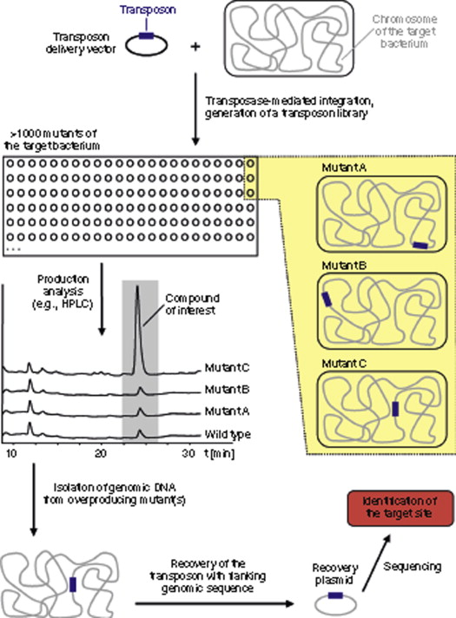
Sign in to download full-size image
Figure . Overview of the transposon strategy. Transformation of the target bacterium with the transposon delivery vector generates mutants that harbor the transposable element (shown in blue) at various random locations in the chromosome. These mutants are analyzed for production of target compounds, and strains overproducing the metabolite (in the case of the search for negative regulators) are further characterized by identifying the target gene.
In a subsequent study, genes encoding negative regulators of secondary metabolite biosynthesis in A. disciformis were analyzed. Angiococcus disciformis produces the highly efficient electron transport inhibitor myxothiazol and the tubulin destabilizer tubulysin.
Evaluation of extracts from 1200 transposon mutants by HPLC revealed six mutants in which myxothiazol production was increased by as much as 30-fold. Identifying the transposon integration sites coupled with sequencing of flanking regions showed that some of the inactivated genes encode proteins with similarity to known bacterial regulators, such as two-component systems and serine–threonine protein kinases.
However, other identified gene products did not resemble any characterized proteins. Taken together, the data show that the transposon-based strategy is a valuable tool for identifying regulatory genes of secondary metabolism, including gene loci that cannot be detected using current in silico approaches. The results also demonstrate that targeted genetic manipulation of regulatory mechanisms is a valuable adjunct to standard strain improvement methods.

MICROBIAL GROWTH AND PRESERVATION
The increase in the cell size and cell mass during the development of an organism is termed as growth. It is the unique characteristics of all organisms. The organism must require certain basic parameters for their energy generation and cellular biosynthesis. The growth of the organism is affected by both physical and Nutritional factors. The physical factors include the pH, temperature, Osmotic pressure, Hydrostatic pressure, and Moisture content of the medium in which the organism is growing.
The nutritional factors include the amount of Carbon, nitrogen, Sulphur, phosphorous, and other trace elements provided in the growth medium. Bacteria are unicellular (single cell) organisms. When the bacteria reach a certain size, they divide by binary fission, in which the one cell divides into two, two into four and continue the process in a geometric fashion. The bacterium is then known to be in an actively growing phase. To study the bacterial growth population, the viable cells of the bacterium should be inoculated on to the sterile broth and incubated under optimal growth conditions.
The bacterium starts utilising the components of the media and it will increase in its size and cellular mass. The dynamics of the bacterial growth can be studied by plotting the cell growth (absorbance) versus the incubation time or log of cell number versus time. The curve thus obtained is a sigmoid curve and is known as a standard growth curve. The increase in the cell mass of the organism is measured by using the Spectrophotometer. The Spectrophotometer measures the turbidity or Optical density which is the measure of the amount of light absorbed by a bacterial suspension.
The degree of turbidity in the broth culture is directly related to the number of microorganism present, either viable or dead cells, and is a convenient and rapid method of measuring cell growth rate of an organism. Thus the increasing the turbidity of the broth medium indicates increase of the microbial cell mass (Fig 1) .The amount of transmitted light through turbid broth decreases with subsequent increase in the absorbance value.
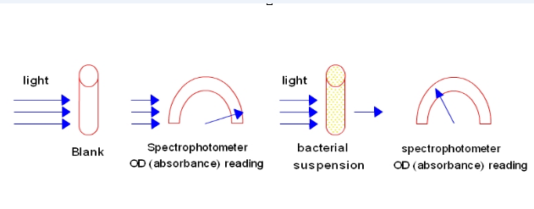
Fig 1: Absorbance reading of bacterial suspension

The growth curve has four distinct phases (Fig 2)

1. Lag phase
When a microorganism is introduced into the fresh medium, it takes some time to adjust with the new environment. This phase is termed as Lag phase, in which cellular metabolism is accelerated, cells are increasing in size, but the bacteria are not able to replicate and therefore no increase in cell mass. The length of the lag phase depends directly on the previous growth condition of the organism. When the microorganism growing in a rich medium is inoculated into nutritionally poor medium, the organism will take more time to adapt with the new environment. The organism will start synthesising the necessary proteins, co-enzymes and vitamins needed for their growth and hence there will be a subsequent increase in the lag phase. Similarly when an organism from a nutritionally poor medium is added to a nutritionally rich medium, the organism can easily adapt to the environment, it can start the cell division without any delay, and therefore will have less lag phase it may be absent.

2. Exponential or Logarithmic (log) phase
During this phase, the microorganisms are in a rapidly growing and dividing state. Their metabolic activity increases and the organism begin the DNA replication by binary fission at a constant rate. The growth medium is exploited at the maximal rate, the culture reaches the maximum growth rate and the number of bacteria increases logarithmically (exponentially) and finally the single cell divide into two, which replicate into four, eight, sixteen, thirty two and so on (That is 2⁰, 2¹, 2², 2³.........2^{n}, n is the number of generations) This will result in a balanced growth. The time taken by the bacteria to double in number during a specified time period is known as the generation time. The generation time tends to vary with different organisms. E.coli divides in every 20 minutes, hence its generation time is 20 minutes, and for Staphylococcus aureus it is 30 minutes.

3. Stationary phase
As the bacterial population continues to grow, all the nutrients in the growth medium are used up by the microorganism for their rapid multiplication. This result in the accumulation of waste materials, toxic metabolites and inhibitory compounds such as antibiotics in the medium. This shifts the conditions of the medium such as pH and temperature, thereby creating an unfavourable environment for the bacterial growth. The reproduction rate will slow down, the cells undergoing division is equal to the number of cell death, and finally bacterium stops its division completely. The cell number is not increased and thus the growth rate is stabilised. If a cell taken from the stationary phase is introduced into a fresh medium, the cell can easily move on the exponential phase and is able to perform its metabolic activities as usual.

4. Decline or Death phase
The depletion of nutrients and the subsequent accumulation of metabolic waste products and other toxic materials in the media will facilitates the bacterium to move on to the Death phase. During this, the bacterium completely loses its ability to reproduce. Individual bacteria begin to die due to the unfavourable conditions and the death is rapid and at uniform rate. The number of dead cells exceeds the number of live cells. Some organisms which can resist this condition can survive in the environment by producing endospores.

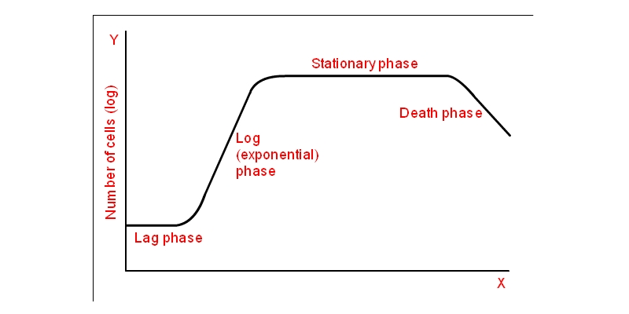
Fig 2: Different phases of growth of a bacteria

CALCULATION:
The generation time can be calculated from the growth curve(Fig 3).

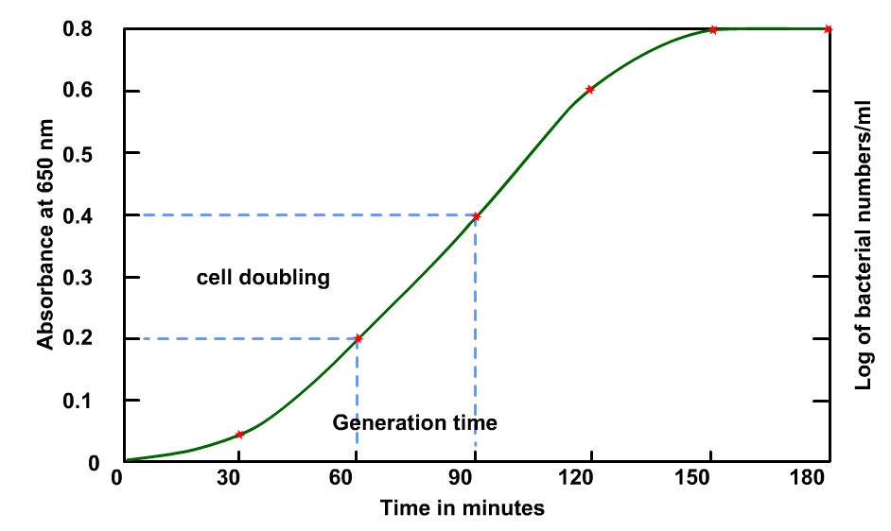

Fig 3: Calculation of generation time

The exactly doubled points from the absorbance readings were taken and, the points were extrapolated to meet the respective time axis.
Generation Time = (Time in minutes to obtain the absorbance 0.4) – (Time in minutes to obtain the absorbance 0.2)
= 90-60
= 30 minutes

Let No = the initial population number
Nt = population at time t
N = the number of generations in time t

Therefore,
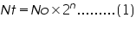

Therefore,
The growth rate can be expressed in terms of mean growth rate constant (k), the number of generations per unit time.
Mean generation time or mean doubling time (g), is the time taken to double its size.

Therefore,

Substituting equation 4 in equation 3
(Since the population doubles t= g)
Therefore,

Mean growth rate constant,
Mean generation time,
Bacteria are prokaryotic organisms that most commonly replicate by the asexual process of binary fission. These microbes reproduce rapidly at an exponential rate under favorable conditions. When grown in culture, a predictable pattern of growth in a bacterial population occurs. This pattern can be graphically represented as the number of living cells in a population over time and is known as a bacterial growth curve. Bacterial growth cycles in a growth curve consist of four phases: lag, exponential (log), stationary, and death.

Key Takeaways: Bacterial Growth Curve
- The bacterial growth curve represents the number of live cells in a bacterial population over a period of time.
- There are four distinct phases of the growth curve: lag, exponential (log), stationary, and death.
- The initial phase is the lag phase where bacteria are metabolically active but not dividing.
- The exponential or log phase is a time of exponential growth.
- In the stationary phase, growth reaches a plateau as the number of dying cells equals the number of dividing cells.
- The death phase is characterized by an exponential decrease in the number of living cells.
Bacteria require certain conditions for growth, and these conditions are not the same for all bacteria. Factors such as oxygen, pH, temperature, and light influence microbial growth. Additional factors include osmotic pressure, atmospheric pressure, and moisture availability. A bacterial population's generation time, or time it takes for a population to double, varies between species and depends on how well growth requirements are met.

Phases of the Bacterial Growth Cycle

The bacterial growth curve represents the number of living cells in a population over time. Michal Komorniczak/Wikimedia Commons/CC BY-SA 3.0
In nature, bacteria do not experience perfect environmental conditions for growth. As such, the species that populate an environment change over time. In a laboratory, however, optimal conditions can be met by growing bacteria in a closed culture environment. It is under these conditions that the curve pattern of bacterial growth can be observed.
The bacterial growth curve represents the number of live cells in a bacterial population over a period of time.
- Lag Phase: This initial phase is characterized by cellular activity but not growth. A small group of cells are placed in a nutrient rich medium that allows them to synthesize proteins and other molecules necessary for replication. These cells increase in size, but no cell division occurs in the phase.
- Exponential (Log) Phase: After the lag phase, bacterial cells enter the exponential or log phase. This is the time when the cells are dividing by binary fission and doubling in numbers after each generation time. Metabolic activity is high as DNA, RNA, cell wall components, and other substances necessary for growth are generated for division. It is in this growth phase that antibiotics and disinfectants are most effective as these substances typically target bacteria cell walls or the protein synthesis processes of DNA transcription and RNA translation.
- Stationary Phase: Eventually, the population growth experienced in the log phase begins to decline as the available nutrients become depleted and waste products start to accumulate. Bacterial cell growth reaches a plateau, or stationary phase, where the number of dividing cells equal the number of dying cells. This results in no overall population growth. Under the less favorable conditions, competition for nutrients increases and the cells become less metabolically active. Spore forming bacteria produce endospores in this phase and pathogenic bacteria begin to generate substances (virulence factors) that help them survive harsh conditions and consequently cause disease.
- Death Phase: As nutrients become less available and waste products increase, the number of dying cells continues to rise. In the death phase, the number of living cells decreases exponentially and population growth experiences a sharp decline. As dying cells lyse or break open, they spill their contents into the environment making these nutrients available to other bacteria. This helps spore producing bacteria to survive long enough for spore production. Spores are able to survive the harsh conditions of the death phase and become growing bacteria when placed in an environment that supports life.

FACTORS AFFECTING MICROBIAL GROWTH

Bacteria, like all living organisms, require an environment that is suitable for growth. This environment must meet several different factors that support bacterial growth. Such factors include oxygen, pH, temperature, and light requirements. Each of these factors may be different for different bacteria and limit the types of microbes that populate a particular environment.
Bacteria can be categorized based on their oxygen requirement or tolerance levels. Bacteria that can not survive without oxygen are known as obligate aerobes.
These microbes are dependent upon oxygen, as they convert oxygen to energy during cellular respiration. Unlike bacteria that require oxygen, other bacteria can not live in its presence. These microbes are called obligate anaerobes and their metabolic processes for energy production are halted in the presence of oxygen.
Other bacteria are facultative anaerobes and can grow with or without oxygen. In the absence of oxygen, they utilize either fermentation or anaerobic respiration for energy production. Aerotolerant anerobes utilize anaerobic respiration but are not harmed in the presence of oxygen. Microaerophilic bacteria require oxygen but only grow where oxygen concentration levels are low. Campylobacter jejuni is an example of a microaerophilic bacterium that lives in the digestive tract of animals and is a major cause of foodborne illness in humans.

Bacterial Growth and pH
Helicobacter pylori are microaerophilic bacteria found in the stomach. They are neutrophiles that secrete an enzyme that neutralizes stomach acid. Science Picture Co/Getty Images
Another important factor for bacterial growth is pH. Acidic environments have pH values that are less that 7, neutral environments have values at or near 7, and basic environments have pH values greater than 7. Bacteria that are acidophiles thrive in areas where the pH is less than 5, with an optimal growth value close to a pH of 3. These microbes can be found in locations such as hot springs and in the human body in acidic areas such as the vagina.
The majority of bacteria are neutrophiles and grow best in sites with pH values close to 7. Helicobacter pylori is an example of a neutrophile that lives in the acidic environment of the stomach. This bacterium survives by secreting an enzyme that neutralizes stomach acid in the surrounding area.
Alkaliphiles grow optimally at pH ranges between 8 and 10. These microbes thrive in basic environments such as alkaline soils and lakes.

Bacterial Growth and Temperature
New Zealand's Champagne Pool is a hot spring that contains a community of thermophilic and acidophilic microorganisms whose distribution relates to the temperature and chemical environment. Simon Hardenne/Biosphoto/Getty Images
Temperature is another important factor for bacterial growth. Bacteria that grow best in cooler environments are called psycrophiles. These microbes prefer temperatures ranging between 4°C and 25°C (39°F and 77°F). Extreme psycrophiles thrive in temperatures below 0°C/32°F and can be found in places such as arctic lakes and deep ocean waters.
Bacteria that thrive in moderate temperatures (20-45°C/68-113°F) are called mesophiles. These include bacteria that are part of the human microbiome which experience optimum growth at or near body temperature (37°C/98.6°F).
Thermophiles grow best in hot temperatures (50-80°C/122-176°F) and can be found in hot springs and geothermal soils. Bacteria that favor extremely hot temperatures (80°C-110°C/122-230°F) are called hyperthermophiles.

Bacterial Growth and Light
Cyanobacteria (blue) are photosynthesizing bacteria that are found in most habitats where water is present. Several spores (pink) are also seen. Steve Gschmeissner/Science Photo Library/Getty Images
Some bacteria require light for growth. These microbes have light-capturing pigments that are able to gather light energy at certain wavelengths and convert it to chemical energy. Cyanobacteria are examples of photoautotrophs that require light for photosynthesis. These microbes contain the pigment chlorophyll for light absorption and oxygen production through photosynthesis. Cyanobacteria live in both land and aquatic environments and can also exist as phytoplankton living in symbiotic relationships with fungi (lichen), protists, and plants.
Other bacteria, such as purple and green bacteria, do not produce oxygen and utilize sulfide or sulfur for photosynthesis. These bacteria contain bacteriochlorophyll, a pigment capable of absorbing shorter wavelengths of light than chlorophyll. Purple and green bacteria inhabit deep aquatic zones.

UNIT –II

Fermentor (Bioreactor): History, Design and Its Construction
1. Meaning of Fermentor
2. History of Fermentors
3. Design
4. Construction
5. Use of Computer in Fermentor
6. Types.

Meaning of Fermentor:
A fermentor (bioreactor) is a closed vessel with adequate arrangement for aeration, agitation, temperature and pH control, and drain or overflow vent to remove the waste biomass of cultured microorganisms along-with their products.
A fermentor is used for commercial production in fermentation industries and is a device in which a substrate of low value is utilized by living cells or enzymes to generate a product of higher value. Fermentors are extensively used for food processing, fermentation, waste treatment, etc.

History of Fermentors:
De Beeze and Liebmann (1944) used the first large scale (above 20 litre capacity) fermentor for the production of yeast. But it was during the first world war, a British scientist named Chain Weizmann (1914-1918) developed a fermentor for the production of acetone.
Since importance of aseptic conditions was recognised, hence steps were taken to design-and construct piping, joints and valves in which sterile conditions could be achieved and manufactured when required.
For the first time, large scale aerobic fermentors were used in central Europe in the year 1930’s for the production of compressed yeast. The fermentor consisted of a large cylindrical tank with air introduced at the base via network of perforated pipes.
In later modifications, mechanical impellers were used to increase the rate of mixing and to break up and disperse the air bubbles. This process led to the compressed air requirements. Baffles on the walls of the vessels prevented forming a vortex in the liquid. In the year 1934, Strauch and Schmidt patented a system in which the aeration tubes were introduced with water and steam for cleaning and sterilization.
The decision to use submerged culture technique for penicillin production, where aseptic conditions, good aeration and agitation were essential, was probably a very important factor in forcing the development of carefully designed and purpose-built fermentation vessels.
In 1943, when the British Govt. decided that surface culture was inadequate, none of the fermentation plants were immediately suitable for deep fermentation. The first pilot fermentor was erected in India at Hindustan Antibiotic Ltd., Pimpri, Pune in the year 1950.

Design of Fermentors:
All bioreactors deal with heterogeneous systems dealing with two or more phases, e.g., liquid, gas, solid. Therefore, optimal conditions for fermentation necessitate efficient transfer of mass, heat and momentum from one phase to the other. Chemical engineering principles are employed for design and operation of bioreactors.
A bioreactor should provide for the following:
(i) Agitation (for mixing of cells and medium),
(ii) Aeration (aerobic fermentors); for O₂ supply,
(iii) Regulation of factors like temperature, pH, pressure, aeration, nutrient feeding, liquid level etc.,
(iv) Sterilization and maintenance of sterility, and
(v) Withdrawal of cells/medium (for continuous fermentors).
Modern fermentors are usually integrated with computers for efficient process monitoring, data acquisition, etc.
Generally, 20-25% of fermentor volume is left unfilled with medium as “head space” to allow for splashing, foaming and aeration. The fermentor design varies greatly depending on the type and the fermentation for which it is used. Bioreactors are so designed that they provide the best possible growth and biosynthesis for industrially important cultures and allow ease of manipulation for all operations.

Size of Fermentors:
The size of fermentors ranges from 1-2 litre laboratory fementors to 5,00,000 litre or, occasionally, even more, fermentors of upto 1.2 million litres have been used. The size of the fermentor used depends on the process and how it is operated. A summary of fermentor or size of fermentor (litres) Industrial product sizes for some common microbial fermentations is given in Table 39.6.
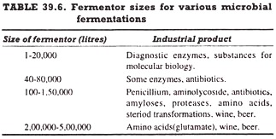

Construction of Fermentors:
Industrial fermentors can be divided into two major classes, anaerobic and aerobic. Anaerobic fermentors require little special equipment except for removal of heat generated during the fermentation process, whereas aerobic fermentors require much more elaborate equipment to ensure that mixing and adequate aeration are achieved.

Since most industrial fermentation process are aerobic, the construction of a typical aerobic fermentor (Fig. 39.1) is the following:
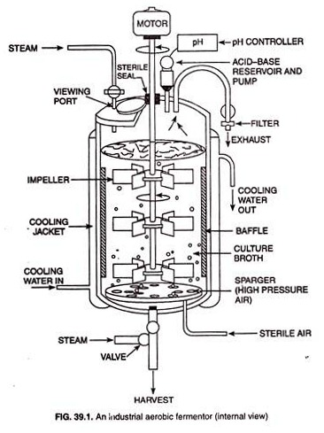

1. Cooling Jacket:
Large-scale industrial fermentors are almost always constructed of stainless steel. A fermentor is a large cylinder closed at the top and the bottom and various pipes and valves are fitted into it. The fermentor is fitted externally with a cooling jacket through which steam (for sterilization) or cooling water (for cooling) is run.
Cooling jacket is necessary because sterilization of the nutrient medium and removal of the heat generated are obligatory for successful completion of the fermentation in the fermentor. For very large fermentors, insufficient heat transfer takes place through the jacket and therefore, internal coils are provided through which either steam or cooling water is run.

2. Aeration System:
Aeration system is one of the most critical part of a fermentor. In a fermentor with a high microbial population density, there is a tremendous oxygen demand by the culture, but oxygen being poorly soluble in water hardly transfers rapidly throughout the growth medium.
It is necessary, therefore, that elaborate precautions are taken using a good aeration system to ensure proper aeration an oxygen availability throughout the culture. However, two separate aeration devices are used to ensure proper aeration in fermentor. These devices are sparger and impeller.
The sparger is typically just a series of holes in a metal ring or a nozzle through which filter-sterilized air (or oxygen-enriched air) passes into the fermentor under high pressure. The air enters the fermentor as a series of tiny bubbles from which the oxygen passes by diffusion into the liquid culture medium.
The impeller (also called agitator) is an agitating device necessary for stirring of the fermenter.
The stirring accomplishes two things:
(i) It mixes the gas bubbles through the liquid culture medium and
(ii) It mixes the microbial cells through the liquid culture medium. In this way, the stirring ensures uniform access of microbial cells to the nutrients.
The size and position of the impeller in the fermentor depends upon the size of the fermentor. In tall fermentors, more than one impeller is needed if adequate aeration and agitation is to be obtained. Ideally, the impeller should be 1/3 of the fermentors diameter fitted above the base of the fermentor. The number of impeller may vary from size to size to the fermentor.

3. Baffles:
The baffles are normally incorporated into fermentors of all sizes to prevent a vortex and to improve aeration efficiency. They are metal strips roughly one-tenth of the fermentors diameter and attached radially to the walls.

4. Controlling Devices for Environmental Factors:
In any microbial fermentation, it is necessary not only to measure growth and product formation but also to control the process by altering environmental parameters as the process proceeds. For this purpose, various devices are used in a fermentor. Environmental factors that are frequently controlled includes temperature, oxygen concentration, pH, cells mass, levels of key nutrients, and product concentration.

Use of Computer in Fermentor:
Computer technology has produced a remarkable impact in fermentation work in recent years and the computers are used to model fermentation processes in industrial fermentors. Integration of computers into fermentation systems is based on the computers capacity for process monitoring, data acquisition, data storage, and error-detection.
Some typical, on-line data analysis functions include the acquisition measurements, verification of data, filtering, unit conversion, calculations of indirect measurements, differential integration calculations of estimated variables, data reduction, tabulation of results, graphical presentation of results, process stimulation and storage of data.
The three types of bioreactors are: (1) Mechanically Agitated Bioreactors (2) Pneumatically Agitated Bioreactors and (3) Wave Bioreactors.

Type # 1. Mechanically Agitated Bioreactors:
The mechanically agitated bioreactors are most commonly used for large-scale culture of plant, animal and microbial cells. In this type of bioreactor, the medium is agitated with the help of a mechanically driven impeller. Various types of impellers are in use, depending upon the requirement. Two traditional types of impeller used in this system are shown in figure. 28.3.
Flat blade turbine impeller with high speed is generally used in bacterial culture. High agitation breaks the incoming air into small bubbles. Since plant cells cannot tolerate high shear conditions and mixing of air may be a more serious problem with plant cell cultures, an alternate impeller, capable of inducing low shear have been used.
Marine propeller impeller is better suited for low shear mixing . It provides axial mixing of the medium. On the other hand, flat-blade turbine promotes radial mixing. For large-scale systems, neither of these two types of impeller is used.
Alternatively, low-shear impellers (e.g., paddle and helical types) have been shown to more useful for plant cell cultivation. Since low agitation is insufficient to break incoming gas into small bubbles, incoming gas stream is dispersed as fine bubbles using an appropriate gas distributor. Enrichment of incoming gas with oxygen is beneficial.
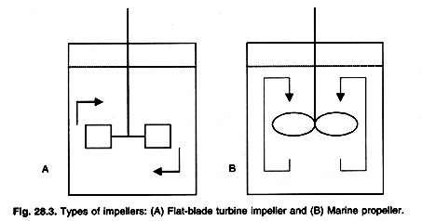

Type # 2. Pneumatically Agitated Bioreactors:
Pneumatically agitated bioreactors are of two type’s viz., the bubble column and air-lift (Fig. 28.4. These bioreactors are tall and thin as compare to mechanical agitation type reactors. Typically, the height-to-diameter ratio in pneumatically agitated bioreactors is high. In bubble columns, air is bubbled at the base of the column and medium is agitated with this.

In air-lift bioreactors, gas is sparged in the riser section and after the gas is disengages at the top of the column; the medium then flows downward in the down-corner section. These two sections may be separated using a baffle, a concentric cylinder, or an external loop. Circulation in the air-lift bioreactor promotes better mixing and therefore, has advantages in suspending cells and clumps more uniformly. But, in large-scale air-lift bioreactors, oxygen transfer rate is low in the down-corner section.
It should be emphasized that the performance of an air-lift bioreactor is strongly dependent upon the geometry of the system. Ratio of the cross-section area of the riser section and down- corner sections is of special importance because this ratio affects mixing and oxygen transfer.
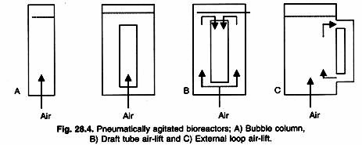

Type # 3. Wave Bioreactor:
Wave bioreactor consists of a pre-sterilized flexible, plastic chamber that is partially filled with medium and inoculated with cells. The remaining part of the chamber is inflated with air. The air is continuously passaged through the head space during the cultivation mixing and mass transfers are achieved by rocking the chamber back and forth.
This rocking motion generates waves at the liquid air interface, greatly enhancing oxygen transfer. The concept of using rocking for agitation is used extensively for the agitation of liquids in laboratory assay plates and gels. In this disposable bioreactor, the cultivation chamber is discarded after harvest, eliminating any need for cleaning or sterilization.
The chambers are made of FDA approved biocompatible polyethylene. Special ports were developed to allow sterile addition or to withdraw samples without the need to place the bioreactor inside the laminar air flow cabinet. Theses bioreactors are available up to a working volume of 500L and due to wave motion known as Wave Bioreactor (Fig. 28.5).
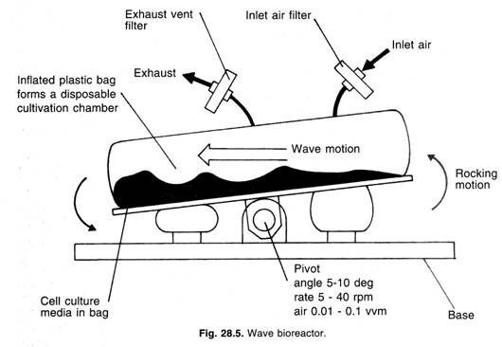
Some examples of Fermenters are:
- 1. Stirred Tank Reactors
- 2.Tower Fermenter
- 3.Bubble column Bioreactors
- 4.Gas/Airlift Bioreactors
- 5.Packed-Bed Bioreactors
- 6.Batch Bioreactors
- 7.Fluidized Bed Bioreactor
8. Membrane Bioreactors
- 9.Photo-Bioreactors
- 10.Wave Bioreactors
- 11.Sparged Tank Fermenters
- 12.Rotary Drum Bioreactors
- 13.Deep Jet Fermenter
- 14.Mist Bioreactors
- 15.Cyclone Column Fermenter

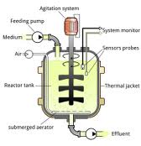
STIRRED TANK FERMENTER
Microbial fermentations received prominence during 1940's namely for the production of life saving antibiotics. Stirred tank reactor is the choice for many (more than 70%) though it is not the best. Stirred tank reactor’s have the following functions: homogenization, suspension of solids, dispersion of gas-liquid mixtures, aeration of liquid and heat exchange. The Stirred tank reactor is provided with a baffle and a rotating stirrer is attached either at the top or at the bottom of the bioreactor. The typical decision variables are: type, size, location and the number of impellers; sparger size and location. These determine the hydrodynamic pattern in the reactor, which in turn influence mixing times, mass and heat transfer coefficients, shear rates etc. The conventional fermentation is carried out in a batch mode. Since stirred tank reactors are commonly used for batch processes with slight modifications, these reactors are simple in design and easier to operate. Many of the industrial bioprocesses even today are being carried out in batch reactors though significant developments have taken place in the recent years in reactor design, the industry, still prefers stirred tanks because in case of contamination or any other substandard product formation the loss is minimal. The batch stirred tanks generally suffer due to their low volumetric productivity. The downtimes are quite large and unsteady state fermentation imposes stress to the microbial cultures due to nutritional limitations. The fed batch mode adopted in the recent years eliminates this limitation. The Stirred tank reactor’s offer excellent mixing and reasonably good mass transfer rates. The cost of operation is lower and the reactors can be used with a variety of microbial species. Since stirred tank reactor is commonly used in chemical industry the mixing concepts are well developed. Stirred tank reactor with immobilized cells is not favored generally due to attrition problems; however by separating the zone of mixing from the zone of cell culturing one can successfully operate the system.
Tower Fermenters:
Tower fermenters have a gradient of yeast and a gradient of wort gravity which goes up the tower (making the tower fermenter a heterogeneous system).
The yeast settles down and forms a plug. They would consume the sugar from the wort and the product would flow upwards. The inlet is present at the bottom and the outlet is at upwards. The purpose of this multi-stage fermenter is to provide a flow of process with the help of gravity. The raw materials, water, and malt are elevated to the top of fermenter first and then they would come down due to gravity.
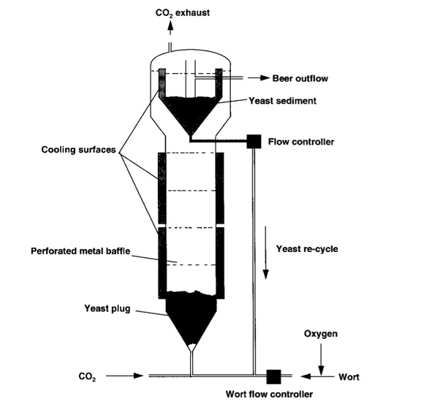
Image
It also carries insulating jackets for maintaining the optimum temperature conditions for the growth of organism.
Bubble Column Bioreactors:
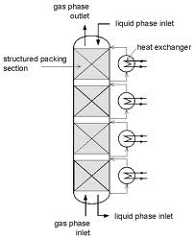
BUBBLE COLUMN FERMENTER
Bubble column fermenter is a simplest type of tower fermenter consisting of a tube which is air sparged at the base.
It is an elongated non-mechanically stirred fermenter with an aspect ratio of 6:1. This type of fermenter was used for citric acid production.

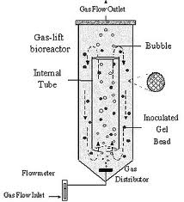
.AIR-LIFT FERMENTER
Airlift fermenter (ALF) is generally classified as pneumatic reactors without any mechanical stirring arrangements for mixing. The turbulence caused by the fluid flow ensures adequate mixing of the liquid. The draft tube is provided in the central section of the reactor. The introduction of the fluid (air/liquid) causes upward motion and results in circulatory flow in the entire reactor. The air/liquid velocities will be low and hence the energy consumption is also low. ALFs can be used for both free and immobilized cells. There are very few reports on ALFs for metabolite production. The advantages of Airlift reactors are the elimination of attrition effects generally encountered in mechanical agitated reactors. It is ideally suited for aerobic cultures since oxygen mass transfer coefficient are quite high in comparison to stirred tank reactors. This is ideal for SCP production from methanol as carbon substrate. This is used mainly
to avoid excess heat produced during mechanical agitation.

Packed Bed Reactors:
In this type of bioreactors, a solid matrix with biocatalyst on the surface/inside of the material, are packed in the column. The nutrient broth with the substrate is passes over the immobilised catalyst which would convert it to product. The product is removed from the solution and solution is recycled. The biocatalyst can be enzymes/microbes or any other material. The flow rate of the nutrient is increased to increase the concentration of nutrient in the bioreactors.
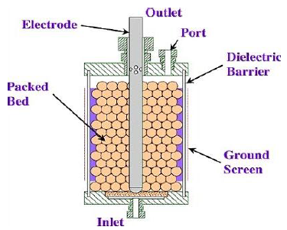
Image: Packed Bed Reactors
These reactors do not allow the accumulation of the product and hence can be used for the bioreactions in which product causes inhibition of the reaction. The maintenance of the pH is difficult in these reactors as the solution is not mixed properly

Batch Reactor:
They are the classic bioreactors with an agitator, pH regulator, temperature regulator, biosensors to measure changes in the suspension, inlet, sample outlet, forth regulator, jacket, etc. These reactors are widely used for the batch process. One batch at a time is allowed to react and after formation of the product, the next batch would begin.
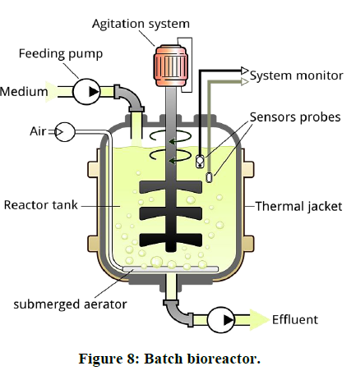
Fluidized Bed Reactors:

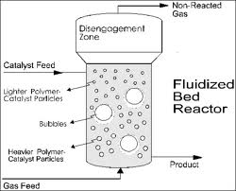
FLUIDISED BED BIOREACTOR
Fluidized bed bioreactors (FBB) have received increased attention in the recent years due to their advantages over other types of reactors. Most of the FBBs developed for biological systems involving cells as biocatalysts are three phase systems (solid, liquid & gas). The fundamentals of three phase fluidization phenomena have been comprehensively covered in chemical engineering literature. The FBBs are generally operated in co-current upflow with liquid as continuous phase and other more unusual configurations like the inverse three phase fluidized bed or gas solid fluidized bed are not of much importance. Usually fluidization is obtained either by external liquid re-circulation or by gas fed to the reactor. In the case of immobilized enzymes the usual situation is of two-phase systems involving solid and liquid but the use of aerobic biocatalyst necessitate introduction of gas (air) as the third phase. A differentiation between the three phase fluidized bed and the airlift bioreactor would be made on the basis that the latter have a physical internal arrangement (draft tube), which provides aerating and non-aerating zones. The circulatory motion of the liquid is induced due to the draft tube.
Basically the particles used in FBBs can be of three different types: (i) inert core on which the biomass is created by cell attachment. (ii) Porous particles in which the biocatalyst is entrapped.(iii) Cell aggregates/ flocs (self-immobilization). In comparison to conventional mechanically stirred reactors, FBBs provide a much lower attrition of solid particles. The biocatalyst concentration can significantly be higher and washout limitations of free cell systems
can be overcome. In comparison to packed bed reactors FBBs can be operated with smaller size particles without the drawbacks of clogging, high liquid pressure drop, channeling and bed compaction. The smaller particle size facilitates higher mass transfer rates and better mixing. The volumetric productivity attained in FBBs is usually higher than in stirred tank and packed bed bioreactors. There are several successful examples of using FBBs in bioprocess development.

Rotary Drum reactor:
In Rotary vacuum filter drum, a drum rotating is placed in a tub of liquid to be filtered/fermented.
The technique is well suited to slurries, and liquids with a high solid content, which could clog other forms of filter. The drum is pre-coated with a filter aid, typically of diatomaceous earth (DE) or Perlite. After pre-coat has been applied, the liquid to be filtered is sent to the tub below the drum.
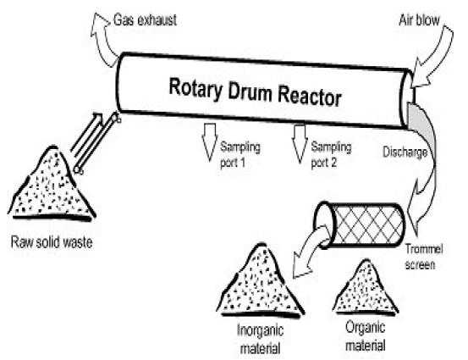
Image: Drum reactors
When the drum rotates through the liquid the liquid is sucked into it due to the vacuum through the filter media to the internal portion of the drum. The solids onto the drum pre-coats the surface and the filtrate pumped away.
This type of reactors give better aeration and mixing due to rotation of the suspension liquid inside the drum. These are commonly used for the solid-substrate fermentation.
Photobioreactors
These bioreactors are used for the bioreactions which occur in the presence of sunlight or artificial illumination. These bioreactors are made up of glass or transparent plastic. Products such as Beta-carotene and astaxanthin can be produced using photobioreactors. Phototropic microbes can be cultured in such bioreactors.
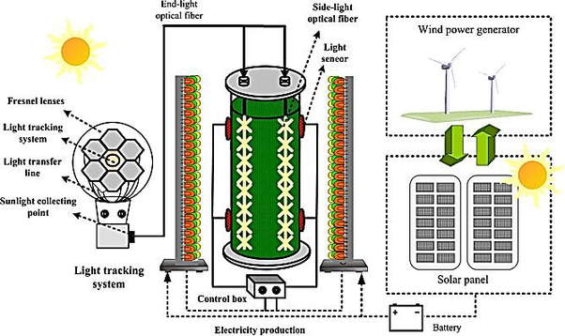
Image: Photobioreactors
These bioreactors consist of an array of glass or tubes which are meant to capture light. The microbial cultures are circulated into the tube by airlift or centrifugation pumps. The operation of photo bioreactors is continuous in nature and temperature is maintained at 35-40˚C.

Types of Fermentation Process

The fermentation unit in industrial microbiology is similar to a chemical plant in the chemical industry. A fermentation process is a biological process and, therefore, has requirements of sterility and use of cellular enzymatic reactions instead of chemical reactions aided by inanimate catalysts, sometimes operating at elevated temperature and pressure. Industrial fermentation processes may be divided into two main types, with various combinations and modifications.

Some of the most important types of fermentation are as follows:
- Solid State Fermentation
- Submerged Fermentation
- Anaerobic Fermentation
- Aerobic Fermentation
- Immobilized Cell Bioreactors
- Immobilized Enzyme Bioreactors.

- Sub-merged Fermentation (SLF) (Submerged Liquid Fermentation)

(a) Batch Fermentation Process

Fermentation is derived from the latin word "fervere" which means to boil, a process typically manifested by the action of yeasts on malted grain during the production of alcoholic beverages. Fermentation could be regarded as a metabolic process involved in the conversion of sugar to acids, gases and/or alcohol. The growth of microorganisms generally results in metabolite production but specific metabolite requires optimal cultural conditions at a particular growth rate for save delivery. A closed loop system where yeasts or bacteria grow in a culture media and an additional material is not added such is called BATCH CULTURE. Growth in a batch culture undergo some series of steps. There is the initial phase that seems to record no growth, the lag phase, followed by the gradual increase that builds up into constant, maximum rate often referred to as the logarithmic phase or exponential phase.

A tank of fermenter is filled with the prepared mash of raw materials to be fermented. The temperature and pH for microbial fermentation is properly adjusted, and occasionally nutritive supplements are added to the prepared mash. The mash is steam sterilized in a pure culture process. The inoculum of a pure culture is added to the fermenter, from a separate pure culture vessel. Fermentation proceeds, and after the proper time the contents of the fermenter, are taken out for further processing. The fermenter is cleaned and the process is repeated. Thus each fermentation is a discontinuous process divided into batches
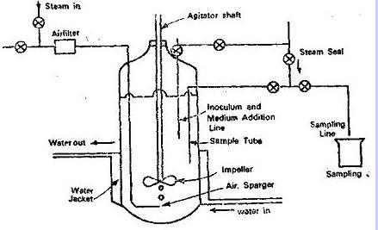

(b) Continuous Fermentation Process

Growth of microorganisms during batch fermentation conforms to the characteristic growth curve, with a lag phase followed by a logarithmic phase. This, in turn, is terminated by progressive decrement in the rate of growth until the stationary phase is reached. This is because of limitation of one or more of the essential nutrients and /or production of inhibitory substances. In continuous fermentation, the substrate is added to the fermenter continuously at a fixed rate. This maintains the organisms in the logarithmic growth phase. The fermentation products are taken out continuously. The continuous fermentation is also referred to as chemostat.

(c) Fed-Batch Culture:

When a batch culture is subsequently led with fresh nutrient medium without removing the growing microbial culture, it is called fed-batch culture. Fed-batch culture allows one to supplement the medium with such nutrients that are depleted or that may be needed for the terminal stages of the culture, e.g., production of secondary metabolites.

Therefore, the volume of a fed- batch culture increases with time. Fed-batch cultures achieve higher cell densities than batch cultures. It is used when high substrate concentration causes growth inhibition. It allows the substrate to be used at lower nontoxic levels, followed by subsequent feeding. It allows the maximum production of cellular metabolites by the culture.

2. Solid State Fermentation (SSF)

Solid-state fermentation (SSF) processes can be defined as “the growth of microorganisms (mainly fungi) on moist solid materials in the absence of free-flowing water”.
Semi Solid OR Solid State Methods - In this, the culture medium is impregnated in a carrier such as bagasse, wheat bran, potato pulp, etc. and the organism is allowed to grow on this. This method allows greater surface area for growth. The production of the desirable substance and the recovery is generally easier and satisfactory. In the development of a fermentation process, the composition of the culture medium plays a major role and will determine to a very great extent the level of end product. For example, a culture medium containing sucrose enables better production of citric acid by A. niger than any other carbohydrate. The pH, temperature of incubation, aeration etc., are all important factors in fermentations and these have to be optimized for each type of fermentation. Emphasis is generally placed on the use of cheap raw materials so that the cost of production is low. In such fermentations, microbial growth and product formation occur at the surface of solid substrates. Examples of such fermentations are mushroom cultivation, mold ripened cheeses, starter cultures, etc. More recently, this approach has been used for the production of extracellular enzymes, certain valuable chemicals, fungal toxins, and fungal spores (used for biotransformation).Traditional substrates are several agricultural products, rice, wheat, maize, soybean, etc. The substrate provides a rich and complex source of nutrients, which may or may not need to be supplemented. Such substrates selectively support mycelial organisms, which can grow at high nutrient concentrations and produce a variety of extracellular enzymes, e.g., a large number of filamentous fungi, and a few bacteria (Actinomycetes and one strain of Bacillus).

According to the physical state, solid state fermentations are divided into two groups: (i) low moisture solids fermented without or with occasional/continuous agitation, and (ii) suspended solids fermented in packed columns, through which liquid is circulated. The fungi used for solid state fermentations are usually obligate aerobes. Solid state fermentations on large scale use stationary or rotary trays. Temperature and humidity controlled air is circulated through the stacked solids. Less frequently, rotary drum type fermenters have been used. Solid state fermentations offer certain unique advantages, but suffer from some important disadvantages. However, commercial application of this process for biochemical production is chiefly confined to Japan.

Solid State Fermentation, SSF
The following are some the advantages of SSF over submerge liquid fermentation (SLF):

- Comparative studies between submerged liquid fermentation (SLF) and SSF claim higher yields than those obtained in the corresponding submerged cultures

- The low availability of water reduces the possibilities of contamination by bacteria and yeast. This allows working in aseptic conditions in some cases.

- Similar environment conditions to those of the natural habitats for fungi, which constitute the main group of microorganisms used in SSF.

- Higher levels of aeration, especially adequate in those processes demanding an intensive oxidative metabolism.

- The inoculation with spores (in those processes that involve fungi) facilitates its uniform dispersion through the medium.

- Culture media are often quite simple. The substrate usually provides all the nutrients necessary for growth.

- Simple design reactors, with few spatial requirements can be used due to the concentrated nature of the substrates.

- Low energetic requirements (in some cases autoclaving or vapour treatment, mechanical agitation and aeration are not necessary).

- Small volumes of polluting effluents. Fewer requirements of dissolvents are necessary for product extraction due to their high concentration.

- The low moisture availability may favour the production of specific compounds that may not be produced or may be poorly produced in SLF.

- In some cases, the products obtained have slightly different properties (e.g. more Thermo-tolerance) when produced in SSF in comparison to SLF.

- Due to the concentrated nature of the substrate, smaller reactors in SSF with respect to SLF can be used to hold the same amounts of substrate

In the same way, SSF has some disadvantages when compared with the submerged-liquid cultures:

- Only microorganisms that can grow at low moisture levels can be used.

- Usually the substrates require pre-treatment (size reduction by grinding, rasping or chopping, homogenisation, physical, chemical or enzymatic hydrolysis, cooking or vapour treatment).

- Biomass determination is very difficult.

- The solid nature of the substrate causes problems in the monitoring of the process parameters (pH, moisture content, and substrate, oxygen and biomass concentration).
- Agitation may be very difficult. For this reason static conditions are preferred.
- Frequently needs high inoculum volumes.
- any important basic scientific and engineering aspects are poorly characterized. Information about the design and operation of reactors on a large scale is scarce.
- Possibility of contamination by undesirable fungi.
- The removal of metabolic heat generated during growth may be very difficult.
- Extracts containing products obtained by leaching of fermented solids are often viscous of nature.
- sssssssMass transfer limited to diffusion.
- In some SSF, aeration can be difficult due to the high solids concentration.
- Spores have longer lag times due to the need for germination.
- Cultivation times are longer than in SLF

3. Anaerobic Fermentation
Basically a fermenter designed to operate under microacrophilic or anaerobic conditions will be the same as that designed to operate under aerobic conditions, except that arrangements for intense agitation and aeration are unnecessary Many anaerobic fermentations do, however, require mild aeration for the initial growth phase, and sufficient agitation for mixing and maintenance of temperature. In anaerobic fermentation, a provision for aeration is usually not needed. But in some cases, aeration may be needed initially for inoculum build up. In most

cases, a mixing device is also unnecessary; while in some cases initial mixing of the inoculum is necessary. Once the fermentation begins, the gas produced in the process generates sufficient mixing. The air present in the headspace of the fermentor should be replaced by CO2, H2, N2 or a suitable mixture of these; this is particularly important for obligate anaerobes like Clostridium. The fermentation usually liberates CO2 and H2, which are collected and used, e.g., CO2 for making dry ice and methanol, and for bubbling into freshly inoculated fermenters. In case of acetogens and other gas utilizing bacteria, O2 free sterile CO2 or other gases are bubbled through the medium. Acetogens have been cultured in 400 Litre-fermenters by bubbling sterile CO2 and 3kg cells could be harvested in each run.

Recovery of products from anaerobic fermenters does not require anaerobic conditions. But many enzymes of such organisms are highly O2, sensitive. Therefore, when recovery of such enzymes is the objective, cells must be harvested under strictly anaerobic conditions.

4. Aerobic Fermentation

A number of industrial processes, although called 'fermentations', are carried on by microorganisms under aerobic conditions. In older aerobic processes it was necessary to furnish a large surface area by exposing fermentation media to air. In modern fermentation processes aerobic conditions are maintained in a closed fermenter with submerged cultures. The contents of the fermenter are agitated with an impeller and aerated by forcing sterilized air The main feature of aerobic fermentation is the provision for adequate aeration; in some cases, the amount of air needed per hour is about 60-times the medium volume. Therefore, bioreactors used for aerobic fermentation have a provision for adequate supply of sterile air, which is generally sparged into the medium. In addition, these fermenters may have a mechanism for stirring and mixing of the medium and cells. Aerobic fermenters may be either of the (i) stirred tank type in which mechanical motor driven stirrers are provided or (ii) of air lift type in which no mechanical stirrers are used and the agitation is achieved by the air bubbles generated by the air supply. Generally, these bioreactors are of closed or batch type, but continuous flow reactors are also used, such reactors provide a continuous source of cells and are also suitable for product generation when the product is released into the medium

5. Surface Culture Method

In this method the organism is allowed to grow on the surface of a liquid medium without agitation. After an appropriate incubation period the culture filtrate is separated from the cell mass and is processed to recover the desirable product. Sometimes the biomass may be reused. Examples of such fermentations are the alcohol production, the beer production and citric acid production. This method is generally time consuming and needs large, area or space.
6. Submerged Culture Method

In this process, the organism is grown in a liquid medium which is vigorously aerated and agitated in large tanks called fermentors. The fermentor could be either an open tank or a closed tank and may be a batch type or a continuous type and are generally made of non-corrosive type of metal or glass lined or of wood. In batch fermentation, the organism is grown in a known amount of culture medium for a defined period of time and then the cell mass is separated from the liquid before further processing while in the continuous culture, the culture medium is withdrawn depending on the rate of product formation and the inflow of fresh medium. Most fermentation industries today use the submerged process for the production of microbial products.
For successful fermentation, it is absolutely essential to ensure:
a. Sterility of the media containing the nutrients.
b. Sterility of incoming and outgoing air.
c. Sterility of the bioreactor.
d. Prevention of contamination during fermentation.
A bioreactor can be sterilized by destroying the organisms by heat/chemicals/radiation or sometimes by physical procedures such as filtration.
Sterilization of media and air are discussed below:

1. Sterilization of Culture Media:
The constituents of culture media, water and containers contribute to the contamination by vegetative cells and spores. The media must be free from contamination before use in fermentation. Sterilization of the media is most commonly achieved by applying heat and to a lesser extent by other means (physical methods, chemical treatment, and radiation).
Heat sterilization:
Heat is the most widely used sterilization technique. The quality and quantity of contamination (i.e., the type and load of microorganisms), composition of the media and its pH and size of the suspended particles are the important factors that influence the success of heat sterilization.
In general, vegetative cells are destroyed at lower temperature in a short time (around 60°C in 5-10 minutes). However, destruction of spores requires higher temperature and relatively longer time (around 80°C for 15-20 minutes). Spores of Bacillus stearothermophilus are the most heat resistant. In fact, this organism is exploited for testing the sterility of fermentation equipment.
Physical methods:
The physical methods such as filtration, centrifugation, and adsorption (to ion-exchangers or activated carbon) are in use. Among these, filtration is most widely used. Certain constituents (vitamins, blood components, antibiotics) of culture media are heat labile and therefore, are destroyed by heat sterilization. Such components of the medium are completely dissolved (absolutely essential or else they will be removed along with microorganisms) and then subjected to filter sterilization.
There are a couple of limitations of filtration technique:
1. Application of high pressure in filtration is unsuitable for industries.
2. Some of the media components may be lost form the media during filtration.
Sometimes, a combination of filtration and heat sterilization are applied. For instance, the water used for media preparation is filtered while concentrated nutrient solution is subjected to heat sterilization. The filtered water is now added for appropriate dilution of the media. The chemical methods (by using disinfectants) and radiation procedures (by using UV rays, y rays, X-rays) are not commonly used for media sterilization.
Batch sterilization:
The culture media are subjected to sterilization at 121°C in batch volumes, in the bioreactor. Batch sterilization can be done by injecting the steam into the medium (direct method) or injecting the steam into interior coils (indirect method). For the direct batch sterilization, the steam should be pure, and free from all chemical additives (that usually come from steam manufacturing process).
There are two disadvantages of batch sterilization:
1. Damage to culture media:
Alteration in nutrients, change in pH and discolouration of the culture media are common.
2. High energy consumption:
It takes a few hours (2-4 hrs.) for the entire contents of the bioreactor to attain the requisite temperature (i.e. 120°C). Another 20-60 minutes for the actual process of sterilization, followed by cooling for 1-2 hours. All this process involves wastage of energy, and therefore batch sterilization is quite costly.
Continuous sterilization:
Continuous sterilization is carried out at 140°C for a very short period of time ranging from 30 to 120 seconds. (This is in contrast to the batch fermentation done at 121°C for 20-60 minutes). This is based on the principle that the time required for killing microorganisms is much shorter at higher temperature. Continuous sterilization is carried out by directly injecting the steam or by means of heat exchangers.
In either case, the temperature is very quickly raised to 140°C, and maintained for 30- 120 seconds. The stages of continuous sterilization process and the corresponding temperatures are depicted in Fig. 19.7. The different stages are— exchanger, heater, heat maintenance unit, recovery of residual heat, cooling and fermenter.
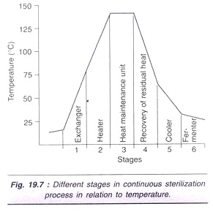
In the continuous sterilization process, 3 types of heat exchangers are used. The first heat exchanger raises temperature to 90-1 20°C within 20-30 seconds. The second exchanger further raises temperature to 140°C and maintains for 30-120 seconds. The third heat exchanger brings down the temperature by cooling in the next 20-30 seconds. The actual time required for sterilization depends on the size of the suspended particles. The bigger is the size, the more is the time required.
The main advantage with continuous sterilization is that about 80-90% of the energy is conserved. The limitation however, is that certain compounds in the medium precipitate (e.g., calcium phosphate, calcium oxalate) due to very high temperature differences that occur in a very short time between sterilization and cooling. The starch-containing culture media becomes viscous in continuous sterilization and therefore is not used.

2. Sterilization of Air:
In general, the industrial fermentations are carried out under vigorous and continuous aeration. For an effective fermentation, the air should be completely sterile, and free from all microorganisms and suspended particles. There is a wide variation in the quantity of suspended particles and microbes in the atmospheric outdoor air.
The microorganisms may range from 10-2,000/m³ while the suspended particles may be 20-100,00/ m³. Among the microorganisms present in the air, the fungal spores (50%) and Gram-negative bacteria (40%) dominate. Air or other gases can be sterilized by filtration, heat, UV radiation and gas scrubbing. Among these, heat and filtration are most commonly used.
(a) Air sterilization by heat:
In the early years, air was passed over electrically heated elements and sterilized. But this is quite expense, hence not in use these days.
(b) Air sterilization by filtration:
Filtration of air is the most commonly used sterilization in fermentation industries.
Depth filters:
When the air is passed through a glass wool containing depth filters the particles are trapped and removed (Fig. 19.8). This filtration technique primarily involves physical effects such as inertia, blocking, gravity, electrostatic attraction and diffusion. Glass wool filters can be subjected to steam sterilization and reused. But there is a limitation in their reuse since glass wool shrinks and solidifies on steam sterilization. In recent years, glass fiber filter cartridges (that do not have the limitations of glass wool filter) are being used.
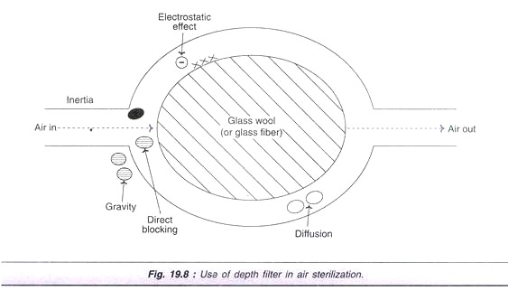
Membrane cartridge filters:
These are removable pleated membrane filters made up of cellulose ester, nylon or polysulfone. Membrane cartridge filters are smaller in size, simpler for operation and replacement. The most important limitation of air sterilization is that there is no filter that can remove bacteriophages. Bacteriophages are capable of crippling the industrial fermentation. e.g., bacteriophages interfere in the production of glutamic acid by Corynebacterium glutamicum.
Upstream processing
- Upstream biological operations: Reactant processing for thermo stable and thermo labile systems; medium formulation involving all phases; medium sterilization – theory and mechanisms, probabilistic and deterministic approaches in the design; Gas sterilization- analysis of collection efficiency from a probabilistic approach, SFE, filter design.
- Downstream biological operations: Arrangements of isolation, recovery, purification, final product formulation; physical separation processes – solid and liquid systems: pretreatment of cells to alleviate mechanical separation processes; disruption of cells including homogenizers, ultrasonic vibrations, pressure, enzymatic etc., kinetics, design and economic consideration; pharmaceutical applications of liquid-liquid extraction; affinity adsorption; rate processes – chromatography; Emerging technologies for cell recovery; separation of intracellular, extracellular, heat and photosensitive materials considering lyophilization; dynamic immobilization, reverse osmosis, electrophoresis, aqueous two-phase systems; electrodialysis, membrane technology; pervaporation, super-critical fluid extractions; case study with design aspect.
- Pharmaceutical packaging operations; Clean room testing and certification and regulatory considerations,validation
Basic Steps of Industrial Fermentation
Any industrial fermentation operation can be broken down into three main stages, viz, upstream processing, the fermentation process and downstream processing.
Upstream processing includes formulation of the fermentation medium, sterilisation of air, fermentation medium and the fermenter, inoculum preparation and inoculation of the medium.
The fermentation medium should contain an energy source, a carbon source, a nitrogen source and micronutrients required for the growth of the microorganism along with water and oxygen, if necessary.
A medium which is used for a large scale fermentation, in order to ensure the sustainability of the operation, should have the following characteristics;
1. It should be cheap and easily available
2. It should maximise the growth of the microorganism, productivity and the rate of formation of the desired product
3. It should minimise the formation of undesired products
Usually, waste products from other industrial processes, such as molasses, lignocellulosic wastes, cheese whey and corn steep liquor, after modifying with the incorporation of additional nutrients, are used as the substrate for many industrial fermentations.
Sterilisation is essential for preventing the contamination with any undesired microorganisms. Air is sterilised by membrane filtration while the medium is usually heat sterilised. Any nutrient component which is heat labile is filter-sterilised and later added to the sterilised medium. The fermenter may be sterilised together with the medium or separately.
The fermentation process involves the propagation of the microorganism and production of the desired product. The fermentation process can be categorised depending on various parameters.
It can be either aerobic fermentation, carried out in the presence of oxygen or anaerobic fermentation, carried out in the absence of oxygen. Many industrial fermentation are carried out under aerobic conditions where a few processes such as ethanol production by yeast require strictly anaerobic environments.
The fermentation process can also be divided into three basic systems, namely batch, continuous or fed-batch, depending on the feeding strategy of the culture and the medium into the fermenter. Each of these processes has their own advantages and disadvantages. In a batch operation, the medium and the culture are initially fed into the vessel and it is then closed. After that, no components are added apart from oxygen (in an aerobic process) and acid or alkali for the pH adjustment. The fermentation is allowed to run for a predetermined period of time and the product is harvested at the end. In a continuous process, fresh medium is continuously added and the products, along with the culture is removed at the same rate, thus maintaining constant concentrations of nutrients and cells are maintained throughout the process. A fed-batch system is a combination of these two systems where additional nutrients are added to the fermenter as the fermentation is in progress. This extends the time of operation but the products are harvested at the end of the production cycle as in a batch fermenter.
The process can also be categorised as solid state fermentation (SSF) or submerged fermentation (SmF), depending on the amount of free water in the medium. In a solid state fermentation, the medium contains no free flowing water. The organisms are grown in a solid substrate which is moistened. This is used in certain industrial process such as ‘koji’ fermentation from soybeans, production of amylase and protease by Aspergillus oryzae on roasted soybeans and wheat, bioremediation, detoxification of agro-industrial wastes, etc. Submerged fermentation is in which microorganisms grow submerged in a liquid medium where free water is abundant. This is the method of choice for many industrial operations over SSF although SSF is also rapidly gaining interest in the present.
Downstream Processing includes the recovery of the products in a pure state and the effluent treatment. Product recovery is carried out through a series of operations including cell separation by settling, centrifugation or filtration; product recovery by disruption of cells (if the product is produced intracellularly); extraction and purification of the product. Finally, the effluents are treated by chemical, physical or biological methods.

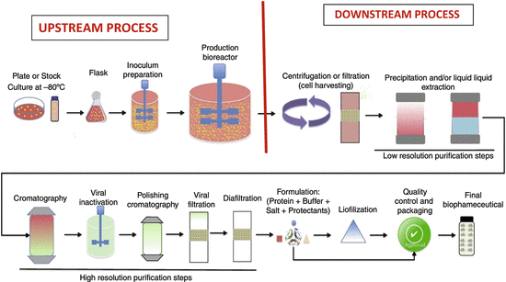
Fermentation Products
Commercially important products of fermentation can be described in five major groups as follows.
1. Biomass (Baker’s yeast, SCP, Starter cultures, animal feed, etc.)
2. Primary metabolites (amino acids, organic acids, vitamins, polysaccharides, ethanol, etc.) and secondary metabolites (antibiotics, etc.)
3. Bioconvertion or biotransformation products (steroid biotransformation, L-sorbitol etc.)
4. Enzymes (amylase, lipase, cellulase, etc.)
5. Recombinant products (some vaccines, hormones such as isulin and growth hormones etc.)

UNIT-III

Media formulation

Introduction
Fermentation technology is widely used for the production of various economically important compounds which have applications in the energy production, pharmaceutical, chemical and food industry. Although, fermentation processes are used from generations, the need for sustainable production of products, meet the market requirements in a cost effective manner has put forward a challenging demand. For any fermentation based product, the most important thing is the availability of fermented product equal to that of market demand. Various microorganisms have been reported to produce an array of primary and secondary metabolites, but in a very low quantity. In order to meet the market demand, several high yielding techniques have been discovered in the past, and successfully implemented in various processes, like production of primary or secondary metabolites, biotransformation, oil extraction etc.
optimization is still one of the most critically investigated phenomenon that is carried out before any large scale metabolite production, and possess many challenges too. Before 1970s, media optimization was carried out by using classical methods, which were expensive, time consuming, involving plenty of experiments with compromised accuracy.
Nevertheless, with the advent of modern mathematical/statistical techniques, media optimization has become more vibrant, effective, efficient, economical and robust in giving the results. For designing a production medium, the most suitable fermentation conditions (e.g., pH, temperature, agitation speed, etc.) and the appropriate medium components (e.g., carbon, nitrogen, etc.) must be identified and optimized accordingly.
Further, by optimizing the above said parameters, maximum product concentration could be achieved. The schematic representation of a systematic approach of fermentation medium designing has been given in Figure 1.
FIGURE 1
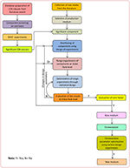
Figure 1. Schematic diagram of a systematic approach of fermentation medium designing.
An increase in productivity reduces the overall cost of the product, as well as the production cost; hence, it is one of the important topics for the research. Usually, enhanced productivity can be achieved either by strain improvement or by optimizing the process parameters. But, strain improvement and optimization are “Catch-22” situation. You cannot chose a lead strain until you have the best medium and you cannot propose a finest medium until you have the lead strain. Usually, the researchers around the world solve this predicament by sticking to one component at a time. However, both strategies cannot guarantee that one of the preferred strain if another medium is used. With this drawback and Catch-22 situation, various new methods have been suggested and investigated, where both the medium design and strain improvement can be carried out simultaneously.
the media formulation and media optimization techniques in terms of their utility, application and feasibility to maximize the metabolite yield produced by the fermentation process. In order to provide clarity and better understanding for the readers, initially we have discussed the roles of various (major) components of the fermentation media, followed by detailed description of statistical/mathematical optimization techniques. Also, the advantages and disadvantages associated with the above methods along with the future directions in the fermentation media design and optimization have been discussed in detail.

Nutritional Control of Metabolite Production
Fermented products that are used in our daily life are either primary or secondary metabolites produced during the trophophase and idiophase of the microbial growth, respectively. High productivity titer is the pre-requisite for the industrial production of any type of metabolite. The production of specific metabolites in high titer could be possible by maintaining proper control and regulation at different levels via transport and metabolism of extra-cellular nutrients, precursor formation and accumulation of intermediates.
Fermentation processes, where the precursor(s) of the specific products are not added in the medium, carbon and nitrogen sources present in the medium during their metabolism may initiate the biosynthesis of precursors that regulate the metabolism and influence the end product synthesis.
Given this in view, nutrients type and their concentrations in the medium play an important role in commencing the production of primary and secondary metabolites as limited supply of an essential nutrient can restrict the growth of microbial cells or product formation. Generally, carbon and nitrogen sources present in the medium can influence the metabolite production.

Carbon Source
Carbon is the most important medium component, as it is an energy source for the microorganisms and plays an important role in the growth as well as in the production of primary and secondary metabolite.
The rate at which the carbon source is metabolized can often influence the formation of biomass and/or the production of primary or secondary metabolites.studying antibiotics production from marine bacteria noticed that the gradually assimilating carbon sources, like, galactose generally enhances the production of secondary metabolites (antibiotics).
A classic example for this is, penicillin production, where glucose is found to have repression effect. Later, it was found that lactose is a slowly assimilating carbon source and helped in the production of secondary metabolites (i.e., penicillin).
Hence, in order to overcome the carbon catabolite repression phenomenon, the production process was established using lactose fermentation. Describing the role of each carbon in different fermentation processes, will increase the length of this manuscript. Hence we compiled a list, wherein we summarized some interfering and non-interfering carbon sources (Table 1).
TABLE 1
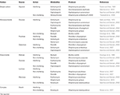
Table 1. Examples of some interfering and non-interfering carbon sources.
Fermentation processes, where raw materials/medium components cover the significant portion of the product cost, selection of these things become an important task for the production companies.
In addition to the rate of assimilation of carbon sources, the nature of carbon source also affects the type and amount of the product. An example of this is ethanol or single-cell protein production, where the raw materials contribute ~60–77% of the production cost; and the selling price of the product is determined largely by the cost of the carbon source.
Methanol could be a very popular inexpensive carbon source for single-cell protein production, but being toxic to the cells even at low concentrations and low flash points, it can never be used in fermentation as media. Hence, not only the cost even the dynamics of the carbon source must be considered whether it plays a role as a substrate in fermentation process or not.

Nitrogen Source
Like carbon, the selection of nitrogen source and its concentration in the media also play a crucial role in metabolite production. The microorganism can utilize both inorganic and/or organic sources of nitrogen.
Use of specific amino acids can increase the productivity in some cases and conversely, unsuitable amino acids may inhibit the synthesis of secondary metabolites.optimization of actinomycin V production by Streptomyces triostinicus found that biosynthesis of actinomycin V involves tryptophan pathway and addition of amino acid tryptophan to the medium enhances the production.
On the contrary, the same amino acid showed inhibitory effect in the production of candicidin from Streptomyces griseus. Nevertheless, it is confirmed that nitrogen molecules have inhibitory effect on the metabolite production in some cases, whereas, some enhancer effects of nitrogen have also been reported (Table 2).
TABLE 2
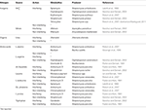
Table 2. Examples of some interfering and non-interfering nitrogen sources.

Phosphate
Phosphate is another basic component which is required for the production of phospholipids present in the microbial cell membranes, and for the production of nucleic acids.
The amount of phosphate which must be added in the fermentation medium depends upon the composition of the broth and the need of the organism, as well as according to the nature of the desired product.
For instance, some cultures will not produce secondary metabolites in the presence of phosphate, e.g., phosphatase, phytases etc.
various secondary metabolites' production such as, actinorhodin, cephalosporin, clavulanic acid, streptomycin, tetracycline, vancomycin etc. is highly influenced by inorganic phosphate concentration present in the production medium.
In most cases, lower concentration of phosphate is required for the initiation of the metabolite (antibiotic) production and beyond a certain concentration it suppresses the secondary metabolism and ultimately inhibits the production of primary or secondary metabolite. High phosphate concentration was reported to inhibit the production of teicoplanin, a glycopeptide antibiotic.
From the above description it is clear that changes in carbon or nitrogen sources of the production medium or variation from their optimum required concentration, may affect the nature of the end product or its productivity. Therefore, the production medium with all the required components in appropriate concentration is required for the production of desired metabolite at large scale
In order to standardize the production medium, the concept of medium optimization has emerged.

Need of Medium Optimization
Medium optimization studies are usually carried out in the chemical, food, and pharmaceutical industries, with respect to increase the yield and activity of the desired product. Currently, there is a very little knowledge available about the role of factors, their levels in controlling the metabolite (e.g., antibiotics, acids) production by different strains.
In order to enhance the productivity of the metabolites (for e.g., antibiotics etc.), researchers investigated the nutritional requirements for the production of secondary metabolites and found that the nutritional requirements were varying from strain to strain.
The quantity and quality of nutrients available and the ability to assimilate successfully are the major determinants of microbial nature and its metabolic activity. Hence, during the medium optimization it must be considered that a minimal growth requirement of the microorganism must be fulfilled for obtaining maximum production of metabolite(s).
As the fermentation process progresses into lower-value, higher-volume chemicals, it becomes necessary to maximize the efficiency and minimize the production cost and waste by-products to compete effectively against the traditional methods.

Media Optimization Strategies
During the medium designing and optimization, there are various strategies available which are frequently used to improve the efficiency of the production medium. Figure 2 is a schematic representation of various techniques used in the medium optimization.
FIGURE 2
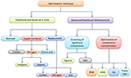
Figure 2. Schematic representation of various techniques used in optimization studies.

Classical Medium Optimization Methods

One-Factor-at-a-Time (OFAT)
In the classical medium optimization technique, one-factor-at-a-time (OFAT) experiments, only one factor or variable is varied at a time while keeping other variables constant. The concentrations of the selected medium components were then changed over a desired range. Because of its ease and convenience, the OFAT has been the most preferred choice among the researchers for designing the medium composition and used in the initial stages in diverse fields.
methodology is still in use even today, during the initial stages of medium formulation for the production of new metabolite or known compound from new source. Based upon the approach applied, OFAT is further sub-grouped into:
Removal experiments:
In this type of experiment, all the medium components are removed from the production medium one-by-one, and after proper incubation period, their effects on the production of secondary metabolite or the product of interest is observed in terms of suitable parameters. Our research group has previously reported that during the production of antifungal compound from Streptomyces capoamus, removal of soybean meal or glycerol or NaCl from the fermentation medium decreased the yield by 20–40%.

Supplementation experiments
Supplementation experiments are generally performed to evaluate the effects of various carbon and nitrogen supplements on metabolite production. During the study of antifungal production from Streptomyces violaceusniger, 70–90% enhancement in the yield was observed by supplementing xylose, sorbitol and hydroxyl proline in the production medium.Similarly, glycerol and peptone was found as a most suitable carbon and nitrogen sources for the production of antifungal and antibacterial metabolites from Streptomyces rimosus under submerged fermentation condition.

Replacement experiments
For medium formulation, carbon/nitrogen sources showing enhancement effect on the desired metabolite production in supplementation experiments are generally tried to be used as a whole carbon/nitrogen source.

Physical parameters
In addition to chemical and biological variables, several researchers used OFAT experiments to standardize the physical parameters such as pH, temperature, agitation and aeration requirements of the fermentation process.
Like any other technique, OFAT method of medium optimization has its own advantages and disadvantages. The major advantage of OFAT is its simplicity by which a series of experiments can be carried out and results can be analyzed by using simple graphs without the aid of high end statistical analysis/programs.
The major drawback of OFAT is the difficulty in estimating the “interactions” from the experiments as it is a hit-and-miss scattershot sequence of the experiments.described the time consumed and cost involved in the analysis of large number of variables as the major disadvantages of OFAT techniques.
In this methodology, sometimes the optimum point may be missed completely, thus it requires a large number of experiments to determine the optimum level, which becomes laborious, time consuming, and uneconomical most of the time.
Nevertheless, OFAT technique can be a best screening tool when nothing about the media is known because of its ease and convenience.

Design of Experiments
The use of statistical method, i.e., design of experiments (DOE) for the media optimization in fermentation process can overcome the limitations of classical OFAT method and can be a powerful tool for the optimization of metabolite production.
proposed a basic theory of experimental design which shows that changing more than one component in the medium at a time can be more efficient over changing only one-factor-at-a-time.
DOE is a series of experiments which are strategically planned and executed to obtain a larger amount of information about the effect of more than one parameter at a time on the output, i.e., product yield. Most DOE procedures allow the preliminary screening of 2–10 medium factors in a limited number of experiments. In this method, several medium factors or components are compared simultaneously and the effects are observed and ranked based on the results. Once the response variables are determined and ranked, statistical performance parameters are generated from the subsequent analysis.
Due to the requirement of higher number of experiments, OFAT is laborious, time consuming process, and extremely tedious for a large number of variables, whereas DOE requires fewer experiments, lesser time, and lesser material to obtain the same amount of information.
The interaction between the factors can be estimated systematically in DOE. After getting the basic idea about the fermentation production process from the literature or from the classical experiments, designing of the experiments are more effective to determine the impact of two or more factors on a response than OFAT.

Parameters of Bioprocess and its Measurement
Important Parameters that can be measured during bioprocessing are :
Physical Parameters
Temperature
Pressure
Flow rates
Viscosity
Turbidity
Power consumption
Chemical Parameters
pH
Substrate concentration
Product concentration
O₂ concentration (dissolved)
Waste gases concentration (e.g. CO₂)
Ionic strength
Biological Parameters
Activities of specific enzymes
Protein concentration
Energetics (ATP concentration)
DNA/RNA content
pH measurement:
There are pH electrodes that can withstand high temperature (sterilization) pressure and mechanical stresses, and yet measure the pH accurately. Combination electrodes (reference electrode, glass electrode) are being used. In fact, electrodes are also available for measuring several other inorganic ions.
O₂ and CO₂ measurement:
Oxygen electrodes and CO₂ electrodes can be used to measure O₂ and CO₂ concentrations respectively. The electrodes are amperometric in nature. They are however, susceptible for damage on sterilization. In a commonly used technique, O₂ and CO₂ respectively can be measured by the magnetic property of O₂ and the infrared absorption of CO₂. This can be done by using sensors.

Use of Mass Spectrometer:
The mass spectrometer is a versatile technique. It can be used to measure the concentrations of N₂, NH₃, ethanol and methanol simultaneously. In addition, mass spectrometer is also useful to obtain information on qualitative and quantitative exchange of O₂ and CO₂.

Use of Gas-permeable Membranes:
The measurement of dissolved gases, up to 8 simultaneously, can be done almost accurately by using gas-permeable membranes. The advantage is that such measurement is possible to carry out in the nutrient medium.

Use of Computers:
Computers are used in industrial biotechnology for data acquisition, data analysis and developing fermentation models.
Data acquisition:
By employing on-line sensors and computers in fermentation system, data can be obtained with regard to the concentration of O₂ and CO₂, pH, temperature, pressure, viscosity, turbidity, aeration rate etc. Certain other parameters (e.g. nutrient concentration, product formation, biomass concentration) can be measured in the laboratory i.e. off-line measurements. The information collected from on-line and off-line measurements can be entered into a computer. In this fashion, the entire data regarding a fermentation can be processed, stored and retrieved.
Data analysis:
The data collected on a computer can be used for various calculations e.g. rate of substrate utilization, rate of product formation, rates of O₂ uptake and CO₂ formation, heat balance, respiratory quotient. Through computer data analysis, it is possible to arrive at the optimal productivity for a given fermentation system.
Development of fermentation models:
The computer can be used to develop mathematical models of fermentation processes. These models in turn will be useful to have a better control over fermentation systems with high productivity in a cost-effective manner.

INTRODUCTION TO SCALE-DOWN AND SCALE UP IN FERMENTATION TECHNOLOGY
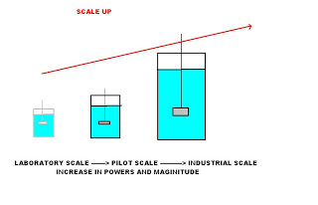
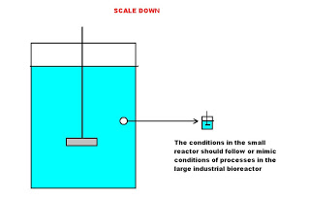
Two of the most common phrases one often met in fermentation technology research is 'Scaling up' and 'Scaling down' studies. However, the phrase 'scaling up' is more commonly understood and practiced during the designing of industrial scale fermentors. Where as 'scaling down' studies are rarely heard that frequent. In reality many fermentation technologists are not aware that during most times of their work they are doing 'scale down studies' Maybe the phrase 'scale up' has more impact factor than 'scale down' studies.
Let us simplify the similarities and differences between these two phrases in fermentation technology. A good example is when we intend to start with a fermentation process with the ultimate objective of producing the fermentation products on the level of industrial scale. Products need to be produced at large volume so that the process is economically viable. This requires scaling up. We do scaling up studies to ensure that the fermentation process is technically and economically viable to be produced in the end at a large scale
SCALE UP STUDIES
----------------------
Scale up studies are studies carried out at the laboratory or even pilot plant scal fermentors to yield data that could be used to to extrapolate and bui;ld the large scale industrial fermentors with sufficient confidence it will function properly with all its behaviours anticipated. More important during scale up exercises you are trying to build industrial size fermentor capable or close of producing the fermentation products as efficient as those produced in small scale fermentors
INITIAL SCALE UP STUDIES
---------------------------------
Most scale up studies are usually carried at different phases involving different scales of fermentors.Preliminary work are carried out at the level of petri dishes and small scale laboratory fermentors to establish whether the process is:
1 Technically viable, meaning it is possible to produce such fermentation process and the products on the small scale. Additional parameters not provided by petri dishes studies and for more confidence are obtained by carrying further studies using submerged liquid fermentation using various sizes laboratory scale fermentors and even a pilot plant fermentor.
There are a few rules of the thumb followed when doing scale up studies such as:
1 Similarity in the geometry and configuration of fermentors used in scaling up
2 A minimum of three or four stages of increment in the scaling up of the volume of fermentation studies. Each jump in scale should be by a magnitude or power increase and not an increase of a few litres capacity. Slight increase in the working volume would not yield significant data for scale up operation
It must be appreciated as the size of fermentation increases during scale up various parameters measured might not show a predictable linear co relationships. Certain parameters changes. Some remained constant. Some parameters need to be modified and adjusted during scale up studies. The objective is to try to get the same fermentation efficiency as obtained in small scale fermentors at the most economical values
IF SCALE UP STUDIES FAILED?
----------------------------------
Should at this stage the fermentation process is technically not possible and is a failure than we have two options:
1 Either find the cause of the failure or back to the drawing board!
2 Abort the whole project with minimum economic loss to the investors
The investors and engineers need more confidence in predicting how the behaviour of the fermentation will occur at the level of industrial scale. If it fails it might mean millions of dollars lost in the exercise where failure was not seen. So scaling up will give the investors more confidence on the chances of success and against economic disasters
The exercise in scaling up involved a number of programmed research or steps that has to be established so as to predict the final behaviour of the final large scale production fermentor. Studies carried out during scale up include:
1 Inoculum development
2 Sterilization establishing the correct sterilization cycle at larger loads
3 Environmental parameters such as nutrient availability,ph, temperature,dissolved
oxygen,dissolved carbon dioxide,
4 Shear conditions, foam production
SCALE DOWN STUDIES
---------------------------
In scale down studies the main objective is to carry out studies on smaller bioreactors in order to gain data and confidence and predict the behaviour how things actually will behave in large production fermentor. Scale down studies are also used while during the operation of large industrial scale fermentors in trouble shooting or trying to optimize the industrial scale fermentation. This method is called the fermentation monitoring experiment.
The goal when scaling down is to create a small-scale or lab-scale system that mimics the performance of its large-scale (pilot or manufacturing) counterpart, when both the process parameters are varied within their operating ranges and also when a process parameter deviates outside its operating range.
The main type of studies in scale down such as:
1 Medium design
2 Medium sterilization
3 Inoculation procedures
4 Number of generations
5 Mixing
6 Oxygen transfer rate
RULES OF SCALE DOWN
---------------------------
In scale down a few rules that should be followed:
SIMILAR FERMENTOR GEOMETRY
-----------------------------------
1 Similar model geometries and ratios of system. The impeller and sparger designs, and placements within the vessel must be identical or similar. Wrong models used in scale down studies might invalidate the data obtained. Since a typical fermentation process might involved different fermentor capacities,scaling down will therefore be very challenging and proper strategies need to be developed during scale down studies.
SIMILAR METHODS OF MEASURING ANALYZING SAMPLES
------------------------------------------------------------------------
Similar methods of analyses and monitoring be applied at scale down studies such as:
1 sample-dilution schemes and measurement times for calculating culture optical densities,
2 wet and dry cell-weights,
3 media metabolite levels.
SAMPLING VOLUME
-----------------------
Due to the involvement of small scale fermentors which contained less working volume, the sampling volumes should be minimized to prevent depletion of culture broth beyond acceptable levels. If the sample size cannot be reduced, then adjust the frequency of sampling.
OXYGEN TRANSFERS
-------------------------
Mass transfer of oxygen between big and small fermentors is a critical issue in scale down studies. The efficiency of oxygen transfer on production scale fermentor is much lower compared to the lab scale fermentor. The strategy in doing scale down studies in oxygen transfer is to maintain similarity in sparger design, calibration and placement within the small fermentor and the large fermentor. If the sparger design is different between scales, then agitation, aeration and oxygen enrichment may need to be adjusted to provide equivalent oxygen transfer in the small fermentor
INOCULA
--------------
It is very important in doing inoculum development during scale down exercise to maintain the vessel geometries, incubation conditions, and working volumes whenever possible during the scale down exercise. If in the process it is not possible to obtain fermentors of similar geometries
the operational control parameters may need to be adjusted to account for different vessel geometries.
STERILIZATIONS
--------------------
During sterilization studies in scale down studies, the sterilization temperatures, procedures for probe calibration, and post-use cleaning protocols should be the similar as the large-scale fermentor.
FERMENTATION FEED
---------------------------
The raw materials used in scale down studies should be identical to those used for the full-scale process.
FERMENTATION CONTROL PARAMETERS
-----------------------------
Similar operating regimes and controls should be applied to the small scale fermentor such as
1 process temperature
2 pH
3 inoculation percentages (v/v) for each step
4 schedule of feed-media additions.
A linear adjustment method should be used for all the volume-dependent operational control-parameter set points except agitation. The scale factor should be equivalent to the ratio of overall process volumes. Examples of linear adjustments in:
1 Pre-and post-sterilization volumes of growth media.
2 Feed media delivery rates.
3 Total airflow.
4 Oxygen flow rate.
AGITATION RATE
---------------------
Set agitation in scale down studies to provide either representative :
1 oxygen transfer rate
2 tip speed,
3Reynolds Number, or
4power-input per unit volume,
Under conditions of similar fermentor geometry it is recommended that the oxygen transfer rate studies be carried out.
CULTURE GROWTH
-----------------------
Culture growth is a critical performance parameter for qualifying the scale-down studies.
Oxygen utilization is a very important performance parameter for scale-down exercise. Similar patterns in dissolved oxygen profiles, and oxygen and airflow rates represent comparability in oxygen usage by the cultures at each scale.
PRODUCT YIELD
------------------
A biochemical finger print should be established for both large scale and scale down fermentation for comparison for similarity in efficacy
PROCESS SENSITIVITY
---------------------------
Process-control sensitivity for dissolved oxygen, pH, temperature, agitation and feed delivery must be verified at the small-scale.
DO SCALE DOWN STUDIES A FEW TIMES
---------------------------------------------
In general, for greater confidence it is good toperform at least three small-scale runs to confirm reproducibility and to determine the inherent variability in the process.

UNIT-IV

Stages in Downstream Processing: 5 Stages
This article throws light upon the five stages in downstream processing. The five stages are: (1) Solid-Liquid Separation (2) Release of Intracellular Products (3) Concentration (4) Purification by Chromatography and (5) Formulation.

In Fig. 20.1, an outline of the major steps in downstream processing is given.
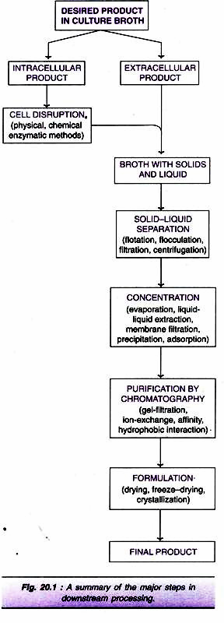

Stage # 1. Solid-Liquid Separation:
The first step in product recovery is the separation of whole cells (cell biomass) and other insoluble ingredients from the culture broth (Note: If the desired product is an intracellular metabolite, it must be released from the cells before subjecting to solid-liquid separation). Some authors use the term harvesting of microbial cells for the separation of cells from the culture medium. Several methods are in use for solid-liquid separation. These include flotation, flocculation, filtration and centrifugation.

Flotation:

When a gas is introduced into the liquid broth, it forms bubbles. The cells and other solid particles get adsorbed on gas bubbles. These bubbles rise to the foam layer which can be collected and removed. The presence of certain substances, referred to as collector substances, facilitates stable foam formation e.g., long chain fatty acids, amines.

Flocculation:
In flocculation, the cells (or cell debris) form large aggregates to settle down for easy removal. The process of flocculation depends on the nature of cells and the ionic constituents of the medium. Addition of flocculating agents (inorganic salt, organic polyelectrolyte, mineral hydrocolloid) is often necessary to achieve appropriate flocculation.

Filtration:
Filtration is the most commonly used technique for separating the biomass and culture filtrate. The efficiency of filtration depends on many factors— the size of the organism, presence of other organisms, viscosity of the medium, and temperature. Several filters such as depth filters, absolute filters, rotary drum vacuum filters and membrane filters are in use.
Depth Filters:
They are composed of a filamentous matrix such as glass wool, asbestos or filter paper. The particles are trapped within the matrix and the fluid passes out. Filamentous fungi can be removed by using depth filters.
Absolute Filters:
These filters are with specific pore sizes that are smaller than the particles to be removed. Bacteria from culture medium can be removed by absolute filters.
Rotary Drum Vacuum Filters:
These filters are frequently used for separation of broth containing 10-40% solids (by volume) and particles in the size of 0.5-10µm. Rotary drum vacuum filters have been successfully used for filtration of yeast cells and filamentous fungi. The equipment is simple with low power consumption and is easy to operate. The filtration unit consists of a rotating drum partially immersed in a tank of broth (Fig. 20.2). As the drum rotates, it picks up the biomass which gets deposited as a cake on the drum surface. This filter cake can be easily removed.
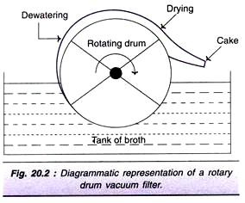
Membrane Filters:
In this type of filtration, membranes with specific pore sizes can be used. However, clogging of filters is a major limitation. There are two types of membrane filtrations—static filtration and cross-flow filtration (Fig. 20.3). In cross-flow filtration, the culture broth is pumped in a crosswise fashion across the membrane. This reduces the clogging process and hence better than the static filtration.
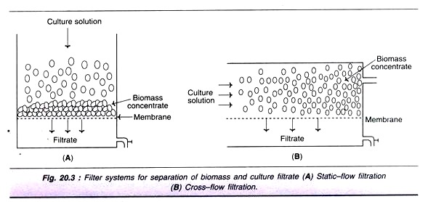
Types of filtration processes:
There are 3 major types of filtrations based on the particle sizes and other characters (Table 20.1). These are microfiltration, ultrafiltration and reverse osmosis.
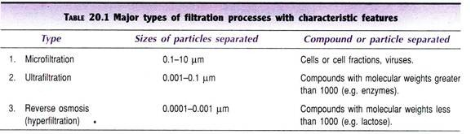

Centrifugation:
The technique of centrifugation is based on the principle of density differences between the particles to be separated and the medium. Thus, centrifugation is mostly used for separating solid particles from liquid phase (fluid/particle separation). Unlike the centrifugation that is conveniently carried out in the laboratory scale, there are certain limitations for large scale industrial centrifugation.
However, in recent years, continuous flow industrial centrifuges have been developed. There is a continuous feeding of the slurry and collection of clarified fluid, while the solids deposited can be removed intermittently. The different types of centrifuges are depicted in Fig. 20.4, and briefly described hereunder.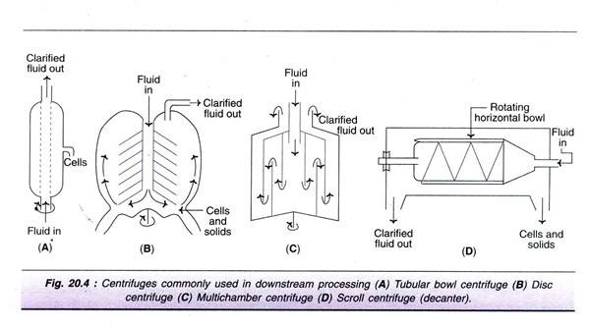Tubular bowl centrifuge (Fig. 20.4A):
This is a simple and a small centrifuge, commonly used in pilot plants. Tubular bowl centrifuge can be operated at a high centrifugal speed, and can be run in both batch or continuous mode. The solids are removed manually.
Disc centrifuge (Fig. 20.4B):
It consists of several discs that separate the bowl into settling zones. The feed/slurry is fed through a central tube. The clarified fluid moves upwards while the solids settle at the lower surface.
Multi-chamber centrifuge (Fig. 20.4C):
This is basically a modification of tubular bowl type of centrifuge. It consists of several chambers connected in such a way that the feed flows in a zigzag fashion. There is a variation in the centrifugal force in different chambers. The force is much higher in the periphery chambers, as a result smallest particles settle down in the outermost chamber.
Scroll centrifuge or decanter (Fig. 20.4D):
It is composed of a rotating horizontal bowl tapered at one end. The decanter is generally used to concentrate fluids with high solid concentration (biomass content 5-80%). The solids are deposited on the wall of the bowl which can be scrapped and removed from the narrow end.

Stage # 2. Release of Intracellular Products:
As already stated, there are several biotechnological products (vitamins, enzymes) which are located within the cells. Such compounds have to be first released (maximally and in an active form) for their further processing and final isolation. The microorganisms or other cells can be disintegrated or disrupted by physical, chemical or enzymatic methods. The outline of different techniques used for breakage of cells is given in Fig. 20.5.
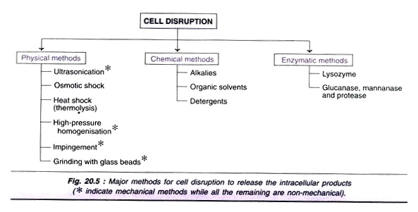
The selection of a particular method depends on the nature of the cells, since there is a wide variation in the property of cell disruption or breakage. For instance, Gram-negative bacteria and filamentous fungi can be more easily broken compared to Gram-positive bacteria arid yeasts.

Cell Disruption:
Physical methods of cell disruption:
The microorganisms or cells can be disrupted by certain physical methods to release the intracellular products.
Ultra sonication:
Ultrasonic disintegration is widely employed in the laboratory. However, due to high cost, it is not suitable for large-scale use in industries.
Osmotic shock:
This method involves the suspension of cells (free from growth medium) in 20% buffered sucrose. The cells are then transferred to water at about 4°C. Osmotic shock is used for the release of hydrolytic enzymes and binding proteins from Gram-negative bacteria.
Heat shock (thermolysis):
Breakage of cells by subjecting them to heat is relatively easy and cheap. But this technique can be used only for a very few heat-stable intracellular products.
High pressure homogenization:
This technique involves forcing of cell suspension at high pressure through a very narrow orifice to come out to atmospheric pressure. This sudden release of high pressure creates a liquid shear that can break the cells.
Impingement:
In this procedure, a stream of suspended cells at high velocity and pressure are forced to hit either a stationary surface or a second stream of suspended cells (impinge literally means to strike or hit). The cells are disrupted by the forces created at the point of contact. Micro fluidizer is a device developed based on the principle of impingement. It has been successfully used for breaking E. coli cells. The advantage with impingement technique is that it can be effectively used for disrupting cells even at a low concentration.
Grinding with glass beads:
The cells mixed with glass beads are subjected to a very high speed in a reaction vessel. The cells break as they are forced against the wall of the vessel by the beads. Several factors influence the cell breakage-size and quantity of the glass beads, concentration and age of cells, temperature and agitator speed. Under optimal conditions, one can expect a maximal breakage of about 80% of the cells.
A diagrammatic representation of a cell disrupter employing glass beeds is shown in Fig. 20.6. It contains a cylindrical body with an inlet, outlet and a central motor-driven shaft. To this shaft are fitted radial agitators. The cylinder is fitted with glass beads. The cell suspension is added through the inlet and the disrupted cells come out through the outlet. The body of the cell disrupter is kept cool while the operation is on.
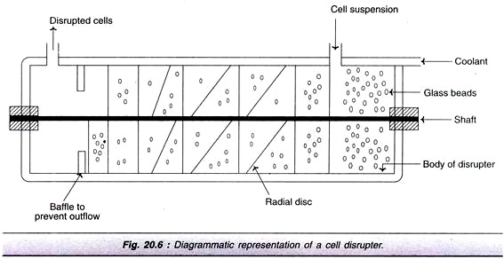
Mechanical and non-mechanical methods:
Among the physical methods of cell disruption described above, ultra sonication, high-pressure homogenization, impingement and grinding with glass beads are mechanical while osmotic shock and heat shock are non-mechanical. The chemical and enzymatic methods (described below) are non- mechanical in nature.
Chemical methods of cell disruption:
Treatment with alkalies, organic solvents and detergents can lyse the cells to release the contents.
Alkalies:
Alkali treatment has been used for the extraction of some bacterial proteins. However, the alkali stability of the desired product is very crucial for the success of this method e.g., recombinant growth hormone can be efficiently released from E. coli by treatment with sodium hydroxide at pH 11.
Organic solvents:
Several water miscible organic solvents can be used to disrupt the cells e.g., methanol, ethanol, isopropanol, butanol. These compounds are inflammable; hence require specialised equipment for fire safety. The organic solvent toluene is frequently used. It is believed that toluene dissolves membrane phospholipids and creates membrane pores for release of intracellular contents.
Detergents:
Detergents that are ionic in nature, cationic-cetyl trimethyl ammonium bromide or anionic-sodium lauryl sulfate can denature membrane proteins and lyse the cells. Non-ionic detergents (although less reactive than ionic ones) are also used to some extent e.g., Triton X-100 or Tween. The problem with the use of detergents is that they affect purification steps, particularly the salt precipitation. This limitation can be overcome by using ultrafiltration or ion-exchange chromatography for purification.
Enzymatic methods of cell disruption:
Cell disruption by enzymatic methods has certain advantages i.e., lysis of cells occurs under mild conditions in a selective manner. This is quite advantageous for product recovery. Lysozyme is the most frequently used enzyme and is commercially available (produced from hen egg white). It hydrolyses β-1, 4-glycosidic bonds of the mucopeptide in bacterial cell walls. The Gram- positive bacteria (with high content of cell wall mucopeptides) are more susceptible for the action of lysozyme.
For Gram-negative bacteria, lysozyme in association with EDTA can break the cells. As the cell wall gets digested by lysozyme, the osmotic effects break the periplasmic membrane to release the intracellular contents. Certain other enzymes are also used, although less frequently, for cell disruption. For the lysis of yeast cell walls, glucanase and mannanase in combination with proteases are used.
Combination of methods:
In order to increase the efficiency of cell disintegration in a cost-effective manner, a combination of physical, chemical and enzymatic methods is employed.

Stage # 3. Concentration:
The filtrate that is free from suspended particles (cells, cell debris etc.) usually contains 80-98% of water. The desired product is a very minor constituent. The water has to be removed to achieve the product concentration. The commonly used techniques for concentrating biological products are evaporation, liquid-liquid extraction, membrane filtration, precipitation and adsorption. The actual procedure adopted depends on the nature of the desired product (quality and quantity to be retained as far as possible) and the cost factor.

Evaporation:
Water in the broth filtrate can be removed by a simple evaporation process. The evaporators, in general, have a heating device for supply of steam, and unit for the separation of concentrated product and vapour, a condenser for condensing vapour, accessories and control equipment. The capacity of the equipment is variable that may range from small laboratory scale to industrial scale. Some of the important types of evaporators in common use are briefly described.
Plate evaporators:
The liquid to be concentrated flows over plates. As the steam is supplied, the liquid gets concentrated and becomes viscous.
Falling film evaporators:
In this case, the liquid flows down long tubes which gets distributed as a thin film over the heating surface. Falling film evaporators are suitable for removing water from viscous products of fermentation.
Forced film evaporators:
The liquid films are mechanically driven and these devices are suitable for producing dry product concentrates.
Centrifugal forced film evaporators:
These equipment evaporate the liquid very quickly (in seconds), hence suitable for concentrating even heat-labile substances. In these evaporators, a centrifugal force is used to pass on the liquid over heated plates or conical surfaces for instantaneous evaporation.

Liquid-Liquid Extraction:
The concentration of biological products can be achieved by transferring the desired product (solute) from one liquid phase to another liquid phase, a phenomenon referred to as liquid-liquid extraction. Besides concentration, this technique is also useful for partial purification of a product.
The efficiency of extraction is dependent on the partition coefficient i.e. the relative distribution of a substance between the two liquid phases. The process of liquid-liquid extraction may be broadly categorized as extraction of low molecular weight products and extraction of high molecular weight products.
Extraction of low molecular weight products:
By using organic solvents, the lipophilic compounds can be conveniently extracted. However, it is quite difficult to extract hydrophilic compounds. Extraction of lipophilic products can be done by the following techniques.
Physical extraction:
The compound gets itself distributed between two liquid phases based on the physical properties. This technique is used for extraction of non-ionising compounds.
Dissociation extraction:
This technique is suitable for the extraction of ionisable compounds. Certain antibiotics can be extracted by this procedure.
Reactive extraction:
In this case, the desired product is made to react with a carrier molecule (e.g., phosphorus compound, aliphatic amine) and extracted into organic solvent. Reactive extraction procedure is quite useful for the extraction of certain compounds that are highly soluble in water (aqueous phase) e.g., organic acids.
Supercritical fluid (SCF) extraction:
This technique differs from the above procedures, since the materials used for extraction are supercritical fluids (SCFs). SCFs are intermediates between gases and liquids and exist as fluids above their critical temperature and pressure. Supercritical CO₂, with a low critical temperature and pressure is commonly used in the extraction. Supercritical fluid extraction is rather expensive, hence not widely used (SCF has been used for the extraction of caffeine from coffee beans, and pigments and flavor ingredients from biological materials).
Extraction of high molecular weight compounds:
Proteins are the most predominant high molecular weight products produced in fermentation industries. Organic solvents cannot be used for protein extraction, as they lose their biological activities. They are extracted by using an aqueous two-phase systems or reverse micelles formation.
Aqueous two-phase systems (ATPS):
They can be prepared by mixing a polymer (e.g., polyethylene glycol) and a salt solution (ammonium sulfate) or two different polymers. Water is the main component in ATPS, but the two phases are not miscible. Cells and other solids remain in one phase while the proteins are transferred to other phase. The distribution of the desired product is based on its surface and ionic character and the nature of phases. The separation takes much longer time by ATPS.
Reverse miceller systems:
Reverse micelles are stable aggregates of surfactant molecules and water in organic solvents. The proteins can be extracted from the aqueous medium by forming reverse micelles. In fact, the enzymes can be extracted by this procedure without loss of biological activity.

Membrane Filtration:
Membrane filtration has become a common separation technique in industrial biotechnology. It can be conveniently used for the separation of biomolecules and particles, and for the concentration of fluids. The membrane filtration technique basically involves the use of a semipermeable membrane that selectively retains the particles/molecules that are bigger than the pore size while the smaller molecules pass through the membrane pores.
Membranes used in filtration are made up of polymeric materials such as polyethersulfone and polyvinyl di-fluoride. It is rather difficult to sterilize membrane filters. In recent years, micro-filters and ultrafiIters composed of ceramics and steel are available. Cleaning and sterilization of such filters are easy. The other types of membrane filtration techniques are described briefly.
Membrane adsorbers:
They are micro- or macro porous membranes with ion exchange groups and/or affinity ligands. Membrane adsorbers can bind to proteins and retain them. Such proteins can be eluted by employing solutions in chromatography.
Pervaporation:
This is a technique in which volatile products can be separated by a process of permeation through a membrane coupled with evaporation. Pervaporation is quite useful for the extraction, recovery and concentration of volatile products. However, this procedure has a limitation since it cannot be used for large scale separation of volatile products due to cost factor.
Perstraction:
This is an advanced technique working on the principle of membrane filtration coupled with solvent extraction. The hydrophobic compounds can be recovered/ concentrated by this method.

Precipitation:
Precipitation is the most commonly used technique in industry for the concentration of macromolecules such as proteins and polysaccharides. Further, precipitation technique can also be employed for the removal of certain unwanted byproducts e.g. nucleic acids, pigments.
Neutral salts, organic solvents, high molecular weight polymers (ionic or non-ionic), besides alteration in temperature and pH are used in precipitation. In addition to these non-specific protein precipitation reactions (i.e. the nature of the protein is unimportant), there are some protein specific precipitations e.g., affinity precipitation, ligand precipitation.
Neutral salts:
The most commonly used salt is ammonium sulfate, since it is highly soluble, nontoxic to proteins and low-priced. Ammonium sulfate increases hydrophobic interactions between protein molecules that result in their precipitation. The precipitation of proteins is dependent on several factors such as protein concentration, pH and temperature.
Organic solvents:
Ethanol, acetone and propanol are the commonly used organic solvents for protein precipitation. They reduce the dielectric constant of the medium and enhance electrostatic interaction between protein molecules that lead to precipitation. Since proteins are denatured by organic solvents, the precipitation process has to be carried out below 0°C.
Non-ionic polymers:
Polyethylene glycol (PEG) is a high molecular weight non-ionic polymer that can precipitate proteins. It reduces the quantity of water available for protein solvation and precipitates protein. PEG does not denature proteins, besides being non-toxic.
Ionic polymers:
The charged polymers such as polyacrylic acid and polyethyleneimine are used. They form complexes with oppositely charged protein molecules that causes charge neutralisation and precepitation.
Increase in temperature:
The heat sensitive proteins can be precipitated by increasing the temperature.
Change in pH:
Alterations in pH can also lead to protein precipitation.
Affinity precipitation:
The affinity interaction (e.g., between antigen and antibody) is exploited for precipitation of proteins.
Precipitation by ligands:
Ligands with specific binding sites for proteins have been successfully used for selective precipitation.

Adsorption:
The biological products of fermentation can be concentrated by using solid adsorbent particles. In the early days, activated charcoal was used as the adsorbent material. In recent years, cellulose-based adsorbents are employed for protein concentration.
And for concentration of low molecular weight compounds (vitamins, antibiotics, peptides) polystyrene, methacrylate and acrylate based matrices are used. The process of adsorption can be carried out by making a bed of adsorbent column and passing the culture broth through it. The desired product, held by the adsorbent, can be eluted.

Stage # 4. Purification by Chromatography:
The biological products of fermentation (proteins, pharmaceuticals, diagnostic compounds and research materials) are very effectively purified by chromatography. It is basically an analytical technique dealing with the separation of closely related compounds from a mixture. Chromatography usually consists of a stationary phase and mobile phase.
The stationary phase is the porous solid matrix packed in a column (equilibrated with a suitable solvent) on to which the mixture of compounds to be separated is loaded. The compounds are eluted by a mobile phase.
A single mobile phase may be used continuously or it may be changed appropriately to facilitate the release of desired compounds. The eluate from the column can be monitored continuously (e.g. protein elution can be monitored by ultraviolet adsorption at 280 nm), and collected in fractions of definite volumes.
The different types of chromatography techniques used for separation (mainly proteins) along with the principles are given in Table 20.2. A large number of matrices are commercially available for purification of proteins e.g., agarose, cellulose, polyacrylamide, porous silica, cross- linked dextran, polystyrene. Some of the important features of selected chromatographic techniques are briefly described.
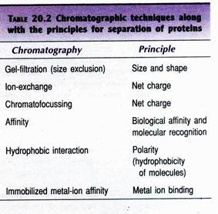
Gel-filtration chromatography:
This is also referred to as size-exclusion chromatography. In this technique, the separation of molecules is based on the size, shape and molecular weight. The sponge-like gel beads with pores serve as molecular sieves for separation of smaller and bigger molecules. A solution mixture containing molecules of different sizes (e.g. different proteins) is applied to the column and eluted.
The smaller molecules enter the gel beads through their pores and get trapped. On the other hand, the larger molecules cannot pass through the pores and therefore come out first with the mobile liquid (Fig. 20.7). At the industrial scale, gel-filtration is particularly useful to remove salts and low molecular weight compounds from high molecular weight products.
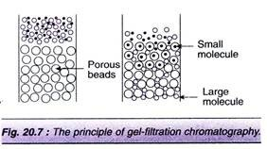
Ion-exchange chromatography:
It involves the separation of molecules based on their surface charges. Ion-exchangers are of two types (cation- exchangers which have negatively charged groups like carboxymethyl and sulfonate, and anion- exchangers with positively charged groups like diethylaminoethyl (DEAE). The most commonly used cation-exchangers are Dowex HCR and Amberlite IR, the anion-exchangers are Dowex SAR and Amberlite IRA.
In ion-exchange chromatography, the pH of the medium is very crucial, since the net charge varies with pH. In other words, the pH determines the effective charge on both the target molecule and the ion-exchanger. The ionic bound molecules can be eluted from the matrix by changing the pH of the eluant or by increasing the concentration of salt solution. Ion-exchange chromatography is useful for the purification of antibiotics, besides the purification of proteins.
Affinity chromatography:
This is an elegant method for the purification of proteins from a complex mixture. Affinity chromatography is based on an interaction of a protein with an immobilized ligand. The ligand can be a specific antibody, substrate, substrate analogue or an inhibitor. The immobilized ligand on a solid matrix can be effectively used to fish out complementary structures.
In Table 20.3, some examples of ligands used for the purification of proteins are given. The protein bound to the ligand can be eluted by reducing their interaction. This can be achieved by changing the pH of the buffer, altering the ionic strength or by using another free ligand molecule. The fresh ligand used has to be removed in the subsequent steps.
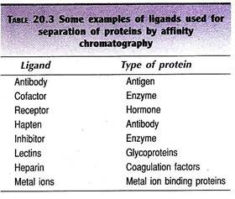
Hydrophobic interaction chromatography (HIC):
This is based on the principle of weak hydrophobic interactions between the hydrophobic ligands (alkyl, aryl side chains on matrix) and hydrophobic amino acids of proteins. The differences in the composition of hydrophobic amino acids in proteins can be used for their separation. The elution of proteins can be done by lowering the salt concentration, decreasing the polarity of the medium or reducing the temperature.

Stage # 5. Formulation:
Formulation broadly refers to the maintenance of activity and stability of a biotechnological products during storage and distribution. The formulation of low molecular weight products (solvents, organic acids) can be achieved by concentrating them with removal of most of the water. For certain small molecules, (antibiotics, citric acid), formulation can be done by crystallization by adding salts.
Proteins are highly susceptible for loss of biological activity; hence their formulation requires special care. Certain stabilizing additives are added to prolong the shelf life of protein. The stabilizers of protein formulation include sugars (sucrose, lactose), salts (sodium chloride, ammonium sulfate), polymers (polyethylene glycol) and polyhydric alcohols (glycerol). Proteins may be formulated in the form of solutions, suspensions or dry powders.
Drying:
Drying is an essential component of product formulation. It basically involves the transfer of heat to a wet product for removal of moisture. Most of the biological products of fermentation are sensitive to heat, and therefore require gentle drying methods. Based on the method of heat transfer, drying devices may be categorized as contact, convection, radiation dryers. These three types of dryers are commercially available.
Spray drying:
Spray drying is used for drying large volumes of liquids. In spray drying, small droplets of liquid containing the product are passed through a nozzle directing it over a stream of hot gas. The water evaporates and the solid particles are left behind.
Freeze-drying:
Freeze-drying or lyophilization is the most preferred method for drying and formulation of a wide-range of products—pharmaceuticals, foodstuffs, diagnostics, bacteria, viruses. This is mainly because freeze-drying usually does not cause loss of biological activity of the desired product.
Lyophilization is based on the principle of sublimation of a liquid from a frozen state. In the actual technique, the liquid containing the product is frozen and then dried in a freeze-dryer under vacuum. The vacuum can now be released and the product containing vials can be sealed e.g., penicillin can be freeze dried directly in ampules.

Integration of Different Processes:
It is ideal to integrate the fermentation and downstream processing to finally get the desired product. However, this has not been practicable for various reasons. Integration of certain stages in downstream processing for purification of product has met with some success. For instance, protein concentration by extraction into two phase systems combined with clarification and purification can be done together.

Sewage treatment
Sewage treatment is the process of removing contaminants from municipal wastewater, containing mainly household sewage plus some industrial wastewater. Physical, chemical, and biological processes are used to remove contaminants and produce treated wastewater (or treated effluent) that is safe enough for release into the environment. A by-product of sewage treatment is a semi-solid waste or slurry, called sewage sludge. The sludge has to undergo further treatment before being suitable for disposal or application to land.
Sewage treatment may also be referred to as wastewater treatment. However, the latter is a broader term which can also refer to industrial wastewater. For most cities, the sewer system will also carry a proportion of industrial effluent to the sewage treatment plant which has usually received pre-treatment at the factories themselves to reduce the pollutant load. If the sewer system is a combined sewer then it will also carry urban runoff (stormwater) to the sewage treatment plant. Sewage water can travel towards treatment plants via piping and in a flow aided by gravity and pumps. The first part of filtration of sewage typically includes a bar screen to filter solids and large objects which are then collected in dumpsters and disposed of in landfills. Fat and grease is also removed before the primary treatment of sewage.

Terminology
The term "sewage treatment plant" (or "sewage treatment works" in some countries) is nowadays often replaced with the term wastewater treatment plant or wastewater treatment station.
Sewage can be treated close to where the sewage is created, which may be called a "decentralized" system or even an "on-site" system (in septic tanks, biofilters or aerobic treatment systems).
Alternatively, sewage can be collected and transported by a network of pipes and pump stations to a municipal treatment plant. This is called a "centralized" system (see also sewerage and pipes and infrastructure).

Origins of sewage
Sewage is generated by residential, institutional, commercial and industrial establishments. It includes household waste liquid from toilets, baths, showers, kitchens, and sinks draining into sewers. In many areas, sewage also includes liquid waste from industry and commerce. The separation and draining of household waste into greywater and blackwater is becoming more common in the developed world, with treated greywater being permitted for use for watering plants or recycled for flushing toilets.

Sewage mixing with rainwater
Sewage may include stormwater runoff or urban runoff. Sewerage systems capable of handling storm water are known as combined sewer systems. This design was common when urban sewerage systems were first developed, in the late 19th and early 20th centuries.
Combined sewers require much larger and more expensive treatment facilities than sanitary sewers. Heavy volumes of storm runoff may overwhelm the sewage treatment system, causing a spill or overflow. Sanitary sewers are typically much smaller than combined sewers, and they are not designed to transport stormwater. Backups of raw sewage can occur if excessive infiltration/inflow (dilution by stormwater and/or groundwater) is allowed into a sanitary sewer system.
Communities that have urbanized in the mid-20th century or later generally have built separate systems for sewage (sanitary sewers) and stormwater, because precipitation causes widely varying flows, reducing sewage treatment plant efficiency.
As rainfall travels over roofs and the ground, it may pick up various contaminants including soil particles and other sediment, heavy metals, organic compounds, animal waste, and oil and grease. Some jurisdictions require stormwater to receive some level of treatment before being discharged directly into waterways. Examples of treatment processes used for stormwater include retention basins, wetlands, buried vaults with various kinds of media filters, and vortex separators (to remove coarse solids).

Industrial effluent
in highly regulated developed countries, industrial effluent usually receives at least pretreatment if not full treatment at the factories themselves to reduce the pollutant load, before discharge to the sewer. This process is called industrial wastewater treatment or pretreatment. The same does not apply to many developing countries where industrial effluent is more likely to enter the sewer if it exists, or even the receiving water body, without pretreatment.
Industrial wastewater may contain pollutants which cannot be removed by conventional sewage treatment. Also, variable flow of industrial waste associated with production cycles may upset the population dynamics of biological treatment units, such as the activated sludge process.

Process steps

Overview
Sewage collection and treatment in the United States is typically subject to local, state and federal regulations and standards.
Treating wastewater has the aim to produce an effluent that will do as little harm as possible when discharged to the surrounding environment, thereby preventing pollution compared to releasing untreated wastewater into the environment.
Sewage treatment generally involves three stages, called primary, secondary and tertiary treatment.
- Primary treatment consists of temporarily holding the sewage in a quiescent basin where heavy solids can settle to the bottom while oil, grease and lighter solids float to the surface. The settled and floating materials are removed and the remaining liquid may be discharged or subjected to secondary treatment. Some sewage treatment plants that are connected to a combined sewer system have a bypass arrangement after the primary treatment unit. This means that during very heavy rainfall events, the secondary and tertiary treatment systems can be bypassed to protect them from hydraulic overloading, and the mixture of sewage and stormwater only receives primary treatment.
- Secondary treatment removes dissolved and suspended biological matter. Secondary treatment is typically performed by indigenous, water-borne micro-organisms in a managed habitat. Secondary treatment may require a separation process to remove the micro-organisms from the treated water prior to discharge or tertiary treatment.
- Tertiary treatment is sometimes defined as anything more than primary and secondary treatment in order to allow ejection into a highly sensitive or fragile ecosystem (estuaries, low-flow rivers, coral reefs...). Treated water is sometimes disinfected chemically or physically (for example, by lagoons and microfiltration) prior to discharge into a stream, river, bay, lagoon or wetland, or it can be used for the irrigation of a golf course, greenway or park. If it is sufficiently clean, it can also be used for groundwater recharge or agricultural purposes.
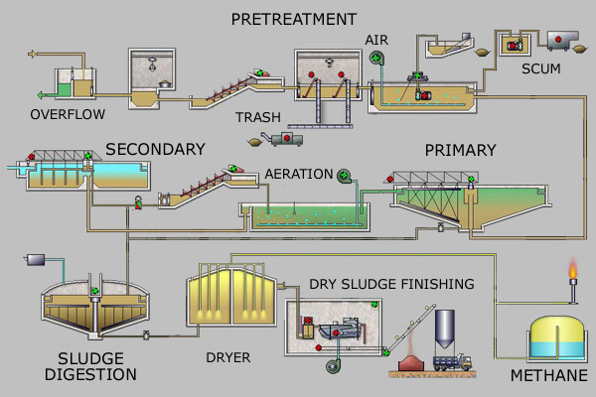
Simplified process flow diagram for a typical large-scale treatment plant
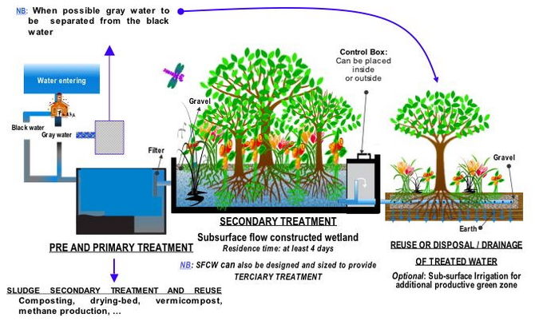
Process flow diagram for a typical treatment plant via subsurface flow constructed wetlands (SFCW)

Pretreatment
Pretreatment removes all materials that can be easily collected from the raw sewage before they damage or clog the pumps and sewage lines of primary treatment clarifiers. Objects commonly removed during pretreatment include trash, tree limbs, leaves, branches, and other large objects.
The influent in sewage water passes through a bar screen to remove all large objects like cans, rags, sticks, plastic packets etc. carried in the sewage stream.his is most commonly done with an automated mechanically raked bar screen in modern plants serving large populations, while in smaller or less modern plants, a manually cleaned screen may be used.
The raking action of a mechanical bar screen is typically paced according to the accumulation on the bar screens and/or flow rate. The solids are collected and later disposed in a landfill, or incinerated. Bar screens or mesh screens of varying sizes may be used to optimize solids removal. If gross solids are not removed, they become entrained in pipes and moving parts of the treatment plant, and can cause substantial damage and inefficiency in the process.

Grit removal
Grit consists of sand, gravel, cinders, and other heavy materials. It also includes organic matter such as eggshells, bone chips, seeds, and coffee grounds. Pretreatment may include a sand or grit channel or chamber, where the velocity of the incoming sewage is adjusted to allow the settlement of sand and grit. Grit removal is necessary to (1) reduce formation of heavy deposits in aeration tanks, aerobic digesters, pipelines, channels, and conduits; (2) reduce the frequency of digester cleaning caused by excessive accumulations of grit; and (3) protect moving mechanical equipment from abrasion and accompanying abnormal wear. The removal of grit is essential for equipment with closely machined metal surfaces such as comminutors, fine screens, centrifuges, heat exchangers, and high pressure diaphragm pumps. Grit chambers come in 3 types: horizontal grit chambers, aerated grit chambers and vortex grit chambers.
Vortex type grit chambers include mechanically induced vortex, hydraulically induced vortex, and multi-tray vortex separators. Given that traditionally, grit removal systems have been designed to remove clean inorganic particles that are greater than 0.210 millimetres (0.0083 in), most grit passes through the grit removal flows under normal conditions. During periods of high flow deposited grit is resuspended and the quantity of grit reaching the treatment plant increases substantially. It is, therefore important that the grit removal system not only operate efficiently during normal flow conditions but also under sustained peak flows when the greatest volume of grit reaches the plant.

Flow equalization
Clarifiers and mechanized secondary treatment are more efficient under uniform flow conditions. Equalization basins may be used for temporary storage of diurnal or wet-weather flow peaks. Basins provide a place to temporarily hold incoming sewage during plant maintenance and a means of diluting and distributing batch discharges of toxic or high-strength waste which might otherwise inhibit biological secondary treatment (including portable toilet waste, vehicle holding tanks, and septic tank pumpers).
Flow equalization basins require variable discharge control, typically include provisions for bypass and cleaning, and may also include aerators. Cleaning may be easier if the basin is downstream of screening and grit removal.

Fat and grease removal
In some larger plants, fat and grease are removed by passing the sewage through a small tank where skimmers collect the fat floating on the surface. Air blowers in the base of the tank may also be used to help recover the fat as a froth. Many plants, however, use primary clarifiers with mechanical surface skimmers for fat and grease removal.

Primary treatment
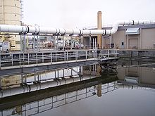
Primary treatment tanks in Oregon, USA
In the primary sedimentation stage, sewage flows through large tanks, commonly called "pre-settling basins", "primary sedimentation tanks" or "primary clarifiers". The tanks are used to settle sludge while grease and oils rise to the surface and are skimmed off.
Primary settling tanks are usually equipped with mechanically driven scrapers that continually drive the collected sludge towards a hopper in the base of the tank where it is pumped to sludge treatment facilities.¹ Grease and oil from the floating material can sometimes be recovered for saponification (soap making).

Secondary treatment
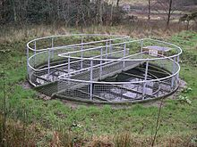
Secondary clarifier at a rural treatment plant
Secondary treatment is designed to substantially degrade the biological content of the sewage which are derived from human waste, food waste, soaps and detergent. The majority of municipal plants treat the settled sewage liquor using aerobic biological processes. To be effective, the biota require both oxygen and food to live. The bacteria and protozoa consume biodegradable soluble organic contaminants (e.g. sugars, fats, organic short-chain carbon molecules) and bind much of the less soluble fractions into floc.
Secondary treatment systems are classified as fixed-film or suspended-growth systems.
- Fixed-film or attached growth systems include trickling filters, constructed wetlands, bio-towers, and rotating biological contactors, where the biomass grows on media and the sewage passes over its surface. The fixed-film principle has further developed into moving bed biofilm reactors (MBBR) and Integrated Fixed-Film Activated Sludge (IFAS) processes. An MBBR system typically requires a smaller footprint than suspended-growth systems.
- Suspended-growth systems include activated sludge, where the biomass is mixed with the sewage and can be operated in a smaller space than trickling filters that treat the same amount of water. However, fixed-film systems are more able to cope with drastic changes in the amount of biological material and can provide higher removal rates for organic material and suspended solids than suspended growth systems.
Some secondary treatment methods include a secondary clarifier to settle out and separate biological floc or filter material grown in the secondary treatment bioreactor.

Tertiary treatment
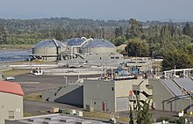
A sewage treatment plant and lagoon in Everett, Washington, USA
The purpose of tertiary treatment is to provide a final treatment stage to further improve the effluent quality before it is discharged to the receiving environment (sea, river, lake, wet lands, ground, etc.). More than one tertiary treatment process may be used at any treatment plant. If disinfection is practised, it is always the final process. It is also called "effluent polishing".

Filtration
Sand filtration removes much of the residual suspended matter. Filtration over activated carbon, also called carbon adsorption, removes residual toxins.

Lagoons or ponds
Settlement and further biological improvement of wastewater may be achieved through storage in large man-made ponds or lagoons. These lagoons are highly aerobic and colonization by native macrophytes, especially reeds, is often encouraged. Small filter-feeding invertebrates such as Daphnia and species of Rotifera greatly assist in treatment by removing fine particulates.

Biological nutrient removal
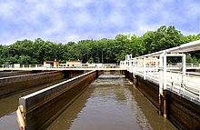
Nitrification process tank
Biological nutrient removal (BNR) is regarded by some as a type of secondary treatment process,^{[2]} and by others as a tertiary (or "advanced") treatment process.
Wastewater may contain high levels of the nutrients nitrogen and phosphorus. Excessive release to the environment can lead to a buildup of nutrients, called eutrophication, which can in turn encourage the overgrowth of weeds, algae, and cyanobacteria (blue-green algae). This may cause an algal bloom, a rapid growth in the population of algae.
The algae numbers are unsustainable and eventually most of them die. The decomposition of the algae by bacteria uses up so much of the oxygen in the water that most or all of the animals die, which creates more organic matter for the bacteria to decompose. In addition to causing deoxygenation, some algal species produce toxins that contaminate drinking water supplies. Different treatment processes are required to remove nitrogen and phosphorus.

Nitrogen removal
Nitrogen is removed through the biological oxidation of nitrogen from ammonia to nitrate (nitrification), followed by denitrification, the reduction of nitrate to nitrogen gas. Nitrogen gas is released to the atmosphere and thus removed from the water.
Nitrification itself is a two-step aerobic process, each step facilitated by a different type of bacteria. The oxidation of ammonia (NH₃) to nitrite (NO₂⁻) is most often facilitated by Nitrosomonas spp. ("nitroso" referring to the formation of a nitroso functional group). Nitrite oxidation to nitrate (NO₃⁻), though traditionally believed to be facilitated by Nitrobacter spp. (nitro referring the formation of a nitro functional group), is now known to be facilitated in the environment almost exclusively by Nitrospira spp.
Denitrification requires anoxic conditions to encourage the appropriate biological communities to form. It is facilitated by a wide diversity of bacteria. Sand filters, lagooning and reed beds can all be used to reduce nitrogen, but the activated sludge process (if designed well) can do the job the most easily. Since denitrification is the reduction of nitrate to dinitrogen (molecular nitrogen) gas, an electron donor is needed. This can be, depending on the waste water, organic matter (from feces), sulfide, or an added donor like methanol. The sludge in the anoxic tanks (denitrification tanks) must be mixed well (mixture of recirculated mixed liquor, return activated sludge [RAS], and raw influent) e.g. by using submersible mixers in order to achieve the desired denitrification.
Sometimes the conversion of toxic ammonia to nitrate alone is referred to as tertiary treatment.
Over time, different treatment configurations have evolved as denitrification has become more sophisticated. An initial scheme, the Ludzack–Ettinger Process, placed an anoxic treatment zone before the aeration tank and clarifier, using the return activated sludge (RAS) from the clarifier as a nitrate source. Influent wastewater (either raw or as effluent from primary clarification) serves as the electron source for the facultative bacteria to metabolize carbon, using the inorganic nitrate as a source of oxygen instead of dissolved molecular oxygen.
This denitrification scheme was naturally limited to the amount of soluble nitrate present in the RAS. Nitrate reduction was limited because RAS rate is limited by the performance of the clarifier.
The "Modified Ludzak–Ettinger Process" (MLE) is an improvement on the original concept, for it recycles mixed liquor from the discharge end of the aeration tank to the head of the anoxic tank to provide a consistent source of soluble nitrate for the facultative bacteria. In this instance, raw wastewater continues to provide the electron source, and sub-surface mixing maintains the bacteria in contact with both electron source and soluble nitrate in the absence of dissolved oxygen.
Many sewage treatment plants use centrifugal pumps to transfer the nitrified mixed liquor from the aeration zone to the anoxic zone for denitrification. These pumps are often referred to as Internal Mixed Liquor Recycle (IMLR) pumps. IMLR may be 200% to 400% the flow rate of influent wastewater (Q). This is in addition to Return Activated Sludge (RAS) from secondary clarifiers, which may be 100% of Q. (Therefore, the hydraulic capacity of the tanks in such a system should handle at least 400% of annual average design flow (AADF). At times, the raw or primary effluent wastewater must be carbon-supplemented by the addition of methanol, acetate, or simple food waste (molasses, whey, plant starch) to improve the treatment efficiency.
These carbon additions should be accounted for in the design of a treatment facility's organic loading. Further modifications to the MLE were to come: Bardenpho and Biodenipho processes include additional anoxic and oxidative processes to further polish the conversion of nitrate ion to molecular nitrogen gas. Use of an anaerobic tank following the initial anoxic process allows for luxury uptake of phosphorus by bacteria, thereby biologically reducing orthophosphate ion in the treated wastewater.
Even newer improvements, such as Anammox Process, interrupt the formation of nitrate at the nitrite stage of nitrification, shunting nitrite-rich mixed liquor activated sludge to treatment where nitrite is then converted to molecular nitrogen gas, saving energy, alkalinity, and secondary carbon sourcing.
Anammox™ (ANaerobic AMMonia OXidation) works by artificially extending detention time and preserving denitrifiying bacteria through the use of substrate added to the mixed liquor and continuously recycled from it prior to secondary clarification. Many other proprietary schemes are being deployed, including DEMON™, Sharon-ANAMMOX™, ANITA-Mox™, and DeAmmon™. The bacteria Brocadia anammoxidans can remove ammonium from waste water through anaerobic oxidation of ammonium to hydrazine, a form of rocket fuel.

Phosphorus removal
Every adult human excretes between 200 and 1,000 grams (7.1 and 35.3 oz) of phosphorus annually. Studies of United States sewage in the late 1960s estimated mean per capita contributions of 500 grams (18 oz) in urine and feces, 1,000 grams (35 oz) in synthetic detergents, and lesser variable amounts used as corrosion and scale control chemicals in water supplies.
Source control via alternative detergent formulations has subsequently reduced the largest contribution, but the content of urine and feces will remain unchanged. Phosphorus removal is important as it is a limiting nutrient for algae growth in many fresh water systems. (For a description of the negative effects of algae, It is also particularly important for water reuse systems where high phosphorus concentrations may lead to fouling of downstream equipment such as reverse osmosis.
Phosphorus can be removed biologically in a process called enhanced biological phosphorus removal. In this process, specific bacteria, called polyphosphate-accumulating organisms (PAOs), are selectively enriched and accumulate large quantities of phosphorus within their cells (up to 20 percent of their mass). When the biomass enriched in these bacteria is separated from the treated water, these biosolids have a high fertilizer value.
Phosphorus removal can also be achieved by chemical precipitation, usually with salts of iron (e.g. ferric chloride), aluminum (e.g. alum), or lime. This may lead to excessive sludge production as hydroxides precipitate and the added chemicals can be expensive. Chemical phosphorus removal requires significantly smaller equipment footprint than biological removal, is easier to operate and is often more reliable than biological phosphorus removal. Another method for phosphorus removal is to use granular laterite.
Some systems use both biological phosphorus removal and chemical phosphorus removal. The chemical phosphorus removal in those systems may be used as a backup system, for use when the biological phosphorus removal is not removing enough phosphorus, or may be used continuously.
In either case, using both biological and chemical phosphorus removal has the advantage of not increasing sludge production as much as chemical phosphorus removal on its own, with the disadvantage of the increased initial cost associated with installing two different systems.
Once removed, phosphorus, in the form of a phosphate-rich sewage sludge, may be dumped in a landfill or used as fertilizer. In the latter case, the treated sewage sludge is also sometimes referred to as biosolids.

Disinfection[

The purpose of disinfection in the treatment of waste water is to substantially reduce the number of microorganisms in the water to be discharged back into the environment for the later use of drinking, bathing, irrigation, etc. The effectiveness of disinfection depends on the quality of the water being treated (e.g., cloudiness, pH, etc.), the type of disinfection being used, the disinfectant dosage (concentration and time), and other environmental variables. Cloudy water will be treated less successfully, since solid matter can shield organisms, especially from ultraviolet light or if contact times are low.

, short contact times, low doses and high flows all militate against effective disinfection. Common methods of disinfection include ozone, chlorine, ultraviolet light, or sodium hypochlorite, Monochloramine, which is used for drinking water, is not used in the treatment of waste water because of its persistence. After multiple steps of disinfection, the treated water is ready to be released back into the water cycle by means of the nearest body of water or agriculture. Afterwards, the water can be transferred to reserves for everyday human uses.
Chlorination remains the most common form of waste water disinfection in North America due to its low cost and long-term history of effectiveness. One disadvantage is that chlorination of residual organic material can generate chlorinated-organic compounds that may be carcinogenic or harmful to the environment. Residual chlorine or chloramines may also be capable of chlorinating organic material in the natural aquatic environment. Further, because residual chlorine is toxic to aquatic species, the treated effluent must also be chemically dechlorinated, adding to the complexity and cost of treatment.
Ultraviolet (UV) light can be used instead of chlorine, iodine, or other chemicals. Because no chemicals are used, the treated water has no adverse effect on organisms that later consume it, as may be the case with other methods. UV radiation causes damage to the genetic structure of bacteria, viruses, and other pathogens, making them incapable of reproduction.
The key disadvantages of UV disinfection are the need for frequent lamp maintenance and replacement and the need for a highly treated effluent to ensure that the target microorganisms are not shielded from the UV radiation (i.e., any solids present in the treated effluent may protect microorganisms from the UV light). In the United Kingdom, UV light is becoming the most common means of disinfection because of the concerns about the impacts of chlorine in chlorinating residual organics in the wastewater and in chlorinating organics in the receiving water. Some sewage treatment systems in Canada and the US also use UV light for their effluent water disinfection.
Ozone (O₃) is generated by passing oxygen (O₂) through a high voltage potential resulting in a third oxygen atom becoming attached and forming O₃. Ozone is very unstable and reactive and oxidizes most organic material it comes in contact with, thereby destroying many pathogenic microorganisms.
Ozone is considered to be safer than chlorine because, unlike chlorine which has to be stored on site (highly poisonous in the event of an accidental release), ozone is generated on-site as needed from the oxygen in the ambient air. Ozonation also produces fewer disinfection by-products than chlorination. A disadvantage of ozone disinfection is the high cost of the ozone generation equipment and the requirements for special operators.

Fourth treatment stage
pollutants such as pharmaceuticals, ingredients of household chemicals, chemicals used in small businesses or industries, environmental persistent pharmaceutical pollutants (EPPP) or pesticides may not be eliminated in the conventional treatment process (primary, secondary and tertiary treatment) and therefore lead to water pollution.
Although concentrations of those substances and their decomposition products are quite low, there is still a chance of harming aquatic organisms. For pharmaceuticals, the following substances have been identified as "toxicologically relevant": substances with endocrine disrupting effects, genotoxic substances and substances that enhance the development of bacterial resistances.
They mainly belong to the group of EPPP. Techniques for elimination of micropollutants via a fourth treatment stage during sewage treatment are implemented in Germany, Switzerland, Sweden and the Netherlands and tests are ongoing in several other countries.^{[26]} Such process steps mainly consist of activated carbon filters that adsorb the micropollutants. The combination of advanced oxidation with ozone followed by granular activated carbon (GAC) has been suggested as a cost-effective treatment combination for pharmaceutical residues.
For a full reduction of microplasts the combination of ultrafiltration followed by GAC has been suggested. Also the use of enzymes such as the enzyme laccase is under investigation. A new concept which could provide an energy-efficient treatment of micropollutants could be the use of laccase secreting fungi cultivated at a wastewater treatment plant to degrade micropollutants and at the same time to provide enzymes at a cathode of a microbial biofuel cells. Microbial biofuel cells are investigated for their property to treat organic matter in wastewater.
To reduce pharmaceuticals in water bodies, "source control" measures are also under investigation, such as innovations in drug development or more responsible handling of drugs.

Odor control
Odors emitted by sewage treatment are typically an indication of an anaerobic or "septic" condition. Early stages of processing will tend to produce foul-smelling gases, with hydrogen sulfide being most common in generating complaints. Large process plants in urban areas will often treat the odors with carbon reactors, a contact media with bio-slimes, small doses of chlorine, or circulating fluids to biologically capture and metabolize the noxious gases. Other methods of odor control exist, including addition of iron salts,
UNIT-V

UNIT-V
APPLICATION OF MICERBES IN FOOD INDUSTRY
Microorganisms play an important role in food industry.It ‘s used in production of various food products, and are also responsible for food spoilage thereby causing intoxication and diseases.
Microbial contamination of food products takes places usually on the way from the field to the processing plant, or during processing, storage, transport and distribution or before consumption. The microorganisms that cause food spoilage and also find the maximum exploitation in production of food and food products are mainly bacteria, molds and yeasts.
Bacteria
Bacteria are the largest group of unicellular microorganisms. The shapes of medically important bacteria are classified into-cocci, or spherical cells; bacilli, or cylindrical or rod shaped cells; and spiral or curved forms. The pathogenic or disease causing bacteria are usually gram negative, however, three gram-positive rods are known to cause food intoxications : Clostridium botulinum,C. perfringens,and Bacillus cereus
Some of the other most common bacteria causing food spoilage, infections and disease are Acinetobacter, Aeromonas, Escherichia, Proteus, Alcaligenes, Flavobacterium, Pseudomonas, Arcobacter, Salmonella, Lactococcus, Serratia, Campylobacter, Shigella, Citrobacter, Listeria, Staphylococcus, Micrococcus, Corynebacterium, Vibrio Enterobacter, Paenibacillus, Weissella, Enterococcus, Yersinia
Different strains of bacteria are also used in production of various food and dairy products. Strains of Streptococcus, Lactobacillus Bifidobacterium, Erwiniaetc. are used in the production of fermented food and dairy products. Streptococcus thermophilus and Lactobacillusbulgaricus are used to produce yogurt.
Molds:
Molds are multicellular filamentous fungi whose growth on foods is usually readily recognized by their fuzzy or cottony appearance. They are mainly responsible for food spoilage at room temperature 25- 30oC and low pH, and have minimum moisture requirement. Molds can rapidly grow on grains and corns when these products are stored under moist conditions. Molds require free oxygen for growth and hence grow on the surface of contaminated food.
Molds also find their use in manufacturing of different foods and food products. They are used in ripening of various types of food products as cheese (e.g. Roquefort,Camembert). Molds are also grown as feed and food and are employed to produce ingredients such as enzymes like amylase used in making bread or citric acid used in soft drinks. Molds are major contributors in the ripening of many oriental foods. A species of Bothrytiscinerea, is used in rotting of grape for production of wine. Lactic fermentations using molds results in a unique Finnish fermented milk called viili.
Yeasts:
Yeasts have the ability to ferment sugars to ethanol and carbon-dioxide and hence they are extensively in food industry. The most commonly used yeast, the baker’s yeast is grown industrially. Saccharomyces carlsbergensis is most commonly used in fermentation of most beers. The other yeast strains of importance are
Brettanomyces, Schizosaccharomyce,, Candida, Cryptococcus, Debaryomyces, Zygosaccharomyces, Hanseniaspora, Saccharomyces
FERMENTED FOODS

Health Benefits of Fermented Foods
A number of health benefits are associated with fermentation. In fact, fermented foods are often more nutritious than their unfermented form.
Here are the key health benefits of fermented foods.

Improves Digestive Health
The probiotics produced during fermentation can help restore the balance of friendly bacteria in your gut and may alleviate some digestive problems.
Evidence suggests that probiotics can reduce uncomfortable symptoms of irritable bowel syndrome (IBS), a common digestive disorder.
One 6-week study in 274 adults with IBS found that consuming 4.4 ounces (125 grams) of yogurt-like fermented milk daily improved IBS symptoms, including bloating and stool frequency.
What’s more, fermented foods may also lessen the severity of diarrhea, bloating, gas, and constipation .For these reasons, adding fermented foods to your diet may be useful if you regularly experience gut issues.

Boosts Your Immune System
The bacteria that live in your gut have a significant impact on your immune system.
Due to their high probiotic content, fermented foods can give your immune system a boost and reduce your risk of infections like the common cold .
Consuming probiotic-rich foods may also help you recover faster when you’re sick.
Additionally, many fermented foods are rich in vitamin C, iron, and zinc — all of which are proven to contribute to a stronger immune system.

Makes Food Easier to Digest
Fermentation helps break down nutrients in food, making them easier to digest than their unfermented counterparts.
For example, lactose — the natural sugar in milk — is broken down during fermentation into simpler sugars — glucose and galactose.
As a result, those with lactose intolerance are generally fine eating fermented dairy like kefir and yogurt .
fermentation helps break down and destroy antinutrients — such as phytates and lectins — which are compounds found in seeds, nuts, grains, and legumes that interfere with the nutrient absorption.
Therefore, consuming fermented beans or legumes like tempeh increases the absorption of beneficial nutrients, making them more nutritious than unfermented alternatives .

Other Potential Benefits
Studies have shown that fermented foods may also promote:
- Mental health: A few studies have linked the probiotic strains Lactobacillus helveticus and Bifidobacterium longum to a reduction in symptoms of anxiety and depression. Both probiotics are found in fermented foods.
- Weight loss: While more research is needed, some studies have found links between certain probiotic strains — including Lactobacillus rhamnosus and Lactobacillus gasseri — and weight loss and decreased belly fat.
- Heart health: Fermented foods have been associated with a lower risk of heart disease. Probiotics may also modestly reduce blood pressure and help lower total and “bad” LDL cholesterol.

Microbial food cultures
Microbial food cultures are live bacteria, yeasts or moulds used in food production. Microbial food cultures carry out the fermentation process in foodstuffs. Used by humans since the Neolithic period (around 10 000 years BC) ]fermentation helps to preserve perishable foods and to improve their nutritional and organoleptic qualities (in this case, taste, sight, smell, touch). As of 1995, fermented food represented between one quarter and one third of food consumed in Central Europe.
More than 260 different species of microbial food culture are identified and described for their beneficial use in fermented food products globally, showing the importance of their use.
The scientific rationale of the function of microbes in fermentation started to be built with the discoveries of Louis Pasteur in the second half of the 19th century. Extensive scientific study continues to characterize microbial food cultures traditionally used in food fermentation taxonomically, physiologically, biochemically and genetically. This allows better understanding and improvement of traditional food processing and opens up new fields of applications.

Historical overview
Microorganisms are the earliest form of life on earth, first evolving more than three billion years ago.] Our ancestors discovered how to harness the power of microorganisms to make new foods, even if they did not know the science behind what they were doing.
Milestones
1665—Robert Hooke and Antoni Van Leeuwenhoek first observe and describe microorganisms
1857–1876—Louis Pasteur proves the function of microorganisms in lactic and alcoholic fermentation
1881—Emil Christian Hansen isolates Saccharomyces carlsbergensis, a pure yeast culture, which is today widely used in brewing of lager beers.
1889–1896—Herbert William Conn, Vilhelm Storch and Hermann Weigmann demonstrate that bacteria are responsible for the acidification of milk and of cream.
1897—Eduard von Freudenreich isolates Lactobacillus brevis.
1919—Sigurd Orla-Jensen classifies lactic acid bacteria on the basis of the bacteria's physiological response patterns.
Starting from 1970s—production of first industrial concentrated cultures, frozen or freeze-dried cultures, for the direct inoculation of processed milk, improving the regularity of production processes.

Function of microbial food cultures in food
Microbial food cultures preserve food through formation of inhibitory metabolites such as organic acid (lactic acid, acetic acid, formic acid, propionic acid), ethanol, bacteriocins, etc., often in combination with decrease of water activity (by drying or use of salt).
Further, microbial food cultures help to improve food safety through inhibition of pathogens or removing of toxic compounds. Microbial food cultures also improve the nutritional value and organoleptic quality of the food.
The microbial food cultures used in food fermentation can be divided into three major groups: bacteria, yeasts and moulds.

Bacteria
Bacterial food cultures can be divided into starter cultures and probiotics.
Starter cultures have mainly a technological function in the food manufacturing. They are used as food ingredients at one or more stages in the food manufacturing process and develop the desired metabolic activity during the fermentation or ripening process. They contribute to the one or multiple unique properties of a foodstuff especially in regard to taste, flavour, colour, texture, safety, preservation, nutritional value, wholesomeness and/or health benefits
Probiotics have a functional role, which refers to the ability of certain microbes to confer health benefits to the consumer.
Generally, the bacteria used as starter culture are not the same used as probiotics. There are, however, cases when one bacterium can be used both as starter culture and as probiotic. The scientific community is presently trying to deepen understanding of the roles played by microbes in food processing and human health.
The most important bacteria in food manufacturing are Lactobacillus species, belonging to the group of lactic acid bacteria
Bacterial food cultures are responsible for the aroma, taste and texture of cheeses and fermented milk products such as yogurts, ayran, doogh, skyr or ymer. They contribute to developing the flavour and colour of such fermented products as salami, pepperoni and dried ham.
Lactic acid bacteria converts the unstable malic acid that is naturally present in wine into the stable lactic acid. This malolactic fermentation gives the stability that is characteristic of high-quality wines that improve on storage.
Lactic acid bacteria are also used in food supplements as probiotics which help to restore the balance in human intestinal biota

Yeasts
The most familiar yeast in food production, Saccharomyces cerevisiae, has been used in brewing and baking for thousands of years.
S. cerevisiae feeds on the sugars present in the bread dough and produces the gas carbon dioxide. This forms bubbles within the dough, causing it to expand and the bread to rise.
Several different yeasts are used in brewing beer, where they ferment the sugars present in malted barley to produce alcohol. One of the most common is S. cerevisiae. The same strain of S. cerevisiae which can also be used in breadmaking is used to make ale-type beers. It is known as a top-fermenting yeast because it creates a foam on the top of the brew. Bottom-fermenting yeasts, such as S. pastorianus, are more commonly used to make lagers. They ferment more of the sugars in the mixture than top-fermenting yeasts, which gives a cleaner taste.
The alcohol in wine is formed by the fermentation of the sugars in grape juice, with carbon dioxide as a by-product. Yeast is naturally present on grapeskins, and this alone can be sufficient for the fermentation of sugars to alcohol to occur. A pure yeast culture, most often S. cerevisiae, is usually added to ensure the fermentation is reliable.
Other yeast cultures like Pichia, Torulaspora and Kluyveromyces are naturally present or added to create special flavours in the wine. Sparkling wine, including champagne, is made by adding further yeast to the wine when it is bottled. The carbon dioxide formed in this second fermentation is trapped as bubbles
Yeasts are also used to produce kefir products., semi-soft ripened cheeses and fermented soy drinks

Moulds
Three main types of cheese rely on moulds for their characteristic properties: blue cheese, soft ripened cheese (such as camembert and brie) and rind-washed cheese (such as époisses and taleggio).
To make blue cheese, the cheese is treated with a mould, usually Penicillium roqueforti, while it is still in the loosely pressed curd form. As the cheese matures, the mould grows, creating blue veins within it which gives the cheese its characteristic flavour. Examples include stilton, roquefort and gorgonzola.
Soft ripened cheese such as brie and camembert are made by allowing P. camemberti to grow on the outside of the cheese, which causes them to age from the outside in. The mould forms a soft white crust, and the interior becomes runny with a strong flavour
Rind-washed cheeses like limburger also ripen inwards, but here, as the name suggests, they are washed with brine and other ingredients such as beer and wine which contain mould. This also makes them attractive to bacteria, which add to the flavour
Traditionally, inoculations of sausages with moulds were done with the indigenous biota of the slaughters. Different moulds (such as P. chrysogenum and P. nalgiovense) can be used to ripen surfaces of sausages. The mould cultures develop the aroma and improve the texture of the sausages. They also contribute to shortening of the ripening period and preserving the natural quality. This expands the shelf life of the meat product.
In the past, soy sauce has been made by mixing soybeans and other grains with a mould (Aspergillus oryzae or A. sojae) and yeast. This mixture was then left to ferment in the sun. Today soy sauce is made under controlled conditions. The key flavour ingredients formed in this process are salts of the amino acid glutamic acid, notably monosodium glutamate.

Production of microbial food cultures]
The industrial production of microbial food cultures is carried out after careful selection process and under strictly controlled conditions. First, the microbiology laboratory, where the original strains are kept, prepares the inoculation material, which is a small quantity of microbes of a single (pure) strain. Then, the inoculation material is multiplied and grown either in fermenters (liquid) or on a surface (solid) under defined and monitored conditions. Grown cells of pure culture are harvested, eventually blended with other cultures and, finally, formulated (preserved) for subsequent transportation and storage. They are sold in liquid, frozen or freeze-dried formats.
Another and traditional way of starting a food fermentation is often referred to as spontaneous fermentation. Cultures come from raw milk, i.e. milk that has not undergone any sanitation treatment or from the reuse of a fraction of the previous production (back-slopping). The composition of such cultures is complex and extremely variable. The use of such techniques is steadily decreasing in developed countries. Some countries even prohibit the back-slopping technique because of the "potential to magnify pathogen loads to very dangerous levels".

Safety and regulatory aspects
Microbial food cultures are considered as traditional food ingredients and are permitted in the production of foodstuffs all over the world under general food laws.
Commercially available microbial food cultures are sold as preparations, which are formulations, consisting of concentrates of one or more microbial species and/or strains including unavoidable media components carried over from the fermentation and components, which are necessary for their survival, storage, standardisation and to facilitate their application in the food production process.
Safety of microbial food cultures, depending on their characteristics and use, can be based on genus, species or strain levels.

Microorganisms with documented history of safe use in food
The first (non-exhaustive) inventory of microorganisms with a documented history of use in food was for the first time compiled in 2001 by the International Dairy Federation (IDF) and the European Food and Feed Cultures Association (EFFCA).
In 2012, this inventory was updated. It now covers a wide range of food applications (including dairy, fish, meat, beverages and vinegar) and features a reviewed taxonomy of microorganisms.

US
In the United States of America, microbial food cultures are regulated under the Food, Drug and Cosmetic Act. Section 409 of the 1958 Food Additives Amendment of the Food, Drug and Cosmetic Act, exempts from the definition of food additives substances generally recognized by experts as safe (GRAS) under conditions of their intended use. These substances do not require premarket approval by the US Food and Drug Administration.
Because there are various ways to obtain GRAS status for microbial food cultures, there is no exhaustive list of microbial food cultures having GRAS status in the US.

European Union
Within the European Union, microbial food cultures are regarded as food ingredients and are regulated by Regulation 178/2002, commonly referred to as the General Food Law.
Since 2007, the European Food Safety Authority (EFSA) has been maintaining a list of microorganisms having qualified presumption of safety (QPS) The QPS list covers only a limited number of microorganisms, which have been referred to EFSA for safety assessment. It has been conceived as an internal evaluation tool for microorganisms used in the food production chain (e.g. feed cultures, cell factories producing enzymes or additives, plant protection) that need an evaluation by EFSA scientific panels before being marketed in the EU.
Microbial food cultures with a long history of safe use are, however, considered to be traditional food ingredients and are legally permitted for use in human food without EFSA evaluation.

Denmark
From 1974 to 2010 Denmark required premarket approval of microbial food cultures. The positive list of microbial food cultures is available on the website of the Danish Veterinary and Food Administration.
In 2010, the regulation changed. Approval is no longer needed but a notification should be made to the Veterinary and Food Administration.

Microbes in the Food Industry | Microorganisms | Biology
There are many useful application of microbes in the food industry. They influence the quality, availability and quantity of food. Microorganisms are used to change one substance to another which is used as food, such as milk to yoghurt and cheese, sugar to wine and bread.
Fermented Dairy Products:
Fermented milk is produced by inoculating pasteurised milk with specific culture of microorganisms. The different fermented dairy products include yoghurt and cheese.

Bacteria is used in Yoghurt Making:
Yoghurt is a dairy product which is produced by the bacterial fermentation of milk. Most commonly, cow’s milk is used, though it can be made from any kind of milk. It can be prepared from a variety of milk including whole, skimmed, dried, evaporated or semi-skimmed milk.
The steps involved in yoghurt making are illustrated in Fig. 1:
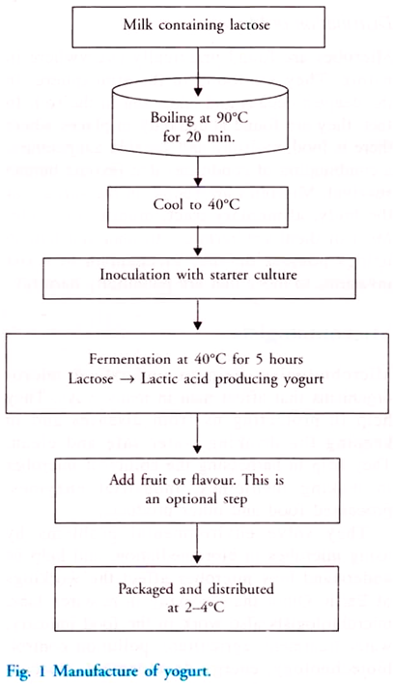
The milk sugar, i.e. lactose is fermented into lactic acid by the friendly bacteria, Streptococcus salivarius, S. thermophilus and Lactobacillus bulgaricus. These bacteria are collectively known as lactic acid bacteria or LAB. The bacteria feed on the lactose and release lactic acid as a waste product.
The acid cause the curdling of the milk protein, casein into a solid mass called curd. The gel like texture and taste of yoghurt is due to the fermentation of lactose to lactic acid. The increased acidity (pH = 4-5) also prevents the proliferation of other potentially pathogenic bacteria.
Both unpasteurised and pasteurized milk may be used for yoghurt making. The use of unpasteurised milk maintains the healthy balance of bacteria and enzymes of milk in its unprocessed state under very carefully controlled temperature and environmental conditions. To ensure complete fermentation two or more different bacteria may be used together.
Yoghurt is often sold sweetened and flavoured, or with fruit added at the bottom. The flavour varies in different countries.
a. Lassi is yoghurt-based beverage in India and is consumed either salty or sweet. Salty lassi is usually flavoured with ground- roasted cumin and black pepper powder, while the sweet variety is served with lemon, mango or other fruit juice.
b. A lassi-like, salty drink called ayran is popular in Turkey and Bulgaria and is prepared by mixing yoghurt with water and salt.
In India, Bulgaria and Turkey yogurt is prepared at home using a small amount of plain active culture yogurt as the starter culture. The milk is boiled to kill undesirable microbes. It is cooled to about 40°C. A tablespoon of starter culture is added and mixed thoroughly. It is left undisturbed for about 6 hours.
Bacteria and Fungi are used in Cheese Making:
Cheese is prepared by inoculating milk with a starter culture containing specific microorganisms. Cheese is a solid food made from the milk of various animals, most commonly cows. Milk from goat, sheep, reindeer and water buffalo may also be used. There are several types of cheese.
Fermentation of milk leads to lactic acid production, which sours the milk. This leads to coagulation of milk protein, casein. The solid part of the milk produced by coagulation is known as curd and the liquid is known as whey.
The curds can be separated and pressed into desired shape and whey is used as food source for yeasts, which in turn can be processed as cattle feed and is rich in protein and vitamins. The cheese can be matured or ripened by the addition of bacteria or fungi or both. The bacteria added reduce the pH, alters texture and develops a flavour.
Coagulation can be controlled using rennet tablets, which contains the enzyme rennin. Rennin is an enzyme present in the stomach of Calves but now is also available in genetically engineered bacteria. Coagulation can also be done using acids such as vinegar or lemon juice.
Depending on the nature of the organism added, cheese is of the following types:

a. Cheddar cheese is prepared by the addition of bacteria to enhance its flavour and texture.
b. The use of mould fungi produces Roquefort cheese and blue cheese
c. A combination of both bacteria and fungi produces camembert cheese.
d. Swiss cheese is prepared by the addition of Propionibacterium sharmanii. The big holes in the cheese is because of the production of large amounts of CO₂.

The natural colour of cheese ranges from off-white to yellow. Herbs and spices may also be added to the cheese. Other factors that contribute to a different flavours and styles of cheese are different levels of milk fat, variations in length of aging, different processing treatments and different breeds of cows, sheep or other mammals.
Table 3 summarises the major classes of cheese:
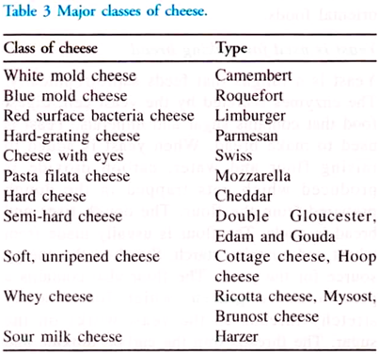
Cheese is sold in the form as slices or in blocks or as a thick fluid. In addition, there is a class of cheese known as processed cheese or cheese food. Processed cheese is similar to cheese, but contains emulsifying salts acting as stabilisers. Heat treatment during the manufacturing process gives processed cheese a mild flavour.
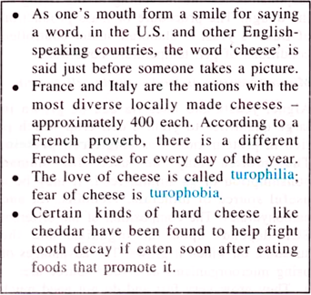

Other Fermented Foods:
Some important food produced in whole or in part by microbial fermentation are pickles, sausages, etc. Different microorganisms are added to specific stages of food production to produce the desired effect. Moulds are used for the fermentation of rice to produce a variety of oriental foods.
Yeast is used for Making Bread:
Yeast is a fungus that feeds saprotrophically. The enzymes secreted by the yeast cell, digest food that contains sugar and minerals. Yeast is used to make bread. When yeast is added to raising flour and water, carbon dioxide is produced which gets trapped in the dough prepared from the flour.
The dough rises and bread is made. The flour is usually made from wheat and contains starch. Starch is the energy source for the yeast. The flour also contains a protein called gluten, which forms sticky stretchy threads as the yeast works on the sugar. The threads trap the carbon dioxide and make the dough rise well.
Some commercial uses of yeast are shown in Table 4:
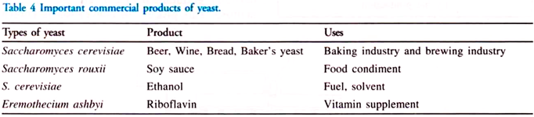
Baker’s Yeast:
Yeast is used as leavening agent in baking since earlier times. The most commonly used species is Saccharomyces cerevisiae because of its ability to ferment sugar in the dough vigorously and to grow rapidly. The carbon dioxide used during the fermentation is responsible for the leavening or the rising of the dough. The procedure of mass production of Baker’s yeast is elaborate under controlled conditions of pH, temperature conditions.
Microorganisms as Food – Single Cell Protein:
Algae, yeasts and bacteria can be grown in large quantities to yield a cell crop which is rich in protein known as single cell protein. The protein may be used for human consumption or as animal feed. It may be a useful source of minerals, vitamins, fat and carbohydrates. The composition of the different SCP depends upon the organism and the substrate on which it grows.
The advantages of using microorganisms as a food source are:
a. They grow very fast and do not need much space as conventional crops.
b. They grow on a wide range of cheap, waste products of agriculture and industry such as petroleum products, methanol, ethanol, sugar, molasses, waste from paper mills etc. The secondary advantage is that they help in recycling the materials and thereby clean up the wastes.
c. They are high yielding. In a growth medium of 1000 lb of yeast in one day, many tonnes of protein is produced. This is about 10-15 times greater than soyabean and about 25-50 times greater than corn.
d. The protein content of the cells is very high. Yeast cells have a protein content as high as 40-50%; for algae the range is 20- 40%.
e. The proteins of the microorganism contain all the essential amino acids.
f. Some microorganisms, particularly yeasts, have high vitamin content.
g. Factors, such as climate do not affect them, since they do not occupy large areas of land.
Pruteen was the first major SCP to be produced. It was produced by a bacterium, Methylophilus methylotrophus. Methanol was used as a source of energy and the temperature was maintained at 30-40°C and pH at 6.7.
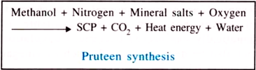
Pruteen was rich in essential amino acids and has high vitamin content. It is twice as nutritious as soyabean meal and was used as an animal feed.
Some disadvantages of using SCP:
a. The high nucleic acid content causes intestinal disturbances. It can also lead to an increase in the uric acid in the blood that will eventually lead to gout. Additional processing can be done to reduce the nucleic acid content, but this would increase the cost.
b. Bacterial cells have small size and low density, which makes harvesting from the fermented medium difficult and costly.
c. The taste is not acceptable for many persons. Individual taste and customs make microorganism unattractive as a food to some individuals.
Chocolate Making:
Chocolate is prepared with the help of microbes. Chocolate comes from the seeds of cacao trees. These seeds are found in a white fleshy pod. To remove the seeds out of the pod, the pod is allowed to ferment with naturally occurring microbes that include yeasts and bacteria

Pickling
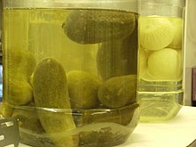
A jar of pickled cucumbers (front) and a jar of pickled onions (back)
Pickling is the process of preserving or extending the shelf life of food by either anaerobic fermentation in brine or immersion in vinegar. In East Asia, vinaigrette (vegetable oil and vinegar) is also used as a pickling medium.
The pickling procedure typically affects the food's texture, taste and flavor. The resulting food is called a pickle, or, to prevent ambiguity, prefaced with pickled. Foods that are pickled include vegetables, fruits, meats, fish, dairy and eggs.
A distinguishing characteristic is a pH of 4.6 or lower, which is sufficient to kill most bacteria. Pickling can preserve perishable foods for months. Antimicrobial herbs and spices, such as mustard seed, garlic, cinnamon or cloves, are often added.
If the food contains sufficient moisture, a pickling brine may be produced simply by adding dry salt. For example, sauerkraut and Korean kimchi are produced by salting the vegetables to draw out excess water. Natural fermentation at room temperature, by lactic acid bacteria, produces the required acidity.
Other pickles are made by placing vegetables in vinegar. Like the canning process, pickling (which includes fermentation) does not require that the food be completely sterile before it is sealed. The acidity or salinity of the solution, the temperature of fermentation, and the exclusion of oxygen determine which microorganisms dominate, and determine the flavor of the end product
When both salt concentration and temperature are low, Leuconostoc mesenteroides dominates, producing a mix of acids, alcohol, and aroma compounds. At higher temperatures Lactobacillus plantarum dominates, which produces primarily lactic acid. Many pickles start with Leuconostoc, and change to Lactobacillus with higher acidity.

History

Pickling likely first originated in the Indus Valley Civilization in northwest India around 2400 BCE. New York Food Museums’s Pickle History section points out the archaeological evidence of cucumbers native to India being pickled and exported to the Tigris Valley of Iraq in 2030 BCE.
Indian pickles are mostly prepared in three ways: salt/brine, oil, and vinegar, with mango pickle being most popular among all
Pickling was used as a way to preserve food for out-of-season use and for long journeys, especially by sea. Salt pork and salt beef were common staples for sailors before the days of steam engines. Although the process was invented to preserve foods, pickles are also made and eaten because people enjoy the resulting flavors. Pickling may also improve the nutritional value of food by introducing B vitamins produced by bacteria.

Etymology
Though pickle originated in India where it is called the "achar", the English term "pickle" comes from the Dutch word "pekel" which refers to the brine. Hobson-Jobson's Definitive Glossary of British India states that the Indian word "āchār" was also mentioned in 1563 CE book authored by the Portuguese physician Garcia da Orta who mentions Indians of the Portuguese Indian colony of Goa preserving cashew with salt Indians called "Āchār".
The Indian food scientist K. T. Achaya explains in his A Historical Dictionary of Indian Food that pickling is cooking without fire. He further adds that the Hindu text the Linga Purana (variously dated from 5th to 10th/15th CE) in Kannada language by Gurulinga Desika provides 50 pickle recipes, and achar also finds mention in the King of Keladi "Basavappa Nayaka" (r. 1697–1714 CE) work Śivatattvaratnākara. W
ith the expansion of Indosphere cultural influence of Greater India, through transmission of Hinduism in Southeast Asia and the Silk Road transmission of Buddhism leading to Indianization of Southeast Asia with non-Indian southeast Asian native Indianized kingdoms adopting Sanskritization of their languages and honorific titles as well as ongoing historic expansion of Indian diaspora has resulted in many overseas places and food items having Indianised names, including adoption of Indian achaar pickle as atchara in Philippines and acar in Indonesia, Malaysia, Singapore and Brunei.
In the U.S. and Canada, and sometimes Australia and New Zealand, the word pickle alone almost always refers to a pickled cucumber, except when it is used figuratively. It may also refer to other types of pickles such as "pickled onion", "pickled cauliflower", etc. In the UK, pickle, as in a "cheese and pickle sandwich", may also refer to Ploughman's pickle, a British version of Indian chutney.

Popularity of pickles around the world

Asia

South Asia
South Asia has a large variety of pickles (known as achar (अचार, اچار) in Nepali, Assamese, Bengali, Hindi (अचार), Punjabi, Urdu (اچار) uppinakaayi in Kannada, lonacha (लोणचं) in Marathi, uppilittathu or achar in Malayalam, oorukai in Tamil, ooragaya in Telugu), which are mainly made from varieties of mango, lemon, lime, goongura (a sour leafy shrub), tamarind and Indian gooseberry (amla), chilli. Vegetables such as eggplant, carrots, cauliflower, tomato, bitter gourd, green tamarind, ginger, garlic, onion, and citron are also occasionally used. These fruits and vegetables are generally mixed with ingredients like salt, spices, and vegetable oils and are set to mature in a moistureless medium.
In Pakistan, pickles are known locally as achaar (in Urdu اچار) and come in a variety of flavors. A popular item is the traditional mixed Hyderabadi pickle, a common delicacy prepared from an assortment of fruits (most notably mangoes) and vegetables blended with selected spices. Although the origin of the word is ambiguous, the word āchār is widely considered to be of Persian origin. Āchār in Persian is defined as ‘powdered or salted meats, pickles, or fruits, preserved in salt, vinegar, honey, sugar or syrup.
In Sri Lanka, achcharu is traditionally prepared from carrots, onions, and ground dates that are mixed with mustard powder, ground pepper, crushed ginger, garlic, and vinegar, and left to sit in a clay pot.

Southeast Asia

Singapore, Indonesian and Malaysian pickles, called acar, are typically made out of cucumber, carrot, bird's eye chilies, and shallots, these items being seasoned with vinegar, sugar and salt. Fruits, such as papaya and pineapple, are also sometimes pickled.
In the Philippines, pickling was traditionally done in earthen jars and is widely known as buro or binuro. Pickling was a common method of preserving food throughout the archipelago before the advent of refrigeration, but its popularity is now confined to vegetables and fruits. Achara remains popular as the Philippine localization of the Malay acar, and is primarily made out of green papaya, carrots, and shallots, seasoned with cloves of garlic and vinegar; but could include ginger, bell peppers, white radishes, cucumbers or bamboo shoots. Pickled unripe mangoes or burong mangga, unripe tomatoes, guavas, jicama, bitter gourd and other fruit and vegetables still retain their appeal. Siling labuyo, sometimes with garlic and red onions, is also pickled in bottled vinegar and is a staple condiment in Filipino cuisine.
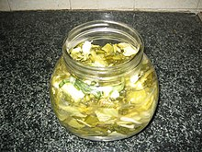
Dưa cải muối made from cải bẹ xanh
In Vietnamese cuisine, vegetable pickles are called dưa muối ("salted vegetables") or dưa chua ("sour vegetables"). Dưa chua or dưa góp is made from a variety of fruits and vegetables, including cà pháo, eggplant, Napa cabbage, kohlrabi, carrots, radishes, papaya, cauliflower, and sung. Dưa chua made from carrots and radishes are commonly added to bánh mì sandwiches. Dưa cải muối is made by pressing and sun-drying vegetables such as cải bẹ xanh and bok choy. Nhút mít is a specialty of Nghệ An and Hã Tĩnh provinces made from jackfruit.
In Burma, tea leaves are pickled to produce lahpet, which has strong social and cultural importance.
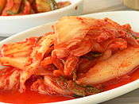
Kimchi is a very common side dish in Korea.

East Asia
China is home to a huge variety of pickled vegetables, including radish, baicai (Chinese cabbage, notably suan cai, la bai cai, pao cai, and Tianjin preserved vegetable), zha cai, chili pepper, and cucumbers, among many others.
Japanese tsukemono (pickled foods) include takuan (daikon), umeboshi (ume plum), gari & beni shōga (ginger), turnip, cucumber, and Chinese cabbage.
The Korean staple kimchi is usually made from pickled napa cabbage and radish, but is also made from green onions, garlic stems, chives and a host of other vegetables. Kimchi is popular throughout East Asia. Jangajji is another example of pickled vegetables.
In Iran, Turkey, Arab countries, the Balkans, and the South Caucasus, pickles (called torshi in Persian, turşu in Turkish language and mekhallel in Arabic) are commonly made from turnips, peppers, carrots, green olives, cucumbers, cabbage, green tomatoes, lemons, and cauliflower.
Sauerkraut, as well as cabbage pickled in vinegar, with carrot and other vegetables is commonly consumed as a kosher dish in Israel and is considered pareve, meaning that it contains no meat or dairy so it can be consumed with either.

Europe

Central and Eastern Europe
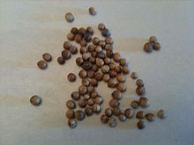
Coriander seeds are one of the spices popularly added to pickled vegetables in Europe.
In Hungary the main meal (lunch) usually includes some kind of pickles (savanyúság), but pickles are also commonly consumed at other times of the day. The most commonly consumed pickles are sauerkraut (savanyú káposzta), pickled cucumbers and peppers, and csalamádé, but tomatoes, carrots, beetroot, baby corn, onions, garlic, certain squashes and melons, and a few fruits like plums and apples are used to make pickles too.
Stuffed pickles are specialties usually made of peppers or melons pickled after being stuffed with a cabbage filling. Pickled plum stuffed with garlic is a unique Hungarian type of pickle just like csalamádé and leavened cucumber (kovászos uborka). Csalamádé is a type of mixed pickle made of cabbage, cucumber, paprika, onion, carrot, tomatoes, and bay leaf mixed up with vinegar as the fermenting agent.
Leavened cucumber, unlike other types of pickled cucumbers that are around all year long, is rather a seasonal pickle produced in the summer. Cucumbers, spices, herbs, and slices of bread are put in a glass jar with salt water and kept in direct sunlight for a few days. The yeast from the bread, along with other pickling agents and spices fermented under the hot sun, give the cucumbers a unique flavor, texture, and slight carbonation.
Its juice can be used instead of carbonated water to make a special type of spritzer ('Újházy fröccs'). It is common for Hungarian households to produce their own pickles. Different regions or towns have their special recipes unique to them. Among them all the Vecsési sauerkraut (Vecsési savanyú káposzta) is the most famous.

Romanian pickles (murături) are made out of beetroot, cucumbers, green tomatoes (gogonele), carrots, cabbage, garlic, sauerkraut (bell peppers stuffed with cabbage), bell peppers, melons, mushrooms, turnips, celery and cauliflower. Meat, like pork, can also be preserved in salt and lard.
Polish, Czech and Slovak traditional pickles are cucumbers, sauerkraut, peppers, beetroot, tomatoes, but other pickled fruits and vegetables, including plums, pumpkins and mushrooms are also common.
North Caucasian, Russian, Ukrainian and Belarusian pickled items include beets, mushrooms, tomatoes, sauerkraut, cucumbers, ramsons, garlic, eggplant (which is typically stuffed with julienned carrots), custard squash, and watermelon. Garden produce is commonly pickled using salt, dill, blackcurrant leaves, bay leaves and garlic and is stored in a cool, dark place.
The leftover brine (called rassol (рассол) in Russian) has a number of culinary uses in these countries, especially for cooking traditional soups, such as shchi, rassolnik, and solyanka. Rassol, especially cucumber or sauerkraut rassol, is also a favorite traditional remedy against morning hangover.

Southern Europe
An Italian pickled vegetable dish is giardiniera, which includes onions, carrots, celery and cauliflower. Many places in southern Italy, particularly in Sicily, pickle eggplants and hot peppers.
In Albania, Bulgaria, Serbia, Macedonia and Turkey, mixed pickles, known as turshi, tursija or turshu form popular appetizers, which are typically eaten with rakia. Pickled green tomatoes, cucumbers, carrots, bell peppers, peppers, eggplants, and sauerkraut are also popular.
Turkish pickles, called turşu, are made out of vegetables, roots, and fruits such as peppers, cucumber, Armenian cucumber, cabbage, tomato, eggplant (aubergine), carrot, turnip, beetroot, green almond, baby watermelon, baby cantaloupe, garlic, cauliflower, bean and green plum. A mixture of spices flavor the pickles.
In Greece, pickles, called τουρσί(α), are made out of carrots, celery, eggplants stuffed with diced carrots, cauliflower, tomatoes, and peppers.

Northern Europe
In Britain, pickled onions and pickled eggs are often sold in pubs and fish and chip shops. Pickled beetroot, walnuts, and gherkins, and condiments such as Branston Pickle and piccalilli are typically eaten as an accompaniment to pork pies and cold meats, sandwiches or a ploughman's lunch. Other popular pickles in the UK are pickled mussels, cockles, red cabbage, mango chutney, sauerkraut, and olives. Rollmops are also quite widely available under a range of names from various producers both within and out of the UK.
Pickled herring, rollmops, and salmon are popular in Scandinavia. Pickled cucumbers and red garden beets are important as condiments for several traditional dishes. Pickled capers are also common in Scandinavian cuisine.

United States and Canada
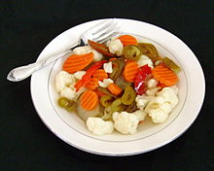
A dish of giardiniera
In the United States and Canada, pickled cucumbers (most often referred to simply as "pickles"), olives, and sauerkraut are most commonly seen, although pickles common in other nations are also available. In Canada, there may be a distinction made between gherkins (usually smaller), and pickles (larger pickled cucumbers).
Canadian pickling is similar to that of Britain. Through the winter, pickling is an important method of food preservation. Pickled cucumbers, onions, and eggs are common individual pickled foods seen in Canada. Pickled egg and pickled sausage make popular pub snacks in much of English Canada.
Chow-chow is a tart vegetable mix popular in the Maritime Provinces and the Southern United States, similar to piccalilli. Pickled fish is commonly seen, as in Scotland, and kippers may be seen for breakfast, as well as plentiful smoked salmon.
Meat is often also pickled or preserved in different brines throughout the winter, most prominently in the harsh climate of Newfoundland.
In the United States, giardiniera, a mixture of pickled peppers, celery and olives, is a popular condiment in Chicago and other cities with large Italian-American populations, and is often consumed with Italian beef sandwiches.
Pickled eggs are common in the Upper Peninsula of Michigan. Pickled herring is available in the Upper Midwest. Pennsylvania Dutch Country has a strong tradition of pickled foods, including chow-chow and red beet eggs.
In the Southern United States, pickled okra and watermelon rind are popular, as are deep-fried pickles and pickled pig's feet, pickled chicken eggs, pickled quail eggs, pickled garden vegetables and pickled sausage
In Mexico, chili peppers, particularly of the Jalapeño and serrano varieties, pickled with onions, carrots and herbs form common condiments. Various pickled vegetables, fish, or eggs may make a side dish to a Canadian lunch or dinner. Popular pickles in the Pacific Northwest include pickled asparagus and green beans.
Pickled fruits like blueberries and early green strawberries are paired with meat dishes in restaurants. In some parts of the United States, pickles with Kool-Aid are a popular food for children.

Mexico, Central America, and South America
In the Mesoamerican region pickling is known as "encurtido" or "curtido" for short. The pickles or "curtidos" as known in Latin America are served cold, as an appetizer, as a side dish or as a tapas dish in Spain. In several Central American countries it is prepared with cabbage, onions, carrots, lemon, vinegar, oregano, and salt.
In Mexico, "curtido" consists of carrots, onions, and jalapeño peppers and used to accompany meals still common in taquerias and restaurants. In order to prepare a carrot "curtido" simply add carrots to vinegar and other ingredients that are common to the region such as chilli, tomato, and onions. Varies depending on the food, in the case of sour.
Another example of a type of pickling which involves the pickling of meats or seafood is the "escabeche" or "ceviches" popular in Peru, Ecuador, and throughout Latin America and the Caribbean. These dishes include the pickling of pig's feet, pig's ears, and gizzards prepared as an "escabeche" with spices and seasonings to flavor it. The ceviches consists of shrimp, octopus, and various fishes seasoned and served cold.

Process
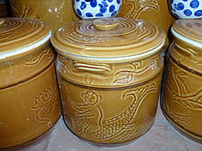
Bát Tràng porcelain vessel for pickling
In traditional pickling, fruit or vegetables are submerged in brine (20-40 grams/L of salt (3.2–6.4 oz/imp gal or 2.7–5.3 oz/US gal)), or shredded and salted as in sauerkraut preparation, and held underwater by flat stones layered on top
Alternatively, a lid with an airtrap or a tight lid may be used if the lid is able to release pressure which may result from carbon dioxide buildup. Mold or (white) kahm yeast may form on the surface; kahm yeast is mostly harmless but can impart an off taste and may be removed without affecting the pickling process
In chemical pickling, the fruits or vegetables to be pickled are placed in a sterilized jar along with brine, vinegar, or both, as well as spices, and are then allowed to mature until the desired taste is obtained.
The food can be pre-soaked in brine before transferring to vinegar. This reduces the water content of the food, which would otherwise dilute the vinegar. This method is particularly useful for fruit and vegetables with a high natural water content.
In commercial pickling, a preservative such as sodium benzoate or EDTA may also be added to enhance shelf life. In fermentation pickling, the food itself produces the preservation agent, typically by a process involving Lactobacillus bacteria that produce lactic acid as the preservative agent.
Alum is used in pickling to promote crisp texture and is approved as a food additive by the United States Food and Drug Administration.
"Refrigerator pickles" are unfermented pickles made by marinating fruit or vegetables in a seasoned vinegar solution. They must be stored under refrigeration or undergo canning to achieve long-term storage
Japanese Tsukemono use a variety of pickling ingredients depending on their type , and are produced by combining these ingredients with the vegetables to be preserved and putting the mixture under pressure.

Possible health hazards of pickled vegetables
The World Health Organization has listed pickled vegetables as a possible carcinogen, and the British Journal of Cancer released an online 2009 meta-analysis of research on pickles as increasing the risks of esophageal cancer.
The report, citing limited data in a statistical meta analysis, indicates a potential two-fold increased risk of oesophageal cancer associated with Asian pickled vegetable consumption. Results from the research are described as having "high heterogeneity" and the study said that further well-designed prospective studies were warranted.
However, their results stated "The majority of subgroup analyses showed a statistically significant association between consuming pickled vegetables and Oesophageal Squamous Cell Carcinoma"
The 2009 meta-analysis reported heavy infestation of pickled vegetables with fungi. Some common fungi can facilitate the formation of N-nitroso compounds, which are strong oesophageal carcinogens in several animal models. Roussin red methyl ester a non-alkylating nitroso compound with tumour-promoting effect in vitro, was identified in pickles from Linxian in much higher concentrations than in samples from low-incidence areas. Fumonisin mycotoxins have been shown to cause liver and kidney tumours in rodents
A 2017 study in Chinese Journal of Cancer has linked salted vegetables (common among Chinese cuisine) to a fourfold increase in nasopharynx cancer, where fermentation was a critical step in creating nitrosamines, which some are confirmed carcinogens, as well as activation of Epstein–Barr virus by fermentation products
Historically, pickling caused health concerns for reasons associated with copper salts, as explained in the mid-19th century The English and Australian Cookery Book: "The evidence of the Lancet commissioner (Dr. Hassall) and Mr. Blackwell (of the eminent firm of Crosse and Blackwell) went to prove that the pickles sold in the shops are nearly always artificially coloured, and are thus rendered highly unwholesome, if not actually poisonous."

Production of Ethanol from Molasses and Whey Permeate Using Yeasts and Bacterial Strains

The application of molasses and whey permeate as potential sources of carbon for ethanol production. Also, to study the elimination of agro-industrial wastes and consequently, decrease the cost of ethanol production. Sugar cane molasses and whey permeate were used as carbon sources for ethanol production by yeasts and bacterial strains. Different concentrations of sugar (10, 15, 20 and 25%) were used to study fermentation by two yeast strains (Kluyveromyces marxianus NRRL85.54 and Saccharomyces cerevisiae O-14) and one bacterial strain ( Zymomonas mobilis ATCC 10988).
Also, Ethanol production was examined by mixture of molasses and whey permeate using these strains and their mixed culture.bResults clearly indicated that the optimal sugar concentration was 10% sugar for high efficiency of ethanol fermentation by Kluyveromyces marxianus NRRL85.54, Saccharomyces cerevisiae O-14 and Zymomonas mobilis ATCC 10988. Results also showed that best agro-industrial waste for ethanol production is whey permeate with K.marixuanus followed by the mixture of molasses and whey permeate (10% sugar concentration) with mixed culture of three strains then molasses with K.marixuanus.

Bacteriocins
- In recent years bacterial antibiotic resistance has been considered a problem due to the extensive use of classical antibiotics in treatment of human and animal diseases . As a consequence, multiple resistant strains appeared and spread causing difficulties and the restricted use of antibiotics as growth promoters. So, the continue development of new classes of antimicrobial agents has become of increasing importance for medicine .
- In order to control their abusive use in food and feed products, one plausible alternative is the application of some bacterial peptides as antimicrobial substances in place of antibiotics of human application. Among them, bacteriocins produced by lactic acid bacteria have attracted increasing attention, since they are active in a nanomolar range and have no toxicity.
- Bacteriocins are proteins or complexed proteins biologically active with antimicrobial action against other bacteria, principally closely related species. They are produced by bacteria and are normally not termed antibiotics in order to avoid confusion and concern with therapeutic antibiotics, which can potentially illicit allergic reactions in humans and other medical problems .
- Bacteriocins differ from most therapeutic antibiotics in being proteinaceous agents that are rapidly digested by proteases in the human digestive tract. They are ribosomally synthesized peptides, and this fact creates the possibility of improving their characteristics to enhance their activitiy and spectra of action .
- Antibiotics are generally considered to be secondary metabolites that are inhibitory substances in small concentration, excluding the inhibition caused by metabolic by-products like ammonia, organic acids, and hydrogen peroxide.
- It is likely that most if not all bacteria are capable of producing a heterogeneous array of molecules in the course of their growth in vitro (and presumably also in their natural habitats) that may be inhibitory either to themselves or to other bacteria .
- Bacteriocin production could be considered as an advantage for food and feed producers since, in sufficient amounts, these peptides can kill or inhibit pathogenic bacteria that compete for the same ecological niche or nutrient pool. This role is supported by the fact that many bacteriocins have a narrow host range, and is likely to be most effective against related bacteria with nutritive demands for the same scarce resources .
RANGE of ACTIVITY
- considering the antimicrobial spectrum, producing species, molecular weight, stability, physical-chemical properties and mode of action of bacteriocins, they form a heterogeneous group. There is the classic type, which has a spectrum of activity only against homologous species, and a second type, less common, which shows action against a wide range of Gram-positive microorganisms. One example of this second type is nisin, which is produced by certain strains of Lactococcus lactis subsp. lactis . Other is pediocin, produced by Pedicoccus pentosaceus
- Nisin, produced by L. lactis subsp. lactis, is active against Gram-negative bacteria, but only when used at high concentrations or when the target cells have been pre-treated with EDTA.
- Bacteriocins are not frequently active against Gram-negative bacteria. The outer membrane of this class of bacteria acts as a permeability barrier for the cell. It is responsible for preventing molecules such as antibiotics, detergents and dyes from reaching the cytoplasmic membrane. However, some studies have already reported bacteriocin activity against this group of bacteria. Examples are plantaricin 35d, produced by Lactobacillus plantarum and active against Aeromonas hydrophila ; bacteriocin ST151BR, produced by Lactobacillus pentosus ST151BR and a bacteriocin produced by Lactobacillus paracasei subsp. paracasei active against Escherichia coli; thermophylin, produced by Streptococcus thermophilus active against E. coli, Yersinia pseudotuberculosis and Yersinia enterocolitica among the Gram-negative species and against several Bacillus species, Listeria monocytogenes and Salmonella typhimurium among the Gram-positives .
- Bacteriocins ST28MS and ST26MS, produced by Lactobacillus plantarum isolated from molasses inhibited the growth of Escherichia coli and Acinetobacter baumanii along with some Gram-positive bacteria. Lade et al (2006) have isolated two Lactobacillus species (L. plantarum and L. lactis) from vegetable waste that produced a bacteriocin which inhibitted the growth of E. coli.
Classification of Bacteriocins
- There is a wide number of bacteriocins produced by different LAB (table 1), and they can be classified according to their biochemical and genetic characteristics .
- Class I. – Lantibiotics: small (< 5 kDa) heat-stable peptides acting on membrane structures; they are extensively modified after translation, resulting in the formation of characteristic thioether amino-acids lanthionine and methyllanthionine. These arise via a two-step process, originated from post-transdutional modifications: firstly, gene-encoded serine and threonine are subjected to enzymatic dehydration to give rise to dehydroalanine and dehydrobutyrine, respectively . A very well known example of this group is nisin .
- T

- he lantibiotic bacteriocins were initially divided into two subclasses based on structural similarities. Subclass Ia included relatively elongated, flexible and positively charged peptides; they generally act by forming pores in the cytoplasmatic membranes of sensitive target species. The prototypic lantibiotic nisin is a member of this group.
- Subclass Ib peptides are characteristically globular, more rigid in structure and are either negatively charged or have no net charge. They exert their action by interfering with essential enzymatic reactions of sensitive bacteria .
- Class II. – Non-Lantibiotics: bacteriocins of variable molecular weight, but usually small (<10 kDa), heat-stable, containing regular amino-acids. This group was divided into three subgroups:
- Class IIa: peptides active against Listeria, the characteristic representants are pediocin PA-1 .
- Class IIb: formed by a complex of two distinct peptides. These peptides have little or no activity and it appears to be no sequence similarities between complementary peptides. In this group are lactococcin G and plantaricins EF e JK.
- Class IIc: Small peptides, heat-stable, which are transported by leader-peptides. In this subclass are found only the bacteriocins divergicin A and acidocin B.
- Class III. – Big peptides, with molecular weight over 30 kDa. In this class are helveticins J, acidofilicin A and lactacins A and B.
- Most of the low molecular weight bacteriocins are highly cationic at pH 7.0, and this seems to be a unifying feature of both the lantibiotics and non-lantibiotics.
- Lantibiotics are the most studied and explored industrially. Nisin, a lantibiotic usually produced by Lactococcus lactis subsp. lactis is used as an additive in foods. All of the variants of nisin are active against Gram-positive bacteria, like Listeria sp, Micrococcus sp and also on sporulating bacteria, like Bacillus sp and Clostridium sp .

