SRINIVASAN COLLEGE OF ARTS AND SCIENCE, PERAMBALUR – 12
DEPARTMENT OF BIOTECHNOLOGY
COURSE MATERIAL
SUBJECT: IMMUNOTECHNOLOGY SUBJECT CODE: 16SCCBT7

UNIT 1

Immunology of Vaccine-Preventable Diseases
Immunology is a complicated subject, and a detailed discussion of it is beyond the scope of this text. However, an understanding of the basic function of the immune system is useful in order to understand both how vaccines work and the basis of recommendations for their use. The description that follows is simplified. Many excellent immunology textbooks are available to provide additional detail.

Immunity
- Self vs. nonself
- Protection from infectious disease
- Usually indicated by the presence of antibody
- Generally specific to a single organism

Active Immunity
- Protection produced by the person’s own immune system
- Often lifetime

Passive Immunity
- Protection transferred from another animal or human
- Effective protection that wanes with time

Antigen
- A live (e.g., viruses and bacteria) or inactivated substance capable of producing an immune response

Antibody
- Protein molecules (immunoglobulins) produced by B lymphocytes to help eliminate an antigen
Immunity is the ability of the human body to tolerate the presence of material indigenous to the body (“self”), and to eliminate foreign (“nonself”) material. This discriminatory ability provides protection from infectious disease, since most microbes are identified as foreign by the immune system. Immunity to a microbe is usually indicated by the presence of antibody to that organism. Immunity is generally specific to a single organism or group of closely related organisms. There are two basic mechanisms for acquiring immunity, active and passive.
Active immunity is protection that is produced by the person’s own immune system. This type of immunity usually lasts for many years, often during a lifetime.
Passive immunity is protection by products produced by an animal or human and transferred to another human, usually by injection. Passive immunity often provides effective protection, but this protection wanes (disappears) with time, usually within a few weeks or months.
The immune system is a complex system of interacting cells whose primary purpose is to identify foreign (“nonself”) substances referred to as antigens. Antigens can be either live (such as viruses and bacteria) or inactivated. The immune system develops a defense against the antigen. This defense is known as the immune response and usually involves the production of protein molecules by B lymphocytes, called antibodies (or immunoglobulins), and of specific cells, including T-lymphocytes (also known as cell-mediated immunity) whose purpose is to facilitate the elimination of foreign substances.
The most effective immune responses are generally produced in response to a live antigen. However, an antigen does not necessarily have to be alive, as occurs with infection with a virus or bacterium, to produce an immune response. Some proteins, such as hepatitis B surface antigen, are easily recognized by the immune system. Other material, such as polysaccharide (long chains of sugar molecules that make up the cell wall of certain bacteria) are less effective antigens, and the immune response may not provide as good protection.

Passive Immunity
Passive immunity is the transfer of antibody produced by one human or other animal to another. Passive immunity provides protection against some infections, but this protection is temporary. The antibodies will degrade during a period of weeks to months, and the recipient will no longer be protected.
The most common form of passive immunity is that which an infant receives from its mother. Antibodies are transported across the placenta during the last 1–2 months of pregnancy. As a result, a full-term infant will have the same antibodies as its mother. These antibodies will protect the infant from certain diseases for up to a year. Protection is better against some diseases (e.g., measles, rubella, tetanus) than others (e.g., polio, pertussis).

Passive Immunity
- Transfer of antibody produced by one human or other animal to another
- Temporary protection
- Transplacental most important source in infancy

Sources of Passive Immunity
- Many types of blood or blood products
- Homologous pooled human antibody (immune globulin)
- Homologous human hyperimmune globulin
- Heterologous hyperimmune serum (antitoxin)
Many types of blood products contain antibody. Some products (e.g., washed or reconstituted red blood cells) contain a relatively small amount of antibody, and some (e.g., intravenous immune globulin and plasma products) contain a large amount.
In addition to blood products used for transfusion (e.g., whole blood, red cells, and platelets) there are three major sources of antibody used in human medicine. These are homologous pooled human antibody, homologous human hyperimmune globulin, and heterologous hyperimmune serum.
Homologous pooled human antibody is also known as immune globulin. It is produced by combining (pooling) the IgG antibody fraction from thousands of adult donors in the United States. Because it comes from many different donors, it contains antibody to many different antigens. It is used primarily for postexposure prophylaxis for hepatitis A and measles and treatment of certain congenital immunoglobulin deficiencies.
Homologous human hyperimmune globulins are antibody products that contain high titers of specific antibody. These products are made from the donated plasma of humans with high levels of the antibody of interest. However, since hyperimmune globulins are from humans, they also contain other antibodies in lesser quantities. Hyperimmune globulins are used for postexposure prophylaxis for several diseases, including hepatitis B, rabies, tetanus, and varicella.
Heterologous hyperimmune serum is also known as antitoxin. This product is produced in animals, usually horses (equine), and contains antibodies against only one antigen. In the United States, antitoxin is available for treatment of botulism and diphtheria. A problem with this product is serum sickness, an immune reaction to the horse protein.

Monoclonal Antibody
- Derived from a single type, or clone, of antibody-producing cells (B cells)
- Antibody is specific to a single antigen or closely related group of antigens
- Used for diagnosis and therapy of certain cancers and autoimmune and infectious diseases, as well as prevention of transplant rejection

Antibody for Prevention of RSV
- Palivizumab (Synagis)
  - monoclonal
  - contains only RSV antibody
  - will not interfere with the response to a live-virus vaccine

Active Immunity
- Immune system produces antigen-specific humoral and cellular immunity
- Lasts for many years, often lifetime
- Sources
  - infection with diseasecausing form of organism
  - vaccination

Vaccination
- Active immunity produced by vaccine
- Immunity and immunologic memory similar to natural infection but without risk of disease
Immune globulin from human sources is polyclonal; it contains many different kinds of antibodies. In the 1970s, techniques were developed to isolate and “immortalize” (cause to grow indefinitely) single B cells, which led to the development of monoclonal antibody products. Monoclonal antibody is produced from a single clone of B cells, so these products contain antibody to only one antigen or closely related group of antigens. Monoclonal antibody products have many applications, including the diagnosis of certain types of cancer (colorectal, prostate, ovarian, breast), treatment of cancer (B-cell chronic lymphocytic leukemia, non-Hodgkin lymphoma), prevention of transplant rejection, and treatment of autoimmune diseases (Crohn’s disease, rheumatoid arthritis) and infectious diseases.
A monoclonal antibody product is available for the prevention of respiratory syncytial virus (RSV) infection. It is called palivizumab (Synagis). Palivizumab is a humanized monoclonal antibody specific for RSV. While certain antibody products like immune globulins interfere with live-virus vaccines, monoclonal antibody products specific to one, non-vaccine microbe do not interfere with live vaccines. Since palivizumab does not contain any other antibody except RSV antibody, it will not interfere with the response to a live virus vaccine.

Active Immunity
Active immunity is stimulation of the immune system to produce antigen-specific humoral (antibody) and cellular immunity. Unlike passive immunity, which is temporary, active immunity usually lasts for many years, often for a lifetime.
One way to acquire active immunity is to survive infection with the disease-causing form of the organism. While exceptions (like malaria) exist, in general, once persons recover from infectious diseases, they will have lifelong immunity to that disease. The persistence of protection for many years after the infection is known as immunologic memory. Following exposure of the immune system to an antigen, certain cells (memory B cells) continue to circulate in the blood (and also reside in the bone marrow) for many years. Upon reexposure to the antigen, these memory cells begin to replicate and produce antibody very rapidly to reestablish protection.
Another way to produce active immunity is by vaccination. Vaccines interact with the immune system and often produce an immune response similar to that produced by the natural infection, but they do not subject the recipient to the disease and its potential complications. Many vaccines also produce immunologic memory similar to that acquired by having the natural disease.
Many factors may influence the immune response to vaccination. These include the presence of maternal antibody, nature and dose of antigen, route of administration, and the presence of an adjuvant (e.g., aluminum-containing material added to improve the immunogenicity of the vaccine). Host factors such as age, nutritional factors, genetics, and coexisting disease, may also affect the response.

Classification of Vaccines

Classification of Vaccines
- Live attenuated
  - viral
  - bacterial
- Inactivated

Inactivated Vaccines
- Whole
  - viruses
  - bacteria
- Fractional
  - protein-based
–toxoid
– subunit
  - polysaccharide-based
–pure
– conjugate

Live Attenuated Vaccines
- Attenuated (weakened) form of the “wild” virus or bacterium
- Must replicate to produce an immune response
- Immune response virtually identical to natural infection
- Usually produce immunity with one dose*
- Severe reactions possible
- Interference from circulating antibody
- Fragile – must be stored and handled carefully
- Viral: measles, mumps, rubella, vaccinia, varicella, zoster, yellow fever, rotavirus, intranasal influenza, oral polio**
- Bacterial: BCG**, oral typhoid
*except those administered orally
**not available in the United States
There are two basic types of vaccines: live attenuated and inactivated. The characteristics of live and inactivated vaccines are different, and these characteristics determine how the vaccine is used.
Live attenuated vaccines are produced by modifying a disease-producing (“wild”) virus or bacterium in a laboratory. The resulting vaccine organism retains the ability to replicate (grow) and produce immunity, but usually does not cause illness. The majority of live attenuated vaccines available in the United States contain live viruses. However, two live attenuated bacterial vaccines are available in the United States (Ty21a and BCG). BCG is not used as a vaccine, but as a treatment for bladder cancer.
Inactivated vaccines can be composed of either whole viruses or bacteria, or fractions of either. Fractional vaccines are either protein-based or polysaccharide-based. Protein-based vaccines include toxoids (inactivated bacterial toxin) and subunit or subvirion products. Most polysaccharide-based vaccines are composed of pure cell wall polysaccharide from bacteria. Conjugate polysaccharide vaccines contain polysaccharide that is chemically linked to a protein. This linkage makes the polysaccharide a more potent vaccine.

Live Attenuated Vaccines
Live vaccines are derived from “wild,” or disease-causing, viruses or bacteria. These wild viruses or bacteria are attenuated, or weakened, in a laboratory, usually by repeated culturing. For example, the measles virus used as a vaccine today was isolated from a child with measles disease in 1954. Almost 10 years of serial passage using tissue culture media was required to transform the wild virus into attenuated vaccine virus.
To produce an immune response, live attenuated vaccines must replicate (grow) in the vaccinated person. A relatively small dose of virus or bacteria is administered, which replicates in the body and creates enough of the organism to stimulate an immune response. Anything that either damages the live organism in the vial (e.g., heat, light) or interferes with replication of the organism in the body (circulating antibody) can cause the vaccine to be ineffective.
Although live attenuated vaccines replicate, they usually do not cause disease such as may occur with the “wild” form of the organism. When a live attenuated vaccine does cause “disease,” it is usually much milder than the natural disease and is referred to as an adverse reaction.
The immune response to a live attenuated vaccine is virtually identical to that produced by a natural infection. The immune system does not differentiate between an infection with a weakened vaccine virus and an infection with a wild virus. Live attenuated vaccines produce immunity in most recipients with one dose, except those administered orally. However, a small percentage of recipients do not respond to the first dose of an injected live vaccine (such as MMR or varicella) and a second dose is recommended to provide a very high level of immunity in the population.
General Rule:
The more similar a vaccine is to the disease-causing form of the organism, the better the immune response to the vaccine.
Live attenuated vaccines may cause severe or fatal reactions as a result of uncontrolled replication (growth) of the vaccine virus. This only occurs in persons with immunodeficiency (e.g., from leukemia, treatment with certain drugs, or human immunodeficiency virus [HIV] infection).
A live attenuated vaccine virus could theoretically revert to its original pathogenic (disease-causing) form. This is known to happen only with live (oral) polio vaccine.
Active immunity from a live attenuated vaccine may not develop because of interference from circulating antibody to the vaccine virus. Antibody from any source (e.g., transplacental, transfusion) can interfere with replication of the vaccine organism and lead to poor response or no response to the vaccine (also known as vaccine failure). Live attenuated vaccines are fragile and can be damaged or destroyed by heat and light. They must be handled and stored carefully.
Currently available live attenuated viral vaccines are measles, mumps, rubella, vaccinia, varicella, zoster (which contains the same virus as varicella vaccine but in much higher amount), yellow fever, rotavirus, and influenza (intranasal). Oral polio vaccine is a live viral vaccine but is no longer available in the United States. Live attenuated bacterial vaccines are bacille Calmette-Guérin (BCG—not currently available in the US) and oral typhoid vaccine.

Inactivated Vaccines
- Cannot replicate
- Less affected by circulating antibody than live vaccines
- Always require multiple doses
- Immune response mostly humoral
- Antibody titer diminish with time
- May require periodic supplemental booster doses
- Whole-cell vaccines
  - viral: polio, hepatitis A, rabies, influenza*
  - bacterial: pertussis*, typhoid*, cholera*, plague*
- Fractional vaccines
- Subunits: hepatitis B, influenza, acellular pertussis, human papillomavirus, anthrax
- Toxoids: diphtheria, tetanus
*not available in the United States
Inactivated vaccines are produced by growing the bacterium or virus in culture media, then inactivating it with heat and/or chemicals (usually formalin). In the case of fractional vaccines, the organism is further treated to purify only those components to be included in the vaccine (e.g., the polysaccharide capsule of pneumococcus).
Inactivated vaccines are not alive and cannot replicate. The entire dose of antigen is administered in the injection. These vaccines cannot cause disease from infection, even in an immunodeficient person. Inactivated antigens are less affected by circulating antibody than are live agents, so they may be given when antibody is present in the blood (e.g., in infancy or following receipt of antibody-containing blood products).
Inactivated vaccines always require multiple doses. In general, the first dose does not produce protective immunity, but “primes” the immune system. A protective immune response develops after the second or third dose. In contrast to live vaccines, in which the immune response closely resembles natural infection, the immune response to an inactivated vaccine is mostly humoral. Little or no cellular immunity results. Antibody titers against inactivated antigens diminish with time. As a result, some inactivated vaccines may require periodic supplemental doses to increase, or “boost,” antibody titers.
Currently available whole-cell inactivated vaccines are limited to inactivated whole viral vaccines (polio, hepatitis A, and rabies). Inactivated whole virus influenza vaccine and whole inactivated bacterial vaccines (pertussis, typhoid, cholera, and plague) are no longer available in the United States. Fractional vaccines include subunits (hepatitis B, influenza, acellular pertussis, human papillomavirus, anthrax) and toxoids (diphtheria, tetanus). A subunit vaccine for Lyme disease is no longer available in the United States.

Polysaccharide Vaccines
Pure polysaccharide
- pneumococcal
- meningococcal
- Salmonella Typhi (Vi)
Conjugate polysaccharide
- Haemophilus influenzae type b (Hib)
- pneumococcal
- meningococcal

Pure Polysaccharide Vaccines
- Not consistently immunogenic in children younger than 2 years of age
- No booster response
- Antibody with less functional activity
- Immunogenicity improved by conjugation

Recombinant Vaccines
- Genetic engineering technology
- Viral: hepatitis B, human papillomavirus, influenza (one brand), live attenuated influenza
- Bacterial: Salmonella Typhi (Ty21a)
Polysaccharide vaccines are a unique type of inactivated subunit vaccine composed of long chains of sugar molecules that make up the surface capsule of certain bacteria. Pure polysaccharide vaccines are available for three diseases: pneumococcal disease, meningococcal disease, and Salmonella Typhi. A pure polysaccharide vaccine for Haemophilus influenzae type b (Hib) is no longer available in the United States.
The immune response to a pure polysaccharide vaccine is typically T-cell independent, which means that these vaccines are able to stimulate B cells without the assistance of T-helper cells. T-cell-independent antigens, including polysaccharide vaccines, are not consistently immunogenic in children younger than 2 years of age. Young children do not respond consistently to polysaccharide antigens, probably because of immaturity of the immune system.
Repeated doses of most inactivated protein vaccines cause the antibody titer to go progressively higher, or “boost.” This does not occur with polysaccharide antigens; repeat doses of polysaccharide vaccines usually do not cause a booster response. Antibody induced with polysaccharide vaccines has less functional activity than that induced by protein antigens. This is because the predominant antibody produced in response to most polysaccharide vaccines is IgM, and little IgG is produced.
In the late 1980s, it was discovered that the problems noted above could be overcome through a process called conjugation, in which the polysaccharide is chemically combined with a protein molecule. Conjugation changes the immune response from T-cell independent to T-cell dependent, leading to increased immunogenicity in infants and antibody booster response to multiple doses of vaccine.
The first conjugated polysaccharide vaccine was for Hib. A conjugate vaccine for pneumococcal disease was licensed in 2000. A meningococcal conjugate vaccine was licensed in 2005.

Recombinant Vaccines
Vaccine antigens may also be produced by genetic engineering technology. These products are sometimes referred to as recombinant vaccines. Five genetically engineered vaccines are currently available in the United States. Hepatitis B, human papillomavirus (HPV), and influenza (one brand) vaccines are produced by insertion of a segment of the respective viral gene into the gene of a yeast cell or virus. The modified yeast cell or virus produces pure hepatitis B surface antigen, HPV capsid protein, or influenza hemagglutinin when it grows. Live typhoid vaccine (Ty21a) is Salmonella Typhi bacteria that have been genetically modified to not cause illness. Live attenuated influenza vaccine has been engineered to replicate effectively in the mucosa of the nasopharynx but not in the lungs.

Principle for Creation of Hybridoma Cells:
The myeloma cells used in hybridoma technology must not be capable of synthesizing their own antibodies. The selection of hybridoma cells is based on inhibiting the nucleotide (consequently the DNA) synthesizing machinery. The mammalian cells can synthesize nucleotides by two pathways—de novo synthesis and salvage pathway (Fig. 17.1).
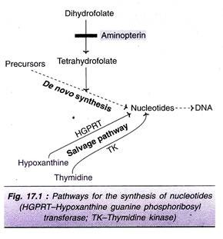
The de novo synthesis of nucleotides requires tetrahydrofolate which is formed from dihydrofolate. The formation of tetrahydrofolate (and therefore nucleotides) can be blocked by the inhibitor aminopterin. The salvage pathway involves the direct conversion of purines and pyrimidine’s into the corresponding nucleotides. Hypoxanthine guanine phosphoribosyl transferase (HGPRT) is a key enzyme in the salvage pathway of purines.
It converts hypoxanthine and guanine respectively to inosine monophosphate and guanosine monophosphate. Thymidine kinase (TK), involved in the salvage pathway of pyrimidine’s converts thymidine to thymidine monophosphate (TMP). Any mutation in either one of the enzymes (HGPRT or TK) blocks the salvage pathway.
When cells deficient (mutated cells) in HGPRT are grown in a medium containing hypoxanthine aminopterin and Thymidine (HAT medium), they cannot survive due to inhibition of de novo synthesis of purine nucleotides (Note : Salvage pathway is not operative due to lack of HGPRT). Thus, cells lacking HGPRT, grown in HAT medium die.
The hybridoma cells possess the ability of myeloma cells to grow in vitro with a functional HGPRT gene obtained from lymphocytes (with which myeloma cells are fused). Thus, only the hybridoma cells can proliferate in HAT medium, and this procedure is successfully used for their selection.

Production of Monoclonal Antibodies:
The establishment of hybridomas and production of MAbs involves the following steps (Fig. 17.2).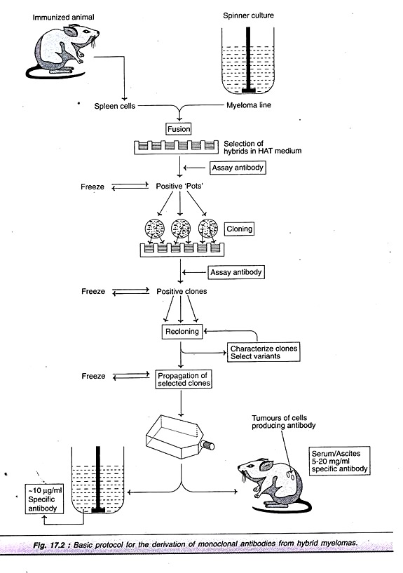
1. Immunization
2. Cell fusion
3. Selection of hybridomas
ADVERTISEMENTS:
4. Screening the products
5. Cloning and propagation
6. Characterization and storage.

1. Immunization:
The very first step in hybridoma technology is to immunize an animal (usually a mouse), with appropriate antigen. The antigen, along with an adjuvant like Freund’s complete or incomplete adjuvant is injected subcutaneously (adjuvants are non-specific potentiators of specific immune responses). The injections at multiple sites are repeated several times.
ADVERTISEMENTS:
This enables increased stimulation of B-lymphocytes which are responding to the antigen. Three days prior to killing of the animal, a final dose of antigen is intravenously administered. The immune-stimulated cells for synthesis of antibodies have grown maximally by this approach. The concentration of the desired antibodies is assayed in the serum of the animal at frequent intervals during the course of immunization.
When the serum concentration of the antibodies is optimal, the animal is sacrificed. The spleen is aseptically removed and disrupted by mechanical or enzymatic methods to release the cells. The lymphocytes of the spleen are separated from the rest of the cells by density gradient centrifugation.

2. Cell Fusion:
The thoroughly washed lymphocytes are mixed with HGPRT defective myeloma cells. The mixture of cells is exposed to polyethylene glycol (PEG) for a short period (a few minutes), since it is toxic. PEG is removed by washing and the cells are kept in a fresh medium. These cells are composed of a mixture of hybridomas (fused cells), free myeloma cells and free lymphocytes.

3. Selection of Hybridomas:
When the cells are cultured in HAT medium (the principle described above), only the hybridoma cells grow, while the rest will slowly disappear. This happens in 7-10 days of culture. Selection of a single antibody producing hybrid cells is very important. This is possible if the hybridomas are isolated and grown individually. The suspension of hybridoma cells is so diluted that the individual aliquots contain on an average one cell each. These cells, when grown in a regular culture medium, produce the desired antibody.

4. Screening the Products:
ADVERTISEMENTS:
The hybridomas must be screened for the secretion of the antibody of desired specificity. The culture medium from each hybridoma culture is periodically tested for the desired antibody specificity. The two techniques namely ELISA and RIA are commonly used for this purpose.
In both the assays, the antibody binds to the specific antigen (usually coated to plastic plates) and the unbound antibody and other components of the medium can be washed off. Thus, the hybridoma cells producing the desired antibody can be identified by screening. The antibody secreted by the hybrid cells is referred to as monoclonal antibody.

5. Cloning and Propagation:
The single hybrid cells producing the desired antibody are isolated and cloned. Two techniques are commonly employed for cloning hybrid cells-limiting dilution method and soft agar method.
Limiting dilution method:
In this procedure, the suspension of hybridoma cells is serially diluted and the aliquots of each dilution are put into micro culture wells. The dilutions are so made that each aliquot in a well contains only a single hybrid cell. This ensures that the antibody produced is monoclonal.
Soft agar method:
In this technique, the hybridoma cells are cultured in soft agar. It is possible to simultaneously grow many cells in semisolid medium to form colonies. These colonies will be monoclonal in nature. In actual practice, both the above techniques are combined and used for maximal production of MAbs.

6. Characterization and Storage:
The monoclonal antibody has to be subjected to biochemical and biophysical characterization for the desired specificity. It is also important to elucidate the MAb for the immunoglobulin class or sub-class, the epitope for which it is specific and the number of binding sites it possesses.
The stability of the cell lines and the MAbs are important. The cells (and MAbs) must be characterized for their ability to withstand freezing, and thawing. The desired cell lines are frozen in liquid nitrogen at several stages of cloning and culture.

Large Scale Production of MAbs:
The production MAbs in the culture bottles is rather low (5-10 (ig/ml). The yield can be increased by growing the hybrid cells as ascites in the peritoneal cavity of mice. The ascitic fluid contains about 5-20 mg of MAb/ml. This is far superior than the in vitro cultivation techniques.
But collection of MAb from ascitic fluid is associated with the heavy risk of contamination by pathogenic organisms of the animal. In addition, several animals have to be sacrificed to produce MAb. Hence, many workers prefer in vitro techniques rather than the use of animals.

Encapsulated hybridoma cells for commercial production of MAbs:
The yield of MAb production can be substantially increased by increasing the hybridoma cell density in suspension culture. This can be done by encapsulating the hybridomas in alginate gels and using a coating solution containing poly-lysine (Fig. 17.3). These gels allow the nutrients to enter in and antibodies to come out.
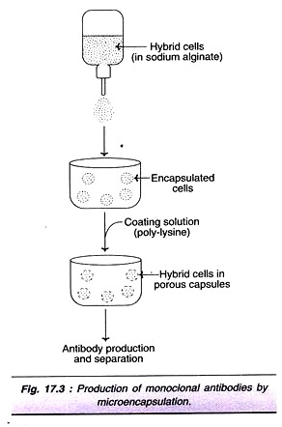
By this approach, a much higher concentration of MAb production (10-100 µg/ml) can be achieved. Damon Biotech Company and Cell-Tech use encapsulated hybridoma cells for large-scale production of MAbs. They employ 100-liter fermenters to yield about 100g of MAbs in about 2 weeks period.

Human Monoclonal Antibodies:
The monoclonal antibodies produced by using mice are quite suitable for in vitro use. However, their administration to humans is associated with immunological complications, since they are foreign to human body. Production of human monoclonal antibodies is preferred. However, it is difficult to produce human MAbs by conventional hybridoma technology.
The following are the major limitations:
i. For ethical reasons, humans cannot be immunized against antigens.
ii. The fused human lymphocyte-mouse myeloma cells are very unstable.
iii. There are no suitable myeloma cells in humans that can replace mouse myeloma cells.
For the above reasons, alternative arrangements are made to produce human MAbs. These are briefly described below.

Viral transformation of human B-lymphocytes:
B-Lymphocytes, actively synthesizing antibody, are treated with fluorescent-labeled antigen. The fluorescent-activated cells are separated. However, B-cells on their own, cannot grow in culture. This limitation can be overcome by transforming B-lymphocytes with Epstein-Bar virus (EBV). Some of the EBV-transformed cells can grow in culture and produce monoclonal antibodies. Unfortunately, the yield of MAb is very low by this approach.

SCID mouse for producing human MAbs:
The mouse suffering from severe combined immunodeficiency (SCID) disease lacks its natural immunological system. Such mouse can be challenged with appropriate antigens to produce human MAbs.

Transgenic mouse for producing human MAbs:
Attempts have been made in recent years to introduce human immunoglobulin genes into the mice to develop transgenic mice. Such mice are capable of synthesizing human immunoglobulin’s when immunized to a particular antigen. The B-lymphocytes isolated from transgenic mice can be used to produce MAbs by the standard hybridoma technology. The above three approaches are quite laborious, and the yield of human MAbs is very low. Consequently, researchers continue their search for better alternatives.

Genetic Engineering Strategies for the Production of Human- Mouse MAbs:
With the advances in genetic engineering, it is now possible to add certain human segments to a mouse antibody. This is truly a hybridized antibody and is referred to as humanized antibody or chimeric antibody.

Substitution of Fv region of human Ig by mouse Fv:
The DNA coding sequences for Fv regions of both L and H chains of human immunoglobulin are replaced by Fv DNA sequence (for L and H chains) from a mouse monoclonal antibody (Fig. 17.4A). The newly developed humanized MAb has Fc region of Ig being human. This stimulates proper immunological response. The chimeric antibodies produced in this manner were found to be effective for the destruction of tumor cells in vitro.
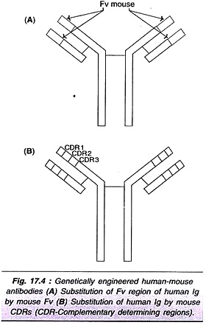

Substitution of Human Ig by Mouse CDRs:
Genetic engineers have been successful in developing human MAbs containing mouse complementary determining regions (CDRs). This is made possible by replacing CDRs genes (CDR₁, CDR₂, and CDR3) of humans by that of mouse. These chimeric antibodies (Fig. 17.4B) possess the antigen binding affinities of the mouse and they can serve as effective therapeutic agents. So far, about 50 monoclonal antibodies have been produced by this approach. However, this technique is costly and time consuming.

Bi-specific monoclonal antibodies:
The MAbs in which the two arms of Fab (antigen-binding) have two different specificities for two different epitopes are referred to as bi-specific MAbs. They may be produced by fusing two different hybridoma cell lines (Fig. 17.5) or by genetic engineering. Bi-specific Fab MAbs theoretically, are useful for a simultaneous and combined treatment of two different diseases.
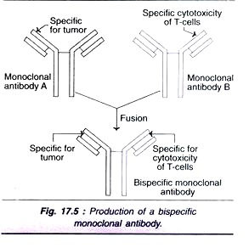

Production of Mabs in E. coli:
The hybridoma technology is very laborious, expensive and time consuming. To overcome these limitation, researchers have been trying to genetically engineer bacteria, plants and animals. The objective is to develop bioreactors for the large scale production of monoclonal antibodies.
It may be noted that the antigen binding regions of antibody (Fv or Fab fragments) are very crucial, while the Fc portion is dispensable. A schematic representation of the procedure adopted for the production of functional antibody fragments is shown in Fig. 17.6, and is briefly described.
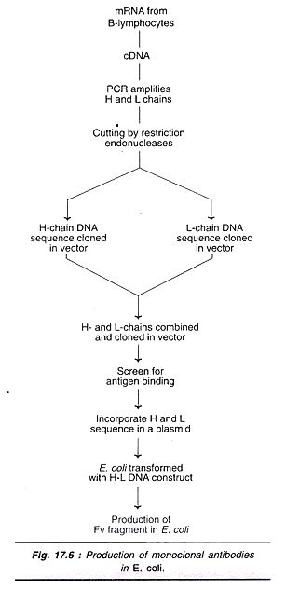
The mRNA from isolated B-lymphocytes of either human or mouse is converted to cDNA. The H and L chain sequences of this cDNA are amplified by PCR. The so produced cDNAs are then cut by restriction endonucleases. H and L chain sequences are separately cloned in bacteriophage vectors.
These sequences are put together and cloned in another bacteriophage vector. The combined H and L chains (forming Fv fragment) are screened for antigen binding activity. The specific H and L chains forming a part of the plasmid are transformed in E. coli. These E. coli, in turn, can be harvested to produce Fv fragments to bind to specific antigens.

Second Generation Monoclonal Antibodies:
In the recent years, a number of improvements have been made to produce more specific, sensitive and desired MAbs. This has been possible due to the rapid advances made in genetic engineering techniques. For instances, by employing site- directed mutagenesis, it is possible to introduce cysteine residues at the predetermined positions on the MAb. These cysteine residues which facilitate the isotope labeling may be more useful in diagnostic imaging and radio-immunotherapy.

Advantages of Monoclonal Antibodies:
Monoclonal antibodies truly represent a homogeneous state of a single molecular species. Each MAb is specific to a given antigenic determinant. This is in contrast to the conventional antiserum that contains polyclonal antibodies. The wide range of applications of MAbs is described later.

Limitations of Monoclonal Antibodies:
Hybridoma technology is laborious and time consuming. MAbs are produced against a single antigenic determinant; therefore, they cannot differentiate the molecule as a whole. Sometimes, they may be incapable of distinguishing groups of different molecules also.
The presence of retroviruses as a part of the mammalian chromosomes is a common occurrence. Mice used in MAb production carry several viruses (adenovirus, hepatic virus, retrovirus, reovirus, cytomegalovirus, thymic virus). The presence of some of these viruses has been detected in the hybridomas.
This poses a great danger, since there is no guarantee that MAb produced is totally virus-free, despite the purification. For this reason, US Food and Drug Administration insists that MAb for human use should be totally free from all pathogenic organisms, including viruses.
Immuno-diffusion is a technique for the detection or measurement of antibodies and antigens by their precipitation which involves diffusion through a substance such as agar or gel agarose. Simply, it denotes precipitation in gel.
It refers to any of the several techniques for obtaining a precipitate between an antibody and its specific antigen.
This can be achieved by:
- a) Suspending antigen/antibody in a gel and letting the other migrate through it from a well or,
- b) Letting both antibody and antigen migrate through the gel from separate wells such that they form an area of precipitation.
Based on the method employed, immuno-diffusion may be:
- Radial immunodiffusion
- Ouchterlony Double Diffusion
Radial immunodiffusion (RID) or Mancini method is also known as Mancini immunodiffusion or single radial immunodiffusion assay. It is a single diffusion technique whereby a solution containing the antigen is placed into wells in a gel or agar surface evenly impregnated with antibody. The diameter of the ring that precipitates around the well as a result of antigen antibody reaction corresponds to the amount of antigen in the solution.
Radial immuno-diffusion is a type of precipitation reaction. It is thus based on the principles of the precipitin curve which states that antigen-antibody interact forming visible cross-linked precipitate when the proper ratio of antigen to antibody is present. In the test, antibody is incorporated into agar and poured into a glass plate to form a uniform layer. Circular wells are cut into the agar and antigen is introduced into the wells. Specific antigens to the impregnated antibodies diffuse through the agar in all directions from the well and react with the antibody present forming visible precipitate or a precipitin ring. Ring shaped bands of precipitates from concentrically around the well indicating reaction. The diameter of the precipitate ring formed, corresponds to the amount of antigen in the solution.
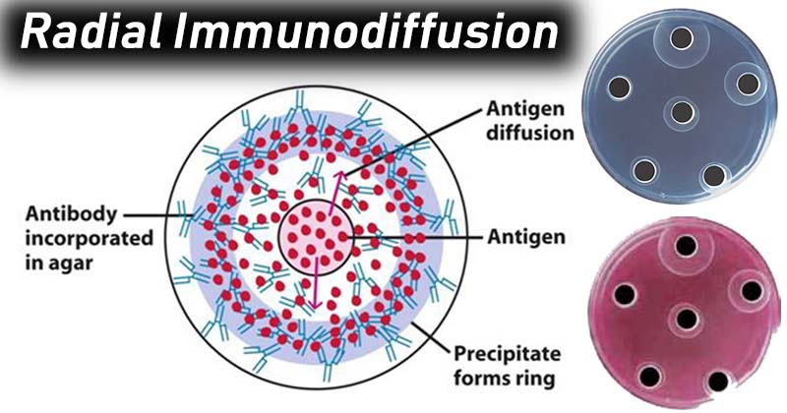
- Precipitation in gels is believed to provide more specific and sensitive results than other methods available.
- The reaction is in the form of bands of precipitation and can be stained for better viewing as well as preservation.
- If a large number of antigens are present, each antigen-antibody reaction will give rise to a separate line of precipitation.
- This technique also indicates identity, cross reaction and non identity between different antigens.

Limitations of Radial Immunodiffusion
- Long reaction time (18-48 hours)
- It has also been proposed that the results of Mancini’s test is influenced by the presence bound metal cations in the test samples (protein).
- Single diffusion menthod of precipitation is considered relatively wasteful than other methods.
- The test has been recently replaced by more sensitive and automated methods, such as nephelometry and enzyme-linked immunosorbent assays.

In immunodiffusion techniques, the antigen and antibody are allowed to diffuse to form a precipitin line and this takes longer time (24-72 hours).
If the movement of antigen and/or antibody is made faster, the precipitin line will form in a very short time so that the diagnosis can be made quickly. This goal is achieved by electrically moving the antigen and antibody. There are many variations of this principle. The two common methods in use are countercurrent immunoelectrophoresis and Laurell’s rocket electrophoresis.
Countercurrent Immunoelectrophoresis (One-dimensional Double Electroimmunodiffusion):
Two wells are cut in the agar on a slide.
↓
One well is filled with antigen and the other well is filled with antibody.
↓
The antibody side of the agar is connected to the anode and the antigen side is connected to the cathode of the electrophoresis apparatus.
↓
Upon application of electricity, the antigen and antibody molecules move (due to their electrical charges) in the agar under the electrical influence.
In an alkaline buffer, most of the clinically important antigens are electronegative and hence they move towards the anode (i.e., towards the antibody well). The antibody molecules are electrically neutral or weakly negative. Normally the electrically negative antibody molecules should move toward the anode.
But the movement of the hydroneum ions in the agar during electrophoresis is very strong and pulls the weakly negative antibody molecules towards the cathode (i.e., towards the antigen well). Since antigen and antibody molecules are moving in opposite directions, they meet each other and form a precipitin line in between the two wells. The precipitin line is visible in 30 minutes (as opposed to 24 hours in diffusion) and is approximately 10 times more sensitive than diffusion.
Countercurrent immunoelectrophoresis is used to detect
a. Meningococcal, cryptococal and hemophilic antigens in the cerebrospinal fluid and

b. Hepatitis B surface antigen in the serum.
Lauren’s Rocket Electrophoresis (One-dimensional Single Electroimmunodiffusion):
This technique is used to quantitate antigens. The antibody is mixed with molten agar and poured on glass slide. After solidification, wells are cut and filled with different concentrations of antigen.

When electricity is applied, the antigen is driven into the agar containing antibodies. Precipitin lines are formed along the lateral margins of the moving boundary of antigen. Gradually, the antigen is lost by precipitation, so that its concentration at the leading edge diminishes and the lateral margins converge to form a sharp point. Thus the resultant pattern of precipitation resembles a spike or rocket.
The distance of the spike from the antigen well increases with increase in antigen concentration. A standard curve can be established by using known concentrations of antigens. The concentration of a test antigen can be determined by interpolation of the standard curve with the distance of rocket formed.
The sensitivity of this technique is approximately 0.5 mg/ml. Laurell technique is also used to detect antigens of cryptococcus, meningococcus and hemophilus in cerebrospinal fluid (CSF).

Quantitative nephelometry is a lab test to quickly and accurately measure levels of certain proteins called immunoglobulins in the blood. Immunoglobulins are antibodies that help fight infection.
This test specifically measures the immunoglobulins IgM, IgG, and IgA.

Normal Results
Normal results for the three immunoglobulins are:
- IgG: 650 to 1600 milligrams per deciliter (mg/dL), or 6.5 to 16.0 grams per liter (g/L)
- IgM: 54 to 300 mg/dL, or 540 to 3000 mg/L
- IgA: 40 to 350 mg/dL, or 400 to 3500 mg/L
The examples above show the common measurements for these test results. Normal value ranges may vary slightly among different laboratories. Talk to your doctor about the meaning of your specific test results. Some labs use different measurements or test different samples.

What Abnormal Results Mean
An increased level of IgG may be due to:
- Chronic infection or inflammation
- Hyperimmunization (higher than normal number of specific antibodies)
- IgG multiple myeloma (a type of blood cancer)
- Liver disease
- Rheumatoid arthritis

The antibodies used in diagnostic techniques are often generated in vivo, when an animal is injected with a specific antigen from another species. The animal's immune system responds by producing antibodies, which can be harvested by taking a serum sample.
This “antiserum” isolated from the animal is then subjected to a purification step to remove contaminants, or to obtain just one type of antibody (monoclonal) from a mixture of antibodies (polyclonal).

Physicochemical fractionation
Physicochemical fractionation describes methods that separate antibodies by size, charge, or chemical properties. The different classes of immunoglobulin (Ig), such as IgM and IgG, often have similar amino acid compositions, solubility, and structure. Physicochemical fractionation exploits this, by removing any molecule that does not carry the same properties.

Size exclusion chromatography
In this method, the molecules are sorted based on their size and molecular weight. The chromatography column consists of dextran, agarose, or polyacrylamide beads. Based on the size of these beads, different size of macromolecules can be isolated.
The low molecular weight components can be removed by dialysis, desalting, and diafiltration. Then, size exclusion resins that consist of high molecular cut-off can further separate immunoglobulins that are less than 140 kDa.

Ammonium sulphate precipitation
This method is used to isolate antibodies from serum, cell culture supernatant, or ascites fluid. The increasing concentration of ammonium sulphate makes proteins and other macromolecules increasingly insoluble, leading to their precipitation.
Different proteins, including antibodies, precipitate at specific concentrations of ammonium sulphate. For example, antibodies precipitate at 40-50% ammonium sulphate. The purity of antibodies precipitated using this method depends on the temperature, pH, the rate at which salt is added, and time.

Ion exchange chromatography

Related Stories
- Flu antibody could be a key to better treatments for severe flu disease
- Skin-protecting antibody may promote tumor growth during chronic tissue inflammation
- Improved antibody validation
Ion exchange chromatography is used to isolate or separate compounds based on their charge. The column consists of positively or negatively charged resins which then bind to negatively or positively charged proteins.
The buffer system can be modified so that the antibody of interest is bound and released in a highly specific way. Alternatively, the system can be designed to bind everything other than the target antibody. This method is cost effective to purify antibodies.

Immobilized metal chelate chromatography
In this method, chelate immobilized divalent metal ions are used to bind proteins that contain three or more histidine residues.
Mammalian IgGs consist of histidine clusters, which can therefore bind to immobilized nickel on a chromatography column. Thus, this method can be used to purify and isolate IgGs from a mixture.

Purifying antibodies based on their classification
Antibodies have evolutionarily conserved structures. Several methods have been developed which isolate antibodies based on the similarities of each class.

Protein A, G, and L
Protein A, G, and L are bacterial proteins and they have specific domains which bind with specific immunoglobulins. Each of the proteins have specific binding properties; protein A and G bind to the Fc region, while protein L bind to the light chain of the Fab region.
Protein A does not bind to IgD and only weakly binds to IgA and IgM. Protein G only binds to IgG, while protein L binds to all antibody classes. Thus, these bacterial proteins can be used to isolate a specific class of immunoglobulin. For example, in a chromatography column with protein A, serum can be passes through the column and the protein A is able to bind to and separate IgG from the serum.

Purification of IgM
Proteins G and A do not bind strongly with IgM as there is steric hindrance of the binding regions on IgM. Thus, to purification of IgM involves several methods, including ammonium sulfate precipitation, ion exchange chromatography, gel filtration, and zone electrophoresis.

Purification of IgA
This method was uncovered when a D-galactose lectin called jacalin was extracted from jackfruit seeds. This compound was found to contain four identical domains, and it binds to IgA. Jacalin can be immobilized on agarose gels and subsequently can be used to purify and separate IgA from other immunoglobulins.

Purification of IgY
IgY is a unique immunoglobulin made by chickens, and it is present in high quantities in egg yolk. Proteins A, G, and L cannot be used to purify IgY as these proteins do not bind to IgY. Thus, ammonium sulfate precipitation method is used to purify IgY.

Antigen-specific affinity purification of antibodies
As antibodies bind to a specific antigen, this interaction can also be used to purify antibodies. Affinity purification involves immobilizing an antigen which is specific for an antibody, such that only antibodies which bind to the specific antigen are isolated. This method is called ligand immobilization method for affinity purification.

UNIT – 2
T Lymphocytes
Development and markers for major T cell subtypes
[enlarge]
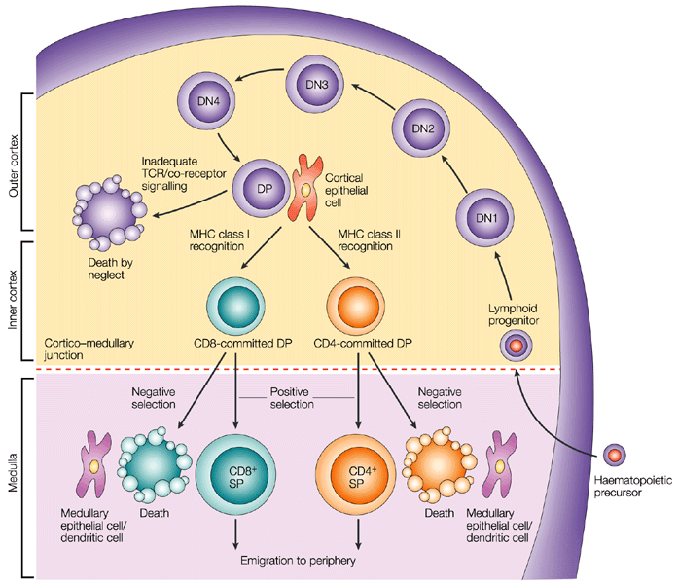
Figure 1. T-cell development in the thymus. T cell progenitors develop in the bone marrow and migrate to the thymus. Early T cells are CD4-CD8- (double-negative thymocytes). After TCR rearrangement, In the thymus double-negative thymocytes differentiate into CD4⁺CD8⁺ (double-positive) thymocytes. Following interaction with self-peptide-MHC class I complexes, thymocytes become CD8⁺ T cells. Thymocytes, interacting with self-peptide-MHC class II complexes, become CD4⁺ T cells [1].
It is well established that CD4⁻CD8⁻ T cell precursors migrate to the thymus where they undergo the following phenotypical stages: CD44⁺CD25⁻ (DN1), CD44⁺CD25⁺ (DN2), CD44⁻CD25⁺ (DN3), and CD44⁻CD25⁻ (DN4), followed by the progression of DN4 cells into the double-positive CD4⁺CD8⁺ T cells [5] (Figure 1). Infection by various pathogens causes activation and proliferation of naïve T cells, which differentiate into lineages with effector and memory fates. Naive CD4⁺ T cells recognize antigens presented by major histocompatibility complex (MHC) class II on antigen-presenting cells. Depending on the specific stimuli, the CD4⁺ T cells can differentiate into various subtypes, including the helper T_{H}1, T_{H}2 and T_{H}17 cells and regulatory T cells (Tregs). A subset of T_{H}2 cells differentiate into allergic disease-related T_{H}2A cells, with a CD45RB^{low} CD27⁻ phenotype and coexpression of the chemoattractant receptor CRT_{H}2, the natural killer cell marker CD161, and the homing receptor CD49d [6]. Memory T cells vary in their surface receptor expression, effector and trafficking abilities. There are four major subsets of memory T cells: central memory, effector memory, tissue-resident memory and stem memory T cells. Multiple signals regulate the differentiation of CD4⁺ T cells into central and peripheral memory cells. CD4⁺ T central memory cells express CD62L and CCR7, which are important for their migration [7]. The peripheral T stem cell memory cells express CXCR3 and CD95 molecules. In addition, both naive and memory T-cell subsets express a variety of functional molecules (Table 1).

Process | Antigen | Function
Costimulation/Survival | CD27 | Costimulation
 | CD28 | Costimulation
 | CD127 | IL-7 signaling
 | PD-1 | Inhibition of effector function
 | CD122 | IL-2/IL-15 signaling
 | CD132 | γc cytokine signaling
 | KLRG-1 | Inhibition of effector function
Activation | HLA | DR Peptide presentation
 | CD38 | Calcium flux/signal transduction
 | CD69 | Proliferation
Adhesion | CD11a | Adhesion to APC/endothelium
 | CD58 | Adhesion to APC
 | CD99 | Transendothelial migration
Migration | CD62L | Secondary lymphoid tissues homing
 | CD103 | Gut homing
 | CCR4 | Chemokine response/T_{H}2 associated
 | CCR5 | Homing to inflamed tissues
 | CCR6 | Chemokine response/T_{H}17 associated
 | CCR9 | Gut homing
 | CCR10 | Skin homing
 | CXCR3 | Homing to inflamed tissues
 | CXCR4 | Homing to bone marrow
 | CLA | Skin homing
Cytolytic molecules | Granzyme A | Cleavage of cellular proteins
 | Granzyme B | Cleavage of cellular proteins
 | Perforin | Pore-forming
Miscellaneous | CD161 | Regulation of proliferation/cytotoxicity
 | IL-18Ra | 18Ra Response to IL-18
 | c-Kit | Response to SCF
 | CD130 | Response to IL-6
Table 1. Expression of functional molecules by circulating naive and memory T-cell subsets. Modified from [8].
The second major group of T cells, CD8⁺ T cells, mediates direct killing of antigen-presenting target cells. Naive CD8⁺ T cells are activated upon recognition of antigens presented by MHC class I on dendritic cells in the spleen or lymph nodes. Activated CD8⁺ T cells expand and become effector CD8⁺ T cells. CD8⁺ T cells tend to be evaluated during the study for tumor-infiltrating T cells. For example, Vodnala SK et al. evaluated the effect of overabundance of potassium in the tumor microenvironment on CD8⁺ T cell stemness and dysfunction in tumors [9].
[enlarge]
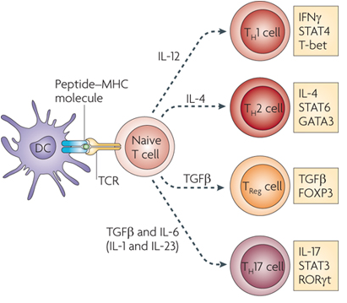
Figure 2. Differentiation of helper CD4⁺ T cell subsets. After activation by antigen-presenting cells, CD4⁺ T cells can differentiate into several subsets: T helper 1 (T_{H}1), T_{H}2, T_{H}17 and regulatory T cells. The differentiation of each T cell subset is regulated by different transcription factors [2].
The majority of the T cells bear α and β chains in their T cell receptor (TCR). However, there is a population of T cells, which have TCR formed by γ and δ chains. These cells, gamma delta T cells, are significantly enriched in epithelia [10, 11]. Gamma delta T cells regulate immune responses by various mechanisms, including suppression of effector T cell and T_{H}1 cell functions, blockage of neutrophil influx and regulation of antigen-presenting cell activity.
Markers for maturation processes
Naive T cells are considered as precursors of the majority of antigen-activated T cell subpopulations. Human naïve CD4⁺ T cells express CD45RA, CCR7, CD62L and CD27. Upon recognition of antigens presented by major histocompatibility complex (MHC) class II on antigen-presenting cells, naïve CD4⁺ T cells undergo proliferation and differentiation into functionally different T cell subsets including IFN-γ producing helper T cell-1 cells (T_{H}1), IL-4-producing T_{H}2, IL-17-producing T_{H}17 cells, and inducible regulatory T cells (iTregs) (Figure 2). Each T cell subset expresses specific transcription factors, such as T-bet (T_{H}1), GATA3 (T_{H}2), RORγt (T_{H}17), and Foxp3 (CD25⁺ Tregs). Grandclaudon M et al used IL-12Rb2 as a T_{H}1 cell marker [12]. With regard to T_{H}17 cells, their differentiation is under control TGF-β and IL-6-induced differentiation, IL-21-induced activation, and IL-23-regulated stabilization [13, 14]. As to iTregs, FOXP3 was found to an important marker of natural CD4⁺CD25⁺ regulatory T cells. Moreover, transfection of CD4⁺CD25⁻ T cells with Foxp3 stimulates their regulatory activity [15]. In addition, TGF-β was found to be crucial for the differentiation of naive CD4⁺ T cells into Foxp3⁺ Tregs [16]. Also, IL-2 is commonly required for TGF-β-regulated iTreg differentiation [17].
With regard to cytotoxic T cells, there are several peripheral subsets of different subsets of CD8⁺ T cells based on the expression of CD45RA and CCR7: a CD45RA⁺CCR7⁺ subset of naive cells, a CD45RA⁻CCR7⁺ subset of antigen-experienced memory T cells, a CD45RA⁻CCR7⁻ effector memory cell subset, and a CD45RA⁺CCR7⁻ subset of differentiated, antigen-experienced effector cells. Also, there are effector memory CD8⁺ T cells expressing CD69 and CD103 and residing in non-lymphoid tissues [18, 19]. A subpopulation of CD8⁺ T cells shows a memory cell phenotype: CD62L⁻/⁺CCR7⁺CD27⁻/⁺. Activated cytotoxic CD8⁺ T cells downregulate expression of L-selectin and CCR7 and upregulate surface expression of CD44, LFA-1 and/or α4β1 integrin. In addition, there are CD8⁻ cytotoxic T cells: CD4⁺ cytotoxic T cells and gamma delta T cells [20]. Hashimoto K et al shows that supercentenarians have much higher level of CD4⁺ cytotoxic T cells in blood circulation than young people [20].
Additional phenotypical markers of Tregs
There are several additional phenotypical markers expressed in both human and mouse Tregs. They include CTLA-4, CD103, GITR and OX40. In particular, CTLA-4 is important for both inhibitory functions and homeostasis of Tregs. Intracellular expression of CTLA-4 was observed in CD4⁺CD25⁺ human Tregs [21]. Another marker, integrin α (CD103) is expressed by Tregs and CD4⁺CD25⁺CD103⁺ Tregs were demonstrated to produce IL-10 actively [22]. In addition, GITR (CD357) is expressed in CD4⁺CD25⁺ human Tregs in peripheral blood [23]. Also, OX40 (CD134) was shown to stimulate the proliferation of CD4⁺FoxP3⁺ Tregs [24]. Moreover, OX40 stimulates migration of Tregs into the peripheral lymphoid and other tissues during inflammation [25].
T cell subsets that regulate B cell functions in the germinal centers
Several specific T cell subsets, including follicular B helper T cells (TFH), follicular regulatory T cells (TFR) and cytotoxic CD8⁺ T cells, reside in the germinal centers and regulate the B cell proliferation [26]. Among these T cell subpopulations, TFH cells belong to CD4⁺ T cells and assist follicular B cells located in secondary lymphoid tissues, such as lymph nodes, spleen, and tonsils. Concerning the specific markers, high expression of CXC-chemokine receptor 5 (CXCR5) characterizes TFH cells [27]. Its interaction with CXC-chemokine ligand 13 (CXCL13) produced by follicular stromal cells mediates the homing of TFH cells into lymphoid follicles [27]. The development of TFH cells is strongly dependent on IL-2 production, as naїve IL2-secreting CD4⁺ T cells are destined to differentiate into TFH cells, while other CD4⁺ T cells, which do not produce IL-2, develop into non-TFH cells [28]. In addition to a universal T cell marker Thy1 (CD90) and CXCR5, TFH cells express ICOS and PD-1 molecules. Upregulation of CXCR5 expression stimulates TFH cells to migrate into the germinal centers, where these cells stabilize their phenotype by contacts with local B cells via ICOS-ICOSL binding [29]. Concerning the regulation of TFH functions, γδ T cells (TCRγδ⁺CXCR5⁺ T cells), which also reside in the lymph nodes, have recently been shown to present antigens to TFH cells and induce their activation [30].
Cellular interactions with TFH cells regulate the proliferation and maturation of B cells in the germinal centers [31]. Besides, TFH cells secrete Il-4 and IL-21 cytokines, which are crucial for the functioning of the germinal centers [31]. Moreover, in the germinal centers, TFH cells are represented by at least two distinct subpopulations: IL-21⁺ T cells regulating the selection of high-affinity B cells and IL-4⁺ T cells promoting differentiation of plasmocytes [32]. A third type, secreting IL-4, IL-5, and IL-13, directs the class switching of B cells from IgG1 to high-affinity IgE during anaphylaxis , and coexpress transcription factors BCL6 and GATA3 [33]. Several studies have shown that chronic viral infection strongly induces differentiation of TFH, which leads to non-specific B cell activation [34].
In addition to TFH cells, researchers have identified TFR cells in the germinal centers. This subset of T cells expresses Foxp3 and also regulates the activity of germinal centers [35]. TFR cells suppress the proliferation of B cells and the production of IgM and IgG antibodies [35, 36] and diminish the secretion of IL-4 and IL-21 by TFH cells in the germinal centers [37].
Measurement of T cell immune responses
The standard methods for measurement of T cell immune responses include Enzyme-Linked Immuno Spot assay (ELISpot), Intracellular Cytokine Staining assay (ICS), Tetramer assay and Flow Cytometry. The ELISpot and ICS assays apply in vitro stimulation to analyze the cytokine expression profiles of responding cells. The ELISpot method detects spots of cytokines secreted by individual cells, and ICS examines surface markers and produced cytokines. Multiple approaches can measure the proliferation of T cells in response to specific antigens, including thymidine incorporation assay, flow cytometric analysis of CD38 expression or ELISA detection of BrdU incorporation into DNA of proliferating T cells.
T cell immunotherapy
T cell immunotherapy has yielded promising results for cancer treatment. Generally speaking, there are two main methods of T cell immunotherapy: 1) application of genetically modified T cell receptors (TCRs) recognizing tumor antigens in relation to HLA and 2) application of chimeric antigen receptors (CARs), which allow binding antigens without HLA recognition [38]. In contrast to CARs, TCRs may recognize both membrane and intracellular antigens.
The α and β chains of TCRs recognize T cell targets, and genetic modification of TCR chains modifies antigen specificity. In particular, TCR for MART-1, gp100, and NY ESO-1 have shown anti-cancer activity in patients with melanoma [39]. Other tumors sensitive to TCR modification therapy include lymphoma [40], neuroblastoma [41] and sarcoma [42].
CARs also modify antigen-specific T cell functions and were effective for the treatment of B cell malignancies [43]. The insertion of co-stimulatory signaling regions into the cytoplasmic domain of CARs significantly upregulated the activity of CAR-modified T cells [44, 45]. These co-stimulatory regions include different domains, such as CD28 [46] and OX40 [47], and can modify the T cell cytotoxic activity, proliferation, and survival.
The therapeutic method of applying cells expanded ex vivo is named adoptive cell transfer. This treatment uses specific T cells isolated from fragmented tumor tissues. Isolated T cells can be expanded with the help of IL-2, selected and adoptively transferred into patients. Before the adoptive cell transfer, the patients undergo lymphodepletion by either chemotherapy or irradiation [48].
[enlarge]
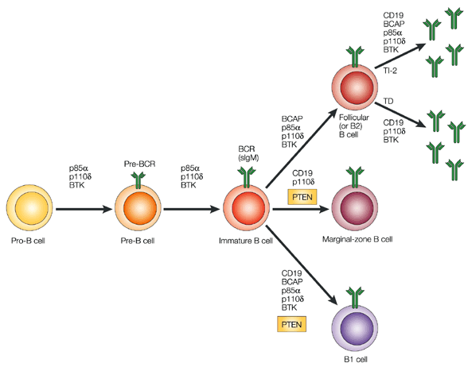
Figure 3. Stages of B cell development. B cell development starts in the bone marrow. Immature B cells migrate to the spleen. There are three subsets of mature B cells: follicular B2 cells, marginal zone B cells and B1 cells. Following exposure to antigens, B cells differentiate into antibody-producing plasma cells [3]. B2 cells may remain plastic and can differentiate to B1 cells upon the self-reactivity of B cell antigen receptor [4].
B Lymphocytes
Markers for major B cell subtypes
There are three main subsets of naïve B lymphocytes: follicular B cells, marginal zone B cells and B1 B cells. Mature follicular B cells migrate through blood and lymph, reside in specific B cell areas of lymph nodes, Peyer’s patches, and the spleen and may present T-dependent antigens to T cells. Marginal zone CD19⁺CD21⁺CD23⁻CD24⁺IgM⁺ B cells reside in the marginal sinus of the spleen and mediate the transport of antigen in immune complexes. B1 cells are involved in the development of IgM responses to bacterial T cell-independent antigens. These cells can migrate from the peritoneum and reside in mesenteric lymph nodes. Memory B-cells are represented by three subsets: pre-switch IgD⁺IgM⁺CD27⁺ B cells, IgD⁻IgM⁺CD27⁺ B cells, post-switch IgA⁺CD27⁺ and IgG⁺CD27⁺ B cells and IgA⁺CD27⁻ and IgG⁺CD27⁻ memory B cells [49]. Circulating plasmablasts can be identified by the expression of CD38 and CD138 [50].
Expression of BCR expression is highly important for maintaining B cells in the peripheral immune system. However, only 30% of B cells in spleen develop into mature B cells. Moreover, mice, which have mutations in genes encoding BCR-related proteins, including BLNK, Btk, and Vav, show disruption of the maturation process [52, 53].
The most cited monoclonal antibodies against T or B cell markers and their number of citations with antibody applications of immunohistochemistry, immunocytochemistry, flow cytometry, and ELISA, among the over 60,000 publications Labome has surveyed for Validated Antibody Database. The most cited monoclonal antibody from each supplier is listed.

B cell maturation markers
Lymphoid progenitors Lin⁻KIT^{low}CSA1^{low}IL-7R⁺ are considered to be a lymphoid progenitor group and can differentiate into both B and T cells. Also, in vitro studies have demonstrated that B220⁻CD19⁺ cells can differentiate into myeloid or B cells [54] and Lin⁻KIT^{low}SCA1^{low}IL-7R⁺FLT3⁺CD34⁻ cells or B220⁻KIT^{low}SCA1⁺CD24⁺CD43⁺ cells contain increased numbers of B cell precursors [55, 56].
Early B220⁺ precursors of B cells do not express cell surface immunoglobulin (Ig), reside in the bone marrow and include pre-pro-B cells, pro-B cells, and pre-B cells. Immature pre-B cells migrate to the spleen, where they differentiate into mature B cells and plasmocytes (Figure 3). Peripheral B cell subsets, including transitional, mature, memory and antibody-secreting cells, express different surface markers (Table 2).
In addition to IgG production, a subpopulation of splenic B cells can possess regulatory functions. Regulatory B cells (Bregs) affect various parts of the immune system with IL-10 playing a key role in these processes. The B10 subgroup of B cells was shown to act as regulatory cells in experimental models of lupus and autoimmune encephalomyelitis [57]. Moreover, IL-10 producing Bregs with the surface phenotype CD19⁺CD24^{hi}CD38^{hi} were found in the peripheral blood in SLE patients [58]. In addition, regulatory phenotypes CD19⁺, CD24⁺CD27⁺ and CD19⁺IgD⁺CD24^{hi}CD38^{hi}CD5^{hi} were shown to have suppressive functions in humans [59, 60].
Regulatory B cells
Several subsets of Bregs were characterized in human peripheral blood. These subsets include B cells with different levels of maturity: transitional CD19⁺CD24^{hi}CD38^{hi} Bregs [61, 62], CD19⁺CD27^{int}CD38⁺, plasmablasts [63] and CD19⁺CD25⁺CD71⁺ B regulatory 1 cells [64]. Recent studies suggest that differentiation and stimulation of Bregs are likely to be induced by inflammation associated with either infection or autoimmune reactions. In particular, toll-like receptor agonists of bacterial origin were shown to activate Bregs in vitro [65, 66]. In addition, the proliferation of Bregs was reported in a murine model of autoimmune arthritis [67].
In addition to the subsets of Bregs mentioned above, Tim-1⁺ B cells were also shown to regulate immune reactions, since Tim-1 mucin domain-mutated mice develop autoimmune disorders [68]. Tim-1⁺ Bregs were identified within different B cell subpopulations, including CD19⁺CD1d^{hi}CD5⁺, MZ and B1 cells [69]. Also, human CD73⁻CD25⁺CD71⁺ BR1 cells were demonstrated to be involved in the development of allergen tolerance [64]. Membrane regulatory molecules expressed by Bregs include CD25, CD71 and CD274 [58, 70, 71].
Measurement of antibody production
One of the most important functions of B cells is antibody production. Enzyme-linked immunosorbent assay (ELISA) can analyze secreted antibodies, plaque-forming cell (PFC) assays can detect antibody-secreting B cells, and ELISPOT can indicate the number of antibody-producing B cells.

UNIT – 3
Surface plasmon resonance or SPR is an optical effect that can be utilized to measure the binding of molecules in real-time without the use of labels. SPR instruments are primarily used to measure the binding kinetics and affinity of molecular interactions. SPR can be used, for example, to measure the binding between two proteins, a protein and an antibody, DNA and a protein, and many more. SPR is unique because it is one of the few techniques that allows determination of binding kinetics and not just binding affinity, as you would get from traditions techniques like ELISA. The binding kinetics, or the on and off rates, can only be determined with a biosensing technique that gives real-time binding data of both the association and dissociation phases of the interaction. This data gives detailed insight into the binding strength and stability of the interaction, which is critical for many industries and research areas. It helps researchers determine which molecules interact, why they interact, and how strongly they interact.
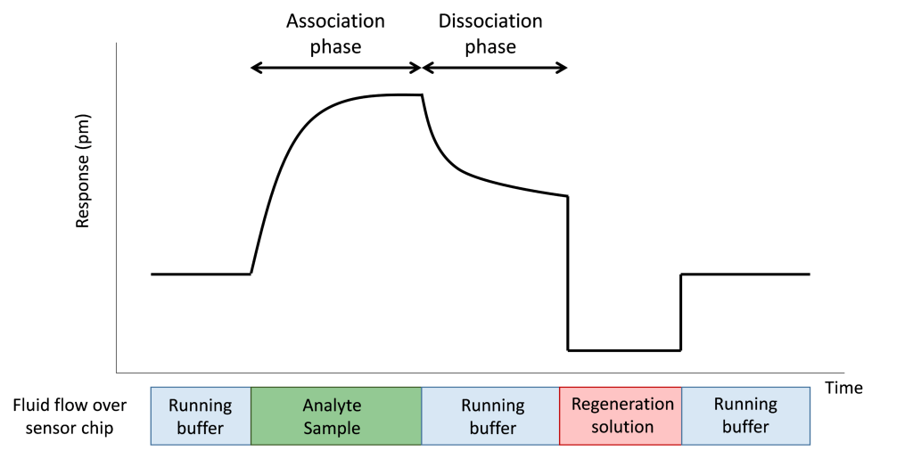
The data from SPR is critical in a number of industries, and has been in use for over 25 years by companies like Pfizer, Roche, and GSK and by many universities throughout the world. Some examples of its applications include:
- Screening and developing new pharmaceuticals and new biotherapeutics
- Quality control in bioprocess monitoring
- Developing new diagnostic assays Basic research such as discovering and characterizing protein function, disease mechanisms, etc.
Group of assays | Assay | Mechanism | Advantages | Disadvantages
Labeled ligand-binding assays | Fluorescent ligand binding assays | Fluorescent labeled ligand binding assay is applied to detect its binding to a target. | These assays have a broad spectrum of wavelengths, therefore it can apply multiple colors. | The assays are susceptible to different fluorescence interferences. Also, the labeling of a ligand, can lead to undesirable alterations in the binding characteristics of the ligand. In addition, it is difficult to obtain good fluorescent ligands for many receptors.
 | Radioligand binding assays | Radioactively labeled ligand binding assay is applied to detect its binding to a target. | The most popular assay for membrane-bound targets. Good robustness, precise determination of receptor density and distribution, ligand binding sites and affinity. | High cost and hazards of handling high levels of radioactivity.
 | Bioluminescent binding assays using nanoluciferase | Bioluminescent reporter nanoluciferase (NanoLuc) is used to study interactions of protein hormones with their receptors. | NanoLuc-based assays have several advantages: high sensitivity, high stability and reproducibility. | Since NanoLuc reporter is larger than radioisotopes, it may potentially influence the receptor binding.
Label-free ligand binding assays | Surface plasmon resonance (SPR) | SPR applies light-excited surface plasmon polaritons to track the binding of ligands to the receptors bound to a gold surface. | SPR is the most popular label-free ligand binding assay. This assay can be used to determine binding kinetics. | This assay has low sensitivity to binding-induced conformational change.
 | Plasmon-waveguide resonance (PWR) | PWR applies a continuous polarized wave laser exciting electromagnetic waves in a resonator made of a thin silver film with a layer of SiO2 and a glass prism. Ligand binding changes amplitude, position and width of reflected lights. | PWR examines anisotropic optical contents of receptor-ligand complexes, thus differentiating mass density changes from conformational changes. | PWR has lower sensitivity than SPR with regard to refractive index, thickness and mass parameters.
 | SPR imaging for affinity-based biosensors | This assay measures the binding kinetics and is related to intensity modulation and analyzes the reflectivity of monochromatic incident p-polarized light detected at a fixed angle. | This assay can be used to monitor binding events in real time. | This assay characterizes different compounds for a specific target, it still provides low throughput.
 | Nanofluidic Fluorescence Microscopy (NFM) | NFM combines nanofluidic-based biosensors and fluorescence microscopy to analyze the protein binding kinetics. | Protein binding kinetics can be analyzed in one single experiment. The time of analysis by NFM is shorter compared to other microfluidic assays. Statistical errors are reduced and there are no limitations on the size of the analyzed molecules. | Limitations of fluorescence microscopy.
 | Whispering gallery microresonator (WGM) | WGM is based on wave sensing binding of molecules to the surface of the cavity induces changes of the resonant wavelength changes. The resonant changes of light permit multiple analyses of molecules. | WGM is a highly sensitive assay for molecule detection. | The possibility to study drug-target interactions under non-equilibrium conditions using this assay is still unclear.
 | Resonant waveguide grating (RWG) | RWG uses a nanograting to couple light into the waveguide via diffraction. The light illuminates the biosensors in microplate at a nominally normal incident angle. The drug binding of the immobilized receptors results in a shift in the resonant wavelength. | RWG assay is effective for affinity screening. | This assay is not applicable to study cells due to the large size of cells and limited penetration ability of an evanescent wave.
 | Biolayer Interferometry Biosensor (BIB) | This assay uses a spectrometer to detect interference patterns formed by light reflected from an optical layer and a biolayer containing proteins of interest. | Effective assay to study binding kinetics. | This assay has been validated mostly for small molecule detection.
Structure-based ligand binding assays | Nuclear magnetic resonance (NMR) | NMR analyzes the magnetic characteristics of certain atomic nuclei, which absorb electromagnetic radiation in the magnetic field. | NMR can be applied to analyze the structure of proteins and the molecular details of protein-ligand interactions and to assist structure-based drug design. Besides, NMR can be used for any class of compounds, for almost all soluble proteins, natively unstructured proteins or membrane proteins. | The high cost of the assay, time-consuming, requires a long time to analyze obtained spectra. The resolving power of NMR is lower than X-ray crystallography.
 | X-ray crystallography | This assay measures the changes of the diffracted X-ray beams in order to produce a three-dimensional image of electron density within the molecule of interest. Obtained image of electron density is used to determine the structure of the molecules. | The solvent effect can be examined by X-ray crystallography. The whole 3D structure can be obtained by the systematic analysis of a crystallized material. | Solutions and behavior of molecules in solution cannot be examined. Direct determination of secondary structures including domain movements cannot be performed.
Thermodynamic binding assays | Thermal denaturation assays (TDA) | TDA detect the thermal denaturation of proteins by differential scanning fluorimetry, which applies a prob fluorophore to monitor thermal denaturation process of proteins in the presence and ligands. | These methods have found applications in chemical profiling of different protein families, identifying novel ligands, and investigating the stability of proteins in buffers in solution | These methods may not be suitable for analysis of very small proteins that do not aggregate upon denaturation.
 | Isothermal titration calorimetry (ITC) | ITC measures the binding enthalpy variation by sensing the heat caused by the binding reaction | This method is useful for detecting highly potent and entropy-driven ligands, compared to others. | This method shows low throughput and sensitivity, and requires large sample volumes.
Whole cell ligand-binding assays | Surface acoustic wave (SAW) biosensor | The surface of the biosensor is excited to oscillate with a high frequency. The phase of the generated acoustic wave is shifted upon mass changes. Conformational characteristics are indicated by a change in amplitude. | Using this assay, the sequential binding of several distinct ligands, targeting different cell surface molecules, to the whole cells can be detected directly in real time. | SAW biosensors for analysis of small molecules using living cells have not developed.
 | RWG biosensor | RWG biosensor can transform drug-receptor interactions in cells into cell phenotypic signatures named dynamic mass redistribution. | This assay measures the consequence of binding, and the stimulus-response interpretation of the initial interaction of drug and receptor. Also, RWG can analyze the functional consequences of ligand binding and dissociation. | RWG biosensor may not be used to detect ligand binding directly.

Immunology is the study of the body’s defence against any kind of infection^{[1,2]}. Even though different types of disease causing microorganisms surround us, we rarely get sick. The protection against infection is termed as immunity and the collection of cells, tissues and molecules that functions to defend us against infectious microbes constitutes immune system ^{[3]}. The immune system is highly organised to discriminate between ‘self’ and ‘non-self’ followed by elimination of ‘non-self^{[4]}. It eliminates infectious organisms from the body; however, it doesn’t see foreign organisms as a whole: it recognises and reacts potentially against any molecule as long as it is foreign or non-self^{[4]}. Origin of Immunology started in 1796 when Edward Jenner, the English Physician, obtained the pus from the pustules of a dairymaid suffering from cowpox and introduced it into the system of an eight-year-old boy through a nick in the arm and demonstrated that the boy developed immunity against the smallpox^{[5,6]}. Rooted in the Latin word vacca for cow, the procedure was termed as vaccination and the introduced substance as vaccine. These terms are still being used to describe the inoculation of healthy individuals with weakened or attenuated strains of disease-causing agents to provide protection from disease.
Today, immunology is a very complex and sophisticated area of biology, which has become one of the most versatile research tools in biology and medicine, as well as a powerful weapon in the armoury of prevention and management of several viral and bacterial diseases. The significance of immunology in human is amply reflected by the large number of Nobel Prizes awarded to research in this area. These award winning discoveries (Table 1) represent the milestones in the development of modern immunology, and constitute more than 10 percent of all Nobel awards for Physiology or Medicine, since year 1901^{[7]}.

Table 1: Nobel prizes awarded for discoveries in immunology or related areas^{[1,7]}

Year | Scientists | Discovery
1901 | Emil von Behring | Serum antitoxins
1905 | Robert Koch | Cellular immunity to tuberculosis
1908 | Ilya Ilyich Mechnikov and Paul Ehrlich | Role of phagocytosis (Mechnikov) and
 |  | antitoxins (Ehrlich) in immunity
1913 | Charles Robert Richet | Anaphylaxis
1919 | Jules Bordet | Complement-mediated bacteriolysis
1930 | Karl Landsteiner | Discovery of human blood groups
1951 | Max Theiler | Development of yellow fever vaccine
1957 | Daniel Bovet | Antihistamines

Table 1: (Contd...)
Year | Scientists | Discovery
1960 F. Macfarlane Burnet and Peter |  | Acquired immunological tolerance
 | Medawar
1972 | Gerald M Edelman and Rodney | Chemical structure of antibodies
 | R Porter
1977 | Rosalyn R. Yalow | Development of radioimmunoassay
1980 | Baruj Benacerraf, Jean Dausset | Major histocompatibility complex
 | and George Snell
1984 | Niels K Jerne, George E. Kohler | Immune regulatory theories (Jerne) and
 | and Cesar Milstein | technological advances in the development
 |  | of monoclonal antibodies (Milstein and
 |  | Köhler)
1987 | SusumaTonegawa | Gene rearrangement in antibody production
1996 | Peter C Doharty and Rolf M | Role of major histocompatibility complex in
 | Zinkernagel | antigen recognition by T cells
2002 | Sydney Brenner, H. Robert | Genetic regulation of organ development
 | Horvitz and J. E. Sulston | and cell death (apoptosis)
2008 | HaraldzurHausen, Françoise | Role of HPV in causing cervical cancer
 | Barré-Sinoussi and Luc | (Hausen) and the discovery of HIV (Barré-
 | Montagnier | Sinoussi and Montagnier)
2011 | Jules Hoffmann, Bruce Beutler | Discovery of activating principles of innate
 | and Ralph Steinman | immunity (Hoffmann and Beutler) and role
of dendritic cells in adaptive immunity

(Steinman)

CELLS AND TISSUES OF THE IMMUNE SYSTEM
All the cells of the immune system develop from precursors in the bone marrow, after which they circulate in the blood and live in lymphoid organs (thymus, lymph nodes, spleen and tonsils) and in virtually all the tissues of the body. They can rapidly migrate to any site of infection, where they are needed. These cells ingest and destroy microbes, other injurious agents, and even body’s own dead or damaged cells. Among circulating white blood cells (leukocytes), the major phagocytes are neutrophils and monocytes. Neutrophils respond rapidly to foreign stimuli and to injury; their reaction is a part of acute inflammation^{[3]}. When blood monocytes enter tissues, they mature, and are called as macrophages. These cells are present under epithelia, in connective tissues, and in all organs. Macrophages respond more slowly than do neutrophils but for longer times; this reaction is typical of chronic inflammation^{[3]}. Macrophages also help to repair damaged tissue. The most important cells of adaptive immunity are lymphocytes which are further classified into two main classes as B and T lymphocytes. B lymphocytes (so called because they mature in the bone marrow) secrete proteins called antibodies, which bind to and eliminate extracellular microbes. T lymphocytes (which mature in the thymus) function mainly to combat microbes that have learned to live inside cells (where they are inaccessible to antibodies). There are two main types of T lymphocytes: helper T cells (Th cells) which help B lymphocytes to make the most effective antibodies and macrophages to kill ingested microbes, and cytotoxic (cytolytic) T lymphocytes (CTLs or Tc cells) which kill infected host cells and thus serve to eliminate reservoirs of infection. A third, small population of lymphocytes is called as regulatory T cells (Tregs) because they control immune responses and prevent harmful immune reactions. There are several other small populations of lymphocytes under research. These various types of lymphocytes can be distinguished by their expression of surface proteins. These surface proteins are named according to the standardized cluster of differentiation (CD) nomenclature, for instance, all B cells are CD19+ and all T cells are CD3+.Among CD3+ T cells, helper T cells are CD4+ and cytotoxic T lymphocytes are CD8+. In order to get immune responses started, foreign substances (antigens) have to be captured, processed and presented to the lymphocytes. The cells that perform this task of processing and presenting antigens are called antigen-presenting cells (APCs). The best-defined APCs are specialized type of cells called dendritic cells (DCs). Most important cell types involved in immune and inflammatory responses are listed in table 2.

Table 2: Major cell types involved in immune and inflammatory responses^{[8,9]}

Cell type | Principal functions
T lymphocyte | Help for B cells and macrophages (CD4+helpercells), killing of infected
 | and tumor cells (CD8+cytotoxicTlymphocytes)
B lymphocyte | Antibody production (B cells develop into plasma cells, which make
 | antibodies)
Dendritic cells | Capture and display of foreign (e.g. microbial) antigens
Macrophages | Phagocytosis and killing of microbes; antigen capture and display; tissue
 | Repair
Neutrophils | Phagocytosis and killing of microbes
THE IMMUNE RESPONSE
The normal immune system has to be capable of recognizing virtually any microbe and foreign substance that one might encounter, and the response to each microbe has to be directed against that microbe. The foreign substances that are recognized by these lymphocytes are called antigens. The immune system recognizes and directs responses against an enormous number of antigens by generating a large number of lymphocytes, each with a single and unique antigen receptor. There are about 10¹² lymphocyte in an adult, and it is estimated that these are able to recognize at least 10⁷ – 10⁹ different antigens. Thus, only a few thousand lymphocytes express identical antigen receptors and recognize the same antigen.
For effective protection of an individual against disease, the immune system must follow three main tasks. Immunological recognition: As a first task the immune system must detect the presence of an infection or antigen^{[2]}. Immune response and regulation: The second task is to fight the infection and, if possible, eliminate it completely, and at the same time the immune response must be kept under control so that it should not itself do damage to the body. Immune regulation, or the ability of the immune system to self-regulate, is thus an important feature of immune responses, and failure of such regulation contributes to conditions such as allergy and autoimmune disease^{[2]}. Immunological memory: The third task of the immune system is to protect the individual against recurring disease due to the same pathogen, so that having been exposed once to an infectious agent, a person will make an immediate and stronger response against any subsequent exposure to it. To understand these tasks step by step, the whole immune response can be divided into two groups: innate and adaptive immune responses explained in following headings and summarized in table 4. ^{[2]}.
INNATE IMMUNE RESPONSE
Innate immunity (the immunity we are born with) is mediated by cells and proteins that are always present in our body since birth and ready to fight against microbes (hence, “innate”), and are involved into action immediately in response to infection. In other words, the innate immune system consists of cells and proteins that are always present and ready to mobilize and fight microbes at the site of infection^{[10]}. Components of innate immunity:
Anatomical Barriers
Epithelial barriers of the skin, gastro-intestinal (GI) tract and respiratory tract, which prevent microbe entry (and have to be breached for a microbe to establish infection, e.g., by cuts and burns), Mucus and other anti-microbial chemicals secreted by epithelia inhibit microbe growth preventing infections. Many ingested microbes are killed or neutralized by digestive enzymes and acidic environment in stomach.
Phagocytes
If microbes breach the epithelial barriers, phagocytic leukocytes (neutrophils and macrophages) ingest them into vesicles and destroy them. In addition, these phagocytes and some other cells like dendritic cells and macrophages secrete inflammatory cytokines that stimulate inflammation and lymphocyte responses. These cells form an important link between innate and adaptive immunity: macrophages and dendritic cells also act as antigen-presenting cells which activate cells of the adaptive immune system.
Natural Killer Cells (NK Cells)
NK cells are specialized cell type expressing receptors that bind to general classes or bacterial or viral antigens rather than very specific peptide sequences. They detect the presence of stressed and infected cells and kill them.
Plasma Proteins and Complement System
Several circulating plasma proteins bind microbes and help to eliminate them, the most important of which are the proteins of the complement system. Complement proteins bind to the pathogens and get activated. These complement proteins then cause phagocytosis by interacting with complement protein receptors on the surface of macrophages. This process of coating a microbe’s surface with a molecule to enhance phagocytosis is termed as opsonisation. Soluble complement proteins can also recruit additional phagocytes at the infection site.
ADAPTIVE IMMUNE RESPONSE
The innate immune response is able to prevent and control many infections. However, many pathogenic microbes have evolved to overcome innate immune defenses, and to protectagainst these infections adaptive immunity comes in action^{[10,13]}. Adaptive immunity is normally silent, and respond (or adapts) to the presence of infectious microbes by becoming active, expanding, and generating potent mechanisms for neutralizing and eliminating the microbes. The components of the adaptive immune system are lymphocytes and their products. Microbes can reach any part of the body including different tissues, blood, gastrointestinal tract, respiratory tract or even inside the cells. The immune system has to eliminate microbes from all the locations of the body. To make it simple adaptive immunity can be further categorized into humoral and cell mediated immunity^{[10,13]}
Humoral Immunity
Humoral immunity is the type of host defense that is mediated by antibodies, the products of B cells. B-cells recognise the stimulation antigen by means of the immune globulins (antibody) that is attached to their own surface. B cells, when stimulated by antigen and factors produced by T helper cells, proliferate and develop into immunoglobulin (antibody) secreting plasma cells^{[2,14]}. An antibody or immunoglobulin is Y-shaped structure consisting of four chains-2 light (L) and 2 heavy (H) depending on their molecular weights (Fig. 1.). These chains are joined together by disulphide
_{bonds} [2, 14, 15].
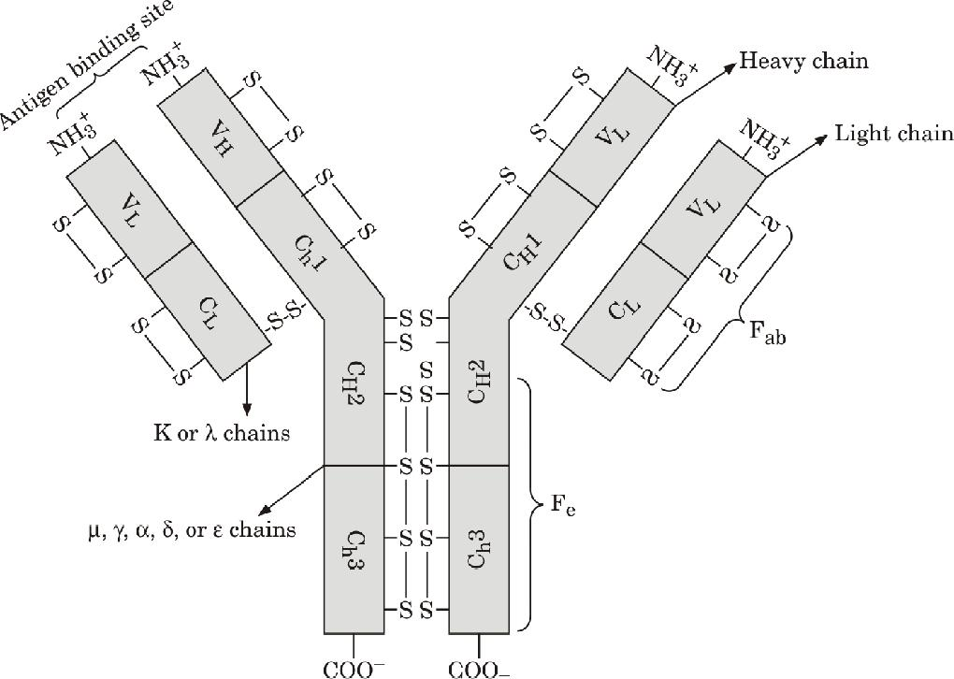

The arms Fab consist of constant and variable regions. The inner (N-terminal) segment of Fab fragments has an amino acid sequence that is largely conserved from molecule to molecule and hence is termed as constant region. The C-terminal end shows considerable variation in its amino acid sequences and is responsible for the high diversity exhibited by immunoglobulin molecules. It is variable region of the molecule that forms the binding site to the antigen (or epitope). Based on the structure of their heavy chain constant regions, immunoglobulins have been classified into five major classes (called as isotype), termed IgG, IgA, IgM, IgD and IgE (Table 3). Actually, helper T cells stimulate the B cells to secrete different classes of antibodies.
Antibody Diversity
The sum total of all the possible antibody specificities that an organism can make is called as antibody diversity. In humans it is estimated that 10⁷ - 10⁸ different antibody molecules exist. How is it possible to maintain such a high number of specificity and diversity?
There are two independent theories explaining the origin of diversity in antibodies^{[9, 14]}

Germ line theory: This theory suggests that there are different V region genes for every possible antibody that can be made.

Somatic mutation theory: This suggests that only one or a few V region genes exist and the antibody diversity is result of somatic mutations that occur in these genes.

Current literature considers both the germ line and somatic mutation theories having some role in maintaining this diversity^{[16]}. The four following mechanism has been suggested for the antibody diversity^{[17, 18]}.
Randomly combining V-(D)-J segments within a chain
Randomly combining heavy and light chain

Imprecise joining

Somatic hypermutation
The variable region of an immunoglobulin is formed by portions of both the heavy and the light chain. The variable portion of the heavy chain is not linearly encoded in the genome, but rather in separated gene segments of three types, V, D and J (variable, diversity and joining). Each of these segments is present in multiple, slightly different variations: for the heavy chain, the number of gene segments is 65 (V), 27 (D) and 6 (J). A complete heavy chain variable region exon is randomly cobbled together by juxtaposing one V, one D and one J segment by a cut and paste process at the DNA level. An enzyme complex containing RAG-proteins (recombination activating gene) excises intervening DNA, and normal DNA repair proteins directly rejoin the segments. In all, there are 65x27x6 ways to recombine the segments, resulting in 10,530 different heavy chain possibilities just by rearranging the building blocks. But that is not all. The rejoining process is somewhat messy: nucleotides can be lost or added by the enzyme terminal deoxy nucleotidyl transferase (TdT), causing additional variability. This mechanism is called junctional diversity or imprecise joining.
Light chain genes are independently generated along the same lines, with the difference that they do not have D segments, just V and J segments. For the ê locus and the ë locus combined, there are 320 ways to assemble a light chain. Combining randomly generated heavy with randomly generated light chains adds another level of variability. Just by rearranging the building blocks, without regarding imprecise joining, 10,530 × 320 = 3.369,600 different antibody molecules can be generated.
In the course of an adaptive immune response, especially if the antigen cannot be eliminated quickly, an additional mechanism adding to overall variability and allowing development of high-affinity antibodies comes into play: somatic hypermutation. In rapidly proliferating B cells, the regions within the rearranged VDJ (heavy chain) or VJ (light chain) exons that encode the protein loops making direct contact with the antigen undergo very high rate of somatic. These complementarity determining regions are therefore also called hypervariable regions^{[18, 19]}.
Antibodies are secreted into mucosal lumens, the blood, and interstitial fluids, and combat microbes at all these sites. Antigens that enter through the epithelia or are present in the blood are first collected and concentrated in the lymph nodes, spleen, and other lymphoid tissues. Here the antigens are recognized by the small number of B cells that express specific receptors for the antigens. The B cells are activated and undergo two important changes. First, the B cells divide, leading to an increase in the number of antigen-specific cells (a process that helps to keep pace with rapidly replicating microbes). Second, the B cells start producing more antibody and secreting this antibody, so it can circulate freely, find the antigen, and get rid of it. Antibody-secreting cells, called plasma cells, are the effect or cells of the B lymphocyte lineage. If the antigen is a protein, it also activates helper T-cells. These helper T cells interact with the antigen-specific B cells and enhance antibody secretion; in fact, helper T cells are absolutely required for effective antibody responses against protein antigens. This type of immunity is effective against extracellular microbes, which are accessible to antibodies.
Cell Mediated Immunity
Cell-mediated (or cellular) immunity is mediated by T cells, and is effective against intracellular microbes. Similar to B-cells recognising the antigens by means of antibodies attached to their own surface, T cells recognise antigens by means of T-cell receptors present on their surface. Unlike B-cells that recognise antigen directly by themselves, T-cells can recognise antigen only if that antigen is processed by APCs and presented with glycoproteins called major histocompatibility complex (MHC)^{[9,15]}. The name MHC because

they were discovered in the context of graft acceptance or rejection (tissue compatibility); human MHC molecules are called HLA (for human leukocyte antigens, because they were detected by antibodies made against leukocytes)^{[3]}. HLA molecules pick up peptides from intracellular microbes and display these peptides for recognition by T cells; this is how T cells sense the presence of microbes inside infected cells. Depending on structure

and their mode of action, MHC molecules have been classified into two main classes^{[1,2,15]}: Class I and Class II. Class I MHC molecules are expressed

by most cells of the body, whereas only antigen presenting cells (B cells, dendritic cells, macrophages and certain T cells) express Class II MHC molecules. Generally class I molecules present antigens to cytotoxic T cells and class II MHC present antigens to helper T cells. Different types of T lymphocytes work in different ways to eliminate intracellular microbes. Cell associated antigens are displayed by MHC molecules and are recognized by helper T cells or by CTLs. These T cell subsets are designed to see antigens present in different cellular compartments (phagocytic vesicles for helper T cells and cytoplasm for CTLs). In order to start T cell responses, the lymphocytes need to see antigen by their antigen receptors, and also see molecules (called “costimulators”) that are induced on APCs by microbes. This requirement for a second, microbe-dependent signal ensures that we respond best to infectious pathogens and not to harmless antigens. Following antigen recognition, the antigen-specific T cells expand in number (even more than do B cells), and begin to differentiate into effector cells, which perform the task of attacking and eliminating microbes. Helper T cells work largely by secreting soluble proteins called cytokines. Cytokine is a general name for any protein that is secreted by cells and affects the behaviour of nearby cells bearing appropriate receptors^{[20]}. Chemokines are secreted proteins that act as chemoattractant (hence the name ‘chemokine’), attracting cells bearing chemokine receptors, such as neutrophils and monocytes, out of the bloodstream and into infected tissue^{[20]}. Different cytokines have different functions^{[21]}; in general, many mediate communications between leukocytes and are therefore called interleukins (ILs). IL-2 is a growth factor for T cells; interferon-ã (IFN-ã) activates macrophages; tumor necrosis factor (TNF) stimulates inflammation; IL-4 stimulates B cells to produce IgE; IL-5 activates eosinophils and so on.Under some conditions of strong stimulation, helper T cells differentiate into subsets that produce restricted sets of cytokine: Th1 cells produce IL-2, IFN-ã and TNF and are thus involved in cell-mediated immunity, and Th2 cells secrete IL-4 and IL-5, and are critical for defense against helminths (parasitic worms)^{[22]}. Recently, a third subset of helper T cells has been discovered, called Th17 cells because their signature cytokine is IL-17^{[23]}. These cells elicit strong inflammatory reactions. Helper T cells act on macrophages that have ingested microbes and activate the macrophages to killthese microbes. CTLs recognize microbes hiding inthe cytoplasm of infected cells (e.g., viruses), and kill the infected cells^{[24]}. These responses are initiated by naive (immunologically inexperienced) lymphocytes recognizing antigen. The lymphocytes that are activated by the antigen then proliferate (divide). Some of these lymphocytes then differentiate from antigen-recognizers into cells that do the job of getting rid of the antigen. Because this is the ultimate “effect” of the immune response, the cells that are responsible for it are called “effector cells”. Other stimulated lymphocytes develop into long-lived memorycells. After the effector cells get rid of the antigen, most of the antigen-activated lymphocytes die, and the response declines to a basal steady state (called homeostasis). At the end, only a few memory cells survive as a “reminder” of the encounter with the antigen. Although the immune system is capable of recognizing millions of foreign antigens, it normally does not react against one’s own (self) antigenic substances and this is because lymphocytes that express receptors for self-antigens are killed or shut off when they recognize these antigens. This phenomenon is called self-tolerance (20, 25), implying that we “tolerate” our own antigens; the breakdown of this process results in autoimmune diseases^{[25]}.
Table 4: Comparison between innate and adaptive (acquired) immunity^{[10,11,13]}
S. No. | Innate immunity | Adaptive immunity
1 | The immunity remains throughout life | Normally silent and develops during life
 | since birth till death. | time and can be short lived or lifelong.
2 | Gives immediate response and | Slower response, may take 1-2 weeks to
 | protection but has limited and lower | give response but is much more efficient
 | efficacy. | than innate response.

- It recognizes general classes of Recognizes highly specific antigens. pathogens (bacteria, viruses, fungi etc)
but cannot make very specific distinction.

4 | ‘In the past’ or ‘pre-exposure’ with | Contact with pathogen or its antigen is
 | pathogen or its antigen is not essential. | essential.
5 | Innate immunity is inheritable. | Adaptive immunity can not be passed to
 |  | next generation except for a brief period
 |  | in neonates.

IMMUNOLOGICAL MEMORY
The initial lymphocyte activation generates not only effector cells but also a small population of antigen-specific lymphocytes that have the capacity to live for a long time, lying in wait for the antigen to return^{[13]}. These long-lived cells are called memory cells, because they ensure that the immune system should remember what microbes it has encountered for immediate response in future when same microbe invades. The number of memory cells increases with age (age in reflecting our exposure to microbes)–almost all circulating T cells in a new-born are naïve cells, whereas as many as half in an adult are memory cells^{[13]}. Memory cells respond more rapidly and powerfully than do naïve lymphocytes; this is why the response to repeat exposures to a microbe (“secondary responses”) are more effective that the response to the first exposure (“primary response”).
HYPERSENSITIVITY
Immune response to any antigen is generally directed to eliminate infectious agent. owever, in some cases it gets misdirected, becomes hyper-reactive and leads to tissue injury and this situation or reaction is termed as hypersensitivity (26). These reactions can be categorized as ‘immediate’ or ‘delayed’ based upon the time taken for symptoms to appear after antigen exposure. These may be divided into ‘humoral’ or ‘cell mediated’ immune response based upon type of components. A four-group classification of hypersensitivity reactions was expounded by British immunologists Gell and Coombs in 1963. Type I (Immediate) hypersensitivity or anaphylaxis: Cross-linking of mast cell-bound IgE by the allergen triggers histamine release and synthesis of other inflammatory mediators such as platelet-activating factor, leukotrienes, bradykinins, prostaglandins, and cytokines which contribute to allergic inflammation. These mediators cause the early phase of allergic reaction that appears within minutes after exposure to the allergen and is therefore referred as immediate hypersensitivity. Allergic rhinitis, asthma and urticaria are some of the examples of type I hypersensitivity. These immunoglobulin E mediated allergic reactions are triggered upon re-exposure of predisposed individuals to allergens.

Type II or Cytotoxic Hypersensitivity: Ab directed against cell surface antigens meditates cell destruction via complement activation or antibody dependent cell cytotoxicity (ADCC).

Type III or Immune Complex-Mediated Hypersensitivity: Ag-Ab complexes deposited in various tissues induce complement activation leading to inflammation and damage to endothelium.

Type IV or Delayed Hypersensitivity: Receptors on the sensitized T lymphocytes (TH1, TH2 or Cytotoxic T cells (CTL) combine with the target cell antigens, release inflammatory cytokines, resulting in cell death.
AUTOIMMUNITY AND AUTOIMMUNE DISEASES
Normally immune responses are directed only to the foreign particles and they do not respond against host tissues or they should show self-tolerance^{[25]}. This is due to the result of the elimination of potentially self-reactive T cells in the thymus. However contrary to their supposed response immune system starts responding to the host issues, in short, the immune system start recognising some self-tissues as non-self and acting against them, this situation of breakdown of self-tolerance is termed as autoimmunity^{[28]}. In autoimmune diseases the antibodies or T cells directed against self are called as autoantibodies and auto reactive T cells, respectively. These auto reactive T cells and autoantibodies are thought to be causally associated with arrange of different pathologies called as autoimmune diseases^{[29]}. Some common autoimmune diseases are rheumatoid arthritis (RA), type 1 diabetes, multiple sclerosis, Addison’s disease, Graves’ disease, myasthenia gravis etc^{[28]}.
IMMUNODEFICIENCY DISORDERS AND AIDS
When one or more components of the immunesystem are defective; the resulting condition is termed as immunodeficiency. Immunodeficiencies are classified as primary (orcongenital) or secondary. Primary
immunodeficiencies are caused byinherited mutations in any of a large number of genes that are involved inor control immune responses^{[2]}. More than 100 primary immunodeficiencies have been described that affect the development of immune cells, their function, or both. Clinical features of these disorders are therefore highly variable, although a common feature is recurrent and often over whelming infections in very young children. Allergy, abnormal proliferation of lymphocytes, autoimmunity, and certain types of cancer can also occur. In contrast, secondary immune deficiencies are acquired as a consequence of other diseases, or are secondary to environmental factors such as starvation, or are an adverse consequence of medical intervention.
In recent years, all other forms of immune deficiencies have been overshadowed by an epidemic of severe immunodeficiency caused by the infectious agent called human immune deficiency virus (HIV). HIV causes acquired immunodeficiency syndrome (AIDS) and was first recognized as opportunistic infections in United States in June 1981^{[1,2]}. This is the most extreme case of immune suppression. HIV infection leads to a gradual loss of immune competence, allowing infection with organisms that are not normally pathogenic. The disease is characterized by a susceptibility to infection with opportunistic pathogens or by the occurrence of an aggressive form of Kaposi’s sarcoma or B-cell lymphoma, accompanied by a profound decrease in the number of CD4+s T cells. HIV infection does not immediately cause AIDS, and the mechanisms of how it does, and whether all HIV-infected patients will progress to overt disease, are incompletely understood.HIV is now a worldwide pandemic, and although great strides are being made in understanding the pathogenesis and epidemiology of the disease, the number of infected people around the world continues to grow at an alarming rate^{[2]}.There are growing epidemics of HIV infection and AIDS in China and in India, where surveys in several states have shown a1-2% prevalence of HIV infection in pregnant women. The incidence of HIVinfection is rising faster in Eastern Europe and Central Asia than in the rest of the world^{[30]}.
APPLICATIONS OF BIOTECHNOLOGY IN IMMUNOLOGY (IMMUNOTECHNOLOGY)
Biotechnology is a term used to describe any technique that uses living organisms (or parts of a living organism) to make products used in agriculture, food science and medicine. Immunotechnology is a term used to describe the branch of biotechnology concerned with the production of immunological agents in living organisms. Advances in Immunotechnology have made it possible to diagnose several diseases and also to produce immunological agents that protect people and animals against many types of diseases. Many organisms have been designed specifically to produce antibiotics or vaccines. Also, chicken embryos are commonly used in the production of vaccines. Advances within this field include the application of genetic engineering to produce edible vaccines. The genetic material of plants is altered to enable them to synthesise vaccines in the edible part of a food plant, i.e. fruit. This is particularly beneficial to countries lacking adequate storage facilities or staff to administer vaccines to its public. Therapeutic substances called ‘biologics’ have also provided new effective treatments for auto-immune diseases such as rheumatoid arthritis. Modified human antibodies and the cell receptors that they bind to, are used to specifically target the substance responsible for causing joint destruction. Frequently biotechnological approaches in immunology are described in following headings.
VACCINES
Vaccines are preparation of antigens in combination with adjuvants (a substance that is formulated as part of a vaccine to enhance its ability to induce protection against infection) and are the most important tools to provide lifelong adaptive immunity against infectious diseases^{[31]}. The antigens used in vaccines may be in the form of live attenuated or killed microorganisms, purified components of microorganisms or an engineered plasmid. Vaccination protects a recipient by establishing an immunological resistance and immunological memory to the source of antigen in vaccine. A goal of vaccination is to stimulate strong memory responses (and long-lived plasma cells)^{[31]}.
Traditional vaccines have been extremely successful in preventing infections by pathogens expressing relatively conserved antigens through antibody mediated effector mechanisms. Vaccinations has eradicated some diseases and mortality due to several of them has been significantly reduced^{[32,33]}. However, there are still many infections where vaccination

is ineffective, which represent a major cause of mortality worldwide. Some of these infections are caused by pathogens with a high degree of antigen variability that cannot be controlled only by antibodies, but require a mix of humoral and cellular immune responses. Novel biotechnological approaches for antigen discovery, expression and formulation allow now for the development of vaccines that can better cope with pathogen diversity and trigger multifunctional immune responses^{[32]}. The availability of novel biotechnological approaches, together with the knowledge of the distinct human immune responses that are required to prevent different types of infection, should help to rationally design effective vaccines where conventional approaches have failed^{[32]}. Conventional and future biotechnologically boosted vaccines can be divided in several groups as below (14, 31, 33).
Live, Attenuated Vaccines
There are some vaccines that include live pathogens but with attenuated (diminished) virulence. These pathogens are unable to cause disease but induce immunity when injected in host. Some examples of this kind of vaccines are BCG (Bacillus Calmette Guerin), Polio vaccine, Vaccine for smallpox etc.
Inactivated or Killed (Dead) Vaccine
In this type of vaccines pathogens killed or inactivated by means of chemical, heat or radiation are used. These vaccines stimulate antibody production in injected host without causing any infection. They are more stable and safer than live attenuated vaccines but they have comparatively weaker response and require repetitive booster doses. Inactivated vaccines usually don’t require refrigeration, and they can be easily stored and transported in a lyophilised form. Some examples of this kind of vaccines are typhoid fever and whooping cough.
Toxoid (Inactivated Toxin) Vaccines
Exotoxins from some pathogenic bacteria are the main cause of illness, these exotoxins are highly antigenic and they stimulate rapid antibody production in the host. Treating them with formalin can inactivate these toxins; such “inactivated” or “detoxified” toxins are called as toxoids. These toxoids are safe to be used as vaccine and this kind of vaccines are called as toxoid vaccines. When the immune system receives a vaccine containing a harmless toxoid, it learns how to fight off the natural toxin. The immune system produces antibodies that block the toxin. Vaccines against diphtheria and tetanus are examples of toxoid vaccines.
Genetically Engineered or Recombinant Vaccines
The vaccines generated by using genetic engineering or recombinant DNA technology are called recombinant vaccine^{[34]}. By using this technique either virulence region from the pathogen is removed from organism making it non virulent or non-pathogenic and using is as live vaccine or producing immunogenic but non-pathogenic segment of the organism as recombinant protein and using that as subunit vaccine.
ubunit Vaccines
In this type of vaccines, insteadof the entire microbe, only specific parts of the pathogen like the antigen or epitopes that best stimulate the immune system are used. Because subunit vaccines contain only the essential antigens and not all the other molecules that make up the microbe, the chances of adverse reactions to the vaccine are very low^{[35]}. Vaccine against hepatitis B is one of the best examples for subunit vaccine.
Conjugate Vaccines
Conjugate vaccines are somewhat similar to recombinant vaccines: they are generated by combination of two different components (like bacterial coats). These components are chemically linked to a carrier protein, and the combination is used as a vaccine. Conjugate vaccines are used to create a more powerful, combined immune response: typically the “piece” of bacteria being presented would not generate a strong immune response on its own, while the carrier protein would^{[36]}. The piece of bacteria can’t cause illness, but combined with a carrier protein, it can generate immunity against future infection. The vaccines against pneumococcal bacterial infections are made using this technique.
DNA Vaccine
Now a day a lot research is going on for DNA vaccines whereby DNA coding for the foreign antigen clonedin appropriate expression vector is directly injected into the animal so that the foreign antigen is directly produced by the host cells^{[37]}. In theory these vaccines would be extremely safe and devoid of side effects since the foreign antigens would be directly produced by the host animal. In addition, DNA is relatively inexpensive and easier to produce than conventional vaccines. Moreover, the time for development is relatively short which may enable timely immunization against emerging infectious diseases.
HYBRIDOMA TECHNOLOGY AND MONOCLONAL ANTIBODY
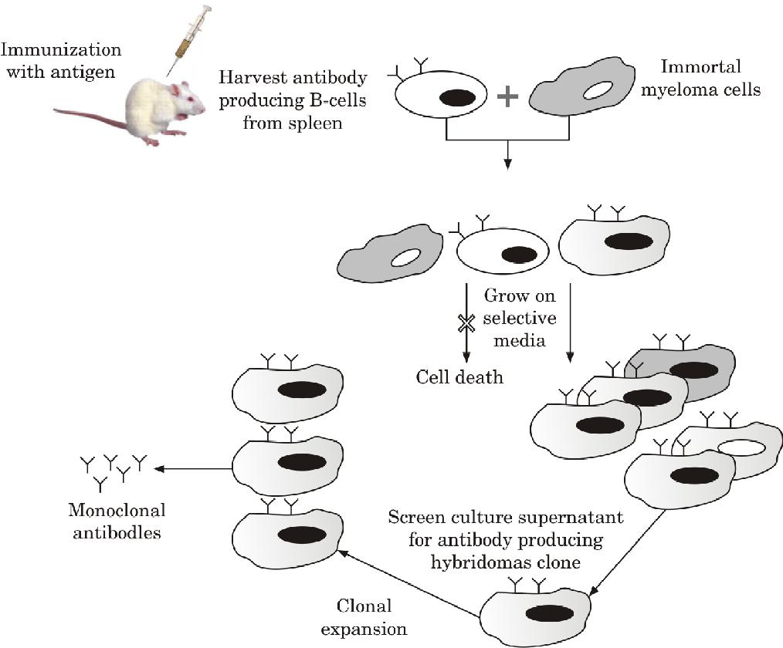
The clonal selection theory suggests that each B-cell is able to produce an unique antibody specific to single antigenic determinant or epitope. A typical antigen is a complex molecule with several antigenic determinants which induces a polyclonal antibody response in an individual, in which antibodies of multiple specificity affinity and avidity are produced by a number of different B cell clones. In a disease called multiple myeloma patients have malignant tumour of B cells and these B cells generally produce antibody of single specificity. The healthy antibody producing B cells has a definite life span but they can be immortalised by fusing with myeloma cell which can divide indefinitely in vitro. George Kohler and Cesar Milstein in 1975 has successfully hybridised these two cell types by fusing an antibody specific B-cell (producing antibody against a single epitope) with myeloma cells which do not secrete antibody but immortal in nature and lack functional hypoxanthine guanine phosphoribosyl transferase (HGPRT), a key enzyme in salvage pathway of DNA synthesis. Hybrid cells are selected from the myeloma cells in a medium containing thymidine, aminopterin (which blocks the de novo pathway of DNA synthesis), and hypoxanthine (HAT medium). In this technique B cells producing an antibody specific to single epitope (monoclonal) is immortalised, such antibodies are termed as monoclonal antibody and the technique is termed as hybridoma technique/technology^{[38]}. The hybridoma technology is briefly summarised in the following figure (Fig. 2.).

The use of monoclonal antibodies is numerous and includes the prevention, diagnosis, and treatment of disease. For example, monoclonal antibodies can distinguish subsets of B cells and T cells, which is helpful in identifying different types of leukaemia^{[39]}.Monoclonal antibody-based treatment of cancer has been established as one of the most successful therapeutic strategies for both hematologic malignancies and solid tumours^{[40,41]}.
ANTIBODY BIOTECHNOLOGY
Much of the early work on the elucidation of antibody structure was performed using fragments of antibodies prepared by enzyme digestion. The development of monoclonal antibody technology was a major step forward in allowing researchers to produce large quantities of well-defined antibodies. More recently, genetic engineering has been used to generate antibodies and antibody fragments for specific applications^{[42,43]}.
Polyclonal and Monoclonal Antibodies
Immunization of an animal stimulates antibody production from a large number of different clones of B cells. These antibodies will differ in their epitope specificity and affinity for the antigen. Such antibodies are referred as ‘polyclonal’. In contrast, the antibodies produced by a single clone of B cells (monoclonal antibodies) have a defined specificity and affinity. Note that a monoclonal antibody is not necessarily of higher affinity than a polyclonalantibody, and whether it is more effective than polyclonal antibody depends on the assay or purpose itis used for^{[42]}.
Humanized Antibodies
Initially monoclonal antibodies were made entirely from mouse cells. For therapeutic purposes, these antibodies have a drawback that the human immune system recognizes these antibodies as foreign (because they’re from a different species) and will mount a response against them. In the short term, this can provide therapeutic immune response but in the long term it may be useless. It means that the antibodies may only work for the first time they are given; after that, the body’s immune system is primed to destroy them before they can provide therapeutic effect.
Over time, researchers replaced some parts of these mouse antibody proteins with human components. Antibodies with a mixture of mouse and human components are known as chimeric antibodies. As more human components were used in the mouse antibody, they were referred to as humanized antibodies. Some monoclonal antibodies are now fully human, which means they are likely to be even safer and may be more effective than earlier monoclonal antibodies. An even newer approach uses fragments of antibodies instead of complete antibody. Smaller fragmentsare more efficient to reach a tumor, which may make them more effective. Clinical trials of monoclonal antibody therapy are being done on almost every type of cancer^{[44]}.
IMMUNOASSAYS
Immunology based assays are very important in laboratories involved in diagnosis of human and animal diseases. Biological assays that use immune cells or antibodies are known as immunoassays. Immunoassays exploit the specificity of binding between antibodies and antigens. In simpler terms, an immunoassay can use a known antibody to detect the presence of an antigen whether it is a component of tissue, an isolated cell or is a soluble molecule. The assays that detect only presence or absence of an antigen are termed as qualitative assays whereas assays capable of providing information to calculate exact amount of antigens are termed as quantitative assays. Antigen specific antibodies developed by hybridoma technology are the key to the success of these immunoassays for different diagnosis applications. Some commonly used assay techniques are described here:
Radioimmunoasay (Ria) and Enzyme Linked Immunosorbent Assay (Elisa)
Radioimmunoassay (RIA) and enzyme-linked immunosorbent assay (ELISA) are direct binding assays for antibody (or antigen); both work on the same principle, but the means of detecting specific binding is different (RIA uses radioactive isotopes whereas ELISA uses chromogenic substrate)^{[1,2]}. Radioimmunoassays are commonly used to measure the levels of hormones in blood and tissue fluids, while ELISA assays are frequently used in viral diagnostics, for example in detecting cases of infection with the human immunodeficiency virus (HIV), which is the cause of AIDS. For both these methods one needs a pure preparation of a known antigen or antibody, or both, in order to standardize the assay. The unlabelled component (antigen or antibody) is attached to a solid support, such as the wells of a plastic multiwall plate, which will absorb a certain amount of any protein (antigen/ antibody). The labelled antibody (Radiolabelled in RIA or Enzyme linked in ELISA) is allowed to bind to the unlabelled antigen, under conditions in which nonspecific adsorption is blocked, and any unbound antibody and other proteins are washed away. Antibody binding in RIA is measured directly in terms of the amount of radioactivity retained by the coated wells, whereas in ELISA the binding is detected by a reaction that converts a colour less substrate into a coloured reaction product. Biotechnological applications like hybridoma technology has made possible to produce very specific antibodies against several pathogens. These specific antibodies can be used in RIA and ELISA for efficient and non-overlapping diagnosis of several diseases like HIV and hepatitis. Technically ELISA can be divided in different subtypes like direct ELISA, indirect ELISA, sandwich ELISA and competitive ELISA(1).
Direct elisa
In direct ELISA, a target antigen, e.g., microbial proteins, or human DNA, is adsorbed on to a plastic surface – typically 96 or 396 small ‘wells’ – allowing many samples to be tested simultaneously. Diluted samples of serum to be tested are added, and any antibodies specific for the target antigen will become bound and immobilized to the plastic surface. Unbound serum components are then washed off and a ‘second’ antibody, which has been linked to an enzyme, is added. An enzyme is chosen that converts a colourless substrate to a coloured product, which can then be measured in a spectrophotometer. Direct ELISA is often used to detect antibodies to microbes in infection.
Indirect elisa
Here an antigen of suspected antibody that might be present in patient sample is added (coated) to the plate. Then dilutes samples from patient is added to see that if any suspected antibody is present, it reacts with the coated antigen fixed in the plate. Then another antibody which is enzyme linked is added to react with antibody from sample and produce color on addition of substrate.
Sandwich elisa

This is a modification of indirect modification of ELISA known as a capture or sandwich ELISA (or more generally as an antigen-capture assay) can be used to detect secreted products such as cytokines. Rather than the antigen being directly attached to a plastic plate, antigen-specific antibodies are bound to the plate, then the serum or other sample to be tested, and finally the enzyme-linked second antibody that recognizes a different epitope from that recognized by the immobilized first antibody is then used as to form an antibody–antigen–antibody ‘sandwich’. These are able to bind antigen with high affinity, and thus concentrate it on the surface of the plate, even with antigens that are present in very low concentrations in the initial mixture. Much effort is being put into improved ELISA-like protocols that have increased sensitivity and can detect many components in a single sample (knownas ‘multiplexing’), reducing sample size, speed and cost.
Immunohistochemistry (IHC)
Immunohistochemistry is a combination of histological, immunological and biochemical techniques. It is a method for confirming the presence and location of proteins in tissue sections^{[2]}. This technique is less sensitive in quantitative aspects than immunoassays such as RIA or ELISA but it enables the observation of proteins in intact tissue. This is especially useful for assessing the progression and treatment of diseases such as cancer. Immuno-histochemical staining is performed with fluorophore conjugated antibodies that recognize the target protein. Since antibodies are highly specific, the antibody will bind only to the protein of interest in the tissue section. The antibody-antigen interaction is then visualized by fluorescent detection, in which a fluorophore-conjugated antibody can be visualized using fluorescence microscopy.
Competitive elisa
The procedures of competitive ELISA are different in as compare to Indirect ELISA, Sandwich ELISA and Direct ELISA. In this ELISA the primary antibody (unlabeled) is incubated with sample antigen to form antigen-antibody complex. Antibody-antigen complexes are then added to 96-well plates, which are pre-coated with the same antigen. Unbound antibody is removed by washing the plate. (The more antigen in the sample, the less antibody will be able to bind to the antigen in the well, hence “competition.”). The secondary antibody that is specific to the primary antibody and conjugated with an enzyme is added followed by addition of substrate is added and the remaining enzymes elicit chromogenic signal. For competitive ELISA, the higher the sample antigen concentration, the weaker the eventual signal. The major advantage of a competitive ELISA is the ability to use crude or impure samples and still selectively bind any antigen that may be present.
HEMAGGLUTINATION AND BLOOD TYPING
The interaction (immune reaction) between antibody and a particulated antigen resulting in a visible clumping is termed agglutination^{[1, 2]}. Antibodies that produce such reactions are called agglutinins. Agglutination reactions are similar in principle to precipitation reactions; they depend on the cross linking of polyvalent antigens. The excess of antibody concentration inhibits precipitation reactions, also inhibit agglutination reactions; this inhibition is called the prozone effect (prozone phenomenon). Hence serial dilutions are usually prepared in many similar immunological techniques to avoid this prozone effect by reaching the dilution of the optimum antibody concentration. All type of agglutination reactions are simple to perform and can detect small amounts of antibodies (concentrations as low as nanograms per milliliter) and of low cost. Hemagglutination, is a specific form of agglutination that involves red blood cells (RBCs)^{[2]}.Hemagglutinationis commonly uses in the laboratories for blood typing. Human blood can be typed into Type A, Type B, Type O or Type AB blood because of the existence of similar antigen molecules embedded in the membrane of the red blood cells (RBCs)(45). Antibodies (agglutinins) for the antigens A and B exist in the plasma and these are termed anti-A and anti-B. The corresponding antigen and antibody are never found in the same individual since, when mixed, they form antigen-antibody complexes, effectively agglutinating the blood. For ABO typing of an individual one drop of blood is mixed with anti-A test serum and another drop is mixed with anti-B test serum, if agglutination occurs with the Anti-A test serum; the blood group will be A, if agglutination occurs with the Anti-B test serum; the blood group will be B, if agglutination occurs with both test serums; it will be AB blood group, failure of agglutination will signify O blood group. When transfusing blood, it is important to remember that the donor’s blood must not contain red blood cells that the recipient’s antibodies can agglutinate. Theoretically, then, individuals belonging to blood group O are universal donors, while those of blood group AB are universal recipients.
FLUORESCENCE ACTIVATED CELL SORTING (FACS) OR FLOW CYTOMETRY
Flow cytometry is one of the most powerful techniques used in the field of Immunology. Single cells are passed into a fine jet of liquid so that they encounter across a beam of lasers. Cells scatter the incoming beam of light by refraction and reflection. Light scattered through a small angle is called ‘forward scatter’ and is proportional to the size of the cells. Light scattered through a 90° angle is called ‘side scatter’ and depends on the granularity of the cell; e.g., a granulocyte has a much larger side scatter than a lymphocyte. Cells can also be mixed with antibodies that bind to specific molecules on the cell’s surface. Each antibody is linked to a molecule (fluorophore) with the property of absorbing light of one wavelength and re-emitting it at another. Light emitted by each cell is collected by a series of mirrors and then detected by one of several photomultipliers and stored on a computer. The precise composition of the mixture of cells can then be determined by analysis of their signals. The results can be displayed in the form of a dot plot in which each cell is represented as a dot, or as a histogram. Results from histogram analyses can be superimposed permitting easy comparisons between different samples. In a further refinement, cells binding different antibodies can be collected in separate tubes [fluorescence-activated cell sorting (FACS)], a powerful tool for isolating very pure cell populations.

