PC PACKAGE
UNIT 1
INTRODUCTION TO COMPUTER:
Charles Babbage is called the "Grand Father" of the computer. The First mechanical computer designed by Charles Babbage was called Analytical Engine. It uses read-only memory in the form of punch cards.
COMPUTER DEFINITION
Computer is an advanced electronic device that takes raw data as input from the user and processes these data under the control of set of instructions (called program) and gives the result (output) and saves output for the future use. It can process both numerical and non-numerical (arithmetic and logical) calculations.
CHARACTERISTICS OF COMPUTER:
1. Speed: - As you know computer can work very fast. It takes only few seconds for calculations that we take hours to complete. You will be surprised to know that computer can perform millions (1,000,000) of instructions and even more per second.
2. Accuracy: - The degree of accuracy of computer is very high and every calculation is performed with the same accuracy.
3. Diligence: - A computer is free from tiredness, lack of concentration, fatigue, etc. Due to this capability it overpowers human being in routine type of work.
4. Versatility: - It means the capacity to perform completely different type of work. You may use your computer to prepare payroll slips. Next moment you may use it for inventory management or to prepare electric bills.
5. Power of Remembering: - Computer has the power of storing any amount of information or data. Any information can be stored and recalled as long as you require it, for any numbers of years. It depends entirely upon you how much data you want to store in a computer and when to lose or retrieve these data.
8. Storage: - The Computer has an in-built memory where it can store a large amount of data. You can also store data in secondary storage devices such as floppies, which can be kept outside your computer and can be carried to other computers.
AREAS OF APPLICATION:
1.Business
A computer has high speed of calculation, diligence, accuracy, reliability, or versatility which has made it an integrated part in all business organizations.Computer is used in business organizations for −
Payroll calculations
Budgeting
Sales analysis
Financial forecasting
Managing employee database
Maintenance of stocks, etc.
2.Banking
Today, banking is almost totally dependent on computers.
Banks provide the following facilities −
Online accounting facility, which includes checking current balance, making deposits and overdrafts, checking interest charges, shares, and trustee records.
ATM machines which are completely automated are making it even easier for customers to deal with banks.
3.Insurance
Insurance companies are keeping all records up-to-date with the help of computers. Insurance companies, finance houses, and stock broking firms are widely using computers for their concerns.
Insurance companies are maintaining a database of all clients with information showing −
Procedure to continue with policies:
Starting date of the policies
Next due installment of a policy
Maturity date
Interests due
Survival benefits
Bonus
4.Education
The computer helps in providing a lot of facilities in the education system.
The computer provides a tool in the education system known as CBE (Computer Based Education).
CBE involves control, delivery, and evaluation of learning.
It is used to prepare a database about performance of a student and analysis is carried out on this basis.
5.Marketing
In marketing, uses of the computer are following −
Advertising − With computers, advertising professionals create art and graphics, write and revise copy, and print and disseminate ads with the goal of selling more products.
Home Shopping − Home shopping has been made possible through the use of computerized catalogues that provide access to product information and permit direct entry of orders to be filled by the customers.
6.Healthcare
Computers have become an important part in hospitals, labs, and dispensaries. They are being used in hospitals to keep the record of patients and medicines. It is also used in scanning and diagnosing different diseases. ECG, EEG, ultrasounds and CT scans, etc. are also done by computerized machines.
Following are some major fields of health care in which computers are used.
Diagnostic System − Computers are used to collect data and identify the cause of illness.
Lab-diagnostic System − All tests can be done and the reports are prepared by computer.
Patient Monitoring System − These are used to check the patient's signs for abnormality such as in Cardiac Arrest, ECG, etc.
Pharma Information System − Computer is used to check drug labels, expiry dates, harmful side effects, etc.
Surgery − Nowadays, computers are also used in performing surgery.
7.Engineering Design
Computers are widely used for Engineering purpose.
One of the major areas is CAD (Computer Aided Design) that provides creation and modific
ation of images. Some of the fields are −
Structural Engineering − Requires stress and strain analysis for design of ships, buildings, budgets, airplanes, etc.
Industrial Engineering − Computers deal with design, implementation, and improvement of integrated systems of people, materials, and equipment.
Architectural Engineering − Computers help in planning towns, designing buildings, determining a range of buildings on a site using both 2D and 3D drawings.
8.Military
Computers are largely used in defence. Some military areas where a computer has been used are −
Military Communication
Military Operation and Planning
Smart Weapons
9.Communication
Communication is a way to convey a message, an idea, a picture, or speech that is received and understood clearly and correctly by the person for whom it is meant. Some main areas in this category are −
E-mail
Chatting
Usenet
FTP
Telnet
Video-conferencing
10.Government
Computers play an important role in government services. Some major fields in this category are −
Budgets
Sales tax department
Income tax department
Computation of male/female ratio
Computerization of voters lists
Computerization of PAN card
Weather forecasting
COMPONENTS OF COMPUTER:
A computer can process data, pictures, sound and graphics. They can solve highly complicated problems quickly and accurately. A computer as shown in Fig. performs basically five major computer operations or functions irrespective of their size and make. These are
1) it accepts data or instructions by way of input,
2) it stores data,
3) it can process data as required by the user,
4) it gives results in the form of output, and
5) it controls all operations inside a computer.
Input Unit
This unit contains devices with the help of which we enter data into the computer. This unit creates a link between the user and the computer. The input devices translate the information into a form understandable by the computer.

CPU (Central Processing Unit)
CPU is considered as the brain of the computer. CPU performs all types of data processing operations. It stores data, intermediate results, and instructions (program). It controls the operation of all parts of the computer.
CPU itself has the following three components:
CPU itself has following three components.
- Memory or Storage Unit
- Control Unit
- ALU(Arithmetic Logic Unit)

Memory Unit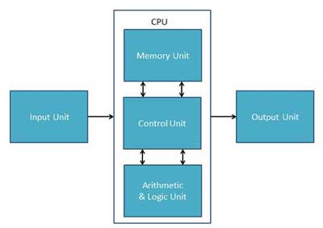
Memory unit is the amount of data that can be stored in the storage unit. This storage capacity is expressed in terms of Bytes. A binary digit is logical 0 and 1 representing a passive or an active state of a component in an electric circuit.
Control Unit
The control unit coordinates the activities of all the other units in the system. Its main functions are to control the transfer of data and information between various units

Arithmetic Logic Unit:
This unit consists of two subsections namely,
- Arithmetic Section
- Logic Section

Arithmetic Section
Function of arithmetic section is to perform arithmetic operations like addition, subtraction, multiplication, and division. All complex operations are done by making repetitive use of the above operations.

Logic Section
Function of logic section is to perform logic operations such as comparing, selecting, matching, and merging of data.

Output Unit
The output unit consists of devices with the help of which we get the information from the computer. This unit is a link between the computer and the users. Output devices translate the computer's output into a form understandable by the users.

MEMORY AND CONTROL UNITS:
A memory is just like a human brain. It is used to store data and instructions. Computer memory is the storage space in the computer, where data is to be processed and instructions required for processing are stored.
Memory is primarily of three types −
- Cache Memory
- Primary Memory/Main Memory
- Secondary Memory

Cache Memory
Cache memory is a very high speed semiconductor memory which can speed up the CPU. It acts as a buffer between the CPU and the main memory.
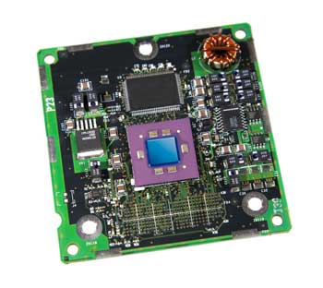

Advantages
The advantages of cache memory are as follows −
- Cache memory is faster than main memory.
- It consumes less access time as compared to main memory.
- It stores data for temporary use

Primary Memory (Main Memory)
Primary memory holds only those data and instructions on which the computer is currently working. It has a limited capacity and data is lost when power is switched off. It is generally made up of semiconductor device. It is divided into two subcategories RAM and ROM.
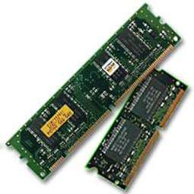

Secondary Memory
This type of memory is also known as external memory or non-volatile. It is slower than the main memory. These are used for storing data/information permanently. For example, disk, CD-ROM, DVD, etc.
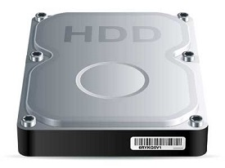
RAM (Random Access Memory) is the internal memory of the CPU for storing data, program, and program result. It is a read/write memory which stores data until the machine is working. As soon as the machine is switched off, data is erased.
RAM is volatile, i.e. data stored in it is lost when we switch off the computer or if there is a power failure. Hence, a backup Uninterruptible Power System (UPS) is often used with computers.
RAM is of two types −
- Static RAM (SRAM)
- Dynamic RAM (DRAM)

Static RAM (SRAM)
The word static indicates that the memory retains its contents as long as power is being supplied. There is extra space in the matrix, hence SRAM uses more chips than DRAM for the same amount of storage space, making the manufacturing costs higher. SRAM is thus used as cache memory and has very fast access.

Characteristic of Static RAM
- Long life
- No need to refresh
- Faster
- Used as cache memory
- Large size
- Expensive
- High power consumption

Dynamic RAM (DRAM)
DRAM, unlike SRAM, must be continually refreshed in order to maintain the data. This is done by placing the memory on a refresh circuit that rewrites the data several hundred times per second. DRAM is used for most system memory as it is cheap and small. All DRAMs are made up of memory cells, which are composed of one capacitor and one transistor.

Characteristics of Dynamic RAM
- Short data lifetime
- Needs to be refreshed continuously
- Slower as compared to SRAM
- Used as RAM
- Smaller in size
- Less expensive
- Less power consumption
ROM stands for Read Only Memory. The memory from which we can only read but cannot write on it. This type of memory is non-volatile. The information is stored permanently in such memories during manufacture. A ROM stores such instructions that are required to start a computer. This operation is referred to as bootstrap. ROM chips are not only used in the computer but also in other electronic items like washing machine and microwave oven.
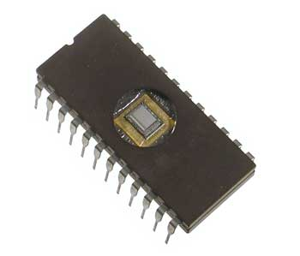
Let us now discuss the various types of ROMs and their characteristics.

MROM (Masked ROM)
The very first ROMs were hard-wired devices that contained a pre-programmed set of data or instructions. These kind of ROMs are known as masked ROMs, which are inexpensive.

PROM (Programmable Read Only Memory)
PROM is read-only memory that can be modified only once by a user. It can be programmed only once and is not erasable.

EPROM (Erasable and Programmable Read Only Memory)
EPROM can be erased by exposing it to ultra-violet light for a duration of up to 40 minutes.

EEPROM (Electrically Erasable and Programmable Read Only Memory)
EEPROM is programmed and erased electrically. It can be erased and reprogrammed about ten thousand times. Both erasing and programming take about 4 to 10 ms (millisecond). In EEPROM, any location can be selectively erased and programmedNon-volatile in nature

CONTROL UNIT
This unit controls the operations of all parts of the computer but does not carry out any actual data processing operations.
Functions of this unit are −
- It is responsible for controlling the transfer of data and instructions among other units of a computer.
- It manages and coordinates all the units of the computer.
- It obtains the instructions from the memory, interprets them, and directs the operation of the computer.
- It communicates with Input/Output devices for transfer of data or results from storage.
- It does not process or store data.
I/O DEVICES:
Input Devices:
The devices which are used to input the data and the programs in the computer are known as "Input Devices". or Input device can read data and convert them to a form that a computer can use.
Following are some of the important input devices which are used in a computer −
- Keyboard
- Mouse
- Joy Stick
- Light pen
- Track Ball
- Scanner
- Graphic Tablet
- Microphone
- Magnetic Ink Card Reader(MICR)
- Optical Character Reader(OCR)
- Bar Code Reader
- Optical Mark Reader(OMR)

Keyboard
Keyboard is the most common and very popular input device which helps to input data to the computer. The layout of the keyboard is like that of traditional typewriter, although there are some additional keys provided for performing additional functions.
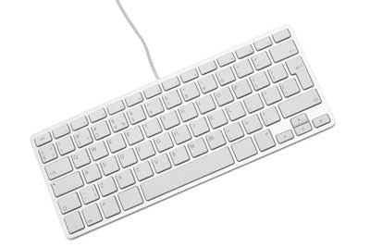
Keyboards are of two sizes 84 keys or 101/102 keys, but now keyboards with 104 keys or 108 keys are also available for Windows and Internet.
The keys on the keyboard are as follows −
S.No | Keys & Description
1 | Typing Keys  These keys include the letter keys (A-Z) and digit keys (09) which generally give the same layout as that of typewriters.
2 | Numeric Keypad  It is used to enter the numeric data or cursor movement. Generally, it consists of a set of 17 keys that are laid out in the same configuration used by most adding machines and calculators.
3 | Function Keys  The twelve function keys are present on the keyboard which are arranged in a row at the top of the keyboard. Each function key has a unique meaning and is used for some specific purpose.
4 | Control keys  These keys provide cursor and screen control. It includes four directional arrow keys. Control keys also include Home, End, Insert, Delete, Page Up, Page Down, Control(Ctrl), Alternate(Alt), Escape(Esc).
5 | Special Purpose Keys  Keyboard also contains some special purpose keys such as Enter, Shift, Caps Lock, Num Lock, Space bar, Tab, and Print Screen.

Mouse
Mouse is the most popular pointing device. It is a very famous cursor-control device having a small palm size box with a round ball at its base, which senses the movement of the mouse and sends corresponding signals to the CPU when the mouse buttons are pressed.
Generally, it has two buttons called the left and the right button and a wheel is present between the buttons. A mouse can be used to control the position of the cursor on the screen, but it cannot be used to enter text into the computer.
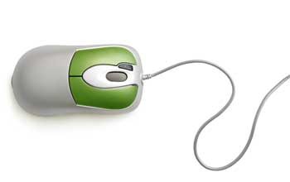

Advantages
- Easy to use
- Not very expensive
- Moves the cursor faster than the arrow keys of the keyboard.

Joystick
Joystick is also a pointing device, which is used to move the cursor position on a monitor screen. It is a stick having a spherical ball at its both lower and upper ends. The lower spherical ball moves in a socket. The joystick can be moved in all four directions.
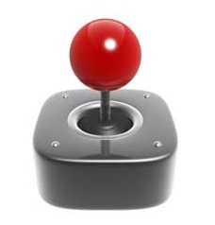
The function of the joystick is similar to that of a mouse. It is mainly used in Computer Aided Designing (CAD) and playing computer games.

Light Pen
Light pen is a pointing device similar to a pen. It is used to select a displayed menu item or draw pictures on the monitor screen. It consists of a photocell and an optical system placed in a small tube.
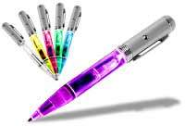

Track Ball
Track ball is an input device that is mostly used in notebook or laptop computer, instead of a mouse. This is a ball which is half inserted and by moving fingers on the ball, the pointer can be moved.
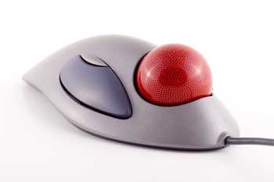
Since the whole device is not moved, a track ball requires less space than a mouse. A track ball comes in various shapes like a ball, a button, or a square.

Scanner
Scanner is an input device, which works more like a photocopy machine. It is used when some information is available on paper and it is to be transferred to the hard disk of the computer for further manipulation.
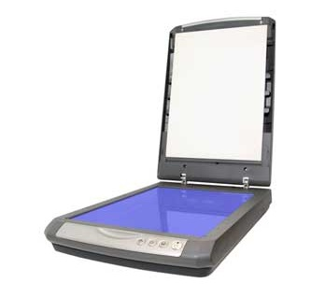
Scanner captures images from the source which are then converted into a digital form that can be stored on the disk. These images can be edited before they are printed.

Digitizer
Digitizer is an input device which converts analog information into digital form. Digitizer can convert a signal from the television or camera into a series of numbers that could be stored in a computer. They can be used by the computer to create a picture of whatever the camera had been pointed at.
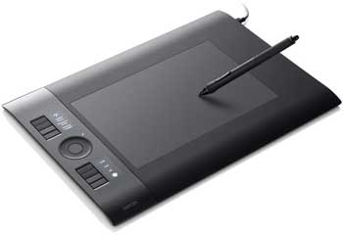
Digitizer is also known as Tablet or Graphics Tablet as it converts graphics and pictorial data into binary inputs. A graphic tablet as digitizer is used for fine works of drawing and image manipulation applications.

Microphone
Microphone is an input device to input sound that is then stored in a digital form.
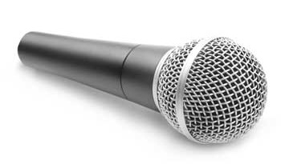
The microphone is used for various applications such as adding sound to a multimedia presentation or for mixing music.

Magnetic Ink Card Reader (MICR)
MICR input device is generally used in banks as there are large number of cheques to be processed every day. The bank's code number and cheque number are printed on the cheques with a special type of ink that contains particles of magnetic material that are machine readable.
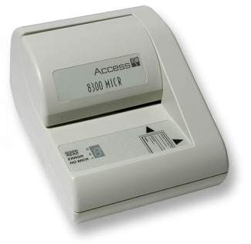
This reading process is called Magnetic Ink Character Recognition (MICR). The main advantages of MICR is that it is fast and less error prone.

Optical Character Reader (OCR)
OCR is an input device used to read a printed text.
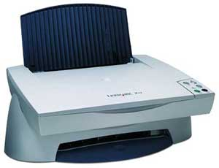
OCR scans the text optically, character by character, converts them into a machine readable code, and stores the text on the system memory.

Bar Code Readers
Bar Code Reader is a device used for reading bar coded data (data in the form of light and dark lines). Bar coded data is generally used in labelling goods, numbering the books, etc. It may be a handheld scanner or may be embedded in a stationary scanner.
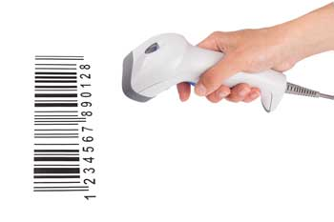
Bar Code Reader scans a bar code image, converts it into an alphanumeric value, which is then fed to the computer that the bar code reader is connected to.

Optical Mark Reader (OMR)
OMR is a special type of optical scanner used to recognize the type of mark made by pen or pencil. It is used where one out of a few alternatives is to be selected and marked.
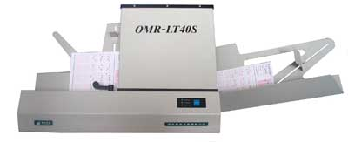
It is specially used for checking the answer sheets of examinations having multiple choice questions.
OUTPUT DEVICES:
Output Device can produce the final product of machine processing into a form usable by humans. It provides man to machine communication.
Following are some of the important output devices used in a computer.
- Monitors
- Graphic Plotter
- Printer

Monitors
Monitors, commonly called as Visual Display Unit (VDU), are the main output device of a computer. It forms images from tiny dots, called pixels that are arranged in a rectangular form. The sharpness of the image depends upon the number of pixels.
There are two kinds of viewing screen used for monitors.
- Cathode-Ray Tube (CRT)
- Flat-Panel Display

Cathode-Ray Tube (CRT) Monitor
The CRT display is made up of small picture elements called pixels. The smaller the pixels, the better the image clarity or resolution. It takes more than one illuminated pixel to form a whole character, such as the letter ‘e’ in the word help.
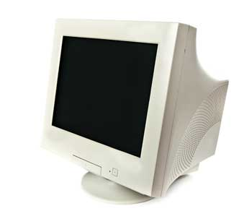
A finite number of characters can be displayed on a screen at once. The screen can be divided into a series of character boxes - fixed location on the screen where a standard character can be placed. Most screens are capable of displaying 80 characters of data horizontally and 25 lines vertically.
There are some disadvantages of CRT −
- Large in Size
- High power consumption

Flat-Panel Display Monitor
The flat-panel display refers to a class of video devices that have reduced volume, weight and power requirement in comparison to the CRT. You can hang them on walls or wear them on your wrists. Current uses of flat-panel displays include calculators, video games, monitors, laptop computer, and graphics display.
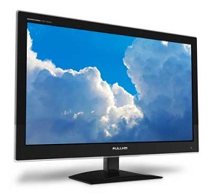
The flat-panel display is divided into two categories −
- Emissive Displays − Emissive displays are devices that convert electrical energy into light. For example, plasma panel and LED (Light-Emitting Diodes).
- Non-Emissive Displays − Non-emissive displays use optical effects to convert sunlight or light from some other source into graphics patterns. For example, LCD (Liquid-Crystal Device).

Printers
Printer is an output device, which is used to print information on paper.
There are two types of printers −
- Impact Printers
- Non-Impact Printers

Impact Printers
Impact printers print the characters by striking them on the ribbon, which is then pressed on the paper.
Characteristics of Impact Printers are the following −
- Very low consumable costs
- Very noisy
- Useful for bulk printing due to low cost
- There is physical contact with the paper to produce an image
These printers are of two types −
- Character printers
- Line printers
Character Printers
Character printers are the printers which print one character at a time.
These are further divided into two types:
- Dot Matrix Printer(DMP)
- Daisy Wheel
Dot Matrix Printer
In the market, one of the most popular printers is Dot Matrix Printer. These printers are popular because of their ease of printing and economical price. Each character printed is in the form of pattern of dots and head consists of a Matrix of Pins of size (5*7, 7*9, 9*7 or 9*9) which come out to form a character which is why it is called Dot Matrix Printer.
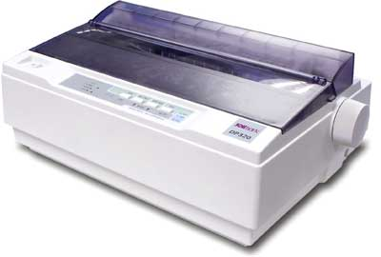
Advantages
- Inexpensive
- Widely Used
- Other language characters can be printed
Disadvantages
- Slow Speed
- Poor Quality
Daisy Wheel
Head is lying on a wheel and pins corresponding to characters are like petals of Daisy (flower) which is why it is called Daisy Wheel Printer. These printers are generally used for word-processing in offices that require a few letters to be sent here and there with very nice quality.
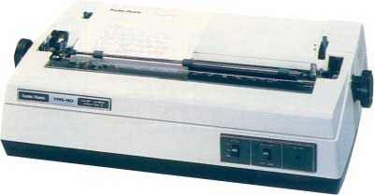
Advantages
- More reliable than DMP
- Better quality
- Fonts of character can be easily changed
Disadvantages
- Slower than DMP
- Noisy
- More expensive than DMP
Line Printers
Line printers are the printers which print one line at a time.
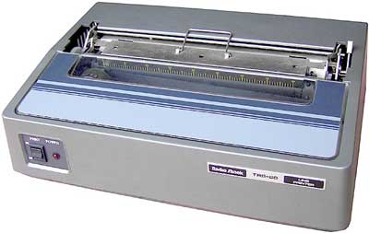
These are of two types −
- Drum Printer
- Chain Printer
Drum Printer
This printer is like a drum in shape hence it is called drum printer. The surface of the drum is divided into a number of tracks. Total tracks are equal to the size of the paper, i.e. for a paper width of 132 characters, drum will have 132 tracks. A character set is embossed on the track. Different character sets available in the market are 48 character set, 64 and 96 characters set. One rotation of drum prints one line. Drum printers are fast in speed and can print 300 to 2000 lines per minute.
Advantages
- Very high speed
Disadvantages
- Very expensive
- Characters fonts cannot be changed
Chain Printer
In this printer, a chain of character sets is used, hence it is called Chain Printer. A standard character set may have 48, 64, or 96 characters.
Advantages
- Character fonts can easily be changed.
- Different languages can be used with the same printer.
Disadvantages
- Noisy

Non-impact Printers
Non-impact printers print the characters without using the ribbon. These printers print a complete page at a time, thus they are also called as Page Printers.
These printers are of two types −
- Laser Printers
- Inkjet Printers
Characteristics of Non-impact Printers
- Faster than impact printers
- They are not noisy
- High quality
- Supports many fonts and different character size
Laser Printers
These are non-impact page printers. They use laser lights to produce the dots needed to form the characters to be printed on a page.
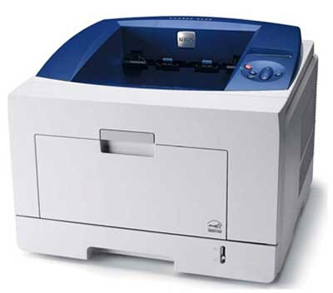
Advantages
- Very high speed
- Very high quality output
- Good graphics quality
- Supports many fonts and different character size
Disadvantages
- Expensive
- Cannot be used to produce multiple copies of a document in a single printing
Inkjet Printers
Inkjet printers are non-impact character printers based on a relatively new technology. They print characters by spraying small drops of ink onto paper. Inkjet printers produce high quality output with presentable features.
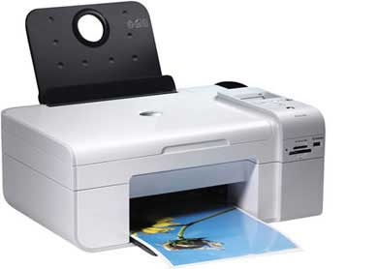
They make less noise because no hammering is done and these have many styles of printing modes available. Color printing is also possible. Some models of Inkjet printers can produce multiple copies of printing also.
Advantages
- High quality printing
- More reliable
Disadvantages
- Expensive as the cost per page is high
- Slow as compared to laser printer

HARDWARE
Hardware represents the physical and tangible components of a computer, i.e. the components that can be seen and touched.
Examples of Hardware are the following −
- Input devices − keyboard, mouse, etc.
- Output devices − printer, monitor, etc.
- Secondary storage devices − Hard disk, CD, DVD, etc.
- Internal components − CPU, motherboard, RAM, etc.

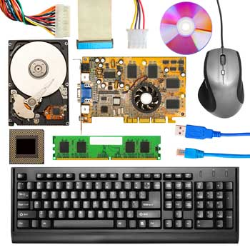
SOFTWARE
Software is a set of programs, which is designed to perform a well-defined
function. A program is a sequence of instructions written to solve a particular problem.
There are two types of software −
- System Software
- Application Software

System Software
The system software is a collection of programs designed to operate, control, and extend the processing capabilities of the computer itself. System software is generally prepared by the computer manufacturers. These software products comprise of programs written in low-level languages, which interact with the hardware at a very basic level. System software serves as the interface between the hardware and the end users.
Some examples of system software are Operating System, Compilers, Interpreter, Assemblers, etc.
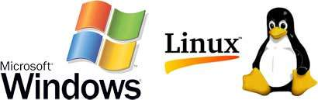
Here is a list of some of the most prominent features of a system software −
- Close to the system
- Fast in speed
- Difficult to design
- Difficult to understand
- Less interactive
- Smaller in size
- Difficult to manipulate
- Generally written in low-level language

Application Software
Application software products are designed to satisfy a particular need of a particular environment. All software applications prepared in the computer lab can come under the category of Application software. Application software may consist of a single program, such as Microsoft's notepad for writing and editing a simple text. It may also consist of a collection of programs, often called a software package, which work together to accomplish a task, such as a spreadsheet package.
Examples of Application software are the following −
- Payroll Software
- Student Record Software
- Inventory Management Software
- Income Tax Software
- Railways Reservation Software
- Microsoft Office Suite Software
- Microsoft Word
- Microsoft Excel
- Microsoft PowerPoint
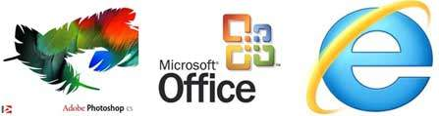
Features of application software are as follows −
- Close to the user
- Easy to design
- More interactive
- Slow in speed
- Generally written in high-level language
- Easy to understand
- Easy to manipulate and use
- Bigger in size and requires large storage space
OPERATING SYSTEM
The Operating System is a program with the following features −
- An operating system is a program that acts as an interface between the software and the computer hardware.
- It is an integrated set of specialized programs used to manage overall resources and operations of the computer.
- It is a specialized software that controls and monitors the execution of all other programs that reside in the computer, including application programs and other system software.
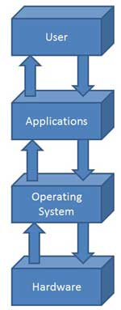

Objectives of Operating System
The objectives of the operating system are −
- To make the computer system convenient to use in an efficient manner.
- To hide the details of the hardware resources from the users.
- To provide users a convenient interface to use the computer system.
- To act as an intermediary between the hardware and its users, making it easier for the users to access and use other resources.
- To manage the resources of a computer system.
- To keep track of who is using which resource, granting resource requests, and mediating conflicting requests from different programs and users.
- To provide efficient and fair sharing of resources among users and programs.

Characteristics of Operating System
Here is a list of some of the most prominent characteristic features of Operating Systems −
- Memory Management − Keeps track of the primary memory, i.e. what part of it is in use by whom, what part is not in use, etc. and allocates the memory when a process or program requests it.
- Processor Management − Allocates the processor (CPU) to a process and deallocates the processor when it is no longer required.
- Device Management − Keeps track of all the devices. This is also called I/O controller that decides which process gets the device, when, and for how much time.
- File Management − Allocates and de-allocates the resources and decides who gets the resources.
- Security − Prevents unauthorized access to programs and data by means of passwords and other similar techniques.
- Job Accounting − Keeps track of time and resources used by various jobs and/or users.
- Control Over System Performance − Records delays between the request for a service and from the system.
- Interaction with the Operators − Interaction may take place via the console of the computer in the form of instructions. The Operating System acknowledges the same, does the corresponding action, and informs the operation by a display screen.
- Error-detecting Aids − Production of dumps, traces, error messages, and other debugging and error-detecting methods.
- Coordination Between Other Software and Users − Coordination and assignment of compilers, interpreters, assemblers, and other software to the various users of the computer systems.

