Subject: Enzymes Class: II B.Sc., Biochemistry

Subject code:16SCCBC4 Unit:1

Semester:IV

By
Dr.K.Bhuvaneswari
Department of Biochemistry
Government Arts and Science college (w) ,orathanadu

Introduction

Enzymes are soluble, colloidal and biological macromolecules which speed up the rate of biochemical reactions without undergoing any change. They are also called as biological catalysts. They are highly selective catalyst that greatly accelerates both the rate and specificity of metabolic reactions.Enzymology deals with the study of Enzymes.Nearly all enzymes are proteins are protein in nature. Enzyme catalysed reactions usually take place under relatively mild conditions (temperatures well below 100ºC, atmospheric pressure and neutral pH) as compared with the corresponding chemical reactions.Enzyme activity can be regulated, varying in response to the concentration of substrates or other molecules.They function under strict conditions of temperature and pH in the body.
Nomenclature of Enzymes

Many enzymes are named by adding the suffix ‘-ase’ to the name of their substrate.Example. Urease is the enzyme that catalyzes the hydrolysis of urea, and fructose-1,6-bisphosphatase hydrolyzes fructose-1,6-bisphosphate.However, other enzymes, such as trypsin and chymotrypsin, have names that do not denote their substrate.Some enzymes have several alternative names.To rationalize enzyme names, a system of enzyme nomenclature has been internationally agreed.This system places all enzymes into one of six major classes based on the type of reaction catalyzed. Each enzyme is then uniquely identified with a four-digit classification number.Example: Trypsin has the Enzyme Commission (EC) number 3.4.21.4, where
- the first number (3) denotes that it is a hydrolase
- the second number (4) that it is a protease that hydrolyzes peptide bonds
- the third number (21) that it is a serine protease with a critical serineresidue at the active site, and
- the fourth number (4) indicates that it was the fourth enzyme to be assigned to this class.
- For comparison, chymotrypsin has the EC number 3.4.21.1, and elastase 3.4.21.36.
Classification of enzymes
- Oxidoreductases
- Catalyze oxidation-reduction reactions where electrons are transferred.
- These electrons are usually in the form of hydride ions or hydrogen atoms.
- The most common name used is a dehydrogenase and sometimes reductase is used.
- An oxidase is referred to when the oxygen atom is the acceptor.
AH + B → A + BH (reduced) A + O → AO (oxidized)

- Transferases
- Catalyze group transfer reactions.
- The transfer occurs from one molecule that will be the donor to another molecule that will be the acceptor.
- Most of the time, the donor is a cofactor that is charged with the group about to be transferred.
- Example: Hexokinase used in glycolysis.
AB + C → A + BC
- Hydrolases
- Catalyze reactions that involve hydrolysis.
- It usually involves the transfer of functional groups to water.
- When the hydrolase acts on amide, glycosyl, peptide, ester, or other bonds, they not only catalyze the hydrolytic removal of a group from the substrate but also a transfer of the group to an acceptor compound
- For example: Chymotrypsin.
AB + H2O → AOH + BH
- Lyases
- Catalyze reactions where functional groups are added to break double bonds in molecules or the reverse where double bonds are formed by the removal of functional groups.
- For example: Fructose bisphosphate aldolase used in converting fructose 1,6-bisphospate to G3P and DHAP by cutting C-C bond.
- Isomerases
- Catalyze reactions that transfer functional groups within a molecule so that isomeric forms are produced.
- These enzymes allow for structural or geometric changes within a compound.
- For example: phosphoglucose isomerase for converting glucose 6-phosphate to fructose 6-phosphate. Moving chemical group inside same substrate.
AB → BA
- Ligases
- They are involved in catalysis where two substrates are ligated and the formation of carbon-carbon, carbon-sulfide, carbon-nitrogen, and carbon-oxygen bonds due to condensation reactions.
- These reactions are coupled to the cleavage of ATP.
X + Y+ ATP → XY + ADP
Coenzymes
A coenzyme is an organic non-protein compound that binds with an enzyme to catalyze a reaction. Coenzymes are often broadly called cofactors, but they are chemically different. A coenzyme cannot function alone, but can be reused several times when paired with an enzyme. They bind loosely to an enzyme at the active site to help catalyze reactions. Most of the coenzymes are vitamins and vitamin derivatives.

Vitamin-derived coenzymes

  - Nicotinamide adenine dinucleotide (NAD)
  - Flavin Mononucleotide (FMN) and Flavin Adenine Dinucleotide(FAD)
  - coenzyme A.
  - Thiamine pyrophosphate (TPP)
  - Pyridoxal phosphate (PAL)
1.Nicotinamide adenine dinucleotide (NAD NADP)
Nicotinamide adenine dinucleotide (NAD) and nicotinamide adenine dinucleotide phosphate (NADP) are derivatives of the B-vitamin, nicotinic acid and functions as one of the most important coenzymes in a cell.
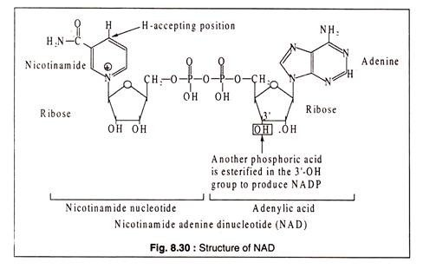
NAD and NADP act as conezymes for many degydrogenases where they are involved in transfer of hydrogen, causing either oxidation or reduction of the substrates. In general, NAD takes part in the catabolic reactions, which NADP in synthetic pathway reactions. Some NAD containing dehydrogenases are lactic dehydrogenase, alcohol dehydrogenase, malate dehydrogenase, glycerin aldehyde phosphate dehydrogenase etc.
Two examples- one of reduction and the other of oxidation:
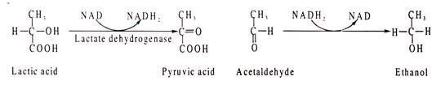
Lactic acid is oxidized to pyruvic acid where NAD acts as H-acceptor. In the other reaction, acetaldehyde is reduced to ethanol where NADH₂ acts as H-donor.

Example of NADP catalysed reacted are glucose 6-phosphate dehydrogenase, isocitrate dehydrogenase, glutamic acid dehydrogenase etc.:
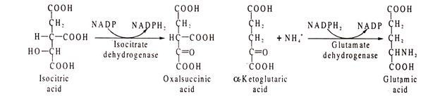
Although the reduced forms of NAD and NADP are usually shown as NADH₂ and NADPH₂ for convenience, it should be noted that the correct forms should be NADH+H⁺ and NADPH+H⁺ respectively, because the positively charged nicotinamide ring accepts one electron and one H-atom from a pair of H-atoms removed from the substrate. The electron goes to the positively charged N-atom and another hydrogen is added at the position .
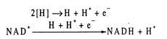
NAD and NADP were previously called DPN (diphosphopyridine nucleotide) and TPN (triphospho pyridine nucleotide), respectively.
2. Flavin Mononucleotide (FMN) and Flavin Adenine Dinucleotide(FAD)
FMN and FAD, commonly called flavoproteins, are also hydrogen transferring coenzymes associated with hydrogenases. The coenzyme parts of these flavoproteins contain the B-vitamin, riboflavin. In contrast to NAD or NADP, the coenzymes of flavoproteins are more tightly bound to the apoenzyme.
The structures of riboflavin, FMN and FAD
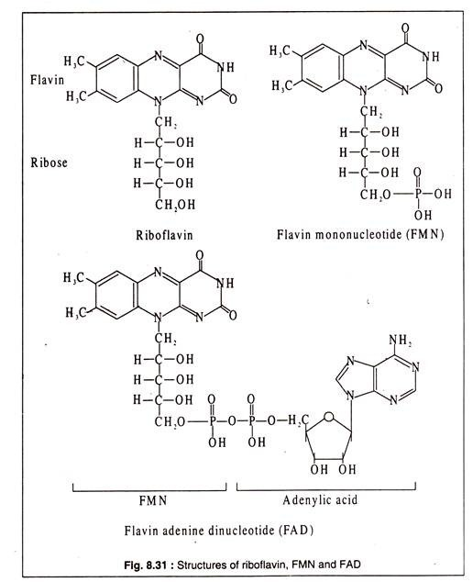
On reduction of FAD by addition of two H-atoms donated by a substrate, it is converted to FADH₂. The substrate is thereby oxidized. An example of FAD containing enzyme is succinate dehydrogenase occurring in the Krebs’ cycle. Succinic acid is oxidized to fumaric acid by the enzyme. The hydrogen accepted by FAD is transferred to the electron transport chain for generation of ATP.
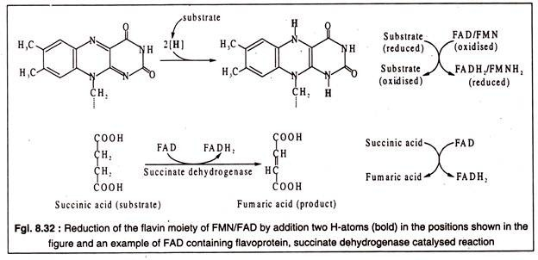3. Coenzyme A (CoA):
Coenzyme A has a complex structure consisting of an adenosine triphosphate, a pantothenic acid which is a B-vitamin and cysteamine. The coenzyme is involved in transfer of acyl-groups. The sulfhydryl (-SH) group of cysteamine moiety of this coenzyme forms a thioester with the carboxyl (-COOH) group of the acyl-compound, such as acetic acid to produce acetyl-CoA which is one of the most important CoA derivatives. The thioester bond is energy-rich and can easily transfer the acetyl- group to an acceptor.
The structure of coenzyme A, formation of a thioester and a reaction involving coenzyme A
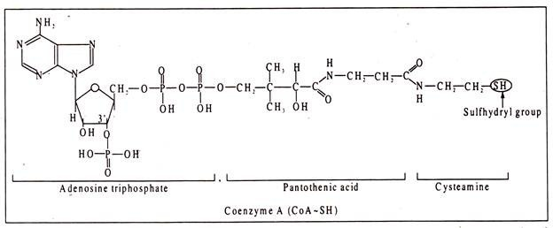
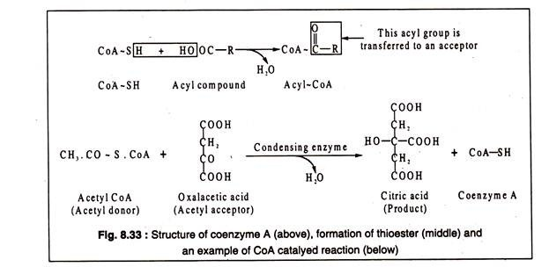4. Thiamine Pyrophosphate (TPP):
TPP is a coenzyme involved in transfer of aldehyde (—C—H) groups, like acetaldehyde and glycol aldehyde. It contains thiamine, a vitamin of B-group. The thiazole group of the coenzyme molecule accepts the aldehyde group and transfers it to an acceptor via other coenzymes, like lipoic acid and coenzyme A. TPP is involved in oxidative decarboxylation of pyruvic acid and α-ketoglutaric acid.
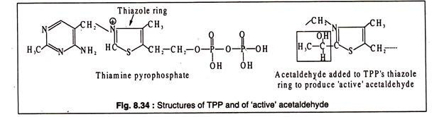
An example of an enzyme complex involving TPP, lipoic acid and coenzyme A is the pyruvate decarboxylase.
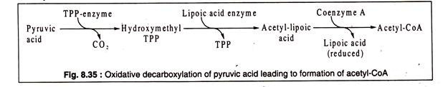
5. Pyridoxal Phosphate (PAL)
Pyridoxal phosphate is a coenzyme associated with transaminases which catalyse transfer of amino groups from amino acids to keto acids. In this transfer process, PAL acts as the acceptor of the amino group and is converted to pyridoxamine phosphate (PAM).
PAM can react with a keto acid to produce an amino acid. PAL and PAM remain bound to the protein part of the transaminase enzyme during these transfer of amino group. Pyridoxal phosphate has a simple molecule containing the B-vitamin, pyridoxine.

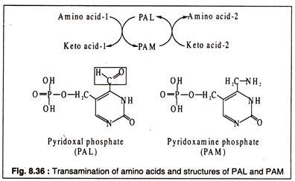

The aldehyde group of PAL is the reactive group of the coenzyme which binds to the amino acid forming a Schiff s base.
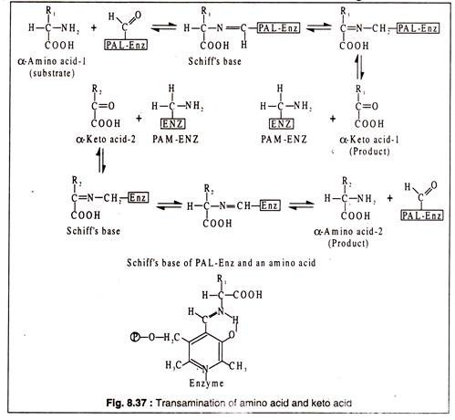

Non-vitamin coenzymes
Non-vitamin coenzymes typically aid in chemical transfer for enzymes. They ensure physiological functions, like blood clotting and metabolism, occur in an organism. These coenzymes can be produced from nucleotides such as adenosine, uracil, guanine, or inosine.
Adenosine triphosphate (ATP)
Adenosine triphosphate (ATP) is an example of an essential non-vitamin coenzyme. In fact, it is the most widely distributed coenzyme in the human body. It transports substances and supplies energy needed for necessary chemical reactions and muscle contraction. To do this, ATP carries both a phosphate and energy to various locations within a cell. When the phosphate is removed, the energy is also released. This process is result of the electron transport chain. Without the coenzyme ATP, there would be little energy available at the cellular level and normal life functions could not occur.
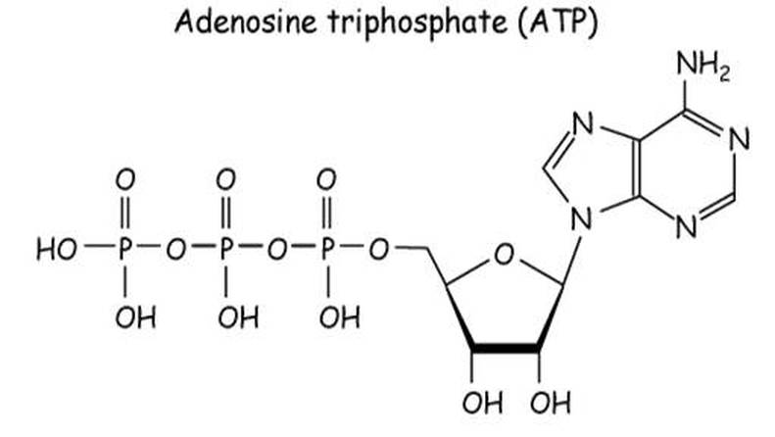

Metalloenzymes
Metalloenzymes are enzymes that contain a tightly bound metal ion. This metal ion forms coordinate covalent bond with the amino acidsof the enzymesor with a prosthetic group. Further, it acts as a coenzyme and imparts the activity of the enzyme. When considering the location of the metal ion in the enzyme, it usually occurs in a specific region on the enzyme surface. Therefore, the ion does not disturb the binding of the substrate with the active site. Sometimes, enzymes require more than one metal ion for its activity. In rare occasions, they require two different metal ions as well. The most common metals that involve in this are Fe, Zn, Cu, and Mn. The metalloenzymes containing metal centers other than iron (non-hemecenters) are wide spread in nature.
Examples
- Amylase, thermolysin are bound with Ca²⁺ ions
- Dioldehydrase, glycerol dehydratase are bound with Co²⁺
- Cytochrome c oxidase, dopamine-b-hydroxylase contains Cu²⁺
- Catalase, nitrogenase, peroxidase, succinate dehydrogenase contains Fe²⁺
- Arginase, histidine-ammonia lyase, pyruvate carboxylase contains Mn²⁺
Metal activated enzymes
Metal activated enzymes are enzymes that have an increased activity due to the presence of metal ions. Most of the times, these metal ions are either monovalent or divalent. However, these ions are not tightly bound with the enzyme as in metalloenzymes. The metal can activate the substrate, thus engage directly with the activity of the enzyme. These enzymes require metal ions in excess. Ex: around 2-10 times higher than the concentration of the enzyme. It is because they cannot bond with the metal ion permanently. However, these enzymes lose their activity during its purification.
Examples
- Pyruvate kinase requires K⁺
- Phosphotransferases requires Mg²⁺ or Mn²⁺

