ANNAI VAILANKANNI ARTS AND SCIENCE COLLEGE, THANJAVUR
PG AND RESEARCH DEPARTMENT OF ENGLISH
QUESTION BANK
LANGUAGE AND LINGUISTICS
Unit – I The Origins and the Development of Language
Unit – II The Organs of Speech – Classification of Speech Sounds
Unit – III Phonology – Morphology
Unit – IV Syntax – Semantics
Unit – V Language, Society and Culture

UNIT – I THE ORIGINS AND THE DEVELOPMENT OF LANGUAGE

THEORIES OF LANGUAGE

The Bow-Wow Theory
According to this theory, language began when our ancestors started imitating the natural sounds around them. The first speech was onomatopoeic—marked by echoic words such as moo, meow, splash, cuckoo, and bang.
.The Ding-Dong Theory
This theory, favoured by Plato and Pythagoras, maintains that speech arose in response to the essential qualities of objects in the environment. The original sounds people made were supposedly in harmony with the world around them.

The La-La Theory
The Danish linguist Otto Jespersen suggested that language may have developed from sounds associated with love, play, and (especially) song.

The Pooh-Pooh Theory
This theory holds that speech began with interjections—spontaneous cries of pain ("Ouch!"), surprise ("Oh!"), and other emotions ("Yabba dabba do!").

The Yo-He-Ho Theory
According to this theory, language evolved from the grunts, groans, and snorts evoked by heavy physical labour.
four distinct elements to language
Phonology refers to the sounds of a language
Semantics is the study of words and their meaning
Grammar refers to the rules used to describe the structure of a language
Which involves syntax or rules that specify how words are combined to form sentences
Pragmatics is the study of how people use language to communicate effectively
Phonemes
The basic building blocks of language
The unique sounds that can be joined to create words
The sound of “p” in pin, pet, and pat
The sound of “b” in bed, bat, and bird
Infants can distinguish many of these sounds, some of them as early as 1 month after birth
Can discriminate sounds they have never heard before such as phonemes from a foreign language

UNIT – II THE ORGANS OF SPEECH – CLASSIFICATION OF SPEECH SOUNDS

1. Which are the organs of speech?
Speech organ. Speech organs, or articulators, produce the sounds of language. Organs used for speech include the lips, teeth, alveolar ridge, hard palate, velum (soft palate), uvula, glottis and various parts of the tongue. They can be divided into two types: passive articulators and active articulators.

2. What is the most important organ of speech and why?
The most important organs in the vocal tract are the tongue, the soft palate, the lower jaw and the lips. The tongue is the most important organ for speech production: its different postures determine the most of phonemes.

3. What is the function of organ of speech?
The various organs which are involved in the production of speech sounds are called speech organs (also known as vocal organs). The study of speech organs helps to determine the role of each organ in the production of speech sounds. They include the lungs, the vocal folds, and most importantly the articulators

4. What is articulation speech?
Speech and language articulation is the process by which a person forms words. This is done with the different parts of a person's jaw and mouth - the tongue, palate, lips and teeth

5. What is the larynx?
The larynx is another name for the voice box. It's a tube about 2 inches (5cm) long in adults. It sits above the windpipe (trachea) in the neck and in front of the food pipe. The food pipe in the upper part of the neck is called the pharynx

6. What are the four processes of speech?
The Four Processes of Speech Production:
- Respiration.
- Phonation.
- Resonance.
- Articulation.

7. What is plosive sound?
Thumb Stops or plosives are consonant sounds that are formed by completely stopping airflow. Stop sounds can be voiceless, like the sounds /p/, /t/, and /k/, or voiced, like /b/, /d/, and /g/. In phonetics, a plosive consonant is made by blocking a part of the mouth so that no air can pass through.

1. The Lungs
The airflow is by far the most vital requirement for producing speech sound, since all speech sounds are made with some movement of air. The lungs provide the energy source for the airflow. The lungs are the spongy respiratory organs situated inside the rib cage. They expand and contract as we breathe in and out air. The amount of air accumulated inside our lungs
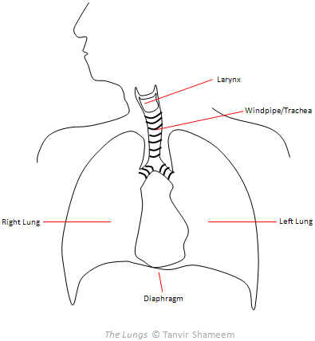

2. The Larynx & the Vocal Folds
The larynx is colloquially known as the voice box. It is a box-like small structure situated in the front of the throat where there is a protuberance. For this reason the larynx is popularly called the Adam’s apple. This casing is formed of cartilages and muscles. It protects as well as houses the trachea (also known as windpipe, oesophagus, esophagus) and the vocal folds (formerly they were called vocal cords). The vocal folds are like a pair of lips placed horizontally from front to back. They are joined in the front but can be separated at the back. The opening between them is called glottis. The glottis is considered to be in open state when the folds are apart, and when the folds are pressed together the glottis is considered to be in close state.
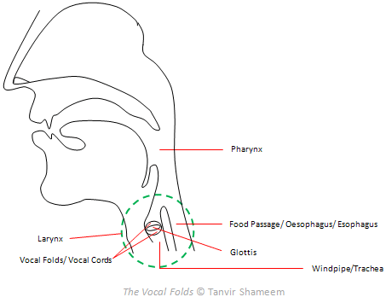

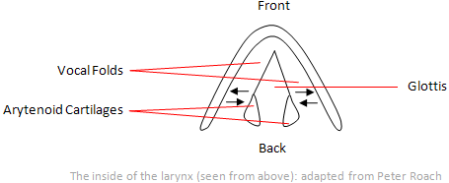
The opening of the vocal folds takes different positions:
- Wide Apart: When the folds are wide apart they do not vibrate. The sounds produced in such position are called breathed or voiceless sounds. For example: /p/f/θ/s/.
- Narrow Glottis: If the air is passed through the glottis when it is narrowed then there is an audible friction. Such sounds are also voiceless since the vocal folds do not vibrate. For example, in English /h/ is a voiceless glottal fricative sound.
- Tightly Closed: The vocal folds can be firmly pressed together so that the air cannot pass between them. Such a position produces a glottal stop / ʔ / (also known as glottal catch, glottal plosive).
- Touched or Nearly Touched: The major role of the vocal folds is that of a vibrator in the production of speech. The folds vibrate when these two are touching each other or nearly touching. The pressure of the air coming from the lungs makes them vibrate. This vibration of the folds produces a musical note called voice. And sounds produced in such manner are called voiced sounds. In English all the vowel sounds and the consonants /v/z/m/n/are voiced.
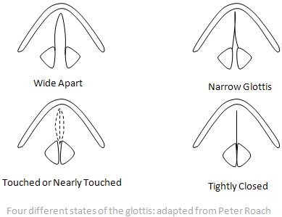
Thus it is clear that the main function of the vocal folds is to convert the air delivered by the lungs into audible sound. The opening and closing process of the vocal folds manipulates the airflow to control the pitch and the tone of speech sounds. As a result, we have different qualities of sounds.

3. The Articulators
Articulators transform the sound into intelligible speech. They can be either active or passive. They include the pharynx, the teeth, the alveolar ridge behind them, the hard palate, the softer velum behind it, the lips, the tongue, and the nose and its cavity. Traditionally the articulators are studied with the help of a sliced human head figure like the following
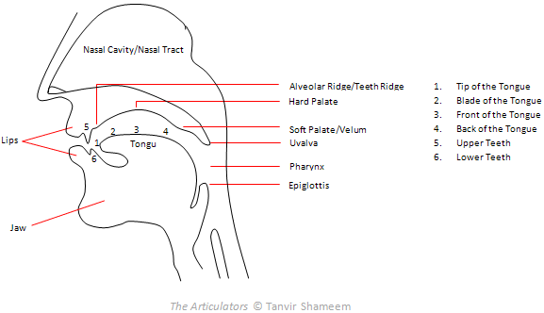

(i) The Pharynx: The pharynx lies between the mouth and the food passage, that is, just above the larynx. It is just about 7cm long in the case of women and 8cm long in the case of men.

(ii) The Roof of the Mouth: The roof of the mouth is considered as a major speech organ. It is divided into three parts:

a. The Alveolar Ridge/Teeth Ridge: The alveolar ridge is situated immediately after the upper front teeth. The sounds which are produced touching this convex part are called alveolarsounds. Some alveolar sounds in English include: /t/d/.
b. The Hard Palate: The hard palate is the concave part of the roof of the mouth. It is situated on the middle part of the roof.
c. The Velum or Soft Palate: The lower part of the roof of the mouth is called soft palate. It could be lowered or raised. When it is lowered, the air stream from the lungs has access to the nasal cavity. When it is raised the passage to the nasal cavity is blocked. The sounds which are produced touching this area with the back of the tongue are called velarsounds. For example: /k/g/.

(iii) The Lips: The lips also play an important role in the matter of articulation. They can be pressed together or brought into contact with the teeth. The consonant sounds which are articulated by touching two lips each other are called bilabial sounds. For example, /p/ and /b/ are bilabial sounds in English. Whereas, the sounds which are produced with lip to teeth contact are called labiodental sounds. In English there are two labiodental sounds: /f/ and /v/.

Another important thing about the lips is that they can take different shapes and positions. Therefore, lip-rounding is considered as a major criterion for describing vowel sounds. The lips may have the following positions:

a. Rounded: When we pronounce a vowel, our lips can be rounded, a position where the corners of the lips are brought towards each other and the lips are pushed forwards. And the resulting vowel from this position is a rounded one. For example, /ə ʊ/.
b. Spread: The lips can be spread. In this position the lips are moved away from each other (i.e. when we smile). The vowel that we articulate from this position is an unrounded one. For example, in English /i: /is a long vowel with slightly spread lips.
c. Neutral: Again, the lips can be neutral, a position where the lips are not noticeably rounded or spread. And the articulated vowel from this position is referred to as unrounded vowel. For example, in English /ɑ: / is a long vowel with neutral lips.

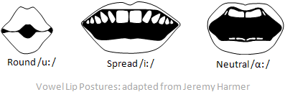

(iv) The Teeth: The teeth are also very much helpful in producing various speech sounds. The sounds which are made with the tongue touching the teeth are called dental sounds. Some examples of dental sounds in English include: /θ/ð/.

(v) The Tongue: The tongue is divided into four parts:
a. The tip: It is the extreme end of the tongue.
b. The blade: It lies opposite to the alveolar ridge.
c. The front: It lies opposite to the hard palate.
d. The back: It lies opposite to the soft palate or velum.

The tongue is responsible for the production of many speech sounds, since it can move very fast to different places and is also capable of assuming different shapes. The shape and the position of the tongue are especially crucial for the production of vowel sounds. Thus when we describe the vowel sounds in the context of the function of the tongue, we generally consider the following criteria:

• Tongue Height: It is concerned with the vertical distance between the upper surface of the tongue and the hard palate. From this perspective the vowels can be described as close and open. For instance, because of the different distance between the surface of the tongue and the roof of the mouth, the vowel /i: /has to be described as a relatively close vowel, whereas /æ / has to be described as a relatively open vowel.

• Tongue Frontness / Backness: It is concerned with the part of tongue between the front and the back, which is raised high. From this point of view the vowel sounds can be classified as front vowels and back vowels. By changing the shape of the tongue we can produce vowels in which a different part of the tongue is the highest point. That means, a vowel having the back of the tongue as the highest point is a back vowel, whereas the one having the front of the tongue as the highest point is called a front vowel. For example: during the articulation of the vowel / u: / the back of the tongue is raised high, so it’s a back vowel. On the other hand, during the articulation of the vowel / æ / the front of the tongue is raise high, therefore, it’s a front vowel.
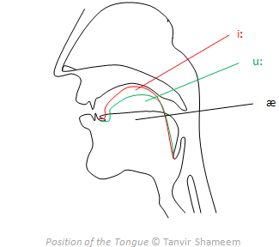

(vi) The Jaws: Some phoneticians consider the jaws as articulators, since we move the lower jaw a lot at the time of speaking. But it should be noted that the jaws are not articulators in the same way as the others. The main reason is that they are incapable of making contact with other articulators by themselves.

(vii) The Nose and the Nasal Cavity: The nose and its cavity may also be considered as speech organs. The sounds which are produced with the nose are called nasal sounds. Some nasal sounds in English include: /m/n/ŋ/.

UNIT – III PHONOLOGY – MORPHOLOGY

1. What is the classification of speech sound?
Diphthongs are described as vowel glides. In the classification of consonants, visible articulatory organs are considered. This makes possible discrimination of seven basic groups: bilabial-spread, bilabial-protruded, labio-dental, interdental, lingual-dentalized, lingual-non-dentalized, and empty.

2. What are the classifications of sounds?
Phonetics is divided into three types according to the production (articulatory), transmission (acoustic) and perception (auditive) of sounds. Three categories of sounds must be recognised at the outset: phones (human sounds), phonemes (units which distinguish meaning in a language), allophones (non-distinctive units).

3. What are the types of sounds in English?
There are five vowels (a,e,i,,o,u) and the rest are all consonants. In English, pronunciation of words centres upon syllables: a syllable is a unit of pronunciation which has one vowel sound, with or without surrounding consonants, forming the whole or a part of a word.

4. How many speech sounds are there in English phonology?
There are 24 different individual consonant speech sounds in the English language and another 20 vowel speech sounds (remember, there are 26 letters of the alphabet…21 consonants and 5 vowels). We call these sounds phonemes. Each phoneme, or speech sound, has a symbolic representation

5. How are vowels classified?
The shape and position of the lips yields a third articulatory dimension by which vowels are classified. ... All vowels can be divided into two main categories: diphthongs and monophthongs. Diphthongs are gliding vowels in the articulation of which there is a continuous transition from one position to another.

6. What are the 44 phonemes?
The 44 Phonemes in English. Despite there being just 26 letters in the English language there are approximately 44 unique sounds, also known as phonemes. The 44 sounds help distinguish one word or meaning from another. Various letters and letter combinations known as graphemes are used to represent the sounds.

1. What is an example of phonology?
An example of phonology is the study of different sounds and the way they come together to form speech and words - such as the comparison of the sounds of the two "p" sounds in "pop-up."

What is phonology in language?
Phonology is the study of how sounds are organized and used in natural languages. The phonological system of a language includes. an inventory of sounds and their features, and. rules which specify how sounds interact with each other.

Phonology is the branch of linguistics concerned with the study of speech sounds with reference to their distribution and patterning. Adjective: phonological. A linguist who specializes in phonology is known as a phonologist.

The aim of phonology is to discover the principles that govern the way sounds are organized in languages and to explain the variations that occur. We begin by analyzing an individual language to determine which sound units are used and which patterns they form--the language's sound system. We then compare the properties of different sound systems, and work out hypotheses about the rules underlying the use of sounds in particular groups of languages.

2. What is difference between phonology and phonetics?
Phonetics is the production and perception of speech sounds in any language and it deals with "phone". Phonology on the other hand is the interpretation of speech sounds in a particular language and it deals with phoneme: the smallest unit of sound.

3. What is morphology and examples?
Morphology is the study of words. Morphemes are the minimal units of words that have a meaning and cannot be subdivided further. ... An example of a free morpheme is "bad", and an example of a bound morpheme is "ly."

4. What do you mean by morphology in English?
In linguistics, morphology (/mɔːrˈfɒlədʒi/) is the study of words, how they are formed, and their relationship to other words in the same language. It analyzes the structure of words and parts of words, such as stems, root words, prefixes, and suffixes.

5. What is a free morpheme example?
A free morpheme is a morpheme (or word element) that can stand alone as a word. It is also called an unbound morpheme or a free-standing morpheme. ... For example, each word in the following sentence is a distinct morpheme: "I need to go now, but you can stay."

6. What is the inflectional morpheme?
In English morphology, an inflectional morpheme is a suffix that's added to a word (a noun, verb, adjective or an adverb) to assign a particular grammatical property to that word, such as its tense, number, possession, or comparison. ... These suffixes may even do double- or triple-duty.

7. What are some examples of inflectional morphemes?
For example, the word <skip> has many forms: skip (base form), skipping (present progressive), skipped (past tense). The inflectional morphemes -ing and -ed are added to the base word skip, to indicate the tense of the word. If a word has an inflectional morpheme, it is still the same word, with a few suffixes added.

8. What is the difference between free and bound morphemes?
In English, there are two main types of morphemes: free and bound. Free morphemes are morphemes that can stand by themselves as single words. Bound morphemes are morphemes that must be attached to another form and cannot stand alone. Bound morphemes include all types of affixes: prefixes and suffixes.

UNIT – IV SYNTAX – SEMANTICS

1. What Is syntax in English?
Syntax is a form of grammar. It is concerned primarily with word order in a sentence and with the agreement of words when they are used together. So it is, in a sense, acting as a kind of 'police officer' for the way in which sentences are constructed. English is a language that has a structure known as SVO.

2. What is an example of syntax?
The format in which words and phrases are arranged to create sentences is called syntax. Let's look at an example of how a sentence can be rearranged to create varied syntax. Examples of Syntax in a Sentence: The boy jumped happily. The boy happily jumped.

3. What are some examples of syntax in literature?
Here are some examples of how syntax governs English.
- Agreement: She is a person. versus She am a person.
- Case: He took me to the restaurant. versus He took I to the restaurant.
- Reflexive pronouns: I bought myself a new shirt. versus I bought my a new shirt.
- Word order: We ate fish for dinner.

4. What are the types of syntax?
Types of Sentence Structures
Types of sentences and their syntax modes include simple sentences, compound sentences, complex sentences, and compound-complex sentences.

5. What is the difference between syntax and semantics?
Semantics is about whether or not the sentence has a valid meaning. Syntax refers to the structure of a language, tracing its etymology to how things are put together. ... On the other hand, the semantics is about meaning

6. What are examples of semantics?
Examples of Semantics: A toy block could be called a block, a cube, a toy. A child could be called a child, kid, boy, girl, son, daughter. The word "run" has many meanings-physically running, depart or go (I have to run, spent (it has run its course), or even a snag in a pair of hose (a run in my hose).

7. What is the use of semantics?
Function of Semantics
The purpose of semantics is to propose exact meanings of words and phrases, and remove confusion, which might lead the readers to believe a word has many possible meanings. It makes a relationship between a word and the sentence through their meanings.

8. What are the branches of semantics?
Both are called semantics. The field of semantics has three basic concerns: the relations of words to the objects denoted by them, the relations of words to the interpreters of them, and, in symbolic logic, the formal relations of signs to one another

9. What are the two types of semantics?
Semantics is the study of meaning. There are two types of meaning: conceptual meaning and associative meaning.

10. What are semantics in language?
Semantics means the meaning and interpretation of words, signs, and sentence structure. ... Semantics can also refer to the branch of study within linguistics that deals with language and how we understand meaning.

UNIT – V LANGUAGE, SOCIETY AND CULTURE

1. What is language culture?
On a deeper level, language is an expression of who we are as individuals, communities, nations. Culture refers to dynamic social systems and shared patterns of behavior, beliefs, knowledge, attitudes and values. ... Languages and cultures merit study and celebration in their own right.

2. What is the relationship between language and culture?
Homologous relationship of culture and language
The phrase, language is culture and culture is language is often mentioned when language and culture are discussed. It's because the two have a homologous although complex relationship. Language and culture developed together and influenced each other as they evolved

3. What does language and society mean?
Social context recognises that people use language and that language is a part of society. Social context tries to describe, and account for, the different ways that different people use language. Social context looks at relationships between language and society and looks at language as people use it

4. What are the 7 functions of language?
Terms in this set (7)
- Instrumental. It used to express people's needs or to get things done.
- Regulatory. This language is used to tell others what to do.
- Interactional. Language is used to make contact with others and form relationship.
- Personal. ...
- Heuristic. ...
- Imaginative. ...
- Representational.

5. What is the most important function of language?
Language plays a very important role in human lives. It is a social phenomenon. One of the main goals of language is to communicate with people and to understand them. When someone speaks, he intends a specific purpose.

6. What are the 4 components of language?
There are four main components of language:
- Phonology involves the rules about the structure and sequence of speech sounds.
- Semantics consists of vocabulary and how concepts are expressed through words.
- Grammar involves two parts. ...
- Pragmatics involves the rules for appropriate and effective communication.

7. What are the 5 stages of language development?
The Five Stages of Second Language Acquisition
Students learning a second language move through five predictable stages: Preproduction, Early Production, Speech Emergence, Intermediate Fluency, and Advanced Fluency

