UNIT-II PAGEMAKER

What Is Adobe PageMaker?
Adobe PageMaker is a software program used to create flyers, brochures, reports and newsletters for educational or small business needs. Adobe PageMaker is a desktop publishing software program that allows you to view entire pages of a publication, such as a report, pamphlet or booklet. Therefore, it's easy to format a document's layout and control various design details, such as fonts and graphics, prior to printing or distribution.

Who are the Users of PageMaker?
Adobe PageMaker provides graphic designers, print professionals or production artists with the ability to create professional page layouts. If you're pursuing such a career, or if you're interested in desktop publishing for educational or small business purposes, you may want experience with this program.

Is Software Currently Available?
As of 2004, Adobe stopped developing the PageMaker 7.0 product and replaced it with InDesign (www.adobe.com). However, PageMaker software is still sold and supported by the company. It's marketed towards small businesses and home offices. Although it's recommended that high-end designers who create newspapers, books and magazines upgrade to Adobe InDesign, many desktop publishers still utilize PageMaker. PageMaker documents can be opened in InDesign and upgrade packages are available.

Storage Capacity
Adobe PageMaker needs 48 MB or more of RAM, 200 MB of available hard-disk space and a high-resolution display.

Adobe® PageMaker® 7.0 software is the ideal page layout program for business, education, and small- and home-office professionals who want to create high-quality publications such as brochures and newsletters. Get started quickly with templates, graphics, and intuitive design tools; work productively across Adobe applications; and easily leverage existing content to create customized communications.
Tools of Page maker
The PageMaker window is designed to provide a number of elements to facilitate creating and editing a document. Learning the purpose of these elements will make working in PageMaker much easier. Here are the elements that you are most likely to use:
Title Bar
The title bar will display the name of your document. If you are working with a brand new document and have yet to name it, the title bar will simply read: Untitled-1.
Rulers
PageMaker provides two customizable rulers, which run horizontally and vertically along your screen. You can set the rulers to measure in either inches or picas (picas are a unit of measurement unique to typography. One pica is equivalent to 12 points, which is about 1/6 of an inch).
Pasteboard
This is the background that lies behind your PageMaker document. It is a handy element to use if you need to move text or images between pages. You can also place these items on the pasteboard until you decide where to position them on the page. Any text or images that you place on the pasteboard won't print.
Page Icons
The numbered page icons at the bottom left-hand corner of your screen each represent the pages of the document you are working on. The icon of the particular page that you are viewing will be highlighted.
The L and R icons in the extreme left represent your master pages. Any items on the master pages appear on all of the document's pages.
Scroll Bars
Much like Word and other Microsoft programs, these are designed to enable you to move from one point to the other on the page you are working on. However, you won't use the scroll bars to move from one page to another.
Resize Box
This is located in the lower right-hand corner of the screen, and is used to adjust the size of the window. To resize the window, you will click and drag here to adjust the window to the size you desire.
Previous Size Box
Also called the "Refresh Box," this feature is in the upper right corner and is used to refresh your screen display. It is particularly useful if you are experimenting with different styles and sizes. Using this feature clears the screen of previous edits so you can start afresh.
The ToolBox
The Adobe PageMaker toolbox offers all the desktop publishing tools you need to design brochures, postcards, business cards, letterheads, or other
publications in PageMaker. To display and access the Toolbox, click on the "Window" menu and click on "Tools." The toolbox will now be displayed. You can toggle between a visible and hidden toolbox as needed to maximize your workspace.
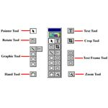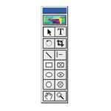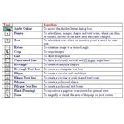
- The Pointer Tool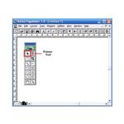
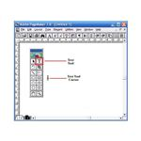
The Pointer tool enables you to pick, drag and drop text boxes, images and other objects, which can then be resized, moved or can have their attributes changed.
- The Text Tool The Text tool enables you to select and edit text, as well as insert text boxes. Click the text tool and then click on the document and start typing in text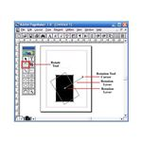 Rotate Tool The rotate tool enables you to rotate a text box or image to a desired angle. Select the rotate tool, and click on the object's reference point. Drag the object to the angle you want it to be.
- Crop Tool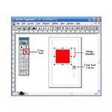
Enables you to crop imported images down to size. You can only use this Pagemaker tool on .tiff images.
- Oblique Line Tool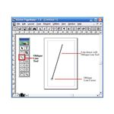
Enables you to draw straight lines at an angle. Click on the oblique line tool, then click on the document. Drag in the desired direction to draw a line.
- 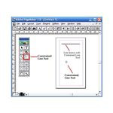 Constrained Line
The constrained line tool enables you to draw horizontal, vertical and 45-degree angle lines. Click on the constrained line tool, then click on the document. Drag in the desired direction to draw a line.
- 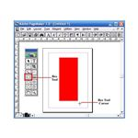 Box Tool
The box tool enables you to create rectangular shapes. Select the box tool and click on the document. Drag to create a rectangular shape.
- 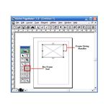Rectangle Frame Tool
The rectangle frame tool enables you to create a rectangular text box that you can type your text into. Select the rectangle frame tool, then click on the document. Drag to draw a rectangular frame. Select the Text tool from the toolbox and click inside the frame. Type in your text. The text will be confined within the text box.
- Circle Tool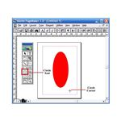
The circle tool enables you to create a circular or oval shape. Select the circle tool, click on the document. Drag to draw a circle or ellipse.
- 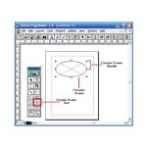 The circular frame tool enables you to create a circular or oval-shaped text box that you can type your text into. Select the circular frame tool, then click on the document. Drag to draw the circular frame. Select the text tool from the toolbox and click inside the frame. Type in your text. The text will be confined within the text box.
- The polygon tool enables you to create a shape that has more than four sides. Select the circular frame tool, then click on the document. Drag to draw the polygonal shape. To modify the polygonal shape, click on Element and then select Polygon Settings from the drop down menu.
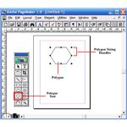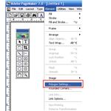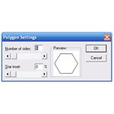
- The polygon frame tool enables you to create a polygonal text box. Select the polygon frame tool, then click on the document. Drag to draw the 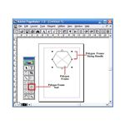 polygon frame. Select the text tool from the toolbox and click inside the frame. Type in your text. The text will be confined within the text box.
- The Hand Tool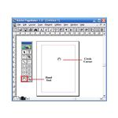
The hand tool enables you to reposition a page on your screen for optimal view. It is especially useful when you are working with a large document and need to navigate a large page. Select the hand tool and click on the page. Drag to navigate from one part of the page to another.
- 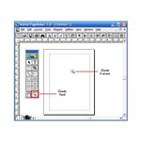 The zoom tool enables you to magnify or shrink the area of the page on your screen. Rulers and guides are crucial desktop publishing tools for document layout. The horizontal and vertical rulers are designed to help you position the different elements on your page. They need to be visible if you want to use the ruler guides.
To display the rulers, click on the View menu and then select Show Rulers.
To hide the rulers, select Hide Rulers in the View menu.
To toggle between displaying and hiding the rulers use the short cut: [Ctrl + R]

