PROGRAMMING IN C++
UNIT – 2
#include <iostream.h>
class XYZ {
private:
int num=100;
char ch='Z';
public:
friend void disp(XYZ obj);
};
//Global Function
void disp(XYZ obj)
{
cout<<obj.num<<endl;
cout<<obj.ch<<endl;
}
int main() {
XYZ obj;
disp(obj);
return 0;
}

CLASSES AND OBJECTS

CLASS
- A class is a way to bind the data and its associated functions together.
- It allows the data (and functions) to be hidden. If necessary , from external use.
- When defining a class, we are creating a new abstract data type that can be treated like any other built-in data type.
- Generally , a class specification has two parts:
- Class declaration
- Class function definitions
- The class declaration describes the type and scope of its members.
- The class function definitions describe how the class functions are implemented.

The general form of a class declaration is :
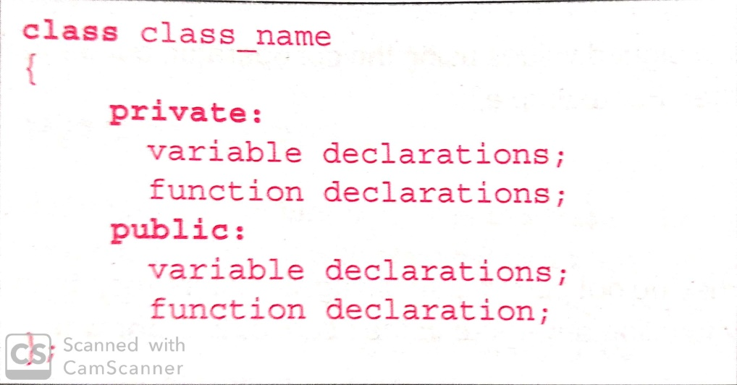

- The body of a class is enclosed within braces and terminated by a semicolon.
- The class body contains the declaration of variables and functions. These function and variables are collectively called class members.
- They are usually grouped under two sections, namely, private and public to denote which of the members are private and which of them are public.
- The keywords private and public are known as visibility labels.
- The variables declared inside the class are known as data members and the functions are known as member functions.
- The binding of data and functions together into a single class-type variable is referred to as encapsulation.
- Class's member functions can be defined inside the class definition or outside the class definition.
- All the features of OOPS, revolve around classes in C++. Inheritance, Encapsulation, Abstraction etc.
- Objects of class holds separate copies of data members. We can create as many objects of a class as we need.

Objects of Classes
- Class is mere a blueprint or a template.
- No storage is assigned when we define a class.
- Objects are instances of class, which holds the data variables declared in class and the member functions work on these class objects.
- Each object has different data variables.

class Abc
{
int x;
void display()
{
// some statement
}
};

int main()
{
Abc obj; // Object of class Abc created
}

Creating Objects
- Once a class has been declared, we can create variables of that type by using class name.
- In C++ , the class variables are known as objects.

Class item
{
….
….
….
}
Item x,y,z;

ACCESSING CLASS MEMBERS
- The private data of a class can be accessed only through the member functions of that class.
- The main cannot contain statements that access number and cost directly.
- The following is the format for calling a member function.
Object-name.function-name(actual-arguments);
- For example, the function call statement
x.getdata(100,75.5);
DEFINING MEMBER FUNCTIONS
- Member functions can be defined in two places
    - Outside the class definition
    - Inside the class definition
- It is obvious that, irrespective of the place of definition, the function should perform the same task.
Outside the class definition
- Member functions that are declared inside a class have to be defined separately outside the class.
- Their definitions are very much like the normal functions.
- They should have a function header and a function body.
- The general form of a member function definition is:
return-type class-name :: function-name (argument declaration)
{
function body
}
- The membership label class-name :: tells the compiler that the function function-name belongs to the class class-name.
- That is, the scope of the function is restricted to the class-name specified in the header line.
- The symbol :: is called the scope resolution operator.
Example:
Void item :: getdata(int a,float b)
{
Number=a;
Cost=b;
}
INSIDE THE CLASS DEFINITION
Another method of defining a member function is to replace the function declaration by the actual function definition inside the class.
Class item
{
Int number;
Float cost;
Public:
Void getdata(int a,float b);
Void putdata(void)
{
Cout<<number<<”\n”;
Cout<<cost<<”\n”;
}
};

PRIVATE MEMBER FUNCTIONS:

- A private member function can only be called by another function that is a member of its class.
- Even an object cannot invoke a private function using the dot operator.

class sample
{
int m;
void read(void);// private member function
public:
void update(void);
void write(void);
};
if s1 is an object of sample,then
s1.read(); // wont work; objects cannot access
//private members
void sample :: update(void)
{
read();
}

STATIC DATA MEMBERS

- A data member of a class can be qualified as static.
- The properties of a static member variable are similar to that of a C static variable.
- A static member variable has certain special characteristics.
  - It is initialized to zero when the first object of its class is created
  - Only one copy of that member is created for the entire class and is shared by all the objects of that class, matter how many objects are created.
  - It is visible only within the class but its lifetime is the entire program.
- Static int a=10;
Sample::a=30;
STATIC MEMBER FUNCTION
- A member function that is declared static has the following properties.
- A static function can have access to only other static members (functions or variables) declared in the same class.
- A static member function can be called using the class name (instead of its objects) as follows.

Arrays of objects

- An array of objects is stored inside the memory in the same way as a multi-dimensional array.
- Member functions are stored separately and will be used by all the objects.

Class employee
{
….
};
Employee manager[3];
Manager[0].getdata();
Manager[1].getdata();
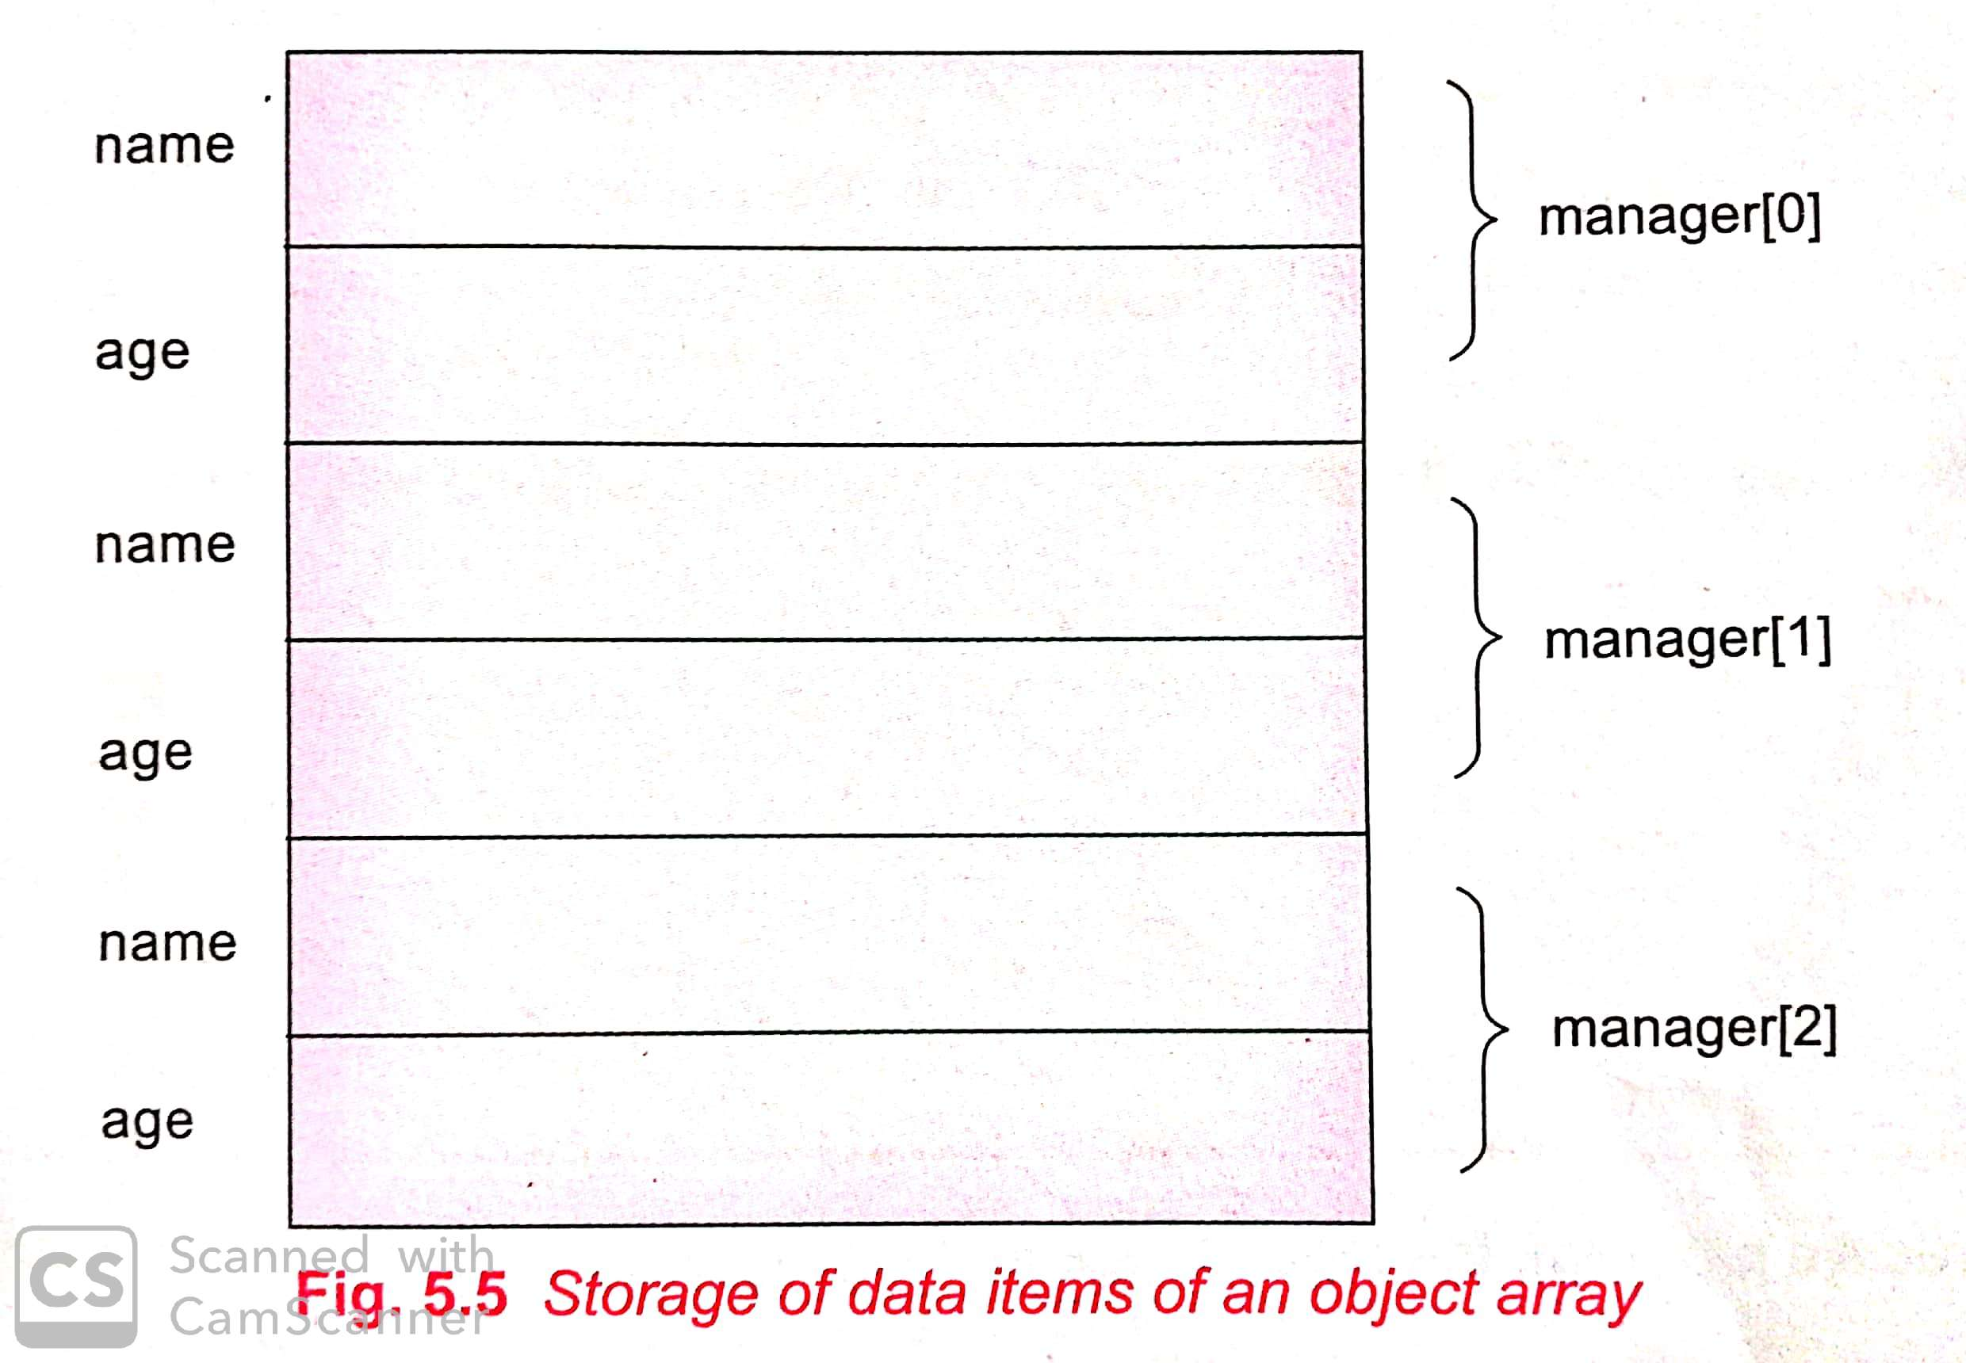

Exercise programs.

- Write a program to take the input of 10 faculty details (ID,name,post,qualification,address) and display it.

CHAPTER -6
CONSTRUCTOR

- A constructor is a special member function whose task is to initialize the objects of its class.
- It is special because its name is the same as the class name.
- The constructor is invoked whenever an object of its associated class is created.
- It is called constructor because it constructs the values of data members of the class.
- A constructor is declared and defined as follows.

class integer
{
int m,n;
public:
integer()
{
……………….
}
……..
……
};
- A constructor that accepts no parameters is called the default constructor.
- The default constructor for class A is A::A().
- If n such constructor is defined, then the compiler supplies a default constructor.
- Therefore a statement such as
A a;
- The constructor functions have some special characteristics. These are
  - They should be declared in the public section.
  - They are invoked automatically when the objects are created.
  - They do not have return types, not even void and therefore, and they cannot return values.
  - They cannot be inherited, though a derived class can call the base class constructor.

Class simple
{
Int m,n;
Public:
simple ();
……
……
};
simple:: simple ()
{
M=0;
N=0;
}
simple s1;
Example program for Default Constructor
#include <iostream>
class construct
{
public:
int a, b;
construct()// Default Constructor
{
a = 10;
b = 20;
}
};
int main()
{
// Default constructor called automatically
// when the object is created
construct c;
cout << "a: " << c.a << endl
<< "b: " << c.b;
return 0;
}

PARAMETERIZED CONSTRUCTORS

- C++ permits us to achieve this objective by passing arguments to the constructor function when the objects are created.
- The constructors that can take arguments are called parameterized constructors.
- The constructor simple() may be modified to take arguments as shown below.
class simple
{
int m,n;
public:
simple(int x,int y); //parameterized constructor
……..
………
};
simple::simple(int x,int y)
{
m=x;
n=y;
}
Simple s1(12,65);
// parameterized constructors
#include <iostream>
class Point
{
private:
int x, y;
public:
// Parameterized Constructor
Point(int x1, int y1)
{
x = x1;
y = y1;
}
int getX()
{
return x;
}
int getY()
{
return y;
}
};
int main()
{
// Constructor called
Point p1(10, 15);
// Access values assigned by constructor
cout << "p1.x = " << p1.getX() << ", p1.y = " << p1.getY();
return 0;
}

Multiple constructors in a class
- The constructor itself supplies the data values and no values are passed by the calling program.
- In the second case, the function call passes the appropriate values from main().
- C++ permits us to use both these constructors in the same class.
- In C++, We can have more than one constructor in a class with same name, as long as each has a different list of arguments. This concept is known as Constructor Overloading.

Example Program.

#include <iostream.h>
class cons
{
public:
float area;
// Constructor with no parameters
cons()
{
area = 0;
}
// Constructor with two parameters
cons(int a, int b)
{
area = a * b;
}
void disp()
{
cout<< area<< endl;
}
};
void main()
{
cons o;
cons o2( 10, 20);
o.disp();
o2.disp();
}

DYNAMIC INITIALIZATION OF OBJECTS
- Dynamic initialization of object refers to initializing the objects at run time i.e. the initial value of an object is to be provided during run time
- Dynamic initialization can be achieved using constructors and passing parameters values to the constructors.
- This type of initialization is required to initialize the class variables during run time.
- Dynamic initialization of objects is needed as
    - It utilizes memory efficiently.
    - Various initialization formats can be provided using overloaded constructors.
    - It has the flexibility of using different formats of data at run time considering the situation.
Example program:-
#include <iostream.h>
class simple_interest
{
float principle , time, rate ,interest;
public:
simple_interest (float a, float b, float c)
{
principle = a;
time =b;
rate = c;
}
void display ( )
{
interest =(principle* rate* time)/100;
cout<<"interest ="<<interest ;
}
};
void main()
{
float p,r,t;
cout<<"principle amount, time and rate"<<endl;
cout<<"2000 7.5 2"<<endl;
simple_interest s1(2000,7.5,2);//dynamic initialization
s1.display();
}

COPY CONSTRUCTOR:-
- A copy constructor is a member function which initializes an object using another object of the same class.
sample i2=i1;
- The process of initializing through a copy constructor is known as copy initialization.
- A copy constructor takes a reference to an object of the same class as itself as an arguments.
EXAMPLE PROGRAM:-
#include<iostream.h>
class code
{
int id;
public:
code
{
}
code(int a)
{
id=a;
}
void display()
{
cout<<id;
}
};
void main()
{
code a(100);
code b=a;
cout<<”\n id of a: “; a.display();
cout<<”\n id of b: “; b.display();
}
DESTRUCTORS
- A destructor as the name implies, is used to destroy the objects that have been created by a constructor.
- The destructor is a member function whose name is the same as the class name but is preceded by a tilde.
~simple()
- A destructor never takes any argument nor does it return any value.
#include<iostream.h>
int count=0;
class test
{
public:
test()
{
count++;
cout<<”\n\n constructor msg: object number “<<count<<”created..”;
}
~test()
{
cout<<”\n\n destructor msg: object number “<<count<<”destroyed..”;
count--;
}
};
void main()
{
cout<<”inside the main block…”;
cout<<”\n\n creating first object t1..”;
test t1;
{
cout<<”\n\n inside block 1…”;
cout<<”\n\n creating two more objects t2 and t3..”;
test t2,t3;
cout<<”\n\n leaving block 1…”;
}
cout<<”\n\n back inside the main block..”;
}

OPERATOR OVERLOADING AND TYPE CONVERSIONS
- The mechanism of giving such special meanings to an operator is known as operator overloading.
- Operator overloading provides a flexible option for the creation of new definitions for most of the C++ operators.
- We can overload all the C++ operators except following.
    - Class member access operators(.*)
    - Scope resolution operator(::)
    - Size operator(sizeof)
    - Conditional operator(?:)

DEFINING OPERATOR OVERLOADING
- Define an additional task to an operator, we must specify what it means in relation to the class to which the operator is applied.
- This is done with the help of a special function called operator function, which describes the task.
- The general form of an operator function is:
returntype classname :: operator op(arglist)
{
function body// task defined
}
- Where return type is the type of value returned by the specified operation and op is the operator being overloaded.
- Operator op is the function name, where operator is a keyword.

RULES FOR OVERLOADING OPERATORS
- Only existing operators can be overloaded. New operators cannot be created.
- The overloaded operator must have at least one operand that is of user-defined type.
- Overloaded operators follow the syntax rules of the original operators. They cannot be overridden.
- There are some operators that cannot be overloaded.
- We cannot use friend functions to overload certain operators. However,member functions can be used to overload them.

TYPE CONVERSIONS
- C applies automatic type conversion to the operands as per certain rules.
- Similarly an assignment operation also causes the automatic type conversion.
- The type of data to the right of an assignment operator is automatically converted to the type of the variable on the left.
int m;
float x=3.14159;
m=x;
- convert x to an integer before its value is assigned to m.
- Three types of situations might arise in the data conversion between uncompatible types.
- Conversion from basic type to class type.
- Conversion from class type to basic type.
- Conversion from one class type to another class type.

