ANNAI VAILANKANNI ARTS & SCIENCE COLLEGE,THANJAVUR DEPARTMENT OF PHYSICS

Operators in C
Operators are the foundation of any programming language. Thus the functionality of C language is incomplete without the use of operators. Operators allow us to perform different kinds of operations on operands.

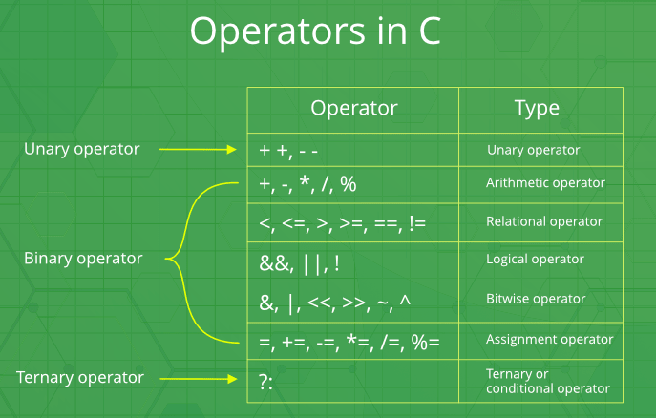
An operator is a symbol that tells the compiler to perform specific mathematical or logical functions. C language is rich in built-in operators and provides the following types of operators
- Arithmetic Operators
- Relational Operators
- Logical Operators
- Bitwise Operators
- Assignment Operators
- Conditional Operators
- Special Operators

Arithmetic Operators
The following table shows all the arithmetic operators supported by the C language. Assume variable A holds 10 and variable B holds 20 then −

Operator | Description | Example
+ | Adds two operands. | A + B = 30
− | Subtracts second operand from the first. | A − B = -10
* | Multiplies both operands. | A * B = 200
/ | Divides numerator by de-numerator. | B / A = 2
% | Modulus Operator and remainder of after an integer division. | B % A = 0
++ | Increment operator increases the integer value by one. | A++ = 11
-- | Decrement operator decreases the integer value by one. | A-- = 9

Relational Operators
The following table shows all the relational operators supported by C. Assume variable A holds 10 and variable B holds 20 then −

Operator | Description | Example
== | Checks if the values of two operands are equal or not. If yes, then the condition becomes true. | (A == B) is not true.
!= | Checks if the values of two operands are equal or not. If the values are not equal, then the condition becomes true. | (A != B) is true.
> | Checks if the value of left operand is greater than the value of right operand. If yes, then the condition becomes true. | (A > B) is not true.
< | Checks if the value of left operand is less than the value of right operand. If yes, then the condition becomes true. | (A < B) is true.
>= | Checks if the value of left operand is greater than or equal to the value of right operand. If yes, then the condition becomes true. | (A >= B) is not true.
<= | Checks if the value of left operand is less than or equal to the value of right operand. If yes, then the condition becomes true. | (A <= B) is true.

Logical Operators
Following table shows all the logical operators supported by C language. Assume variable A holds 1 and variable B holds 0, then −
Operator | Description | Example
&& | Called Logical AND operator. If both the operands are non-zero, then the condition becomes true. | (A && B) is false.
|| | Called Logical OR Operator. If any of the two operands is non-zero, then the condition becomes true. | (A || B) is true.
! | Called Logical NOT Operator. It is used to reverse the logical state of its operand. If a condition is true, then Logical NOT operator will make it false. | !(A && B) is true.

Bitwise Operators
Bitwise operator works on bits and perform bit-by-bit operation. The truth tables for &, |, and ^ is as follows −
p | q | p & q | p | q | p ^ q
0 | 0 | 0 | 0 | 0
0 | 1 | 0 | 1 | 1
1 | 1 | 1 | 1 | 0
1 | 0 | 0 | 1 | 1

Assume A = 60 and B = 13 in binary format, they will be as follows −
A = 0011 1100
B = 0000 1101
-----------------
A&B = 0000 1100
A|B = 0011 1101
A^B = 0011 0001
~A = 1100 0011

The following table lists the bitwise operators supported by C. Assume variable 'A' holds 60 and variable 'B' holds 13, then –
Operator | Description | Example
& | Binary AND Operator copies a bit to the result if it exists in both operands. | (A & B) = 12, i.e., 0000 1100
| | Binary OR Operator copies a bit if it exists in either operand. | (A | B) = 61, i.e., 0011 1101
^ | Binary XOR Operator copies the bit if it is set in one operand but not both. | (A ^ B) = 49, i.e., 0011 0001
~ | Binary One's Complement Operator is unary and has the effect of 'flipping' bits. | (~A ) = ~(60), i.e,. -0111101
<< | Binary Left Shift Operator. The left operands value is moved left by the number of bits specified by the right operand. | A << 2 = 240 i.e., 1111 0000
>> | Binary Right Shift Operator. The left operands value is moved right by the number of bits specified by the right operand. | A >> 2 = 15 i.e., 0000 1111

Assignment Operators
The following table lists the assignment operators supported by the C language −

Operator | Description | Example
= | Simple assignment operator. Assigns values from right side operands to left side operand | C = A + B will assign the value of A + B to C
+= | Add AND assignment operator. It adds the right operand to the left operand and assign the result to the left operand. | C += A is equivalent to C = C + A
-= | Subtract AND assignment operator. It subtracts the right operand from the left operand and assigns the result to the left operand. | C -= A is equivalent to C = C - A
*= | Multiply AND assignment operator. It multiplies the right operand with the left operand and assigns the result to the left operand. | C *= A is equivalent to C = C * A
/= | Divide AND assignment operator. It divides the left operand with the right operand and assigns the result to the left operand. | C /= A is equivalent to C = C / A
%= | Modulus AND assignment operator. It takes modulus using two operands and assigns the result to the left operand. | C %= A is equivalent to C = C % A
<<= | Left shift AND assignment operator. | C <<= 2 is same as C = C << 2
>>= | Right shift AND assignment operator. | C >>= 2 is same as C = C >> 2
&= | Bitwise AND assignment operator. | C &= 2 is same as C = C & 2
^= | Bitwise exclusive OR and assignment operator. | C ^= 2 is same as C = C ^ 2
|= | Bitwise inclusive OR and assignment operator. | C |= 2 is same as C = C | 2

Conditional operator
The conditional operators in C language are known by two more names
- Ternary Operator
- ? : Operator
It is actually the if condition that we use in C language decision making, but using conditional operator, we turn the if condition statement into a short and simple operator.
The syntax of a conditional operator is :
expression 1 ? expression 2: expression 3
Explanation:
- The question mark "?" in the syntax represents the if part.
- The first expression (expression 1) generally returns either true or false, based on which it is decided whether (expression 2) will be executed or (expression 3)
- If (expression 1) returns true then the expression on the left side of " : " i.e (expression 2) is executed.
- If (expression 1) returns false then the expression on the right side of " : " i.e (expression 3) is executed

Special operator
Operator | Description | Example
sizeof | Returns the size of an variable | sizeof(x) return size of the variable x
& | Returns the address of an variable | &x ; return address of the variable x
* | Pointer to a variable | *x ; will be pointer to a variable x

