BHARATHIDASAN UNIVERSITY TIRUCHIRAPPALLI- 620 024

ENVIRONMENTAL STUDIES 19UGCES

(Applicable to the candidates admitted from the Academic year 2019-20 onwards)

By

Dr. N. PRAKASH, M.Sc., M.Phil., B.Ed., Ph.D.,
HOD & Assistant Professor
Department of Chemistry
Annai Vailankanni Arts and Science College
Thanjavur-07

Unit: 2
Natural Resources

Natural resources are classified into two types.
- Renewable resources.
- Non renewable resources.
1.Renewable resources.
Resources that are the capable of being regenerated by ecological process with a reasonable time period are called renewable resources.
Ex : Soil, water, air, wildlife , natural vegetation
The renewable resources are further classified into
i)Continuous resources:
The resources are continuously renewed.
Ex : Solar energy, wind. Tidal energy
ii)Extrinsic resources:
These resources are prone to breakdown or degradation, yet are available continuously if well managed.
Ex ; Human , skills, Institutions, Management.
2.Non renewable resources:
Resources that are not capable of being regenerated by ecological process are called non- renewable resources.
Ex : Minerals, coal, oil, natural gas, ground water.
Forest Resourses
Forest are the most important renewable natural resourses on this earth. About one- third of the world’s land surface is covered with forest.
Types of forest
According to the type of vegetation, forests are classified into three major types
1.Evergreen forests
2.Deciduous forests
3.Coniferous forests.
1.Evergreen forests:
- Evergreen forests are generally found in the equatorial region.
- Where the temperature and rainfall is very high.
- Due to heavy rainfall throughout the year these forests are evergreen.
Ex : The silent valley in Kerala.
Important trees : Teak, mahogany, rosewood.
2. Deciduous forests
These forests are two types
i)Tropical deciduous forests
ii)Temperature deciduous forests
i)Tropical deciduous forests:
- These forests are generally found in the tropical monsoon.
- Forests receive only seasonal rainfall,
- They shed their leaves during the summer season.
Important trees: Teak, sandalwood, pillaimarudhu.
ii)Temperature deciduous forests:
- Due to severe winter with heavy snow fall the trees shed their leaves just before the winter season.
3.Coniferous forests:
- The snow slides down the sloping sides of the trees.
- The needle type leaves preserve the moisture.
Important trees: Pine tree, spruce tree
FUNCTIONS OF FORESTS
- Forests perform very important functions to both human and nature.
- They are habitats to millions of plants, animals and wildlife.
- They recycle rain water and remove pollution.
- They control water quality and quantity.
- They moderate temperature, weather and help to maintain humidity.
- They influence soil conditions and prevent soil erosion and watershed functions.
- They promote tourism and contribute aesthetic beauty.
USES AND BENEFITS OF FORESTS
Commercial Uses:
Man depends heavily on a larger number of plant and animal products from forests for his daily needs.
- The chief product that forests supply is wood, which is used as fuel, raw material for various industries as pulp, paper, newsprint, board, timber for furniture items, other uses as in packing articles, matches, sports goods etc.
- Indian forests also supply minor products like gums, resins, dyes, tannins, fibers, etc.
- Many of the plants are utilized in preparing medicines and drugs.
- Forest produces variety of animal products like honey, ivory, hides etc.
- Many forests lands are used for mining, agriculture, grazing, and recreation and for development of dams.
Ecological Uses:
i)Production of Oxygen:
During photosynthesis trees produce oxygen which is essential for living organisms.
ii)Reducing Global Warming:
- The main green house gas carbon dioxide is absorbed by the forests as a raw material for photo synthesis.
- Thus forest can acts as a sink for carbon dioxide thereby reducing the problem of global warming caused by green house gas CO₂.
iii)Soil Conservation:
- Forests bind the soil particles tightly in their roots and prevent soil erosion.
- They also act as wind breakers.
iv)Regulation of hydrological Cycle:
- Watersheds in forest act like giant sponges, absorbing the rainfall, slowing down the runoff.
- They control climate through transpiration of water and seed clouding.
v)Pollution moderators:
- Forests can absorb many toxic gases and noises and help in preventing air and noise pollution.
vii)Wild life habitat:
- Forests are the homes of millions of wild animals and plants.
- About 7 million species are found in the tropical forests alone.
Aesthetic Value:
- Forests also have aesthetic value.
- It serve as a gene reserve of important species.
Touristic Value:
- Ecotourism provides growing income for those who have facilitated.
- Several countries are now attracting the tourists.
OVER EXPLOITATION OF FOREST
- Man depends heavily on forests for food, medicine, shelter, wood and fuel.
- Due to over population they are not sufficient to people’s demand.
- With growing civilization the demands for raw material like timber, pulp, minerals, fuel, wood etc., increases resulting in large scale logging, mining, road-building and clearing of forests.
Reason for over exploitation in India:
- In India the minimum area of forests to maintain good ecological balance is 33% of total area.
- But at present it is only 22%.
- So over exploitation of forest material occur.
Causes of Over exploitation:
The main causes of over exploitation are,
- Increasing agricultural production.
- Increasing industrial activities.
- Increase in demand of wood resources.
Effects (or) Consequences of over exploitation:
- Over exploitation of forest resources led to migration of farmers.
- It causes heavy environmental damage.
- Tropical forests are destroyed at very high rate.
- Countless plant and animal species are endangered.
- Marine population will go into extinction.
DEFORESTATION
Definition:
- Deforestation - destruction of forests.
- It is the process of removal (or) elimination of forest resources due to many natural (or) man-made activities.
Deforestation in India:
- Deforestation is a continuous process in India where about 1.3 hectares of forest land has been lost.
- The per capita availability of forest in India is 0.08 hectares per person which is much lower than the world average of 0.8 hectares.
- The presence of waste land is a sign of deforestation in India.
Causes of Deforestation:

Developmental Projects:
Developmental projects cause deforestation in two ways,
- Through submergence of forest area under water.
- Destruction of forest area
Ex: Bigdams, hydroelectric projects, road construction etc.

Mining Operations:
- Mining cause serious impact on forest areas.
- It reduces forest area.
Ex: Mica, Coal, manganese, limestone, etc.
Raw materials for industries:
- Wood is the raw material for many purposes.
Ex: Making boxes, furniture, plywood etc.,
- Every year the demand of wood increased continuously.

Fuel Requirements:
- In India rural and tribal population depend on forest for their daily needs.
- This leads to deforestation.
Shifting Cultivation:
Replacement of natural forest ecosystem to monospecific tree plantation lead to disappearance of many plant and animal species.
Forest Fires:
- Forest fire is the major causes for deforestation.
- Due to human interruption and rise in ambient temperature causes forest fire.
- Due to forest fire thousands of forest area gets destructed.
Consequences (Or) ill effects (Or) Impact of deforestation on the environment:
Deforestation will have the following social, economic, and ecological effects.
Global warming:
Cutting and burning of forest trees increases the CO₂ content in the atmosphere.
It changes the
- Global climatic pattern.
- Rising sea levels.
- Depletion of protective ozone layer.
Loss of genetic diversity:
- Destruction of forest destroys the greatest store house of genetic diversity.
- It provides new food , medicines etc.
Soil Erosion:
- Deforestation causes soil erosion, landslides, floods, drought.
- Natural vegetation acts as natural barrier to reduce the wind velocity and prevent soil erosion.
Loss of biodiversity:
- Loss of medicinal plants.
- Loss of timber, fuel wood.
- Animal species loss their food, habitat etc.
Loss of food grains:
Due to soil erosion countries lose their food grains, fruit production and root based foods.
Unemployment Problems:
The people around forest area lose their livelihood.
Flood and Landslides:
Frequent floods, landslides in hilly areas and wind speed are heavy.
Preventive measures (or) Avoid of Deforestation (or) Methods of conservation of forests:
Conservation of forest includes planting of new trees and protecting the existing ones.
The following steps involved in conservation of forests
- New plants more or less the same variety should be planted to replace the trees cut down.
- Discourage the use of wood for fuel.
- Forest pests can be controlled by spraying pesticides by using aeroplanes.
- Overgrazing by cattle must be controlled.
- Government should discourage the migration of people into the islands from mainland.
- Education and awareness programmes must be conducted.
- Strict implementation of law of Forest Conservation Act.

Timber Extraction
- Due to population growth and lack of alternative fuels people living near forest area using wood as a fuel.
- Hence wood (timber) extraction increases day by day.
Uses of Timber:
- Timber is used as raw materials for wood based industries like pulp, paper, furniture etc.
- It is also used for various developmental activities like railways, boats, road construction etc.
Consequences and effects of Timber extraction:
- Large scale timber extraction causes deforestation.
- It leads to soil erosion, loss of fertility, landslides, and loss of biodiversity.
- It also leads to loss of tribal people culture and extinction of tribal people.
- Timber extraction reduces thickness of forest.

Mining
- Mining is the process of extracting mineral resources and fossil fuels like coal from the earth.
- These deposits found in the forest region, and any operation of mining will naturally affect the forests.
- Mining operation requires removal of vegetation along with soil mantle.
Types of mining:
1. Surface mining:
It involves mining of minerals from the shallow deposits.
2. Underground mining:
It involves mining of minerals from deep deposits.
Steps involved in mining:
Mining operation involves the following steps.
- Exploration: Investigation and searching of minerals.
- Development: Various observations.
- Exploitation: Extraction of minerals.
- Ore processing: Separation of Ore.
- Extraction and purification of minerals.
Effects of Mining (or) Impacts of mining:
- Mining activity not only destroys trees, but also pollutes soil, water, air with heavy metal toxins.
- Destruction of natural habitat at the mine and waste disposal site.
- Due to mining trenches are formed on the ground leading to water logged area and contaminates the underground water.
- During mining vibrations are developed which leads to earthquake.
- When materials are disturbed in significant quantities but large quantities of sediments are transported by water erosion.
- Noise pollution is the major problem for mining operation.
- Mining reduces the shape and size of the forest.
- As a result of continuous mining landslides occur.
- Due to the discharge of waste minerals in water pollutes the surface and underground water.
- Migration of tribal people from mining area to other areas for searching food and land.

DAMS AND THEIR EFFECTS ON FORESTS AND TRIBAL PEOPLE
- Dams are the massive artificial structures built across the river to store water for many beneficial purposes.
- These dams also responsible for the destruction of vast areas of forest and displacement of local people.
- India has more than 1600 large dams.
Ex: Tehri dam is the highest dam built across the river Bhagirathi in the state of Uttaranchal.
Effects of Dam on Forest:
- Thousands of hectares of forests have been cleared for executing river valley projects which breaks the natural ecological balance of the region.
- Due to dam construction the forest area is also cleared for residential accommodation, office buildings, storing materials, laying roads, etc.
- Hydroelectric projects also led to widespread loss in forest area
- It also led to killing of wild animals and destroying aquatic life.
- Hydroelectric projects provide the widespread of water borne diseases.
- It also causes water logging which leads to salinity and reduces the fertility of the land.
Effects on Dam onTribal people:
- The greatest social cost of big dam is the widespread displacement of tribal people such a biodiversity cannot be tolerated.
- Displacement and cultural change affects the tribal people both mentally and physically.
- They do not accommodate the modern food habits and life styles.
- Tribal people are ill-treated by the modern society.
- Many of the displaced people were not recognized and resettled or compensated.
- Tribal people and their culture cannot be questioned and destroyed.
- Body conditions of the tribal people will not suit with the new areas hence they will be affected by many diseases.
WATER RESOURCES
- Water is an important component of all living beings.
- Nearly 80% of earth’s surface is covered by water.
Hydrological cycle
- Water exists in three phases, solid, liquid and gas.
- It is circulated in accordance with the hydrological cycle.
Definition:
The movement of water in a cyclic manner is called hydrological cycle.
Steps involved in Hydrological cycle:
Hydrological cycle involves the following steps.
1.Evaporation
2.Condensation and Precipitation
3.Transpiration and respiration.
1.Evaporation:
- The transformation of water from liquid to gas phases is called evaporation.
- Heat energy from the sun constantly causes evaporation from all the water surfaces.
- Oceans, rivers, streams, lakes, ponds, and surfaces of terrestrial organisms lose water due to evaporation.
- The energy from the sun drives weather systems which move the clouds from one place to another.

2.Condensation and precipitation:
- The transformation of water vapour to liquid water droplets in the air, creating clouds and fog etc are called condensation.
- Condensed water vapour that falls to the Earth's surface in the form of rain is called precipitation.
- Once water condenses it is pulled into the ground by gravity.
- The gravity pull the underground and surface water lower and lower until it reaches the oceans.
3.Transpiration and Respiration:
- Organisms play an very important role in the water cycle.
- The release of water vapour from plants and soil into the air is called transpiration.
- Both animals and plants during respiration break down the sugars and produce energy with the liberation of carbon dioxide and water.
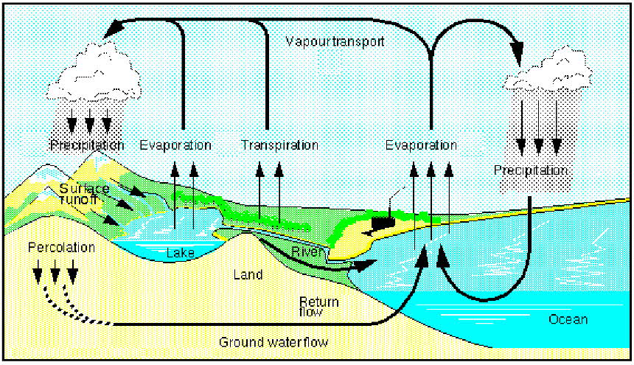
Uses of Water
Consumptive Use:
Water is completely utilized and it is not reused.
Ex: Domestic application, industry, irrigation etc.
Non-Consumptive Uses:
Water is not completely utilized and it is reused.
Ex: Hydropower plant
Other Important uses of Water:
- Water is used for domestic purposes like drinking, cooking, bathing and washing etc.
- It is also used for commercial purposes like hotels, theaters, educational institutions, offices, etc.,
- About 60-70% of water is used for irrigation.
- 20-30% of fresh water is used for industries like refineries, iron, steel, paper and pulp industries etc.
- Water is essential for sustainable life on earth.
- Water shaped the earth's surface and regulates our climate.
Over – Utilization of Water (Surface and Ground water)
- Rapid increase in population and industrial growth have increased the demand for water resources.
- Due to increase of water usage the annual extraction of ground water is more compared to annual recharge.
Effects on Over-utilization of water (or) Consequences of over drawing of Ground water:
Decrease of Ground water:
Due to increase the usage of ground water, the ground water level decreases.
Reason:
- Erratic and inadequate rainfall reduce the storage of water in reservoirs.
- Building construction activities are sealing the permeable soil zone, reduce the percolation of rain water and increase the surface runoff.
Ground Subsidence:
When the ground water withdrawal is more than its recharge rate, the sediments in the aquifer get compacted which results in sinking of overlaying land surface. This process is known as ground subsidence.
Problems:
- Structural damage in buildings.
- Fracture in pipes.
- Reversing the flow of canals and tidal flooding.
Lowering of water table:
Over utilization of ground water in arid and semi-arid regions for agriculture disturbs the state of equilibrium of the reservoir.
Problems:
- Lowering of water table.
- Decreased pressure in the aquifers and changes in the speed and direction of water flow.
Intrusion of salt water:
In coastal area over exploitation of ground water leads to intrusion of salt water from the sea.
Problem:
- Water cannot be used for drinking and agriculture.
Earthquake and Landslides:
Over utilization of ground water leads to decrease in water level, which cause earthquake, landslides and famine.
Drying up of Wells:
- Due to over utilization of ground water, the level of ground water gets depleted much faster than they can be regenerated.
- This leads to trying up of dug wells and bore wells.
Pollution of water:
When ground water level near the agricultural land decreases, water containing nitrogen as nitrate fertilizer which percolates into the ground and pollute the water.
Problem:
- When nitrate concentration exceeds 45mgs/lit, the water becomes unsuitable for portable use by infants.
BIG-DAMS –BENEFITS AND PROBLEMS
- Dams are built across river in order to store water for irrigation, drinking, hydroelectric power generation and flood control.
- Most of the dams built for more than one purposes called “Multipurpose dams ”.
- These are also called as Temples of Modern India by Jawaharlal Nehru.
Benefits of Constructing dams:
- Dams are built to control flood and store flood water.
- It is used for diverting part (or) all of the water from the river into the channel.
- It is mainly used for drinking and agricultural purposes.
- Dams are built for generating electricity.
- It is used for recreational purposes.
- Navigation and fishery can be developed in the dam areas.
Problems of Constructing Dams:
The impacts of big dams can be upstream as well as downstream levels.
Upstream Problems:
- Displacement of tribal people
- Loss of forests, flora and fauna
- Changes in fisheries
- Stagnation and water logging around reservoirs retards plant growth.
- Loss of non-forest land
- Landslips, sedimentation and siltation occurs.
- Breeding of vectors and spread of vector –borne diseases.
- Reservoir induces seismicity causing earthquakes
- Microclimatic changes
- Navigation and aquaculture activities can be developed in the dam area. Downstream problems:
- Water logging and salinity due to over irrigation
- Microclimatic changes
- Reduced water flow and slit deposition in river.
- Flash foods
- Salt water intrusion at river mouth
- Loss of land fertility
- Outbreak of vector-borne diseases like malaria.

MINERAL RESOURCES
Minerals:
Minerals are naturally occurring substances having definite chemical composition and physical properties.
Ores:
Ores are minerals or combination of minerals from which useful substances, such as metals, can be profitably extracted and used for manufacture.
Formation of mineral deposits:
- Concentration of minerals at a particular spot which can be extracted profitably, gives rise to a mineral deposit.
- It is a very slow biological process, it makes millions of years to develop as a mineral deposit.
Various biological processes:
- Mineral deposits are formed due to the biological decomposition of dead animals and organic matters.
- It is also formed due to the concentration of minerals during cooling of molten rock (lava from volcano).
- It is formed due to the evaporation of sea water.
- They are formed due to oxidation – reduction reaction inside the earth.
- Formation of mineral deposits due to the concentration minerals during weathering, transport and sedimentation.
Classification of mineral resources:
U.S. Geological survey classifies the mineral resources into three types.
1. Identified Resources
2. Undiscovered Resources
3. Reserves.
1. Identified resources:
The location, existence, quantity and quality of minerals are known by the direct geological evidence and measurements.
2. Undiscovered Resources:
These mineral resources are exist on the basis of geological knowledge and theory but their specific locations, quality and quantity are unknown.
3. Reserves:
These mineral resources are identified resources from which usable minerals can be profitably extracted.
Uses of minerals:
- Minerals are used in large number of ways in every day in domestic, agriculture, industrial and commercial sectors.
- Economy and political power of the country is determined by number of reserves of minerals and technical know, how to extract the minerals.
Uses:
The important uses of minerals are,
- Development of industrial plants and machinery
Ex: Iron, aluminium , copper
- Construction, housing, settlements
Ex: Iron, Aluminium, Nickel
- Generation of energy
Ex: coal, lignite, uranium
- Agriculture- as fertilizers, seed dressings and fungicides.
- Jewellery
Ex: Gold, silver, platinum, diamond.
- Making of alloys for various purposes.
Ex: Phosphorites.
- Communication purposes
Ex: telephone wires, cables, electronic devices.
- Medical system- particularly in Ayurvedic System
Ex: Sulphur pyrites.
Classification of minerals:
On the basis of classification and usage minerals are classified into two types.
I.Based on composition:
Based on composition minerals are classified into two types.
1. Metallic minerals:
In metallic minerals various metals can be extracted.
Ex: Iron, Aluminium, copper, zinc etc.
2. Non-metallic minerals:
In non-metallic minerals various non-metallic minerals can be extracted.
Ex: Quartz, feldspar, dolomite, calcite etc.
II. Based on usage:
Based on usage minerals are classified into two types.
1.Critical minerals:
These are essential for the economic power of a country.
Ex: Iron, aluminium, copper and gold.
Strategic minerals:
These are required for the defence of a country.
Ex: Manganese, cobalt, platinum, and chromium.

ENVIRONMENTAL EFFECTS (or) IMPACTS OF EXTRACTING MINERAL RESOURCES
Most important environmental concern arises from the extraction and processing of minerals during mining, melting, roasting etc.
Environmental damage:
The environmental damage caused by mining activities are,
Devegetation and defacing of landscape:
- Mining requires removal of vegetation along with underlying soil mantle and overlying rock masses.
- This results in several ecological losses and destruction of landscape in the area.
Groundwater contamination:
- Mining pollutes the groundwater.
- Sulphur, usually present as an impurity in many ores gets converted into sulphuric acid through microbial action which makes the water acidic.
- Heavy metals also get leached into ground water.
Surface water pollution:
- The acid mine drainage contaminates the nearby streams and lakes.
- The acidic water, radioactive substances like uranium, heavy metals also contaminate the water bodies and kill aquatic animals.
Air pollution:
- During extraction and purification process like smelting, roasting emits enormous quantities of air pollutants.
- Suspended particulate matter, Oxides of sulphur, arsenic, cadmium and lead etc contaminate the atmosphere and public suffers from several health problems.
Subsidence of land:
- Subsidence of mining areas results in tilting of buildings, cracks in houses, buckling of roads, bending of rail tracks and leaking of gas from cracked pipe lines leading to serious disasters.
Occupational Health Hazards:
- Miners working in different type of mines suffer from asbestosis, silicosis, black lung diseases, etc.
Effects of Over Exploitation of Mineral Resources:
- Rapid depletion of mineral deposits.
- Over exploitation of mineral deposits leads to wastage and dissemination of mineral deposits.
- It causes environmental pollution.
- Over exploitation needs heavy energy requirement.
Management of Mineral Resources:
- The efficient use and protection of mineral resources.
- Modernization of the mining industries.
- Search for new deposit.
- Re-use and Re-cycling of the metals.
- Environmental impacts can be minimized by adopting eco-friendly mining technology.
- Low grade ores can be better utilized by using microbial-leaching techniques.
FOOD RESOURCES
- Food is an essential requirement for the human survival.
- Each person has minimum food requirement.
- The main components of food are carbohydrates, fats, proteins, minerals and vitamins.
Types of food supply:
Humans depend on three systems for their food supply,
1. Croplands:
It produces grains and provide76% of the world’s food supply.
Ex: Rice, wheat, maize, barley, sugarcane, potato etc.
2. Rangelands:
It produces from grazing livestock and provide 17% of the world’s food.
Ex: Meat, milk, fruits etc.
3. Oceans:
Oceanic fisheries supply 7% of the world’s food.
Ex: Fish, prawn, crab etc.
WORLD FOOD PROBLEMS
Population explosion is the main problem for world’s food problem.
- The world population increases and cultivable land area decreases, so the food problem arises in the world.
- Environmental degradation like soil erosion, water logging, water pollution, salinity affects agricultural lands.
- Urbanisation is another reason for world’s food problem.
- Food grains like rice, wheat, corn and the vegetable like potato are the major food for the people all over the world, so the food problem arises.
- A key problem is the human activity which degrades the earth’s net productivity which supports all life.
UNDER NUTRITION AND MALNUTRITION
Under Nutrition:
People cannot buy enough food to meet their basic energy needs, suffer from under nutrition. They receive less than 90% of minimum dietary calories.
Effect of Under Nutrition:
Suffer from mental retardation and infectious diseases like measles and diarrhea.
Malnutrition:
Deficiency or lack of nutrition often leads to malnutrition.
Deficiency of nutrient | Effects
Proteins | Growth
Iron | Anemia
Iodine | Goitre
Vitamin A | Blindness

OVERGRAZING
Definition:
Overgrazing is the process of eating away the forest vegetation without giving it a chance to regenerate.
Effects (or) Impact of overgrazing:
Land degradation:
- Overgrazing removes the grass cover.
- The humus content of the soil is decreased and it leads to poor, dry, compacted soil, which cannot be used for further cultivation.
Soil erosion:
- The roots of the grasses are very good binders of soil.
- When the grasses are removed, the soil becomes loose and gets eroded by the action of wind and water.
Loss of useful species:
- Overgrazing affects the composition of plant population and their regeneration capacity.
- The grass land consists of grasses and forbs with high nutritive value.
- Due to overgrazing many important species are destroyed which affect the nature of the environment.
AGRICULTURE
Definition:
Agriculture is an art, science and industry of managing the growth of plants and animals for human use.
Types of Agriculture:
The two major types of agriculture are,
- Traditional agriculture
- Modern agriculture (or) Industrialized agriculture.
1. Traditional Agriculture:
It involves
- A small plot
- Simple tools
- Surface water
- Organic fertilizer and a mix of crops
They produce enough food to feed their families and to sell it for their income.
Effects (or) Impacts of Traditional agriculture:
Deforestation:
Cutting and burning of trees in forest leads to loss of forest cover.
Soil Erosion:
- Clearing of forest cover exposes the soil to wind and rainfall.
- It leads to soil erosion and loss the fertility of the soil.
Loss of Nutrients:
- During cutting and burning of trees , the organic matter in the soil gets destroyed and most of the nutrients are used by the crops with in short period.
- It makes the soil becomes poor in nutrient and leads the farmers shift to another area.

MODERN AGRICULTURE
- It makes use of hybrid seeds of selected and single crop variety.
- High-tech equipments.
- lots of energy subsidies in the form of fertilizers and, pesticides
- Irrigation water
Effects (or) Impacts of Modern Agriculture (or) Adverse effects of Agricultural practices (or) Environmental effects of Agriculture:
1. Problems in using Fertilizers:
i) Macronutrient imbalance:
- Chemical fertilizers have nitrogen, phosphorus and potassium (N, P and K) which are essential macronutrients. 11
- Excessive use of fertilizers cause micronutrient imbalance.
Ex: Excessive fertilizer use in Punjab and Haryana has caused deficiency of the micronutrient Zinc in the soils, which affects the productivity of the soil.
ii) Blue Baby Syndrome (Nitrate Pollution):
- Nitrogenous fertilizers applied in the fields, they leach deep into the soil and contaminate the ground water.
- The nitrate concentration in the water increases and which exceeds 25 mg/lit, they cause a serious health problem called "Blue Baby Syndrome" (methaemoglobinemia).
- This disease affects the infants to the maximum extent causing even death.
iii) Eutrophication:
A large proportion of nitrogen and phosphorus used in crop fields is washed off along with runoff water and reaches the water bodies causing over nourishment of the lakes. This process is known as Eutrophication. Due to Eutrophication the lakes get attacked by algal blooms.
- These algal species grow very fast by using the nutrients.
- The algal species quickly complete their life cycle, pollute the water and affect the aquatic life.

2. Problems in using Pesticides:
To improve the crop yield, lot of pesticides are used in the agriculture.
i) First generation pesticides:
Sulphur, arsenic, lead, or mercury are used to kill the pests.
ii) Second generation pesticides:
- DDT is used to kill the pests.
- These pesticides protect our crops from huge losses due to pests, they produce number of side effects.
iii) Death of non-target organisms:
Many insecticides not only kill the target species but also kill several non-target species that are useful to us.
iv) Producing new pests:
- Some pest species survive even after the pesticide spray, which generates highly resistant generations.
- They are immune to all types of pesticides and are known as "Super pests".
v)Bio-magnification:
- Many of the pesticides are non-biodegradable and keep on accumulating in the food chain.
- This process is called biological magnification.
- This is very harmful to the human beings.
vi)Risk of Cancer:
Pesticides enhance the risk of cancer in two ways,
- It directly acts carcinogens.
- It indirectly suppress the immune system.

Desired qualities of an ideal pesticides:
- An ideal pesticides must kill only the target species.
- It must be biodegradable.
- It should not produce new pests.
- It should not produce any toxic pesticide vapour.
- Excessive synthetic pesticide should not be used.
- Chlorinated pesticides and organophosphate pesticides are hazardous, so they should not be used.
3. Water logging:
Water logging is the land where water stand for most of the year.

Problems (or) Effects of water logging:
- During water logged conditions, pore voids in the soil get filled with water and the soil air gets depleted.
- Roots of the plants do not get adequate air for respiration.
- So the mechanical strength of the soil decreases and crop yield falls. Causes of water logging:
- Excessive water supply to the croplands.
- Heavy rain.
- Poor drainage.
Remedy measures:
- Preventing excessive irrigation.
- Using sub-surface drainage technology.
- Bio-drainage by trees like Eucalyptus tree are some method of preventing water logging.
4. Salinity:
- The water not absorbed by the soil undergo evaporation leaving behind a thin layer of dissolved salts in the topsoil.
- This process of accumulation of salts is called salinity of the soil.
- Saline soils are characterized by the accumulation of soluble salts like sodium chloride, calcium chloride, magnesium chloride, and sodium sulphate etc.
- The pH of the water exceeds 8.0.
Problems in Salinity:
Due to salinity, the soil becomes alkaline and crop yield decreases.
Remedy measures:
- The salt deposit is removed by flushing them out by applying more good quality of water in such soils.
- Using sub-surface drainage system the salt water is flushed out slowly.

ENERGY RESOUCES
Definition:
Energy may be defined as, “any property, which can be converted into work.” (or)
Energy is defined as, “the capacity to do work.”
Development of energy:
- The first form of energy is the fire.
- The early man discovered fire and used it for cooking and heating purposes
- Wood is the main source of energy, which is later replaced by coal.
- Coal is now being replaced by the oil and gas.
- Now due to insufficient availability and price hike, people started of thinking and using several alternative sources of energy.
Woodcoaloilalternate energy (solar, wind, tidal energy)

1. Renewable energy resources (or) non-conventional energy resources
- Natural resources can be regenerated continuously and are inexhaustible.
- They can be used again and again in an endless manner.
Example: Wood, solar energy, wind energy, hydropower energy, etc.,
Merits of renewable energy resources
- Unlimited supply.
- Provides energy security.
- Fits into sustainable development concept.
- Reliable and the devices are modular in size.
- Decentralized energy production.
2. Non- Renewable energy resources (or) Conventional energy resources
- Natural resources which cannot be regenerated once they are exhausted.
- They cannot be used again.
Example: Coal, petroleum, natural gas, and nuclear fuels.
Wood is renewable resources but not coal-why?
- Wood is renewable resources because we can get new wood by growing a sapling into a tree within 15-20 years.
- But the formation of coal from trees has taken million of years and cannot be regenerated in our life time.

RENEWABLE ENERGY RESOURCES
1. SOLAR ENERGY
The energy that we get directly from the sun is called solar energy.
METHODS OF HARVESTING SOLAR ENERGY
1. Solar cells (or) photovoltaic cells (or) PV cells:
- Solar cells consist of a p-type semiconductor (Si doped with B) and n-type semi-conductor (Si doped with P).
- They are in close contact with each other.
- When the solar rays fall on the top layer of p-type semi-conductor, the electrons from the valence band get promoted to the conduction band and cross the p-n junction into n-type semi-conductor.
- There by potential difference between two layers is created, which causes flow of electrons. 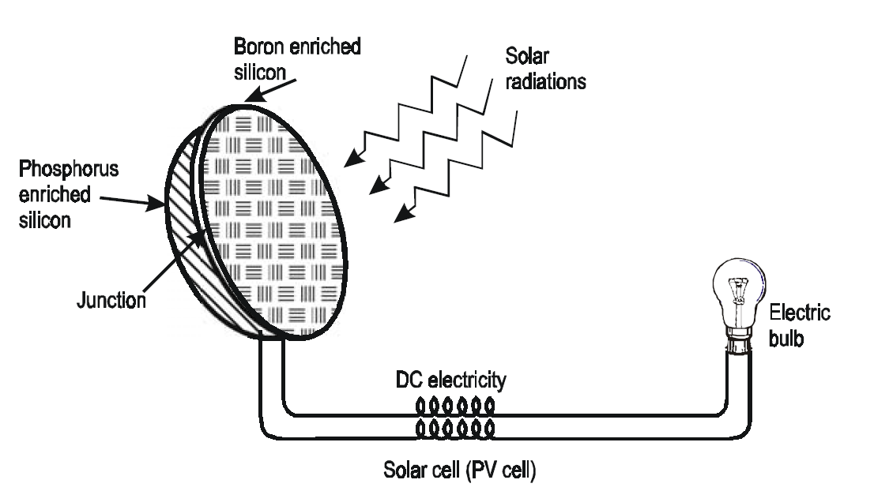

Uses:
Used in calculators, electronic watches, street lights, water pumps to run radios and TVs.
Solar Battery
- When a large number of solar cells are connected in series it form a solar battery.
- Solar battery produce more electricity which is enough to run water pump, to run street-light, etc.
- They are used in remote areas where conventional electricity supply is a problem. 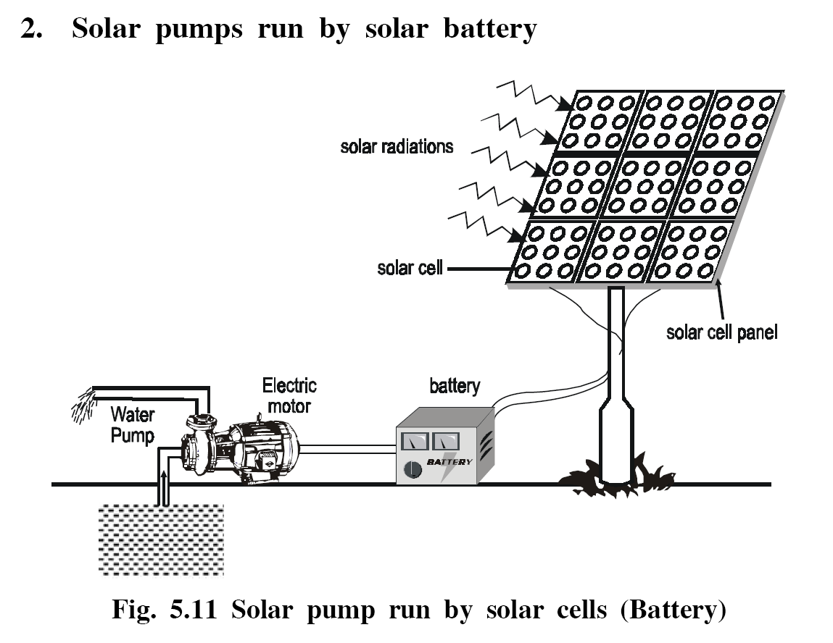
2. Solar heat collectors
Solar heat collectors consist of natural materials like stones, bricks, (or) materials like glass, which can absorb heat during the day time and release it slowly at night.
Uses
Used in cold places, where houses are kept in hot condition using solar heat collectors.
3. Solar water heater
- It consists of an insulated box inside of which is painted with black paint.
- Provided with a glass lid to receive and store solar heat.
- Inside the box it has black painted copper coil, through which cold water is allowed to flow in, which gets heated up and flows out into a storage tank.
- From the storage tank water is then supplied through pipes. 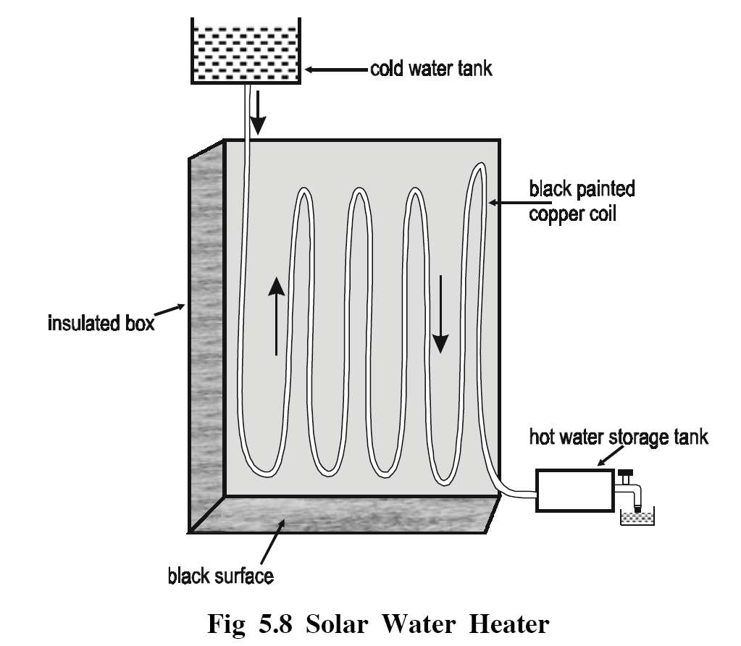
Significance of solar energy:
- Solar cells are noise and pollution free.
- Solar water heaters, cookers, require neither fuel nor attention while cooking food.
- Solar cells can be used in remote and isolated areas, forests, hilly regions.

WIND ENERGY
Definition
- Moving air is called wind.
- Energy recovered from the force of the wind is called wind energy.
- The energy possessed by wind is because of its high speed.
- The wind energy is harnessed by making use of wind mills.
METHODS OF HARVESTING WIND ENERGY
1. Wind Mills
- The strike of blowing wind on the blades of the wind mill makes it rotating continuously.
- The rotational motion of the blade drives a number of machines like water pump, flour mills and electric generators.
2. Wind farms
- When a large number of wind mills are installed and joined together in a definite pattern it forms a wind farm.
- The wind farms produce a large amount of electricity.
Conditions
The minimum speed required for satisfactory working of a wind generator is 15 km/hr.
Advantages
- It does not cause any air pollution
- It is very cheap.
Significance of Wind energy:
- The generation period of wind energy is low and power generation starts from commissioning.
- It is recommended to broaden the nation’s energy options for new energy sources.
OCEAN ENERGY
Tidal energy (or) Tidal power:
- Ocean tides, produced by gravitational forces of sun and moon, contain enormous amount of energy.
- The “high tide” and “low tide” refer to the rise and fall of water in the oceans.
- The tidal energy can be harnessed by constructing a tidal barrage.
- During high tide, the sea-water is allowed to flow into the reservoir of the barrage and rotates the turbine, which intern produces electricity by rotating the generators.
- During low tide, when the sea level is low, the sea water stored in the barrage reservoir is allowed to flow into the sea and again rotates the turbine.
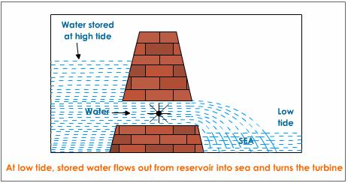
Significance of Tidal Energy:
- Tidal power plants does not require large areas they are on the bays or estuaries.
- Sea water is inexhaustible; it is independent of the uncertainty of precipitation.
- It is a pollution free energy source.
Ocean thermal energy:
- There is often large temperature difference between the surface level and deeper level of the tropical oceans.
- This temperature difference can be utilized to generate electricity.
- The energy available due to the difference in temperature of water is called ocean thermal energy.
Condition
The temperature difference should be of 20⁰C or more is required between surface water and deeper water.
Process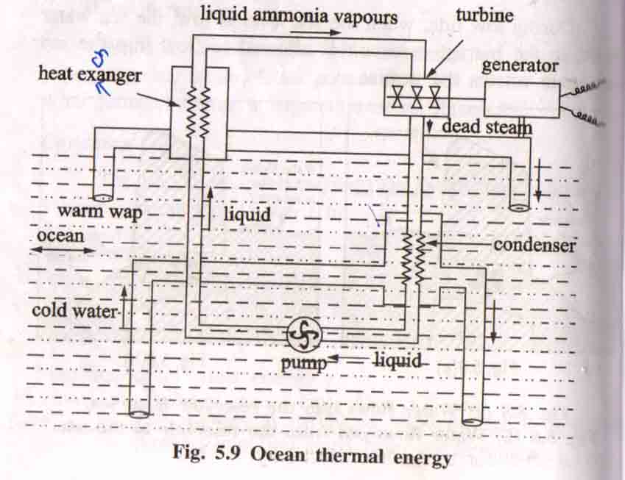
- The warm surface water of ocean is used to boil a low boiling liquid like ammonia.
- The high vapour pressure of the liquid, formed by boiling is used to turn the turbine of the generator and generates electricity.
- The cold water from the deeper ocean is pumped to cool and condense the vapour into liquid.
Significance of OTE:
- OTE is continuous, renewable and pollution free.
- The use of cold deep water, as the chiller fluid in air conditioning, has also been proposed.
- Electric power generated by OTE can be used to produce hydrogen.
3. Geo-thermal Energy
- Temperature of the earth increases at a rate of 20-75⁰C per km, when we move down the earth surface.
- High temperature and high pressure steam fields exists below the earth’s surface in many places.
- The energy harnessed from the high temperature present inside the earth is called geothermal energy.
1. Natural geysers:
Some places, the hot water (or) steam comes out of the ground through cracks naturally in the form of natural geysers.
2. Artificial geysers
- Some places, we can artificially drill a hole up to the hot region and by sending a pipe in it, we can make the hot water or steam to rush out through the pipe with very high pressure.
- Thus, the hot water (or) steam coming out from the natural (or) artificial geysers is allowed to rotate the turbine of a generator to produce electricity.
Significance of geo-thermal energy:
The power generation level is higher for geo-thermal than other solar and wind energies.
It can be brought on line more quickly than most other energy sources.
GTE is effectively and efficiently used in hot water bath, resorts, aquaculture, green houses etc.
BIOMASS ENERGY
- Biomass is the organic matter, produced by plants or animals, used as sources of energy.
- Most of the biomass is burned directly for heating, cooling and industrial purposes.
Eg: Wood, crop residues, seeds, cattle dung, sewage, agricultural
wastes.
Biogas
- Mixture of methane, carbon dioxide, hydrogen sulphide, ete.
- It contains about 65% of methane gas as a major constituent
- Biogas is obtained by the anaerobic fermentation of animal dung or plant wastes in the presence of water.
1. Bio fuels:
Biofuels are the fuels, obtained by the fermentation of biomass.
Eg: Ethanol, Methanol
(a)Ethanol
- Ethanol can be easily produced from the sugarcane.
- Its calorific value is less when compared to petrol, and produces much less heat than petrol.
(b)Methanol
- Methanol can be easily obtained from ethanol or sugar-containing plants.
- Its calorific value is also too low when compared to gasoline and diesel.
(c)Gasohol
- Gasohol is a mixture of ethanol + gasoline.
- In India trial is being carried out to use Gasohol in cars and buses.
- Gasohol is common fuel in Brazil and Zimbabwe for running cars and buses.
Hydrogen Fuel
- Hydrogen can be produced by thermal dissociation or photolysis or electrolysis of water.
- It possesses high calorific value.
- It is non polluting, because the combustion product is water.
2H₂+O₂---->2H₂O+150KJ
Disadvantages of hydrogen fuel
- Hydrogen is highly inflammable and explosive in nature.
- Safe handling is required
- It is difficult to store and transport.
Significance of bio-energy:
The cost of bio-energy obtained from biomass plant is less than the cost of energy from fossil fuels.
Biomass consumes more CO₂ than is released during combustion of biomass.
It provides a stored form of energy and in many cases in a form suitable for vehicle propulsion.
NON-RENEABLE ENERGY SOURCES
1. Coal:
Coal is a solid fossil fuel formed in several stages as buried remains of land plants that lived 300-400 million years ago were subjected to intense heat and pressure over millions of years.
Various stages of coal:
Wood Peat Lignite Bituminous coal Anthracite
- The carbon content of Anthracite is 90% and its calorific value is 8700 k.cal. 17
- The carbon content of bituminous, lignite and peat are 80, 70 and 60% respectively.
- India has about 5% of world’s coal.
- Indian coal is not good because of poor heat capacity.
Disadvantages:
- When coal is burnt it produces CO₂ causes global warming
- Coal contains impurities like S and N, it produces toxic gases during burning.
2. Petroleum:
Petroleum or crude oil = hydrocarbons +small amount S, O, N.
Occurrence:
The fossil fuel formed by the decomposition of dead animals and plants that were buried under lake and ocean at high temperature and pressure for million years
Fractional distillation
From crude petroleum oil the various hydrocarbons are separated by fractionating the crude oil.

Fractionating column
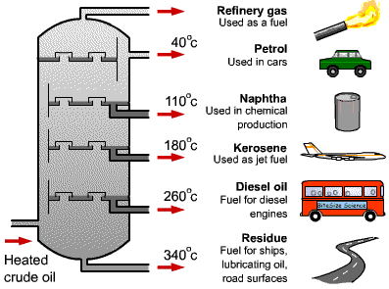
3.LPG (Liquefied Petroleum Gas):
- The petroleum gas, converted into liquid under high pressure as LPG LPG is colorless and odorless gas.
- During bottling some mercaptans is added, to detect leakage of LPG from the cylinder.
Natural Gas:
- Mixture of 50-90% methane and small amount of other hydrocarbons.
- Its calorific value ranges from 12,000-14,000 k-cal/m³.
- It is further divided into two types.
(i)Dry gas
If the natural gas contains lower hydrocarbons like methane and ethane, it is called dry gas.
(ii)Wet gas
If the natural gas contains higher hydrocarbons like propane, butane along with methane it is called wet gas.
Occurrence
Formed by the decomposition of dead animals and plants, those were buried under lake and ocean, at high temperature and pressure for millions of years.
NUCLEAR ENERGY
Dr. H. Bhabha –father of nuclear power in India. India has 10 nuclear reactors, which produce 2% of India’s electricity.
Nuclear Fission:
Heavier nucleus is split into lighter nuclei, on bombardment by fast moving neutrons, and a large amount of energy is released.
Eg:
Fission of U²³⁵
When U²³⁵ nucleus is hit by a thermal neutron, it undergoes the following reaction with the release of 3 neutrons.
₉₂U²³⁵ + ₀n¹₅₆Ba¹³⁹ + ₃₆Kr⁹⁴ + 3₀n¹ + Energy
- Each of the above 3 neutrons strikes another U²³⁵ nucleus causing (3x3) 9 subsequent reactions.
- These 9 reactions further give rise to (3x9) 27 reactions.
- This process of propagation of the reaction by multiplication in threes at each fission is called chain reaction. 18

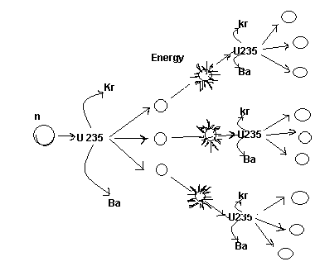

Nuclear fusion:
Lighter nucleus are combined together at extremely high temperatures to form heavier nucleus and a large amount of energy is released.
Eg: Fusion of ₁H².
₁H² + ₁H² → ₂He⁴ + energy

USES OF ALTERNATE (RENEWABLE) ENERGY SOURCES
Why Alternate (Renewable) Energy Sources are required?
The importance of solar energy can be emphasized particularly in view of the fact that fossil fuels and other conventional sources are not free from environmental implications.
- Energy sources which have least pollution, safety and security snags and are universally available have the best enhance of large scale utilization in future
- Hydro-electric power generation is expected to upset the ecological balance existing on earth
- Besides space heating, hydel power plants critically pollute the aquatic and terrestrial biota.
- Radioactive pollutants released from nuclear power plants are chronically hazardous.
- The commissioning of boiling water power reactors (BWRS) have resulted in the critical accumulation of large number of long lived radionuclides in water.
- The dangerous radiowaste cannot be buried in land without the risk of polluting soil and underground water.
- Nor the waste can be dumped into the rivers without poisoning aquatic life and human beings as well
- The burning of coal, oil, wood, dung cakes and petroleum products has well debated environmental problems.
- The smoke so produced causes respiratory and digestive problems leading to lungs, stomach and eye diseases.
- The disposal of fly ash requires large ash ponds and may pose a severe problem considering the limited availability of land.
- Thus the non-conventional sources of energy are needed.

Objectives
- To provide more energy to meet the requirements of increasing population.
- To reduce environmental pollution
- To reduce safety and security risks associated with the use of nuclear energy.
ENERGY CONVERSION PROCESSES
Energy conversion process is the process of changing energy from one form to another.
Energy source -------- > Energy conversion -------- > Useful Energy.
ANAEROBIC DIGESTION
- Anaerobic digestion is a series of biological processes in which micro-organisms break down biodegradable materials in the absence of oxygen.
- One of the product is bio-gas.
- Anaerobic digestion is used to convert live stock manure, municipal waste water solids, food waste, high strength industrial waste water and residuals, fats, oils and greases into bio-gas.

Various steps involved in Anaerobic Digestion:
Anaerobic digestion involves the four stages of biological and chemical reactions.
Stage I – Hydrolysis:
The digestion process begins with bacterial hydrolysis of the input materials to break down insoluble organic polymers to soluble materials such as carbohydrates and make them available for other bacteria.
Stage II – Acidogenesis:
Acidogenic bacteria converts the sugars and amino acids into carbon dioxide, hydrogen, ammonia and organic acids.
Stage III – Acetogenesis:
These organic acids are converted into acetic acid along with additional ammonia, hydrogen and carbon dioxide by the acetogenic bacteria (acid-forming bacteria).
Stage IV – Methanogenesis:
Finally the above products are converted into methane and carbon dioxide by methanogenesis.
Carbonic acids & Alcohols
Sugars
Carbohydrates

Fatty acids
Fats
Hydrogen, Carbon dioxide, Ammonia
Proteins
Amino acids

Hydrogen, Acetic acid, Carbondioxide
Methane &Carbon dioxide
Methanogenesis Acetogenesis

Thus, the final chemical reaction for the overall processes is
C₆H₁₂O₆ ----------- > 3CH₄ + 3CO₂

BIO - GAS (or) GOBAR GAS
Bio-gas is a mixture of various gases formed by the anaerobic degradation of biological matter in the absence of free oxygen.
Composition of Bio-gas:
Compound | %
Methane | 25 - 75
Carbon dioxide | 25 - 50
Nitrogen | 0 - 10
Hydrogen | 0 - 1
Hydrogen Sulphide | 0 - 3
Oxygen | 0

Production of Bio-gas:
Bio-gas is produced in a bio-gas plant.
Construction:
- Bio-gas or Gobar gas plant consists of a well like underground tank called digester covered with dome shaped roof with a gas out let pipe.
- The dome of the digester acts as gas holder.
- On the left hand side of the digester there is a sloping inlet chamber through which cattle Dung + water slurry is introduced.
- On the right hand side, there is an outlet chamber, through which spent dung slurry gets collected.

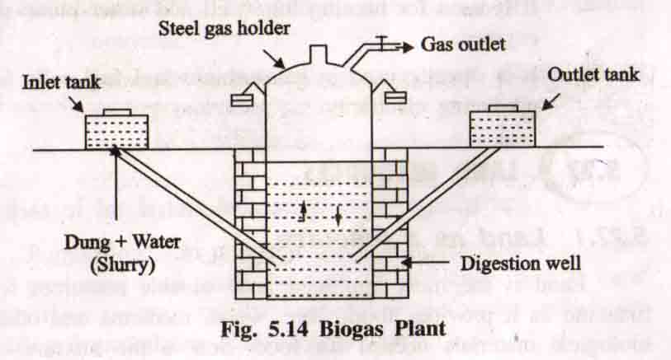
Working:
- Animal dung + water slurry is fed into the digester through the inlet chamber.
- The slurry in the digester is left for two months for fermentation.
- Anaerobic micro-organisms are the responsible for this action.
- After anaerobic fermentation, bio-gas is collected in the dome, it exerts a large pressure on the slurry and this in turn forces the spent slurry to the over flow tank through the outlet chamber.
- Once the bio-gas plants starts functioning more and more slurry may be fed into the digester to get continuous supply of bio-gas.
Uses of bio-gas:
- Bio-gas is used for cooking food and heating water.
- It is used to run engines.
- It is used as an illuminant in villages.
- It is used for running tube - well and water pump-set engines.
- It is directly used in gas turbines and fuel cells for producing electricity.
LAND RESOURCES
Land as a resource:
- Land is the most important and valuable resources for mankind.
- It provides food, fibre, wood, medicine and other biological materials for food.
- Soil is the mixture of inorganic materials (rocks and minerals) and organic materials (dead animals and plants).
- Top soil is classified as renewable resources, it is regenerated continuously by natural process.
- If the rate of erosion is faster than the rate of renewal, then the soil becomes a non-renewable resource.
Uses of land resources:
- Land provide, food, wood, minerals, etc., for us
- Land nurtures the plants and animals that provide our food and shelter.
- Land is used as watershed or reservoir
- Land acts as a dust bin for most of the wastes, created by the modern society.
- Land is used for construction of buildings, industries.
LAND (SOIL) DEGRADATION
Land degradation is the process of degradation of soil or loss of fertility of the soil.
Harmful effects of land (soil) degradation:
- The soil texture and soil structure are deteriorated
- Loss of soil fertility, due to loss of invaluable nutrients
- Increase in water logging, salinity, alkalinity and acidity problems.
- Loss of economic social and biodiversity.
Causes of (or factors influencing) land degradation:
1. Population:
- Population increases , more land is needed for producing food, fibre and fuel wood.
- So land resources degraded by over population &over exploitation.
2. Urbanization:
- Increased urbanization due to population growth reduces the extent of agricultural land.
- To compensate the loss of agricultural land, forests are cleared.
- Urbanization leads to deforestation, affects millions of plants and animal species and reduces the land.
3. Fertilizers and pesticides
Increased applications of fertilizers and pesticides leads to pollution of land, water and soil degradation.
4. Damage of top soil
Increase in food production generally leads to damage to top soil through nutrient depletion.
5. Water-logging
Water logging, soil erosion, salination and contamination of the soil with industrial wastes all cause land degradation.
SOIL EROSION
Soil erosion is the process of removal of superficial layer of the soil from one place to another. It removes the soil components and surface liter.
Types of soil erosion
(i)Normal erosion
- It is caused by the gradual removal of top soil by the natural process.
- The rate of erosion is slower.
(ii)Accelerated erosion
- Caused by man-made activities
- The rate of erosion is much faster than the rate of formation of soil.
Harmful effects of soil erosion
- Soil fertility is lost because of loss of top soil layer.
- Loss of its ability to hold water and sediment.
- Sediment runoff can pollute water and kill aquatic life.
Causes of (factors causing)soil erosion:
i) Water
Affects soil erosion in the form of rain, run-off, rapid flow, wave action.
ii)Wind
Wind is the important climatic agent, which carry away the fine particles of soil and creates soil erosion.
(iii)Biotic agents
- Overgrazing, mining and deforestation are the major biotic agents, cause soil erosion.
- Due to these processes, the top soil is disturbed and exposed directly to the action of various physical forces, which induces erosion.
- 35% of world soil erosion is due to overgrazing.
- 30% of world soil erosion is due to deforestation.
(iv) Landslides:
It causes soil erosion.
(v)Construction
Construction of dams, buildings, roads removes the protective vegetal cover and leads to soil erosion.
Control of soil erosion (or) soil conservation practices
To control soil erosion and conserve the soil the following conservation practices are supplied.
1. Conservational till farming (or) no-till-farming:
- In tradition method, the land is ploughed and soil is broken up and leveled to make a planting surface.
- This disturbs the soil and makes it susceptible to erosion
- However, no-till-farming causes minimum disturbance to the top soil
- Here the tilling machines make slits in the unploughed soil and inject seeds, fertilizers and water in the slit.
- So the seed germinates and the crop grows.
2. Contour farming:
- It involves planting crops in rows across the contour of gently sloped land.
- Each row acts as a small dam to hold soil and to slow water runoff.

3. Terracing:
It involves conversion of steep slopes into broad terraces, which run across the contour.
This retains water for crops and reduces soil erosion by controlling runoff.
4. Alley cropping (or) Agro forestry:
- It involves planting crops in strips or alleys between rows of trees of shrubs that can provide fruits and fuel wood.
- Even when the crop is harvested, the soil will not be eroded because trees and shrubs still remain on the soil and hold the soil particles.
5. Wind breaks or shelter belts:
- The trees are planted in long rows along the boundary of cultivated lands, which block the wind and reduce soil erosion.
- Wind breaks help in retaining soil moisture, supply of some wood for fuel and provide habitats for birds.
DESERTIFICATION
- Progressive destruction or degradation of arid or semiarid lands to desert.
- Desertification leads to the conversion of range lands or irrigated croplands to desert.
- Desertification is characterized by devegetation, depletion of depletion of ground water, salination and soil erosion.
Harmful effect of desertification:
- Around 80% of the productive land in the arid and semi-regions are converted into desert.
- Around 600 million people are threatened by desertification.
Causes (or)Reasons of Desertification:
(a)Deforestation:
- The process of denuding and degrading a forest land initiates a desert.
- If there is no vegetation to hold back the rain water, soil cannot soak and groundwater level do not increases.
- This also increases, soil erosion, loss of fertility.
(b)Over grazing :
- The increase in cattle population heavily grazes the grass land or forests and as a result denudes the land area.
- The denuded land becomes dry, loose and more prone to soil erosion and leads to desert.
(c)Water management:
Over utilization of ground water, particularly in the coastal regions, is resulting in saline water intrusion into aquifers which is unfit for irrigation.
(d)Mining and quarrying:
These activities are also responsible for loss of vegetal cover and denudation of extensive land area leading to desertification.
(e)Climate change:
Formation of deserts take place due to climate change, ie., failure of monsoon, frequent droughts.
(f)Pollution:
Excessive use of fertilizers and pesticides and disposal of toxic water into the land also leads to desertification.

LANDSLIDES
Definition:
Landslides are the downward and outward movement of a slope composed of earth materials such as rock, soil, artificial fills. Other names of landslides are rockslide, debris slide, slump, earth flow and soil creep.
Man induced landslides
During construction of roads and mining activities huge portions of fragile mountainous areas are cut and thrown into adjacent areas and streams.These land masses weaken the already fragile mountain slopes and lead to landslides called man induced landslides.
Harmful effect of landslides
- Landslide increases the turbidity of nearby streams and reducing their productivity.
- Destruction of communication links.
- Loss of habitat and biodiversity.
- Loss of infrastructure and economic loss.
Causes of landslides
1. Removal of vegetation:
Deforestation in the sloppy area creates soil erosion, which leads to landslides.
2. Underground mining:
This causes subsidence of the ground.
3. Transport:
Due to the movement of buses and trains in the unstable sloppy region causes landslides.
4. Addition of weight:
Addition of extra weight (or) construction on the slope areas leads to landslide.
5. Ground water level:
Over exploitation of ground water also leads to landslides.
ROLE OF AN INDIVIDUAL IN CONSERVATION OF NATURAL RESOURCES
- Different natural resources like forests, water, soil, food, mineral and energy resources play a vital role in the development of a nation.
- Due to advancement in technology and population growth, the present world facing lot of problems on degradation of natural resources.
Measures recommended for conservation of natural resource:
I. Conservation of energy:
- Switch off lights, fans and other appliances when not in use.
- Use solar cooker for cooking your food on sunny days which will be more nutritious and will cut down on your LPG expenses.
- Dry the clothes in sun instead of driers.
- Grow deciduous trees and climbers at proper places outside your home to cut off intense heat of summers and get a cool breeze and shade. This will cut off your electricity charges on coolers and air-conditioners.
- Use always pressure cooker.
- Ride bicycle or just walk down for small distances, instead of using car or scooter.
II. Conservation of Water
- Use minimum water for all domestic purposes.
- Check for water leaks in pipes and toilets and repair them promptly.
- Reuse the soapy water, after bathing, washing cloths,for washing off the courtyards, drive ways, etc.
- Use drip irrigation and sprinkling irrigation to improve irrigation efficiency and reduce evaporation.
- The wasted water from sinks, cloth-washers, bathtubs etc. which can be used for watering the plants
- Build rain water harvesting system in your house.
III. Conservation of soil
- Grow different types of plants, herbs, trees and grass in your garden and open areas, which bind the soil and prevent erosion.
- While constructing your house, don't uproot the trees as far as possible.
- Do not irrigate the plants using a strong flow of water; it will wash off the top soil.
- Soil erosion can be prevented by using sprinkling irrigation.
- Use green manure in the garden, which will protect the soil.
- Do not over-irrigate your agricultural fields without proper drainage to prevent water logging and salination.
- Use mixed cropping so that some specific soil nutrients will not get depleted.
IV. Conservation of food resources:
- Eat only minimum amount of food. Avoid over eating.
- Don’t waste the food before getting spoiled give it to someone.
- Cook only required amount of the food.
- Don’t cook food unnecessarily.
- Don’t store large amount of food grains and protect them from damaging insects.
V. Conservation of Forest
- Use non-timber products.
- Plant more trees and protect them.
- Grassing, fishing must be controlled.
- Minimize the use of papers and fuel wood.
- Avoid of executing developmental works like dam, road construction in forest areas.
EQUITABLE USE OF RESOURCES FOR SUSTAINABLE LIFE STYLE
Sustainable development:
Sustainable development is the development of healthy environment without damaging the natural resources. In other words, all the natural resources must be used in such a way that it must be available for the future generation also.
Unsustainable development:
Unsustainable development is the degradation of the environment due to over utilization and over exploitation of the natural resources.
Causes of Unsustainability:
The main cause is due to the difference between the less developed countries and more developed countries,
- Over population in poor countries, consume too low resources with low income.
- Rich countries consume more resources with more income.
Conditions for sustainable life style:
- It is essential to achieve a more balanced and equitable distribution of land resources and income to meet everyone’s basic needs.
- Rich countries should lower down their consumption levels and fulfill the minimum needs of poor.
INTRODUCTION TO ENVIRONMENTAL BIOCHEMISTRY
Xenobiotics:
Biochemistry is used in environmental science to understand the effects of environment on living organisms as they interact with environmental pollutants. These pollutants are called xenobiotics.
Definition environmental biochemistry:
Environmental biochemistry involves approaches to treat polluted air, waste water and solid waste using metabolic activities of micro-organisms.
Aims of Environmental biochemistry:
- It aims to manufacture of products in environmentally harmonious ways, which allow for the minimization of harmful solids, liquids or gaseous outputs.
- It aims to create a cleaner ecosystems.
Proteins:
Protein is the principle constituent of animal origin.
All raw animals and plant food stuffs contain proteins, but plants it occurs in lesser extent.
The structure of protein is
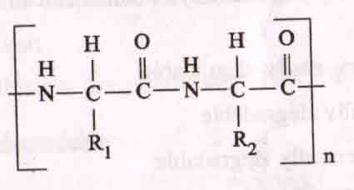
Degradation of proteins
- Environmental toxins can damage proteins.
- If a damaged protein is not repaired, it is degraded easily.
- The degradation of a protein, usually by a hydrolysis, at one or more of its peptide bonds.
- Generally biological degradation of a protein in nature follows three steps and different organisms metabolize product at each step.

Nitrates
Nitrites
Ammonia
Amino acid

Bio chemical degradation of pollution
- Most of the organic matter, present in waste water, includes degradable carbohydrates, proteins and lipids of different complexities. 25
- The treatment of such waste water aims at oxidizing or degrading the organic compounds to decrease the biological oxygen demand(BOD).
- The degradation is performed by a single micro- organism or a group of micro- organism under aerobic or anaerobic conditions.
Types of biodegradable pollutants
Based on degradability, pollutants can be grouped into four types.
- Very easily degradable . 2. Easily degradable . 3. Potentially degradable . 4. Very slowly degradable
1. Very easily degradable
Pollutants:
Simple sugars, amino acids, organic acids, simple short polymers.
Organisms:
- Bacteria, fungi, protozoa, and algae posses the ability to degrade these pollutants.
- Generally it constitutes a small amount of the pollutants in the environment that are quickly removed by the microbes for their growth.
- It occurs under aerobic conditions.
Time of removal:
These pollutants are removed within hours of their release.
2. Easily degradable
Pollutants:
Branched and straight chained polysaacharides, proteins, fatty acids.
Organisms:
- More than one bacterial strain accelerates the degradation process.
- Generally degradation of such pollutants do not necessarily require adaptation of the micro- organisms.
Time of removal:
These pollutants are removed in 10-14 days.
3. Potentially degradable
Complex substances like saturated fatty oils, lipo proteins, fats and aliphatic hydrocarbons.
Organisms:
- Extremely high bacterial densities are required for these degradation.
- Degradation of such pollutants occurs slowly with prolonged exo-enzyme activity at extremely high bacterial densities.
- Only adaptive strains of bacteria are able to perform the degradation of such pollutants, but to accelerate degradation artificial conditions are required for enhancing the bacterial growth.
Time for removal:
These pollutants are removed in 3 weeks.
5. Very slowly degradable
Pollutants:
Ligno cellulose, organo chlorines, PCB, OC, insecticides and some aromatic hydrocarbons belong to this category.
Organisms:
- Very high biomass s required for these degradation.
- Degradation of such pollutants require high concentration of exoenzymes to initiate the degradation process.
- Artificial inoculation, growth subsidization and addition of growth supporting substances accelerate the degradation time.
Degradation Curve:
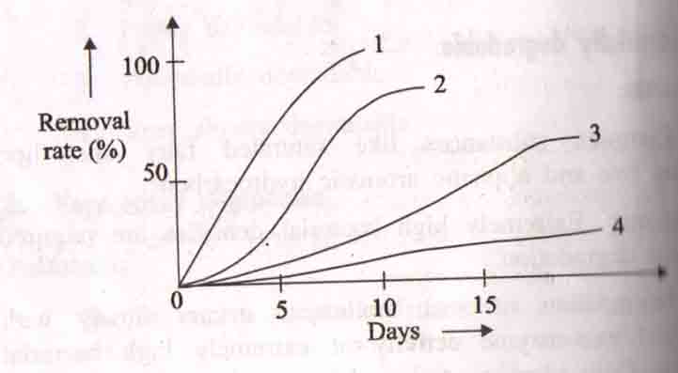
Degradation curve for different types of pollutants are
Curve 1 : Very easily degradable
Curve 2 : Easily degradable
Curve 3 : Partially degradable
Curve 4 : Difficult to degradable.
Bioconversion of pollutants:
Bioconversion is the change of pollutants into a source of energy by the action of micro-organisms. It is the cheap and safe method.
Ex: Bioconversion of biomass into ethanol, methanol (or) methane.
Types of Bioconversion:
1. Enzymatic hydrolysis
2. Synthesis gas fermentation
3. Composting.
1. Enzymatic hydrolysis:
A feedstock is mixed with strong enzymes which converts a portion of cellulosic material into sugar then fermented into ethanol.
2. Synthesis gas fermentation:
- A feed stock is mixed with 30% water and is gasified in a closed environment into a “syn gas” using carbon monoxide and hydrogen.
- The cooled syngas is then converted into usable products through exposure to bacteria.
3. Composting:
A feed stock of organic matter is subjected to some organisms to reduce and convert organic waste into high quality feed stuff and oil rich material for the biodiesel industry.
................................

