

**BHARATHIDASAN UNIVERSITY TIRUCHIRAPPALLI- 620 024**

**ENVIRONMENTAL STUDIES 19UGCES**

**(Applicable to the candidates admitted from the Academic year 2019-20 onwards)**

**By**

**Dr. N. PRAKASH, M.Sc., M.Phil., B.Ed., Ph.D.,**

**HOD & Assistant Professor**

**Department of Chemistry**

**Annai Vailankanni Arts and Science College**

**Thanjavur-07**

**Unit: 5**

**Environmental Pollution**

Pollution:

*“The unfavorable alteration of our surroundings”* and it changes the quality of air, water, landis called pollution*.*

Types of pollutants

1. Bio degradable pollutants – Decompose rapidly by natural processes.

2. Non- degradable pollutants - Do not decompose or slowly decompose in the environment. Slowly decomposed materials are more dangerous because it is very difficult to remove them.

Classification of Pollution

1. Air pollution
2. Water pollution
3. Soil pollution
4. Marine pollution
5. Noise pollution
6. Thermal pollution and
7. Nuclear hazards
8. Air pollution

“The presence of one or more contaminants like dust smoke, mist and odour in the atmosphere which effects human, plants and animals”

*Ex: Industrialisation , Urbanisation etc.*

Chemical composition of Atmospheric air

|  |  |
| --- | --- |
| Constituents of Air | Percentage (%) |
| Nitrogen (N2) | 78 |
| Oxygen (O2) | 21 |
| Argon (Ar) | <1 |
| CO2 | 0.037 |
| Water vapour | Remaining |
| O3, He, NH3 | Trace amount |

Indian and ambient air quality standards

* Indian air quality standards are legal limits, placed on the concentration of air pollutants.
* Ambient air quality standards are permissible exposure of all living and non-living things for 24 hours per day, 7 days per week.

|  |  |  |  |  |  |
| --- | --- | --- | --- | --- | --- |
| Category | Area | Concentration in | | | |
|  | SPM | SO2 | NOX | CO |
| A | Industrial and mixed use | 500 | 120 | 120 | 5,000 |
| B | Residential and rural | 200 | 80 | 80 | 2,000 |
| C | Sensitive (hill stations, tourist resorts, monuments) | 100 | 30 | 30 | 1,000 |

Sources to air pollution:

Sources of air pollution involve two types.

1.Natural Sources:

These pollutants are caused by natural sources.

Ex: Forest fires, biological decay, volcanic eruptions, radioactive materials.

2. Man-made Sources:

These pollutants are caused by man-made activities.

Ex: Coal, wood and other fuels used in vehicles, homes, industrialization.

Classification of air pollutants :

Depending upon the origin, air pollutants are classified into two types,

1.Primary air pollutants:

“Emitted directly in the atmosphere in harmful form”

Eg: CO, NO, SO2

Indoor air pollutants:

They are primary air pollutants. Main indoor air pollutant is Radon gas.

Sources:

* Radon gas is emitted from building materials like bricks, Concrete , Tiles etc
* Present in natural gas and ground water.
* Burning of fuels liberates pollutants like CO, SO2, formaldehyde and BAP etc.

2. Secondary air pollutants:

Some of the primary air pollutants react with one another or with basic components of air to form new pollutants”. They are called as secondary air pollutants.

Ex: Ozone, SO3

NO / NO2 -----moist-- > HNO3 / NO3

Common air pollutants sources and their effects

|  |  |  |  |  |
| --- | --- | --- | --- | --- |
| Substance | Nature | Sources | Health effects | Environmental effects |
| Carbon monoxide | Colourless,odourless,  poisonous gas formed  during incomplete  combustion of carbon containing fuels. | Cigarettesmoking, incompleteburning  Offuels, motor vehicle exhaust. | Causes headaches, anemia,coma, irreversible brain cell damage  and death. | Increases  the globe temperature. |
| Nitrogen dioxide | Reddish brown irritating gas that gives photochemical smog. It  can be converted into  nitric acid in  atmosphere.  NO2+ Moisture → HNO3 | Fuels burning in vehicles,  industrial plants. | Lung irritation  and  damage. | HNO3 acid deposition damage trees, soils, aquatic  life. It corrode metals, stones on building, statues, monuments  etc |
| Sulphur  dioxide | Colourless, irritating gas formed by the combustion of coal and oil. It can be converted to sulphuric  acid in atmosphere. | Burning of coal, industrial processes. | Breathing  problems. | Reduce visibility, acid  deposition damage  trees, soils and aquatic life |
| Suspended particulate matter. | Includes variety of  particles and droplets (aerosols). | Burning in coal  in industries, diesel  in vehicles, agriculture, unpaved roads  etc. | Nose and throat irritation,Lung  damage,bronchitis, asthma,  reproductive problems and cancer. | Reduce visibility,  acid deposition, damage trees, soils and  aquatic life. |
| Ozone | Highly reactive irritating  gas with unpleasant  odour, It is a major component  of photochemical smog. | Chemical reaction with volatile organic compounds and nitrogen oxides. |  | Moderates  the climate. |
| Photo  chemical smog. | Brownish smoke formed during automobile traffic. | Formed due to chemical reaction with nitrogen oxides and hydrocarbon. | Breathing problems, cough, eye, nose and throat irritation, heart diseases. | Damage plants and trees. Smog reduces visibility. |
| Hydro  carbons | Lower hydrocarbons get accumulated due to the  decay of vegetable matter. | Agriculture, decay  of plants, burning  of wet logs. | Carcinogenic. | Ethylene causes plant damage even at lowconcentrations. |

Control Measures to air pollution

1. Source control

* Use only unleaded petrol
* Use fuels that have low sulphur and ash content
* Plant trees along busy streets because they remove particulates and carbon monoxide and absorb noise.
* Industries and waste disposal sites should be situated outside the city centre.
* Use catalytic converters to help control the emissions of carbon monoxide and hydrocarbons.
* Houses, schools, restaurants & park should not be located on busy street.
* Reduce the number of private vehicles on the road by developing efficient public transport system.

2. Control measures in Industrial centers

* Emission rates should be restricted to permissible levels
* Air pollution control equipments must be made mandatory
* Continuous monitoring of the atmosphere to know the emission level

Equipments used to control air pollution

Mechanical devices such as scrubbers, cyclone separator, bag houses & electro-static precipitators, reducing particulate pollutants.

Chemical and photochemical reactions in the atmosphere

1.Smog

* Smog is a mixture of smoke and fog in suspended droplet form.
* The brownish smoke like appearance that frequently forms on clear, sunny days over large cities with significant amount of traffic.

Types

1. London smog
2. Los Angels smog or Photochemical smog

i. London smog

* It is a coal smoke and fog.
* Fog is the mixture of SO2+SO3+humidity.
* It is bad in morning hours and becomes worse after sunrise.
* Sunlight induced oxidation of SO2 and SO3 and react with humidity form sulphuric acid.

SO2+(O)→ SO3

SO3+H2O→ H2SO4

ii. Los Angels smog or Photochemical smog

* It is formed by combination of NO, NO2,CO2,H2O,CO,SO2 and unburnt hydrocarbons.
* The important reaction is dissociation of NO2 in sunlight.

N2+O2→ 2NO

2NO + O2 → 2NO2

NO2 + Sunlight → NO + (O)

O2+ (O) → O3

Hydrocarbon+O2, O, O3, NO2,NO→ Oxidized hydrocarbons

* These oxidized hydrocarbons with ozone in the presence of humidity causes photochemical smog.

Health effects of Smog:

* It causes irritation to eyes, nose, throat and lungs.
* It causes bronchial irritation.

Environmental effects of smog

* It produces acid rain.
* It damages plants and trees.
* Smog can reduce visibility.

Control measure of smog

* Decrease nitrogen oxides and hydrocarbon levels in the air.
* Use the unleaded petrol in automobiles.

2. PAN (Peroxy acetyl nitrates)

Peroxy acetyl nitrates is a secondary pollutant present in photochemical smog.

Production of PAN

* They are formed by the photochemical reaction between hydrocarbons, nitrogen oxides and light.
* It is an oxidant and more stable than ozone.

Hydrocarbons + O2 + light → CH3COOO.

CH3COOO. + NO2 → CH3COOONO2

Effects:

* At lower concentrations it is a powerful respiratory and eye irritants, toxic in nature.
* At higher concentrations cause extensive damage to vegetation, causing skin cancer.
* Damages plants and arts
* React explosively

3. Acid Rain (or) Acid Precipitation (or) Acid snow

* Acid rain means the presence of excessive acids in rain water.
* The precipitation of CO2, SO2, and NO2 gases as pollutants in water.
* The thermal power plants, industries and vehicles release nitrous oxide and sulphur dioxide into atmosphere due to burning of coal and oil.
* When these gases react with water vapour in the atmosphere, they form acids and reaches to earth as acid rain.

SOX + H2O → H2SO4

NOX + H2O → HNO3

Effects of acid rain :

1. Human beings:

* Destroy life – nervous, respiratory and digestive system
* Causes premature death from heart and lung disorders.

2. On Buildings:

* Acid rain corrodes houses, monuments, statues, bridges and fences
* Acid rain contribute the corrosion of metals and deterioration of paint and stone

*Eg:* Taj Mahal is suffering due to SO2 and H2SO4 acid fumes.

3. On terrestrial and Lake Ecosystem:

* Acid rain reduces rate of photosynthesis and growth of crops.
* Acid rain causes complications in ponds, rivers, lakes and reduces the fish population

Control measures :

* Use Clean combustion technologies
* Emission of SO2 and NO2 from industries should be reduced
* Replacement of coal by natural gas
* Liming of lakes and soils.

4.Oxygen and Ozone chemistry

Oxygen Chemistry

* Our atmosphere currently contains about 21% of free oxygen
* It plays an important role in sustaining life without oxygen, humans and animals would be unable to breathe and consequently die.

Production of oxygen

Oxygen is produced in various ways.

1. Photochemical dissociation

Photochemical dissociation of water molecules by UV rays produces about1-2% of our oxygen.

2. Photosynthesis

Photosynthesis is performed by plants, which involves the following general reaction

CO2 + H2O +hν(Sunlight) → Carbohydrates + O2

3. Industrial production

Oxygen is industrially by fractional distillation of liquefied air.

Structure of O2:

* It is a colourless , odourless gas.
* Electronic configuration of oxygen is 1s22s22p4 and valency is 2.
* It is paramagnetic.

Ozone Chemistry

It is a gas found throughout the atmosphere, highly concentrated in the stratosphere between 10 & 50km above the sea level.

Production of ozone:

In the presence of lighting or spark of light, O2 molecules dissociate to form oxygen atoms.

O2(g) + Spark →2O*

These oxygen atoms react with O2 molecules to form ozone (O3)

O2(g) + O* (g) → O3(g)

Structure of Ozone:

It is an unstable compound with a sharp, pungent odour.

Properties of Ozone:

* Ozone undergoes slow decomposition to give oxygen.

3O3(g) → 3O2(g)

* At lower concentration ozone is relatively pleasant.
* At higher concentration ozone leads to coughing, rapid beating of heart, chest pain and body pain.

Ozone Layer Depletion (Ozone Hole)

Ozone:

* It is a gas found throughout the atmosphere, highly concentrated in the stratosphere between 10 & 50km above the sea level- Ozone layer
* It protect us from the ultraviolet radiation from the sun.
* UV radiation affects the DNA molecules, causing damage to the outer surface of plants & animals.
* In humans it causes skin cancer.

Formation of Ozone (O3)

1. It is formed in the stratosphere by photochemical reaction

O2+hv  O*+O*

1. The Atomic Oxygen rapidly react with molecular oxygen to form ozone

O*+O2+M  O3+M

Where, M= Third body (nitrogen)

1. Ozone absorbs harmful UV radiations and product us

Mechanism (or) Formation of Ozone hole

1. CFC’s released into atmosphere by refrigeration units, air conditioner, aerosol sprays & cleaning solvents
2. CFC’s release chlorine which break ozone into oxygen

CF2Cl2+hv  Cl+CF2Cl

CF2Cl+O2  CF2O+ClO

Cl+O3  ClO+O2

ClO+O*  Cl+O2

1. Each Chlorine atom is capable to attacking several ozone molecules
2. Long chain process is happened here.
3. A 1% loss of ozone results in a 2% increase in UV rays reaching the earth surface

Ozone depleting chemicals

Chloro Fluro carbon : by refrigirator, blowing agent

Hydro chloro fluoro carbon : by refrigirator, blowing agent

Bromo fluoroCarbon : by fire extinguishers

Other chemicals : by Halogen compounds, sulphur dioxide

Effects

On human health – Skin cancer, cataracts, allergies etc.

On aquatic systems - Affects phytoplankton, fish

On materials - Weathering of paints, plastics

On climate – Increasing the average temperature of the earth surface.

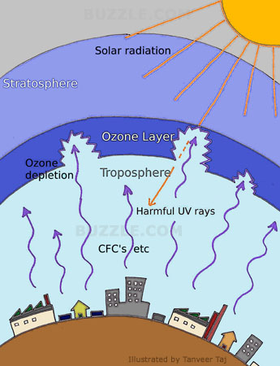

Measurement of ozone:

* The amount of atmospheric ozone is measured by Dobson spectrometer and is expressed in Dobson units.
* 1DU is equivalent to a 0.01 mm thickness of pure ozone at the density it posses if it is brought to the ground level (1atm) pressure.

Ozone concentration:

* In temperate region – 350DU
* In tropics region – 250DU
* In Polar region – 450DU

Control Measures:

* Replacing CFCs
* Use of methyl bromide – crop fumigant
* Ozone depleting chemicals should be stopped

Properties of Terrestrial and Marine water:

Terrestrial or surface water

The water stored on the surface of earth is called terrestrial or surface water.

Types of Terrestrial Water

1. Standing Water bodies
2. Flowing Water Bodies

Standing Water Bodies

Lakes:

***Oligotrophic lakes*:** Deep. Clear & deficient in nutrients without much biological activity

***Eutrophic lakes*:** Contains more nutrients& more turbid & support more life's

***Dystrophic lakes:***Shallow & colored lakes, low pH & clogged with plants life

**Reservoirs:** Larger than lakes

**Estuaries:** Formed at mouth of river, where the join the ocean, mixing of fresh & salt water

Flowing Water Bodies

* Water, which originate from the point of precipitation and flows in streams & rivers are called flowing water bodies
* It carries sedimentary materials & dissolved minerals

Physical and chemical properties of terrestrial water

* At room temperature water is colorless, tasteless and odorless.
* Water is a universal solvent.
* Water has high specific heat and it can absorb large amount of heat
* Water in a pure state at neutral pH.
* Water has high surface tension.

Marine water

* Marine water is the water found in sea or ocean
* On average marine water has salinity about 35%.
* Properties of marine water vary according to latitude, depth, nearness to land and input of fresh water.

Physical and chemical properties of Marine water:

* Marine water is denser than fresh water
* pH of marine water is between 7.5 to 8.4
* The speed of sound in sea water is 1500meters per second

Marine water is differ from terrestrial water:

* Marine water contains more dissolved ions than terrestrial water.
* It contains about 2.8 times more bicarbonate than terrestrial water.
* These differences are only due to varying residence time of sea water solutes.

Water Quality Parameters:

The quality of water varies to place to place and seasons.

The important parameters are

1. Physical parameters
2. Chemical parameters
3. Biological parameters

Physical parameters:

|  |  |  |  |
| --- | --- | --- | --- |
| Parameters | Sources | Sanitary Significance | Removal |
| Colour: Shade imparted by organic or inorganic material , which change the appearance of the water. | Organic sources:  Algae, tannins, humic compounds, organic dyes.  Inorganic sources:  Fe and Mn compounds, Chemicals and inorganic dyes. | 1.The colours and materials which produce colour are objectionable in which the water and manufactured product are come in contact.  Ex: Dyeing,  2.Variation in colour of water  from the same source with time serves as a index of quality of water.  Ex: Yellow tinge => Presence of Cr and organic matter.  Yellow red => presence of Iron. | Colour and colour producing materials are removed by coagulation, settling, adsorption and Filtration. |
| Tastes and Odours: Disagreeable odours and tastes are objectionable for various industrial processes such as food products, beverages, textiles, paper, pulp. | Organic sources:  Algae, decaying vegetation etc.  Inorganic sources:  Mercaptans, amines and sulphides. | ------ | Organic tastes and odours can be removed by aeration (or) activated carbon treatment.  Inorganic tastes like H2S (or) Iron can be removed by Oxidation, chlorination and precipitation. |
| Turbidity and Sediments:  Turbidity is the reduction of clarity of natural water due to the presence of finely divided insoluble impurities suspended in water. | Inorganic sources:  Clay, silt, silica, ferric hydroxide, calcium carbonate, sulphur etc.  Organic Sources:  Finely divided organic or animal matter, oils, fats, greases, micro-organisms etc | Tolerance of turbidity depends on the type of industry and the grade of product manufactured. | Turbidity of water can be removed by sedimentation followed by  Coagulation and filtering  Coagulation and settling  Coagulation, settling and filtering. |

Chemical parameters:

1. PH:

* Hydrogen ion concentration is represented by the PH value.
  + - PH = -log [ H + ]
* PH is defined as the negative logarithm of hydrogen ion concentration.
* PH value ranges from 0-14.

2. Acidity:

Acidity of water is the measure of base-neutralizing ability. Acidity in water is imparted by dissolved CO2 and mineral acids.

Sources:

* Mineral acids
* Carbon dioxide

Sanitary significance:

* Mineral acids cause more environmental and health problems than CO2 acidity.
* Undesirable to consume.
* Acid water contacts with stone, concretes and metals it corrodes and solubilising heavy metals, so structure gets collapsed.

3. Alkalinity:

Alkalinity of water is the measure of acid – neutralizing ability. Neutral alkalinity is imparted by hydroxides, carbonates and bicarbonates.

Sources:

Industries like fertilizer, detergent, leather and paint.

Sanitary significance:

* Very high alkalinities are harmful to aquatic organisms.
* Alkalinity in boiler feed water causes caustic embrittlement of pipes.

Removal of alkalinity:

Alkalinity can be removed by adding limited amount of HCl

4. Fluoride:

* Fluoride is found in ground water as a result of dissolution from geologic formulations.
* Surface water contains smaller concentration of fluoride.

Sources:

* Fluoride containing minerals.
* Contaminated domestic sewage, run-off from agricultural lands etc.

Sanitary significance:

* Optimum fluoride concentrations in public water supplies are in the range of 0.7 to 1.2mg/lit.
* If the fluoride levels are optimum beneficial health effects have been observed.
* If fluoride concentration is low in drinking water causes dental caries in children.
* If fluoride concentration is high it causes fluorosis.

Removal of Fluoride:

* Precipitation using aluminium salts in alkaline media.
* Using strongly basic anion exchange resin.
* By adsorption on activated carbon.

5.Nitrogen:

It is a inert gas, unimportant as far as water treatment is conserved.

Sources:

Plant materials, fertilizers.

Sanitary Significance:

* It is inert, in analyzing nitrogen is not determined.
* It has corrosive effect on metals.

Removal of nitrogen:

Nitrogen can be removed by boiling the water.

6.Chlorides:  
 It is not harmful as such, if their concentration exceed over 250mg/lit impart peculiar taste to water and unacceptable for drinking purpose.

7.Sulphates:

When sulphates are present excess in drinking water it produce a cathartic effect on the people consuming such water.

8.Nitrates:

Excessive concentration of nitrate is undesirable for infants. The maximum contaminant level of nitrogen is 10mg/lit.

9.Arsenic:

* It is a heavy toxic metal.
* A very small dose causes severe poisoning.
* The minimum limit of arsenic in drinking water is 0.05mg/lit.

Biological impurities:

* Micro – organisms are abundant in surface water but deep well waters its count is very low.
* The growth of these organisms in water are used in industrial purposes, it may cause a serious problems hence its growth must prevent.
* The temperature range of organic growth in water is 100C – 350C.

Sanitary significance:

* Due to the growth of micro-organisms in pipe lines carrying capacity gets reduced.
* It blocks the flow of valves, nozzles, filters and hence efficiency gets reduced.
* Algae, fungi and bacteria produces fouling and corrosion.

Prevention of growth of micro-organisms:

* The growth of micro-organisms can be controlled by Chlorination.
* Adding Sterilizing agents such as CuSO4, Sodium pentachloro phenate.
* Iron and manganese bacterial growths known as Crenothrix, are prevented by removal of these metals followed by chlorination.

Water quality standards

Specification of Drinking Water:

* Water should be *clear & odorless*
* It should be *cool*
* It should be pleasant to taste
* Turbidity is not exceed 10ppm
* pH at 7 to 8.5
* Chloride & Sulphate contents *less than 250ppm*
* Hardness- less than 500ppm
* Fluoride- less than 1.5ppm
* Free from *bacteria*
* Free from objectionable dissolved gases H2S
* Free from objectionable minerals lead, chromium, manganese & arsenic salts
* Total hardness should be less than 500 ppm
* Total dissolved solids – 1500 mg/lit
* Dissolved oxygen – 3 mg/lit
* Fluoride -- 1.5 to 3.0 mg/lit
* Arsenic – 0.05 to 0.2 mg/lit

Water pollution

Water pollution is defined as *“The alteration in physical, chemical or biological characteristics of water which effects human, aquatic life and environment”.*

Sources and Effects of Water pollution

1. Infectious agents

**Example**: Bacteria, viruses, protozoa and parasitic worms.

**Sources:** Human and animal wastes.

**Effects:** Variety of diseases.

2. Oxygen demanding wastes

**Example**: Animal manure and plant debris that can be decomposed by aerobic bacteria.

**Sources:** Sewage, paper mills, and food processing facilities.

Effects: Wastes can degrade quality by depleting water of dissolved oxygen, make aquatic life to die.

3. In organic Chemicals

**Example:** Water soluble inorganic chemicals. Compounds of toxic metals such as lead, arsenic and selenium. Salts such as Nacl in water.

**Sources:** Surface runoff, industrial effluents, household cleansers.

Effects:

skin cancers & neck damage.

Damage nervous system, liver & kidneys.

Lower crop yields.

Harm fish & other aquatic life.

Accelerate corrosion of metals.

4. Organic Chemicals

**Examples:** Oil, gasoline, plastics, pesticides, cleaning solvents, detergents.

S**ources**: Industrial effluents, household cleansers, runoff from farms.

Effects:

Causes nervous system damage, cancer.

harm to fish & wild life.

5. Plant Nutrients

Example: Water soluble compounds containing nitrate, phosphate and ammonium.

Sources: Sewage, manure, runoff fertilizers.

Effects:

Excessive growth of algae and other plants, which deplete dissolved oxygen in water and kill the fish.

Excessive level of nitrates in drinking water, will reduce the oxygen carrying capacity of blood.

6.Sediments

**Example:** Soil, slit, etc.

**Sources:** Land erosion.

Effects:

Reduce photosynthesis.

Disrupt aquatic food webs.

Carry pesticides, bacteria and harmful substances.

Clog and fill lakes, artificial reservoirs, stream channels and harbours.

7. Radioactive materials

**Example:** Radioactive isotopes of iodine, radon, uranium, cesium and thorium.

**Sources:** Nuclear power plants, mining, nuclear weapons production.

**Effects:** Genetic mutation, birth defects, and certain cancers.

8. Heat (Thermal pollution)

**Example:** Excessive heat.

**Sources:** Water cooling of electric power plants.

**Effects:**

* Lower the dissolved level, aquatic organisms more vulnerable to disease, parasites and toxic chemicals.
* A power plant first opens or shuts down for repair, fish and other organisms adapted to a particular temperature range can be killed by the abrupt change in water temperature known as thermal shock.

9. Point and non-point sources of water pollution

**Point sources:** These are discharged pollutants at specific locations through pipes, ditches or sewers.

**Ex:** Factories, sewage treatment plants.

**Non-point sources:** They are usually large land areas or air sheds that pollute water by runoff.

**Ex:** Runoff of chemical from cropland to surface water, livestock feedlots, logged forests, urban street etc.

Characteristics (or) Testing of river water

**1.Dissolved oxygen (DO):**

It is the amount of oxygen dissolved in a given quantity of water at a particular pressure & temperature.

**Significance of DO:**

* Do is vital for support of fish and other aquatic life in river water.
* It determines the biological changes brought by aerobic or anaerobic micro-organisms.
* Do determinations serves as a control of river pollution.
* A minimum level of DO in river must be maintained 4mg/lit.

**2.Biochemical Oxygen Demand (BOD):**

It is the amount of oxygen required for the biological decomposition of organic matter present in the water.

**Significance of BOD:**

* It is important indication of organic matter present in river water.
* Complete oxidation occurs in indefinite period is taken as 5 days at 200C and can be written as BOD5.
* The rate of oxidation and demand depends on the amount and type of organic matter present in river water.

**3.Chemical Oxygen Demand (COD):**

It is the amount of oxygen required for chemical oxidation of organic matter using oxidizing agent like K2Cr2O7 & KMnO4.

**Significance of COD:**

* It helps to determine the pollutional strength of river water.
* It is a rapid process and takes only 3 hours.

Control measures of water pollution

* The administration of water pollution should be in the hand of state or central government.
* Scientific techniques are needed to control pollution in river, ponds or streams.
* Industrial plants should be based on recycling operations.
* The national goal should be “conservation of forests” and campaign should be “plant more trees”.
* Highly qualified and effective persons should be consulted for effective control or water pollution.
* Awareness to public through Radio, TV etc.,
* Suitable laws, standards and practices should be framed to regulate pollution.
* Basic and applied research in public health engineering should be encouraged.
* The possible of reuse or recycling of waste material should be encouraged.
* Companies should not discharge any type of waste either treated or untreated into rivers, lakes, ponds etc.
* Use of Pesticides, fertilizers should be limited and use natural manures.
* Prevent rainwater from entering sewage drainages.

Waste water Treatment (or) Sewage Treatment

The sewage or waste water treatment process involves following steps.

Objectives

* To convert harmful compounds to harmless compounds.
* To eliminate offensive smell.
* To remove the solid content of the sewage.
* To destroy the disease producing micro-organisms.

Steps of waste-water treatment

1. Preliminary Treatment
2. Primary Treatment (or) Settling Process
3. Secondary (or) Biological Treatment
4. Tertiary Treatment
5. Disposal of sludge

1. Preliminary Treatment

* Coarse size solids and suspended impurities are removed.
* By passing the waste water through bar and mesh screens.

2. Primary Treatment (or) Settling Process

* Greater portion of the suspended organic and inorganic solids are removed by settling process.
* Quick settling coagulants alum and ferrous sulphate are added with sewage and produce precipitates.
* These precipitates are settled and then removed.

Al2(SO4)3 + 6H2O → 2Al(OH)3 + 3H2SO4

3. Secondary (or) Biological Treatment

Biodegradable organic impurities are removed by aerobic bacteria. It removes upto 90% of the oxygen demanding wastes.

This is done by

1. Trickling filter and
2. Activated sludge process
3. Trickling Filter Process

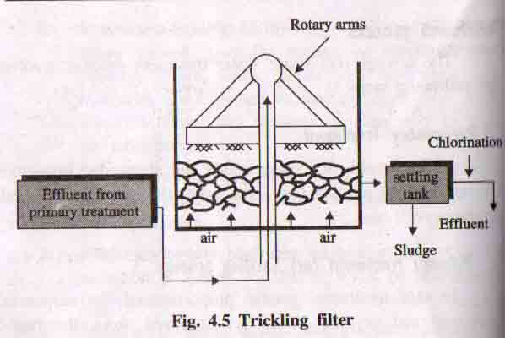

* Trickling filter is a circular tank and is filled with either coarse or crushed rock.
* Sewage is sprayed over this bed by slowly rotating arms.
* The microorganism present in the sewage is growing on the surface of filtering media using organic material of the sewage as food.
* Aerobic oxidation process carried out here.
* After aerobic oxidation the treated sewage is sent to the settling tank and sludge is removed.
* This process is used to remove 80-85% of BOD.

1. Activated Sludge Process

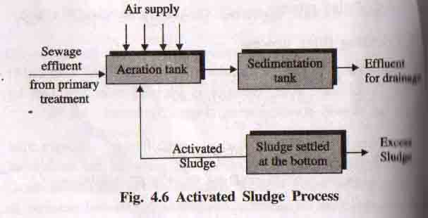

* Activated sludge is biologically active sewage and it has large number of aerobic bacterias it can easily oxidise the organic impurities .
* Sewage effluent from primary treatment is mixed with activated sludge.
* The mixture is aerated in the aeration tank.
* Now the organic impurities are get oxidized by using microorganisms.
* The treated sewage is sent to the sedimentation tank.
* The sludge settle down in this tank called activated sludge.
* This process is used to remove 90-95% of BOD.

4. Tertiary Treatment

* After the secondary treatment, the sewage has a lower BOD (25ppm)
* It can be removed by tertiary treatment
* The effluent is introduced into flocculation tank, where lime is added to remove phosphates.
* The effluent is led to ammonia stripping tower, where pH is maintained to 11 and the NH4 is converted to gaseous NH3.
* Then the effluent is allowed to pass through activated charcoal column, where minute organic wastes are adsorbed by charcoal.
* Finally the effluent gets treated with chlorine (disinfectant) in chlorination tank.

V. Disposal of sludge

Sludge formed from different steps can be disposed by

* Dumping into low-lying areas,
* Burning of sludge (Incineration),
* Dumping into sea,
* Using as low grade fertilizers.

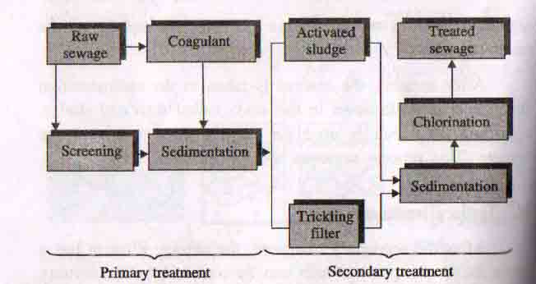

Absorption of Heavy Metals

Heavy metals are chemical elements with 5 times specific gravity of water and atomic number greater than 20.

Sources of heavy metals in the environment:

* Number of heavy metals are present in the environment.
* But some of them are toxic and the rest non-toxic.

Ex:

Mining industry, Chemical and leather industry, thermal power plants etc.

Health effect:

Small amount of heavy metals like antimony, arsenic, bismuth, cadmium, cerium, chromium, cobalt, lead, copper, gold are necessary for good health. But large amount may cause acute or chronic toxicity.

**Removal of Heavy metals by absorption**

Heavy metals present in water can be removed by following process.

**Using Coconut shell carbons:**

Coconut based carbon was used to remove 94% of Cr(IV) solution.

**Using Rice – Husk carbon(RHC)**

* Rice hulls (or) Rice husk is a better adsorbent used in water treatment process.
* It is used for the adsorption of Cr and Zn metal ions.

**Using Fly ash:**

* Fuel (Fly) ash is a very good adsorbents in water purification process.
* Fly ash (or) coal fly ash blends is used for the removal of heavy metals like copper and chromium ion from waste water.

**Using Clay and Coal – based adsorbents:**

* Fullers earth and calcinated kaoline have been used for the removal of Pb and Cd from water.
* China clay was used for the removal of As (III) and Zn (II) from distilled water

**Water treatment Process**

**1.Zeolite (or) Permutit process:**

* Zeolites are naturally occurring hydrated sodium aluminosilicate.
* General formula is Na2O.Al2O3.xSiO2.yH2O(x = 2 -10, y = 2-6).
* Natural zeolites are green sand and non-porous.
* The synthetic form of zeolite is known as permutit which is porous and gel like structure hence it is used for water softening.
* Synthetic zeolite is represented by Na2Ze.
* Sodium ions are loosely held in Na2Ze is replaced by Ca2+ and Mg2+ ions present in water.

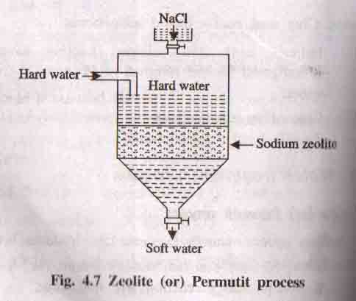

**Process:**

When hard water is passed through a bed of sodium zeolite it exchanges sodium ions with Ca2+ and Mg2+ ions present in hard water to form calcium and magnesium zeolite.

Various Reactions:

Ca(HCO3)2 + Na2Ze → CaZe + 2NaHCO3

MgSO4 +Na2Ze → MgZe + Na2SO4

The softened water contains large amount of sodium salts. It does not cause any hardness but cannot used in boilers.

Regeneration:

After some time zeolite is exhausted and it can be regenerated by treating with 10% solution of NaCl.

Advantages of Zeolite process:

* Water obtained this process will have hardness of 1-2 ppm.
* Method is cheap because the regenerated zeolite can be used again.
* No sludge is formed.
* Equipment is compact and occupy small space.
* Operation is easy.

Disadvantages of Zeolite Process:

* Turbid water cannot be treated, because it blocks the pores of zeolite bed.
* Acidic water cannot be treated, Because it decomposes the structure of zeolite.
* Water containing Fe, Mn cannot be treated, because regeneration is difficult.
* This process cannot be used for softening brackish water, because it contains Na+ ions. So ion exchange reaction will not occur.

Ion Exchange (or) Demineralization process:

* This ion removes all the ions present in the hard water.
* The soft water produced by lime-soda and zeolite process does not contain hardness producing ions like Ca2+ and Mg2+ions, but it will contain other ions like Na+,K+,SO42- , Cl- etc.
* But demineralized water does not contain both anions and cations.
* This process is carried out by ion exchange resins.
* Ion Exchange Resin:
* Ion exchange resins are long chain, cross linked, insoluble organic polymers with micro porous structure.
* The functional groups attached to the chain are responsible for the ion exchanging properties.

**Types of Ion exchange Resins:**

Two types of resins are used.

1.Cation Exchanger

2.Anion Exchanger.

**1. Cation Exchanger**

* Resins containing acidic functional groups like (-COOH, -SO3H) are capable of exchanging their H+ ions with other cautions of hard water.
* It is represented as RH2.

2. Anion Exchanger

* Resins containing basic functional groups (-NH2, -OH) are capable of exchanging their anions with other anions of hard water.
* It is represented as R (OH)2.

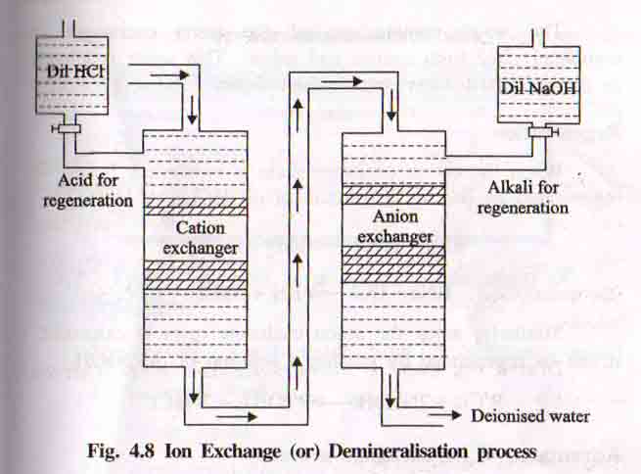

Process:

The hard water first passed through a cation exchange column which absorbs all the cations present in hard water.

RH2 + CaCl2 → RCa + 2HCl

RH2 + MgSO4 → RMg + H2SO4

The cation free water then passed through anion exchange column, which absorbs all the anions present in hard water.

R’(OH)2 + 2HCl → R’Cl2 + 2H2O

R’(OH)2 + H2*S*O4 → R’SO4 + 2H2O

The water coming out from anion exchanger is free from both cations and anions. This water is known as demineralized (or) Deionised water.

Regeneration:

When the cation exchanger is exhausted it can be regenerated by passing a solution of dil.HCl (or) dil.H2SO4.

RCa + 2HCl → RH2 + CaCl2

Similarly when the anion exchanger is exhausted it can be regenerated by passing a solution of dil.NaOH.

R’Cl2 + 2NaOH → R’(OH)2 + 2NaCl.

Advantages of Ion – Exchange process:

* Highly acidic or alkaline water can be treated by this process.
* Water obtained this process have very low hardness(2ppm).

Disadvantages of Ion – Exchange Process:

* Water containing turbidity, Fe and Mn cannot be treated, because turbidity reduces the output and Fe, Mn form stable compound with resin.
* Equipment is costly and more expensive chemicals are needed.

Soil pollution

Soil pollution is defined as*“The contamination of soil by human and natural activities which may cause harmful effects on living things”.*

Composition of Soil

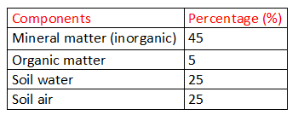

Types, Sources and effects of soil pollution

The major sources of Soil Pollution are

1. Industrial wastes

2. Urban Wastes

3. Agricultural Practices

4. Radioactive Pollutants

5. Biological agents

**1. Industrial wastes:**

Disposal of industrial wastes is the major problem for pollution

**Sources:**

The disposal of industrial waste from Chemical industries like oil refineries, Cement, Sugar factories, dyeing, tanneries Pharma industries, Textiles , Mineral & mining industries, Pulp & paper mills, pesticides, distilleries, fertilizers.

**Effects:**

* Affect and alter the chemical & biological properties of soil
* These pollutants enter into human food chain and causes serious effect on living organisms.

**2. Urban Wastes**

* It comprises both commercial and domestic wastes.
* All urban solid wastes are referred to as refuse.

**Sources:**

The domestic wastages like garbage, vegetables, leaves and commercial wastages like Plastics, Rubbers, Glasses, Metallic cans, Fuel residues, Containers, paper, etc.,

**Effects:**

Disposed into soil become more dangerous

**3. Agricultural Practices**

Modern agricultural practices pollute the soil to a large extent.

**Sources:**

* Fertilizers and pesticides nitrogen, sodium, potassium, sulphate, nitrates, etc.,
* Advancing agro-technology, huge quantities of fertilizers, pesticides, herbicides, weedicides are added to increase the crop yield
* Farm wastes, manure, slurry, debris

**Effects:**

* N-nitrosoamines and nitrosoamides which are powerful carcinogenic agents cause cancer
* Pesticides like DDT, BHC are increase the crop yields and cause soil pollution.

**4. Radioactive Pollutants**

Radioactive substances releases from Nuclear power plants, enter into land and accumulate then create the land pollution.

**Sources:**

* From Nuclear reactor in Nuclear power plants
* Nuclear dust and radioactive wastes by nuclear testing laboratories and industries.

**Effects:**

Radiations which are harmful to plants, animals, humans and aquatics life.

**5. Biological agents**

The biological agents like manures and digested sludge contain fungi, virus, protozoa and bacteria can cause the soil pollution

**Sources:**

* The Human, animal and bird’s excreta
* Municipal garbage, faulty sanitation, etc.,

**Effects:**

* Serious damage to plants life because of virus and worms
* Cause some harmful effect to human and animals

Effects of Soil pollution

1. Sewage waste water contain pathogenic bacteria and viruses enter the soil & spread infections like dysentery, typhoid, cholera, fever etc.,
2. Chemicals containing As, Hg, Cd, Zn, Pb and Fe are enter into food chain which are toxic & cause health problems.
3. Water logging and salinity increases the dissolved salt content in the soil.
4. Sewage and industrial effluent pollute the soil and affect human health.
5. Various fertilizers, pesticides and industrial effluents cause changes in physical, chemical and biological properties of soil.
6. Some toxic chemicals in pesticides reduce soil productivity.

Control measures of Soil pollution

1. Soil erosion can be controlled by verity of forestry & farm activities.
2. The solid waste materials are properly disposed and dumped by closed tanks.
3. Avoid excess use of fertilizer & insecticides.
4. Industrial wastes should be recycled & reused.
5. Nuclear explosions & improper disposal of radioactive wastes should be banned.
6. Proper treatments for effluents before discharge them on the soil.
7. Ban on Toxic chemicals.
8. Decrease of the available farm land due to urbanization
9. Public awareness is used to educate the people about health hazards by environmental pollution.

Solid waste management

“Solid waste management is a planned process of effective control of the production, storage, collection, transportation, processing and disposal of solid waste in acceptable & economic way”.

Types of Solid wastes:

Depending upon the nature, solid wastes are classified into three types.

1. Urban (or) Municipal wastes
2. Industrial wastes
3. Hazardous wastes.

Sources of solid waste

I. Urban Waste

*i.Domestic Waste:* It contains waste from home like food waste, cloth, waste paper, glass bottles, polythene bags, waste metals, etc,

*ii.Commercial Waste:* Waste from shops, markets, hotels and offices, institutions waste paper, packing materials, etc,.

*iii.Construction Waste*: It includes construction material wastes like wood, concrete, debris, etc,.

*iv.Biomedical Waste:* It includes organic material waste like anatomical waste, infectious waste, etc,.

**Characteristics of Urban Waste**

***i.Biodegradable****:* It can be degraded by microorganisms.

**Ex:** Food, vegetable, tea leaves, egg shells, etc.,

***ii.Non- Biodegradable*:** It cannot be degraded by microorganisms.

**Ex:** Polythene bags, scrap metals, glass bottles, etc.,

II. Industrial Waste

*i.Nuclear Power Plants:* It generates radioactive waste.

*ii.Thermal Power Plant:* It produces fly ash in large quantities.

*iii.Chemical Industries:* It produces large quantities of hazardous & toxic wastes.

*ivOther Industries:* It produces also wastes industries like packing, rubbish, scrap metals, glass, wood, etc,.

III. Hazardous Waste

Chemical Manufacturing companies, petroleum refineries, paper mills, smelters, radioactive substances, biological waste and other industries.

Characteristics of Hazardous Waste

***i. Toxic Wastes*:** Poisonous even in very small or traces amounts.

a. Acute toxicity: Immediate effect on humans or animals causing death.

b. Chronic toxicity: Long term effect slowly causing harm to the persons.

***ii. Reactive Waste*:** React with air, water, heat and generate toxic gases.

Ex: Gun powder, nitroglycerine, etc.,

**iii. *Corrosive Waste****:* Destroy materials and living tissues by chemical reaction.

Ex: Acids, bases.

***iv. Radioactive Waste:*** From Nuclear power plants & persist in the environment for long time.

***v. Infectious Waste:*** It causes infection to others

Ex: used bandages, surgery waste, needles, etc.,

***vi. Heavy metals*:** Lead, mercury & arsenic are hazardous substances.

Effects of solid waste (or) Effects of improper solid waste management

* Solid waste produces foul smell, mosquitoes spread diseases like malaria & dengue.
* Industrial solid wastes which affect the soil characteristics .
* The solid wastes leaching into the water, causes of killing of fishes & other organisms.
* Toxic chemical substances may percolate into the ground and contaminate the ground water.
* Burning of solid wastes (Eg: plastics) produce toxic fumes which harmful to human beings.
* Solid waste dumped into water body may cause floods that will affect roads and trains.

Solid Waste management (or) Waste shed Management

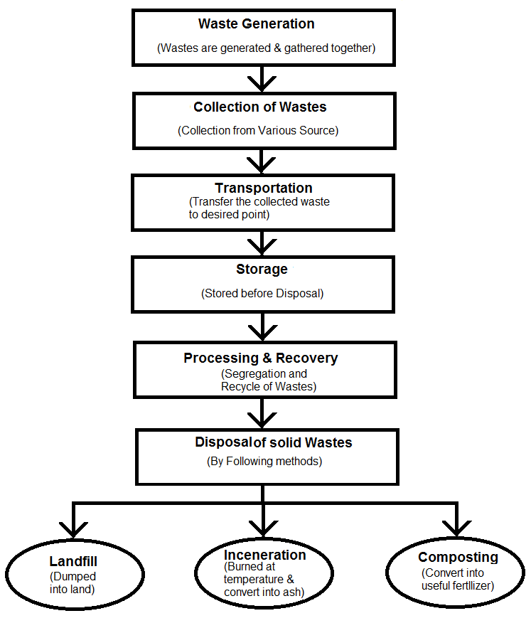

The important steps of solid waste management

I. Reduce, Reuse and Recycle (3R)

*i.Reduce the Raw material usage:* If the usage of raw materials are reduced, the generation waste also get reduced.

*ii.Reuse of Waste materials:* Reuse the materials as possible way.

Ex: rubber rings from discarded cycle tubes can reduce the waste generation during production of rubber bands, refillable containers can be reused after discarded.

*iii.Recycling of materials:* Reprocessing of the discarded materials into new useful products.

**Ex:** i) Preparation of new cans and bottles from old aluminum cans and glass bottles.

ii) Preparation of fuel pellets from kitchen waste.

II. Discarding Wastes

The following disposal methods are in discarding the solid wastes.

Disposal Methods of Solid waste

1. Landfill
2. Incineration
3. Composting

1. Landfill

* The solid wastes are dumped into land by land filling
* Solid wastes are placed in sanitary landfill system in alternate layers of 80 cm thickness of refuse.
* Covered with selected earth fill of 20 cm thickness.
* After 2 or 3 days solid wastes volume shrinks by 25-30%.
* Then the land is used for parks, roads, small buildings etc.

Advantages

* Simple and economical.
* Segregation is not required.
* Landfill areas can be used for other purposes.
* Natural resources are retained to the soil.

Disadvantages

* Large area is required.
* Transportations cost is heavy.
* Bad odors, if landfill is not properly managed.
* Insecticides, pesticides should be applied at regular intervals.
* Causes of fire hazards due to formation of methane.

2. Incineration

* In this method combustible substances (rubbish, garbage, dead organisms) & non-combustible substances (glass, porcelain, metals) are separated first.
* The combustible waste substances are first dried in a preheater.
* Then it is taken in large incinerating furnaces which incinerate about 100 to 150 tonnes per hour.
* The fuel gases and oxygen mixture is allowed to pass for the efficient burning of the waste (refuse) materials.
* The temperature is maintained between 700oC to 1000oC
* The left out ashes & clinkers from the furnace is further disposed by landfill method and the wastes gases get out through the chimney.
* The heat produced in the incinerator is used for generating electricity though turbines.
* The non combustible substances are left out for recycling & reuse.

Advantages:

* Require little space.
* Cost of transportation is not high.
* Safest and hygienic.
* Capacity 300 tonnes per day and can generate 3MV of power.

Disadvantages:

* Capital and operating cost is high
* Need skilled persons
* Formation of smokes, dusts, and ashes causes air pollution

3. Composting

* In this method the bulk organic waste is converted into fertilizer by biological action.
* The separated compostable waste is dumped in underground trenches(1.5m)
* Covered with earth of 20 cm and left over for decomposition
* Micro organism (actinomycetes) is introduced to start decomposition.
* After 2 or 3 days the organic waste are destroyed by micro organism and produce heat
* Composting will happen at 75oC
* Finally the refuse can converted to powdery brown colored odorless mass called Humus(fertilizer).
* It contains lots of nitrogen, essential for plants growth apart from phosphates and other minerals.

Advantages:

* It can be sold thereby reduce the cost of disposing the wastes.
* Recycling occurs.
* Increase of water retention and ion exchange character of soil.
* Number of industrial waste can also be treated by this method.
* Manure can be produced.

Disadvantages:

* The non consumable has to be disposed separately.
* The usage of this compost manure is not yet reached the knowledge of all farmers.
* No assured market.

Marine Pollution

Marine pollution is *“The discharge of waste substances into the sea, resulting in harm to living resources, hazards to human health, hindrance to fishery and impairment of quality for use of sea water”*

Sources of marine Pollution

i.Dumping the wastes: Huge amounts of sewage, garbage, agricultural discharge, pesticides, heavy metals, plastics are dumped in sea.

Effects: So many marine birds are affected by gastro-intestinal disorders.

ii.Oil pollution of Marine water (oil spilling) : Caused by petroleum and its products.

Effects: Oil films inhibit photosynthesis & formation of oxygen. This inhibit the growth of marine plants

Effects of marine pollution

1. Dumping the commercial wastes and domestic wastes are affecting marine resources.
2. Detergents used to clean up the spill are also harmful to marine life.
3. Fishes die because the slimy mucus of gills is affected by oil.
4. Oil spilling causes low body temperature in birds resulting in hypothermia.
5. Oil films decreases the rate of oxygen uptake by water.
6. Cause damage to marine fauna & flora including algae, fish, birds, invertebrates
7. Oil films inhibit photosynthesis & inhibit the growth of the plants
8. Hydrocarbon & benzpyrene accumulate in fish & consumption of fish by man cause cancer.

Control measures of marine pollution

1. Toxic pollutants from industries and sewage treatment plans should not be discharged in coastal areas
2. Dumping of toxic, hazardous wastes and sewage sludge should be banned
3. Municipal waste, domestic waste and industrial waste should be treated before being allowed to mix with the sea
4. People should be educated about marine ecosystem and the benefits offered by them
5. Proper plans for conserving marine biodiversity must be taken into account of human needs
6. The public beaches have to be maintained in a neat manner to meet hygienic and tourism value
7. The industries near the coastal area should be equipped with pollution control instruments and waste water facilities
8. Oil spillage and drilling near coastal areas should be reduced.
9. Local communities must be involved in protecting and managing their coastal resources.

Noise Pollution

Noise pollution is defined as *“The unwanted, unpleasant (or) disagreeable sound that causes discomfort for all living things”.*

Unit of Noise: Decibel

Sound intensity is measured in decibel (dB), which is one tenth of the longest unit Bel. One dB is equal to the faintest sound, a human ear can hear.

Noise level:

* Normal conversation sound ranges from 35dB to 60dB.
* Impairment of hearing due to the noise exposure 80dB or more.
* Noise above 140dB becomes painful.

Source of Noise Pollution

1. Natural sources – Natural disasters

Ex: Cyclone, storm, earthquake, volcanic eruptions.

1. Industrial Noise -The different machines operating factories.

Ex: drilling sound, mechanical saws

1. Transport Noise - Road traffic noise, rail traffic noise and air craft noise
2. Neighborhood Noise- Household gadgets and community

Ex: Musical instruments, TV, VCR, Radios, telephones, loudspeakers

Effects of Noise Pollution

1. It causes High BP, mental stress, heart attacks, neurological problems and birth defects
2. It may damage to heart, brain, kidneys, liver & produce emotional disturbance
3. It cause damage of some part of auditory system and chronic damage to inner ear hair cells
4. This affects human health, comfort and efficiency.
5. It causes hearing loss, hyper tension, sleeplessness, blood pressure changes, etc.,
6. Impulsive noise also causes psychological and pathological disorders.
7. Brain is also adversely affected by loud and sudden noise as that of jet and aero plane noise.
8. Ultrasonic sound can affect the digestive, respiratory, cardio vascular system.
9. Blood is also thickened by excessive noises
10. Optical system is also affected by noise pollution & lead to colour perception & loss of night vision

Control measure of Noise Pollution

1. Selection of Machinery- It does not create more sound.
2. Sound absorbing materials -Suitable sound absorbing materials like felt, acoustical tiles
3. Plantation of Trees -Plantation of trees on road sides, parks can reduce the noise level.
4. Oiling – Proper oiling will reduce the noise from the machines.
5. Noise can be reduced by prescribing noise limits for vehicular traffic
6. Make the design of noise proof buildings
7. Reduce the traffic density in residential areas
8. Giving preference to mass public transport system
9. Reduction in sources of noise such as old vehicles and machines.

Thermal Pollution

Thermal pollution is defined as *“The addition excess heat to water that changes the physical, chemical and biological characteristics of water”.*

Sources of Thermal Pollution

i. Nuclear Power Plants - Discharged larger amount of heat from nuclear experiments & explosions, emission from nuclear reactors.

ii.Coal-Fired Power Plants- It may increase the temperature of lake or river up to 15°C.

iii. Industrial Effluents - Power stations discharged hot water .It increases temperature from 8-10°C.

iv.Hydro-electric Power Plants- Its cooling arrangements also causes thermal pollution.

v. Domestic sewage - Municipal sewage has higher temperature which decreases the dissolved oxygen content &result in foul & offensive smell in water.

Effects of Thermal Pollution

1. Reduction in Dissolved Oxygen: Concentration of dissolved oxygen (DO) decreases and increases the oxygen demand
2. Increase in Toxicity: The rising temperature increases the toxicity of the poison present in water.
3. Interference with biological activities: Temperature affects physiology metabolism and biochemical process in controlling respiratory rates, digestion, and excretion.
4. Interference with reproduction: In fishes, several activities like nest building, hatching, migration and reproduction.
5. Effect of marine life: Increasing temperature affects physiology, metabolism, growth.

Control measures (or) management of Thermal Pollution

1. Cooling towers:

1. The hot water coming out from reactor is sprayed through cooling towers through air
2. It transfer the heat from hot water to surrounding atmosphere by evaporation
3. The cold water is collected in a container is returned back to water system

Two types of cooling towers

a.Wet Cooling Tower:

* The hot water from reactor is allowed to spray over baffles
* Cool air, with high velocity is passed from sides, which takes away the heat and cools the water.

|  |  |
| --- | --- |
|  |  |

b.Dry Cooling Tower:

* The hot water from reactor is allowed to circulate in a long spiral pipes
* Cool air is passed with the help of fan, over this hot pipes, which cools down the hot water.

2. Cooling ponds:

* This is a simplest method to reduce temperature
* The heated effluents on the surface of water in cooling ponds maximize dissipation of heat to the atmosphere
* This warm water act as a cooling pond

3. Artificial lakes:

* The heated effluent from thermal power plants is discharged directly in to artificial lakes at one end
* While the cooled water is transferred back to water system from the other end
* Heat is eventually dissipated through evaporation.

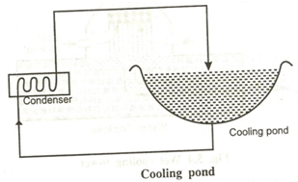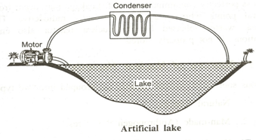

NUCLEAR HAZARDS (POLLUTION)

Radioactive Pollution is caused by “natural as well as artificial radiation from radioactive materials”

Sources of Nuclear Hazards

1. Natural Sources - Sun, soil, rocks, air, water, food ..,may contain radioactive substances
2. Man- made sources- nuclear power plants, X-rays, nuclear accidents, nuclear weapons.

Effects of Nuclear Hazards

1. After nuclear explosion the nuclear waste materials settle down on earth’s surface can cause heavy damage to human, animals and plants
2. Radioactive radiation affects the macromolecules such as DNA, RNA cells in the human body and also function of glands and organs
3. The exposure of high radiation, people is affected from blood cancer, bone cancer, brain damage, deformities etc.,
4. Radiation sickness is marked by vomiting and bleeding of the gums
5. Its creates mouth ulcer, red spots on the skin
6. Internal bleeding and blood vessel damage, severe burning of eyes, coughing and gastrointestinal problem

Control measure of Nuclear Hazards

1. Nuclear devices should never be exploded in air, they should be exploded underground
2. Leakage of radioactive materials from reactors and testing laboratories should be carefully checked.
3. Minimum number of nuclear installations should be prescribed
4. Radioactive liquid wastes are stored in multi layer concrete tanks and buried into underground
5. In nuclear mines wet drilling may be employed
6. In nuclear reactor closed cycle coolant system may be used
7. Fission reactions should be minimized
8. Disposal methods are the possible ways to distribute the radioactive pollutants.

Disposal methods of Radioactive Wastes

Nuclear wastes are disposed is strictly controlled by International agreement

1.High level wastes (HLW)

It has high radioactive per unit volume

They have cooled and stored for several decades before disposal

It is too dangerous, so it should be converted in to inert solid (ceramics) and buried deep in to earth

**Example:** Spent nuclear fuel

2.Medium level wastes (MLW)

MLW are solidified and *mixed with concrete in steel drums before being buried* in deep mines or below sea bed in concrete chambers

**Example:** Filters, reactor components

3.Low level wastes (LLW)

LLW are disposed off in steel drums in concrete chamber

**Example:** Solids or liquids contaminated with traces of radioactivity 24

**Role of an individual in prevention of pollution (Answer for 12th question)**

* The proper implementation and especially the individual participation are the important aspects which used to reduce the pollution
* Each individual has responsibility to product environment in such a way that reduce environmental pollution
* The individual participation is useful in law making processes and restraining the pollution activities
* A small effort made by each individual at his own place will have pronounced effect at the global level
* Pollution prevention can increase the economy of the country

**Role and responsibility of individual participation in environmental protection**

* Plant more trees in all places
* Help more in pollution prevention than pollution control
* Use water, energy and other resources efficiency
* Purchase recyclable, recycled and environmentally safe products
* Use natural gas than coal and petroleum
* Production the forests and reduce deforestation
* Use eco friendly products
* Use CFC free refrigerators
* Use rechargeable batteries
* Increase use of renewable resources
* Remove NOX from motor vehicle exhaust
* Reduce garbage, rubbish by recycling and reuse
* Use organic manure instead of inorganic fertilizers
* Use office machines in well ventilated areas
* Don’t use non-biodegradable substances like plastics and polystyrene, etc
* Use less polluting substitutes for harmful cleaning agents, paints and other products
* Reduce the population growth
* Environmental education should be given in primary to higher classes

**Role of Women in environmental protection**

* Women also play an important role in environmental production
* Considering their status in social production, consumption and their influence to future generations at home
* Various roles of women about environmental protections are
* In rural areas, women plant trees and grass, grow vegetables
* In urban areas, they go shopping using cloth bags to reduce pollution
* Women refuse to use disposal products to save energy and resources
* Women choose green products instead of poor quality that harm the environment
* Women reduce the amount of trash they dispose off so as to recycle natural resources
* Women buy non-phosphate detergents to reduce the incidence of water pollution
* They refuse to eat meat, so variety of animals are preserved
* They value paper and thus protect trees
* Women bring the concept of environmental protection into families and thus plant a green seed in the heart of children.

...............................................