COMPUTER NETWORKS
UNIT –I
Definition:
- A Collection of autonomous Computers Inter connected by a simple technology, two computers are set to be interconnected, if the are able to exchange information.
- The connection may be use copper wire, fiber optics, microwave, and infrared or communication satellite.
Data communications:
- Data communications are the exchange of information (data) between two devices via some form of transmission medium such as a wire cable.
- For data communication to occur, the communicating devices must be part of a communication system made up of a combination hardware and software.
Fundamental characteristics of effectiveness of data communication:
- Delivery
- Accuracy
- Timeliness
- Jitter
Delivery:
  - The system must delivered data to the correct destination.
  - Data must be received by the intended device (or) user.
Accuracy:
  - The system must deliver the data accurately, data that have between altered in transmission and left uncorrected are unusable.
Timeliness:
  - The system must delivered data in a timely manner, data delivered late are useless
  - For example in the case of video and audio, timely delivery means delivery data as they are produced and without significant delay, it is called real-time transmission.
Jitter:
  - Jitter refers to the variation in the packet arrival time, it is the uneven delay in the delivery of Audio (or) video packet.
Components:
- A data communication system has five components
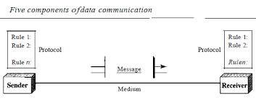
- Message
- Sender
- Receiver
- Transmission medium
- Protocol
Message:
  - The message is the information (data) to be communicated.
  - Popular forms of information include text, numbers, pictures, audio and video.
Sender:
  - The sender is a device that sends that data message; it can be a computer, telephone handset, Video camera.

Receiver:
    - The receiver is a device that receives the message; it can be a computer, telephone handset, television.
Transmission medium:
    - The transmission medium is the physical path by which a message travels from sender to receiver.
    - Some example of transmission medium include twisted pair cable, co-axial cable, fiber-optic cable and radio waves.
Protocol:
  - A protocol is a set of rules that govern data communication.
  - It represents an agreement between the communicating devices, without a protocol two devices may be connected but not communicating.
Data representation:
- Text
- Numbers
- Images
- Audio
- Video
Text:
- In Data communications text is represented as a bit pattern (0’s or 1’s).
- Different sets of bit patterns have been designed to represent text symbols.
- ASCII (American Standard Code for Information Interchange):
- ANSI (American National Standard Institute).
Numbers:
- Numbers are also represented by bit patterns.
- ASCII is not used to represent numbers.
- The numbers is directly converted to a binary number.
Images:
- Images are also represented by bit pattern.
- An image is composed of a matrix of pixels.
Audio:
- Audio refers to the recording or broad casting of sound or music.
- Audio data is naturally differ from text, numbers or images,
- It is continuous not discrete.
Video:
- Video refers to the recording (or) broad casting a pictures or movie.

Data flows:
Communication between two devices can be
- Simplex
- Half – duplex
- Full – duplex(duplex)
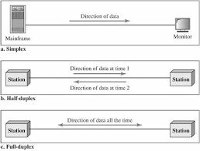

Simplex:
- The communication is unidirectional, as an a one way street, only one of the two devices on a link can transmit, the other can only receive.
Example:
- Keyboard
- Traditional monitor
Half-duplex:
- It is like a one lan road with traffic allowed in both directions but not simultaneously.
Example:
- Small bridge,
- Walkie-talkie.
Full – duplex (duplex):
- It is also called duplex in this method both station can transmit.
- The full duplex mode is like a two way street with traffic in both direction at the same time.
Example: telephone line
Networks:
- A network is a set of devices (node) connected by communication link.
- A node can be a computer, printer or any other device capable of sending and receiving data.
Distributed processing:
- Most network used distributed processing, in which a task is divided among multiple computers, instead of on single large machine being responsible for all aspect of a process.
Network criteria:
- Performance
- Reliability
- Security
Performance:
- Performance can be measured in many ways, including transits time and response time. Transits time is the amount of time required for a message to travel one device to another.
Response time:
- Response time is the elapsed time between an enquiry and a response.
- The number of uses, the type of transmission medium, capacity of hardware and the efficiency of the software.
Reliability:
- To accuracy of delivery, network reliability is measured by the frequency of failure.
Security:
- Network security includes protecting data from unauthorized access, protecting data from damage.
Types of connection:
- Point-to-point
- Multi point
Point-to-point:

- A dedicated link between two devices.
- The entire capacity of the link reserved for transmission between those devices.
Multi point:
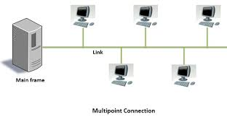

- A multi point connection is one in which more than two specific devices shared a single link.
- Several devices can use the link simultaneously.

Topology:
- It refers to the structure of the network.
- Two (or) more devices connect to link two or more link form a topology.
- Topology of the network is the geometric representation of the relationship of all kinds of link and linking devices.
Types of topology:
- Mesh topology
- Star topology
- Tree topology
- Bus topology
- Ring topology
- Hybrid topology
Mesh topology:
- Any device has a dedicated point to-point link to every other device.
- The term dedicated means that the link carries traffic only between the two devices.
- A fully connected mesh network has [n(n-1)/2] physical channel to link end device.
Diagram:
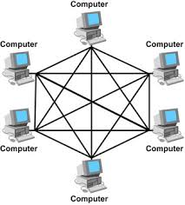
- To accommodate that many link every device on the network must have n-1 input, output port.
Advantages:
- It eliminates the traffic problem.
- Then the reason in dedicated link guarantees that each connection can its own data.
- A mesh topology is robust.
- If only link becomes unusable, it does not affect the entire system.
- Its privacy (or) security when every message send travel along dedicated line, only intended recipients see it
- Fault identification and fault isolation is easy.
Disadvantages:
- They amount of cabling and the number of input, output path required.
- Every device must be connected to every other device, installation and reconfiguration are difficult.
- The hardware required to connected each link can use expensive.
- A mesh topology is usually implemented in a limited fashion.
Star topology:
- Each device has a dedicated point to point link only to the “central controller” usually called a “HUB”.
- The devices are not directly linked to each other.
- It does not allow direct traffic between devices.
- The central controller act as an exchange machine.
Diagram:
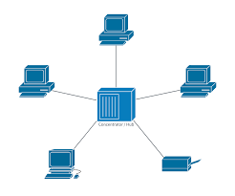
Advantages:
- Less expensive
- Easy to install and reconfigure.
- Robustness
- Easy fault identification and fault isolation.
Disadvantages:
- If the “HUB” is failure than the entire network will failed.
Tree Topology:
- It is a variation of star Topology.
- Node in a tree is linked to a central HUB that controls the traffic.
- Not every device plug directly into the central HUB.
- The majority of a device connects to a secondary then in term is connected to the central HUB.
- The central “HUB” in the tree is a active HUB.
Diagram:
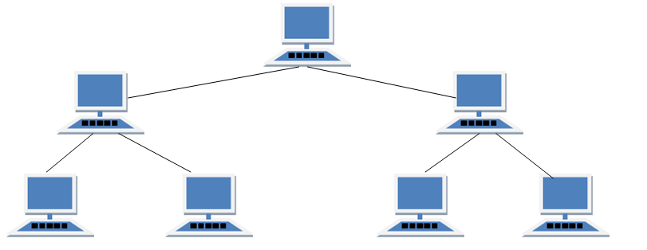
Advantages:
- Less expensive
- Easy to install and Re-configure
- Robustness
- Easy fault identification and fault isolation.
- It allows more devices to be attached to a single central HUB.
- The signal can travel long distance.
Disadvantages:
- If the central HUB is failure then the entire network will failed.
Bus topology:
- It is a multipoint configuration, one long cable act a backbone to line all devices in the work station.
- Nodes are connected by drop lines and taps
- Drop line is a connection running between the device and the main cable
- Tap is a connector.
Diagram:
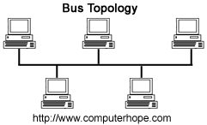
- As a signals travel along the backbone, some of its energy is transformed into cable, therefore it’s become weaker and weaker.
- For this reason there is a limit on the number of devices
Advantages:
- Easy installation.
- Backbone cable is a most efficient path.
Disadvantages:
- Difficult reconfiguration and then fault isolation.
- Adding new devices required modification or replacement of the backbone.
- The fault is make in the bus cable stops all transmission.
Ring topology:
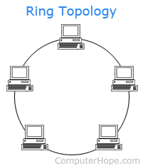
- In a ring topology each device has a dedicated point-to-point link configuration only with two devices on either side of it.
- A signal is passed along the ring in one direction from device to device, until it reaches its destination.
- In a ring, a signal is circulating at all times if one devices not receive signal with in a specific period it can issue an alarm, the alarm alert the network operator to the problem and its location.
Advantages:
- Easy to install and Re configuration
- Easy fault isolation.
Disadvantages:
- Uni-directional traffic.
- Break in the ring can visible the entire network.
Hybrid topology:
- Network combines several topologies is as sub network linked to together a larger topology.
- Ex: one department may use bus topology while another department has a ring topology; the two can be connected to each other via a central controller in a star topology.
Diagram:
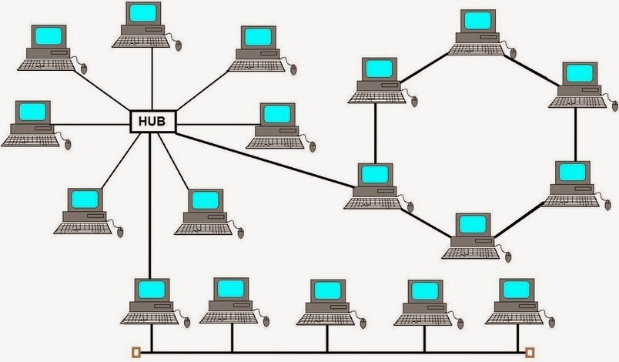
Types of network:
- Local area network(LAN)
- Metropolitan area network(MAN)
- Wide area network(WAN)
Local area network (LAN):
- Local area networks are generally called LAN’s or privately owned network, within a single building or campus of up to few kilometers insides.
- They are widely used to connect personal computers and workstation in company offices and factories to share resources and exchange information (for example printer).
- LAN’s are differentiating from other kind of network by the three characteristics.
- Size
- Transmission technology
- Topology
Single building LAN:

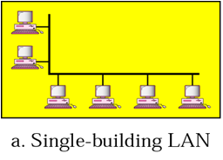

Multi building LAN:
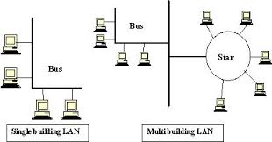

Size:
- LAN’s are restricted in size LAN’s size is limited to a few kilometers.
Transmission technology:
- Transmission technology consists of a cable to which all the machines are attached like a telephone company party lines are used in village areas.
- Traditional LAN’s run at speed of 10 MBPS(Mega Bytes per second ) to 100 MBPS, now LAN’s operate at up to 10 GBPS.
Topology:
LAN supported three types of topology.
- Bus
- Star
- Ring
Metropolitan area network (MAN):
- MAN’s cover the city then best known example is cable television network available in many cities.

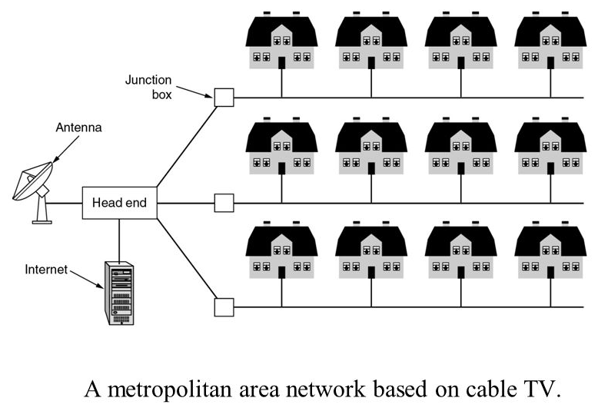
- In early days antenna system used in area with poor over the air, television reception.
- Now a days a large antenna was placed on top of a near by hills and signal was that fibered to the subscriber house.
- It may be single network such as cable television network (or) connecting a number of LAN’s.
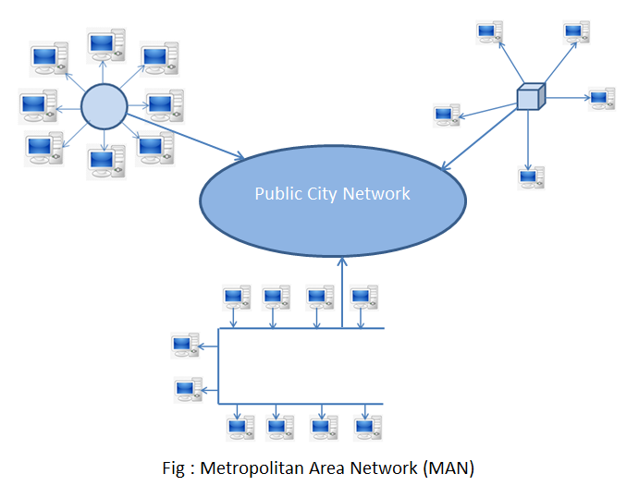
Wide area network:
- It is provide long distance transmission of data, voice, image and video information.
- Over the large geographical areas, such as country, continent.
- It may be a public, leased (or) private communication devices.
- It contains a collection of machines intended for running user application, this machines are called host.
- The host are connected by a communication subnet, the host owned by the customers, for example (personal computer).
- The job of the subnet is to carry the messages from host to host just as the telephone system carries words from speaker to listener.
- In most wide area networks the subnet consists of two components.
- Transmission lines
- Switching lines

Transmission lines:
- Transmission line move bits between the machines, the can man be copper wire, co-axial cable fiber optics.

Switching elements:
- Switching elements are specialized computers that connect three (or) more transmission lines.
- The data arrive in one incoming line, the switching element must choose on outgoing line on which to forward then
- These switching computers is called router.

Network models:
- Network is a combination of hardware and software that send data from one location to another.
- The hardware consist of the physical equipment that carries signals from one point of the network to another
- The software consists of instruction sets that make possible the services that we expect from a network.
Layered task:
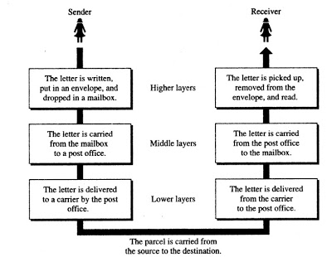
- In the above diagram we have a sender, receiver and a carrier that transport the letter.

Sender side:
Higher layer
- The sender writes the letter, insert the letter in a envelope, write the sender and receiver address and drop the letter in a mailbox.
Middle layer:
- The letter is picked up by a letter carrier and delivered to the post office.
Lower layer:
- The letter is stored at the office, a carrier transport the letter.
Receiver side:
Lower layer:
- The carrier transports the letter the post office.
Middle layer:
- The letter is stored and delivered to the recipients.
Higher layer:
- The receiver pickup the letter,open the envelope and read it.

Reference model:
- OSI (open system interconnection)
- TCP/IP(Transmission protocol/internet protocol)

OSI reference model:
- It is developed by international standards organizations (ISO)this model is also called the ISO, OSI (Open system interconnection) reference model.
- Open system model that allows any two different system to communicate.
- The purpose of OSI model is to open communication between different system without changing its hardware and software.
Principle:
- A layer should be created where a different abstraction s needed.
- Each layer should perform a well defined function.
- The function of each layer should be defined internationally, standardized protocol.
- The layer boundary choosen to minimize the information flow across the interface
The model:
- The OSI reference model is a layered framework, it provide a communication between all types of computer system.
- It consist of seven separate but related layers, each layer define a process of moving into the network.
Types of layer:
- Layer1: application layer
- Layer 2:presentation layer
- Layer3: session layer
- Layer4: transport layer
- Layer5: network layer
- Layer 6:datalink
- Layer7:physical layer
Diagram:
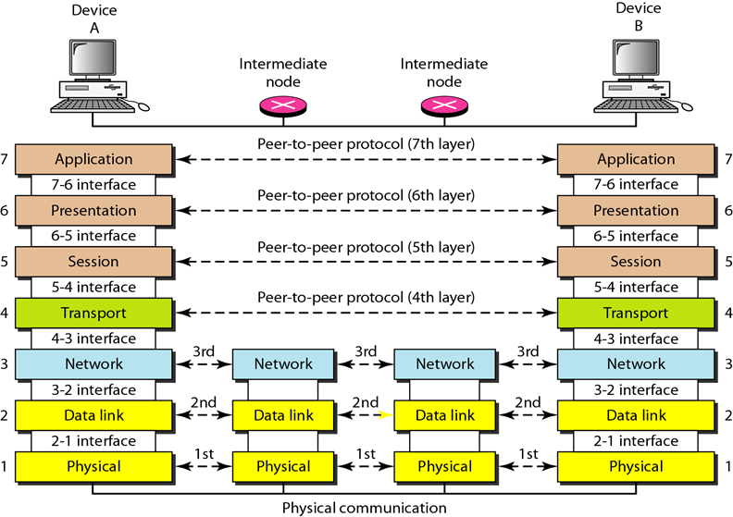
Function of the layer:
Physical layer:
- It deals with mechanical electrical and timing interface.
- It’s concerned with transmitting raw bits over a communication channel
- Bit 0’s and 1’s is used, if sender send a one bit to receiver, the receiver the same one bit not as ‘0’ bit.
- It deal with how many volt should be used to represent a one bit and how many for ‘0’ bit, how many Nanosecond a bit used, whether transmission may proceed simultaneously in both direction, how the initial connection is established and how its closed when both side are finished, how many pins the network connected have and what each pin is used for.

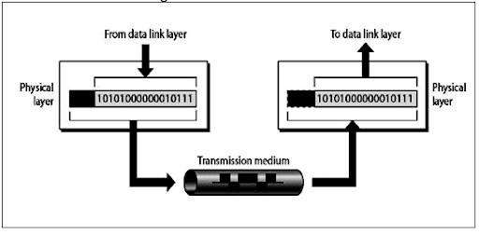
Data link layer:
- The main task of the datalink layer is to transform a raw transmission facilities into a line that appears free of undetected transmission errors to the network layer.
- To accomplish this task by having the sender breakup the input data into data frames and transmit the frame sequence.
Frame:
- The datalink layer divide the stream of bits into manageable data unit is called frame.
- If the service is reliable, the receiver conform correct receipt of each frame by sending back on acknowledgement frame.
- Another important issued is how keep a fast transmitter from a slow receiver
- In data, some traffic regulation mechanism is needed to let then transmitter know how much buffer space is the receiver has at the moment.
Network layer:
- The network layer controls the operation of the subnet, it deals with determining how the pockets are routed from source to destination.
- The network layer ensure that each pocket gets from its point of origin to destination.
- If the two system are connected to the same link there is no need for a network layer, otherwise two system are attached to a different network with connecting device between the network, there is a need for the network layer to accomplish source to destination delivery.
- If the system are connected in different network we need logical addressing it is used to differentiate the source and destination system.
Transport layer:
- Transport layer is a true end to end layer.
- The basic functions at the layer is to accept data from above, split it up into smaller units, it need to be pass to the network layer the transport layer also determine what types of service to provide session layer and user of the network.
- The most popular types of transport connection is an error free point to point channel, that delivered message in order in which the where send.
Session layer:
- The session layer allows were an different machines to establish session between them
- Various services include:
- Dialog control
- Token management
- Synchronization
Dialog control:
- It keeping track of whose to transmit the data.
Token management:
- Preventing to parties from attending same critical operation at the same time.
Synchronization:
- Check pointing long transmission to allow them to continue from where often a crush.
- It allows a process to add check points into a stream of data.
Example: file size=3000 pages.
- Set check point = after every 100 pages.
- Each 100 pages unique is received and acknowledged independently.
Presentation layer:
- Presentation layer is deal with the syntax and semantics of the information transmitted.
- In order to make it possible for computers with different data representation to communicate.
- Standard encoding technic is used.
- Example: banking records.
Application layer:
- It enables the user to access the network. It provides user interface and support for the services, such as electronic mail, remote file access and transfer, shared database management system.
- The application layer contains a variety of protocols that are commonly needed by user, widely used application protocols is http.
- When a browser want a page, it send the name of the page, the server using http and the server send the page back.
- FTP – file transfer protocol.
- SMTP – simple mail transfer protocol.
- HTTP – hyper text transfer protocol.

TCP/IP Reference model (or) TCP/IP protocol Suite:
Introduction:
- OSI Reference model is a ground parent of all wide area computer network.
- The existing protocols, had trouble in internetworking so, anew reference architecture was needed.
- This architecture later becomes known as TCP/IP reference model.
Diagram:
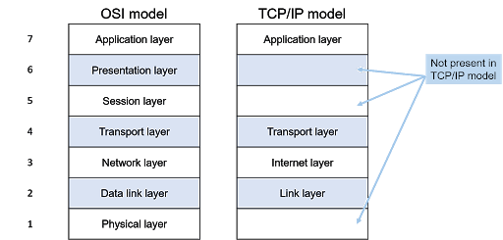
Internet layer:
- Internet layer is a linch pin that hold the whole architecture, it’s to permit host to inject packet into any network and have them travel independently to the destination, the may even arrive in a different order than they were send, the higher layer to rearrange them.
- A best analog example is postal mail system.
- The internet layer defines an official packet format and protocol called IP [Internet protocol].
- The job of the internet layer is to delivered internet protocol packet.
- Packet routing is clearly the major issue in the transaction; TCP/IP internet layer is similarly in functionality to the OSI network layer.
Transport layer:
- The layer above the internet layer in the TCP/IP model is usually called the transport layer.
- It is designed similar to transport layer in the OSI reference model.
- In this layer have two end-to-end transport protocols.
1. TCP – Transmission control protocol
2. UDP – user datagram protocol
TCP(Transmission control protocol):
- TCP is a reliable connection oriented protocol that allows a byte stream originating on one machine to be delivered without error on other machine in the internet.
- It fragment the incoming byte stream into discrete messages and passes each one on the internet layer, at the destination the receiving the received message into the output stream.
- TCP also handle flow control.
UDP(user datagram protocol):
- UDP is an unreliable connection less protocol for applications.
- Similar to client server model, request reply
- Example is transmitting video or speech.
Application layer:

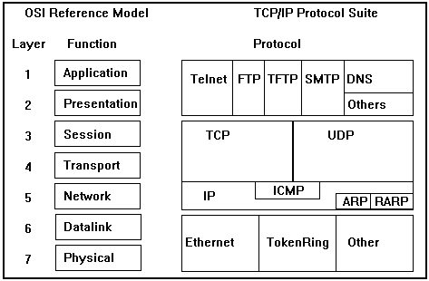

- TCP/IP model does not have a session layer and presentation layer on the top of the transport layer is the application layer, it contains all the higher level protocols.
- It is included virtual (TELNET) FTP and email (SMTP).
- Virtual terminal protocol allows a user on one machine to log an to a distance machine.
- FTP protocol provides a way to move data efficiently from one machine to another machine.
- SMTP is used to send electronic mail (or) email.
- The DNS for mapping host name on to the network address.
Host–to- network- layer:
- It is placed in below the internet layer
- It can send the data in the form of IP packet.
- This protocol is not defined and varies from host-to-host and network-to-network.
Multiplexing:
- Multiplexing is a set of technic that allows the simultaneous transmission of multiple signal across a single data link
Diagram:
- Multiplexing scheme can be divided into three basic category.
1. Frequency division multiplexing (FDM)- ANALOG
2. Wavelength division multiplexing (WDM)-ANALOG
3. Time division multiplexing (TDM)- DIGITAL
Frequency division multiplexing (FDM) analog:
- The frequency spectrum is divided into frequency bandwidth, each user having exclusive portion of some band.
- Ex: AM radio broadcasting.
- The allocated spectrum is about one MHz roughly 500 KHz to 1500 KHz
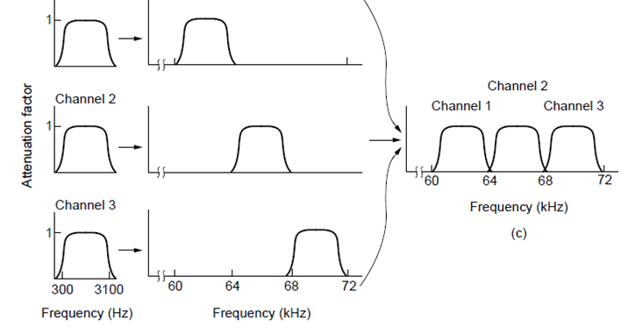
Wavelength division multiplexing (WDM)-analog:
- Frequency division multiplexing can be applied to fiber optics cable is called wavelength division multiplexing.

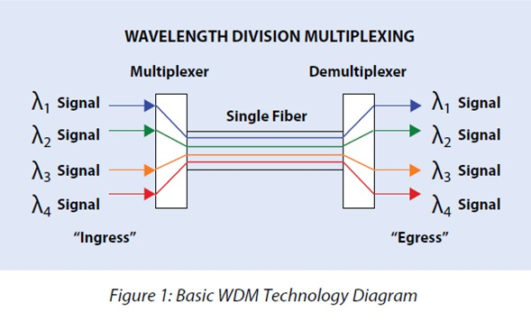

- The above diagram four fiber come together at on optical combiner each will energy present at a different wavelength, therefore beam are combined on to a single shared fiber for transmission to a distance destination.
- At the end, the beam is split up over as many fibers as there where on the input side.
- The frequency can be multiplexing together on the long haul fiber
- Wavelength division multiplexing invented around 1990’s it is commercial system had eight channel of 2.5 gbps per channel.
- In 1998 the system width 40 channels of 2.5gbps, in 2001 96 channels of 10 gbps.

Time division multiplexing (TDM) digital:
- In time division multiplexing user take each one periodically getting the entire bandwidth for a little burst of time.
- Ex: AM radio broadcasting
- In some countries, the individual stations have to logical sub channel, for example music and advertising.
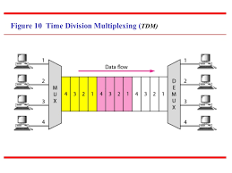
- This to alternate time and the same frequency, first burst of music, then a burst of advertising, this situation is time division multiplexing (TDM).
- TDM can be handled entirely by digital electronics, so it can only we used for digital data.
- The local loop produce analog signal so a conversion is needed from analog to digital in the end office.
Transmission media:
- A transmission medium can be defined as anything that can carry information from a source to a destination.

- Transmission types:
- Guided transmission media(wired)
- Un guided transmission media(wireless)

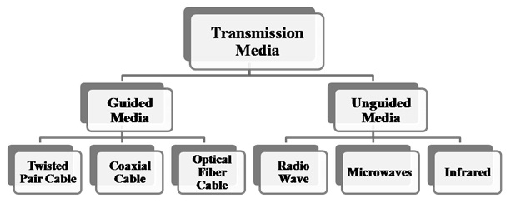
Guided transmission media:
- The purpose of physical layer is to transmit the raw bits stream from one machine to another machine.
- Various physical medium can be used for the actual transmission.
Types of guided transmission medium.
- Magnetic media
- Twisted pair cable
- Co-axial cable
- Fiber optics
Magnetic media:
- One of the most common way to transport data from one computer another is to write them on to magnetic tape(or) removable media.
- Physically transport the tap or disk to the destination machine and read them backing again.
- This method is not as sophisticated method of communication it is often more cast and process is delay.
Twisted pair cable:
- Many applications need online connection one of the oldest and still most common transmission medium is twisted pair cable.
- An twisted pair cable consist of two insulated copper wire about 1mm thick.
- The wires are twisted together in a helical form of just like a DNA molecule.
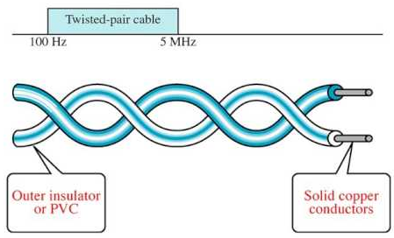
- The most common application of the twisted pair cable is the telephone system.
- Nearby all telephone are connected to the telephone company office by a twisted pair cable.
- It can run several kilometers without amplification but long distance repeater are needs.
- Twisted pair cable can be used for either analog (or) digital signals.
- The bandwidth depends on their thickness of the line and the distance travel.
Category of twisted pair cable:

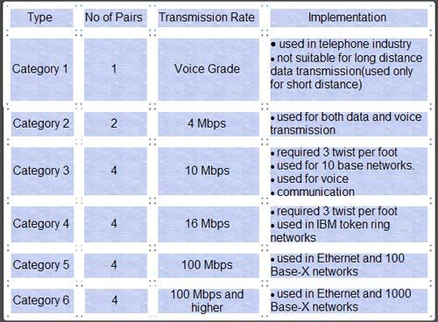
- Category-I used in telephone system.
- Category-II suitable for voice and data transmission up to 4 mbps.
- Category-III required at least 3 twist, it can be used for data transmission up to 10mbps
- Category-IV it required 3 twist per feet, data transmission up to 16 mbps.
- Category-V it is used for data transmission up to 100 mbps.
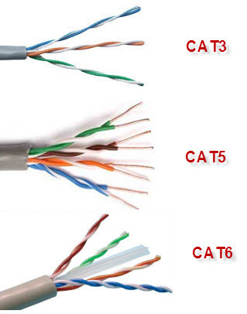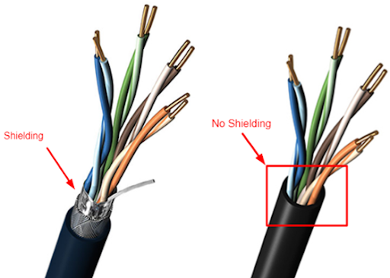

- All of this wiring types are referred as UTP(Unshielded twisted pair cable)

Co axial cable:
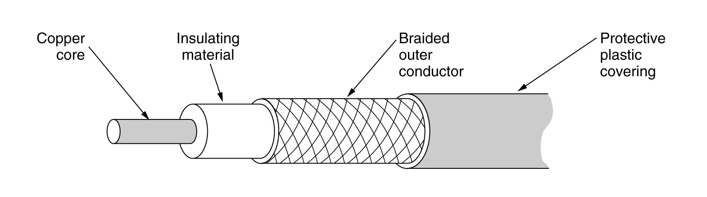
- Another common transmission medium is the co axial cable it has shielding then twisted pair cable, so it can span longer distance at higher speed.
- Two kinds of co-axial cable is widely used.
- 50 ohm,(digital)
- 75 ohm,(analog)
- 50 ohm cable is commonly used for digital transmission.
- 75 ohm cable is used for analog transmission and also used in cable television network.
- Co – axial cable consist of stiff copper wire as the core, surrounded by a isolating material.
- The isolated is enhanced by a cylindrical conductor after as a braid mesh
- The outer conductor is covered in a productive plastic sheet.
- Co-axial cable give a good communication of high bandwidth and excellent noise immunity.
- Model cables have a bandwidth closely to (one) 1 GHz it is used to widely used in telephone system for long distance cable television network and metropolitan area network(MAN)
Fiber optics cable:
- An optical transmission system have three components
- Light source
- Transmission medium
- detector
- A pulse light indicates a’1’ bit and the absence of light indicate a ‘0’ bit the transmission medium on ultra thin fiber glass.
- The detector generate on electrical pulse when light falls on it, by attacking a light source to one end of an optical fiber and a detector to the other end.
- We have a unidirectional data transmission system that accept on electrical signal, convert and transmit it by light pulse. And the reconvert the output to on electrical signal at the receiving end.
Diagram:
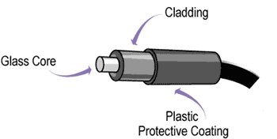
- Fiber optical cable are similar to co-axial cable except without the bride
- At the center is the glass core, in multimode fiber the core is 50 microns diameter, about the thickness of the human’s hair.
- In single mode fiber the core is 10 microns.
- The core is surrounded by a glass cladding with a lower index of refraction to keep all the light in core.
- This plastic jacket to protect the cladding.
Fiber cables:
- Fibers can be connected in three different ways.
1. Can terminated connectors and plugged into fiber sockets.
Connectors loss 10 to 20 percentage of the light but it is easy to reconfigure system.
2. Spliced mechanically it just lay them to carefully cut end next to each other in a special sleeve and clamp them in place.
It takes trained persons about 5 minutes and result in a 10 percentage less
3. Two pieces of fiber can be melted to form a solid connection.
Light source:
Two types of light sources is used,
- 1.led
- 2. Semi-conductor laser.
ITEM | LED | SEMICONDUCTOR LASER
Data Rate | Low | High
Fiber Type | Multimode | Multi Mode or Single Mode
Distance | Short | Long
Life Time | Long Life | Short Life
Cost | Low Cost | Expensive

Unguided (or) wireless transmission:
- Unguided media are wireless transmission transport electromagnetic waves without using a physical conductor.
- In future we have only two kinds of communication that is fiber (fixed) and wireless (Movable).

1. Radio wave transmission
2. Micro wave transmission
3. Infrared transmission

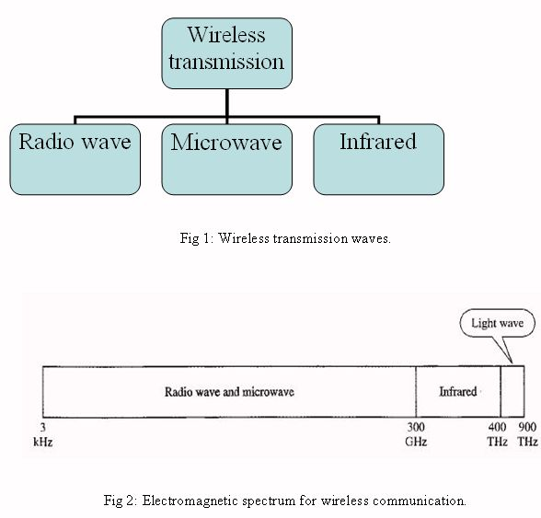
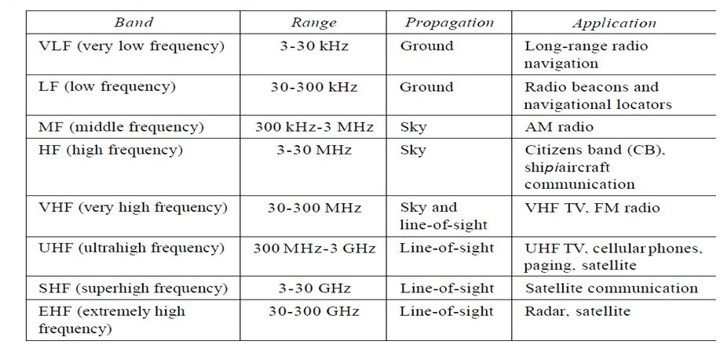
Radio wave transmission:
- Radio wave are easy to generate can travel long distance and can penetrates building easily, so they are widely used for communication both indoors and outdoors.
- Radio waves are an Omni directional that they are travel in all direction from the source to destination.
- The properties of radio waves are frequency depended at lower frequency radio waves pass through obstacles. Well at the higher frequency radio waves travel in straight line.
- All government tightly license the use of radio transmission.
- Surface propagation
- Ionosphere propagation
Surface propagation:
- In this radio waves travel through the lowest portion of the earth.
- In the very law frequency low frequency and middle frequency band radio waves follow the ground.
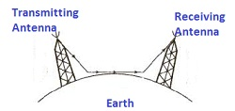
- These waves can be detected for 1000 km at the lower frequency.
- Am radio broadcasting used the middle frequency (MF frequency).
- Ground waves from bastion AM radio stations cannot be heard easily in newyork city, radio waves in this band pass through building easily, that the reason for portable radio work indoor.
- The main problem with using this band for data communication is the low bandwidth.
Ionosphere propagation:
- If frequency signals move upward into the ionosphere where the reflected back to the earth.

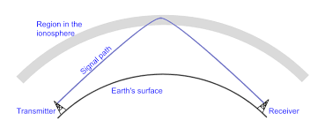
- In the high frequency very high frequency (VHF) bands the ground waves to be observed by the earth.
- The waves that reach the ionosphere at the high of 100 to 500 km are reflected by it and send back to the earth.
- The military communication also uses the HF and VHF band.
Microwave transmission:
- A micro wave signals propagate in directional at a time, to increase the distance repeater can be used in each antenna.
- Signal received by one antenna and can be converted into transmittable form and relayed to the next antenna.

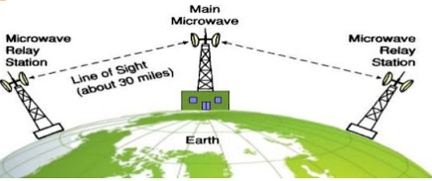
- Above 100 MHz the waves, travel in nearly straight lines, and can be narrowly focused.
- Concentrating all the energy into small beam by means of parabolic antenna.
- The transmitting and receiving antenna much accurately align with each other.
- Unlike radio wave at lower frequency microwaves do not fast through building well.
- Microwave communication is widely used for long distance telephone communication, mobile phone and television broadcasting.
Infrared transmission:
- Infrared wave are widely used for short range communication.
- The remote control used on television VCR and stereo is infrared communication.
- It is easy to build and in cheep in cost.
Major:
- The do not pass through solid object
- The do not pass through solid walls.
- No government license is needed to operate on infrared system.
- It is not a major player in a communication game.
Switching :
- A switching network consist of a series of interlinked nodes, called switches.
- Switches are devices capable of creation temporary connection between two (or) more devices linked to the switch.
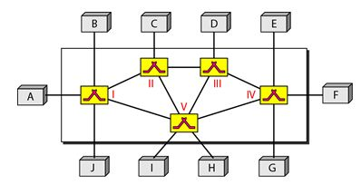

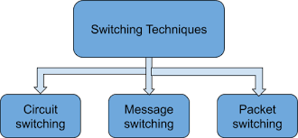

- Three types of switching technic is available but now a days we use two types only.
Circuit switching:
- This method is highly simplified method.
- Your computer based telephone call, the switching equipment within telephone system seek out a physical path all the way from your telephone to the receiver telephone. This technic is called circuit switching.
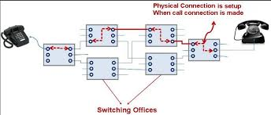
- Each of six rectangles represents a carrier switching office.
- In this diagram each office having a three incoming lines and three outgoing lines.
- When a call passes through a switching office, a physical connection is established between the line on which the call came in and one of the output line.
- In this method, once a call has been setup, a dedicated path between both end, until the call is finished.
- An important property of the circuit switching is the need to setup an end to end path before any data can be send.
- The elapsed time between the end of dialing and the start of linking can easily be 10 seconds, more on long distance (or) international calls.
- During this time interval the telephone system hunting for a path.
Message switching:
- In this method of switching no physical path is established in advance between the sender and receiver.
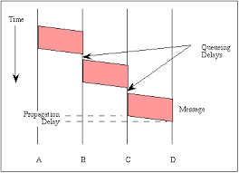
- When a sender has a block of data to be send it is stored in the first switching office and then forwarded later one hope at a time.
- Each block is received entirely, inspected for errors. And then retransmitted this technique is called store and forward technique.
- The first electro mechanical telecommunication system used message switching namely telegram.
Packet switching:
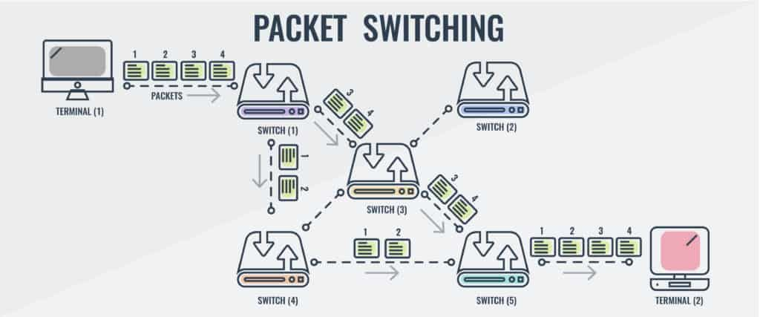

- Packet switching network places a tight upper limit on block size allowing packet to be buffered in router main memory instead of on disk.
- Packet switching network are well suited for handling interactive traffic.
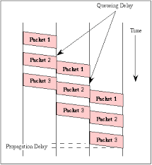
- The first packet of a multi packet message can be forwarded before the second one as fully arrived, it reducing delay.
- Computer network is normally used packet switching technique occasionally circuit switching is used but never used message switching technique.
- Circuit switching required end to end setup before communication begin, but a packet switching technique does not required any advance setup.
Comparison between circuit and packet switching:

