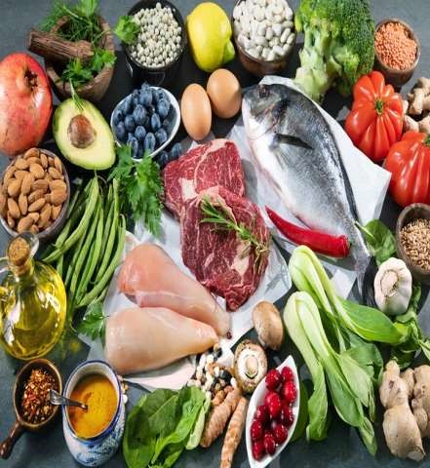
DR .P Murugan
Principal i/c
Asst. Professor
Bhararthidhasan University Model college
Vedharanyam- 614810
DIGESTION AND

ABSORPTION

OF PROTEINS

OBJECTIVES
- Sources of proteins
- Digestion of proteins
- Absorption of proteins
- Abnormalities of protein digestion and absorption

Sources of proteins
- Exogenous (dietary) proteins
- Endogenous proteins

Exogenous (dietary) proteins
 Daily requirement -- 0.5–0.7 g/kg body weight and for children (1–3 years), it is 4 g/kg.

Exogenous (dietary) proteins
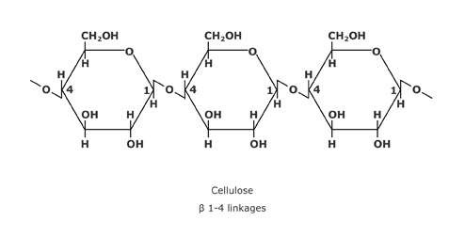
 Structure -- made of long chains of amino acids bound together by peptide linkages.

Exogenous (dietary) proteins
- Sources of dietary proteins with high biological value
- Meat, fish, eggs, cheese and other milk products, Soyabeans, wheat and various types of pulses are also rich source of proteins.

Endogenous proteins
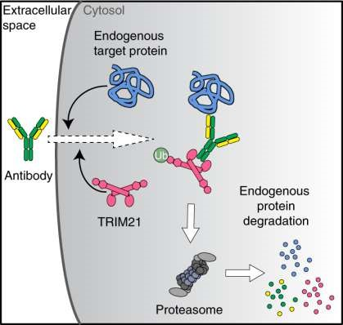
- Total - 30–50 g/day.
- The proteins which reach the intestine through various gastrointestinal secretions and those which are present in the desquamated epithelial cells of the gut

Digestion of proteins
 Digested by the proteolytic enzymes to amino acids and small polypeptides.

Digestion of proteins
 Digestion of proteins does not occur in the mouth, as there are no proteolytic enzymes in the saliva.

Digestion of proteins
 Digestion of proteins, thus begins in the stomach and is completed in the small intestine.

DIGESTION OF PROTEINS
- In stomach.
- In small intestine.

stomach
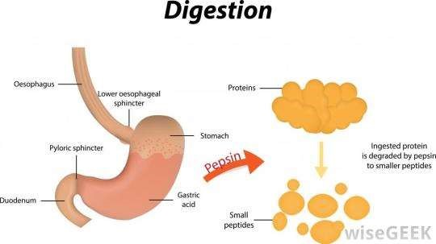
- Pepsin - secreted by
chief cells of the main gastric glands in an inactive form
(pepsinogen)
- Digest - about 10–15% proteins entering the GIT.

stomach
Pepsinogen
Pepsin
Proteins
Proteoses,
peptones and
polypeptides
The optimum
pH for the
action
of pepsin is 2.0;

small intestine
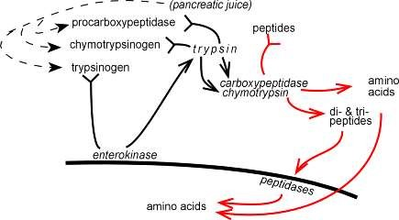
- Enzymes responsible are
- Pancreatic proteases
- Brush border peptidases
- Intracellular peptidases

Pancreatic proteases
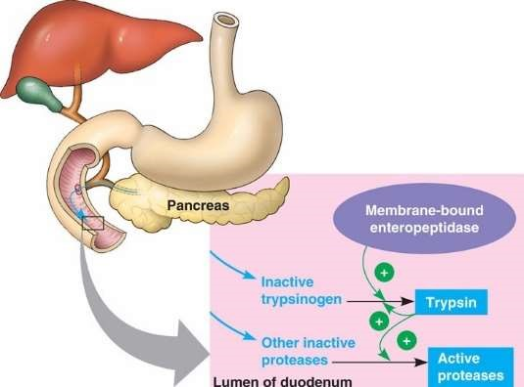
- Digest proteins into dipeptides, tripeptides & small polypeptides.
- These are further absorbed into
epithelial cells of mucosa & digested by intracellular enzymes into amino acids

Brush border peptidases
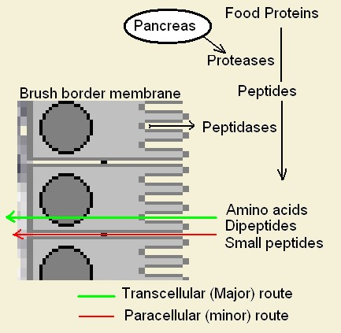
- Includes aminopeptidase, dipeptidase, tripeptidase.
- Finally converts proteins into polypeptides & amino acids.

Intracellular peptidases
 These digest the last dipeptides & tripeptides into amino acids which enters the blood.

Digestion of nuclei acid and nucleoproteins
 These are found in abundance in foods such as liver, kidney, pancreas, yeast etc.

Digestion of nuclei acid and nucleoproteins
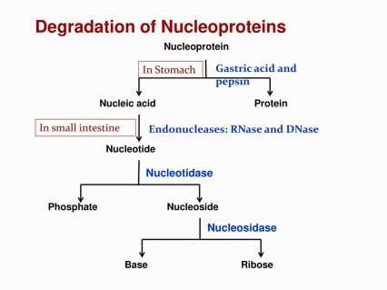
 Brush border enzymes as nucleases, nucleotidase & nucleosidase converts nucleotides & nucleosides into pentoses.

Absorption of proteins
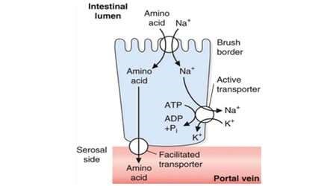
 Mechanism of absorption into intestinal epithelial cells occurs through luminal membrane of epithelial cells.

Absorption of proteins
- Mechanisms
- Na dependent active transport mechanism  Simple diffusion  Endocytosis.

Na dependent active transport mechanism
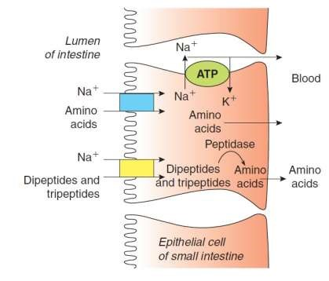
- Creation of electrochemical gradient across the cell
- Binding of Na & amino acids to carrier protein
- Movement of Na &
amino acid inside cell.

Simple diffusion
- The dextro amino acids are absorbed solely by the passive diffusion.
Endocytosis.
- Proteins absorbed by endocytosis usually excite immunological/allergic reaction.
Endocytosis.
- In newborn infants, immunoglobulins present in the colostrum are absorbed in the intestinal mucosa by endocytosis and impart passive immunity to child.

Further digestion in the epithelial cells
 In the cell peptidases break the remaining linkages of tripeptides, and dipeptides causing release of amino acids.

Transport of amino acids into blood capillaries
 the amino acids are transported into the interstitial space across the basolateral membrane of the cells by facilitated or simple diffusion.

Transport of amino acids into blood capillaries
 From the interstitium, the amino acids enter the capillaries of villus by simple diffusion, and then via portal vein, they reach the liver and general circulation.

Abnormalities of protein digestion and absorption
- Inadequate absorption of proteins, due to lack of trypsin is a common consequence of pancreatic diseases.
- Malabsorption of amino acids due to lack of transporters is relatively rare.
OBJECTIVES seen…………..
- Sources of proteins
- Digestion of proteins
- Absorption of proteins
- Abnormalities of protein digestion and absorption

THANK YOU

