Internet Overview

Internet
Internet is defined as an Information super Highway, to access information over the web. However, It can be defined in many ways as follows:
- Internet is a world-wide global system of interconnected computer networks.
- Internet uses the standard Internet Protocol (TCP/IP).
- Every computer in internet is identified by a unique IP address.
- IP Address is a unique set of numbers (such as 110.22.33.114) which identifies a computer location.
- A special computer DNS (Domain Name Server) is used to give name to the IP Address so that user can locate a computer by a name.
- For example, a DNS server will resolve a name http://www.tutorialspoint.com to a particular IP address to uniquely identify the computer on which this website is hosted.
- Internet is accessible to every user all over the world.
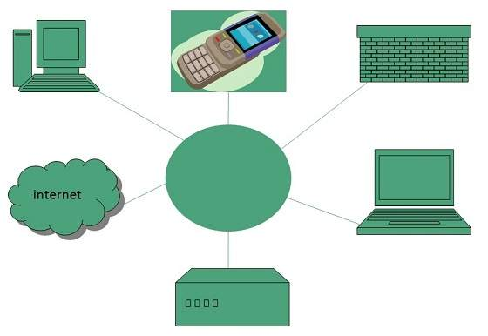

Evolution
The concept of Internet was originated in 1969 and has undergone several technological & Infrastructural changes as discussed below:
- The origin of Internet devised from the concept of Advanced Research Project Agency Network (ARPANET).
- ARPANET was developed by United States Department of Defense.
- Basic purpose of ARPANET was to provide communication among the various bodies of government.
- Initially, there were only four nodes, formally called Hosts.
- In 1972, the ARPANET spread over the globe with 23 nodes located at different countries and thus became known as Internet.
- By the time, with invention of new technologies such as TCP/IP protocols, DNS, WWW, browsers, scripting languages etc., Internet provided a medium to publish and access information over the web.

Advantages
Internet covers almost every aspect of life, one can think of. Here, we will discuss some of the advantages of Internet:
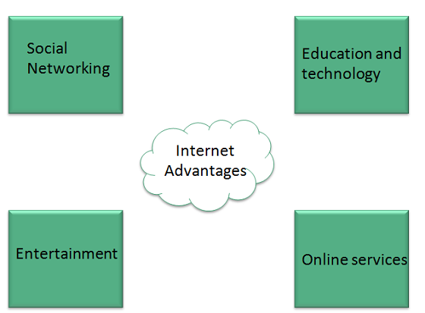
- Internet allows us to communicate with the people sitting at remote locations. There are various apps available on the wed that uses Internet as a medium for communication. One can find various social networking sites such as:
  - Facebook
  - Twitter
  - Yahoo
  - Google+
  - Flickr
  - Orkut
- One can surf for any kind of information over the internet. Information regarding various topics such as Technology, Health & Science, Social Studies, Geographical Information, Information Technology, Products etc can be surfed with help of a search engine.
- Apart from communication and source of information, internet also serves a medium for entertainment. Following are the various modes for entertainment over internet.
  - Online Television
  - Online Games
  - Songs
  - Videos
  - Social Networking Apps
- Internet allows us to use many services like:
  - Internet Banking
  - Matrimonial Services
  - Online Shopping
  - Online Ticket Booking
  - Online Bill Payment
  - Data Sharing
  - E-mail
- Internet provides concept of electronic commerce, that allows the business deals to be conducted on electronic systems

Disadvantages
However, Internet has proved to be a powerful source of information in almost every field, yet there exists many disadvantages discussed below:
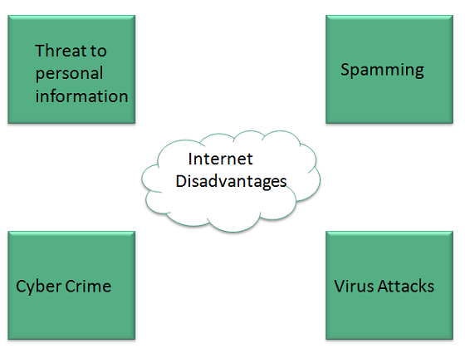
- There are always chances to loose personal information such as name, address, credit card number. Therefore, one should be very careful while sharing such information. One should use credit cards only through authenticated sites.
- Another disadvantage is the Spamming.Spamming corresponds to the unwanted e-mails in bulk. These e-mails serve no purpose and lead to obstruction of entire system.
- Virus can easily be spread to the computers connected to internet. Such virus attacks may cause your system to crash or your important data may get deleted.
- Also a biggest threat on internet is pornography. There are many pornographic sites that can be found, letting your children to use internet which indirectly affects the children healthy mental life.
- There are various websites that do not provide the authenticated information. This leads to misconception among many people.

Intranet Overview

Intranet
Intranet is defined as private network of computers within an organization with its own server and firewall. Moreover we can define Intranet as:
- Intranet is system in which multiple PCs are networked to be connected to each other. PCs in intranet are not available to the world outside of the intranet.
- Usually each company or organization has their own Intranet network and members/employees of that company can access the computers in their intranet.
- Every computer in internet is identified by a unique IP address.
- Each computer in Intranet is also identified by a IP Address, which is unique among the computers in that Intranet.
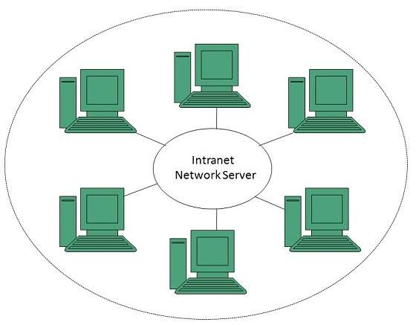

Benefits
Intranet is very efficient and reliable network system for any organization. It is beneficial in every aspect such as collaboration, cost-effectiveness, security, productivity and much more.
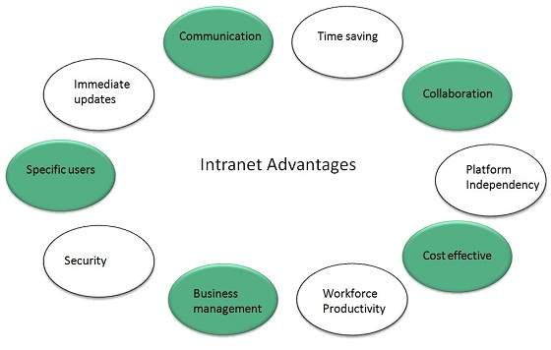

Communication
Intranet offers easy and cheap communication within an organization. Employees can communicate using chat, e-mail or blogs.

Time Saving
Information on Intranet is shared in real time.

Collaboration
Information is distributed among the employees as according to requirement and it can be accessed by the authorized users, resulting in enhanced teamwork.

Platform Independency
Intranet can connect computers and other devices with different architecture.

Cost Effective
Employees can see the data and other documents using browser rather than printing them and distributing duplicate copies among the employees, which certainly decreases the cost.

Workforce Productivity
Data is available at every time and can be accessed using company workstation. This helps the employees work faster.

Business Management
It is also possible to deploy applications that support business operations.

Security
Since information shared on intranet can only be accessed within an organization, therefore there is almost no chance of being theft.

Specific Users
Intranet targets only specific users within an organization therefore, once can exactly know whom he is interacting.

Immediate Updates
Any changes made to information are reflected immediately to all the users.

Issues
Apart from several benefits of Intranet, there also exist some issues.. These issues are shown in the following diagram:
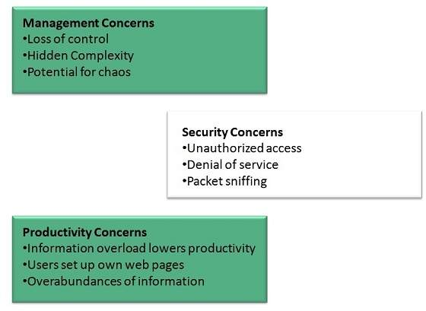

Applications
Intranet applications are same as that of Internet applications. Intranet applications are also accessed through a web browser. The only difference is that, Intranet applications reside on local server while Internet applications reside on remote server. Here, we've discussed some of these applications:
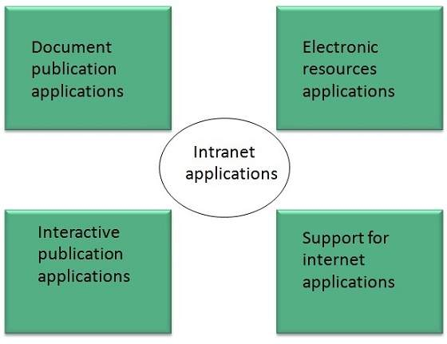

Document publication applications
Document publication applications allow publishing documents such as manuals, software guide, employee profits etc without use of paper.

Electronic resources applications
It offers electronic resources such as software applications, templates and tools, to be shared across the network.

Interactive Communication applications
Like on internet, we have e-mail and chat like applications for Intranet, hence offering an interactive communication among employees.

Support for Internet Applications
Intranet offers an environment to deploy and test applications before placing them on Internet.

Internet vs. Intranet
Apart from similarities there are some differences between the two. Following are the differences between Internet and Intranet:
Intranet | Internet
Localized Network. | Worldwide Network
Doesn't have access to Intranet | Have access to Internet.
More Expensive | Less Expensive
More Safe | Less Safe
More Reliability | Less Reliability

Extranet Overview

Extranet
Extranet refers to network within an organization, using internet to connect to the outsiders in controlled manner. It helps to connect businesses with their customers and suppliers and therefore allows working in a collaborative manner.
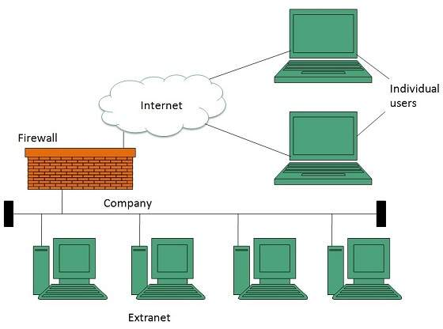

Implementation
Extranet is implemented as a Virtual Private Networks (VPN) because it uses internet to connect to corporate organization and there is always a threat to information security. VPN offers a secure network in public infrastructure (Internet).
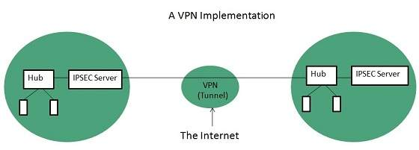
Key Points
- The packet is encapsulated at boundary of networks in IPSEC complaint routers.
- It uses an encryption key to encapsulate packets and IP addresses as well.
- The packet is decoded only by the IPSEC complaint routers or servers.
- The message is sent over VPN via VPN Tunnel and this process is known as tunneling.
VPN uses Internet Protocol Security Architecture (IPSEC) Protocol to provide secure transactions by adding an additional security layer to TCP/IP protocol. This layer is created by encapsulating the IP packet to a new IP packet as shown in the following diagram:
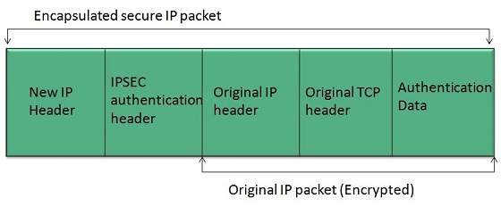

Benefits
Extranet proves to be a successful model for all kind of businesses whether small or big. Here are some of the advantages of extranet for employees, suppliers, business partners, and customers:
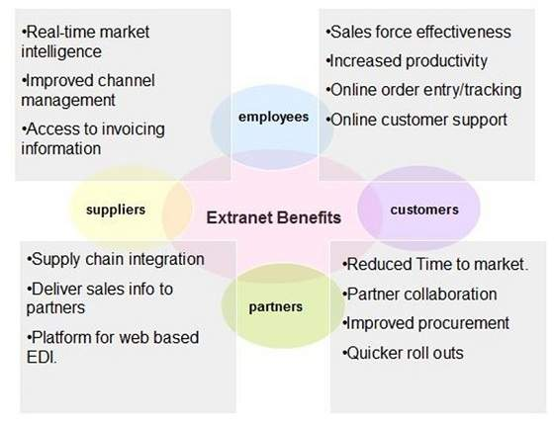

Issues
Apart for advantages there are also some issues associated with extranet. These issues are discussed below:

Hosting
Where the extranet pages will be held i.e. who will host the extranet pages. In this context there are two choices:
- Host it on your own server.
- Host it with an Internet Service Provider (ISP) in the same way as web pages.
But hosting extranet pages on your own server requires high bandwidth internet connection which is very costly.

Security
Additional firewall security is required if you host extranet pages on your own server which result in a complex security mechanism and increase work load.

Accessing Issues
Information can not be accessed without internet connection. However, information can be accessed in Intranet without internet connection.

Decreased Interaction
It decreases the face to face interaction in the business which results in lack of communication among customers, business partners and suppliers.

Extranet vs. Intranet
The following table shows differences between Extranet and Intranet:
Extranet | Intranet
Internal network that can be accessed externally. | Internal network that can not be accessed externally.
Extranet is extension of company's Intranet. | Only limited users of a company.
For limited external communication between customers, suppliers and business partners. | Only for communication within a company.

