Sengamala Thayaar Educational Trust Women’s College

(Affiliated to Bharathidasan University)
(Accredited with ‘A’ Grade {3.45/4.00} By NAAC) (An ISO 9001: 2015 Certified Institution)
Sundarakkottai, Mannargudi-614 016.
Thiruvarur (Dt.), Tamil Nadu, India.

HUMAN PHYSIOLOGY

G.K.GOMATHI

ASSISTANT PROFESSOR
DEPARTMENT OF NUTRITION AND DIETETICS

I B.Sc NUTRITION AND DIETETICS
HUMAN PHYSIOLOGY

Blood: Composition, Functions, Transfusion and Blood Group
Blood is a red colour pigment that circulates in the body. It contains plasma, red blood cells, white blood cells, and platelets. It performs various functions in the body. Let us study in detail about the composition and function of blood, its components, blood transfusion, blood pressure, and blood group.

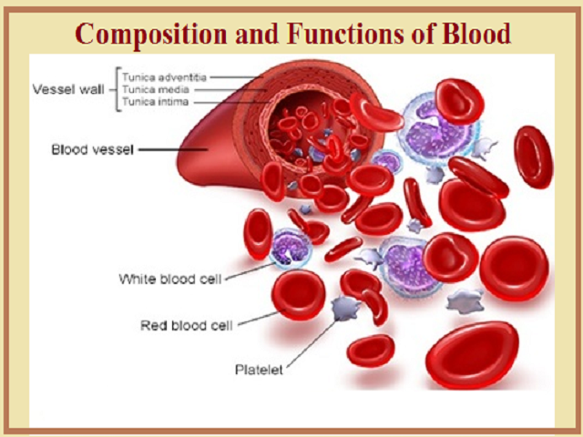
Blood is a connective tissue that helps in the transportation of substances, protects against diseases and regulates the temperature of the body. Do you know why the colour of blood is red?
It is red in colour due to a red pigment called haemoglobin present in its red cells. The components of Blood are Plasma, Red blood corpuscles (Red blood cells or RBCs), White blood corpuscles (White blood cells or WBCs) and platelets.

Plasma is a liquid also known as the fluid matrix and consists of three types of cells that keep floating in it namely red blood cells, white blood cells, and platelets.
Functions of Blood
Blood has three main functions in the human body i.e Transport of substances from one part of the body to the other like respiratory gases, waste products, enzymes, etc, protection against diseases and regulation of body temperature.
- Blood regulates body temperature.
- It carries oxygen from lungs to different parts of the body.
- It carries carbon dioxide from the body cells to the lungs for breathing out.
- It carries digested food from the small intestine to all parts of the body.
- It carries hormones from the endocrine glands to different organs of the body.
- It carries waste product urea from the liver to the kidneys for excretion.
- Defends against infection.
On average, a healthy man has about 5 litres of blood in the body, while a woman has about 500 ml less than man. So, total blood is about 60-80 ml/kg of body weight.
Plasma
The fluid or liquid part of blood is called plasma. It is a colourless liquid that contains 90% water, protein, and inorganic salts. Plasma also contains some traces of other substances like amino acids, organic acids, vitamins, pigments and enzymes. It carries these dissolved substances from one part to another part in the body. The protein in plasma includes antibodies to assist in the body’s defence system against disease and infection.

Red Blood Corpuscles (RBC)
RBC is also known as erythrocytes. They are disc-shaped cells concave in the middle and visible under a microscope. RBC carries oxygen from the lungs to all the cells of the body. They have no nucleus and contain a pigment called haemoglobin which is made up of an iron-containing pigment known as haema and a protein called globin. RBCs are produced in the spleen and the bone marrow and live for about four months because they lack a nucleus. So, when we donate blood to save the life of a person, then the loss of blood from our body is recovered within a day because red blood cells are made very fast in the bone marrow. The life of the RBC is about 100-120 days.
Functions
- Haemoglobin in RBC picks up oxygen in the lung tissues by forming a chemical compound with it.
- This oxygen is carried to the tissues where it is used in the chemical reactions to produce energy.
- It then combines with carbon dioxide which is produced in these reactions and returns to the lungs with the heart where the cycle starts again.

White Blood Corpuscles (WBC)
WBC is also known as leukocytes. They fight with infection and protect us from diseases because they eat up the germs which cause diseases. That is why they are also known as ‘soldiers’ of the body’s defence system. They are round or irregular, semi-transparent cells containing a nucleus and visible under a microscope. They are a little larger than RBC. Some White blood cells make chemicals called ‘antibodies’ to fight against infection i.e why they provide immunity in our body. WBC in the blood is much smaller in number than red blood cells.
Functions
- Broadly, WBC acts as a defence system in the body.
- There are several varieties of WBC performing specific functions such as, Neutrophils (65 to 70% of the total WBC) attack the invading bacteria and engulf them. Lymphocytes (25% of WBC) produces antibodies which protect the body against the antigen and thus provide immunity against infection. Basophils secrete anticoagulant called heparin which prevents clot within the blood cells. Eosinophils and monocytes also assist in the defence mechanism of the body by becoming active against specific antigens.

Blood platelets
Blood Platelets are also known as thrombocytes. They are tiny, circular or oval colourless cells formed in the bone marrow. They lack a nucleus and help in the coagulation of blood (clotting of blood) in a cut or wound, due to which bleeding stops. All the blood cells are made in the bone marrow from the cells called stem cells.
Blood clotting is a body’s defence system to combat bleeding. Plasma contains soluble protein fibrinogen of the blood which produces the insoluble protein called fibrin essential for blood coagulation which is formed in the liver.
Process of clotting
In an injury blood platelets break down and release an enzyme which helps in the formation of fibrin from fibrinogen. This fibrin forms clot in the form of a mass of fibres which stops bleeding from blood vessels. After clotting, a straw-coloured fluid called serum is left.
Blood Grouping
In 1900-1902, K. Landsteiner classified human blood into four groups A, B, AB and O. The cells of these group contains corresponding antigens – A, B and AB except O. That is why O is donated to any of the groups and so is known as Universal donor. AB group is known as Universal recipient because it can receive A, B, AB, and O blood groups.
Blood Group | Can donate blood to | Can receive blood from
A  B  AB  O | A, AB  B, AB  Only AB  AB, A, B, and O | A and O  B and O  AB, A, B, and O  Only O

Rh factor
It is a blood antigen discovered in 1940 by Landsteiner and A.S Weiner and played an important role during a blood transfusion. The Rh factor is an agglutinogen found in RBC of most people called Rh+. It was initially found in the rhesus monkey and later in man. People who do not have this antigen in their blood are called Rh-. The Rh- blood does not carry anti- Rh antibodies naturally but could synthesize them if synthesized through blood transfusion of Rh+ blood. If Rh+ blood is transfused into an Rh- patient, the serum will produce anti-Rh agglutinin. If another dose of Rh+ blood is given, the anti-Rh agglutinin will cause clumping of RBC of the donor’s blood as soon as it enters the patient receiving it.
Erythroblastosis Foetalis: If the father's blood is Rh+ and the mother's blood is Rh- then the child to be born dies at the pregnancy or short span of time after birth. Basically, this happens in the case of the second issue.
Blood Transfusion
This technique was first developed by James Blundell in 1825. The injection of blood from one person (donor) into the circulatory system of another is called a blood transfusion. It is done after the proper matching of blood groups and the Rh factor.
What is Blood Pressure and how it is measured?
Blood Pressure
Blood Pressure is the force exerted by the blood beating against artery walls. The highest point in the pressure range is called systolic pressure (upper reading) and the lowest point is called diastolic pressure (lower reading). It is measured by an instrument called a sphygmomanometer. The diastolic pressure is always lower than the systolic pressure. The average systolic pressure of a healthy young man is about 120 mm Hg and the diastolic pressure is about 80 mm Hg that is, 120/80 is the normal blood pressure. High blood pressure is known as hypertension and low blood pressure is known as hypotension.
Transport in Humans
‘Circulatory system’ or ‘Blood circulatory system’ is the main transport system in human beings. In this blood carries oxygen, digested food and other chemicals like hormones and enzymes to all parts of the body and take away waste products like carbon dioxide and urea. Therefore, the human blood circulatory system consists of the heart which pumps and receives blood and the blood vessels through which blood flows in the body.
In the circulatory system, blood flows through three types of blood vessels: Arteries, veins, and capillaries. The blood vessels are present in all parts of the human body so, that blood reaches everywhere in the body.
There is another system with the blood circulatory system for transport in human beings is the Lymphatic System. Lymph is the liquid that circulates and carries materials in the lymphatic system. Thus, we can conclude that in Human beings, the various substances are transported through two liquids called ‘blood ‘and ‘lymph’.
Haemolymph: Body fluid of Arthropoda is a colourless made of plasma and haemocytes. It do not contain any respiratory pigment like a cockroach.
