SENGAMALA THAYAAR EDUCATIONAL TRUST WOMEN'S COLLEGE,
(Affiliated to Bharathidasan University)
(Accredited with ‘A’ Grade {3.45/4.00} By NAAC)
(An ISO 9001: 2015 Certified Institution)
Sundarakkottai, Mannargudi-614 016.
Thiruvarur (Dt.), Tamil Nadu, India.

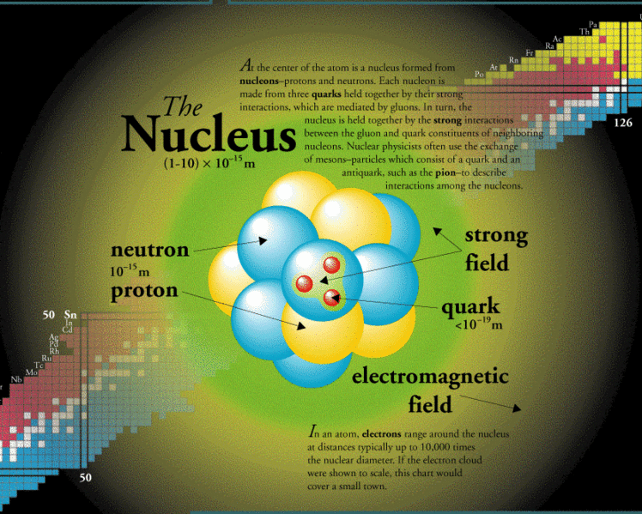
Class: III B.Sc., PHYSICS
Subject: NUCLEAR PHYSICS
Subject Code: 16SCCPH8
BY,
Mrs. R.RADHA
ASSISTANT PROFESSOR,
DEPARTMENT OF PHYSICS

UNIT –I General Properties of Nuclei and Nuclear Models
Constituents of nuclei-Classification of nuclei - Nuclear mass and binding energy - Binding energy and stability of nucleus, Mass defect and Packing fraction, Binding fraction Vs. Mass number curve - Nuclear size - Nuclear spin-Nuclear energy levels - Nuclear magnetic moment --Parity of nuclei - Nuclear forces - Yukawa’s model of nuclear force.
Nuclear Models - Liquid drop model, Semi-empirical mass formula - Shell model- Salient features of shell model.

The Nucleus:Introduction
A simple description of the nucleus tells us that it is composed of protons and neutrons. These two particle types are collectively called nucleons, i.e. particles which inhabit the nucleus.
From a mass point of view the mass of a proton is roughly equal to the mass of a neutron and each of these is about 2,000 times the mass of an electron. So most of the mass of an atom is concentrated in the small region at its core.
From an electrical point of view the proton is positively charged and the neutron has no charge. An atom all on its own (if that were possible to achieve!) is electrically neutral. The number of protons in the nucleus of such an atom must therefore equal the number of electrons orbiting that atom.
Constituents of nuclei:
With the discovery of neutron by Chadwick in 1932, it was recognized that the atomic nuclei are composed of two different types of elementary particles –protons and neutrons. Collectively, the neutrons and protons are referred to as nucleons. The nucleons are fundamental particles in the same sense as electrons are .Any particular type of nucleus, a species of nucleus, is called a nuclide.
The negatively charged electrons move around the nucleus and the orbits or effects of the electrons extend to about 10⁻¹⁰m, the so, called radius of the atom. The radius of atypical nucleus however is about 10⁻¹⁴m.
The atom is thus electrically neutral has a massive nucleus. The distribution of mass in the atom is such that most of its space is empty. The clouds of extra-nuclear electrons again are arranged in layers or shells. The outermost or valence electrons dictate the chemical properties of the atom.
According to Coulomb’s law, the positively charged protons, closely spaced within the nucleus, should repel each other on strongly that they should fly apart. It is thus difficult to explain the stability of the nucleus unless one assumes that nucleons (protons and neutrons) are held together under the influence of a very strong short range attractive force.
The number of protons in the nucleus determines the atomic number of the nuclide. It is also called Z-value or the proton number. The sum of the numbers of protons (Z) and neutrons (N) in the nucleus, i.e. the total number of nucleons in a nucleus, is known as its mass number A.
A = N+Z
Obviously, the mass number A is an integer just as both N and Z are, For a given Z, the neutron number N is given by
N = A-Z
A nucleus of an atom X of atomic number Z and a mass number A,i.e, a nuclide is symbolically represented by ^{A}X_{Z.}

Classification of Nuclei:
- The term Atomic Number is defined in nuclear physics as the number of protons in a nucleus and is given the symbol Z.
- The term Mass Number is defined as the number of nucleons in a nucleus, that is the number of protons plus the number of neutrons, and is given the symbol A.
- It is possible for nuclei of a given element to have the same number of protons but differing numbers of neutrons that is to have the same Atomic Number but different Mass Numbers. Such nuclei are referred to as Isotopes. All elements have isotopes and the number ranges from three for hydrogen to over 30 for elements such as cesium and barium.

where X is the chemical symbol of the element; A is the "Mass Number," (protons+ neutrons); Z is the "Atomic Number,"
The first isotope commonly called hydrogen has a Mass Number of 1, an Atomic Number of 1 and hence is identified as:
The second isotope commonly called deuterium has a Mass Number of 2, an Atomic Number of 1 and is identified as:
The third isotope commonly called tritium.
Isobars: Nuclei with the same mass number A but different atomic number Z are called isobars .For instance, the two nuclides ₈O¹⁶and ₇N¹⁶are isobaric to each other. Both have same mass number A=16 but Z= 8 for ₈O¹⁶ and Z=7 for₇N^{16.}
Isotones:
Nuclei with the same number of neutrons.i.e, having the same N are called isotones.eg: nuclides ₁₁Na²³ and ₁₂Mg²⁴ both have 23-11=12 or 24-12=12 neutrons in the nucleus.
Mirror Nuclei:
The Pairs of isobaric nuclei where the proton number Z and the neutron number N are interchanged and differ by one unit are known as mirror nuclei. Eg: ₆C¹¹ and ₅B¹¹.
Nuclear mass and Binding Energy:
The mass –spectroscopic measurements give not the masses of the nuclei but those of the atoms. The nuclear mass M_{nuc} is obtained from the atomic mass M (A,Z) by subtracting the masses of Z orbital electrons.
M_{nuc} = M (A, Z) –Zm_{e} ……….. (1)
The nuclei are very strongly bound and energies of ̴ few Mev are needed to break away a nucleon from the nucleus. So, to break up a nucleus of Z protons and N neutrons completely into separate particles, a minimum amount of energy is to be supplied to the nucleus. This energy is called the binding energy, EB of the nucleus. Out of Z protons and N neutrons remaining at rest and separate from one another, a nucleus of mass number A (=N+Z) and nuclear charge Z, an amount of energy is equal to E_{B} will be evolved.
According to special theory of relativity, the energy equivalent E corresponding to a complete inversion of a mass m into energy is E = mc², where c is the velocity of light in free space. If M be the amount of mass disappeared, then the
Binding Energy, E_{B =} Δ M c² ……… (2)
If M_{H ,} M_{n} be the masses of hydrogen atom and the neutron respectively,

Δ M =Z M_{H} +N M_{n} - M (A, Z) ……. (3)
Then M (A, Z) is the mass of the atom of mass number A and atomic number Z,
E_{B} = [Z M_{H} +N M_{n} - M (A, Z)] c² ……… (4)
E_{B} = [Z M_{p} +N M_{n} + Zm_{e} - M_{nuc} – Zm_{e}] c²
E_{B} = [Z M_{p} +N M_{n} - M_{nuc}] c² …. .….(5)
So, the mass –loss Δ M for the formation of nucleus is equal to the sum of the masses of Z protons, N neutrons minus the nuclear mass of the atom.
In energy unit,
Δ M = Z M_{p} +N M_{n} - M_{nuc.}

Unit of Atomic Mass:
The unit of atomic mass is defined to be one –twelfth of the mass of the atom of carbon isotope , ¹²C tto be exactly 12 units, and is symbolized by u, for ‘unified atomic mass unit’
1 u :1 amu = 1.0003172:1
The unit of atomic mass in ¹²C scale is therefore 10²³
1u = $\frac{1}{12}$ ×$\frac{12×10-3}{NA}$ = $\frac{10-3}{6.02205×1023}$ kg,(N_{A} = Avogadro number)
= 1.660566 × 10⁻²⁷ kg
The energy – equivalent of 1 u is thus
1u = 1.6605566×10⁻²⁷× 8.98755×10¹⁶
= 14.924419×10⁻¹¹ J
1u = 931.501 Mev
The energy –equivalents of the rest mass of electron, proton and neutron are respectively given as under:
Electron (m_{e}) = 9.10953×10⁻³¹kg = 5.4858010⁻⁴ u
Proton (m_{p}) = 1.677265×10⁻²⁷kg = 1.0072765 u
Neutron (m_{e}) = 1.67495×10⁻²⁷kg = 1.0086650 u
Binding energy and Stability of nucleus:
If E_{B} > 0, i.e. positive, the nucleus is stable and energy from outside is to be supplied to disrupt the nucleus into its constituents separately. If, however, E_{B} < 0, i.e. negative, the nucleus is unstable and will disintegrate of itself. The E_{B} - value is a measure of the stability of the nucleus. More the E_{B} more is the stability.
Let us compute the binding energy E_{B} for an α – particle, i.e., ₂He⁴.The helium nucleus is made up of 2 protons and 2 neutrons.
Z M_{p} = 2 х 1.007276 = 2.014552 u
N M_{n} = 2 х 1.008665 = 2.017330 u
Total = 4.031882 u
Atomic mass of ₂He⁴ = 4.002603 u
Difference = + 0.029279 u
The plus sign indicates that the nucleus is stable. And since 1u ~931Mev, the binding energy in Mev is E_{B} = 0.09279 х 931 = 27.16 Mev. The binding energy of He – nucleus is 27.16 Mev and this explains why it is a very stable structure, coming out as it does as α – particle in radioactive decay. Every nuclide has a fixed binding energy meaning that the same amount of energy would always be required to pull the nucleons completely apart. This binding energy divided by the number of nucleons is called the (average) binding energy per nucleon , or binding fraction ,f_{B} = $\frac{EB}{A}$ .
Mass defect and Packing fraction:
According determination of the atomic masses indicates that they are not exactly whole numbers, although the difference is small. For instance, the atomic mass of C¹² is exactly 12 u, but the masses of other atoms, although very close to, are not exactly whole numbers .For instance,
H¹ = 1.007825 u; H² = 2.014102 u; He⁴ = 4.002603 u; O¹⁶ = 15.994915 u; Ra²²⁶ = 226.02543 u
Mass defect – The difference between the measured atomic mass M (A, Z) in u , and the mass number A of a nuclide is called the mass defect , Δ M ʹ

Δ M ʹ = M (A, Z) –A
The mass defect of He⁴ = 4.002603 – 4 = + 0.002603 u and that O¹⁶ = 15.994915 -16 = -0.005085 u. The mass defect can therefore be both positive and negative .It is found that the mass defect is positive for very light and very heavy atoms, and it is negative for atoms in the intermediate range.
Packing fraction – Aston expressed the departure of atomic masses from their mass numbers in terms of packing fraction for each nuclide.
The Packing fraction f is defined as the mass defect per nucleon in the nucleus, i.e., the mass defect of an atom divided by its mass number. So,
f = $\frac{Δ M ʹ}{A}$ = $\frac{M\left(A.Z\right)-A}{A}$
= $\frac{M\left(A.Z\right)}{A}$ – 1

Or,$M\left(A.Z\right)=A(1+f)$, f has the same sign as the mass defect Δ M ʹ.

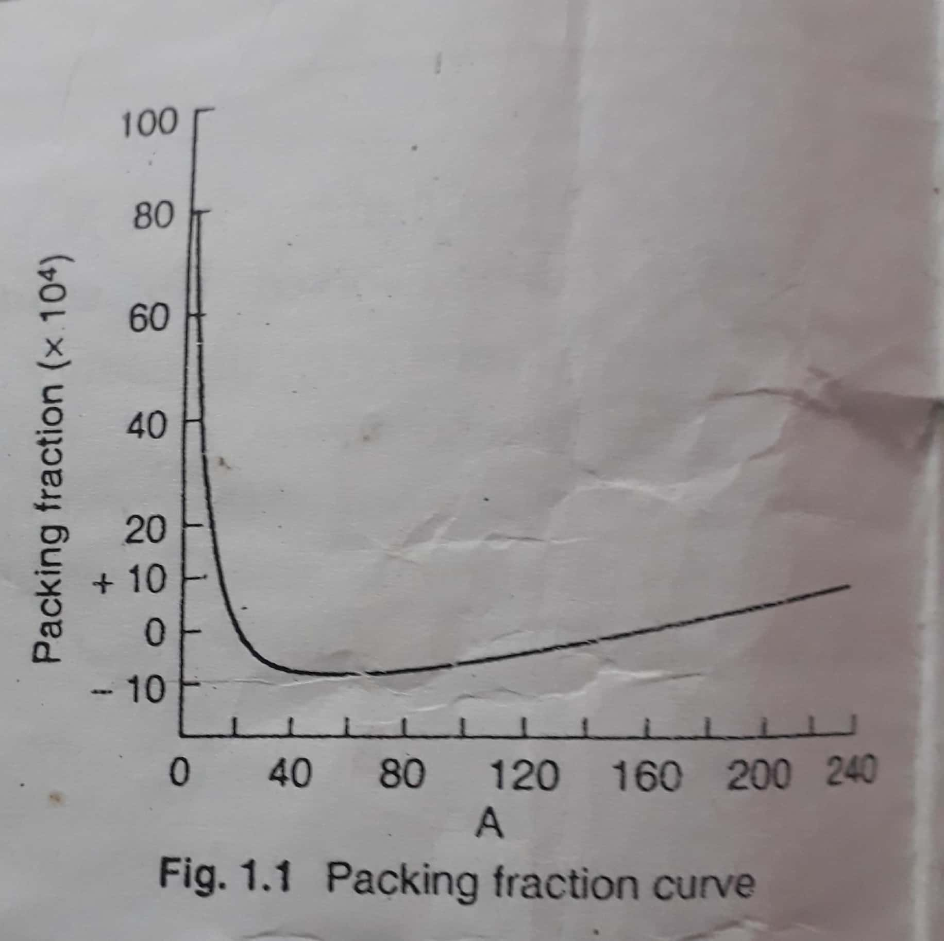

It is found that the packing fraction f varies with the mass number .It is observed that the packing fraction is positive for very light nuclei and as A increases,f decreases rapidly, becoming negative for A > 20.It attains a minimum value (-ve) at A ̴ 60,where it starts increasing again but rather slowly .For A ̴ 180 , it becomes (+ve) again.
This variation of f with A can be explained from the consideration of nuclear binding energy. We have,
f_{B} = $\frac{EB}{A}$ = $\frac{Z MH +N Mn - M (A, Z) }{A}$
expressed in energy unit.
Computations of f_{B} ‘s for different nuclides shows that they are highly variable. For instance ,
it is 1.112 Mev for deuteron, 7.07 Mev for α –particles (⁴He) and 7.98Mev for O¹⁶ are relatively more strongly bound.

Binding fraction Vs mass number curve:
The nature of variation of f_{B} with a, for different nuclei is represented graphically in fig .1.2 and is called the binding fraction curve.
A critical survey of the curve will readily bring out the following points of immense physical importance:
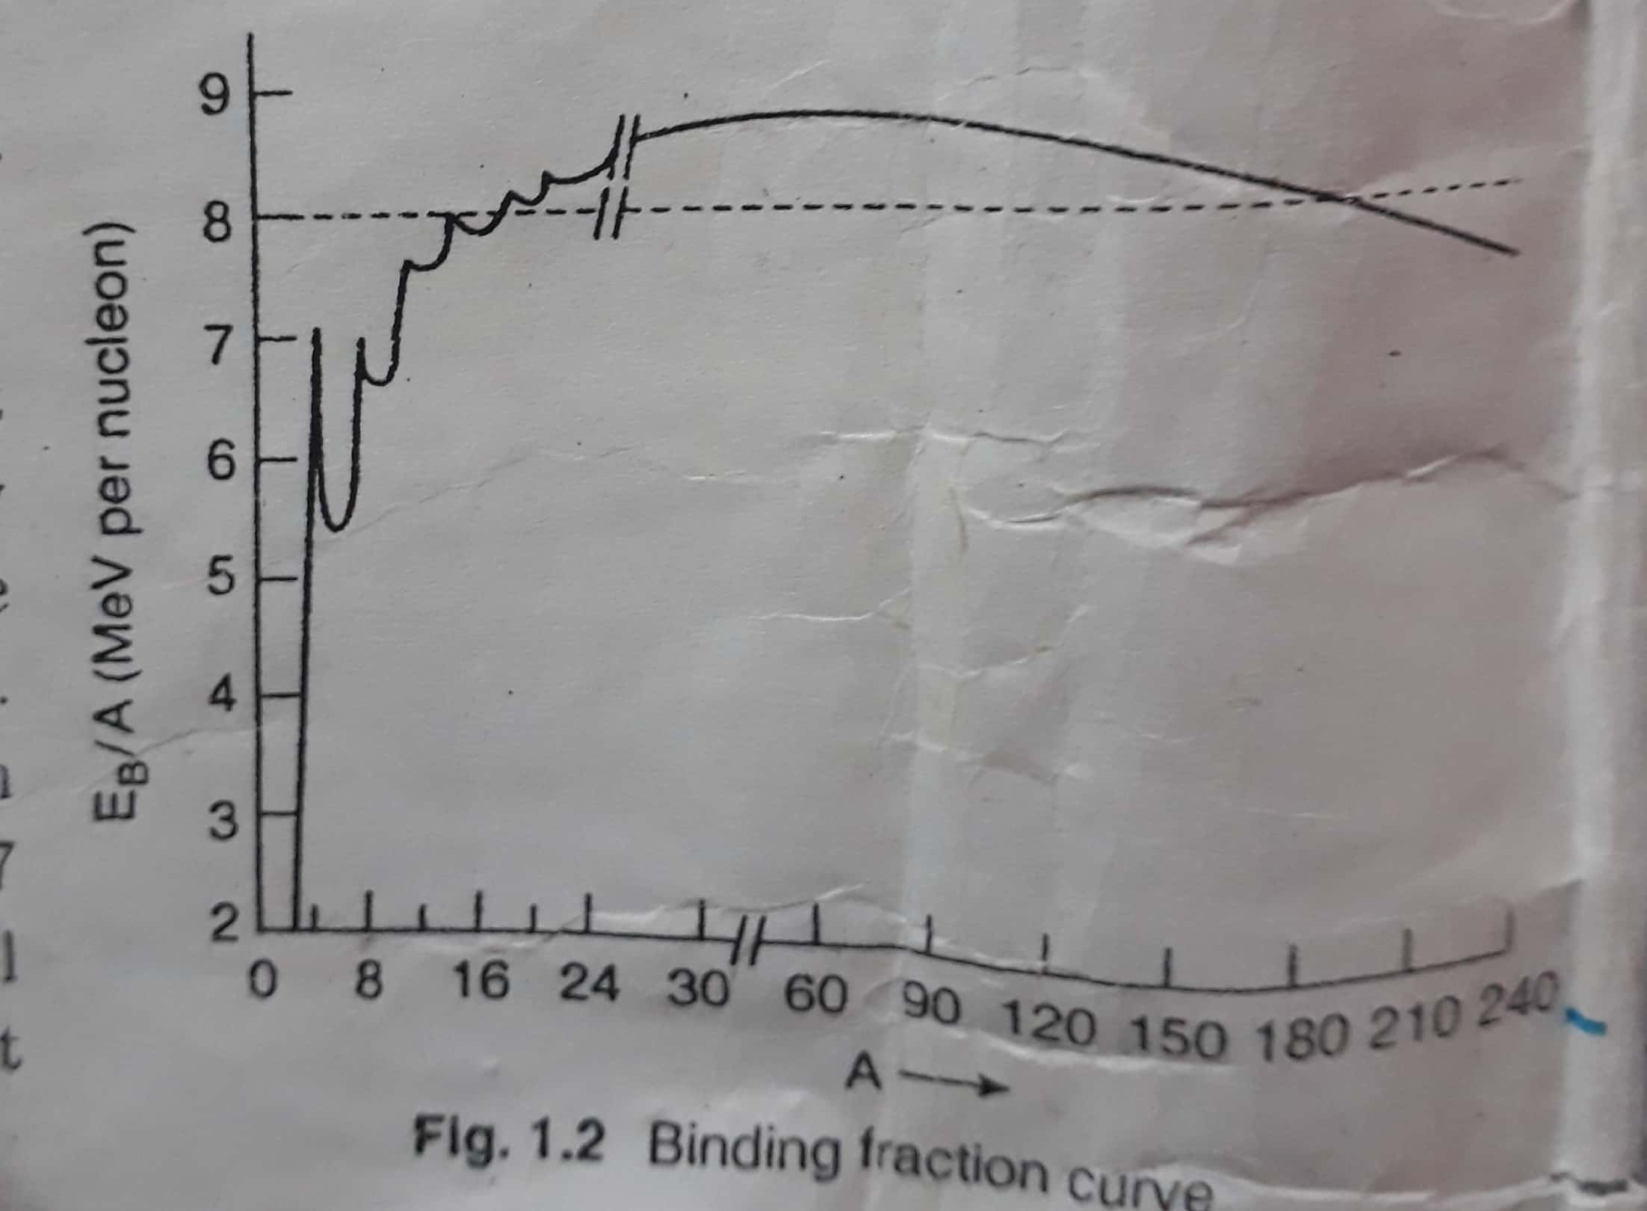

- f_{B} is very small for very light nuclei and goes on increasing rapidly with increasing A and reaches a value ̴ 8Mev for the mass number A ̴ 20.Therfore ,the rise of the curve is much slower, reaching a maximum value of 8.7 Mev for A = 56.If A is increased still further ,the curve again decreases but slowly.
- The variation in f_{B} is very slight in the range of mass number 20 < A <180 and in this region f_{B} may be considered to remain virtually constant having a mean value ̴ 8.5Mev.
- For A > 180, i.e, for heavy nuclei, the f_{B} value decreases monotonically with increasing A and is ̴ 7.5 Mev fir heaviest nuclei.
- A rapid fluctuation in f_{B} is for very light nuclei with some peaks in the curve in this region, corresponding to the even – even nuclei ,such as ⁴He,⁸Be,¹²C,¹⁶O etc with mass number A = 4n, where n = 1,2,3,4. …etc. Peaks in the curve are also seen at Z or N equal to 20, 28, 50, 82,126.These are called magic numbers.

Nuclear size:

Nuclear Radius: Experiments indicate that the majority of atomic nuclei are spherical, or nearly so, in shape .So, its volume is proportional to the total number of nucleons in it or its mass number A.
$\frac{4}{3}$π R³ α A
Or R α A^{1/3}
R = r_{o} A^{1/3} …… (1)
Where R is the radius of the nucleus and r_{o} a constant called nuclear radius parameter. The value of r_{o} ranges from {1.1-1.5} ×10⁻¹⁵m.
The nuclear radius , is the radius of nuclear mass distribution .Since nuclear charge parameter Z α A i.e, is almost proportional to the mass number and the nuclear charge density The average value of R estimated by this method is (1.23 + 0.03) A^{1/3}× 10⁻¹⁵m.
- is nearly same that the nuclear volume. Hence nuclear charge ̴ mass radius of the nucleus.
- The size of the nucleus was first estimated from Rutherford’s α –particle, if the K.E of α – particle be equal to the repulsive Coulomb energy between α –particle (of charge 2e,mass m and velocity v) and the nucleus (of charge Ze) such that the distance of closest approach R is given by
$\frac{1}{2}$mv² = $\frac{2e×Ze}{4πϵoR}$ = R = $\frac{Z e2}{πϵomv2}$
Substituting for m= 6.64×10⁻²⁷ kg, e = 1.6 ×10⁻¹⁹ C and v = 10⁷m/s, the value of R for Z = 20 is ̴ 1.5×10^{-14m.}
The mean squared radius $〈r2〉$ of nuclear charge distribution is given by

$〈r2〉$ = $\frac{\int_{o}^{R}{r2} 4πr2ρ〈r〉dr}{\int_{o}^{R}{} 4πr2ρ〈r〉dr}$ = $\frac{\int_{o}^{R}{r4} dr}{\int_{o}^{R}{} r2dr}$ = $\frac{3}{5}$R²

For a uniformly charged sphere of radius R, ρ = constant and ρ = 0 for > R.
R² = $\frac{5}{3}〈r2〉$ ……. (2)
Estimation of nuclear radius – Of the different methods generally used to estimate the nuclear radius, we shall describe here only two of them: (i) the mirror nuclei method (ii) the muonic x-ray method.
Mirror nuclei method: The mirror nuclei are pairs of nuclei obtained from each other by the interchange of neutron with proton, e.g, (₆C¹³,₇N¹³) .A mirror nucleus like ₇N¹³ is unstable and is converted to ₆C¹³ by positron (ꞵ⁺) emission .
₇N¹³→₆C¹³+ ꞵ⁺ + υ
Where υ is the neutrino, a neutral particle of negligible mass.
If Z be the atomic number of the daughter nucleus, then it can be shown that the difference in Coulomb energies of mirror nuclei is

$\frac{1}{4πϵo}$ $\left(\frac{6Ze2}{5R}\right)$
Where R = the radius of the daughter nucleus.
- The rest mass energy m_{e}C² to produce positron (ii) the K.E Eꞵ⁺ of the ꞵ⁺ particle and (iii) the rest mass (m_{n} - m_{p}) C²required for conversion of larger mass m_{n} into a proton of smaller mass m_{p}.
$\frac{1}{4πϵo}$ $\left(\frac{6Ze2}{5R}\right)=$m_{e}C² + Eꞵ⁺ + (m_{n} - m_{p}) C²
$where$R could be readily estimated.
The average value of R estimated by this method is (1.23 ± 0.03) A^{1/3}× 10⁻¹⁵m.
Muonic x-rays:
The energies of x-rays emitted by muons are called muonic x-rays. When a beam of muons, whose mass is 207m_{e} and charge equal to e, is incident on nuclei like graphite, the muons in Bohr’s quantized orbits. Naturally the orbit has a radius 207 times smaller and energy 207 times greater than that an electron. Muons x-rays are produced when such μ- mesons are excited and de-excited; the energies of such x-rays depend on the value of R, the nuclear radius and may be used to estimate the size of the nucleus.
The average value of R estimated by this method is (1.20 ± 0.03) A^{1/3}× 10⁻¹⁵m.
- The distribution of density of protons in the nucleus is slightly different from that of all the nucleus within the nucleus.
- The nuclear charge distribution is not spherically symmetric.
- The charge radius of a nucleus.
Nuclear density:
The nuclear density ρ_{N} can be estimated from the relation
ρ_{N} = $\frac{nuclear mass}{nuclear volume}$
But the nuclear mass M_{N} is approximately equal to Am_{N} where A is the mass number and m_{N} the Mass of the nucleon ̴ 1.67× 10⁻²⁷kg.
The nuclear volume, VN ₌ $\frac{4}{3}$π R³ = $\frac{4}{3}$π(r_{o} A^{1/3})³ = $\frac{4}{3}$πr_{o}³A

ρ_{N} = $\frac{AmN }{\frac{4}{3}πro3A }$ = $\frac{mN }{ \frac{4}{3}πro3}$ = $\frac{1.67×10-27 }{ \frac{4}{3}π(1.3×10-15) }$ ……(3)

Using the relation (3) above, we have

ρ_{N} ~ 1.816×10¹⁷ kg/m³

So, density of nucleus is independent of A (3), its value is almost the same for all nuclei.

Nuclear spin:

According to Bohr’s theory of atom, we observed that the corresponding atomic states of the isotropic nuclides do not possess the same energy. This is because the reduced mass of the electron depends on the nuclear mass. This isotopic shift apart each atomic energy level with a given value of J shows a splitting even when a single isotope of an element or a mono-isotopic element is taken. This splitting, which finer than the fine structure is splitting, is referred to as hyperfine – structure of the level.Unlenbeck and Goudsmit to explain the doublet structure of the alkali spectra. Pauli, suggested in 1942 that the hyperfine structure could be explained if we assume that the nucleus of the atom possess an angular momentum of spin with an associated magnetic moment.

The methods employed to study the angular momentum of spin and the magnetic moment of nuclei are based on (i) the hyperfine structure of spectral lines (ii) alternating intensities in homonuclear molecular spectra (iii) microwave spectra (iv) magnetic resonance and the deflection of atomic and molecular beams (v) Nuclear magnetic resonance (NMR) (vi) Optical detection of NMR.

The spin of a nucleus is the resultant of the spins of its constituent nucleons – protons and neutrons. The spin of protons and neutrons can be represented ,like that of an electron ,by the same quantum number ½.They have an angular momentum ½ (h/2π) or ½ ℏ due to spin.

$Ῑ$ = $\sum_{n}{ ln +\sum_{s}{ ls = L+S} }$

Where $\sum_{s}{ ls }$is the contribution of the spin and $\sum_{n}{ ln }$is the contribution of orbital angular momentum of all nucleons inside the nucleus.

The magnitude of the total angular momentum vector $Ῑ$ $\sqrt{I (I+1)}$ (h/2π) where I is a quantum number that gives the maximum value of $Ῑ$ along the specific Z – direction. I may be zero, half integral or an integral multiple of h/2π.

Now, the orbital angular momentum L is an integral multiple of h/2π .The spin angular momentum S is either a half – integral multiple or an integral multiple of h/2π ,depending on whether the number of nucleons is odd or even. The nuclei in the ground state with even Z and even N nucleons have zero angular momentum without exception. So, for even A-type nuclei having either odd Z, odd N or even Z, even N nucleons, the vector $Ῑ$ will be zero or an integral multiple of h/2π.And for odd A – type nuclei having either odd Z , even N or even Z , odd N nucleon, $Ῑ$ will be an odd half – integral multiple of h/2π.

$Ῑ$ = ½, 3/2, 5/2, 7/2 …… for odd A – type nuclei

And $Ῑ$ = 0, 1, 2, 3 …… for even A – type nuclei

The total angular momentum $Ῑ$ of a nucleus is loosely but usually called the spin of the nucleus or nuclear spin, but it is different from the spin angular quantum number. The total angular momentum of a nucleus can be computed from the multiplicity and relative spacing of spectral lines in an applied magnetic field. If a nucleus with total angular momentum $Ῑ$ be placed in a extremely applied magnetic field, the magnetic quantum number m_{I} have values ranging from +I to –I and thus split the energy levels into 2I+ 1 sub – levels. The transitions between these sub – states may be used to estimate I from the multiplicity of spectral lines.

The Cartesian components of spin angular momentum vector S of a spin ½ - particle are expressed as

S_{x} = ½ ℏ ϭ_{x ,} S_{y} = ½ ℏ ϭ_{y ,} S_{z} = ½ ℏ ϭ_{z ,} ……. (1)

Where ϭ_{x} , ϭ_{y,} ϭ_{z}, known as Pauli matrices are given as

ϭ_{x} = $\left(\begin{matrix}0 & 1 \\ 1 & 0\end{matrix}\right)$, ϭ_{y} = $\left(\begin{matrix}0 & -i \\ i & 0\end{matrix}\right)$, ϭ_{z} = $\left(\begin{matrix}1 & 0 \\ 0 & -1\end{matrix}\right)$ …… (2)

From (1) and (2) we have

Sx² + Sy² + Sz² = ¾ ℏ .1 = S² …… (3 )

S2 is an operator representing the square of the spin angular momentum of the particle.

The magnitude of the spin S is $\frac{\sqrt{3}}{4}$ ℏ and the projection of the spin along z-axis is ± ½ ℏ. In the above representation, Sz = ½ ℏ ϭ_{z} has Eigen values ± ½ ℏ corresponding to Eigen – states

α = (1, 0) and β = (0, 1) respectively.

χ = φ + α + φ – β …… (4)

Where | φ₊ |² + | φ₋ |² = 1 ……. (5)

α and β form the basis vectors of a two – dimensional vector space (called spin space).

So, eqn (4) can be

χ = [φ_{+,} φ₋]

χ is called a spinor , α and β are known as Pauli ‘s fundamental spinors.

Nuclear energy levels:

Studies of inelastic scattering and nuclear reaction indicate that the nuclei possess a discrete spectrum of excited states – the nuclear energy levels. As suggested in Bohr’s theory, when the nucleus is in an excited state it may give up the energy and come back to the ground state by an emission of photon of energy exactly equal to the difference of the energies of the two states involved. For instance, the light nucleus ¹²C may break up into
- ⁸Be + ⁴He
- ¹¹B + ¹H
- ¹¹C +¹n
- ¹⁰B+ ²H etc

The minimum energy value for the above disruptions of ¹²C nucleus is all above the ground state energy. It implies that the nucleus in the ground state is stable against these decays. But those excited states which are above the thresholds can break up in various ways indicating that the nucleus does not remain in an excited state indefinitely. The life time of an excited state is finite and may be short or long depending on such factors as the probability of decay, the number of possible decay modes, selection rules, etc. From the uncertainty relations ΔE .Δt ̴ Ћ, it follows that if the life time is finite, the energy of the state cannot be ideally sharp but would show a

width or energy spread, ΔE = Ћ/ Δt.

Nuclear magnetic moment :Nuclear magnetron

The magnetic dipole moment associated with a spinning electron is given by 1Bohr magnetron, μ_{B} where

μ_{B} = $\frac{eЋ}{2me}$ = $\frac{eЋ}{4πme}$ (Ћ =h/2π)

= 9.27×10⁻²⁴ J / Tesla

In analogy, the magnetic dipole moment associated with nuclear spin is given by what is called a nuclear magnetron, ꞵ_{N.}

ꞵ_{N} = $\frac{eЋ}{2mp}$ = $\frac{eЋ}{4πmp}$ = 5.05×10⁻²⁷ J / Tesla

Where $mp=1836 me$ ,is a mass of a proton.

The ratio of a nuclear magnetron to a Bohr magnetron

$\frac{ꞵN}{μB}$ = $\frac{me}{mp }$ = $\frac{1}{1836}$

The nuclear magnetron is thus 1836 times smaller than the Bohr magnetron and is also called Rabi magnetron.

For all nuclei, the magnetic moment μ_{I} is given by

μ_{I} = gꞵ_{N} = $\frac{eЋ}{2mp}$

Where g –factor(also called gyromagnetic ratio) varies from nucleus to nucleus

For proton, g = 2.792 so that μ_{proton} = 2.7927 ꞵ_{N}

For neutron, g = -1.913so that μ_{neutron} = -1.9131ꞵ_{N}
- The magnetic moment of a proton is not 1 nuclear magnetron.it has instead a moment +2.7927 ꞵ_{N}. The positive sign indicates that the direction of the magnetic moment vector μ, coincides with that of the angular momentum vector I ,as if there were circulation of positive charge.
- The neutron has no net electric charge. But it has also a magnetic moment equal to - 1.9131ꞵ_{N}. The negative sign indicates that the direction of the angular momentum vector I is opposite to that the magnetic moment vector μ.

Parity of nuclei:

Parity is purely a quantum mechanical concept having no classical analogue.

It was first proposed by Eugene Wigner and describes the kind of spatial symmetry of physical phenomena. A particle moving with a large velocity can be quantum mechanically associated with a wave and the wave motion can be described by a wave function Ψ(x, у,ᴢ) which depends on the space coordinates (x,у,ᴢ).Also ,if Ψ* be the complex conjugate of Ψ , Ψ* Ψ = $\left|Ψ\right|$² gives the probability of finding the particle at any given out. Parity is the property of such a wave function representing a quantum mechanical nuclear state, which may or may not change its sign on inversion of the space coordinates throughout from (x, у, ᴢ) to (-x, -у,-ᴢ) i.e., on reflection of the coordinate system at the origin. The parity of a nucleus is thus related to the behavior of nuclear wave front as a result of reflection.

Definition: If the sign of the wave function Ψ does not, as a whole, change with the change in sign of the space coordinates – the so-called process of reflection of nuclear position about the origin of (x, у, ᴢ), system of axis –the parity is said to be even or positive .If however the sign of spatial part of wave function changes with change in sign of space co-ordinates, the system is said to have odd or negative parity.

Ψ (-x, -у,-ᴢ) = + Ψ(x, у, ᴢ) even (+) parity

Ψ (-x, -у,-ᴢ) = - Ψ(x, у, ᴢ) odd (-) parity

Parity, thus defined depends on the quantum state of motion of the system and for a particle under a central force (i.e. hydrogen –like atoms), the parity P is determined by the orbital number l : P = (-1)^{l} ,so that for l = 0 or even ,the parity is even and for l = odd , the parity is odd. In the case of a system of particles P = (-1)^{L} where L = Σl, the orbital angular momentum of the system.

Let us further investigate the consequence of this reflection of the coordinate system called the parity operation, P. It is equivalent to changing from a right –handed frame of reference to left-handed one.

Consider a system of n-particles so that
P Ψ (ṝ₁, ṝ ₂,….. ṝ _{n}) = Ψ( - ṝ ₁, - ṝ ₂,…..- ṝ _{n}) ….(1)

Assuming that the Hamiltonian H of the system remains invariant under inversion about the origin, P H(ṝ₁, ṝ ₂,….. ṝ _{n}) = H(ṝ₁, ṝ ₂,….. ṝ _{n}) …. (2)

But, Schrodinger’s wave equation gives

H Ψ (ṝ ₁, ṝ ₂… ṝ _{n}) = E Ψ (-ṝ ₁, - ṝ ₂,…..- ṝ _{n}) ….(3)

PH Ψ (ṝ ₁, ṝ ₂… ṝ _{n}) = PE Ψ (-ṝ ₁, - ṝ ₂,…..- ṝ _{n}) = E Ψ (-ṝ ₁, - ṝ ₂,…..- ṝ _{n}) ….(4)

Using (1)

H Ψ (v₁, ṝ ₂… ṝ _{n}) = E Ψ (-ṝ ₁, - ṝ ₂…- ṝ _{n}) ….(5)

By virtue of (4)

Ψ (-ṝ ₁, - ṝ ₂,…..- ṝ _{n}) thus satisfies the same differential equation as Ψ (ṝ ₁, ṝ ₂… ṝ _{n}).As summing non-degeneracy ,the two solutions of Schrodinger’s equation must be connected by a phase factor ,so that

Ψ (-ṝ ₁, - ṝ ₂,…..- ṝ _{n}) = k Ψ (ṝ ₁, ṝ ₂… ṝ _{n}) ……(6)

PΨ (-ṝ ₁, - ṝ ₂,…..- ṝ _{n}) = Ψ (ṝ ₁, ṝ ₂… ṝ _{n}) = kP Ψ (ṝ ₁, ṝ ₂… ṝ _{n})

= k Ψ (-ṝ ₁, - ṝ ₂,…..- ṝ _{n}) = kk Ψ (ṝ ₁, ṝ ₂… ṝ _{n}) …..(7)

By virtue of (6)

K² = 1 = k = ± 1 …..(8)

From (6) and (8), Parity is a quantum number implying that all wave functions are either odd or even under space inversion or P-inversion.

It was believed, till 1956, that in all nuclear reactions, the parity was conserved. But in 1956, direct experimental evidence was obtained that parity is not conserved in nuclear phenomena involving weak interaction forces. The non-conservation of parity was first suspected theoretically by Li and Yang and was confirmed experimentally by Wu in 1956.

The weak interaction in ꞵ - decay provides an example of non – conservation of parity. The conservation of parity leads to some important selection rules in nuclear, atomic and molecular processes and in the production and decay of elementary particles. Parity P is a good quantum number is that nuclei can have no permanent electric dipole moment.

Quantum mechanically is defined as

$〈D〉$ = $\int{\sum_{j}{e}}$_{j}r_{j} $\left.Ψ((r1, r2… rn)\right]$ ² dr₁ dr_{1 …..} dr_{n …….} (9)

$〈D〉= -$ $〈D〉=0$

The electric dipole moment of a nucleus in its ground state vanishes. This is also true for all non- degenerate excited states of the nucleus.

Properties of the nuclear force:

According to Coulomb’s law, the positively charged protons, closely spaced within the nucleus, should repel each other strongly .It is difficult to explain the stability of nucleus unless one assumes that nucleons are under the influence of some very strong attractive forces. The forces inside the nucleus, binding neutron to neutrons , proton to protons and neutrons to protons are classified as strong interactions and are represented as n – n , p – p and n – p forces respectively. In 1935, Yukawa postulated a particle, a pion with rest mass 270 m_{e} that played an integral part in the explanation of nuclear forces.

According to Yukawa, the following are the characteristics of nuclear forces:
- They are short range forces, i.e, and effective only at short ranges.
- They are charge – independent, i.e, they do not seem to depend on the charge of the particle.
- They are the strongest known forces in nature.
- They get readily saturated by the surrounding nucleons.
- They are spin – dependent.

Short range : The results of scattering experiments :pp scattering , np scattering etc. show that nuclear forces operate over extremely short distances inside the nucleus . Between two nucleons, the distance is order of 1 Fermi or less. They are not like the inverse square law forces such as Coulomb force between electric charges. If a nucleus is bombarded with protons and if the range of nuclear force be of the same order of magnitude as Coulomb repulsion, they would be affected by both type of forces .But the scattering of protons will be difficult from the one corresponding to a pure Coulomb scattering.

The protons that pass not too close to the nucleus are scattered by electric repulsive forces. But if the energy of the incident protons be large enough to overcome Coulomb repulsion, they may pass very close to nucleus, within a distance r₀ from the Centre of the nucleus, and fall in the range of attractive nuclear forces. The scattering of protons in this case is mainly due to strong and attractive nuclear forces and the distribution is directly is different from Coulomb scattering.

There is some evidence to suggest that at extremely short distances (0.5 F), the attractive forces turns into repulsion so that in a stable nucleus, the nucleons do not get too close together.

Charge Independence :

Experimental evidence indicates that the interaction between any two nucleons is independent of the charge. Also the interactions among the nuclear forces between n- n, p – p and p – exclusive of Coulomb forces, have been found to be the same to a high degree of accuracy.

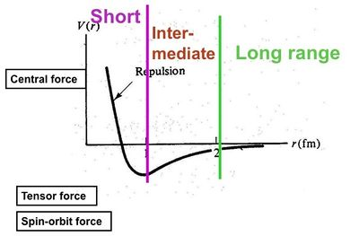

Strong forces : The strong interactions , the forces between the nucleons , are the strongest forces found in nature. The gravitational and the electromagnetic interaction were known to us long before the nuclear forces , they were associated with macroscopic bodies ,e.g .the gravitational forces between the planets and the sun and the electrical forces between charged bodies.

Saturation : Nuclear forces are the only ones in nature that show saturation effect. The ability of nuclear forces to act upon other particles attains a point of saturation when a nucleon gets completely surrounded by other nucleons. Those nucleons that are located outside the surrounding nucleons do not ‘feel’ the interaction of the surrounded nucleon.

Summarizing : (i) the forces between nucleons are attractive in nature when they are 0.5 – 25 F. (ii) these forces are of short range having maximum value at about 2 х 10⁻¹⁵ m and fall off sharply with distances ,becoming negligible beyond this range (iii) they are charge –independent so that the nuclear force between a proton and a neutron or between a neutron and a neutron are almost the same. (iv) They have the property of saturation – a particular nucleon interacts with a limited number of nucleons around it and the other surrounding ones remain. So they become saturated over short distances (v) the nuclear forces depend on the mutual orientation of spins of various nucleons and are different in parallel and antiparallel spins.

- The strong nuclear force (ii) the electromagnetic force (iii) the weak interaction forces (iv) the gravitational force

According to Yukawa’s theory, protons and neutrons do not exist independently within a nucleus but constantly exchange charges by emission and absorption of ℼ - mesons (pion) in themselves. This constant emission and absorption result in an exchange of virtual mesons by nucleons ,within the nucleus, in ultra-short intervals ̴ 10⁻²³ to 10⁻²⁴ s.As the exchange occurs in avery short time , the uncertainly principle requires that no visible change in nucleonic mass would be observed. This gives rise to rapid meson exchange or meson field between protons and neutrons in which meson acts as a quantum of nuclear force. The process is analogous to exchange of photons between charged particles in electromagnetic interactions.

֘Yukawa’s model of nuclear force:
In 1935, a Japanese Physicist Yukawa proposed a theory of nuclear force, which is finally referred as Meson –theory of nuclear forces. Yukawa proposed the existence of a new field, now known as Meson field and pointed out that the nuclear forces arise due to continuous exchange of mesons between the nucleons .Yukawa took the theory from quantum field theories of electromagnetic field in which the exchange of photon takes place and gravitational field in which the exchange of graviton is assumed. Both the field particles (photon and graviton) have zero rest mass but the nuclear field has finite rest mass i.e., nuclear force is short –range force .The rest mass M_{π} of the field particle as follows.
When one nucleon exerts a force on the other, a meson is created .The creation of meson takes the conservation of energy by an amount ΔE, corresponding to meson rest mass.
ΔE = m_{π} c² ……… (1)
The time for which meson can exist is determined by the uncertainty relation of wave mechanics is given by
ΔE Δt ̴ $ℏ$ = Δt ̴ $ℏ\frac{Ћ}{ΔE}$ …………. (2)
The maximum distance traversed by meson in this time at maximum possible speed, the speed of light c is
r_{o} = c Δt , Substituting value of Δt from (2)
r_{o} = c $\frac{ℏ}{ΔE}$ = c $\frac{ℏ}{mπ c2 }$ (using (1))
= $\frac{ℏ}{mπ c }$
$mπ= \frac{ℏ}{roc}$ …………. (3)
Assuming range of nuclear force r_{o} = 1.4 F = 1.4 ×10⁻¹⁵m, we get
$mπ=\frac{(1.05×10-34 joule-second )}{\left(1.4 ×10-15 metre\right)×( 3×108\frac{metre}{second})}$ metre
= 0.25 ×10⁻²⁷ kg
In terms of mass of electron m_{e} = 9.1 × 10⁻³¹ kg
$mπ=\frac{0.25 ×10-27}{9.1 × 10-31 }$ m_{e} = 270 m_{e}
After Yukawa’s hypothesis a search for π –mesons was started .In 1945 Powel coworkers discovered π –mesons in cosmic radiation, having mass 273 m_{e} .This is in agreement with theoretical mass of π –mesons ( = 270 m_{e} ) .The π –mesons are of three positive (π⁺), negative (π⁻) and neutral (πº ) , all have intrinsic spin I = 0.
Exchange of Neutral Pion
nº → nº + πº ; p⁺ + πº → p ⁺
Exchange Charged Pion
n₁ $⇋$ p₁⁺ + π ⁻ ; p₂⁺ + π ⁻ $⇋$ n₂
p₁⁺ $⇋$ n₁ + π ⁺ ; n₂ + π ⁺ $⇋$ p₂⁺
In the first case the first nucleon (neutron n₁) emits a negative pion i.e., it absorbed second nucleon (proton p₂ ) .In the exchange process n₁ is converted into proton p₁ another proton p₂ is converted into a neutron n₂ .According to Yukawa the pion exchange among nucleons gives rise to strong attractive force , now called the exchange force. The π – mesons are regarded as the quanta for the meson field. A nucleon is regarded as a source of field quanta and hence of meson – field .A nucleus supposed to be surrounded by virtual photons.
The relativistic relation between energy E and momentum p of a particle of rest mass given by
E² = p² c² + m² c⁴
In Quantum Mechanics the energy operator is E^ = i $\frac{∂}{∂t}$ and momentum operator ^p ,
Substituting values of E and P in operator form, we get
$\left(i ℏ \frac{∂}{∂t}\right)$ . $\left(i ℏ \frac{∂}{∂t}\right)= \left( \frac{ℏ}{i}∇\right)$ . $\left( \frac{ℏ}{i}∇\right)$c² + m² c⁴
- $ℏ$ ²$\frac{∂^{2}}{∂t^{2}}$ = - $ℏ$ ²c² 𝛁² + m² c⁴
$\left(∇2 - \frac{1}{c2} \frac{∂^{2}}{∂t^{2}}-\frac{m^{2}c2}{ℏ^{2}}\right)$ = 0
If φ (r, t) is the pion – wave function, then the wave equation for pion takes the form
$\left(∇2 - \frac{1}{c2} \frac{∂^{2}}{∂t^{2}}-\frac{m^{2}c2}{ℏ^{2}}\right)$ φ (r,t) = 0
This is relativistic Schrodinger equation (also called klein Gordan equation) for a free particle of spin 0. If we set m → 0, then
$\left(∇2 - \frac{1}{c2} \frac{∂^{2}}{∂t^{2}}\right)$ φ (r,t) = 0
This is Maxwell’s equation from which electromagnetic field is derived. This is equation to be derived from the energy equation for particles of rets mass zero.
E² - p² c² = 0
The simplest type of electromagnetic field is the electrostatic field for which$\frac{∂φ}{∂t}$ = 0, so it is given by
∇² φ = 0 (Laplace equation)
Its solution is φ = $\frac{1}{4πε}\frac{e}{r}$ δ
For $π-mesons,$equation may be expressed as
$\left(∇2 - \frac{1}{c2} \frac{∂^{2}}{∂t^{2}}-\frac{m^{2}c2}{ℏ^{2}}\right)$ φ = 0
The time independent part of equation is = $\left(∇2 -\frac{m^{2}c2}{ℏ^{2}}\right)$ φ = 0
If ꞵ = $\frac{m^{2}c}{ℏ^{2}}$ we get
(∇² ⁻ ꞵ² ) φ = 0,
From equation ꞵ = $\frac{mπc}{ℏ}$ = $\frac{1}{r0}$ , i.e., Poisson‘s equation is ∇² φ = - $\frac{ρ}{ε0}$
Therefore, (∇² ⁻ ꞵ² ) φ = $\frac{1}{ε0}$ g δ (r)
Where g is measure of nuclear field and is called the mesonic charge.
δ (r) = 1 at r = 0 ; δ (r) = 0 at r # 0
The solution of equation may be expressed as φ (r) = - λ g $\frac{e^{-βr}}{r}$
Where λ is a constant which depends on system of units.
The meson – potential will be V = g φ (r) = - λ g² $\frac{e^{-βr}}{r}$
This is the required Yukawa potential and is shown graphically in fig (9.4)
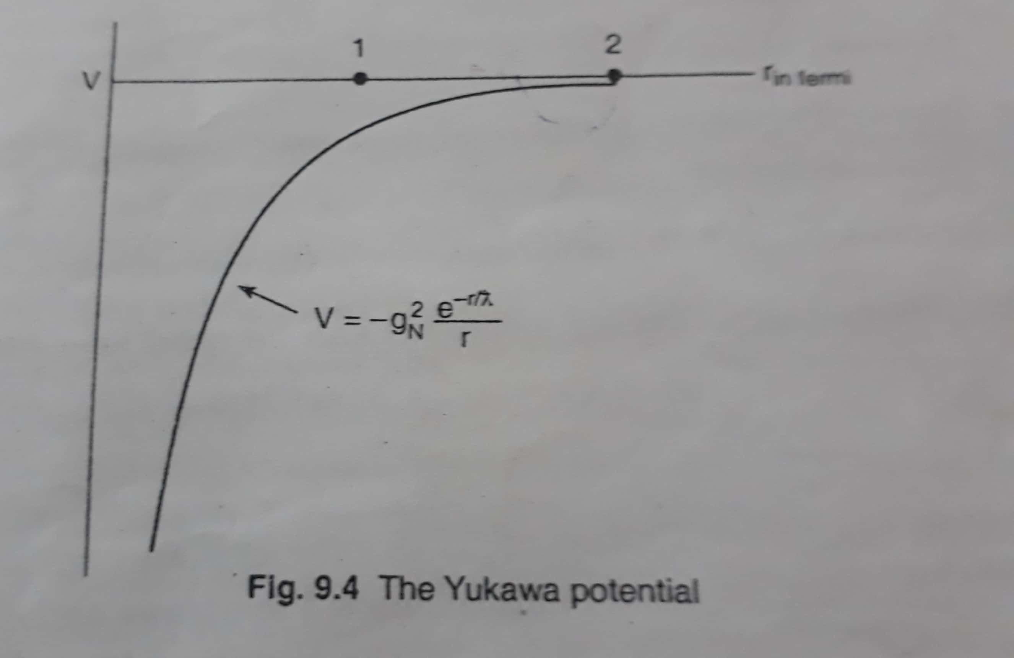
The presence of exponential term indicates that nuclear potential decreases more rapidly than Coulomb potential. For example pion has negative intrinsic parity , therefore it cannot be transferred from a neutron to proton on S –state(l = 0) and still conserve parity .To conserve parity and angular momentum both , the only possible state for the pion is P – state ( l =1).
Liquid Drop Model:
The Liquid drop is a very simple model of the nucleus and was first proposed by Niels Bohr and F.Kalcar in 1937 .In spite of its simplicity, it could account for a good number of features of nuclear behavior.
Bohr observed that three exists many similarities between the drop of a liquid and a nucleus .For instance , (i) both the liquid drop and the nucleus possess constant density; (ii) the constant binding energy per nucleon of a nucleus is similar to the latent heat vaporization of liquid (iii) the evaporation of a drop corresponds to the radioactive properties of the nucleus (iv) the condensation of drop bears semblance with the formation of the compound nucleus .Guided by these observations , Bohr had suggested that this idea could be extended to a more quantitative description of the nucleus of the atom.
According to this model, the nucleus is supposed to be spherical in shape in the stable state with radius R = r_{o} A^{1/3} , just as a liquid drop in spherical due to symmetrical surface tension forces. The surface tension effects are analogous to the potential barrier effects on the surface of the jucleus.The density of a liquid is independent of the volume, as in the case with the nucleus. But whereas the nuclear density is independent of the type of nucleus, the density of a liquid does depend on its nature. Like the nucleons inside the nucleus, the molecules in the liquid drop interact only with their immediate neighbours. The non – independence of the binding energy per nucleon on the number of nucleons is analogous to the non –independence of the heat of vaporization of a liquid on the size of the drop. Molecules in a liquid drop evaporate from the surface when its temperature is raised due to their increased energy of thermal agitation. If high energy nuclear projectiles bombarded the nucleus, compound nucleus is formed in which the nucleus quickly share the incident energy and the emission of nucleons occurs. In splitting of the liquid drop into two more or less equal parts when set into vibrations with sufficient amount of energy.
Semi-empirical mass formula:
Since nuclear masses are accurately known experimentally, the nuclear binding energy B.E is also known accurately. But using a semi – empirical approach , that is ,an approach based on experimental results , Weizsacker in 1935 proposed the following semi – empirical formula to achieve a quantitative and basic understanding of the nuclear binding energy B.E(in Mev) for the nucleus (Z,A).
B.E = aʋ A – as A^{2/3} – ac $\frac{z (z-1)}{A1/3 }$ - an $\frac{ (A-2Z)2}{A }$ ± $\frac{δ}{A3/4 }$ …… (1)
With the constants or coefficients having typically the values all in Mev : aʋ = 14.0 , as = 13.0 , ac = 0.60 , an = 19 and $δ=33.5$for even – even or odd – odd nuclei and $δ=0$ for even –odd nuclei.
The mass formula has many applications, eg ., prediction of stability against ꞵ - decay for members of an isobaric family , explanation of fission by Bohr and Wheeler and calculation of stability limit against spontaneous fission etc.
The liquid drop suggests like that the volume energy and surface energy of a liquid drop , there will be various contributions to the nuclear binding energy.
- Volume energy term: The first term Bʋ = aʋ A , is the volume effect representing the volume energy of all nucleons .The larger the total number of nucleons A, the more difficult it is to remove an individual nucleon from the nucleus. Since the nuclear density is nearly constant , the nuclear mass is proportional to the nuclear volume , which again is proportional , for spherical nucleus ,to R³ ,if R α A^{1/3}. So the volume energy , Bʋ α A .Thus the main contribution B.E comes from the total number of nucleons A and , as a first approximation,
Bʋ = aʋ A
Where aʋ is a constant, called the volume coefficient.
- Surface energy term : The second term , B_{S} = as A^{2/3} , is the surface effect, similar to the surface tension in liquids ; like the molecules on the surface of a liquid , the nucleons at the surface of the nucleus are not completely surrounded by other nucleons. The total binding energy is thus reduced due to nucleons on the surface. This correction due to surface energy, B_{S} ,is proportional to the surface area of the nucleus i.e., to 4πR² , for spherical nucleus of radius R. But R α A^{1/3}.So B_{S} α A^{2/3}.
B_{S} = as A^{2/3}
Where the constant as is called the surface coefficient.
- Coulomb energy term: The third term, B_{c} is the Coulomb electrostatic repulsion between the charged particles, protons, in the nucleus, Since each charged particle repulses all other charged particles, this term would be proportional to the possible number of contributions for a given proton number Z, which is Z (Z-1)/R energy of interaction between the protons is again inversely proportional to the distance of separation R. So the energy associated with Coulomb repulsion is
B_{c = k} $\frac{z \left(z-1\right)}{R} = k \frac{z \left(z-1\right)}{rO A1/3}$
B_{c} = _{ac} $\frac{z (z-1)}{A1/3 }$
R is replaced by r_{o} A^{1/3} and since this repulsive effect also dilutes the binding energy, it appears as a negative quantity in the semi – empirical mass formula.
- Asymmetry energy term: The fourth term B_{a} originates from the symmetry between the number of protons and neutrons in the nucleus .For stable lighter nuclei, the number of protons is almost equal to that of neutrons: N = Z. As A increases, the symmetry of proton and neutron number is lost and the number of neutrons exceeds that of protons to maintain nuclear stability .This neutron excess i.e., excess of neutrons decreases the stability or B.E of the medium or heavy nuclei.
The asymmetry energy, Ba, is directly proportional to (i) the neutron excess, N – Z or A – 2Z (A = N + Z), present in asymmetric nuclei and (ii) the fraction of nuclear volume in which the excess neutrons are present. As the nuclear volume is proportional to A, the fractional volume of the nucleus in which excess neutrons are present will be proportional to (N –Z)/A i.e., neutron excess per nucleon.
B_{a} α (N –Z), and also
α $(N – Z)/$A
B_{a} = a_{n} $\frac{(N – Z)2}{A}$
B_{a} = a_{n}$\frac{ (A-2Z)2}{A }$
Where a_{n} is a constant, called the asymmetry coefficient.
- Pairing Energy term: All the energy terms introduced so far involve a smooth variation of B.E with change in proton number Z or neutron number N. But B.E/A vs. A plot shows a number of kinds and evidence of favored pairings. For nuclides, with Z (or N) = 2, 4, 8,20,50,82 and 126 (magic numbers) have larger B.E value. This fact is not taken into account in a liquid drop model; intrinsic nucleonic spin and shell effects are disregarded. This omission demands a correction which is made in part by introducing the last term which is a pure corrective term called the pairing energy term B_{p}
If nuclei with even Z and even N are most stable, whereas nuclei having odd Z and odd N are last stable and nuclei with odd N and even Z , or even N and odd Z lie in between .Each of the protons and neutrons having spin ½ form pairs with parallel and anti –parallel spin in even N –even Z type nuclei having them a stable configuration .But in odd Z-odd N type nuclei , one unpaired proton and one unpaired neutron are left to make the nuclei less stable. So the pairing of spins increases the B.E of even Z- even N type nuclei and decreases in odd N nuclei .Thus , the correction term Bp of pairing energy which is proportional to A ^{-3/4} is given by
B_{P} = $\frac{δ}{A3/4 }$
Where $δ$a constant .This relation is was determined empirically by Fermi.
Classification of Stable Nuclides
S.No. | Z | N | A | No.of stable nuclei | $$δ$$ | B_{P}
1 | even | Even | even | 165 | -33.5 | - $\frac{δ}{A3/4 }$
2 | even | Odd | odd | 55 | 0 | 0
3 | odd | Even | odd | 50 | 0 | 0
Binding energy B.E of a nucleus is thus finally given by
B.E = aʋ A – as A^{2/3} – ac $\frac{z (z-1)}{A1/3 }$ - an $\frac{ (A-2Z)2}{A }$ ± $\frac{δ}{A3/4 }$
f_{B} = $\frac{ B.E}{A}$ = aʋ - $\frac{as}{A1/3 }$ - ac $\frac{z (z-1)}{A4/3 }$ - an $\frac{ (A-2Z)2}{A2 }$ ± $\frac{δ}{A7/4 }$
f_{B} is the binding fraction , i.e., the binding energy per nucleon.
The formula for the mass of the nucleus is given by
Z^{A} M = Z M_{P} + (A –Z) M_{n} - B.E /c²
Z^{A} M = Z M_{P} + (A –Z) M_{n} - 1/ c² [aʋ A – as A^{2/3} – ac $\frac{z (z-1)}{A1/3 }$ - an $\frac{ (A-2Z)2}{A }$ ± $\frac{δ}{A3/4 }$]
The above equation is known as Semi – empirical mass formula of Weizsacher.
Shell Model:
The large binding energy of He – nucleus (α – particle) suggests that 2 protons and 2 neutrons form a stable nuclear configuration .Taking the clue from the chemical stability of closed electron sub – shells and shells in atoms ,the physicist enquired nucleons too form similar closed sub – shells and shells in nuclei ,i.e., if protons and neutrons in a nucleus are also arranged in some type of a shell structure.
Points in favour of the shell model:
- Just an inert gases , with 2, 10 ,18 , 36 , 54 …… electrons, closed nucleus showing high chemical stability , nuclei with 2 , 8 , 20 , 50 , 82 and 126 nucleons are called magic numbers of the same kind are particles stable. The binding energy is found to be unusually high implying high stability is reflected in high abundance of isotopes with these proton numbers and isotope of these neutron numbers .Nuclei both with Z and N = each a magic number , is to be doubly magic.
- The number of stable isotopes (Z =const.) and isotopes (N =const.) with respective number of protons and neutrons equal to either of the magic numbers e.g., S_{n} (Z = 50) has stable isotopes, C_{a} (Z= 20) has 63; the biggest group of at N = 82, then at N = 50 and N = 20.
- The three naturally occurring radioactive series decay to the stable end ₈₂ P_{b}²⁰⁸ with Z = 82 and N = 126 indicating extra stable configuration of magic numbers.
- The neutron absorption cross – section is low for nuclei with N = magic numbers like 50, 82 and 126, indicating reluctance of magic nuclei to accept extra neutrons in their completely filled shells.
- Isotopes like ₈O¹⁷ , ₃₆K⁸⁷ and ₅₄Xe¹³⁷ are spontaneous neutron emitters when excited by preceding ꞵ - decay .The isotopes have N =9 , 51 and 83 respectively .i.e.,
N = (8 + 1), (50 + 1) and (82 + 1).One can interpret this loosely bound neutron as a valence neutron which the isotopes emit to assume some magic N –value for their stability.
- Electric quadrupole moment Q of magic nuclei is zero indicating spherical symmetry of the nucleus for closed shells. When Z –value or N –value is gradually increased from one magic number to the next. Q increases from zero to a maximum and then decreases to zero at the next magic number.
- The energy of α and ꞵ - particles emitted by magic radioactive nuclei is larger.

Salient features of Shell Model:
This model assumes that each nucleon stays in a well – defined quantum state. Unlike atom, the nucleus has no obvious massive central body acting as fixed force Centre of charge.
In the shell model , each nucleon is considered as a single particle that gives independently of others in the time – averaged field of the remaining (A – 1) nucleons acting as a core , and is confined to its own orbit completing several revolution with being disturbed by others by way of collisions. This implies that the mean free with before collisions of nucleons is much larger than the nuclear diameter. It amounts by assuming the interaction among the nucleons to be weak.
In terms of Schrodinger‘s equation, each nucleon thus moves in the assume that potential which may be taken as a an average harmonic oscillator potential so that
V(r) = 0, Schrodinger equation then becomes
$\left(- \frac{ℏ2 }{2M} ∇2+\frac{1 }{2} Kr2\right)$ ᴪ = Eᴪ …… (1)
The solution of equation (1) is given by
E_{n} = $\left(N+\frac{1 }{2} \right)$ ℏꞷ ……. (2)
Where N = oscillator quantum number = 0, 1, 2, 3 ….so that in the harmonic oscillator model, all the energy Eigen states are equally spaced. The wave function ᴪ has both angular (orbital) and the radial part.
Each nucleon is supposed to have an orbital angular momentum | l| = $\sqrt{l(l+1)}$ ,where $l=0,1,2,3,…$the nuclear orbital quantum number .Another quantum number very similar to but not the principal quantum number of electronic orbit , the radial part of nuclear wave function and is symbolized by n = 1,2 ,3 ….Each nucleon has also spin angular momentum | s | = $\sqrt{s(s+1)}$ ℏ where s = ½ and behavior of an independent particle subject to Pauli’s Principle that no two identical nucleons can be in the same quantum state. By Mayer, Jensen and others, there is a strong interaction between the orbital and the intrinsic spin angular momentum of each nucleon. The quantum mechanical rules for angular momenta l ℏ and spin s ℏ must be such that j is restrict to the following two values : j = l +1/2 and j = l -1/2.
Each of two j –levels and each nucleus energy level with a given l splits into two sub –levels, except for l=0, when j has one value ½.The level j = l +1/2 corresponds to parallel (↑↑) and j = j = l -1/2 anti-parallel (↓↑) to each other. To designate the nucleonic states, spectroscopic notation of atomic physics followed. Each sub – level can have a maximum of (2j + 1) nucleons of the same for a given so it can house (2 j + 1) protons and (2j + 1) neutrons. Nucleons designate with n- values followed by spectroscopic notation of l –values (s, p, d,f) for l = 0,1,2,3… the j –values are shown as subscript and the superscript give number of nucleons required to complete the sub – shells.
For l = 0, j = l +½ = ½ and the number of nucleons j = 2j + 1 = 2 х ½ + 1 = 2 and the state is designate along with n –value. Similarly, for l = 1, j = l ± s = l ± ½ = 3/2 and ½ .The number of nucleon nave two sub –shells are thus 2 х 3/2 + 1 = 4 and (2 х ½ +1) = 2.The two sub –shells are designated 1as (1p_{3/2})⁴ and (1p_{1/2})² respectively.
Nucleonic sub – shells and shells
n | l | j | Designation and no. of p or n to fill sub -shells | Progessive Total
1 | 0 | 1/2 | (1s_{1/2})² 2 | 2
1  1 | 1  1 | 3/2  1/2 | (1p _{3/2})⁴  (1p _{1/2})² 6 | 8
1  2  1 | 2  0  2 | 5/2  ½  3/2 | (1 d_{5/2})⁶  (2 s_{1/2})² 12  (1 d_{3/2})⁴ | 20
1  2  1  2  1 | 3  1  3  1  4 | 7/2  3/2  5/2  ½  9/2 | (1f_{7/2})⁸  (2p_{3/2})⁶  (1f_{5/2})⁶ 30  (2p_{1/2})²  (1g_{9/2})¹⁰ | 50
1  2  2  3  1 | 4  2  2  0  5 | 7/2  5/2  3/2  ½  11/2 | (1g_{7/2})⁸  (2d_{5/2})⁶  (2d_{3/2})⁴ 32  (3s_{1/2})²  (1 h _{11/2})¹² | 82
1  2  2  3  3  1 | 5  3  3  1  1  6 | 9/2  7/2  5/2  3/2  ½  13/2 | (1h_{9/2})¹⁰  (2f_{7/2})⁸  (2f_{5/2})⁶ 44  (3p_{3/2})⁴  (3p_{1/2)}²  (1i_{13/2})¹⁴ | 126

